WebSpider

Table of Contents

Change Log 2

Screens 3

Home Screen 3

Application Details 3

Tabs 3

Scheduled Tasks 3

Status Bar 3

AdiGlobal.us 4

Icons 4

Tabs 4

Modes 4

Display Area 5

Tasks 6

Buttons 6

Tasks Details 6

Settings 8

General Settings 8

Email Settings 9

AdiGlobal Settings 10

# Change Log

9.0.0.1 April 3, 2015

Bug fixes

9.0.0.1 February, 2015

Bug fixes

# Screens

## Home Screen

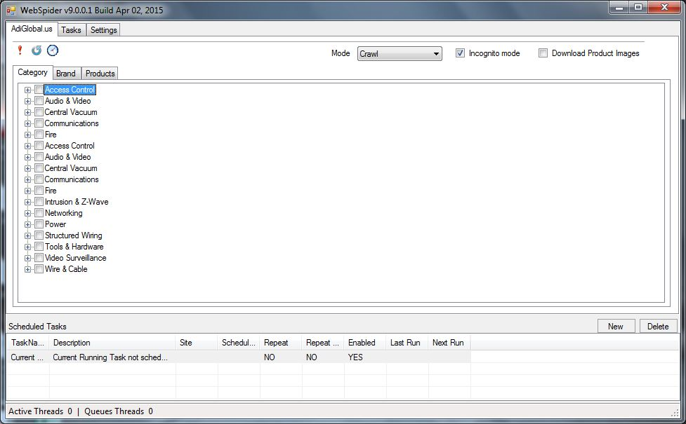

### Application Details



Application name with build number and date of build

### Tabs



Mail tabs showing AdiGlobal.us, Tasks and Settings

* AdiGlobal.us Crawl or update product information for http://adiglobal.us
* Tasks Currently running or pending tasks.
* Settings Settings related to the application

### Scheduled Tasks



### Status Bar



Here you can view actively running tasks and pending tasks

## AdiGlobal.us



### Icons

Product Priority



Reload Brand/Categories

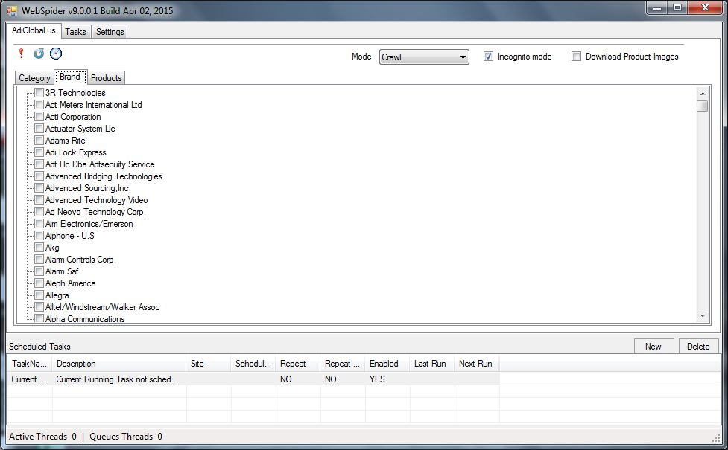

Timer



### Tabs

Tabs contains list of categories, brands or products to crawl or update.

### Modes

|  |  |
| --- | --- |
|  | Select scrapping mode here. Different modes are   * Crawl – Crawls the site for categories/brands * Update – Updates existing products from database. * Clearance Zone – Collects Clearance Zone products * Hot Deals – Collects Hot Deals items. * Online Specials – Collects Online Specials items. * Sale Center – Collects Sale Centre product information. * In Stock – Collects information for In-Stock items |
|  | Incognito Mode prevents login (anonymous browsing) when checked. |
|  | Downloads product images along with other information when checked. |

### Display Area



Select the categories, brands or products you wish to download/update here.

Once you have finished selecting, move on to the next tab – Tasks.

## Tasks

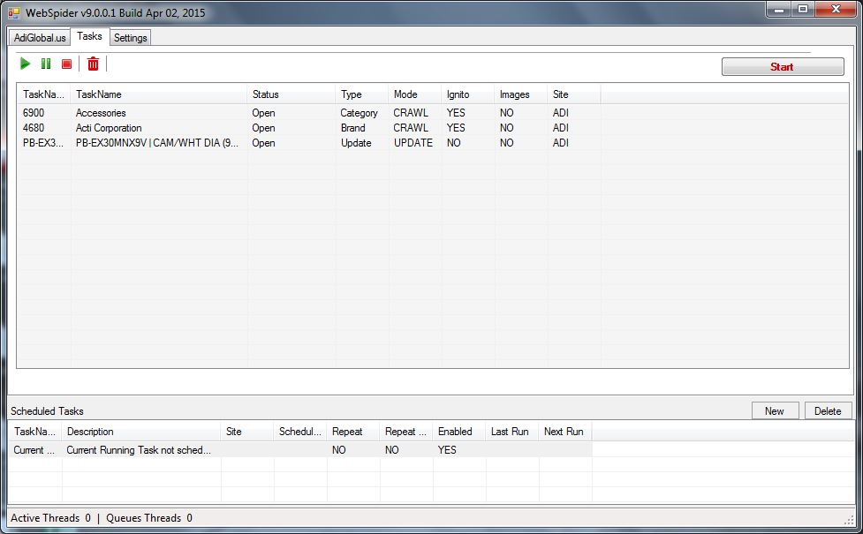

### Buttons

|  |  |
| --- | --- |
|  | Resume all paused tasks |
|  | Pause all tasks |
|  | Stop all tasks |
|  | Delete task |
|  | Start processing tasks |

### Tasks Details



#### Right Click Menu

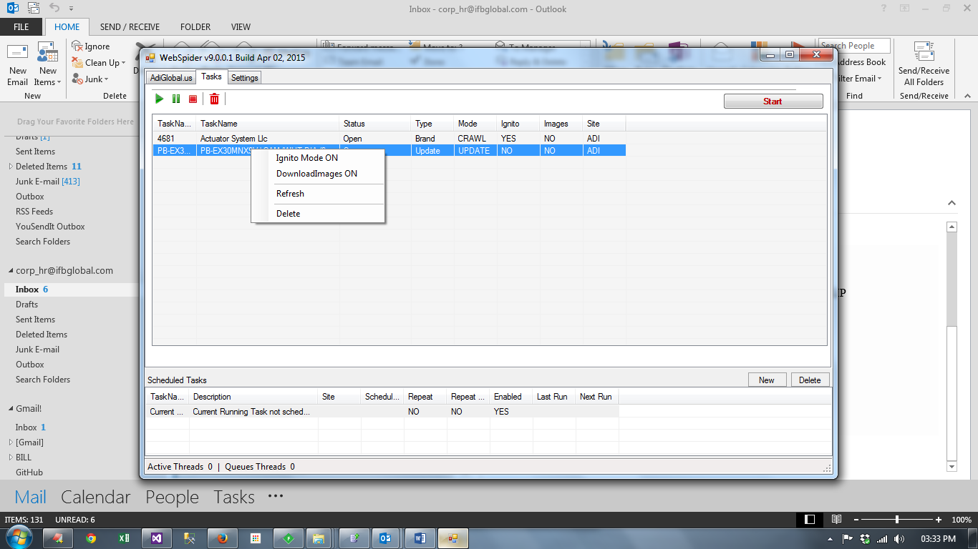

|  |  |  |
| --- | --- | --- |
| Menu Item | Description | Shortcut Key |
| Incognito Mode ON/OFF | Turn on or off incognito mode | Ctrl + I |
| Download Images ON/OFF | Download product images or do not download images | Ctrl + D |
| Refresh | Refresh tasks list |  |
| Delete | Delete selected item from tasks list | Delete |

## Settings

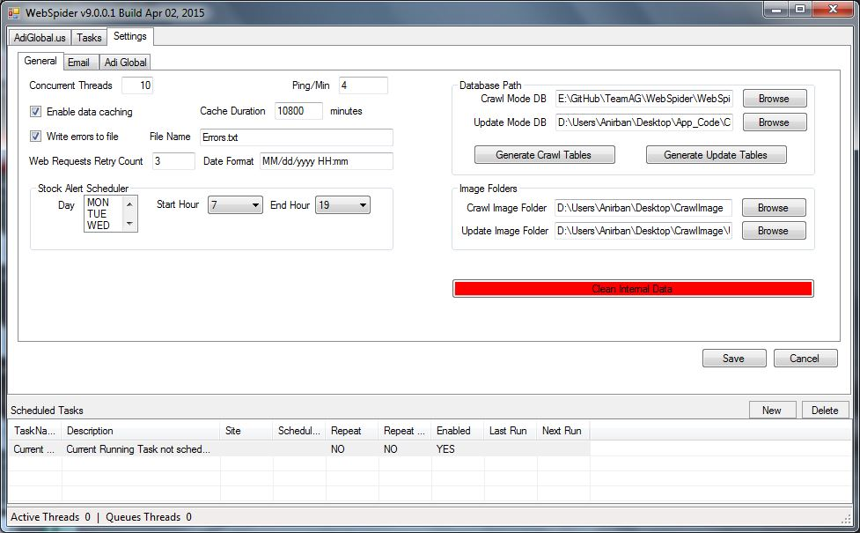

### General Settings

|  |  |
| --- | --- |
| Concurrent Threads | Number of browser instances to run concurrently. |
| Ping/Min | Ping rate – maximum number of hits to server per minute. |
| Enable Data Caching | Data caching stores the server pages into files before processing. Cached data is valid for **Cache Duration** after which data is discarded. If **Data Caching** is enabled, the same URL will not be hot twice if data from the previous hit is valid, instead data will be read from file. |
| Cache Duration | Duration in minutes for which data in cache is valid. |
| Write errors to file | Write application errors to files. |
| Web Requests Retry Count | The maximum number of retries before a URL is declared inaccessible. |
| Date Format | The Default Date format. |
| Stock Alter Scheduler | Day and time for the stock alert scheduler to run. |
| Database Path | Path to Access Databases containing update and crawl databases. |
| Generate Crawl Tables | Generates table structure in crawl database. [Note1] |
| Generate Update Tables | Generates table structure in update database. [Note1] |
| Image Folders | Folder for downloading images. |
| Clear Internal Data | Clears all internal data from application storage.[Note 2] |

**Notes**

*Note 1: Clear Internal data before clearing Generate Tables*

*Note 2: Restart the application after cleaning internal data to load brand categories automatically. Otherwise you may load brand and categories by clinking on the* ***Reload*** *icon in AdiGlobal tab.*

### Email Settings

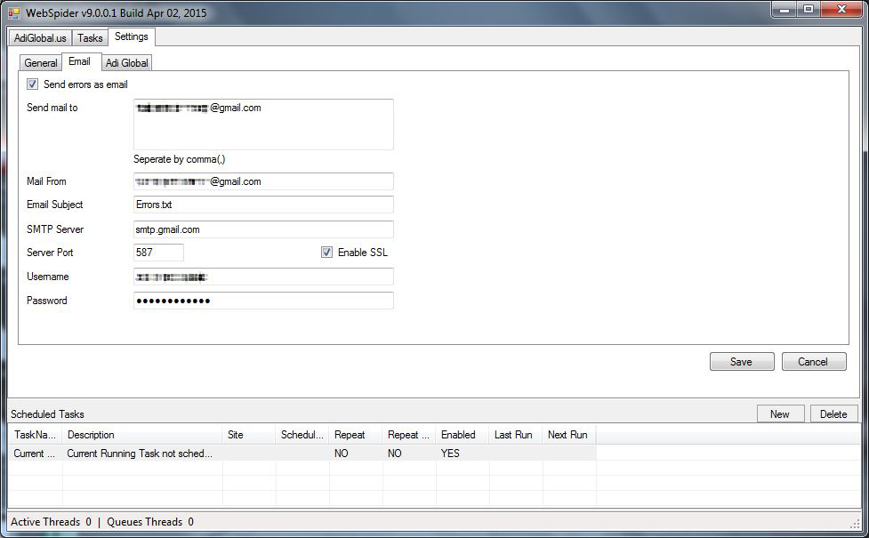

|  |  |
| --- | --- |
| Send Errors as email | Sends error details by email when cheked |
| Send mail to | Sends mail to this address. You can add multiple addresses separate by comma. |
| Mail From | Send mail from this address. Usually this the same address beginning with **Username**. |
| Email Subject | Subject of the mail |
| SMTP Server | Mail Server address |
| Server Port | Mail Server port |
| Enable SSL | Check if mail server uses SSL |
| Username | Username for logging into mail sever |
| Password | Password for server |

### AdiGlobal Settings

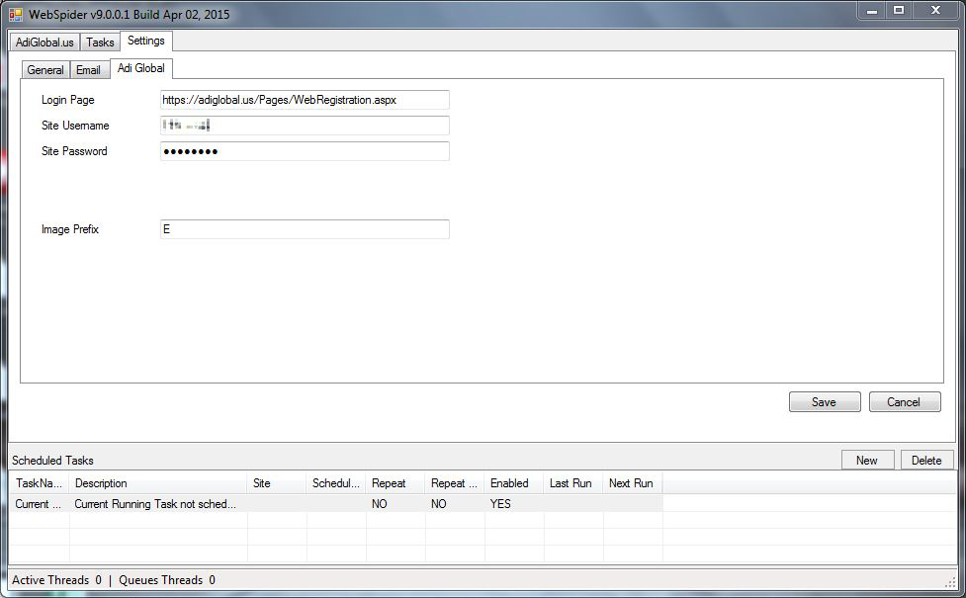

|  |  |
| --- | --- |
| Login Page | URL of the login Page |
| Site Username | Username for Adiglobal.us |
| Site Password | Password for AdiGlobal.us |
| Image Prefix | Prefix to be added to image files downloaded from AdiGlobal.us |