SECTION 1: Setups and Project Standards
Screenshot 1.1 — Project Initialisation
- Claude Code launched in your terminal inside the project directory
- The project folder structure visible (terminal ls/dir or file explorer)



Screenshot 1.2 — CLAUDE.md Content
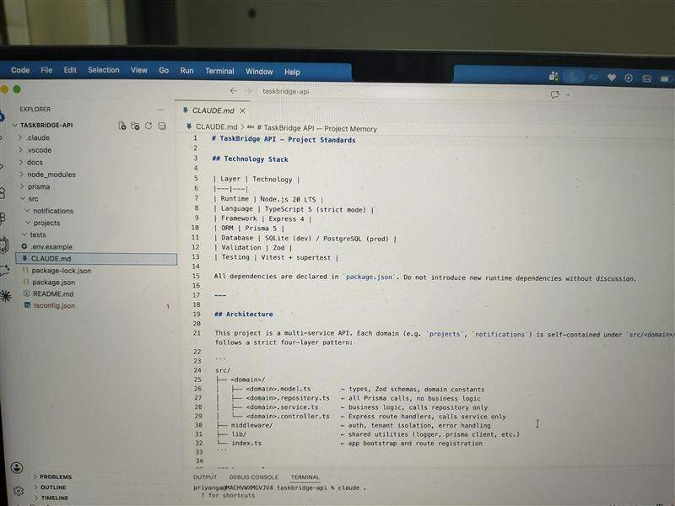
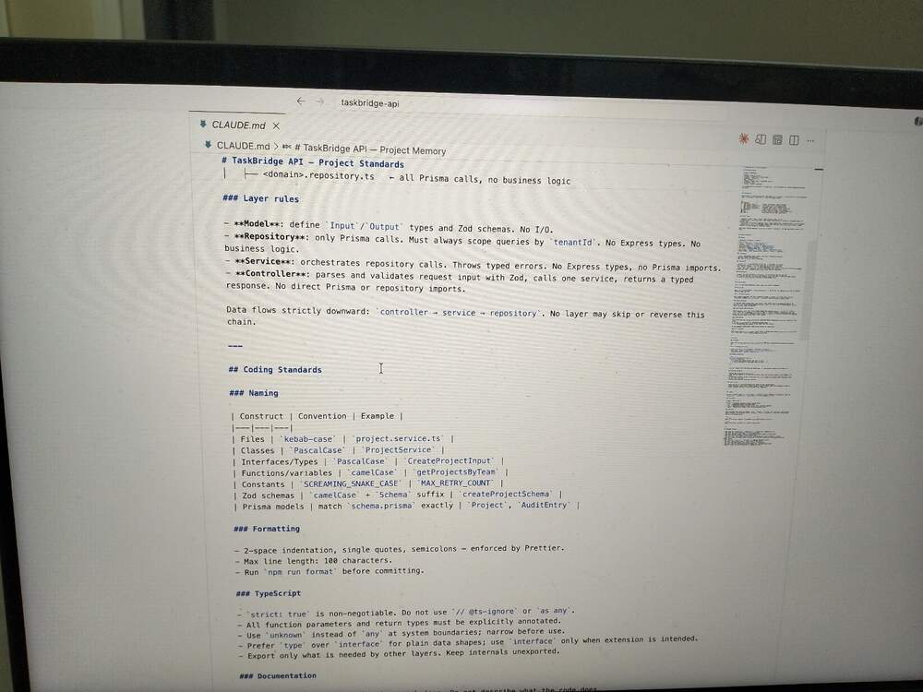
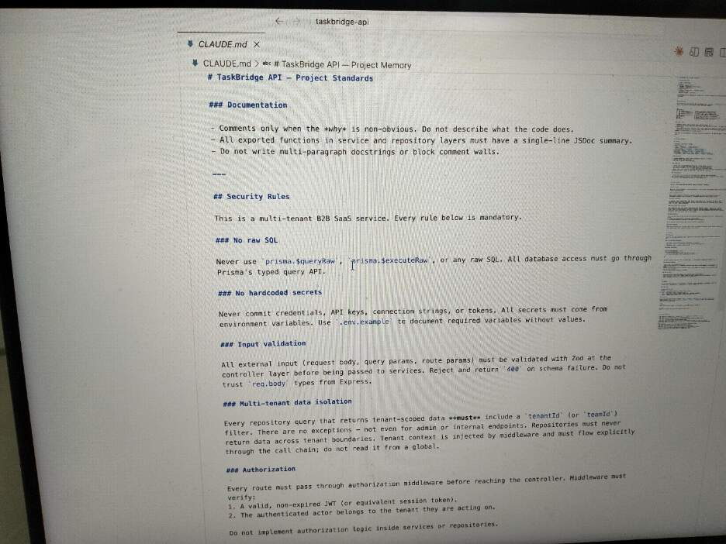
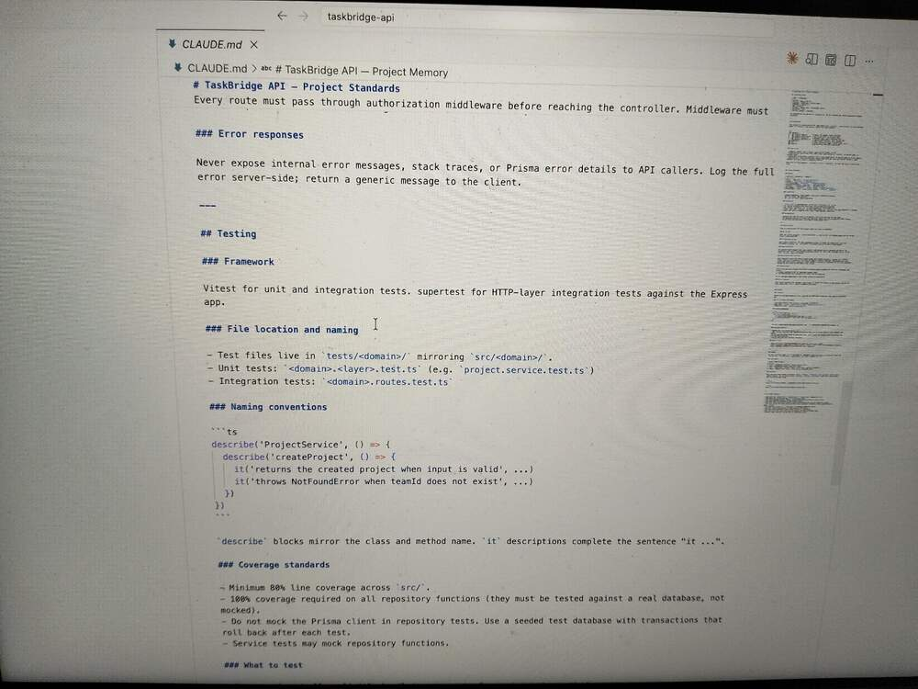
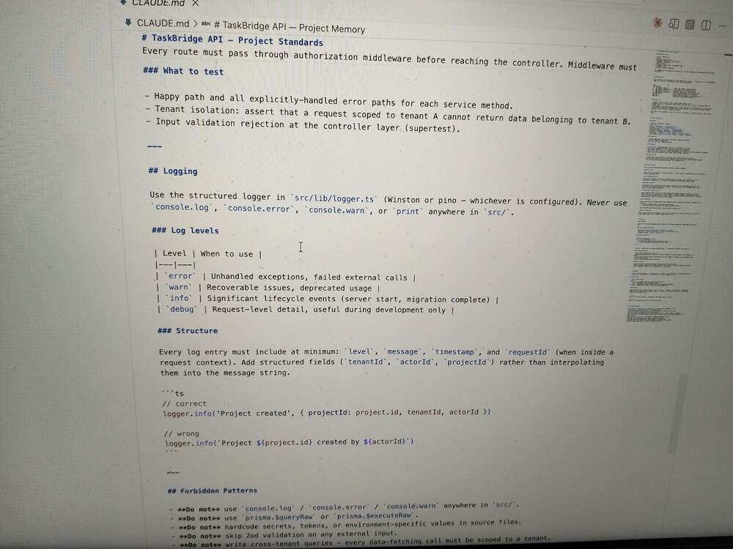
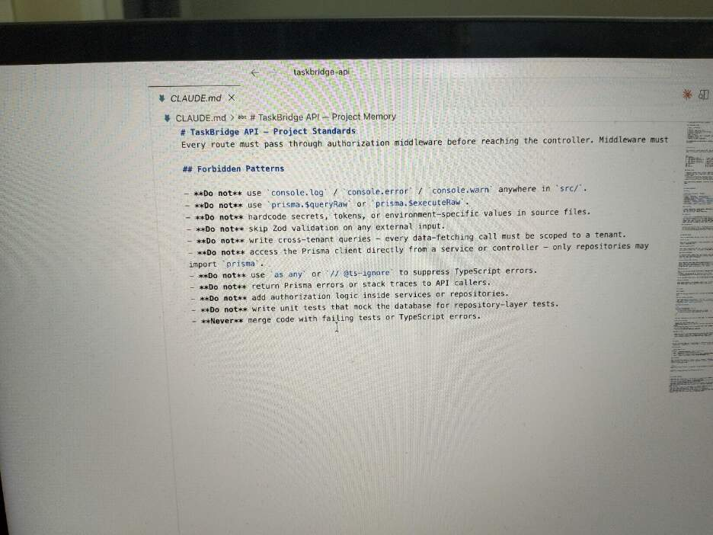
1A. The CLAUDE.md is structured to enforce constraints at the right layer - security rules sit closest to the data (repository scoping, no raw SQL), while architectural rules prevent those constraints from being bypassed by accident (no controller importing Prisma directly). For a fintech B2B SaaS context the three rules that matter most are mandatory tenant ID scoping on every query (a missing filter leaks one customer 's financial data to another - the kind of incident that ends companies), no raw SQL via Prisma (parameterized queries are the primary defence against SQL injection on sensitive financial records), and no internal errors returned to the callers (stack traces and Prisma messages exposed schema structure and can be used to probe for vulnerabilities). The Structured logging standard is the fourth I'd highlight the audit trails with consistent tenant ID or actor ID fields are not just good practice in fintech, they are often a complaint requirement for SOC 2 and similar frameworks.

SECTION 2: Transaction Module — AI Generation
Screenshot 2.1 — The Low-Effort Prompt
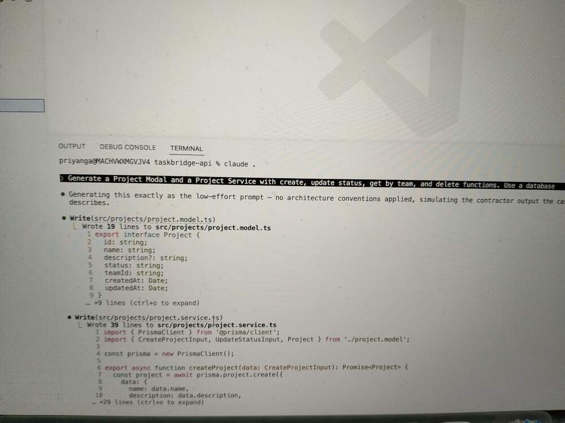

Screenshot 2.2 — Generated Files
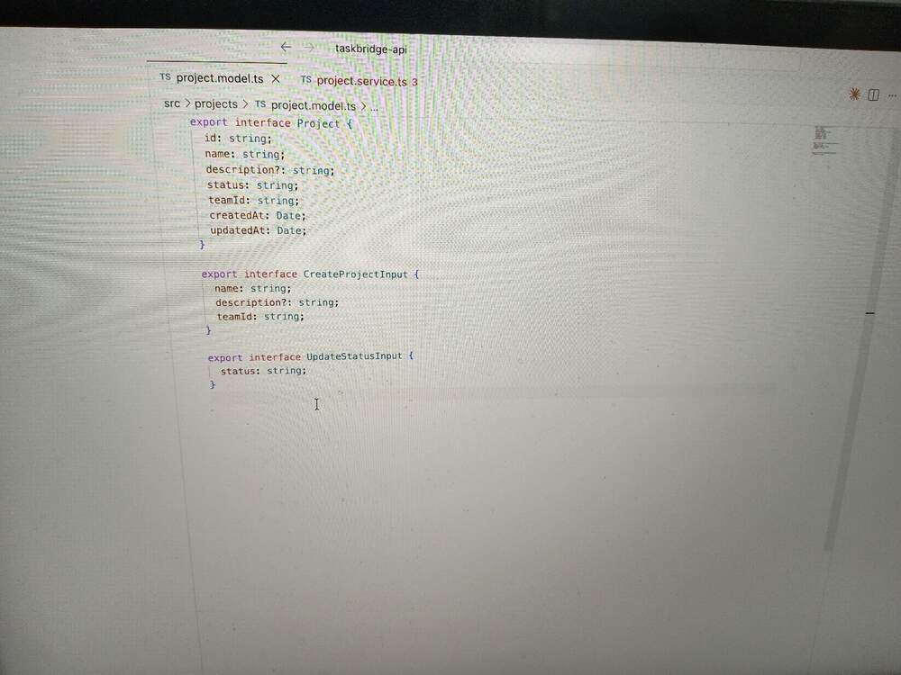
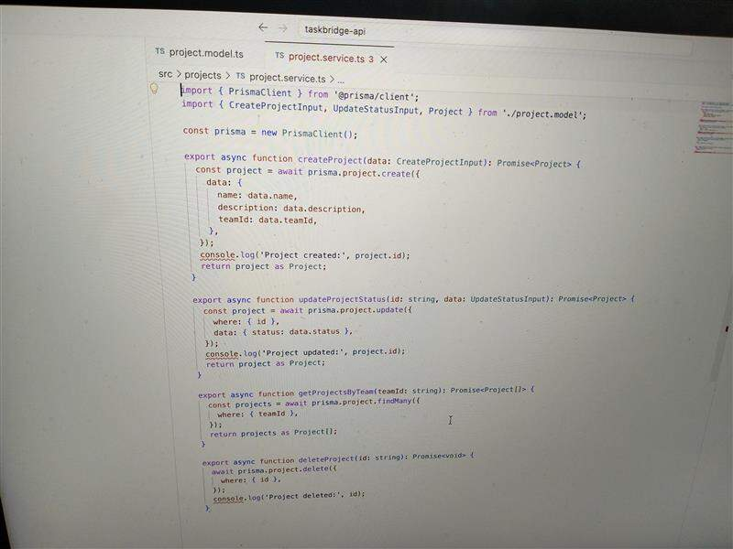

2A. I would see few things that are potentially problematic
- new PrismaClient() inside the service file. Every import of this module spins up a new database connection pool. It is classic rushed-code mistake.
- Console.log everywhere – No Structured logging, no log levels, no request context.
- No tenant isolation – getProjectsByTeam filters only by teamId, but there is nothing tying teamId to an authenticated tenant. One team could theoretically query another team’s projects by guessing an ID.
- Status is a free form string. No enum, no allowed values list – any caller can set any status and it writes straight to the database.
- No error handling and input validation.

SECTION 3: Code Review of AI Output
Screenshot 3.1 — Using Claude Code for Review
Prompt 1:
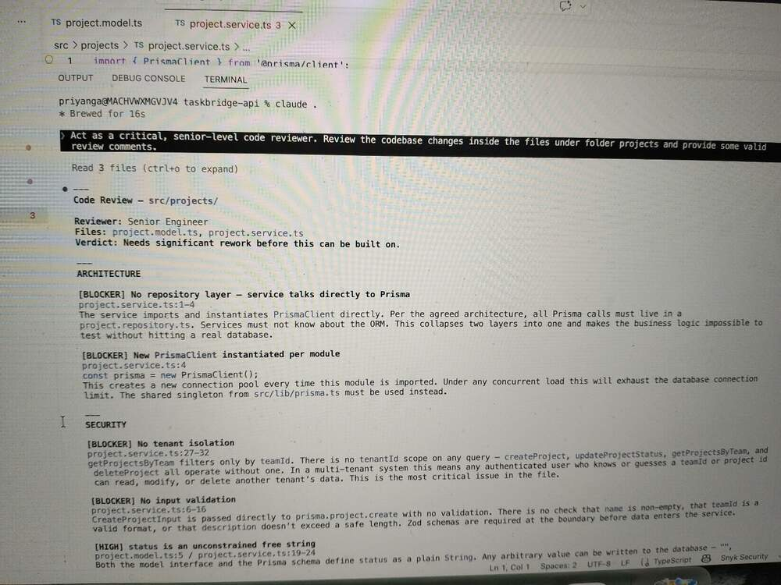

Prompt 2:
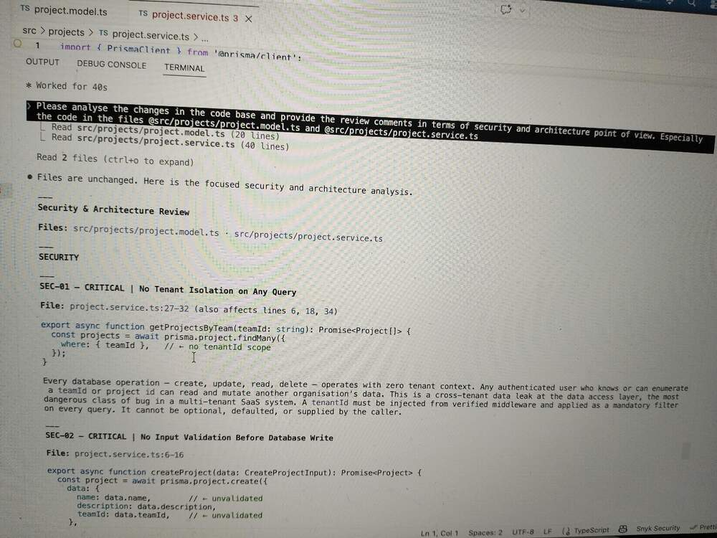

Screenshot 3.2 — An Issue You Caught That Claude Code Missed
getProjectByTeam performs an unbounded database query.
File: project.service.ts: 27-32
There is no take, skip or cursor argument. If a team accumulates hundreds or thousands of projects, a single API call loads the entire result set in to memory, serialises it and sends it over the write. This has two consequences:
Security: It is straightforward application-layer DoS vector. An authenticated caller can issue repeated calls that each consume significant memory and database I/O. No rate limiting elsewhere in this code would save it because the damage happens inside the query itself.
Architecture: findMany with no limit is never safe as a permanent design.
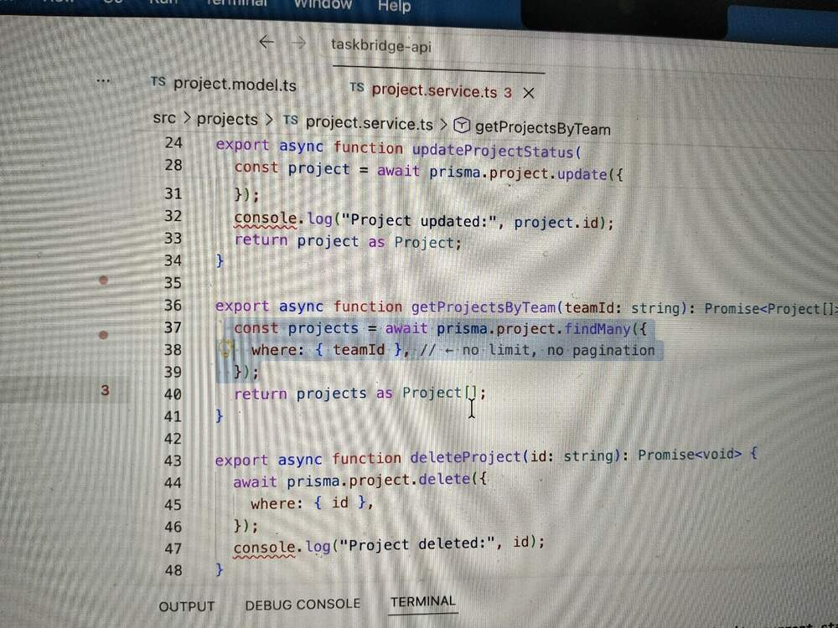

Write — Review Findings Table:
# | Location (file + function) | Category (Bug / Security / Architecture / Performance / Standards) | Severity (Critical / High / Medium / Low) | What's Wrong & Fintech Impact | How I Detected It (Claude Code feature used OR "Manual review") | Recommended Fix
1 | Project.service.ts – all functions | Security | Critical | No tenantId scope on any query. Any authenticated users who knows or guesses a teamId or projectId can read and mutate another organisation’s data. In fintech this is a cross tenant breach and a direct regulatory violation (GDPR, SOC 2) | Claude Code | Inject tenantId from verified JWT middleware; add it as a mandatory WHERE filter on every Prisma query – create, read, update, delete.
2 | Project.service.ts – createProject, updateProjectStatus | Security | Critical | No run time input validation. Typescript interfaces are erased at compile time – nothing validates incoming HTTP data. | Claude Code | Add Zod schemas in project.model.ts; validate all external input at the controller boundary before the service is called.
3 | Project.service.ts:4 | Architecture | Critical | New PrismaClient() instantiated inside the module. Every import creates a new connection pool. Under concurrent load this exhausts the database’s maximum connection count, causing connection timeout across the entore platform | Claude Code | Replace with shared singleton from src/lib/prisma.ts. One instance for the entire platform.
4 | Project.services.ts – all functions | Architecture | Critical | No repository layer. The service imports PrismaClient directly, collapsing the repository -> service boundary. Business logic and data access are permanently coupled – neither is testable in isolation, and any ORM change rewrites both layers. | Claude Code | Extract all Prisma calls in to project.repository.ts. Service imports only from the repository, never from @prisma/client
5 | Project.service.ts: 18-25, 34-39 | Security | High | Unhandled Prisma errors leak internal details. A P2025 Record not found exception bubbles up as a raw 500 with stack trace, exposing ORM internals, table names. In fintech, this aids targeted API probling. | Claude code | Catch PrismaClientKnownRequestError; mapP2025 to a typed ProjectNotFoundError; return generic, controlled HTTP response. Never surface stack traces to the caller.
6 | Project.service.ts: 34-39 | Security | High | Hard delete with no compliance guard. Project has an audit entry relationship. Deleting a project either cascades and permanently destroys immutable audit history or throws a foreign key constraint error. Audit log destruction is compliance violation under most fintech regulatory framwework. | Claude code | Replace hard delete with a soft delete. If hard delete is ever required, make it an explicit, access controlled admin operation with a mandatory retention check.
7 | Project.service.ts: 27-32 | Performance | High | getProjectByTeam performs an unbound findMany with no take, skip or cursor. A team with thousands of project loads the entire result set to memory in a single query – a memory exhaustion. In fintech, slow or crashing APIs during peak settlement windows are a business critical failure. | Manual | Add mandatory pagination. Enforce a hard maximum page size default at the repository layer so callers cannot opt out.
8 | Project.model.ts / project.service.ts | Security | High | Status is an unconstraint string in both the interface and Prisma schema. Any arbitrary value writes to the database. Downstream compliance logic and audit customers that switch on status will behave unpredictable or silently misclassify records. | Claude code | Define an union type (‘ACTIVE’ | ‘COMPLETED’ | ‘ARCHIVED’) and a Zod enum; reject any value outside the set before it reaches the repository.
9 | Project.service.ts: 14, 23, 38 | Standards | Medium | Console.log used for all observabilities. In Fintech, unstructured logs fail SOC 2 audit trail requirement. | Claude code | Replace with structured logger from src/lib/logger.ts.

3A. Issues Claude Code Introduced That Required Human Judgment
Issue 1: Claude Code Generated an Entirely Wrong Domain
What happened:
When asked “Generate a transaction model and the transaction service”, claude code built a complete fintech transaction domain - model, service, repository, prisma scheme changes with full confidence. The project is a B2B project collaboration platform. Transactions have no place in it. The files had to be explicitly deleted after the case study PDF was checked
Why a human must catch this:
A human engineer read the prompt against the context of what the system is for. They would have paused at “transaction” and asked is this a payment platform? does this belong here? Claude code has no such instinct. It optimizes for completing the task as stated, not for whether the task fits the system. The domain mismatch was obvious to the reader who had spent five minutes with the README but invisible to a tool responding to a literal instruction.
Why this is especially dangerous with filesystem access:
Claude code wrote six files and modified the prisma schema before any concern was raised. In a real sprint those files enter git history potentially get referenced in other PRs, and require deliberate cleanup work. The cost of a wrong generation is not just deletion - it is wasted review time, polluted history and the risk that someone builds on the wrong foundation before the mistake is caught. A human pausing to ask a clarifying question costs 30 seconds. Reversing committed, wrong domain code costs hours
Issue 2: Claude code never notices that no audit entry is ever written
What happened:
The case study it's explicit, every project change must produce an immutable auditory capturing who changed what and when. The Prisma scheme already has an audit entry model with the direct relation to the project. The project service has createProject, updateProjectStatus and deleteProject. Not one of those functions writes an AuditEntry. This gap was not flagged in the first impression pass, not flagged in the general review and not flagged in the focused security and architecture architectural review. It was never mentioned at all.
Why a human must catch this:
This is a requirements-to-code traceability check. It requires holding the case study brief, the prisma schema and the service implementation in mind simultaneously and asking does the code deliver what was specified? Claude code reviewed the code as code. It checked for quality, security and architectural patterns. It did not check whether the implementation actually satisfies the feature requirement. A human reviewer reads the ticket, reads the schema, reads the service and notice the missing correction. That cross-artifact reasoning something claude code does poorly when it is in the review mode rather than the generation mode
Why this is especially dangerous with filesystem access:
This is a silent functional omission - the code compiles, the test would pass if written naively and the service appears to work. But the compliance requirement is not met. In a fintech or B2B SaaS context, an audit trail that is never written is not a minor gap, it is a regulatory exposure that could survive undetected until an external audit. A tool that writes directly to your file system and then reviews its own output is subject to the same blind spots as a developer proofreading their own code, compound by the fact that Claude code has no stake in whether the requirements are actually met.

SECTION 4: Transaction Module — Remediation
Screenshot 4.1 — Remediation Prompt(s)
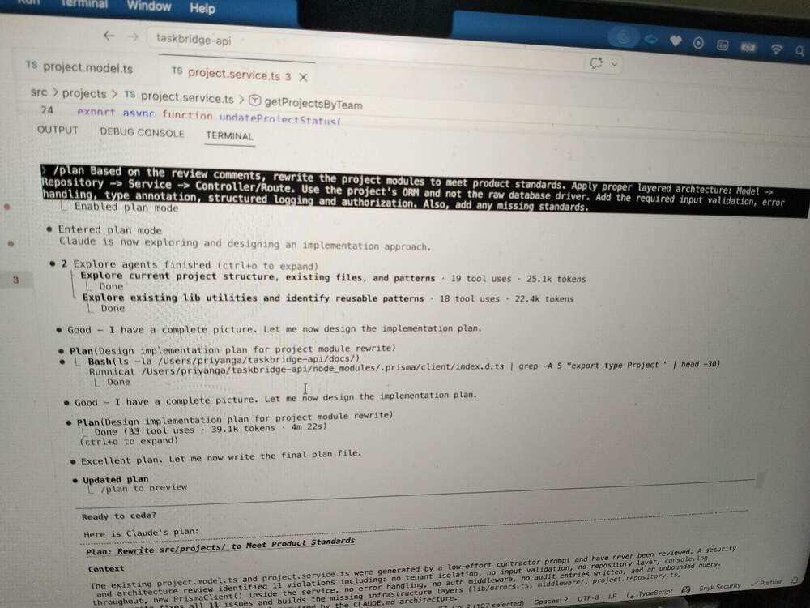
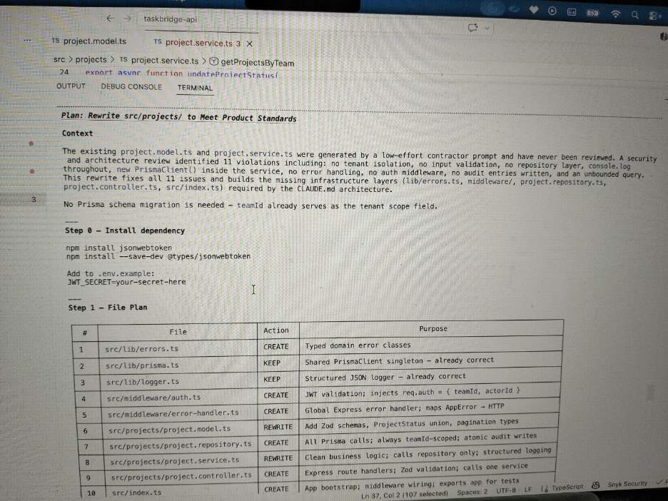
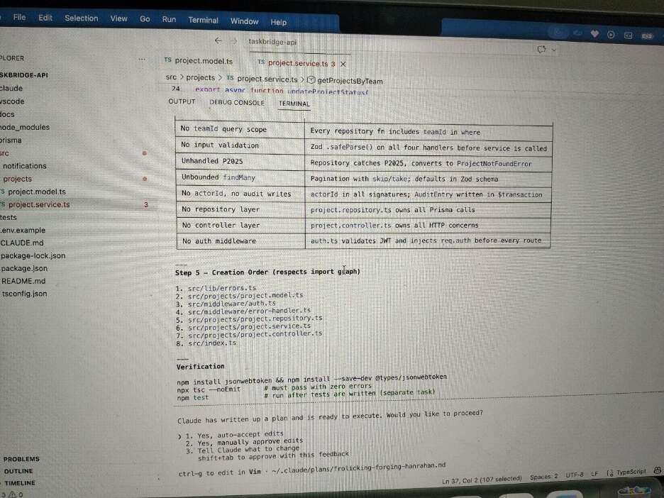

Screenshot 4.2 — Remediated Code (Key Files)
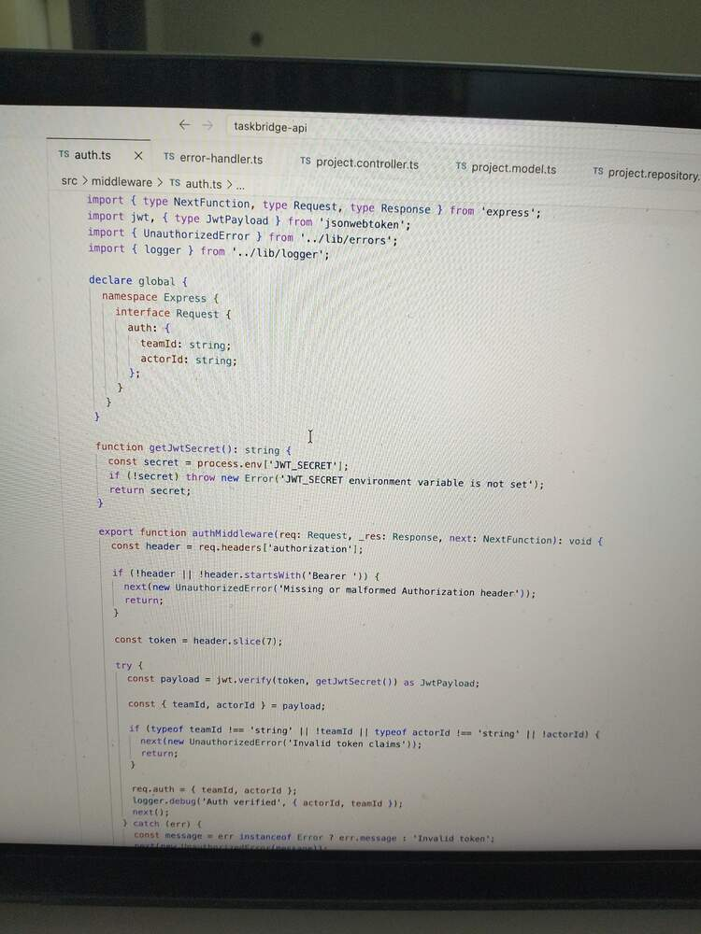
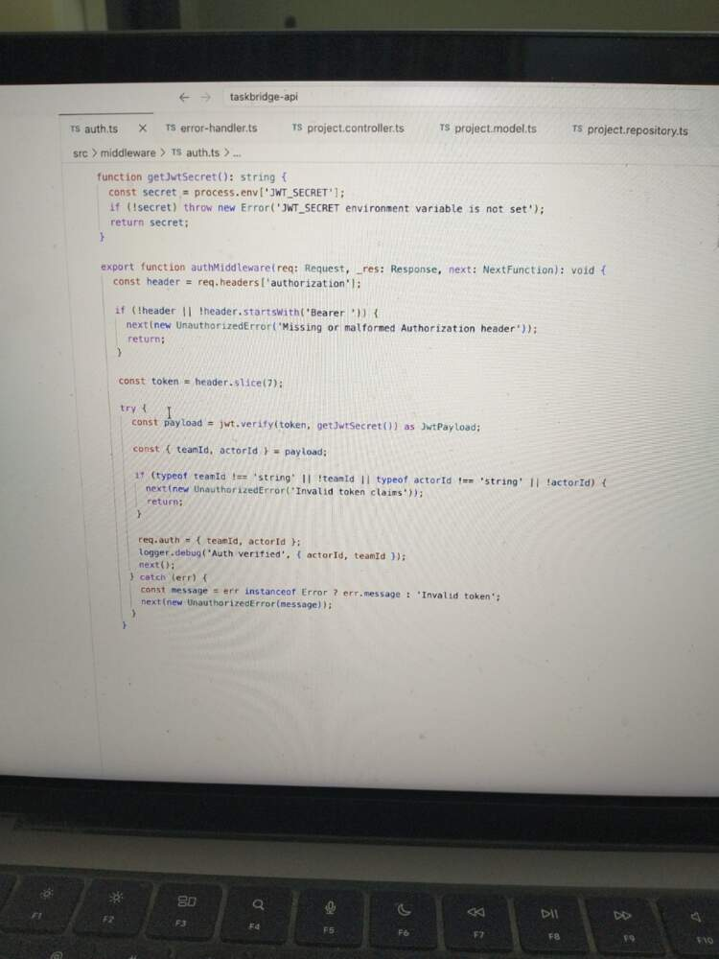
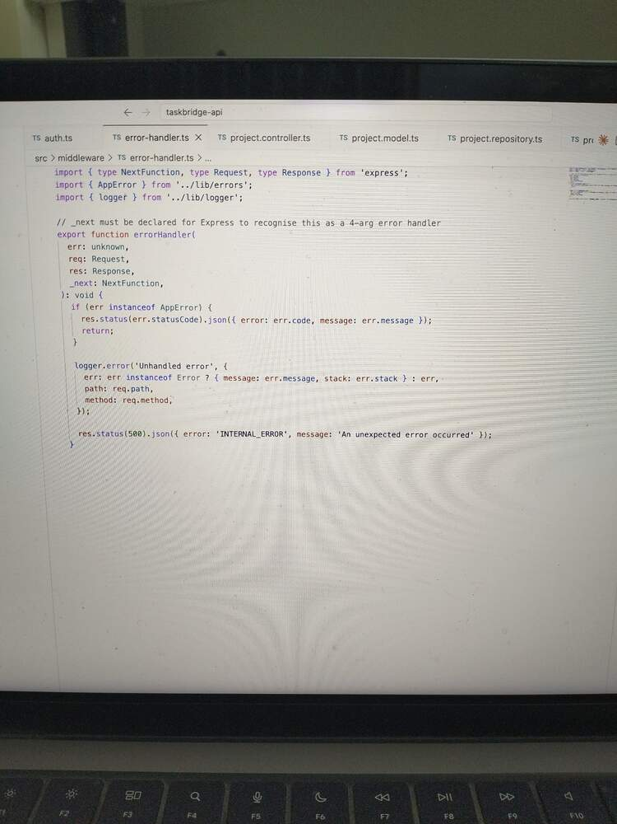
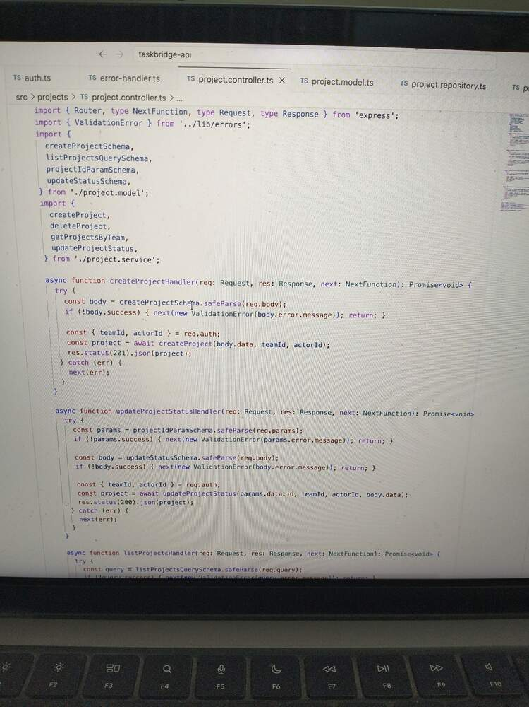
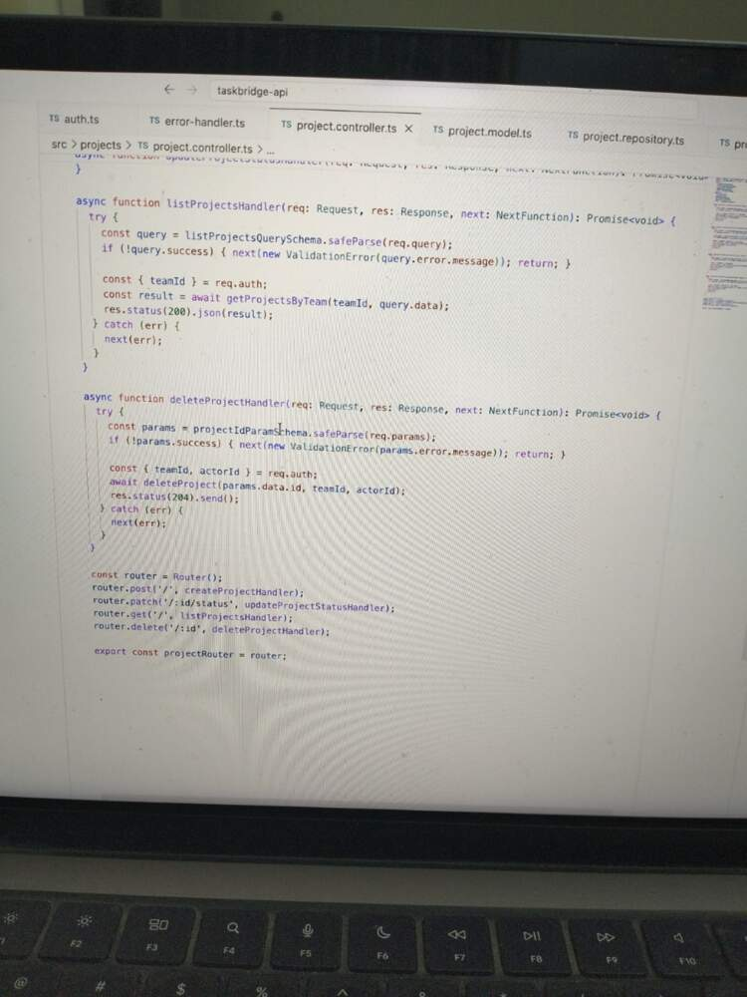

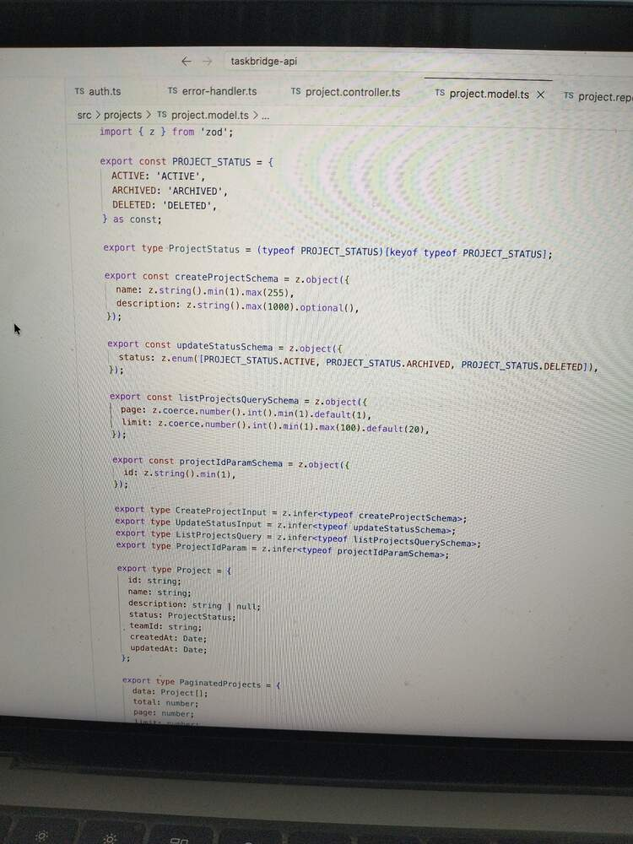
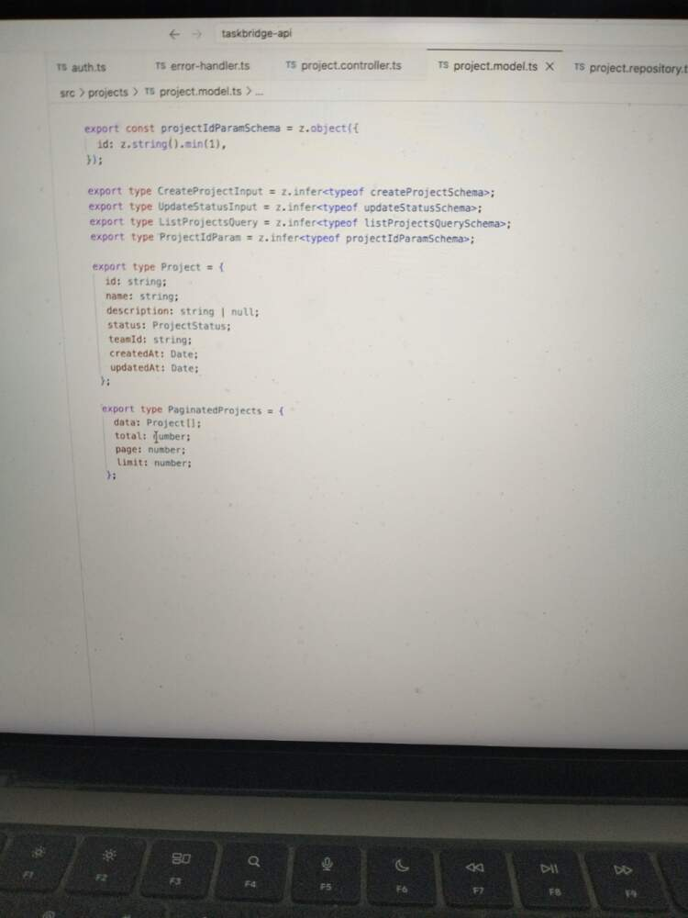
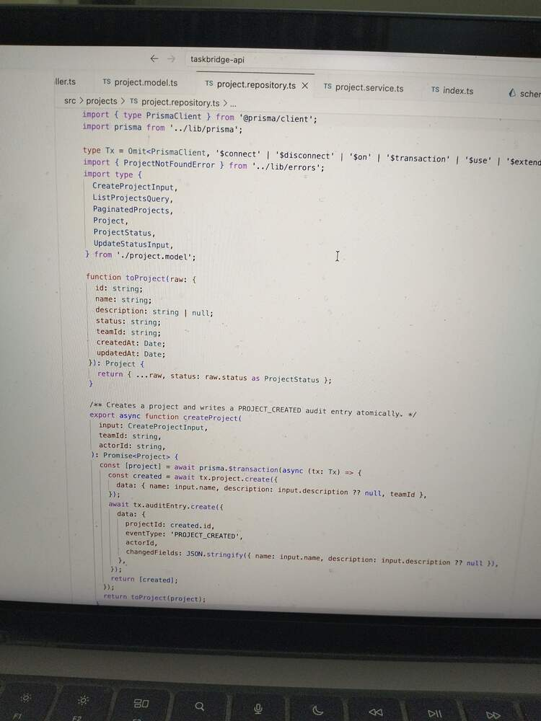
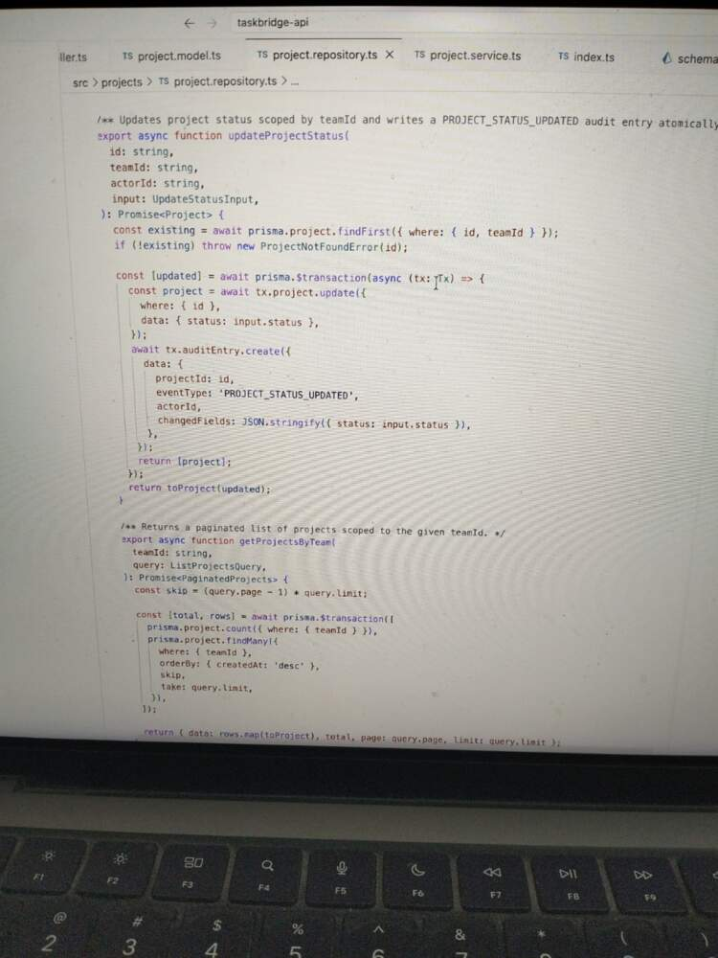
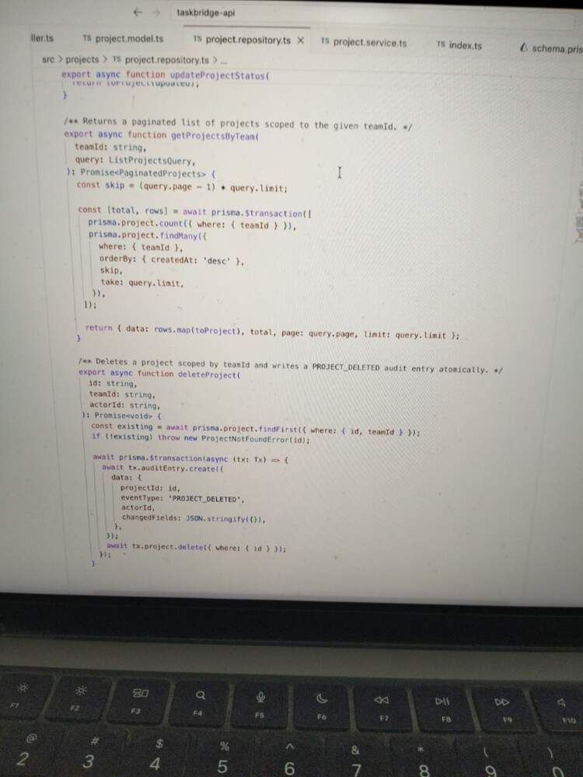

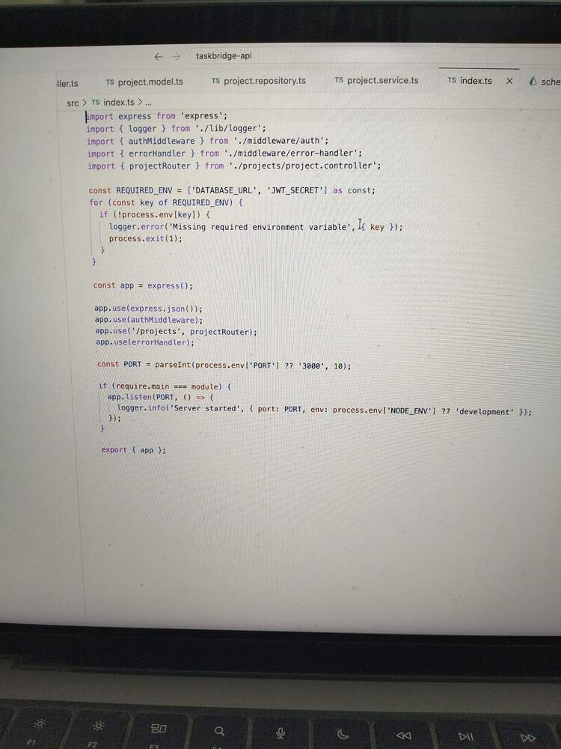
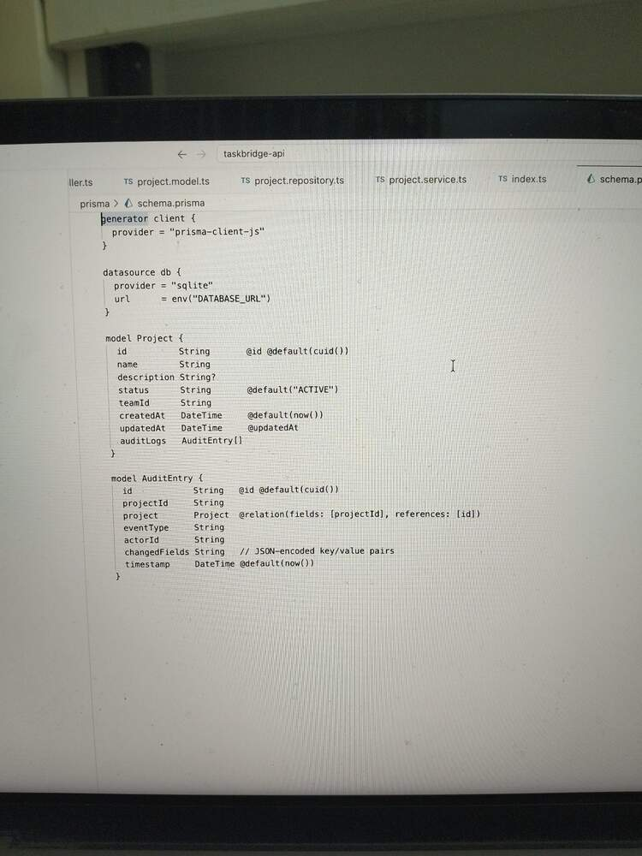
4A. What were the 3 most important changes between the initial AI-generated code and your remediated version? Why does each change matter for a production fintech application?
- Tenant isolation on every database query – The original code has none. The remediated code enforces teamId at two points: the repository always includes it in where, and mutations do a findFirst({where:{id:teamId}) ownership check before proceeding.
  - Why it matters to fintech: A cross tenant data leak is not a bug you patch quietly. It is a regulatory incident. Under GDPR, SOC 2 and most financial services frameworks, exposing one customer 's data to another triggers mandatory breach notification, potential fines and audit findings. The architectural lesson is that the tenant isolation must be enforced at the data layer it cannot be left to callers to pass the right value
- Atomic audit writes inside $transaction - The original never wrote an AuditEntry at all- despite the schema having one. The case study requirement for an immutable audit log was simply absent from the code. The remediated version writes an AuditEntry in the same $transaction as every mutation. If the project writes fails, the audit entry is rolled back, if the audit writes fails the project change is rolled back. The are are always consistent.
  - Why it matters to fintech: An audit trial that can fall out of sync with the data it describes is worse than no audit trail. It gives false assurance. Regulators and auditors require that every stage change be traceable – who did what, to what and when. In payment or complaints context, a missing audit state change can mean you cannot reconstruct what happened during an incident. The $transaction guarantee is what makes the Audit log trustworthy, not just present
- Layered architecture separating auth, validation and data access – The original was a single service file where HTTP concerns, Prisma calls and business logic were all mixed together. The remediation version enforces strict separation.
  - Why it matter to fintech: In Production, you need to be able to answer four questions independently – did auth pass ? was the input valid ? did business logic apply correctly? Did the database call succeeded ?. It also means that you can test each layer in isolation.

SECTION 5: Expense Splitting Feature
Screenshot 5.1 — Prompt Chain
Prompt 1:
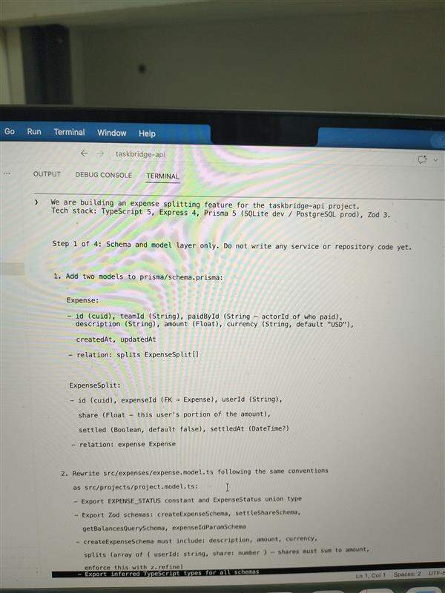
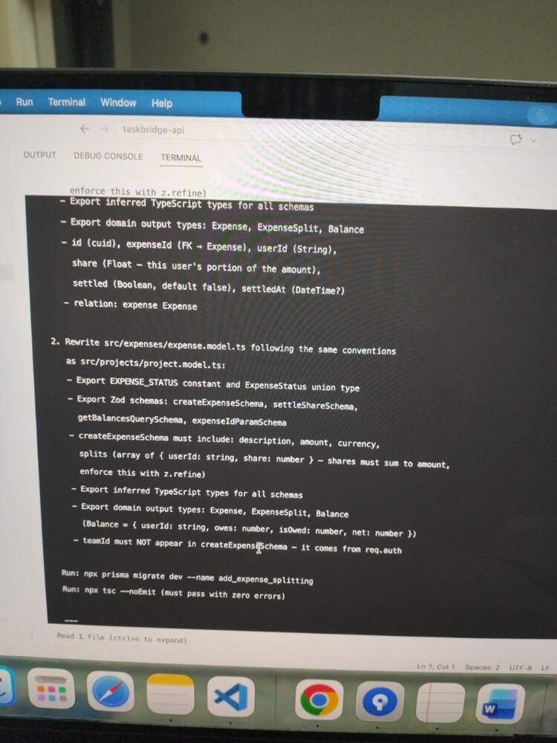
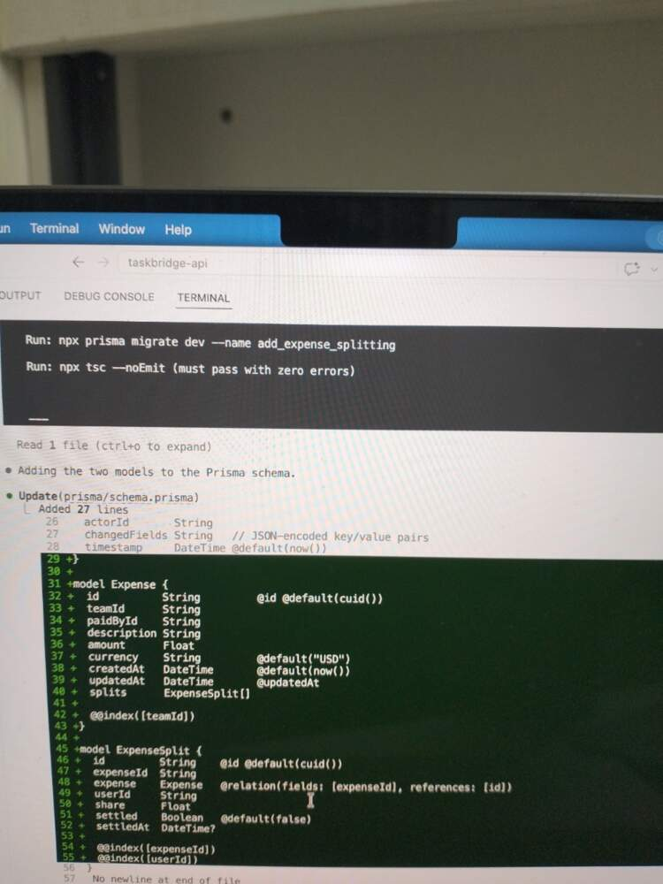

Prompt 2:
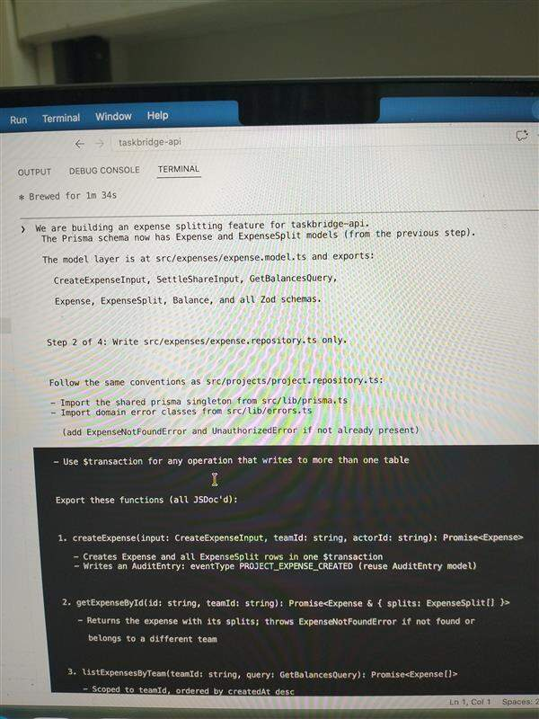
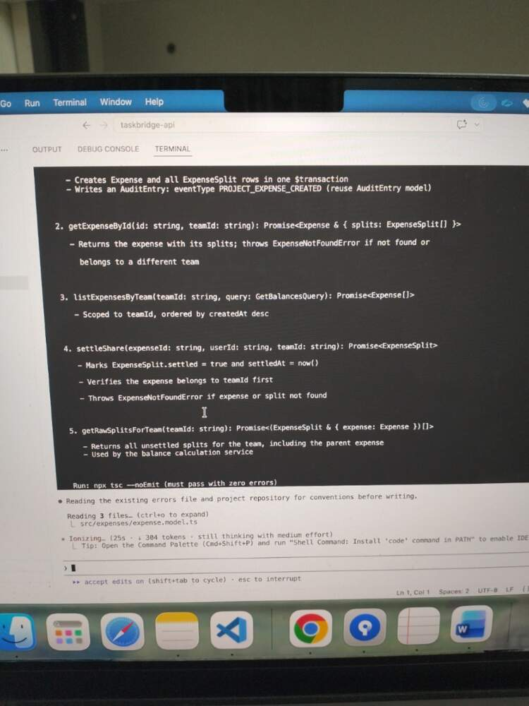

Prompt 3:
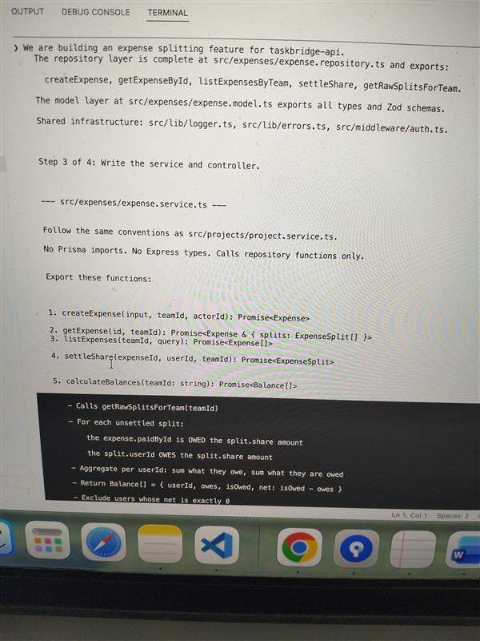
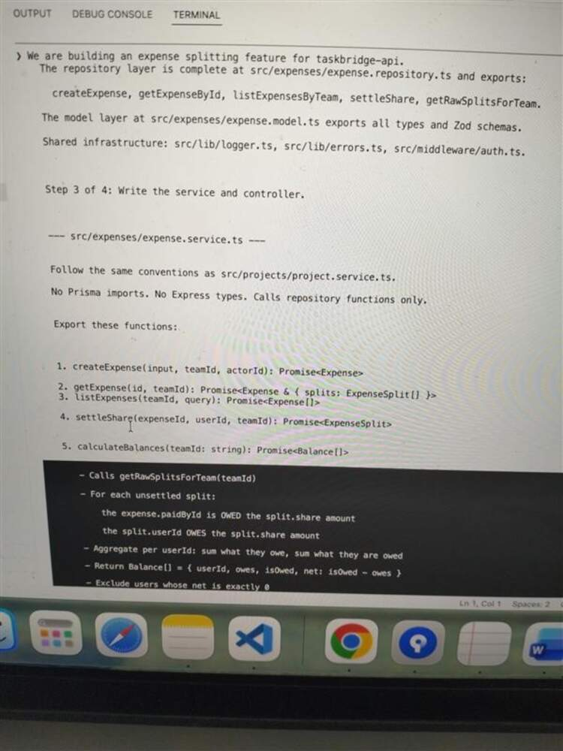

Prompt 4:
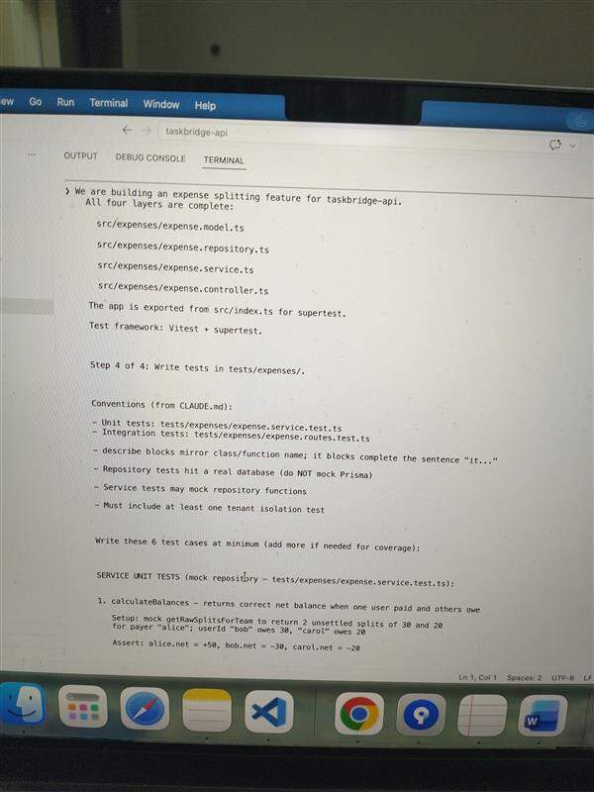
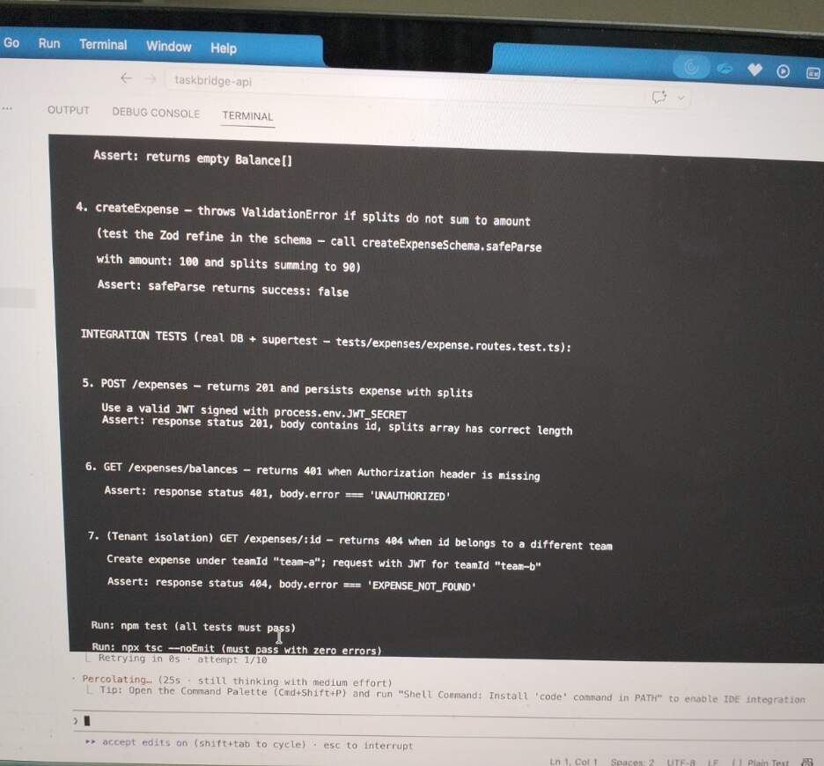

Screenshot 5.2 — Generated Expense Splitting Code
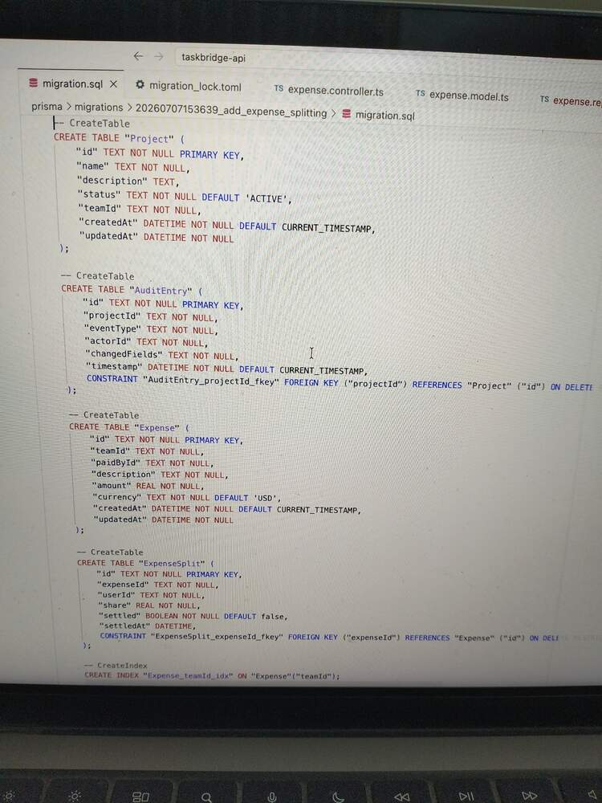

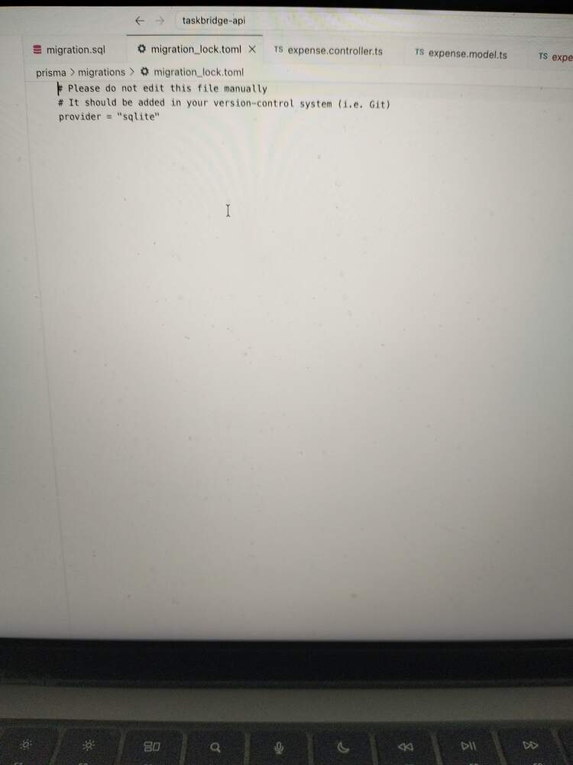
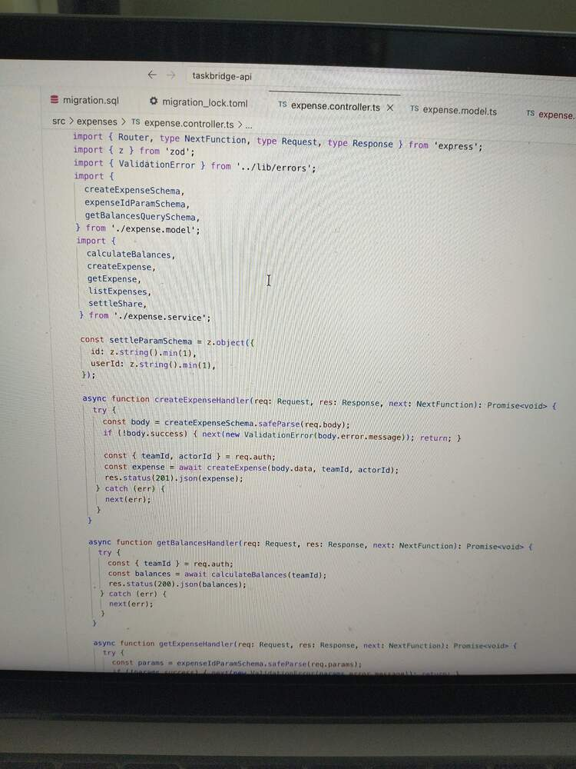
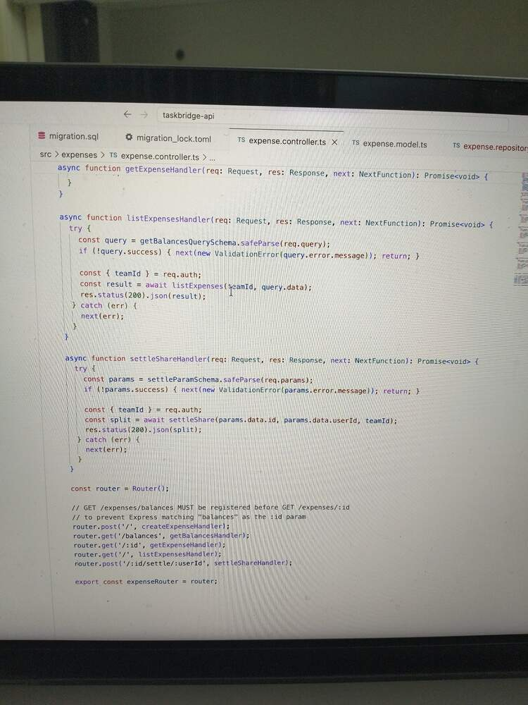
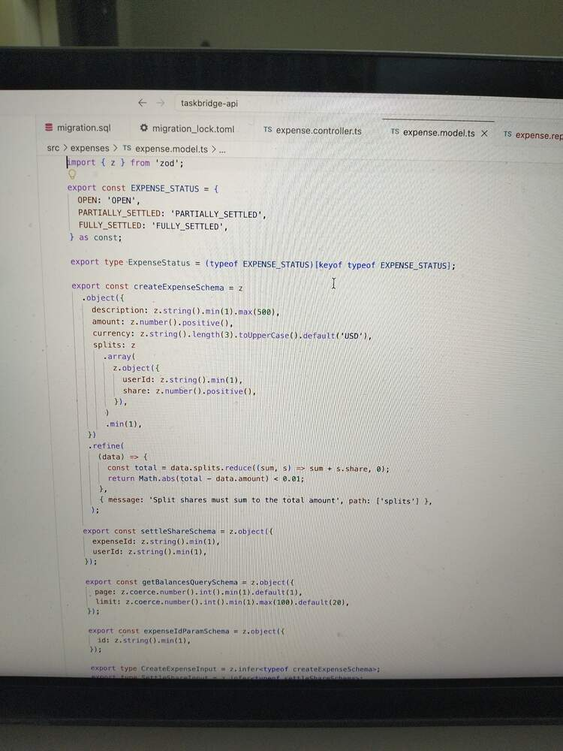
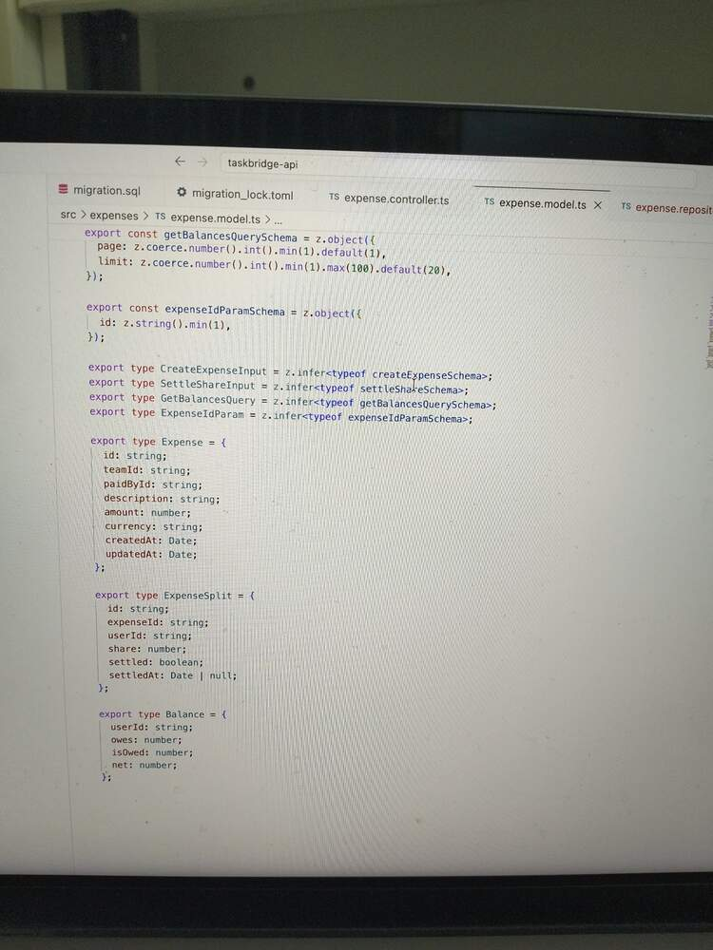

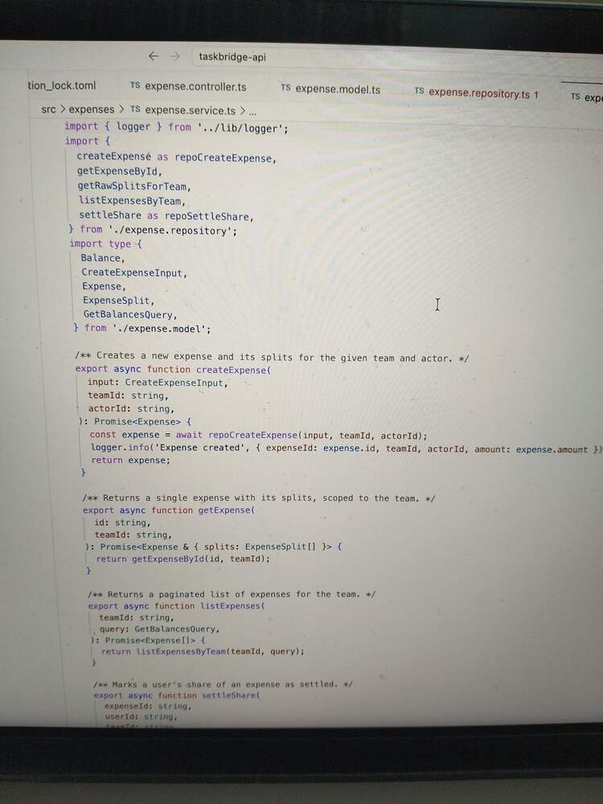

Screenshot 5.4 — Tests
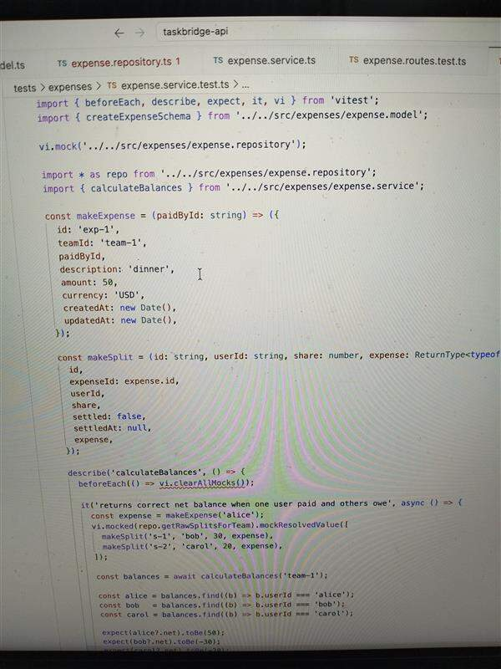
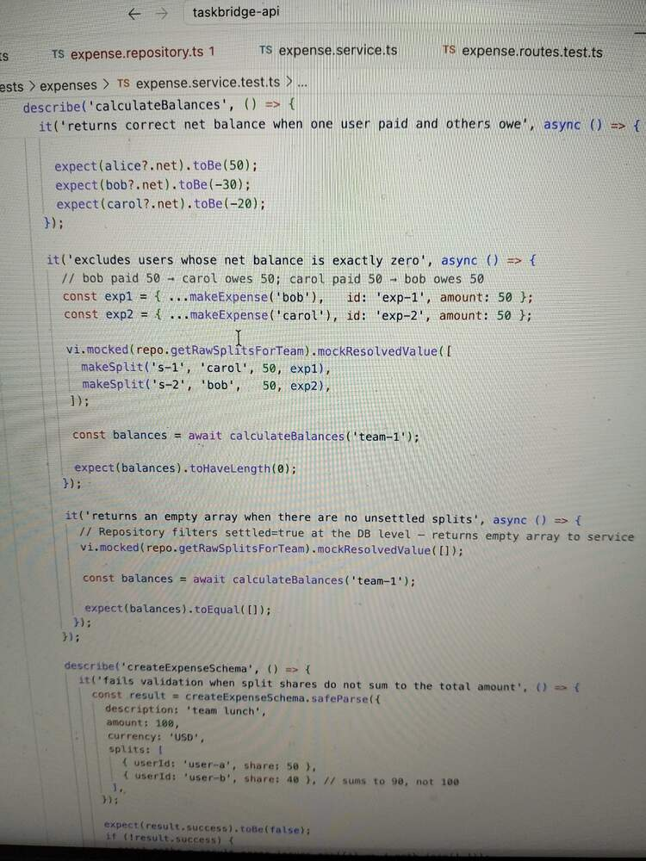
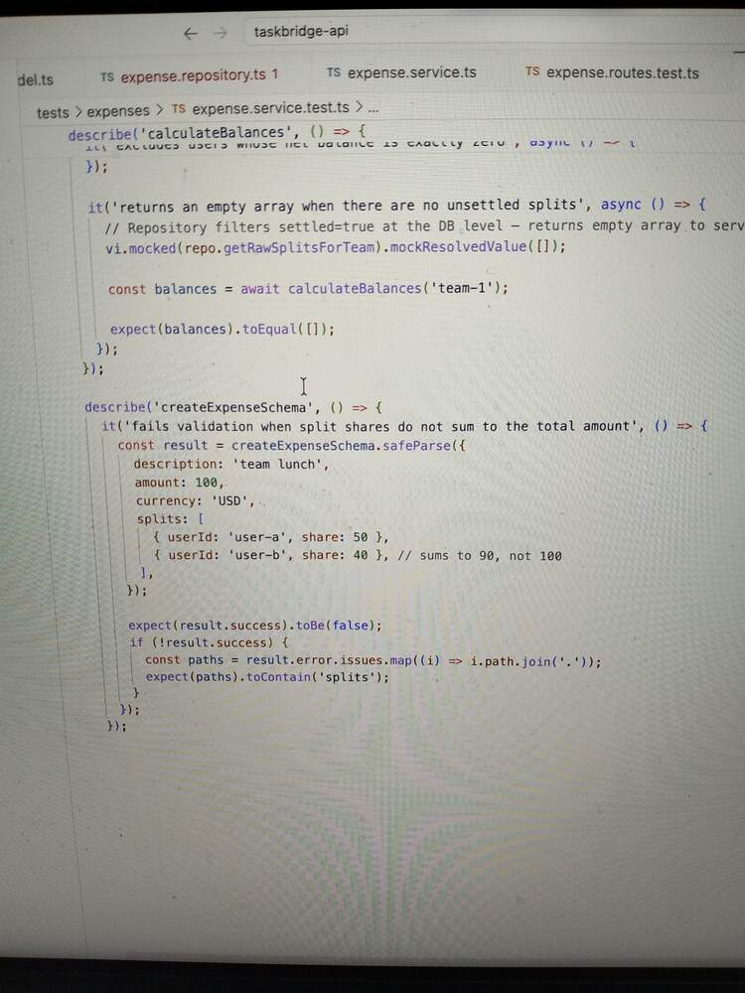
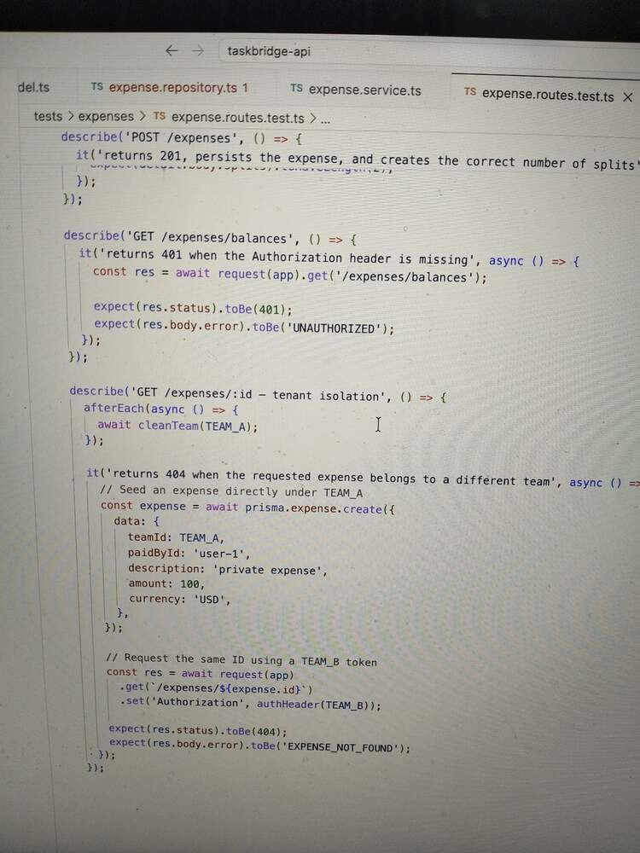
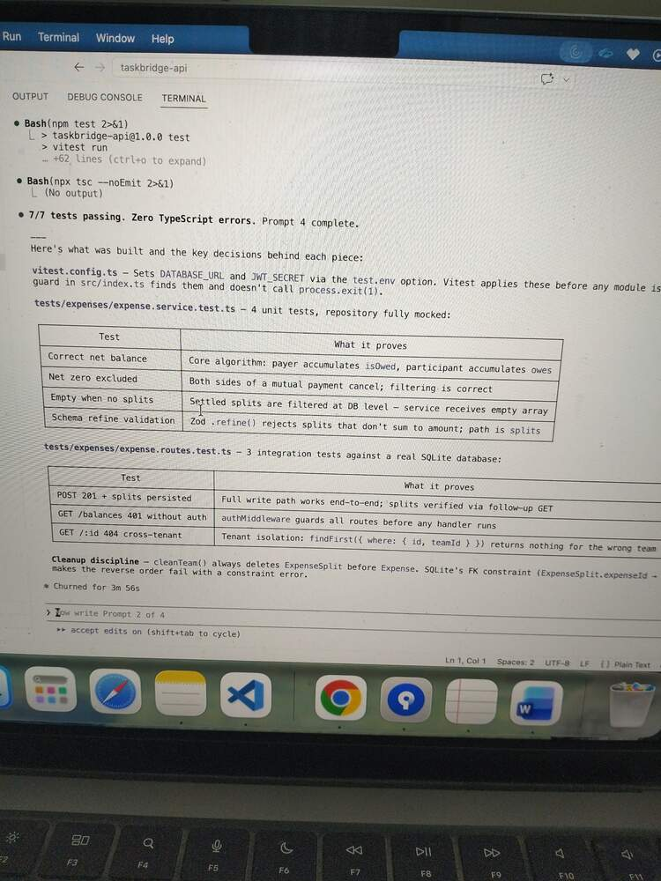

Prompt Engineering Documentation:
Prompt # | Prompt Text (exact or summarised) | Claude Code Feature Used | Prompting Technique Applied | Why This Approach?
1 | Add Expense + ExpenseSplit schema; write modal layer only; run migrate +tsc | FileSystem Write - Schema and modal files created directly on disk; terminal run Prisma migrate+tsc –noEmit | Decomposition + constraint | Breaking in to layers prevents Claude conflating concerns early; hard constraint stops creep in to unvalidated layers.
2 | Write expense.repository.ts: follow same conventions as project.repository.ts; every query scoped by teamId | File system read | Few shot | Pointing to a concrete working example eliminates guess work on naming, mapper pattern and $transaction usage.
3 | Write service+controller; register expenseRouter in index.ts; No Prisma inports, no Express types | Multi file edit | Constraint | Layer boundary constraints are machine checkable by tsc; role-based anchoring to existing files keeps architecture consistent without restating all rules.
4 | Write 7 tests; 4 unit (mocked repo) + 3 integration (real DB +supertest); must include tenant isolation test. | Terminal execution | Specificity | Concrete assertion values make the balance algorithm unambiguous; referencing prior layer exports ensures mocks and imports match actual signature.

5A. Post-Generation Corrections — List every correction you made to Claude Code's output. For each: What did Claude Code produce? What was wrong? How did you fix it (follow-up prompt, manual edit, or different Claude Code feature)?
- Error handler had the reversed parameter names
What Claude code produced:
export function errorHandler(
err: unknown,
req: Request,
_res:Response,
res:NextFunction,):void { res as unknown as Response).status(…)

What was wrong:
_res and res were swapped. The actual Response object was named res but typed as NextFunction, requiring a double cast as unknown as Response to call.status(). Typescript didn’t catch it because the case suppressed the error.

How I fixed: (Manual edit)
Rewritten with correct parameter names and types:
export function errorHandler(
err: unknown,
req: Request,
res:Response,
_next:NextFunction,):void { res.status(err.statusCode).json(…)

- Unused Prisma import left in project.repository.ts with a void guard workaround
What Claude code produced:
Import {Prisma} from ‘@prisma/client’;
Void (Prisma as unknown) // <- suppression hack
What was wrong:
Prisma was imported for P2025 error catching but the implementation switched to findFirst pre-checks instead. The unused import would have failed noUnusedLocals. The void hack at the bottom was a workaround but not a fix.
How I fixed: (Manual edit)
Both the import and the void guard was removed entirely.

SECTION 6: Collaboration & PR Readiness
PR Description:
Summary:
This PR delivers two features for the TaskBridge notification and audit service sprint; a production ready rewrite of the AI generated project service and a new expense splitting feature, both build to the layered architecture defined in CLAUDE.md( model -> repository -> service -> controller). The project service rewrite resolves 11 security and architecture violation from the original contractor code including cross tenant data leaks, missing input validation, raw prisma client instantiation in the service layer, unhandled prisma errors and an unbounded findMany - all of which posted direct complaince and data integrity risk in the multi tenant B2B context. The expense splitting feature adds Expense and ExpenseSplit prisma models, a balance calculation service that aggregates net positions across unsettled splits, five rest endpoints and seven passing tests covering the core algorithm, scheme validation, authentication enforcement and tenant isolation. Auth middleware now gates every route via JWT verification, with team ID and actor ID flowing from the verified token through the full chain into atomic $transaction audit writes - never from the request body.
AI Tool Disclosure:
- Which Claude Code features did you use? Plan Mode, @references, CLAUDE.md
- Where did you accept Claude Code's output as-is vs where did you override/modify it? – I accept the Claude Code’s output directly when the plan is given in plan mode and ask for my approval. For some, unused imports, I modified the code.
- What is your estimate of AI-generated vs hand-written code percentage? – AI generated 95% and handwritten is 5%
- Did CLAUDE.md improve the quality of generated output? – Yes, since it is having all the coding standards defined.
- Did you use /compact or /clear during your session? When and why? – I didn’t used both since I had enough context window for my full development for this project.
Testing: What tests exist, what they cover, any known gaps – Two tests file and seven test cases total. It includes 4 -unit tests (repository mocked), 3 integration tests (real SQLite DB).
Known gaps:
- Auth middleware handles TokenExpiredError and JsonWebTokenError but neither is tested.
- No tests confirm Zod validation fires at the controller and returns VALIDATION_ERROR.
Risks & Trade-offs:
Floating point arithmetic for money.
Every amount and share field in the schema is typed as Float (IEEE 754 double). The z.refine validation in createExpenseSchema uses a tolerance of 0.01 to check that splits sum to the total.
Math.abs(total – data.amount) <0.01
And calculateBalances excludes users with net !==0 using exact equality:
If(net !==0) balances.push(…)
These two rules are in distinct conflict.
Peer Review Simulation:
Write 3 review comments as if reviewing a teammate's version of the Expense Splitting feature:
Comment # | Code Location (file + function/line) | What Should Change | Why (benefit or risk)
1 | Src/expenses/expense.modal.ts:14 | Replace float with Int across the schema, Zod validators and domain types. Accept amount in smallest currency value from the customer. | Float is IEEE 754 – 33.33 + 33.33+33.34 does not equal to 100 in binary floating point.
2 | Src/expenses/expense.repository.ts: 40-70 - createExpense | The _actorId parameter should be renamed to actorId. | Skipping the audit write means every expense creation, settlement and deletion is invisible to the complaince log.
3 | Src/expenses/expense.repository.ts: 112-130 - settleShare | Add a guard that checks split.settled === true before updating and throws a typed error if the split is already settled. | Currently calling POST /expenses/:id/settle/:userId twice on the same split silently overwrites settledAt with a new timestamp on the second call.

6A. For the comment you identified as an "AI blind spot" — explain in 2–3 sentences why this type of issue is typically missed by AI tools and why human review catches it.
settleShare double-settle is the AI blind spot.
Claude code generated the settleShare function to satisfy the stated requirement – “mark a split as settled” – and it does exactly that. The Problem is not what the code does but what it does not prevent, and that requires reasoning about how real users misuse system.
Huma reviewers catch this because they carry menta models built from past failures – they have seen a retry loop settle the same invoice twice, or watched a timestamp get overwritten and break a reconciliation report.

SECTION 7: Tool Strategy & Reflection
Write — Feature Usage Log:
# | Where in the Case Study | Claude Code Feature Used | Why This Feature (Not Another) | What Happened
1 | Setting up project standards before any code was written | CLAUDE.md | Need conventions to persist across all the prompts in the session | Security rules, logging standards, and forbidden patterns were written once and enforced automatically.
2 | Reviewing the project files before rewriting | Filesystem read tool | Needed exact line numbers, import paths and current content to write precise review comments. | Files read in full; review comments referenced exact line numbers and quoted actual code rather than describing it generically
3 | Deciding how to rewrite the project module across 8 files | Plan mode | Highest code changes are required. Wrong approach would require full revert. Plan mode forces alignment before writing. | Two explore agents and one plan agent launched in parallel. Plan file written to .claude/plan/; Then plan got approved.
4 | Running Prisma migrate dev, tsc, --noEmit and npm test as verification gates at the end of each prompt. | Bash / Terminal execution | Type checking and migration must run against real project state. | tsc –noEmit caught 7 typescript errors after the first repository write.
5 | Creating multiple files in one session | Multi file filesystem write / Edit. | Each files depends on the previous one’s exports. Creating them out of order would cause unresolvable import errors mid-session. | 8 files written sequentially respecting the dependency chain.
6 | Building the expense splitting features across four sequential prompts. | Prompt chaining with context handoff | A single large prompt would exceed the useful context and produce unreviewed scaffolding. | Prompt 1 output was explicitly listed as the input contract of Prompt 2. Prompt 2 exports were listed for Prompt 3; all four layers were listed for Prompt 4.

Scenario Responses:
For each scenario below, name the specific Claude Code feature you would use and explain why in 2–3 sentences:
- You need to understand a complex 500-line function in an unfamiliar codebase before modifying it - Feature: Code Intelligence - Code Intelligence provides symbol-level navigation, definitions, references, and type information, making it easier to understand how a large function interacts with the rest of the codebase. Instead of manually tracing dependencies, you can quickly explore related functions, classes, and callers to build context before making changes
- You want to refactor 10 files to use a new logging library without breaking anything - Feature: Subagents (or Agent Teams for larger efforts) - Subagents can analyze and update files in isolated contexts, helping Claude manage multi-file refactors without overwhelming the main conversation. They can parallelize analysis and implementation work while keeping the overall task organized and reducing the risk of missed updates
- You need to quickly check if a regex pattern handles edge cases correctly - Feature: Built-in command execution/tools - Claude Code can run commands and execute test snippets directly, allowing you to try sample inputs and validate regex behavior immediately. This is much faster and more reliable than reasoning about every edge case manually
- Your team wants automated code quality checks running in a CI/CD pipeline with no human interaction - Feature: CI / Headless mode (-p mode) - Claude Code supports non-interactive execution for automation scenarios, making it suitable for CI/CD pipelines. This allows code reviews, checks, and other workflows to run automatically without requiring developer intervention
- You're reviewing a teammate's AI-generated authentication module for security vulnerabilities - Feature: /security-review - The security review feature is designed specifically to inspect code for potential security issues. It focuses attention on vulnerabilities, unsafe patterns, and authentication-related risks that may be overlooked during a standard code review.
- Your team needs Claude Code to consistently follow project-specific conventions across all developers and all sessions - Feature: CLAUDE.md - CLAUDE.md provides persistent project instructions that Claude loads for every session. It is the recommended place to define coding standards, tooling requirements, workflow expectations, and other team conventions so behavior remains consistent across developers
- Your Claude Code session has been running for 45 minutes and suggestions are becoming less accurate and relevant - Feature: /compact - The /compact command compresses and preserves the important context from a long conversation while removing less relevant details. This helps restore focus and improve response quality during lengthy coding sessions
- You want Claude Code to automatically run your test suite every time it writes a file - Feature: Hooks (specifically PostToolUse) - Hooks allow you to trigger scripts automatically when specific events occur. A PostToolUse hook can run your test suite after every file write or edit, ensuring continuous validation without having to remind Claude manually.

Limitations Encountered:
# | What You Prompted | What Claude Code Produced (Specific) | How You Detected the Problem | How You Fixed It | What You'd Prompt Differently Next Time
1 | Write the error handler middleware following Express conventions | Error handler response and request parameters swapped. Required double-cast to work around the wrong types. | Code review of the generated file; the cast as unknown as response on what was typed as NextFunction was an immediate red flag. | Rewrote with correct signature – underscore on the unused param, not the used one. | The fourth parameter of tan express error handler must be NextFunction named _next. The third parameter is Response. Do not swap these.
2 | Rewrite project.service.ts following the new architecture | Write tool returned. File has beeb modified since read, either by the user or by the linter. Read it again before attempting to write. Write blocked entirely | Error message from the write tool itself. | Used the read tool to reload the current file state, then reinitiate the write. | Before writing any file that was read earlier in the session, re read it immediately before the write to ensure the content hasn’t drifted. Never assume the cached read is still current.

SECTION 8: Architecture Documentation
The solution follows a strict layered architecture consisting of Controller → Service → Repository → Model (Prisma), ensuring clear separation of concerns and maintainability.
- Controllers expose REST endpoints and handle request validation, authentication context, and response formatting.
- JWT Authentication Middleware validates every incoming request before it reaches business logic.
- Actor ID and Team ID are extracted exclusively from verified JWT tokens and propagated through all layers.
- Services contain business logic, orchestration, expense calculations, audit generation, and tenant enforcement rules.
- Repositories encapsulate all database access and prevent direct Prisma usage within services.
- Prisma Models define persistence entities, including Expense and ExpenseSplit for the new expense-sharing capability.
- The rewritten Project Service addresses critical issues such as cross-tenant data exposure, missing validation, unbounded queries, and improper database access patterns.
- Multi-tenant isolation is enforced across all service and repository operations using the authenticated team context.
- The Expense Splitting Module calculates participant balances and aggregates net positions across unsettled expense splits.
- Database operations that modify business data and audit records execute within atomic Prisma $transaction blocks.
- The Audit Service records actor actions with guaranteed consistency and traceability for compliance requirements.
- Error handling is centralized to capture and safely manage Prisma and application-level exceptions.
- Five REST APIs support expense creation, split management, balance retrieval, and related workflows.
- Automated tests validate balance calculations, schema validation, authentication enforcement, tenant isolation, and core business rules.
- The architecture provides secure, scalable, and compliance-ready processing for both project management and expense-sharing workflows in a multi-tenant B2B environment.

