|  | **Pimpri Chinchwad Education Trust’s**  **Pimpri Chinchwad College of Engineering** |
| --- | --- |
| **Experiment No. 7**  **Experimentation details** | |

**Department: E&TC Academic Year: 2023-24 Semester-I**

**Class: B.Tech E&TC Course: VLSI Design Lab**

**Name of Student:**

**Div and Batch:**

**Roll No:**

**Title of the Experiment:**

**Model and verify FIFO using VHDL and implement on FPGA and evaluate power and timing performance**

**Software Requirements: Xilinx 14.7 ISE Design Suite**

**Hardware Requirements: Xilinx Spartan-6 XC6SLX45 FPGA**

**VHDL Code for FIFO (8x3)**

library IEEE;

use IEEE.STD_LOGIC_1164.ALL;

use IEEE.STD_logic_arith.ALL;

use IEEE.STD_logic_unsigned.ALL;

use IEEE.NUMERIC_STD.ALL;

entity fifo is

generic (depth : integer := 8); --depth of fifo

port ( clk : in std_logic;

reset : in std_logic;

enr : in std_logic; --enable read,should be '0' when not in use.

enw : in std_logic; --enable write,should be '0' when not in use.

data_in : in std_logic_vector (2 downto 0); --input data

data_out : out std_logic_vector(2 downto 0); --output data

fifo_empty : out std_logic; --set as '1' when the queue is empty

fifo_full : out std_logic --set as '1' when the queue is full

);

end fifo;

architecture Behavioral of fifo is

type memory_type is array (0 to depth-1) of std_logic_vector(2 downto 0);

signal memory : memory_type :=(others => (others => '0')); --memory for queue.

signal readptr,writeptr : integer := 0; --read and write pointers.

signal empty,full : std_logic := '0';

signal dataout:std_logic_vector(2 downto 0);

begin

fifo_empty <= empty;

fifo_full <= full;

p12:process(clk,reset)

--this is the number of elements stored in fifo at a time.

--this variable is used to decide whether the fifo is empty or full.

variable num_elem : integer := 0;

begin

if(reset = '1') then

dataout <= (others => '0');

empty <= '0';

full <= '0';

readptr <= 0;

writeptr <= 0;

num_elem := 0;

elsif(rising_edge(clk)) then

if(enr = '1' and empty = '0') then --read

dataout <= memory(readptr);

readptr <= readptr + 1;

num_elem := num_elem-1;

end if;

if(enw ='1' and full = '0') then --write

memory(writeptr) <= data_in;

writeptr <= writeptr + 1;

num_elem := num_elem+1;

end if;

--rolling over of the indices.

if(readptr = depth-1) then --resetting read pointer.

readptr <= 0;

end if;

if(writeptr = depth-1) then --resetting write pointer.

writeptr <= 0;

end if;

--setting empty and full flags.

if(num_elem = 0) then

empty <= '1';

else

empty <= '0';

end if;

if(num_elem = depth) then

full <= '1';

else

full <= '0';

end if;

end if;

end process;

data_out<=dataout;

end Behavioral;

**RTL Schematic**

**Block Diagram of Design**

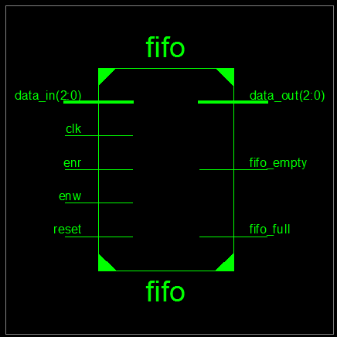

**Detailed Schematic**

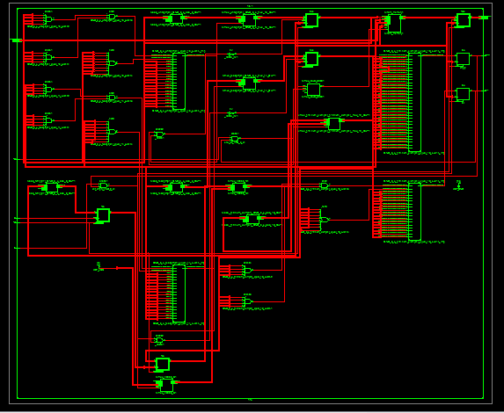

**VHDL Test Bench**

LIBRARY ieee;

USE ieee.std_logic_1164.ALL;

USE ieee.std_logic_arith.ALL;

ENTITY fifo_tb IS

END fifo_tb;

ARCHITECTURE behavior OF fifo_tb IS

--Inputs and outputs

signal Clk,reset,enr,enw,empty,full : std_logic := '0';

signal data_in,data_out : std_logic_vector(2 downto 0) := (others => '0');

--temporary signals

signal i : integer := 0;

-- Clock period definitions

constant Clk_period : time := 10 ns;

constant depth : integer := 8; --specify depth of fifo here.

BEGIN

-- Instantiate the Unit Under Test (UUT)

uut: entity work.fifo generic map(depth => depth) PORT MAP (clk,reset,enr,enw,data_in,data_out,empty,full);

-- Clock process definitions

Clk_process :process

begin

Clk <= '0';

wait for Clk_period/2;

Clk <= '1';

wait for Clk_period/2;

end process;

-- Stimulus process

stim_proc: process

begin

reset <= '1'; --apply reset for one clock cycle.

wait for clk_period;

reset <= '0';

wait for clk_period*3; --wait for 3 clock periods(simply)

enw <= '1'; enr <= '0'; --write 8 values to fifo.

for i in 1 to depth loop

Data_In <= conv_std_logic_vector(i,3);

wait for clk_period;

end loop;

enw <= '0'; enr <= '1'; --read 8 values from fifo.

wait for clk_period*depth;

wait;

end process;

end behavior;

**Simulation Results**

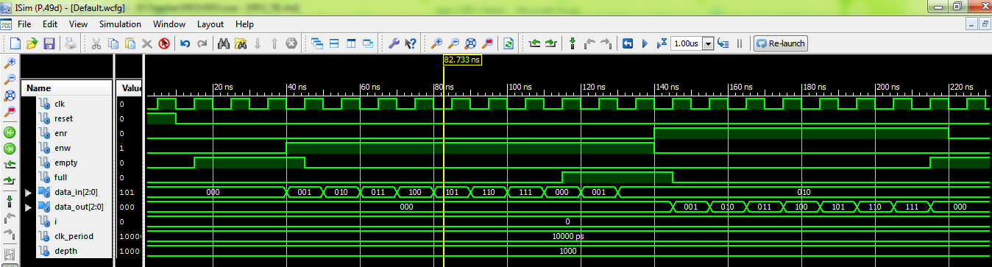

**Implementation code with slow clock on Spartan 6**

library IEEE;

use IEEE.STD_LOGIC_1164.ALL;

use IEEE.STD_logic_arith.ALL;

use IEEE.STD_logic_unsigned.ALL;

use IEEE.NUMERIC_STD.ALL;

entity fifo is

generic (depth : integer := 8); --depth of fifo

port ( clk : in std_logic;

reset : in std_logic;

enr : in std_logic; --enable read,should be '0' when not in use.

enw : in std_logic; --enable write,should be '0' when not in use.

data_in : in std_logic_vector (2 downto 0); --input data

data_out : out std_logic_vector(2 downto 0); --output data

fifo_empty : out std_logic; --set as '1' when the queue is empty

fifo_full : out std_logic --set as '1' when the queue is full

);

end fifo;

architecture Behavioral of fifo is

type memory_type is array (0 to depth-1) of std_logic_vector(2 downto 0);

signal memory : memory_type :=(others => (others => '0')); --memory for queue.

signal readptr,writeptr : integer := 0; --read and write pointers.

signal empty,full : std_logic := '0';

signal temp:std_logic_vector(27 downto 0);

signal sclk:std_logic;

signal dataout:std_logic_vector(2 downto 0);

begin

fifo_empty <= empty;

fifo_full <= full;

p11: process(clk,reset)

begin

if(reset='1')then temp<=(others=>'0');

elsif(clk'event and clk='1') then

temp<= temp + 1;

end if;

end process;

sclk<=temp(27);

p12:process(sclk,reset)

--this is the number of elements stored in fifo at a time.

--this variable is used to decide whether the fifo is empty or full.

variable num_elem : integer := 0;

begin

if(reset = '1') then

dataout <= (others => '0');

empty <= '0';

full <= '0';

readptr <= 0;

writeptr <= 0;

num_elem := 0;

elsif(rising_edge(sclk)) then

if(enr = '1' and empty = '0') then --read

dataout <= memory(readptr);

readptr <= readptr + 1;

num_elem := num_elem-1;

end if;

if(enw ='1' and full = '0') then --write

memory(writeptr) <= data_in;

writeptr <= writeptr + 1;

num_elem := num_elem+1;

end if;

--rolling over of the indices.

if(readptr = depth-1) then --resetting read pointer.

readptr <= 0;

end if;

if(writeptr = depth-1) then --resetting write pointer.

writeptr <= 0;

end if;

--setting empty and full flags.

if(num_elem = 0) then

empty <= '1';

else

empty <= '0';

end if;

if(num_elem = depth) then

full <= '1';

else

full <= '0';

end if;

end if;

end process;

data_out<=dataout;

end Behavioral;

**Device Specifications to be selected while implementing:**

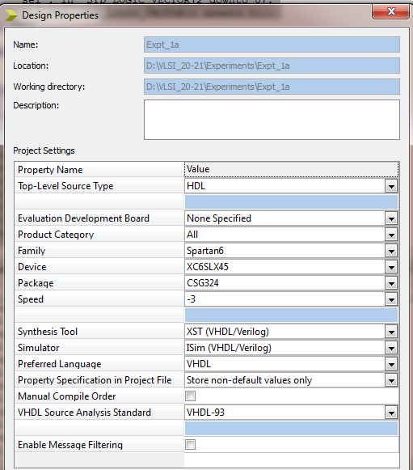

**Implementation Constraint File**

NET "reset" LOC = "E4";

NET "CLK" LOC ="L15";

NET "enr" LOC ="T5";

NET "enw" LOC ="R5";

NET "data_in<0>" LOC ="A10";

NET "data_in<1>" LOC ="D14";

NET "data_in<2>" LOC ="C14";

NET "data_out<0>" LOC = "U18"; # Bank = 1, Pin name = IO_L52N_M1DQ15, Sch name = LD0

NET "data_out<1>" LOC = "M14"; # Bank = 1, Pin name = IO_L53P, Sch name = LD1

NET "data_out<2>" LOC = "N14"; # Bank = 1, Pin name = IO_L53N_VREF, Sch name = LD2

NET "fifo_empty" LOC = "P16"; # Bank = 1, Pin name = IO_L61P, Sch name = LD3

NET "fifo_full" LOC = "D4";

**Implementation Successful**

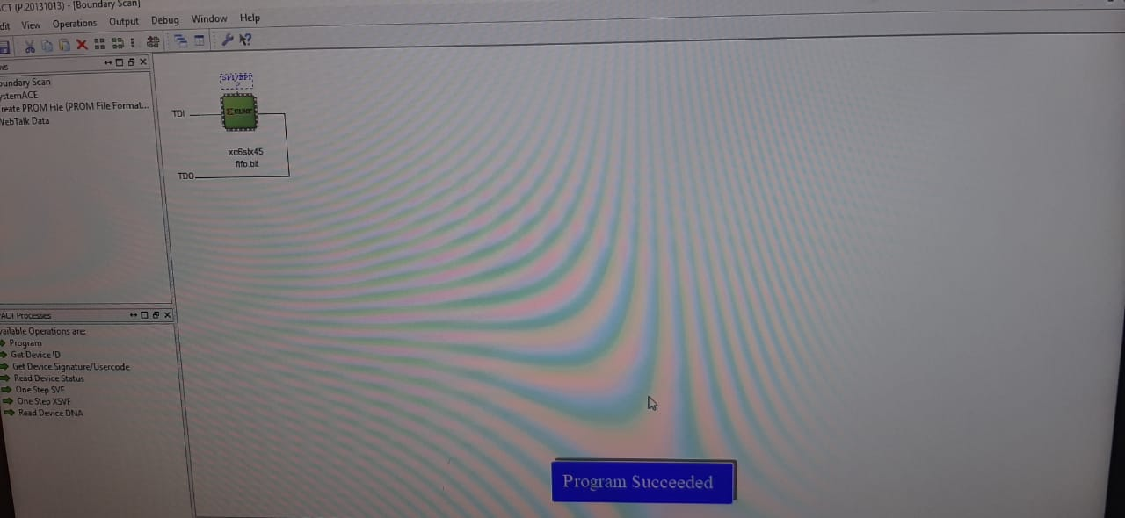

**Hardware Snapshots**

**Digilent ATLYS Spartan 6 FPGA Board**

