Agile Handbook – Terms, Metrics & RealWorld Examples
This handbook explains core Agile/Scrum/Kanban terms and metrics with simple definitions, formulas, and real‑world examples. The charts use synthetic sample data to illustrate concepts (no client data).

1) Core Agile / Scrum / Kanban Terms
Agile: An iterative, value‑focused mindset emphasizing collaboration, fast feedback and frequent delivery.
Scrum: A framework with time‑boxed sprints (1–4 weeks), roles (PO, SM, Team) and ceremonies (planning, daily, review, retro).
Kanban: Flow‑based system with WIP limits and continuous delivery; focuses on cycle time and throughput.
Product Backlog: Ordered list of work items owned by the Product Owner.
Sprint Backlog: Stories selected for a sprint plus a plan to deliver them.
DoR / DoD: Definition of Ready/Done: entry criteria to start; exit criteria to finish with quality.
Story Points: Relative effort sizing considering complexity, risk and testing—not hours.
Velocity: Story points completed per sprint by the team (used for forecasting, not individual performance).
Lead Time: Request to Done.
Cycle Time: Start to Done for a work item.
Burndown: Chart of remaining work vs time (ideally trending down).
Burn‑up: Chart of completed work vs time, plotted against total scope (makes scope change visible).
CFD: Cumulative Flow Diagram showing WIP and bottlenecks across workflow states.
WIP Limit: Cap on how many items can be in a stage to reduce multitasking and wait times.

2) Metrics, Formulas & When to Use
Velocity (team‑level): Sum of story points Done in a sprint. Use 5–6 sprint average for forecasting. Do not compare individuals.
Sprint Burndown: Remaining SP per day. Flat lines signal blockers or late starts; steep drops at end imply batching.
Burn‑up: Completed SP per day vs scope line. Excellent for stakeholder transparency when scope changes.
Cycle Time: Avg days from Start→Done per item. Lower = faster flow; track by card type to spot bottlenecks.
Lead Time: Avg days from Request→Done (customer view). Drives SLA discussions.
Throughput: Items finished per period (e.g., per week). Good for Kanban forecasting.
Defect Leakage: Defects found in UAT/Prod ÷ total. Rising leakage → improve AC, risk‑based tests, shift‑left.
Release Predictability: Delivered / Committed scope per release. Aim for >85–90% with stable DoR/DoD.

3) Visual Examples (Sample Data)
3.1 Sprint Burndown – Interpretation:
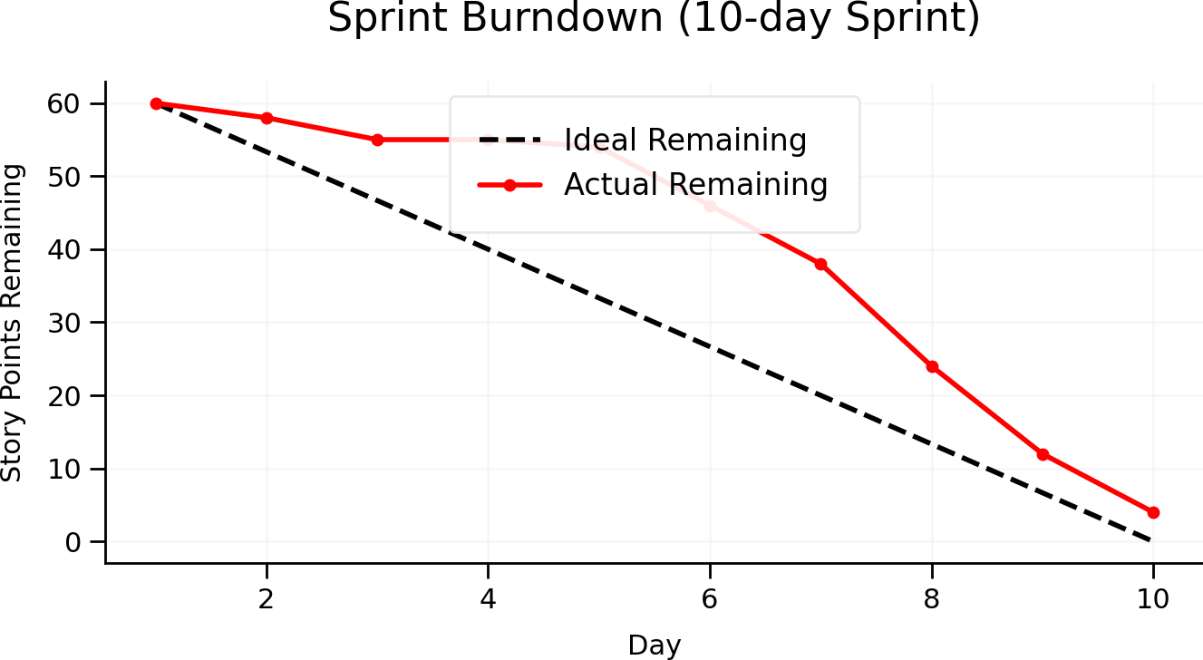
• Ideal vs Actual: Flat line days 3–4 indicate blockers; sharp drop after day 5 shows batch completion. Action: surface blockers early, split stories smaller, limit WIP.
3.2 Burn‑up – Scope Change Highlighted:
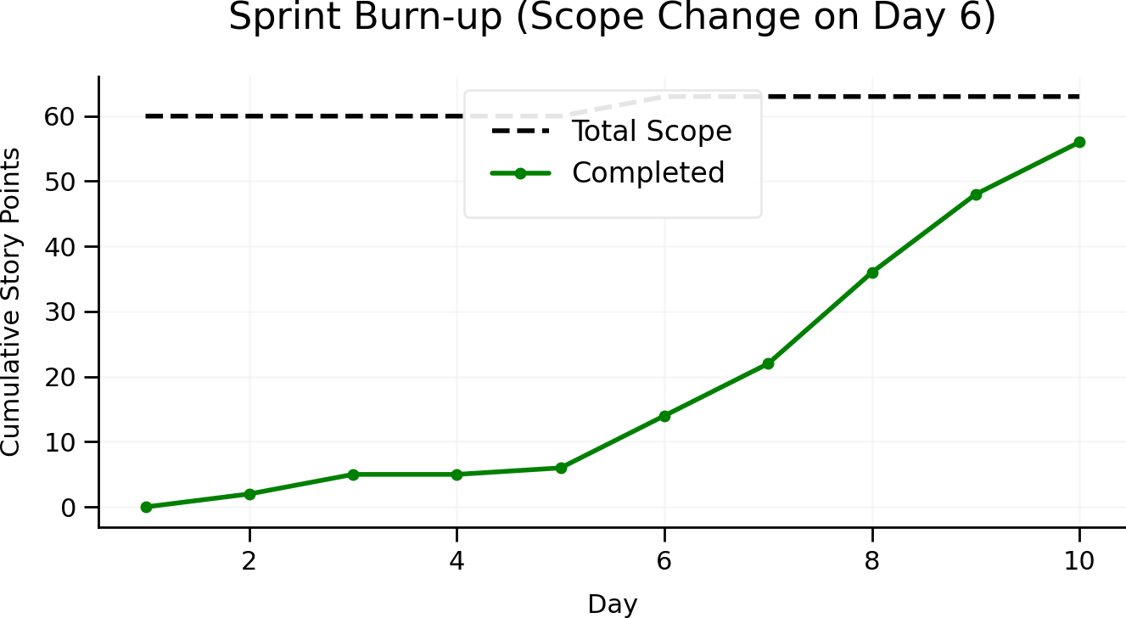
• Total scope increased on day 6 (from 60→63 SP). Burn‑up makes this visible, preventing false “under‑delivery” narratives when scope grows mid‑sprint.
3.3 Velocity Trend – Forecasting with Averages:
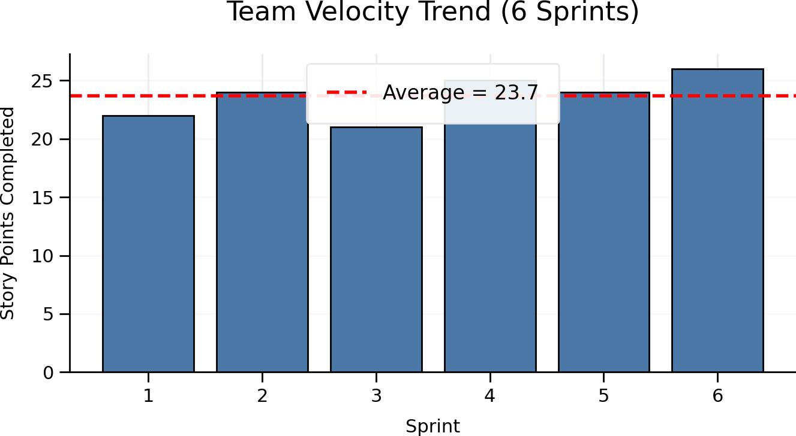
• Average ≈ 23.7 SP over 6 sprints. Use this for planning the next increment and communicate P50/P80 ranges rather than single‑date promises.
3.4 Cumulative Flow Diagram (CFD) – Bottlenecks:
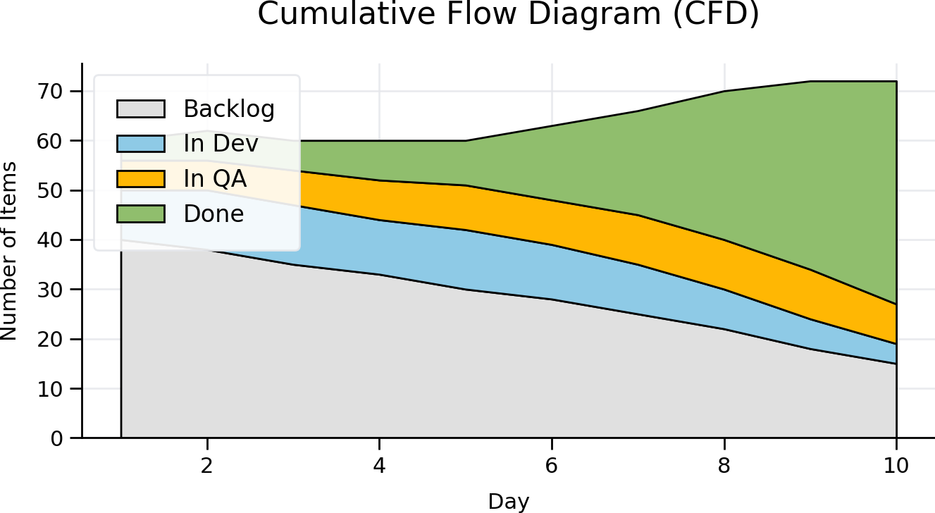
• “In QA” band widens around days 6–8 → test bottleneck. Remedies: raise QA capacity, earlier test involvement, stabilize environments, and slice stories smaller.

4) Real‑World Interview Q&A (Agile Delivery)
Q: How do you use velocity without pressuring the team?
A: I track 5–6 sprint trends and use it only for forecasting. If it dips, I look for causes (scope churn, dependencies, oversized stories), not culprits. We stabilize DoR and reduce WIP before increasing targets.
Q: Burndown shows flat line mid‑sprint—what do you do?
A: Investigate blockers, check DoR gaps, and enforce “start smaller, finish earlier”. If QA is idle at start, introduce contract tests or test‑data prep to parallelize work.
Q: Burn‑up vs Burndown—when do you prefer burn‑up?
A: When stakeholders keep adding scope mid‑sprint. Burn‑up plots both completed work and total scope, so progress isn’t perceived as a miss when scope grows.
Q: Cycle time increased—what’s your fix?
A: Map wait states, introduce WIP limits, reduce hand‑off queues, and promote pairing. Track by item type (defects vs features) to target the true constraint.
Q: Defect leakage rising—what actions?
A: Improve AC quality, add risk‑based tests, shift‑left checks (contract/perf/security), and run root‑cause on top 3 recurring patterns. Tie fixes to DoD so they stick.
Q: Release predictability is low—how to recover?
A: Reduce scope churn via tighter backlog refinement, anchor sprint goals, and use evidence‑based forecasting with buffers. Share P50/P80 and hold a no‑surprises cadence with stakeholders.

