Session-2
Role of Business Analyst:

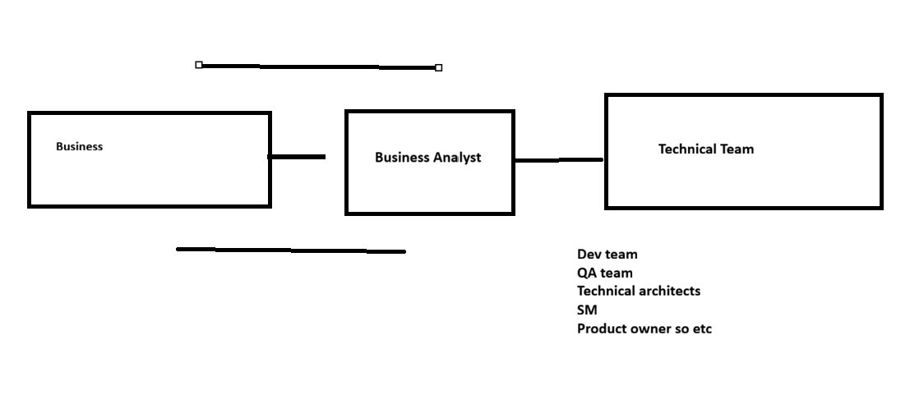Session-2

Role of the Business Analyst (BA) — Waterfall vs Agile, Estimation & Velocity
- Waterfall Model — How It Actually Runs (and Why It’s Risky)
JAD (joint application development)- stakeholders
Business invited all the technical team to discuss the requirement
Session-1---------------------------------------------Session 20
Requirement got fixed-> BRD development completed
Business requirement Document
- Developer started coding-6 months
- QA team designing the test cases
- QA started testing 3-4 months
- On month 10th, QA found which break the system
After 10 month we found whole system is breaking with that loop hole and it may create in future.

JAD (Joint Application Development) / Workshops
- What it is: Facilitated workshops where business stakeholders + BA + architects + dev + QA collaborate to clarify and finalize requirements.
- Output: BRD (Business Requirements Document) and often SRS (System/Software Requirements Specification) or FRD (Functional Requirements Document).
Note: In many enterprises, BA writes BRD/FRD; architects/analysts may own SRS. The exact label varies by organization.

Typical Waterfall Sequence (example timeline)
- Requirements & Sign-off (BA leads, multiple JAD/workshops; “Session-1 … Session-N”)
- Design (HLD/LLD)
- Development (e.g., ~6 months on a medium/large project)
- System/Integration Testing (QA designs test cases earlier, but execution usually starts once builds are available; e.g., 3–4 months)
- UAT → Release

Real Risk in Waterfall
- Late feedback: If a system-breaking defect is discovered in month 10, it’s expensive to fix because code, tests, and plans are already baked.
- Cost impact: Many teams (e.g., 15 people) have already billed for months → high rework cost and delayed time-to-market.
- Market risk: When markets shift fast (think mobile OS waves), long cycles lose edge.
Your “Android vs Nokia/Windows” point = time-to-market matters. Waterfall can be too slow when requirements or market signals change rapidly.

2) Agile Model — Faster Feedback, Incremental Value

Core Ideas
- Break the product into small, testable increments.
- Prioritize what delivers value earliest.
- Time-boxed sprints (e.g., 2 weeks).
- Continuous collaboration: PO, BA, Dev, QA, SM.

Roles (simplified)
- Product Owner (PO): Owns value and priority.
- Business Analyst (BA): Clarifies business needs, writes/refines epics/user stories, acceptance criteria, supports backlog refinement, assists with UAT/business demos.
- Scrum Master (SM): Process facilitation, impediment removal.
- Dev/QA: Build and validate increments.

Backlog & Prioritization
- Product Backlog: Single ordered list of requirements (epics/stories).
- Example priorities (MoSCoW or simple rank):
  - Req-1 → P1
  - Req-5 → P2
  - Req-2 → P8
  - Req-10 → P10
- The PO orders; the team discusses feasibility and estimates with BA support.

3) Sample Agile Project
Project: ABC
Team: Dev, QA, BA, PO, SM
Sprint cadence: 2-week sprints
Illustration: Sprint-1 to Sprint-7

Sprint-1: Sprint Planning (What you commit)
- Inputs: Ordered backlog, team capacity, prior velocity (if any), DoR (Definition of Ready).
- Example (as BA, you prepared 5 stories with AC):
  - Story-1 → 5 points
  - Story-2 → 6 points
  - Story-3 → 7 points
  - Story-4 → 4 points
  - Story-5 → 3 points
Planned total = 25 story points
Story Points = Relative effort, not hours. They consider:
- Complexity 2) Amount of work 3) Risk/uncertainty.

4) Estimation Examples (Corrected)

Story Example-A (Very Small UI tweak)
- As a user, I want a label change on a web page: “Facebook” → “facebook”.
- Complexity: Very low
- Work: Small
- Risk: None
- Estimate: 1 point

Story Example-B (New API endpoints)
- Add REST API endpoints to exchange data with another system.
- Complexity: Medium
- Work: Moderate
- Risk: Some dependencies (schemas, auth, envs)
- Estimate: 5 points
Points are relative; “5” here is relative to other stories in the team’s scale.

5) Common Scales (Use One, Don’t Mix Mid-sprint)

Fibonacci (most common)
1, 2, 3, 5, 8, 13, 21, 34 …
- 1 → very small
- 2 → small
- 3 → small-medium
- 5 → medium
- 8 → medium-large
- 13 → complex
(21/34 are for large epics or to signal split this story.)

T-Shirt Sizing (early discovery or epic-level)
- XS ~ 1, S ~ 2, M ~ 5, L ~ 8, XL ~ 13
Use to coarsely estimate epics/features before breaking into stories.
Tip: Use T-shirt for early roadmap sizing, then Fibonacci when stories meet DoR.

6) Velocity (Team’s Throughput) — Correct Calculation
- Sprint-1: 25 pts
- Sprint-2: 30 pts
- Sprint-3: 25 pts
Velocity = (25 + 30 + 25) / 3 = 26.7 ≈ 27 points/sprint
Velocity is historical, used for forecasting, not a target to “chase”.
Don’t compare velocity across teams; it’s team-specific and contextual.

7) Capacity vs Story Points (Common Confusion)
- Story Points ≠ Hours.
- Teams sometimes maintain a capacity plan in hours (holidays, meetings, BA/QA/Dev availability) to check if the planned points are realistic.

Example capacity breakdown for a 5-point story (illustrative only):
- Dev-1: 6 hours
- Dev-2: 4 hours
- QA-1: 6 hours
- Plus code review, QA prep, environments, etc.
This mapping is for planning sanity check, not for converting all points to hours.

8) BA Responsibilities Highlight (Waterfall vs Agile)
Common BA core:
- Elicit requirements (workshops/JAD), define scope, write BRD/FRD, model processes, define acceptance criteria, traceability, support UAT.
In Agile, additionally:
- Split epics → user stories, maintain clear acceptance criteria, ensure DoR/DoD alignment, backlog refinement, collaborate with PO on priorities, support sprint reviews with business, assist with release planning.

