Class 1: menu_controller
extends Control

onready var tween = get_node("tween")

func _ready():
pass

func _on_exit_button_pressed():
_targets("exit_container");

func _on_ensiklopedia_button_pressed():
_targets("ensiklopedia_container");

func playAction():
print("Bermain!!")

func aboutAction():
_targets("about_container");

func _on_no_button_pressed():
_targets("start");

func _on_exit_yes_button_pressed():
get_tree().quit();

func _targets(var screen = "start"):
var target_coordinates = Vector2(0, 0)
if has_node(screen):
target_coordinates = get_node(screen).get_pos()
get_node("buttons").set_hidden(true);
else:
get_node("buttons").set_hidden(false);
var current_coordinates = get_pos()
var distance = current_coordinates.distance_to(target_coordinates)
var time = distance/1200
if time > 0:
tween.interpolate_property(self, "rect/pos", current_coordinates, -target_coordinates, time, Tween.TRANS_EXPO, Tween.EASE_OUT, 0)
tween.start()

Class 2: ensiklopedia_controller
extends ReferenceFrame
onready var gambar = [
"res://assets/ensiklopedia/tampilan encyclopedia 1.png",
"res://assets/ensiklopedia/tampilan encyclopedia 2.png",
"res://assets/ensiklopedia/tampilan encyclopedia 3.png",
"res://assets/ensiklopedia/tampilan encyclopedia 4.png",
"res://assets/ensiklopedia/tampilan encyclopedia 5.png",
"res://assets/ensiklopedia/tampilan encyclopedia 6.png"
]
onready var currentFrame = 0
onready var kontenEnsiklopedia = get_node("Sprite")
onready var tombolNext = get_node("next")
onready var tombolPrev = get_node("prev")
const MAX_FRAME = 5
const MIN_FRAME = 0

func _ready():
currentFrame = 0
_target(currentFrame)

func nextAction():
currentFrame += 1
_target(currentFrame)

func prevAction():
currentFrame -= 1
_target(currentFrame)

func _target(var currentFrame = 0):
if currentFrame == MIN_FRAME:
tombolPrev.set_hidden(true)
elif currentFrame == MAX_FRAME:
tombolNext.set_hidden(true)
else:
tombolNext.set_hidden(false)
tombolPrev.set_hidden(false)
kontenEnsiklopedia.get_texture().load(gambar[currentFrame])

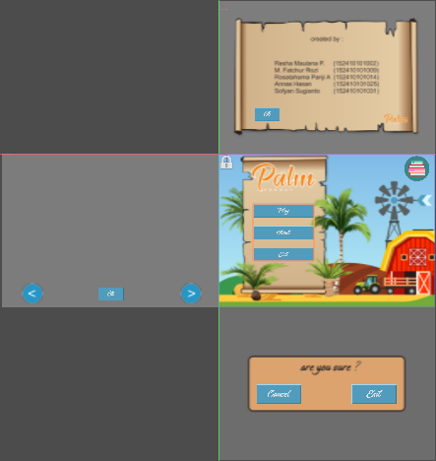Gambar 2: viewport pengembangan
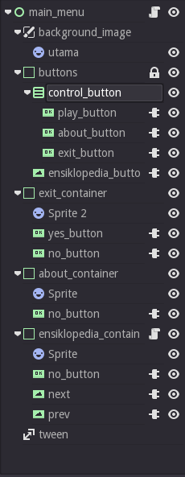Gambar 1: Hierarki viewport
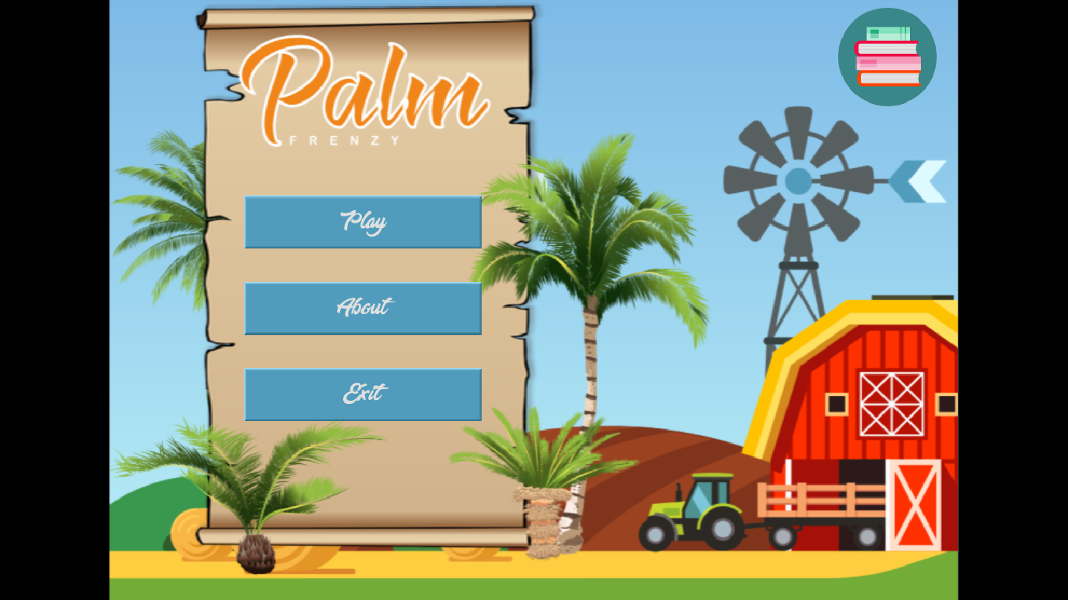Gambar 3: menu awal
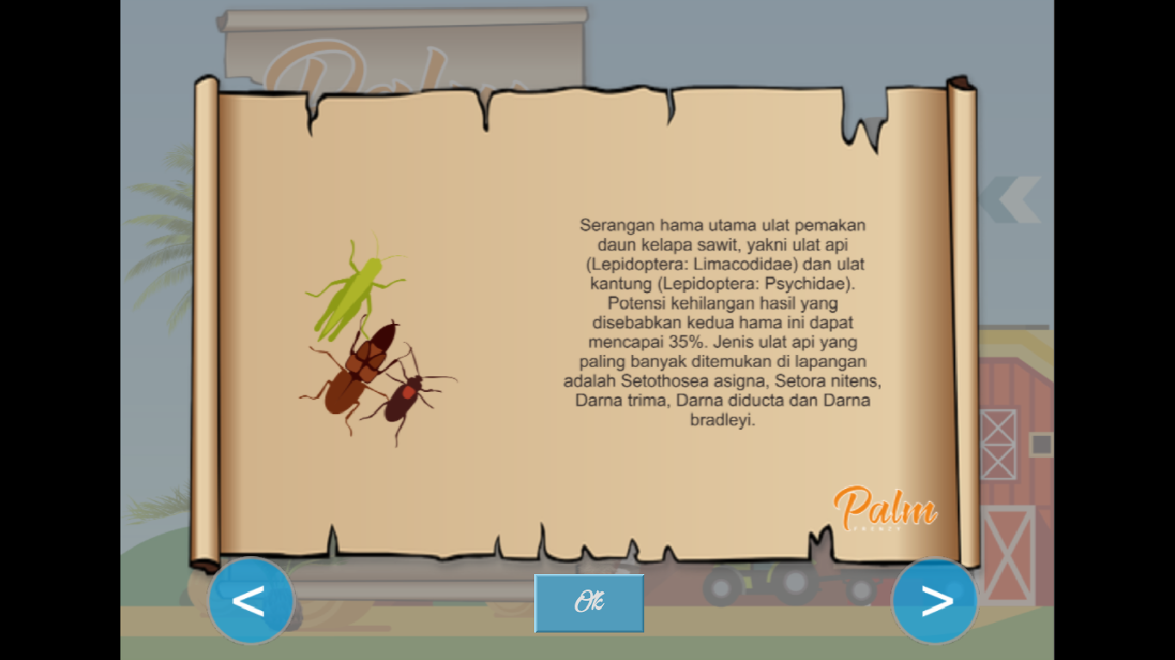Gambar 6: Ensiklopedia
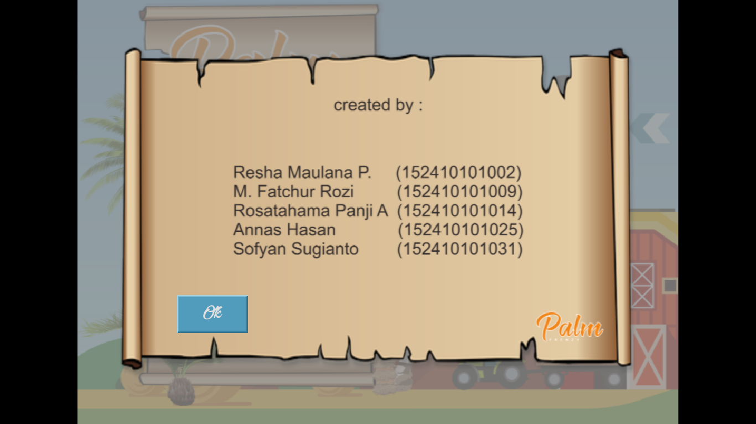Gambar 5: saat klik About
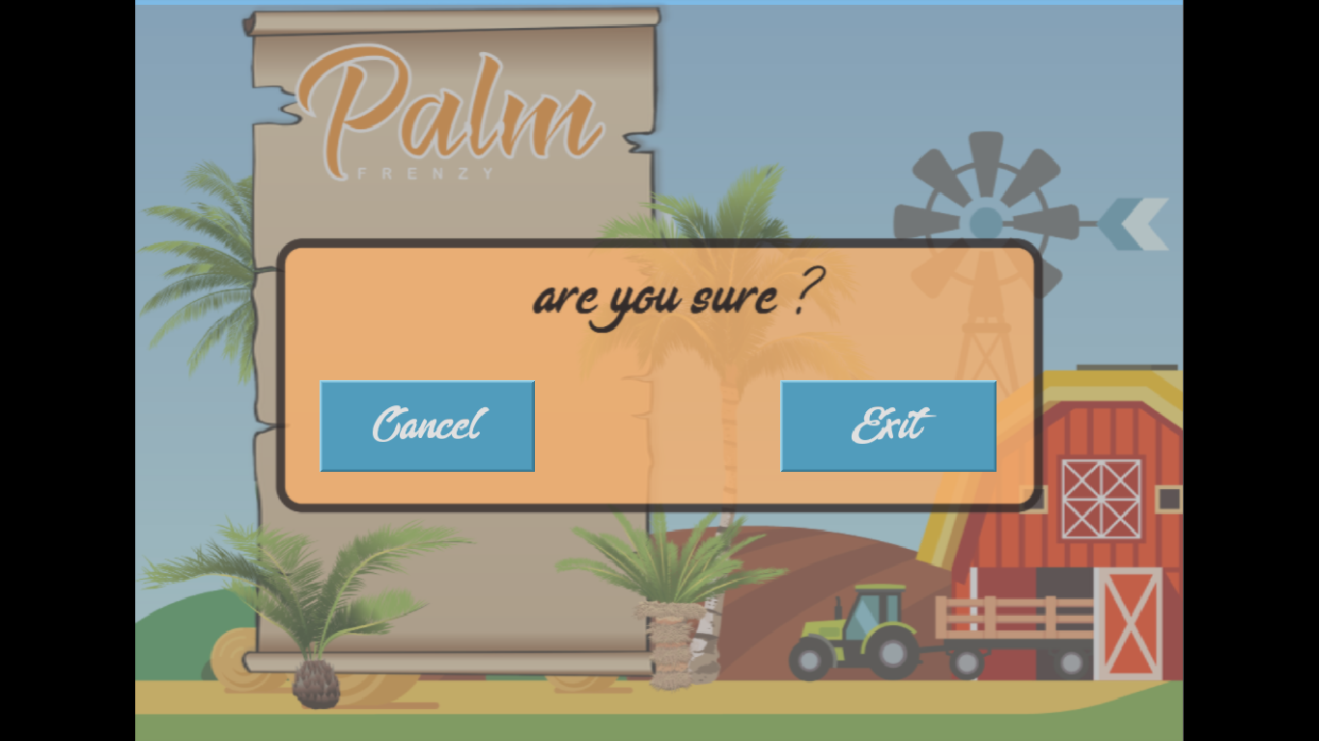Gambar 4: saat klik exit
Code 1: Tampilan Play Game
extends Control

onready var menu_utama = "res://scenes/main_menu.tscn"
onready var currentScreen = "awal"
func _ready():
for items in get_children():
if items.has_node("cancel_button"):
items.get_node("cancel_button").connect("pressed",self,"_on_cancel_button_pressed",[items.get_name()])

func _on_exit_pressed():
queue_free()
get_tree().change_scene(menu_utama)

func _on_new_button_pressed():
get_node("container_tombol_utama").set_hidden(true);
get_node("container_tombol_new").set_hidden(false);

func _on_continue_button_utama_pressed():
get_node("container_tombol_utama").set_hidden(true);
get_node("container_tombol_continue").set_hidden(false);

func _on_cancel_button_pressed(var target="awal"):
get_node(target).set_hidden(true)
get_node("container_tombol_utama").set_hidden(false)

func _on_delete_button_pressed():
pass # replace with function body

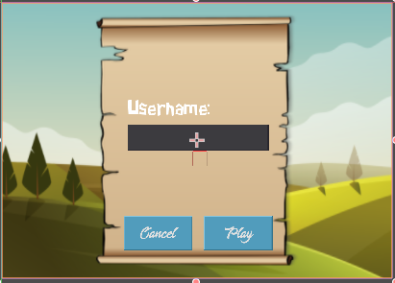Screenshot 1: Tampilan New Game

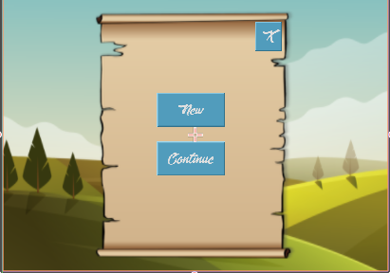Screenshot 2: Tampilan New Game

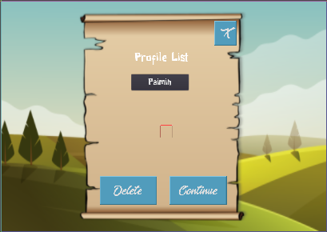Screenshot 3: Tampilan Saat Continue

