Code 1: Coding Toko
extends Control
const H_PUPUK = 20
const H_AIR = 40
const H_SAWIT = 100
const H_TRUK = 500
const H_PABRIK = 1000
const H_PABRIK2 = 2000

var pupuk=0
var air=0
var sawit=0
var truk=0
var pabrik=0
var pabrik2=0
var total_harga = 0
onready var l_total = "Total = 0"

func _ready():
get_node("harga").set_text(l_total)
for components in get_node("shop_container").get_children():
if components.has_node("SpinBox"):
components.get_node("SpinBox").connect("value_changed",self,"_on_value_changed",[components.get_name()])

func _on_value_changed(value,parent):
l_total = "Total = "
if parent == "pupuk":
pupuk = value * H_PUPUK
elif parent == "air":
air = value * H_AIR
elif parent == "sawit":
sawit = value * H_SAWIT
elif parent == "truk":
truk = value * H_TRUK
elif parent == "pabrik":
pabrik = value * H_PABRIK
else:
pabrik2= value * H_PABRIK2

total_harga = pupuk + air + sawit + truk + pabrik + pabrik2
get_node("harga").set_text(l_total + str(total_harga))

func _on_cancel_button_pressed():
queue_free()
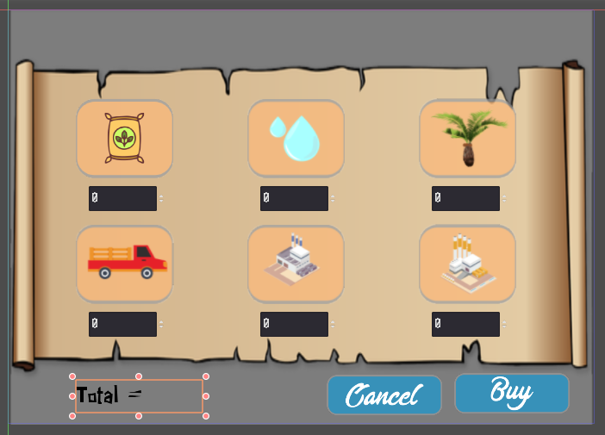Screenshot 1: Tampilan Menu Toko
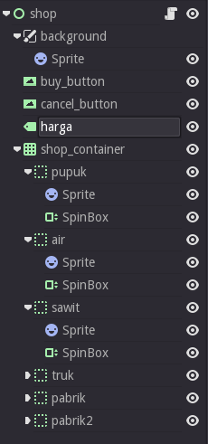Screenshot 2: Tampilan Hierarki Pengembangan Menu Shop

