extends Sprite

onready var timer = get_node("Timer")

export (float, 0.0, 100.0, .1) var start_time = 15.0
export (float, 0.0, 100.0, .1) var end_time = 20
var kebutuhan = 0

func _ready():
object_state.air_value = false
timer.set_timer_process_mode(Timer.TIMER_PROCESS_FIXED)
timer.set_wait_time(end_time - start_time)
timer.set_one_shot(true)
timer.connect("timeout", self, "gameover")

# add_child(timer)
timer.start()

set_fixed_process(true)

func gameover():
queue_free()

var t = 1
func _fixed_process(delta): # Print testing
if(t >= 1):
t -= 1
print(timer.get_time_left())
# set_value(timer.get_time_left())
if(timer.get_time_left() < 35 and timer.get_time_left() > 15):
if kebutuhan % 3 == 0:
get_node("air").set_hidden(false)
elif kebutuhan % 3 == 1:
get_node("pupuk").set_hidden(false)
else:
if kebutuhan < 10:
get_node("air").set_hidden(false)
else:
get_node("panen").set_hidden(false)
elif(timer.get_time_left() < 15):
if kebutuhan < 10:
self.set_frame(1)
else:
print("switched")
set_frame(3)
t += delta

Drawing 1: Script sawit.gd
Drawing 2: Script kebutuhan sawit.gd
Drawing 3: global_variables.gd
const ADDITIONAL_TIME = 5.0
var clicked = 0

func _on_air_pressed(): # Button for testing
# Must get time before stopping timer.
var new_time = timer.get_time_left() + ADDITIONAL_TIME
#set_value(new_time)
kebutuhan+=1
if kebutuhan < 10:
set_frame(0)
else:
set_frame(2)
timer.stop()
timer.set_wait_time(new_time)
timer.start()
extends Sprite

var nilai = false
onready var koin = get_node("Area2D")
func _ready():
pass
func _picked_up():
nilai = true
print("picked up")
get_node("/root/object_state").air_value =nilai
get_node("../").set_fixed_process(false)
get_node("../")._on_air_pressed()
get_node("../").set_fixed_process(true)
set_hidden(true)

func _on_Area2D_input_event( viewport, event, shape_idx ):
if event.type == InputEvent.MOUSE_BUTTON and event.pressed == false:
# Start dragging when the user presses the mouse button over the clickable area
_picked_up()

extends Node

var air_value = false
var truk_value = false
var pabrik_value = false

Drawing 4: hud.gd
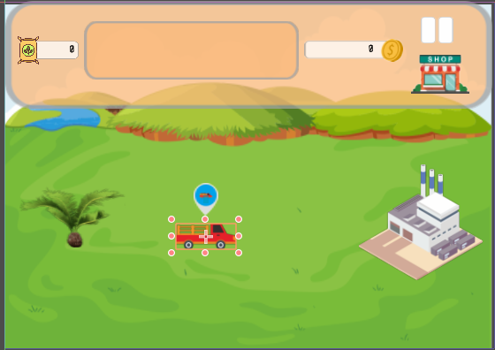Illustration 1: In-Game UI
extends Node2D

func _ready():
pass

func _on_shopButton_pressed():
var toko = preload("res://scenes/shop.tscn").instance()
toko.set_z(99)
get_node("../../").add_child(toko)

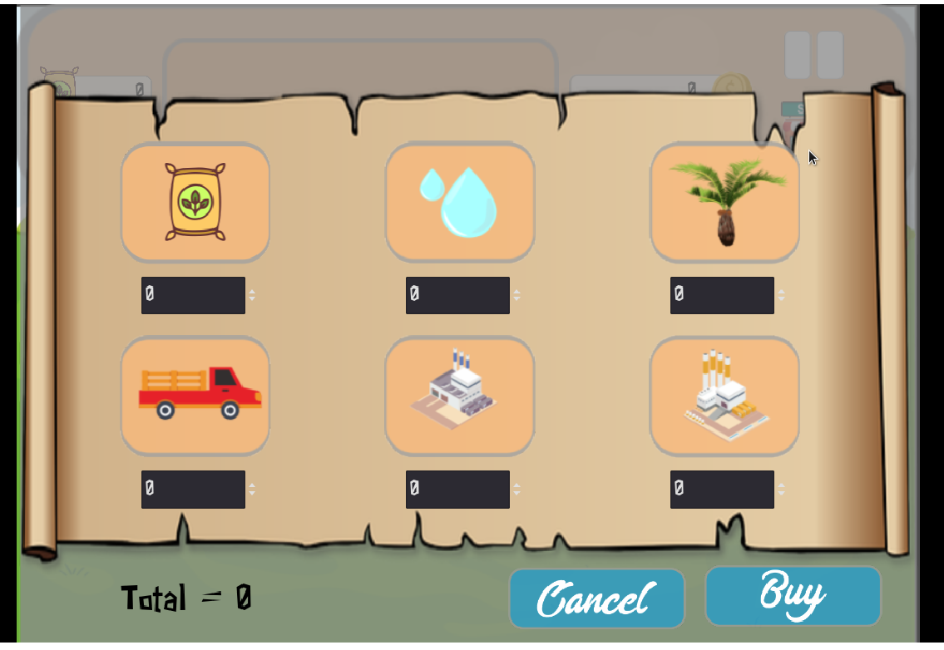Illustration 2: In-Game Shop

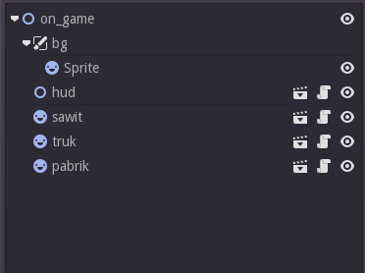Illustration 4: on-game-workspace
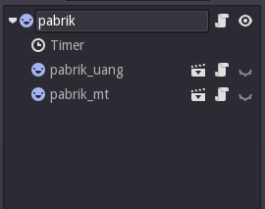Illustration 3: pabrik-workspace
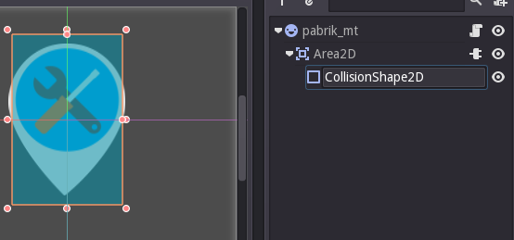Illustration 5: pabrik-mt-workspace
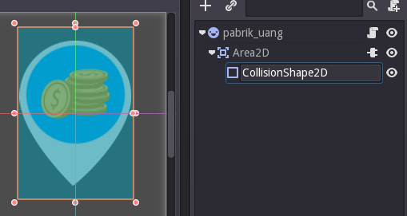Illustration 6: pabrik-uang-workspace
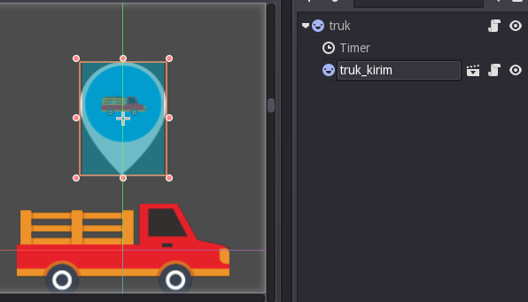Illustration 7: truk-kirim-workspace
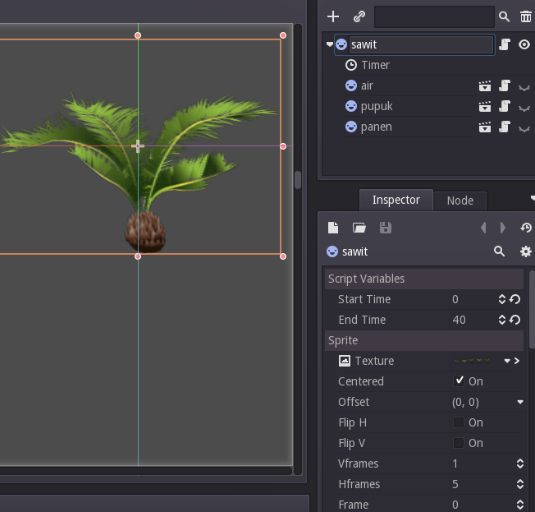Illustration 8: sawit-workspace
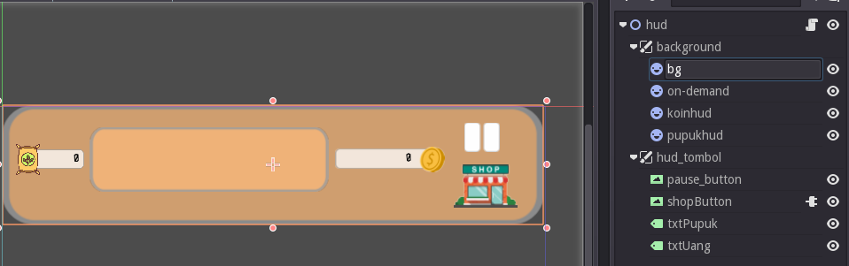Illustration 9: hud-workspace
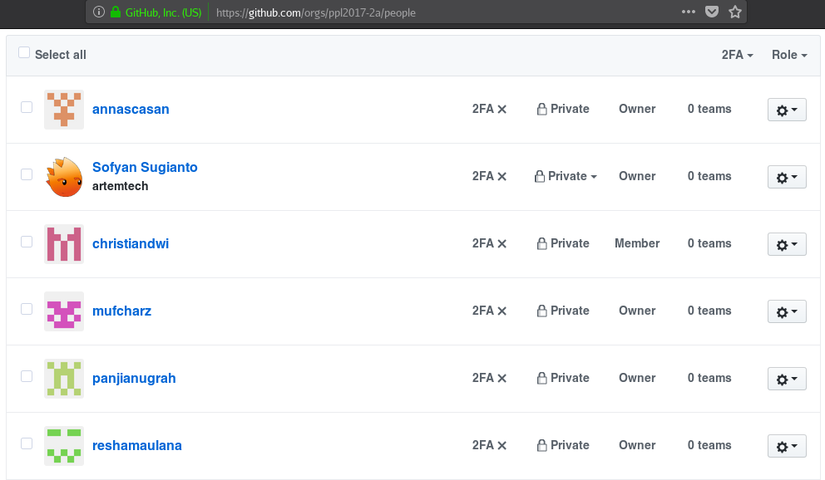Illustration 10: https://github.com/ppl2017-2a/

