Pat Pleiss

7/8/2016

***1. Identify which tags are used for each of the 15 elements in the attached image (next page).***

1. <img src="imagename.jpg" alt="Interface The Web School">

2. <a href="https://**interfaceschool**.com/home.html">

3. <h1 style="font-family:verdana; color:white;"><em>BUILDING PEOPLE<br/>WHO BUILD THE WEB&trade;</em></h1>

4. <h6 style="font-family:verdana; color:white;">Learn Code, Design, Business &amp; more at The Web School.</h6>

5. <a href="courses.html"><button type="button">View Courses</button></a>

6. <div style="width:800px; height:180px; background-color:#31336E; <img src="pixels.jpg" height="180" width="180"></div>

7. <h2 style="font-family:verdana;">OFFERING HANDS-ON INSTRUCTION IN</h2>

8. <div><img src="computer.jpg"></div>

9. <p> WEB DEVELOPMENT</p>

10. <a href="courses.html"><button type="button">View Current Courses</button></a>

11. <h2 style="font-family:verdana;">WHO WE ARE</h2>

12. <div>

13. <h3>SUBSCRIBE TO OUR MAILING LIST</h3>

14. <form>

<input type="email" placeholder="email address"/>

</form>

15. <input type="submit" value="Subscribe">

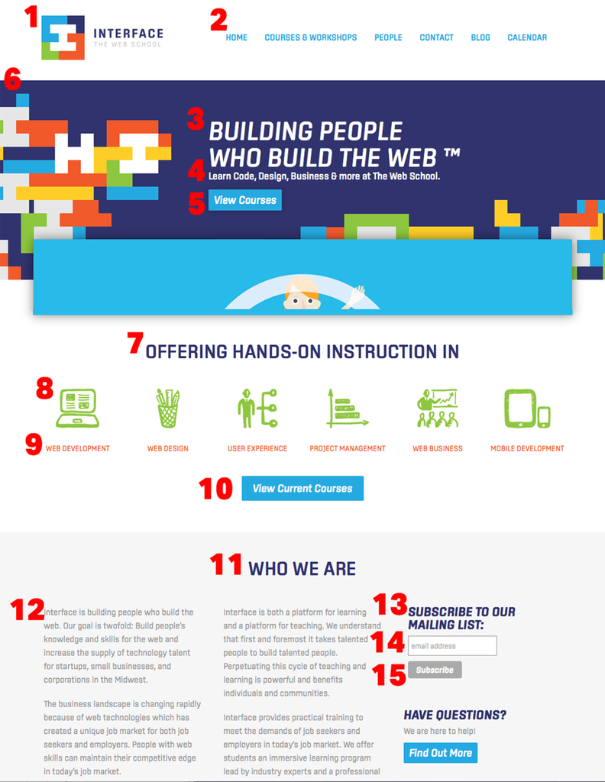

***2. Choose any other website and identify five unique tags used on the page.  
    a. Provide the link to the site.  
    b. For each of the five unique tags, please describe which element you are referencing.***

a. <http://www.timesonline.com/entertainment/local_entertainment/def-leppard-reo-speedwagon-fill-first-niagara-pavilion/article_2ba392ca-45d3-11e6-8f86-2706a26a73b4.html>

b. 1. <base href="http://www.timesonline.com/content/tncms/live/" />

Located in the header section of the code. This tag specifies the base URL for all relative URLs in the document.

2. <section id="main-top-container" class="container-fullscreen-region container-fluid"></section>

The <section> tag defines sections in a document, such as chapters, headers, footers, or any other sections of the document. This tag is referencing the main top container, which includes the black menu bar at the top of the screen.

3. <article itemscope … url="http://www.timesonline.com/entertainment/local_entertainment/def-leppard-reo-speedwagon-fill-first-niagara-pavilion…3b4.html">…</article>

The HTML <article> element represents a self-contained composition in a document, page, application, or site, which is intended to be independently distributable or reusable (e.g., in syndication). For example, a news article. This tag designates the section that begins at the article's headline and ends just above an ad that is centered near the bottom of the page.

4. <iframe src="http://stats-… style="position: absolute; width: 0px; height: 0px;"></iframe>

The <iframe> tag specifies an inline frame. An inline frame is used to embed another document within the current HTML document. This tag appears shortly after the body, it appears it serves as an invisible container for the main article.

5. <meta name="keywords" content=", concert news, first niagara pavilion concert news, entertainment news, reo speedwagon, def leppard">

This tag is found in the header. Meta elements are typically used to specify page description, keywords, author of the document, last modified, and other information.