MISO Tutorial

Constructing a library from a blood sample

This guide is a tutorial for sequencing lab technicians learning to use MISO for the first time. It outlines a typical process in a sequencing lab, namely how to prepare and track a blood sample from a human patient into a library ready for sequencing.

## Step 1: Receiving and logging the blood sample

1. **Navigate** to the ***Preparation*** section in the left taskbar. **Click** on ***Samples***.

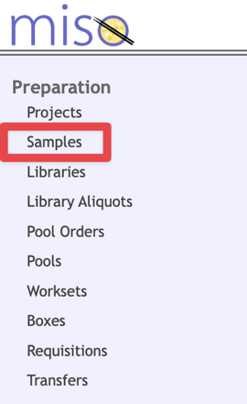

1. **Click** the ***Create*** button in the main window.

1. In the *Create Samples* pop-up, keep the *Quantity* value at 1. Then **click** ***Create*.**
2. You will encounter the following table (in the app it continues off to the right):

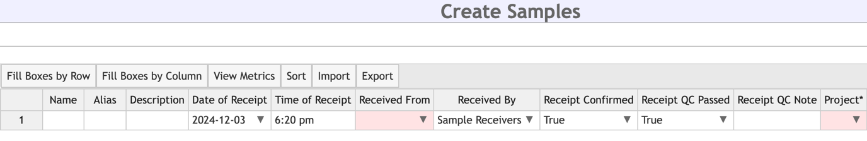

**Enter** the required column items as follows:

|  |  |
| --- | --- |
| *Alias* | Enter a unique identifier used for internal tracking.  ***NOTE****: There is often a systematic naming convention within each project.* |
| *Description* | Enter a free-form description of the sample. |
| *Received From* | Select the originating lab of the sample.  If it doesn’t appear, ask an administrator to add it under *Configuration* > *Labs* |
| *Received By* | Select the internal group you belong to. |
| *Project* | Select the sequencing project it belongs to.  If it doesn’t appear, ask an administrator to add it under *Configuration* > *Projects* |
| *Sample Type* | Select **GENOMIC** |
| *Scientific Name* | Select **Homo sapiens** |
| *Volume (& Concentration)* | If the sample is measured by mass:  Enter **mg** for *Vol Units* and enter the mass in *Volume*.  If measured by volume:  Enter **µL** for *Vol Units*, enter the volume in microlitres, and enter the concentration in *Conc*. [using the correct concentration units in *Conc. Units*]. |
| *QC Status* | Select **Not Ready** |

1. **Click** the ***Save*** button in the top right corner.

## Step 2: Creating a library from the sample

1. **Open** the ***Samples*** window and select the **select** the checkbox of the sample to be extracted.
2. **Click** ***Propagate*** in the main window.

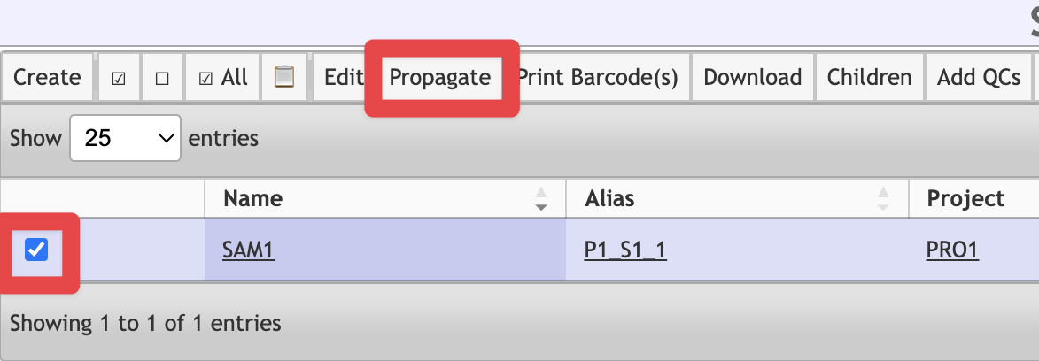

1. In the *Propagate Samples* pop-up window, **select *Library*** in the *To:* field.

1. You will encounter the following table:

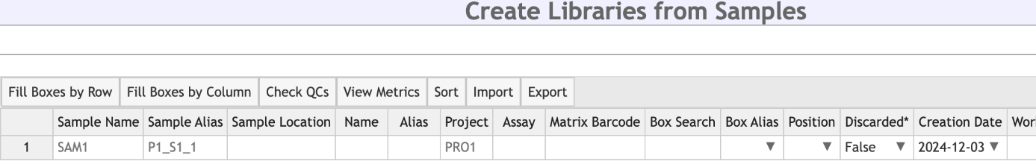

**Enter** the required column items as follows:

|  |  |
| --- | --- |
| *Alias* | Enter a unique identifier used for internal tracking.  ***NOTE****: There is often a systematic naming convention within each project.* |
| *Platform* | Select **Illumina** |
| *Type* | Select **Paired End** |
| *Selection* | Select **RANDOM** |
| *Strategy* | Select **WGS** |
| *Index Kit* | If the library will eventually be pooled with others for sequencing:  Select the **barcode kit** used when constructed (e.g. SureSelect XT). Enter **Index 1** and **Index 2** as appropriate.  Else:  Select **no indices** |
| *Kit* | Select the library kit used to construct the library.  If it doesn’t appear, ask an administrator to add it under *Configuration* > *Kits* |
| *QC Status* | Select **Not Ready** |

1. **Click** the ***Save*** button in the top right corner.

## Step 3: Inserting quality control (QC) information of library

The typical QC criteria for a genomic library is making sure the fragment size of the DNA is long enough to get consistent reads. To add this:

1. **Open** the ***Libraries*** window and select the **select** the checkbox of the library to be checked.
2. **Click** ***Add QCs*** in the main window.

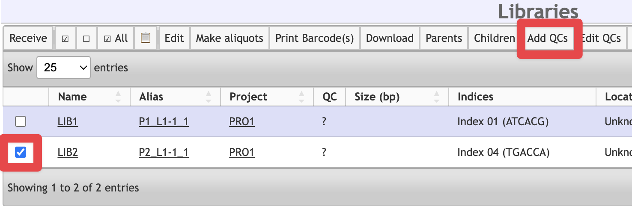

1. In the *Add QCs* pop-up that appears, keep the *QCs per Library* and *Controls per QC* values at 1. Then **click** ***Add***.
2. You will encounter the following table:

**Enter** the required column items as follows:

|  |  |
| --- | --- |
| *Date* | Enter the date the QC was performed. |
| *Type* | Select **Insert Size** |
| *Result* | Enter the **average fragment size** determined by the QC process. |

1. **Click** the ***Save*** button in the top right corner.
2. [*Optional*] **Click** the ***Attach Files*** button on the main Libraries window to attach any QC files produced by the instruments.

## Step 4: Preparing library aliquots

1. **Open** the ***Libraries*** window and select the **select** the checkbox of the library to be checked.
2. **Click** ***Make aliquots*** in the main window.

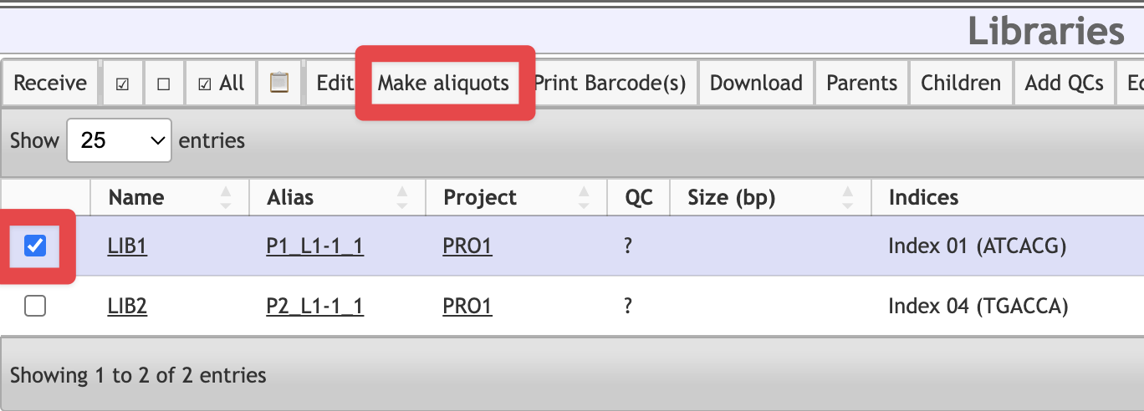

1. **Click** ***Create*** in the *Create Aliquots* pop-up that appears.
2. If the library passes the internal QC metrics:

**Select *Ready*** for *QC Status.*

If it fails QC:

**Select *Failed: QC*** for *QC Status.*

1. **Click** the ***Save*** button in the top right corner.

## Step 5: [Optional] Pooling libraries

If multiple libraries need pooling for sequencing:

1. **Open** the ***Library Aliquots*** window and select the **select** the checkbox of the library to be checked.
2. **Click** ***Pool together*** in the main window.

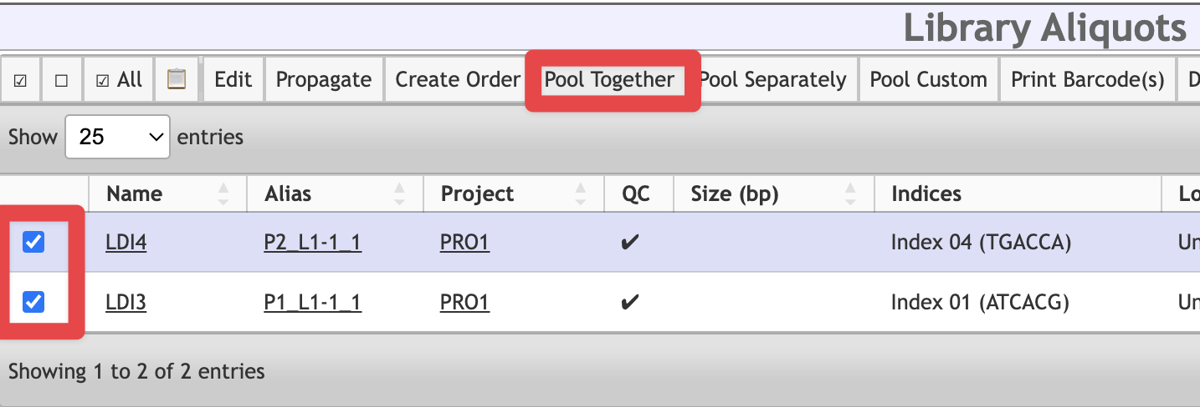

1. **Click** ***Create*** in the *Create Pools* pop-up that appears.
2. In the *Create Pools from Library Aliquots* table, **enter** the **final volume and concentration** of the pool.
3. **Click** the ***Save*** button in the top right corner.

The process is now complete! You can now assign individual library aliquots or a pool to a sequencing container (i.e. flowcell and lane in the sequencing machine).