Multi-Cloud MERN Platform
  - Project report — HeroVired DevOps Capstone, Problem Statement #5: Multi-Cloud Deployment and Management with Terraform
Rishav Mukhopadhyay
31 October 2026
Table of Contents

Summary
HeroVired DevOps Capstone · Problem Statement #5: Multi-Cloud Deployment and Management with Terraform GitHub organisation: ppmcad16a-cloud-platform · Live domain (during sessions): https://rishavmukhopadhyay.store
A polyglot MERN e-commerce shop, split into six microservices, runs on Google Cloud (GKE), Microsoft Azure (AKS) and Amazon Web Services (EKS). Everything is created by Terraform, delivered by GitHub Actions + Jenkins, protected by keyless identities, watched by Prometheus/Grafana/Loki, backed up to all three clouds, and switched on and off with one Ansible command each.
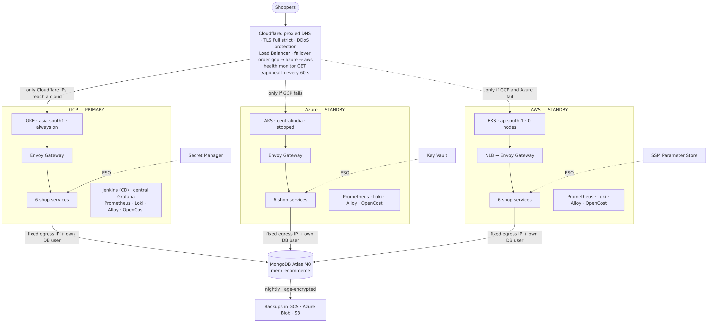
Architecture

Results at a glance (final test, 30–31 Oct 2026)
What we proved | Result | Evidence
Whole platform from code in parallel (3 clusters + add-ons + shop) | up.yml green on all 3 clouds in 23 min 13 s (warm GKE/AKS, cold EKS) | Test report §B
Same app in 3 clouds, one shared database | 6/6 services ready in every cloud, /api/health = ok ×3 | §C
CI → CD with one merge | PR → scan → same image in 3 registries → Jenkins → live in gcp, azure, aws in 4 min 57 s | §D
Automatic cloud failover | GCP down → standbys woken automatically → shop back, RTO 3 min 42 s (target 20 min) | §G
Disaster recovery | Encrypted backup in GCS + S3 + Azure Blob; restore drill passed from all 3 | §G
Monitoring & alerting | Central Grafana over 3 clouds; MernServiceDown + Cloudflare pool alerts in Slack, then RESOLVED | §E
Cost control | Real bill Oct 1–30: AWS $6.76 · Azure ₹349.61 · GCP ₹474.75 (credits) ≈ US $17 for the month | Monitoring & cost

Technology in one table
Area | Technology
Application | React (client), Node.js (api-gateway, catalog, notification, seed-db), Java 21 Spring Boot (identity), Python Flask + gunicorn (commerce)
Database | MongoDB Atlas M0 (AWS Mumbai), database mern_ecommerce, one DB user per cloud
Infrastructure as code | Terraform 1.16.6 — per-cloud stacks (bootstrap / foundation / cluster / add-ons) + global-platform
Clouds | GKE asia-south1-a · AKS centralindia · EKS ap-south-1
Kubernetes add-ons | Envoy Gateway v1.9.2 (Gateway API), External Secrets 2.12.0, AWS LB Controller 3.6.0, kube-prometheus-stack 92.6.0, Loki 7.3.0, Alloy 1.13.1, OpenCost 2.5.32, Jenkins 5.9.68
Global traffic | Cloudflare DNS, TLS Full (strict) with Origin CA certs, Load Balancer with /api/health monitors, Zero Trust Access, a Worker for automatic failover
Secrets | GCP Secret Manager · Azure Key Vault · AWS SSM Parameter Store, synced by External Secrets with workload identity
CI | GitHub Actions reusable workflows (core-cloud-platform@v2), gitleaks, Trivy, keyless OIDC
CD | Jenkins in GKE (Configuration-as-Code, Job DSL, Generic Webhook Trigger), Helm 4
Automation | Ansible 2.21 in WSL Ubuntu: toolchain, preflight, up, down, standby, wake, deploy, drills
Observability | Prometheus + Alertmanager, Grafana (central), Loki + Alloy, OpenCost, Slack alerts
Disaster recovery | mongodump + age encryption → GCS, S3, Azure Blob; scripted restore drills

01 — Project overview

The problem
“In multi-cloud environments, managing resources across multiple cloud providers (AWS, Azure, GCP) can be complex and error-prone, especially when attempting to maintain consistent configurations and enable failover across clouds.” — Capstone Problem Statement #5
The task is a Terraform-based solution that deploys an application to AWS, Azure and GCP, keeps their configuration consistent, fails over automatically when a cloud breaks, recovers data after a disaster, and shows health and cost of everything in one place.

What we built
One real application — a MERN e-commerce shop split into six microservices in three languages — running as three identical copies, one per cloud, behind one domain name.
Building block | In one sentence
Three clusters | GKE (primary, always on), AKS and EKS (standbys that sleep like a stopped EC2 instance and wake in minutes).
One front door | Cloudflare sends every shopper to the first healthy cloud in the order GCP → Azure → AWS and checks each cloud’s /api/health every 60 s.
One database | MongoDB Atlas; each cloud has its own database user and its own fixed outgoing IP on the allow-list.
Everything as code | Terraform for all infrastructure (13 stacks in 4 platform repos), Helm for the workloads, Ansible to run a session in one command.
Keyless security | No cloud key is stored anywhere. GitHub Actions, Jenkins and the pods prove who they are with short-lived OIDC / workload-identity tokens.
CI → CD | A merged pull request is tested, scanned, pushed to three registries and deployed cloud-by-cloud with automatic rollback.
Observability | Prometheus, Loki and OpenCost in each cluster; one central Grafana; alerts to Slack.
Disaster recovery | Nightly encrypted database backups in all three clouds, plus restore drills that prove they work.

Goals → how they are met → proof
Project goal (problem statement) | How it is met | Proof
1. Multi-cloud deployment with Terraform for high availability | Terraform stacks per cloud (bootstrap, foundation, cluster, addons) + global-platform; same Helm chart and same image in all clouds | Architecture, Test §C
2. Automate infrastructure and configuration with reusable modules | Per-cloud modules/ (network, cluster), a versioned observability module (v1.1.0) used by all three clusters, reusable GitHub workflows (@v2), Ansible playbooks with guarded terraform apply | Setup guide, Runbook
3. Load balancing and failover across clouds | Cloudflare Load Balancer, 3 pools, /api/health monitor, failover order; stopped standbys woken automatically by Cloudflare → Worker → GitHub Actions | Failover, Test §G — RTO 3 min 42 s
4. Disaster recovery, replication across clouds, tested failover | age-encrypted mongodump stored in GCS, S3 and Azure Blob; restore drill restores each copy into a scratch DB and compares document counts | Test §G — 3/3 restores passed
5. Monitoring, alerts and cost visibility | kube-prometheus-stack + Loki + OpenCost per cloud, central Grafana, 5 custom alerts + Cloudflare pool alerts → Slack, cloud budgets | Monitoring & cost, Test §E

Tools asked for vs. tools used
Asked for | Used | Note
Terraform (HCL) | Terraform 1.16.6 | all infrastructure, including DNS, load balancer, database users and vault secrets
Python (optional) | Python | commerce service; Ansible is Python-based
AWS, Azure, GCP | all three | Mumbai / Central India regions
Vault for credentials | each cloud’s own vault (Secret Manager, Key Vault, SSM Parameter Store) + External Secrets Operator | a cloud’s secrets never leave that cloud; no static cloud keys exist at all (OIDC)
Prometheus + Grafana | kube-prometheus-stack in every cluster + central Grafana | plus Loki/Alloy for logs and OpenCost for cost
PagerDuty or Slack | Slack | Alertmanager, Cloudflare notifications, Jenkins
GitHub/GitLab CI/CD | GitHub Actions (CI, image publishing, failover wake-up) + Jenkins (CD) | Terraform itself is applied through guarded Ansible playbooks — see Limitations

Deliverables
Deliverable | Where
Automated multi-cloud deployment system | repos gcp-platform, azure-platform, aws-platform, global-platform, platform-deployments, platform-automation
High availability and load balancing | Cloudflare LB in global-platform/loadbalancer.tf; failover wake-up in global-platform/failover.tf + platform-automation/.github/workflows/failover-wake.yml
Disaster recovery and data replication | platform-deployments/pipelines/{backup,restore-drill}.Jenkinsfile, scripts/dr/; chapter 08
Monitoring and cost dashboard | observability-platform (dashboards + alert rules), central Grafana; chapter 07
Comprehensive documentation | this handbook (setup, usage, DR, troubleshooting)

Design decisions (and why)
Decision | Why | Trade-off
Primary + stopped standbys instead of three always-on clouds | Standby nodes cost nothing while asleep (≈ US $212/month of node cost saved, see cost) but the configuration is complete, so waking is minutes, not a rebuild | A real outage costs a few minutes (measured RTO 3 min 42 s) instead of ~60 s
Cloudflare in front instead of one cloud’s DNS | A cloud-neutral front door cannot fail together with one of the clouds | One more vendor; Load Balancing is a paid add-on
One shared Atlas database | Same data in every cloud with zero sync logic; Atlas M0 is free | The database is a shared dependency — protected by 3-cloud backups, not live replication
Clusters exist only during working sessions | Pay only for hours used; the bill for October was ≈ US $17 | Start-up takes ~25–40 minutes (parallel up.yml)
Jenkins for CD, GitHub Actions for CI | GitHub is good at build/test/publish per repo; Jenkins coordinates a cross-cloud rollout with gates and rollback | Jenkins lives in GKE, so a GCP outage needs the break-glass deploy.yml
Keyless everywhere | No secret to leak, rotate or forget | OIDC trust rules must be exact (repo id, branch)

02 — Architecture
Architecture

1. A request, end to end
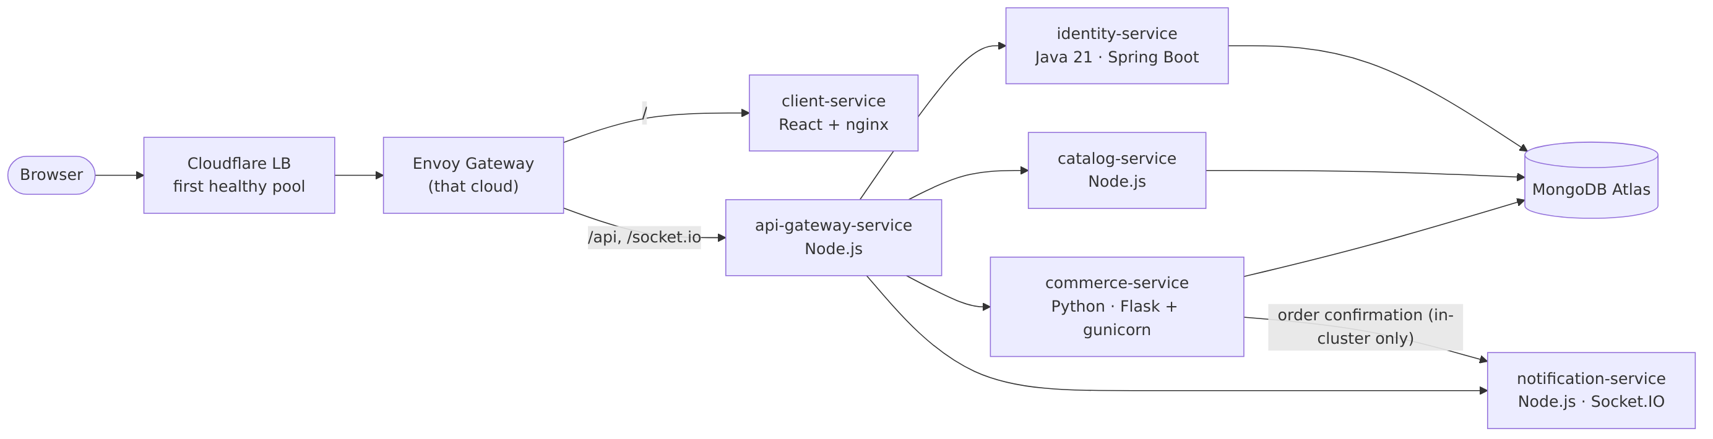
Request flow
- The browser resolves rishavmukhopadhyay.store. Cloudflare answers with its own edge address (the record is proxied), terminates TLS and forwards the request to the first healthy pool — GCP, then Azure, then AWS (steering_policy = "off" = failover order).
- The request reaches that cloud’s Envoy Gateway (Gateway API). Its load balancer accepts only Cloudflare’s IP ranges plus the admin IP, so nobody can bypass Cloudflare.
- Envoy routes / to client-service (React served by nginx) and /api + /socket.io to api-gateway-service.
- The API gateway forwards to identity, catalog, commerce and notification over Kubernetes DNS. Services talk only inside their own cluster — there is no VPN or network link between clouds.
- Services that store data connect to MongoDB Atlas through the cloud’s NAT with a fixed outgoing IP; Atlas only accepts those IPs, and each cloud uses its own database user.

2. The three clouds
 | GCP (primary) | Azure (standby) | AWS (standby)
Region | asia-south1 (Mumbai), zone -a | centralindia (Pune) | ap-south-1 (Mumbai), 2 AZs
Cluster | GKE Standard prod-gke, Kubernetes 1.36 | AKS prod-aks (Free tier, Azure CNI Overlay, Entra RBAC), 1.36 | EKS prod-eks (Pod Identity, EBS CSI, LB Controller), 1.37
Nodes | 2 × e2-standard-2 (autoscale 2–3) | 2 × Standard_D2as_v5 | 2 × t3.large (0 while asleep, max 3)
Network | VPC prod, nodes 10.30.0.0/20, pods 10.30.128.0/17 | VNet 10.20.0.0/16 | VPC 10.10.0.0/16, private node subnets
Outgoing IP | Cloud NAT with prod-egress (permanent, 34.93.192.167) | NAT Gateway + static public IP | NAT Gateway + Elastic IP
Entrance | static IP prod-ingress → Envoy LB | static IP pip-prod-ingress → Envoy LB | NLB (LB Controller) → Envoy
Registry | Artifact Registry mern | ACR acrmern0botwx (+ mirrors of ESO/OpenCost images) | ECR, one repo per service
Vault | Secret Manager | Key Vault kv-mern-0botwx | SSM Parameter Store /mern/*
Backups | GCS …-mongo-backups | Blob stbackup0botwx/mongo-backups | S3 ppmcad16a-mongo-backups-…
Extra role | Jenkins (CD), central Grafana | — | —
All three use the same machine shape (2 vCPU, 8 GB) so the same Helm values fit everywhere. Azure’s free-trial limit of 4 vCPU per region is respected.

3. Terraform layout — what lives how long
Every cloud repo has the same four layers. Each layer is a separate Terraform stack with its own remote state (GCS / Azure Storage / S3, versioned).
Layer | Contents | Lifetime
bootstrap/ | state bucket, GitHub OIDC trust + plan/apply identities, monthly budget | created once, by hand
environments/prod/foundation/ | registry, vault, backup bucket, CI push identities, DR identities, failover identity, GKE egress IP | permanent — survives between sessions
environments/prod/cluster/ | network, NAT, Kubernetes cluster, node pool, ingress IP | per session — created by up.yml, destroyed by down.yml
environments/prod/addons/ | Envoy Gateway, External Secrets, monitoring stack, Jenkins (GCP), LB Controller (AWS), platform config chart | per session
global-platform (own repo) | Cloudflare DNS / LB / pools / monitors / Access / Worker / notifications, Atlas users + allow-list, app secrets written into all 3 vaults | per session (re-created by up.yml)
Stacks read each other’s outputs through terraform_remote_state (for example, AKS and EKS read GKE’s egress IP from GCP’s foundation state so they can let Jenkins reach their APIs, and global-platform reads every cluster’s ingress and egress IPs).
Because the GKE egress IP lives in the permanent foundation layer, the three clusters no longer depend on each other and are created in parallel:
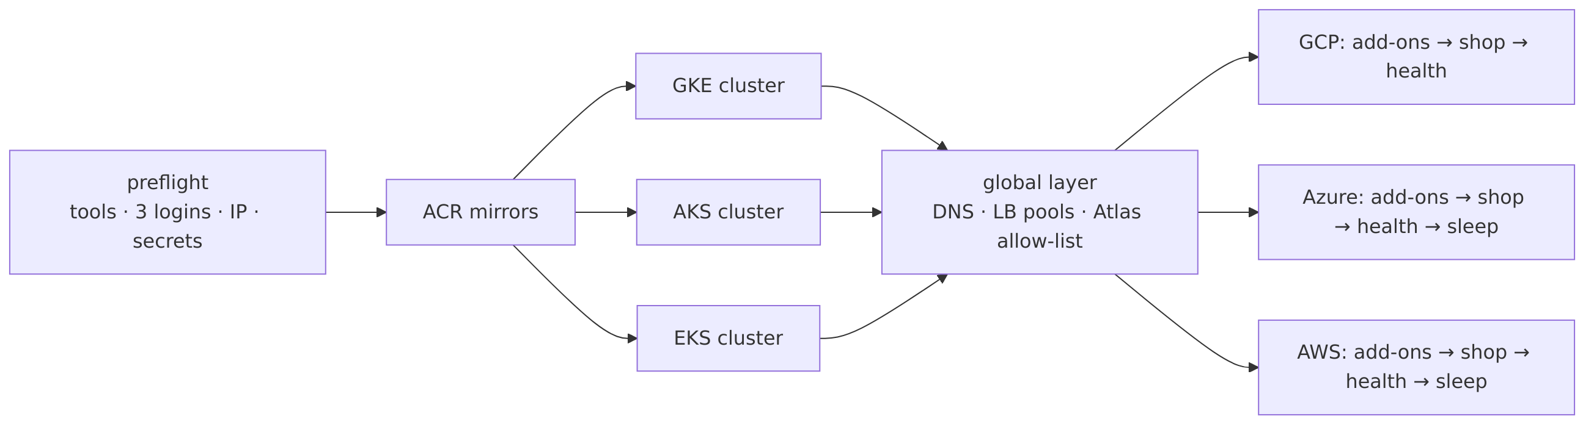
Session start

4. Inside each cluster
One reusable Helm chart (platform-deployments/charts/microservice) deploys every service with:
Feature | Setting | Why
Rolling update | maxUnavailable: 0, maxSurge: 1 | a new pod must be Ready before an old one stops — zero downtime
Probes | startup + liveness (/health) + readiness (/ready, checks MongoDB) | traffic only reaches pods that can really serve
Graceful stop | preStop drain + 30 s grace period | in-flight requests finish during a rollout
Autoscaling | HPA 2–4 replicas at 70 % CPU (notification: 1 replica — Socket.IO keeps chat state in memory) | absorbs load spikes
Disruption budget | PDB minAvailable: 1 | node maintenance never removes the last copy
Hardening | non-root, read-only root filesystem, no privilege escalation | smaller blast radius
Network policy | ingress allowed only from the gateway / the services that need it | a compromised pod cannot reach everything
Secrets | ExternalSecret from the cloud vault (cloud-vault ClusterSecretStore) | no secret in git or in Helm values
Routing | HTTPRoute for /, /api, /socket.io on the shared Envoy Gateway | one public entrance per cloud
Metrics | ServiceMonitor | Prometheus scrapes /metrics
Per-service settings are in values/services/<service>.yaml; per-cloud differences (registry, hostnames, cloud label) in values/clouds/<cloud>.yaml.

5. The stopped-standby model
State | GCP | Azure | AWS
Normal | serving everyone | az aks stop — control plane and VMs off | node group 0 nodes (control plane stays)
GCP outage | down | woken: az aks start | woken: node group 0 → 2
Waking time (measured) | — | ≈ 6 min | ≈ 3 min
Waking is done by (a) automatically: a Cloudflare notification “pool mern-gcp unhealthy” → Worker mern-failover → GitHub Actions failover-wake.yml, which logs in keylessly with identities that may only start AKS / resize the node group; or (b) by hand: ansible-playbook playbooks/wake.yml -e cloud=azure. A woken standby first catches up to the primary’s image versions (sync-shop), because Jenkins skips sleeping clouds.
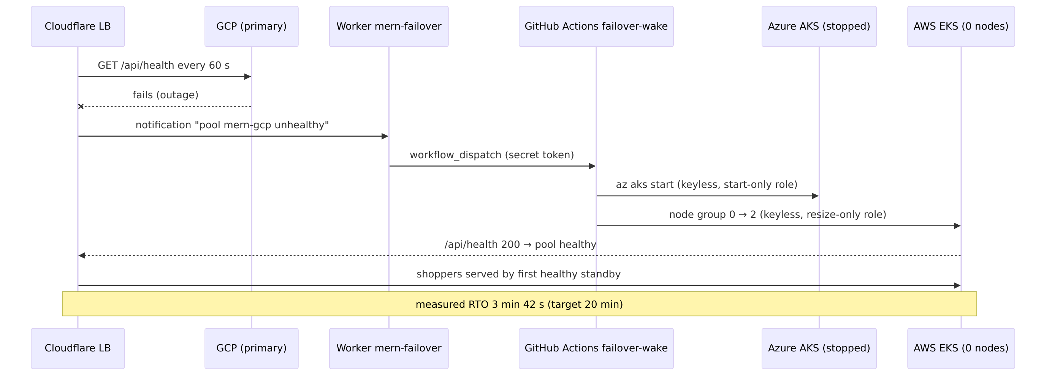
Failover sequence

6. Observability topology
- Every cluster runs Prometheus + Alertmanager, Loki + Alloy and OpenCost, all installed from the same tagged module (observability-platform//modules/mern-observability?ref=v1.1.0), so rules and alerts are identical everywhere.
- The central Grafana in GKE queries GCP locally and Azure/AWS through obs-azure. / obs-aws. hostnames — read-only (GET) and protected by a Cloudflare Access service token.
- Each cloud’s Alertmanager sends to Slack on its own, so alerts still arrive when GCP (and the central Grafana) is down.

7. Repositories
Repository | Purpose
api-gateway-service, identity-service, catalog-service, commerce-service, notification-service, client-service, seed-db-service | application code, tests (coverage gates), Dockerfile, a 30-line main.yaml that calls the shared CI
core-cloud-platform | reusable GitHub workflows (node/java/python, docker-build, trigger-deploy, security-scan) + learning guides
gcp-platform, azure-platform, aws-platform | Terraform per cloud (bootstrap, foundation, cluster, addons) and its modules
global-platform | Cloudflare, Atlas, shared secrets, failover Worker
platform-deployments | Helm chart, values, Jenkinsfiles (deploy, backup, restore-drill), DR scripts, local Docker Compose
observability-platform | versioned Terraform module: alert rules, recording rules, dashboards
platform-automation | Ansible playbooks + the failover-wake workflow
.github | organisation profile page
Every repository protects main: changes arrive through pull requests with required checks.

03 — Security
The platform follows three rules: no stored credentials, every identity can do exactly one job, and every network door is closed unless it must be open.

1. Identities — no keys anywhere
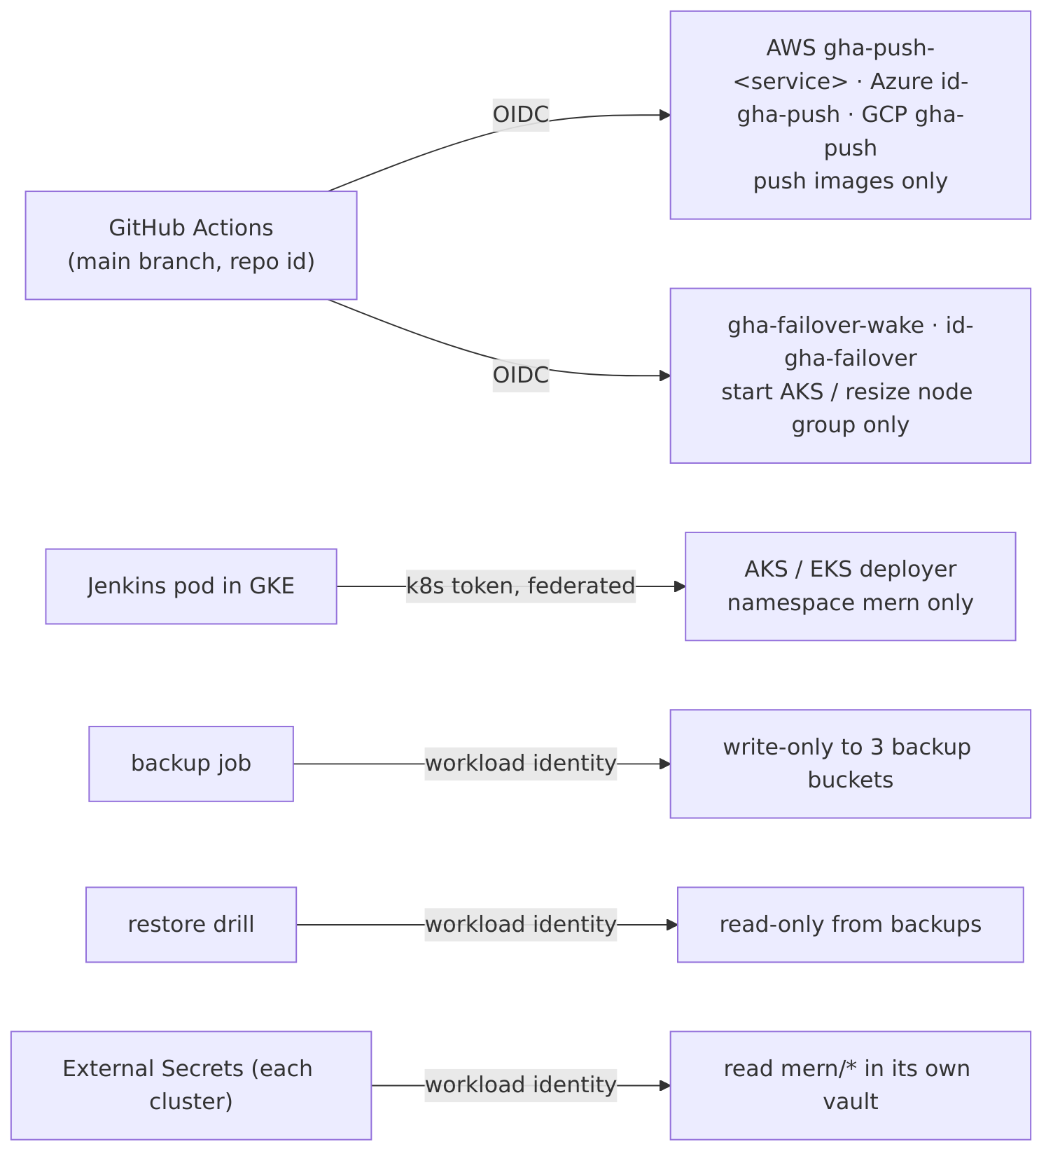
Identities
Who | How it proves who it is | What it may do — and nothing else
GitHub Actions in a service repo | GitHub OIDC token, trusted only for the main branch of that repo, matched by the repo’s permanent numeric id | push images: AWS gha-push-<service> (its own ECR repo only), Azure id-gha-push (AcrPush), GCP gha-push (Artifact Registry writer + read 3 CI secrets)
GitHub Actions failover-wake | OIDC, platform-automation main branch | Azure id-gha-failover: custom role read + start the AKS cluster; AWS gha-failover-wake: describe + resize the node group
Jenkins (pod in GKE) | its Kubernetes service-account token, federated to Azure and AWS | deploy into namespace mern of AKS/EKS only; read AKS power state / EKS node group size (to skip sleeping standbys)
Backup job | workload identity | write-only to the three backup buckets (no read, no delete — even in Azure, via a custom role)
Restore drill | workload identity | read-only from the backup buckets; Atlas user restore-drill may only touch the scratch database mern_restore_drill
External Secrets (each cluster) | workload identity / Pod Identity | read mern/* secrets in its own cloud’s vault only
Cluster nodes | node identity | pull from that cloud’s registry only
You (admin) | SSO / az login / gcloud auth login | everything — used only from the laptop, never stored in CI
Immutable OIDC subject. The trust rules use GitHub’s immutable subject format repo:ppmcad16a-cloud-platform@308835253/<repo>@<repo-id>:ref:refs/heads/main. A repository that is deleted and re-created under the same name gets a new id and does not inherit cloud access.
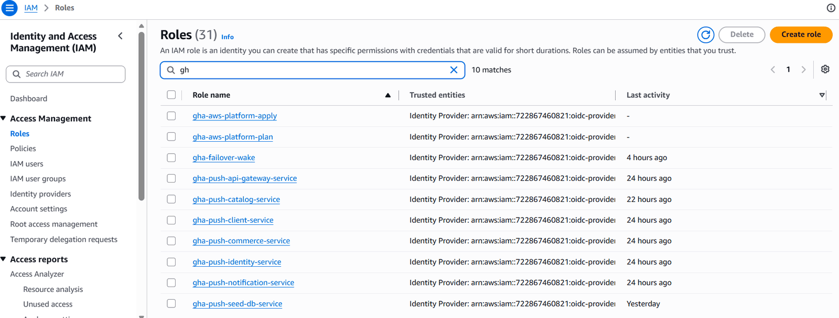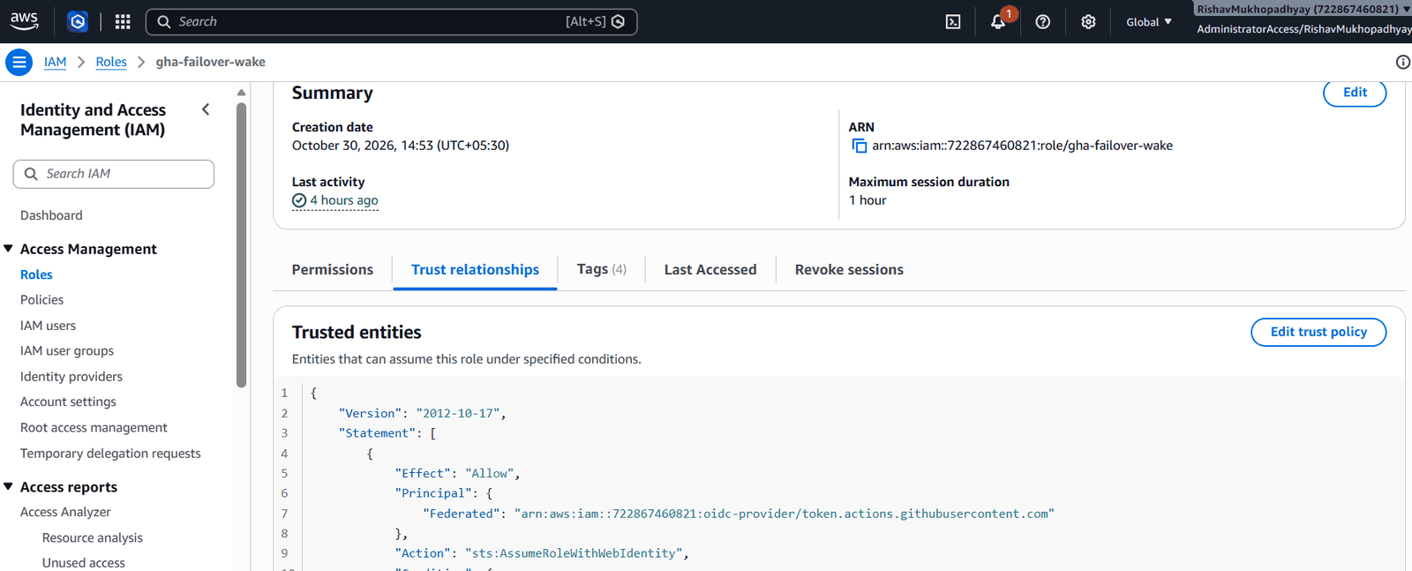

2. Secrets
Secret | Created by | Stored in | Read by
mern-mongo-uri (one DB user per cloud) | global-platform (Atlas provider) | each cloud’s own vault | that cloud’s services via External Secrets
mern-jwt-secret (identical in all clouds, ≥ 32 chars) | global-platform (random_password) | all three vaults | identity, gateway, notification — a login made in one cloud stays valid after failover
mern-origin-tls-crt/-key | Cloudflare Origin CA via Terraform | all three vaults | Envoy Gateway (TLS between Cloudflare and the cluster)
mern-seed-admin-password | global-platform | all three vaults | seed job only
mern-slack-webhook-url | by hand, once, in GCP Secret Manager; global-platform copies it | all three vaults + Cloudflare notification webhook | Alertmanager (each cloud), Jenkins, Cloudflare
CI tokens (Cloudflare Access service token, Jenkins trigger token) | global-platform | GCP Secret Manager | GitHub Actions (gha-push may read exactly these)
failover-github-token | by hand (fine-grained PAT, actions:write on one repo) | GCP Secret Manager → Worker secret binding | Cloudflare Worker
mern-backup-age-key (private key) | by hand, once | GCP Secret Manager, copied to Key Vault and SSM outside /mern/ | restore drill only — no cluster can read it
Rules: no secret value is ever committed; terraform.tfvars files are git-ignored and contain only IP addresses and e-mails; global provider tokens (Cloudflare, Atlas) are typed into the session with hidden input and kept only in memory; Jenkins scripts use set +x before any command that handles a token.
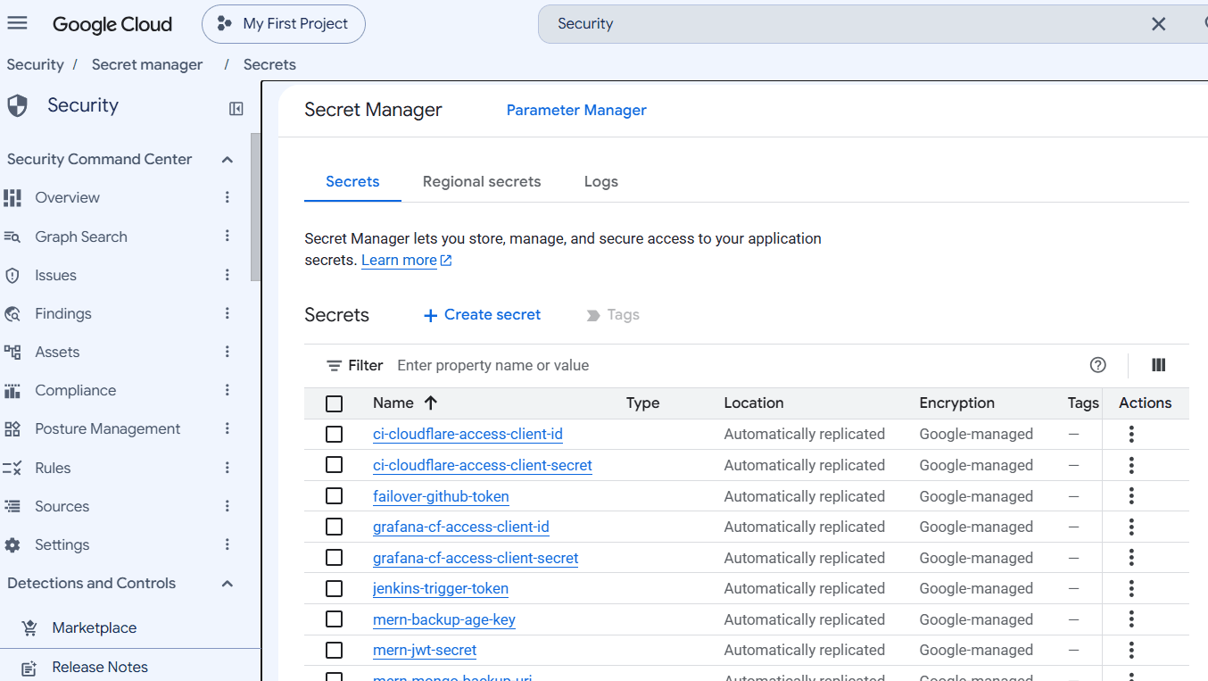
Secret Manager — names only

3. Network doors
Door | Who may come in
Cloudflare edge | the internet (HTTPS only, TLS 1.2+, Always use HTTPS)
Each cloud’s entrance (Envoy LB) | Cloudflare IP ranges (read live from cloudflare.com) + the admin IP
Kubernetes API of each cluster | the admin IP + GKE’s fixed egress IP (so Jenkins can deploy)
Pods | only the callers listed in their NetworkPolicy (gateway, specific services, Prometheus)
MongoDB Atlas | the three clusters’ fixed egress IPs (managed by Terraform)
Jenkins, Grafana, obs-* | Cloudflare Access: admins by e-mail one-time PIN; GitHub Actions and Grafana by service token
TLS mode | Full (strict): Cloudflare verifies the origin’s certificate
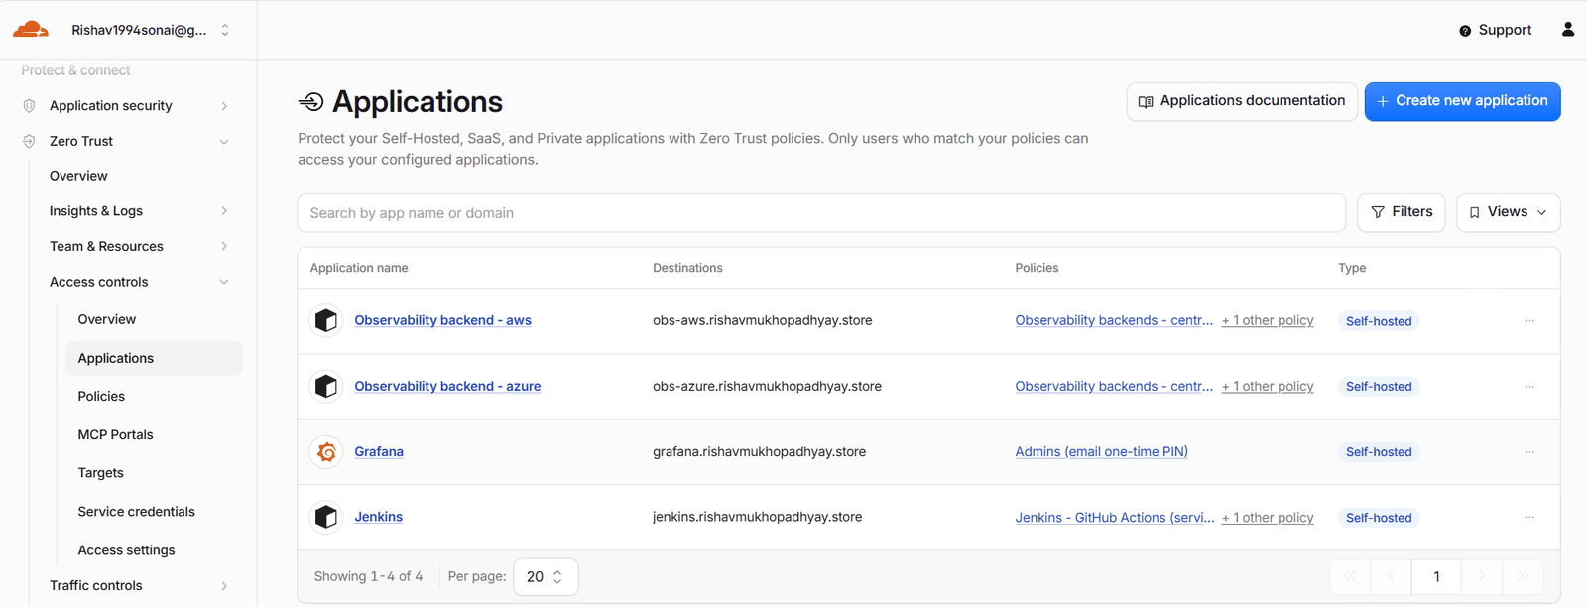
Cloudflare Access applications
Finding from the final test: the Atlas IP access list also contained a manually added 0.0.0.0/0 entry from early local development, which would have allowed connections from anywhere. It was removed on 31 Oct 2026; the list now holds only the Terraform-managed cluster IPs (plus three legacy personal IPs scheduled for removal). See Troubleshooting.
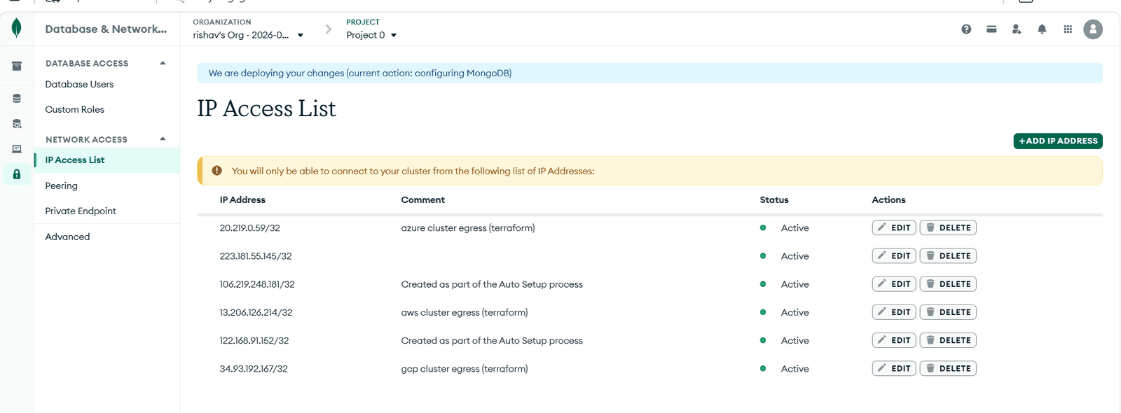
Atlas IP access list after the fix

4. Supply chain
Control | Where
Every third-party GitHub Action pinned to a full commit SHA | core-cloud-platform/.github/workflows/*
New tool / provider / chart versions adopted only when ≥ 14 days old | team rule; Terraform lock files committed (incl. linux_amd64 hashes)
Trivy downloaded from the official release and checksum-verified, then blocks fixable HIGH/CRITICAL vulnerabilities | docker-build.yaml
gitleaks scans the whole git history of every repo on every PR | security-scan.yaml
Images are tagged main-<sha> and immutable in all three registries | ECR / ACR / Artifact Registry settings
The same digest is pushed to all registries — what was scanned is what runs | docker-build.yaml
Workflows run with permissions: contents: read (+ id-token: write only where a cloud login is needed) | all workflows

5. Least-privilege checks
Check | How to see it
The backup identity can write a backup but cannot list or read one | tested with a throw-away pod (AccessDenied on list/read)
gha-push-<service> may push only to its own ECR repository | aws-platform/environments/prod/foundation/ci-push.tf — the policy’s Resource is that one repository
The Jenkins deployer is limited to namespace mern | Kubernetes Role/RoleBinding in the platform-config chart (no ClusterRole)
The failover identity can start AKS but not stop, delete or change it | custom role “MERN failover - start AKS”: managedClusters/read + start/action only
Jenkins/Grafana are not reachable without Cloudflare Access | an unauthenticated request receives the Access login page, not the application

04 — Setup guide: run it yourself
There are two ways to run this project:
Option | What you get | Needs | Time | Cost
A. Local | the whole shop (6 services + MongoDB) on your laptop | Docker Desktop | ~30 min | free
B. Full platform | the multi-cloud platform in your own AWS, Azure and GCP accounts | 3 cloud accounts, a domain on Cloudflare, Atlas, Slack, a GitHub org | 1 day the first time, then ~30 min per session | ≈ US $1 per working hour while all clusters run
Commands are marked PowerShell (Windows) or Ubuntu (WSL). Never mix them: a prompt starting with PS C:\ is PowerShell, a prompt like user@host:/mnt/c/...$ is Ubuntu.

Option A — the shop on your laptop
Prerequisites: Git, Docker Desktop (4 GB RAM free), JDK 21 (only to build the Java service).
# PowerShell — clone the services and the deployment repo side by side
mkdir mern; cd mern
foreach ($r in "api-gateway-service","identity-service","catalog-service","commerce-service","notification-service","client-service","seed-db-service","platform-deployments") {
git clone https://github.com/ppmcad16a-cloud-platform/$r.git
}
cd platform-deployments\local
copy .env.example .env
# edit .env: JWT_SECRET (at least 32 random characters), SEED_ADMIN_EMAIL, SEED_ADMIN_PASSWORD
python -c "import secrets; print(secrets.token_urlsafe(48))" # a good JWT_SECRET
cd ..\..\identity-service; .\mvnw.cmd -B package -DskipTests; cd ..\platform-deployments\local
docker compose up --build -d # first build takes several minutes
docker compose ps # wait until every service is "healthy"
docker compose --profile seed run --rm seed # once: admin user + 100 sample products
Open http://localhost:8080. Check the backend with curl http://localhost:3000/api/health — every service should say "up". Stop with docker compose down (add -v to delete the local database). Details: platform-deployments/local/README.md.

Option B — the full multi-cloud platform in your accounts

B1. Accounts and services you need
Item | What exactly | Notes
AWS | an account on the paid plan (credits are fine), an SSO/admin user | the AWS free plan blocks EKS
Azure | a subscription with ≥ 4 vCPU quota in your region | free trials allow 4 vCPU per region — the design fits that
GCP | a project with billing linked | trial accounts cap at 8 vCPU
Domain on Cloudflare | a zone you own + the Load Balancing add-on | needed for the global front door and failover
Cloudflare API token | zone DNS/SSL/Load Balancing edit + account Access, Workers, Notifications edit | typed in at session start, never stored
MongoDB Atlas | an M0 (free) cluster, an organisation API key with Project Owner on that project, your IP on the key’s access list | typed in at session start
Slack | a channel + an incoming webhook URL | stored once in GCP Secret Manager
GitHub | an organisation where you are Owner | branch protection + OIDC trusts are per repo

B2. Your copy of the repositories
Create your organisation, then copy every repository into it (history included):
# PowerShell — needs the GitHub CLI (gh auth login first)
$org = "<your-org>"
$repos = "core-cloud-platform","api-gateway-service","identity-service","catalog-service","commerce-service","notification-service","client-service","seed-db-service","gcp-platform","azure-platform","aws-platform","global-platform","platform-deployments","observability-platform","platform-automation"
foreach ($r in $repos) {
git clone --mirror https://github.com/ppmcad16a-cloud-platform/$r.git "$r.git"
gh repo create "$org/$r" --public
git -C "$r.git" push --mirror "https://github.com/$org/$r.git"
git clone "https://github.com/$org/$r.git"
}
Then replace the project-specific values. Find every place with one search in the folder that holds all repos:
Get-ChildItem -Recurse -File -Exclude *.lock.hcl | Select-String -List -Pattern "722867460821|9c0602c2|0fd463ca|project-899ced78|692591977615|rishavmukhopadhyay|ppmcad16a|0botwx|011ab039|9b10c019|6a00a473|fnonccf|308835253|rishav1994sonai" | Select-Object Path -Unique
Value in this project | Meaning | Replace with
722867460821, ap-south-1 | AWS account id, region | yours (aws sts get-caller-identity)
9c0602c2-…, 0fd463ca-…, centralindia | Azure subscription id, tenant id, region | yours (az account show)
project-899ced78-a554-40c2-96c, 692591977615, asia-south1 | GCP project id, project number, region | yours (gcloud projects describe <id>)
ppmcad16a-cloud-platform, 308835253 | GitHub org name and org id | yours (gh api orgs/<org> --jq .id)
repo ids in */environments/prod/foundation/ci-push.tf and failover-identity.tf | GitHub numeric repo ids used in OIDC trust rules | gh api repos/<org>/<repo> --jq .id for each repo
rishavmukhopadhyay.store | public domain | your Cloudflare zone
011ab039…, 9b10c019… | Cloudflare zone id, account id | Cloudflare dashboard → zone overview
6a00a473…, capstoneproject.fnonccf.mongodb.net, CapstoneProject | Atlas project id, SRV host, cluster name | Atlas → Project settings / Connect
0botwx, o398md | random suffixes of Azure names | generated by Terraform — update the references after your foundation apply
rishav1994sonai@gmail.com | budget alert e-mail | yours
AGE_RECIPIENT in platform-deployments/pipelines/backup.Jenkinsfile | backup public key | yours (step B6)

B3. Workstation (Windows 11 + WSL Ubuntu 24.04)
# PowerShell (admin), once
wsl --install -d Ubuntu-24.04
winget install Git.Git GitHub.cli Docker.DockerDesktop
# Ubuntu — Ansible in its own Python environment, then every pinned tool with one playbook
sudo apt-get update && sudo apt-get install -y python3-venv wslu
python3 -m venv ~/.venvs/ansible && source ~/.venvs/ansible/bin/activate
pip install "ansible-core==2.21.5" "kubernetes==37.0.1" "python-debian==1.1.1"
cd /mnt/c/<path-to-your-repos>/platform-automation
ansible-galaxy collection install -r requirements.yml
ansible-playbook playbooks/toolchain.yml -K # terraform, kubectl, helm, kubelogin, aws, az, gcloud (checksum-verified)
Edit platform-automation/inventory/group_vars/all.yml: repos_root (your repos folder as seen from WSL), image_tags_file, the account ids, domain, acr_name.
Network tip: if Helm chart downloads time out after exactly 30 s, one of GitHub’s download addresses may be unreachable from your ISP — test and pin a working one as described in Troubleshooting.

B4. Log in (Ubuntu)
gcloud auth login && gcloud auth application-default login
BROWSER=wslview az login --tenant <tenant-id> && az account set --subscription <subscription-id>
aws configure sso --profile HeroviredProfile # first time; later: aws sso login --profile HeroviredProfile

B5. Bootstrap each cloud (once)
The bootstrap stack creates the bucket that will hold its own state, so it is applied with local state first and then moved:
# Ubuntu — repeat for gcp-platform, azure-platform, aws-platform
cd <repos>/gcp-platform/bootstrap
mv backend.tf backend.tf.off # 1. no remote state yet
terraform init && terraform apply # creates state bucket, GitHub OIDC trust, plan/apply identities, budget
mv backend.tf.off backend.tf # 2. now move the state into the new bucket
terraform init -migrate-state # answer "yes"

B6. One-time secrets (stored by hand, never in git)
# Ubuntu
# 1. Slack webhook -> GCP Secret Manager (global-platform copies it to the other two vaults)
printf '%s' 'https://hooks.slack.com/services/…' | gcloud secrets create mern-slack-webhook-url --data-file=-
# 2. Backup encryption key pair. The PRIVATE key goes only into the vault (and your password manager);
# the PUBLIC key (age1…) goes into AGE_RECIPIENT in backup.Jenkinsfile.
sudo apt-get install -y age
age-keygen -o /tmp/age.key && grep 'public key' /tmp/age.key
gcloud secrets create mern-backup-age-key --data-file=/tmp/age.key && shred -u /tmp/age.key
# 3. Failover token: a fine-grained GitHub token with Actions: read & write on platform-automation only
read -rsp "PAT: " T; printf '%s' "$T" | gcloud secrets create failover-github-token --data-file=-; unset T

B7. Permanent foundations
# Ubuntu — repeat for gcp-platform, azure-platform, aws-platform
cd <repos>/gcp-platform/environments/prod/foundation
terraform init && terraform plan # read it
terraform apply # registry, vault, backup bucket, CI/DR/failover identities (GCP: also the egress IP)
Create the git-ignored inputs:
MYIP=$(curl -s https://api.ipify.org)/32
for c in gcp azure aws; do for s in cluster addons; do
echo "admin_cidr = \"$MYIP\"" > <repos>/$c-platform/environments/prod/$s/terraform.tfvars
done; done
cat > <repos>/global-platform/terraform.tfvars <<EOF
admin_emails = ["you@example.com"]
workers_subdomain = "<your-workers-subdomain>"
EOF

B8. First images
One green run on main per service fills all three registries. The copy in B2 already started a run per repo, but it failed at the cloud login because the OIDC trusts did not exist yet — re-run it now:
# PowerShell — re-run the latest main-branch run of every service repo
foreach ($r in "api-gateway-service","identity-service","catalog-service","commerce-service","notification-service","client-service","seed-db-service") {
$id = gh run list -R "<your-org>/$r" --branch main -L 1 --json databaseId -q ".[0].databaseId"
gh run rerun $id -R "<your-org>/$r"
}
Also turn on branch protection for main in every repo (pull request + required checks), as described in Repositories & shared CI.
Write the tags they produced (main-<sha>, visible in each run’s summary) into the file named by image_tags_file:
{ "identity-service": "main-xxxxxxx", "catalog-service": "main-xxxxxxx", "commerce-service": "main-xxxxxxx",
"notification-service": "main-xxxxxxx", "api-gateway-service": "main-xxxxxxx", "client-service": "main-xxxxxxx",
"seed-db-service": "main-xxxxxxx" }

B9. First session
# Ubuntu, in platform-automation — type the two provider secrets once (hidden, memory only)
read -rsp "Cloudflare API token: " CLOUDFLARE_API_TOKEN; echo; export CLOUDFLARE_API_TOKEN
read -rsp "Atlas public key: " MONGODB_ATLAS_PUBLIC_KEY; echo; export MONGODB_ATLAS_PUBLIC_KEY
read -rsp "Atlas private key: " MONGODB_ATLAS_PRIVATE_KEY; echo; export MONGODB_ATLAS_PRIVATE_KEY
time ansible-playbook playbooks/up.yml -e keep_awake=true # 25-40 min
# once: admin user + sample catalogue (the database is shared, so run it in one cloud only)
TAG=main-xxxxxxx # the seed-db-service tag from your image-tags file
IMG=asia-south1-docker.pkg.dev/<gcp-project>/mern/seed-db-service:$TAG
sed "s#IMAGE_PLACEHOLDER#$IMG#" ../platform-deployments/jobs/seed-db.yaml | kubectl --context <gke-context> apply -f -
kubectl --context <gke-context> -n mern wait --for=condition=complete job/seed-db --timeout=5m
Open https://<your-domain>, https://jenkins.<your-domain> and https://grafana.<your-domain> (Cloudflare Access e-mails you a PIN; passwords: terraform output -raw jenkins_admin_password / grafana_admin_password in gcp-platform/environments/prod/addons).
From now on every merged pull request deploys itself (CI/CD). At the end of a session run ansible-playbook playbooks/down.yml (Runbook).

B10. Checklist — is everything right?
Check | Expected
for c in gcp azure aws; do curl -s https://$c.<domain>/api/health; done | "status":"ok" three times
Cloudflare → Load Balancing | 3 pools healthy (or gcp healthy + standbys critical after standby.yml)
Grafana → MERN shop – multi-cloud overview | one row per cloud, 6 services with ready pods
Jenkins | jobs deploy-mern, backup-mongo, restore-drill
ansible-playbook playbooks/drill-restore.yml | Restore drill PASSED

05 — Operations runbook
All commands run in Ubuntu (WSL) inside platform-automation, after:
source ~/.venvs/ansible/bin/activate
cd /mnt/c/Users/dell/Documents/HeroVired/Capstone/repos/platform-automation
aws sso login --profile HeroviredProfile # AWS SSO sessions expire - renew at the start of every session
Every playbook that changes Terraform goes through tasks/tf-apply.yml: plan → check the kind of each change → apply exactly that plan. Session start may only create/update; session end may only delete/update. A plan that would replace or delete something unexpectedly stops the run before anything happens.

Quick reference
I want to… | Command | Time
start a session (standbys go to sleep at the end) | ansible-playbook playbooks/up.yml | 25–40 min
start with all three clouds awake | ansible-playbook playbooks/up.yml -e keep_awake=true | 25–40 min
put the standbys to sleep | ansible-playbook playbooks/standby.yml (or -e cloud=azure) | ~5 min
wake one standby | ansible-playbook playbooks/wake.yml -e cloud=aws | 3–10 min
deploy without Jenkins (break-glass) | ansible-playbook playbooks/deploy.yml -e service=catalog-service -e tag=main-ba5cc42 | ~3 min
prove the backups restore | ansible-playbook playbooks/drill-restore.yml | ~10 min
failover drill (GCP fails) | ansible-playbook playbooks/drill-failover.yml (-e wake_via=manual to wake by playbook) | 25–30 min
end the session — delete everything that costs per hour | ansible-playbook playbooks/down.yml | 30–40 min
Tip: wrap long runs as time ansible-playbook … 2>&1 | tee ~/run-$(date +%F).log to keep a log and the duration.

1. Start a session
- Make sure your public IP is in the six terraform.tfvars files (admin_cidr) — preflight checks it.
- Type the provider secrets once (hidden, memory only):
- read -rsp "Cloudflare API token: " CLOUDFLARE_API_TOKEN; echo; export CLOUDFLARE_API_TOKEN
read -rsp "Atlas public key: " MONGODB_ATLAS_PUBLIC_KEY; echo; export MONGODB_ATLAS_PUBLIC_KEY
read -rsp "Atlas private key: " MONGODB_ATLAS_PRIVATE_KEY; echo; export MONGODB_ATLAS_PRIVATE_KEY
- ansible-playbook playbooks/up.yml. Order: preflight → ACR mirrors → GKE + AKS + EKS in parallel → global layer → each cloud independently: add-ons → shop (6 services at once) → health check → standbys sleep.
- Result: https://<domain> served by GCP; Azure stopped, AWS at 0 nodes.
The versions deployed come from C:\Users\dell\image-tags.json; keep it updated after each release (Jenkins records what it deployed in Slack).

2. End a session
ansible-playbook playbooks/down.yml
Order: preflight → wake sleeping standbys (so Kubernetes can remove its own load balancers and disks) → AKS + EKS: add-ons destroy → state must be empty → leftover check (no k8s-* load balancer, no orphaned disk) → cluster destroy → GKE the same → global layer (delete/update only).
If the leftover check stops the run, Kubernetes did not finish cleaning up. Wait 5 minutes and re-run, or remove the leftover by hand (section 7). Never continue with -refresh=false: it can wipe state while the real resources keep running.
Afterwards, prove nothing is billing:
gcloud container clusters list; gcloud compute instances list; gcloud compute forwarding-rules list
az aks list -o table
aws eks list-clusters --region ap-south-1 --profile HeroviredProfile
aws elbv2 describe-load-balancers --region ap-south-1 --profile HeroviredProfile --query "LoadBalancers[].LoadBalancerName"
aws ec2 describe-nat-gateways --region ap-south-1 --profile HeroviredProfile --filter Name=state,Values=available --query "NatGateways[].NatGatewayId"
Only the permanent foundation remains (registries, vaults, backup buckets, state buckets, GCP’s prod-egress IP).

3. Deploy, roll back
Situation | What to do
normal release | merge the pull request — CI pushes the image and Jenkins deploys GCP → Azure → AWS (CI/CD)
roll back | Jenkins → deploy-mern → Build with Parameters → the previous IMAGE_TAG
deploy to some clouds only | same, with TARGETS=gcp (comma list)
Jenkins is down (e.g. GCP outage) | ansible-playbook playbooks/deploy.yml -e service=<svc> -e tag=<tag> — deploys to every awake and reachable cloud with the same rolling update + rollback; -e target=azure for one cloud
an image reached only some registries | the CI run is green with a warning; re-run the workflow when the cloud is back (it fills the gap and then deploys), or deploy now with TARGETS= the clouds that have it
A sleeping standby is skipped by Jenkins and caught up automatically when it wakes (sync-shop compares its versions with GCP’s).

4. Standbys
Action | Command | What happens
sleep | playbooks/standby.yml | Azure: az aks stop. AWS: node group min/desired 0.
wake | playbooks/wake.yml -e cloud=<azure\|aws> | start → nodes Ready → shop healthy → catch up to GCP’s versions
automatic wake | nothing — Cloudflare notification → Worker → GitHub Actions failover-wake.yml | runs only when the gcp pool becomes unhealthy
Known behaviour: AWS sleep can take up to 30 minutes because the PodDisruptionBudgets (minAvailable: 1) refuse to evict the last copy of each service while the whole node group is going away. The playbook reports “asleep” as soon as the setting is 0. Finish the drain at once:
kubectl --context arn:aws:eks:ap-south-1:722867460821:cluster/prod-eks drain -l eks.amazonaws.com/nodegroup=default \
--ignore-daemonsets --delete-emptydir-data --disable-eviction --force --timeout=180s
Also wait until a woken AKS has finished starting (az aks show … --query provisioningState = Succeeded) before stopping it again — Azure refuses a stop during a start.

5. Drills
Drill | Command | Pass criteria
restore | playbooks/drill-restore.yml | Jenkins restore-drill runs for gcs, s3, azure; each downloads the newest backup, verifies its SHA-256, decrypts it, restores into mern_restore_drill and matches document counts → Restore drill PASSED
failover | playbooks/drill-failover.yml | standbys asleep → GCP’s gateway scaled to 0 → shop fails → standbys woken (automatically or -e wake_via=manual) → shop answers again → GCP repaired → standbys back to sleep → RTO ≤ 20 min

6. Your public IP changed mid-session
Symptoms: kubectl times out (dial tcp …:443: i/o timeout), Atlas answers IP_ADDRESS_NOT_ON_ACCESS_LIST. Three places need the new IP:
- The six terraform.tfvars (admin_cidr) — PowerShell:
- $R="C:\Users\dell\Documents\HeroVired\Capstone\repos"; $old="<old-ip>/32"; $new="<new-ip>/32"
foreach ($c in "gcp","azure","aws") { foreach ($s in "cluster","addons") {
$f="$R\$c-platform\environments\prod\$s\terraform.tfvars"
[IO.File]::WriteAllText($f, (Get-Content $f -Raw).Replace($old,$new)) } }
- Atlas → Organization → Access Manager → Applications → API Keys → your key → Edit → API access list → Use current IP.
- Re-run up.yml (or, before a teardown, terraform apply in the three cluster stacks — each plan must show 1 to change on the cluster’s API allow-list).
After a network change also re-test WSL downloads (Troubleshooting).

7. Remove a leftover AWS load balancer by hand
A="--region ap-south-1 --profile HeroviredProfile"
LB=$(aws elbv2 describe-load-balancers $A --query "LoadBalancers[?starts_with(LoadBalancerName,'k8s-')].LoadBalancerArn" --output text)
TGS=$(aws elbv2 describe-target-groups $A --load-balancer-arn $LB --query "TargetGroups[].TargetGroupArn" --output text)
aws elbv2 delete-load-balancer $A --load-balancer-arn $LB && aws elbv2 wait load-balancers-deleted $A --load-balancer-arns $LB
for tg in $TGS; do aws elbv2 delete-target-group $A --target-group-arn $tg; done
# then the controller's security groups (k8s-traffic-*, k8s-envoygat-*): remove rules that reference them, then delete them

8. Rotate a secret
Secret | How
Atlas DB passwords, JWT secret, seed admin password | terraform apply -replace=random_password.<name> (or -replace the Atlas user) in global-platform; External Secrets refreshes within 1 h — restart the deployments to pick it up at once
Slack webhook | new value in GCP Secret Manager mern-slack-webhook-url, then up.yml / global-platform apply copies it
Cloudflare / Atlas provider keys | create new ones in the provider console, revoke the old ones; they are typed in per session and never stored
failover GitHub token | new fine-grained PAT → gcloud secrets versions add failover-github-token → apply global-platform
backup age key | new key pair; keep the old private key until every backup encrypted with it has expired

06 — CI/CD: from a pull request to three clouds
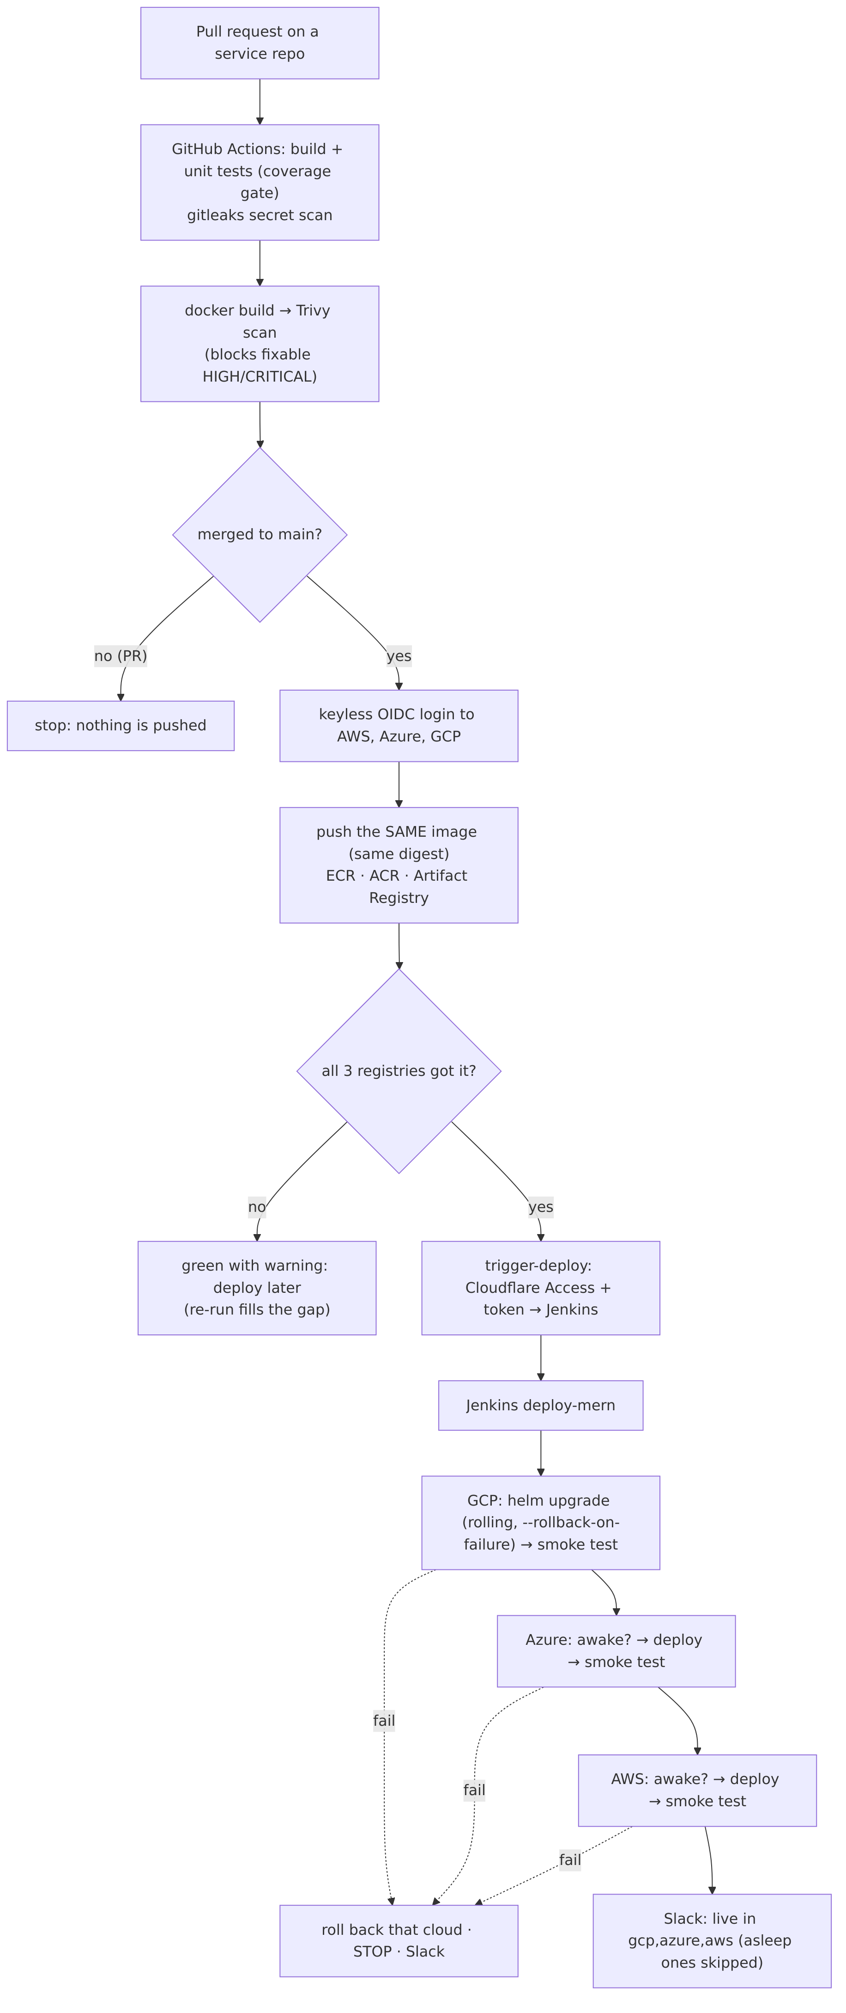
CI/CD flow

1. Continuous integration (GitHub Actions)
Each service repository contains only a small main.yaml that calls a shared, versioned workflow in core-cloud-platform (node-app.yaml, java-app.yaml or python-app.yaml @v2). The shared workflow does:
Step | Pull request | Push to main
install + unit tests with coverage gate | ✅ | ✅
gitleaks over the whole git history | ✅ | ✅
docker build + Trivy (blocks fixable HIGH/CRITICAL) | ✅ | ✅
keyless login to AWS, Azure, GCP | — | ✅
push the same image (tag main-<sha>) to ECR, ACR, Artifact Registry | — | ✅
ask Jenkins to deploy | — | ✅ (if all three registries have the image)
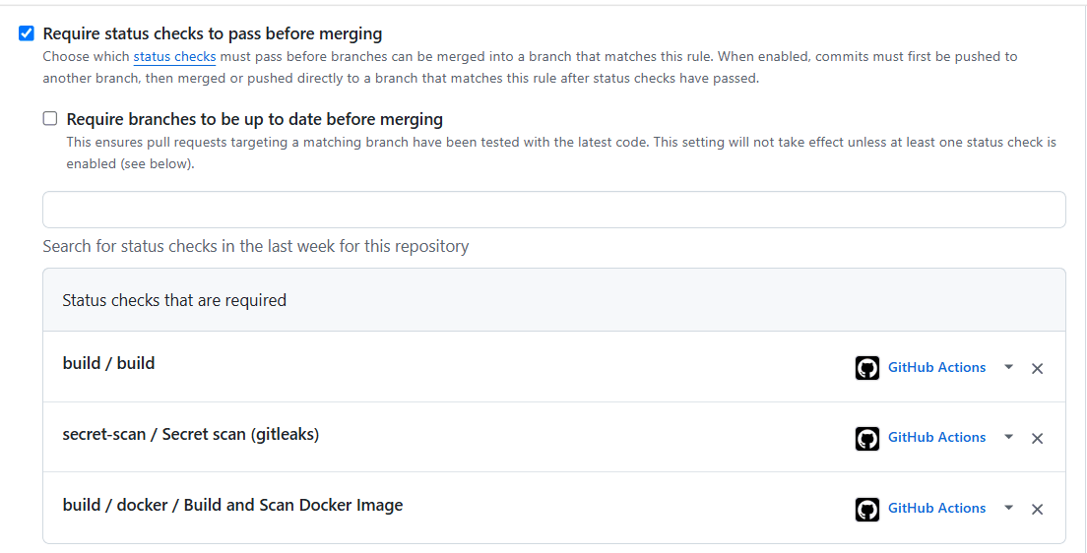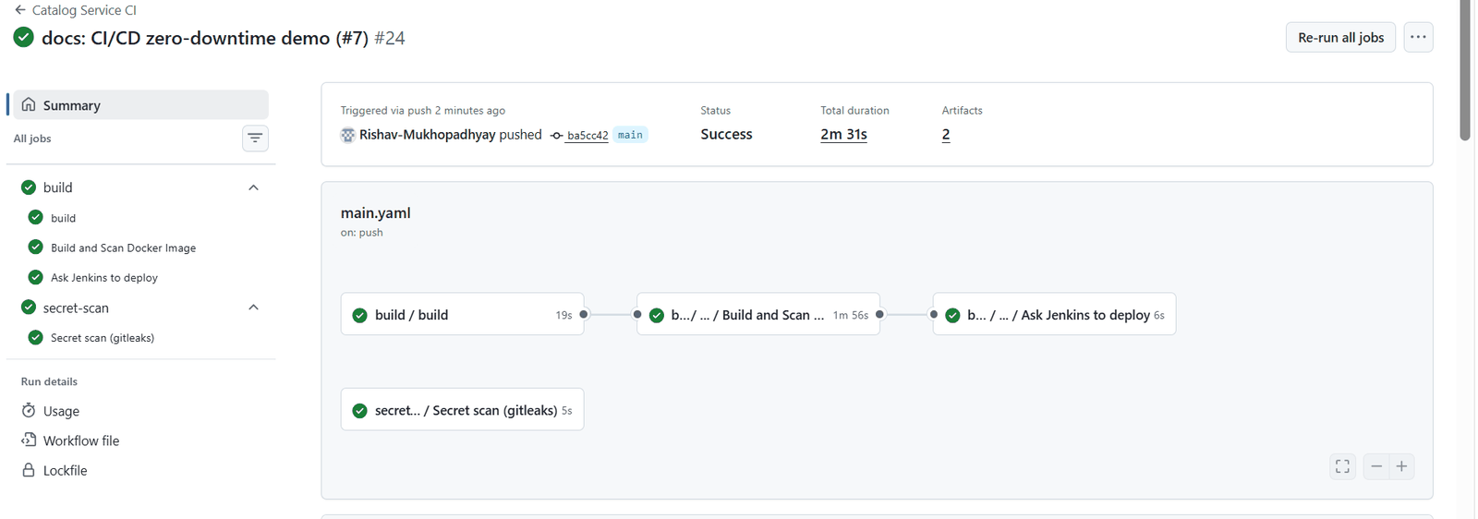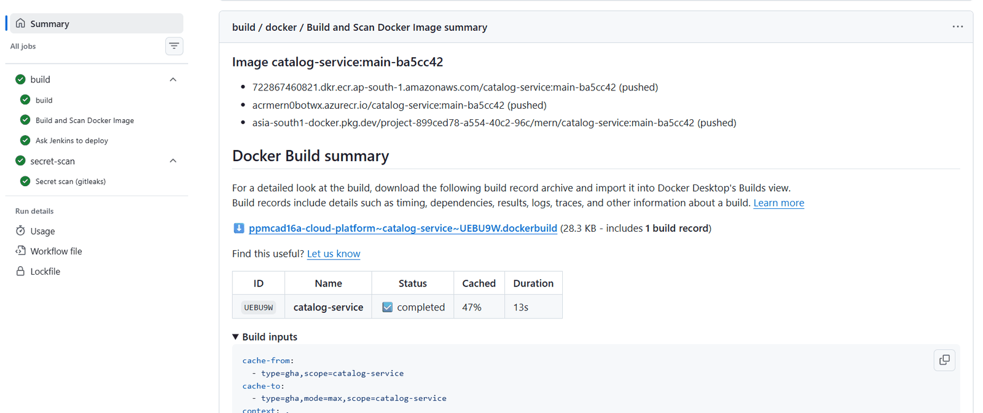
Registry outage tolerance (v2.2.0). Each cloud’s login and push stand on their own. If one registry is down, the image still goes to the others and the run ends green with a warning naming the missing cloud — but the automatic deploy waits, because Jenkins would fail on the cloud without the image. Re-running the workflow later skips registries that already have the tag, fills the gap and then deploys.
Registries that got the image | Run | Automatic deploy
3 | green | yes
1–2 | green + warning | no — re-run later, or deploy now with TARGETS=
0 | red | no
Versioning of the shared workflows: v1 (build + scan), v2.0.0 (push to 3 registries), v2.1.1 (deploy trigger), v2.2.0 (registry-outage tolerance); v2 always points to the newest compatible 2.x. Release order: merge → pull → check git log -1 → tag → move v2.

2. The hand-off to Jenkins
trigger-deploy.yaml reads two secrets from GCP Secret Manager (with the keyless CI identity), then calls https://jenkins.<domain>/generic-webhook-trigger/invoke with {"service": …, "image_tag": …}. The request must pass two locks: Cloudflare Access (service token) and the Jenkins trigger token. When the clusters are off, the job ends green with “Jenkins is offline … deploy later with SERVICE=x IMAGE_TAG=y”.
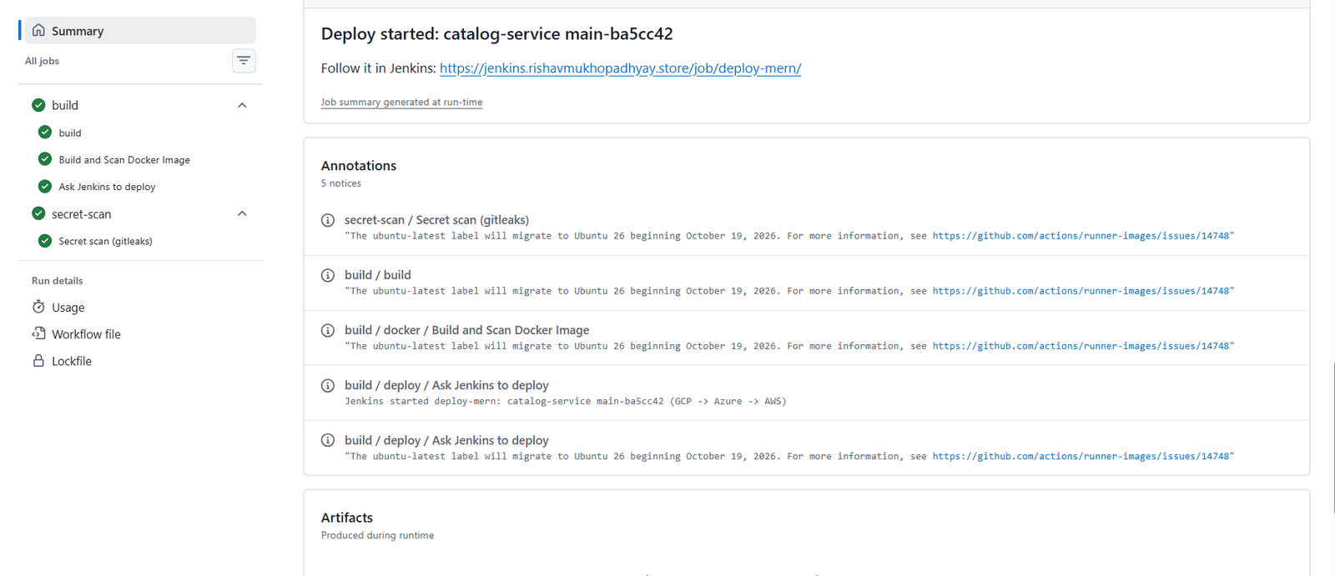
Jenkins triggered from GitHub

3. Continuous delivery (Jenkins in GKE)
Jenkins is installed by Terraform (Helm chart 5.9.68) with Configuration-as-Code and Job DSL, so it is rebuilt identically every session. Jobs: deploy-mern, backup-mongo, restore-drill.
deploy-mern parameters: SERVICE, IMAGE_TAG, TARGETS (default gcp,azure,aws). Stages:
Stage | What happens
Validate | service name, tag format, target list
GCP: deploy → smoke test | helm upgrade --install --rollback-on-failure --wait --timeout 8m, then https://gcp.<domain>/api/health must answer 200
Azure: awake? | reads AKS power state; if Stopped → “sleeping standby, skipped”
Azure: credentials → deploy → smoke test | federated login (no stored key), same Helm command
AWS: awake? → credentials → deploy → smoke test | node group size 0 → skipped; else the same
Slack | ✅ deploy-mern #N: <service> <tag> is live in gcp,azure,aws (asleep, skipped: …) or a failure message
Clouds are deployed one after another. A failure rolls back that cloud (Helm restores the previous revision) and stops — later clouds keep the old version, earlier ones already run the new one, so releases must be backward compatible.
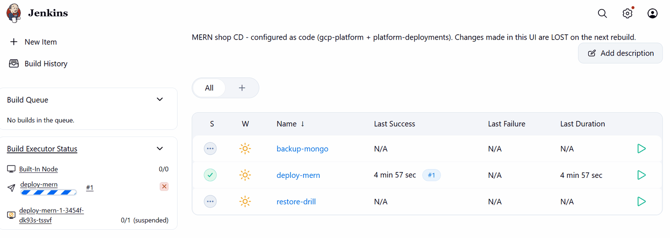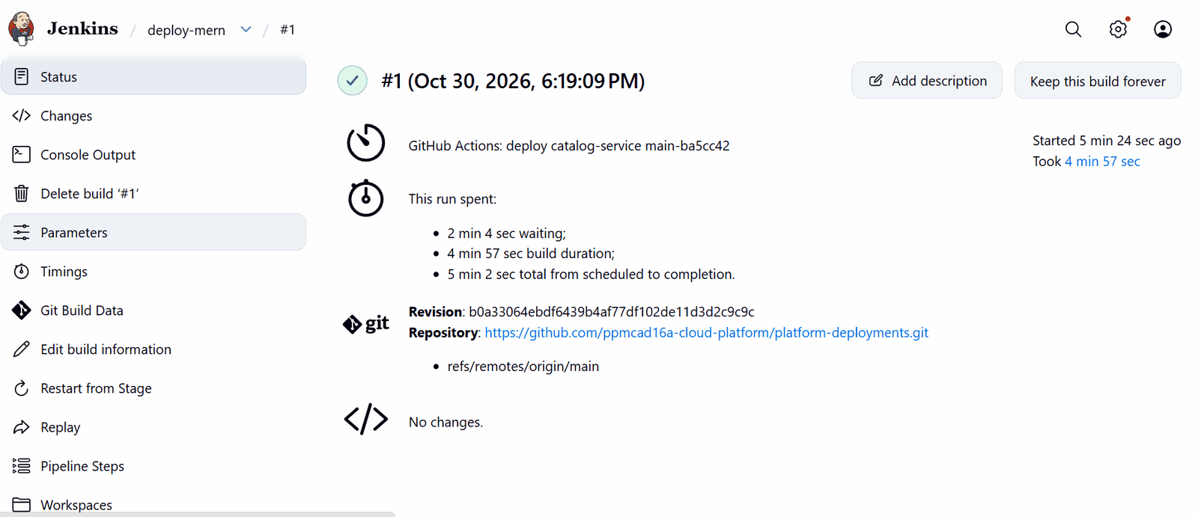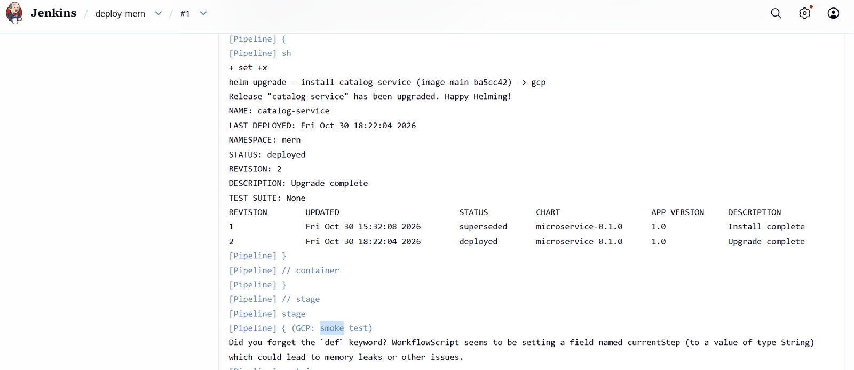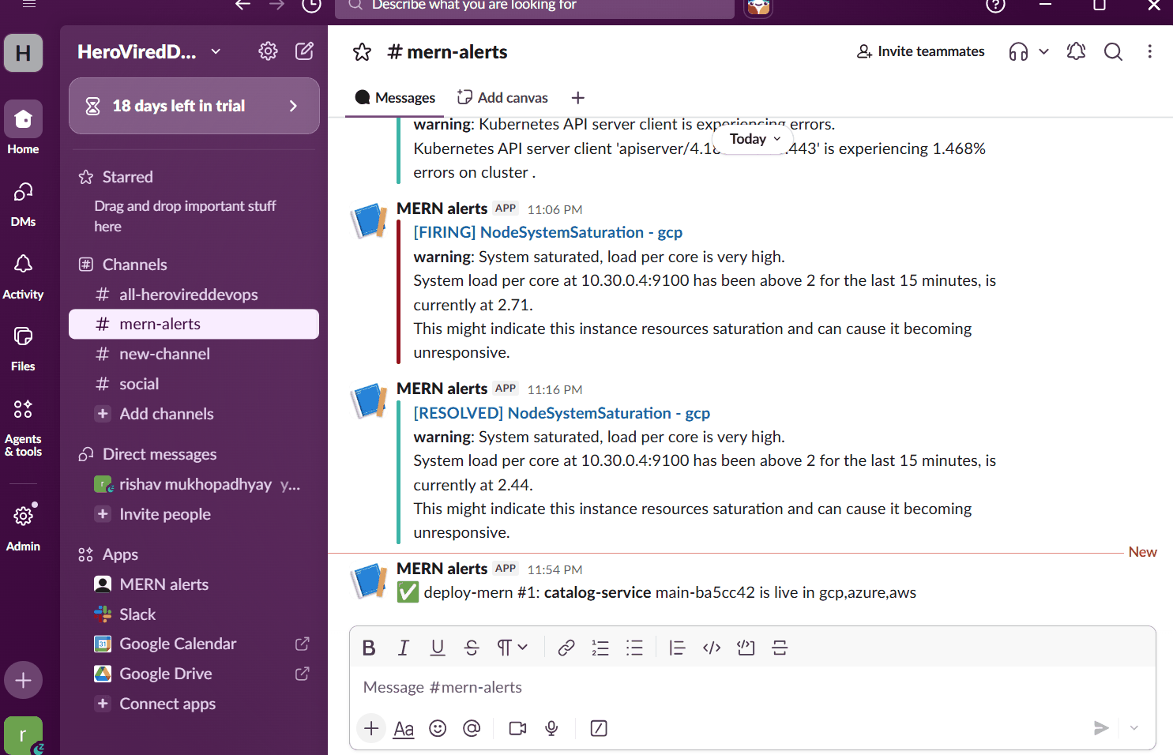

4. Why a deploy causes no downtime
- Kubernetes rolling update with maxUnavailable: 0: a new pod starts next to the old ones.
- The new pod receives traffic only after its readiness probe (/ready, checks MongoDB) passes.
- The old pod gets SIGTERM, the preStop hook gives Envoy time to stop routing to it, the service finishes in-flight requests and exits (graceful shutdown in every language).
- PodDisruptionBudgets keep at least one copy during node maintenance; HPA keeps 2–4 replicas.
- Only one cloud changes at a time, and Cloudflare keeps serving from the primary.
Measured: on 29 Oct 2026 a probe that requested all three clouds continuously during a CI-triggered deploy recorded 0 failed requests (catalog-service PR #6, run “CD test 2 (zero-downtime probe)”). In the final test (30 Oct) the probe was stopped before the deploy started, so that run is not counted as evidence; the Grafana Failed requests (5xx) panel read 0.00 % in every cloud afterwards. The probe script and how to repeat the measurement are in Test report §D.

5. Failure and edge cases
Case | Behaviour
tests, gitleaks or Trivy fail | nothing is pushed or deployed
a registry is down | push to the others, warning, no auto-deploy (§1)
Jenkins offline | green run with “deploy later”
smoke test fails in Azure | Azure rolled back, AWS untouched, Slack alert (proven with a tag that exists only in GCP: Azure failed after up to 8 min, Rollback to 2, AWS got no new revision)
standby asleep | skipped, caught up on wake
GCP (Jenkins) down | break-glass ansible-playbook playbooks/deploy.yml -e service=… -e tag=…

6. Where the pieces live
Piece | Repo / file | Purpose
Push identities | aws/azure/gcp-platform/environments/prod/foundation/ci-push.tf | keyless identities that may only add images
Language pipelines | core-cloud-platform/.github/workflows/{node,java,python}-app.yaml | build + test; inputs push-images, deploy-after-push
Image workflow | core-cloud-platform/.github/workflows/docker-build.yaml | build, scan, push to 3 registries (main only)
Deploy trigger | core-cloud-platform/.github/workflows/trigger-deploy.yaml | reads the Access and trigger tokens from GCP Secret Manager, calls Jenkins
Service opt-in | <service>/.github/workflows/main.yaml | push-images: true, deploy-after-push: true (seed-db: image only)
Jenkins door | global-platform/jenkins-access.tf | DNS (only while GKE runs), Access application + policies, service token, CI secrets
Jenkins itself | gcp-platform/environments/prod/addons/jenkins.tf + values/jenkins.yaml | Helm release, Configuration-as-Code, Job DSL, Generic Webhook Trigger
Pipelines | platform-deployments/pipelines/*.Jenkinsfile | deploy, backup, restore drill

7. Manual operations
- Open Jenkins: https://jenkins.<domain> → Cloudflare e-mails a PIN → user admin, password terraform output -raw jenkins_admin_password in gcp-platform/environments/prod/addons.
- Roll back: run deploy-mern with the previous IMAGE_TAG.
- Deploy to one cloud only: set TARGETS (e.g. gcp).
- Failure test: an IMAGE_TAG that exists only in Artifact Registry deploys to GCP, fails in Azure after up to 8 minutes (Helm --timeout 8m), rolls Azure back and skips AWS; old pods serve throughout.
Verified on 29 Oct 2026: 7 services built, scanned and pushed with an identical digest in ECR, ACR and Artifact Registry; the offline path ended green with “deploy later”; a merge (catalog-service PR #5 → main-c33cefa) started Jenkins and reached all clouds; the failure path rolled Azure back (Rollback to 2) and gave AWS no new revision.

07 — Monitoring, alerts and cost

1. What runs where
Component | In every cluster | Central (GKE only)
Prometheus + Alertmanager (kube-prometheus-stack 92.6.0) | ✅ scrapes nodes, pods and every service’s /metrics | —
Loki 7.3.0 + Alloy 1.13.1 | ✅ collects every container’s JSON logs, adds cloud, app, pod labels | —
OpenCost 2.5.32 | ✅ cost per node / namespace from list prices | —
Alert rules + dashboards | ✅ from module observability-platform v1.1.0 (identical in every cloud) | —
Grafana | — | ✅ https://grafana.<domain> behind Cloudflare Access; data sources: 3 × Prometheus, 3 × Loki
Azure and AWS expose their Prometheus/Loki to the central Grafana only through obs-azure. / obs-aws. hostnames — GET only, Cloudflare Access service token required.
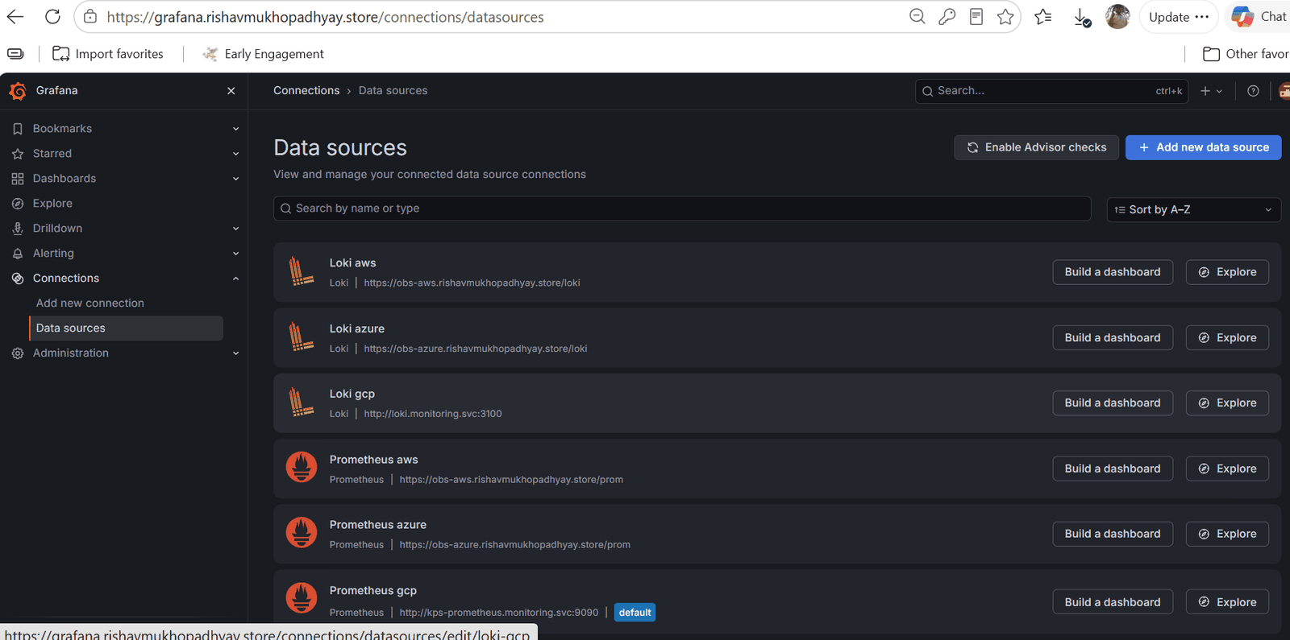
Grafana data sources

2. Dashboards
MERN shop — multi-cloud overview (one row per cloud, cloud selector at the top):
Panel | Meaning
Services with ready pods | how many of the 6 services can serve right now (healthy = 6)
Requests per second | traffic through the gateway
Failed requests (5xx) | share of server errors
Cluster cost run-rate | OpenCost: this cluster’s nodes, per 30-day month at the current size
Requests per second by service · 95th percentile response time · 5xx per second · container restarts | per-service RED metrics (rate, errors, duration)
MERN shop — logs: log lines mentioning “error” per service, and the raw JSON logs, filterable by cloud and service. In Explore, {namespace="mern", app="catalog-service"} shows one service’s logs in one cloud.
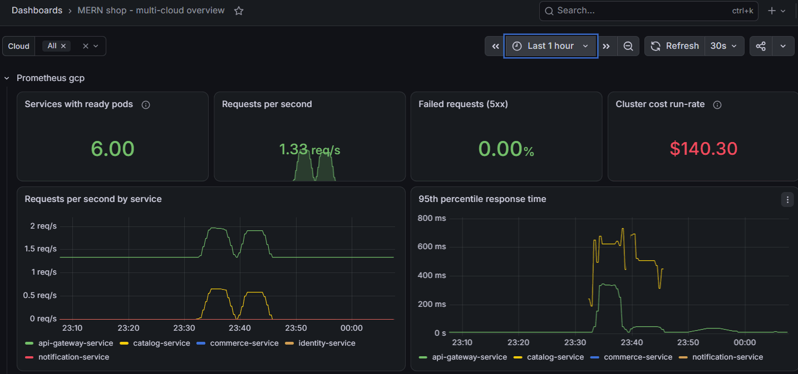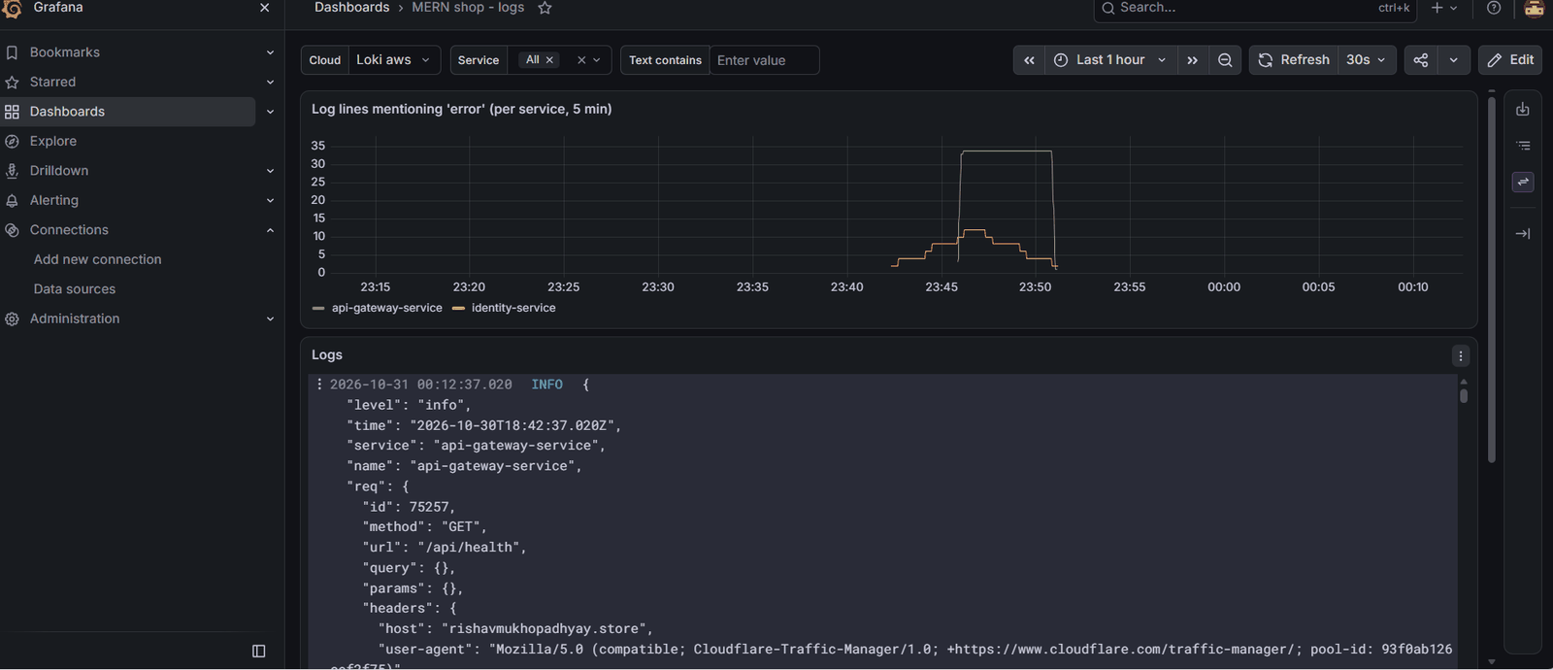

3. Alerts → Slack (#mern-alerts)
Alert | Fires when | Severity
MernServiceDown | a deployment in mern has no ready pod for 2 min — this cloud cannot serve it | critical
MernHighErrorRate | > 5 % of a service’s requests fail with 5xx for 5 min (health-check traffic excluded since v1.1.0) | critical
MernServiceDegraded | fewer ready pods than wanted for 10 min (crash loop, image pull, no room) | warning
MernSlowResponses | p95 response time > 1 s for 10 min | warning
MernPodRestarting | a container restarted > 2 times in 15 min | warning
kube-prometheus-stack defaults | e.g. NodeSystemSaturation, API-server errors | warning/critical
Cloudflare pool health | a cloud’s pool turns unhealthy / healthy | notification
Jenkins | deploy succeeded / failed / standby skipped; backup and restore results | info
Each cloud’s Alertmanager posts to Slack directly (webhook from its own vault), so alerts keep arriving when GCP — and the central Grafana — is down.
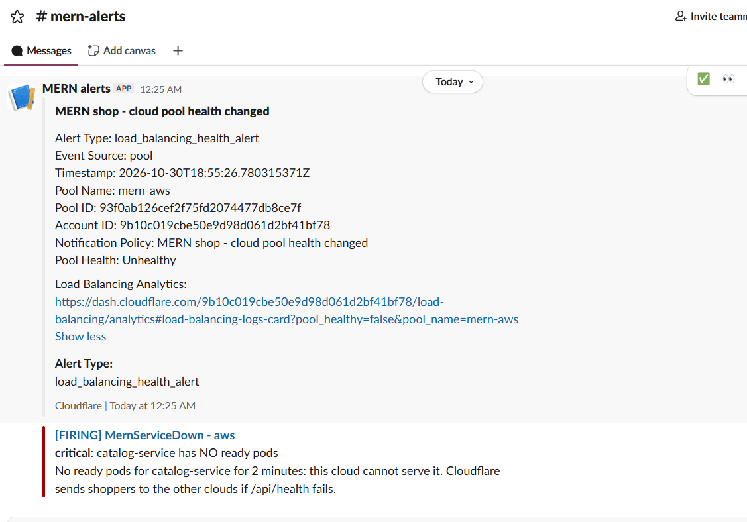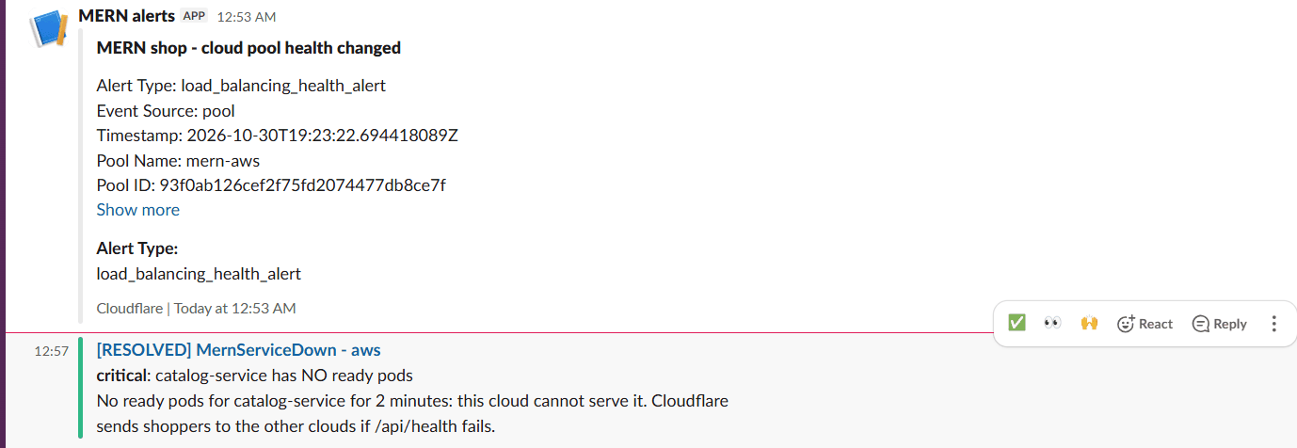

4. Cost

4.1 What was actually billed (1–30 October 2026)
Cloud | Billed | Main items
AWS | US $6.76 | EKS control plane, EC2 nodes, NAT gateway, load balancer
Azure | ₹349.61 (≈ US $4.2) | NAT gateway, VMs, container registry, load balancer, storage
GCP | ₹474.75 gross (Compute ₹228.78 · Kubernetes Engine ₹149.38 · Networking ₹96.59), ₹0 payable (free credits)
MongoDB Atlas | US $0 | M0 free tier
Total | ≈ US $17 for a month of building and testing three clouds | plus the Cloudflare Load Balancing add-on (US $5/month) and the domain
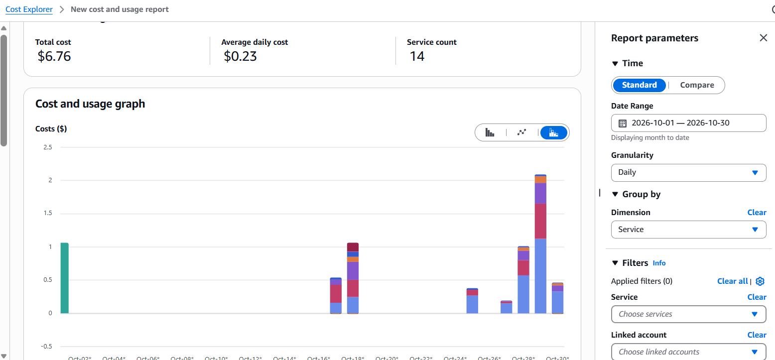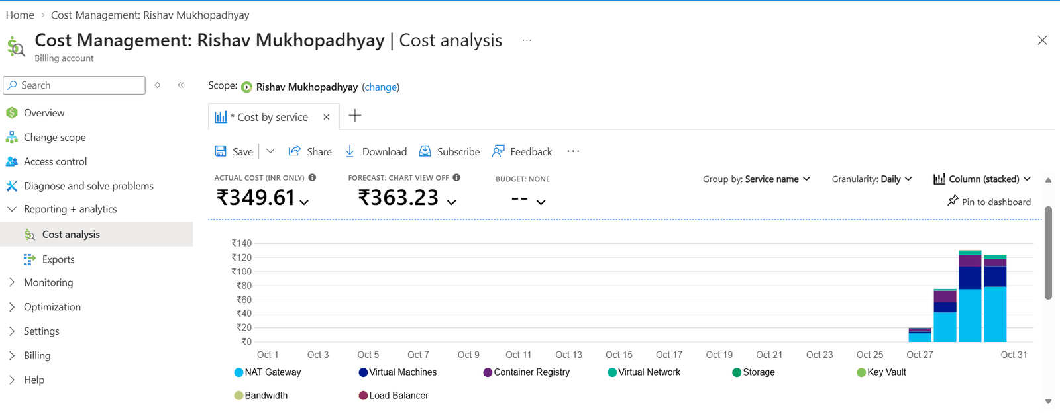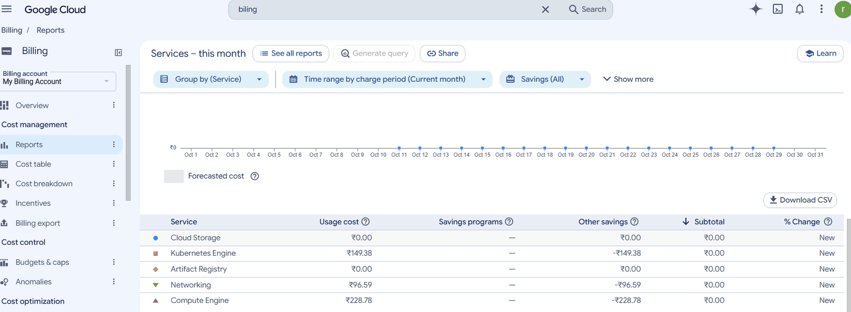

4.2 What it would cost to leave running
OpenCost run-rates measured with all three clusters awake (nodes only, list prices, per 30-day month):
Cluster | Run-rate
GCP (2 × e2-standard-2 + Jenkins/Grafana load) | US $140.30
AWS (2 × t3.large) | US $130.82
Azure (2 × D2as_v5) | US $81.17

Operating model | Node cost / month | Comment
Active-active, 24/7 | ≈ US $352 | plus 3 × NAT, LB, EKS control plane (US $73)
Primary + stopped standbys, 24/7 | ≈ US $140 | standby nodes cost $0 while asleep → −60 % (≈ US $212 saved); the EKS control plane, NAT gateways, IPs and disks still cost money
Sessions only (what we run) | pay per hour of use | ≈ US $0.8–1 per working hour with all three clusters awake (nodes ≈ $0.48/h + NAT, load balancers, EKS control plane); nothing per-hour between sessions

4.3 How cost is kept low
Measure | Effect
Clusters, add-ons and the global layer exist only during sessions (up.yml / down.yml) | no node, NAT or load-balancer cost between sessions
Stopped standbys | Azure/AWS nodes off unless GCP fails
Small, equal node shapes (2 vCPU / 8 GB), autoscaling 2–3 | fits free-trial quotas
GKE zonal Standard cluster | no GKE management fee for one zonal cluster
AKS Free tier, Atlas M0 | $0 control plane / database
Artifact Registry keeps only the newest 10 images; Azure backup storage has a lifecycle policy | storage stays small
down.yml leftover check | catches orphaned load balancers and disks — the classic silent cost
Budgets (AWS $10, Azure $10, GCP ₹850 ≈ $10) with e-mail alerts | warning long before credits run out
OpenCost per namespace | shows what each part of the platform costs
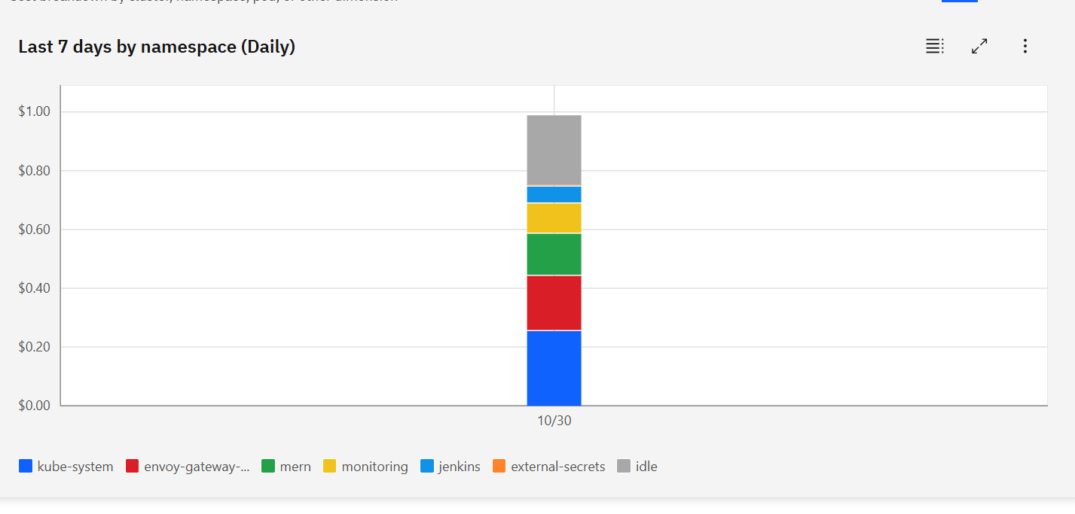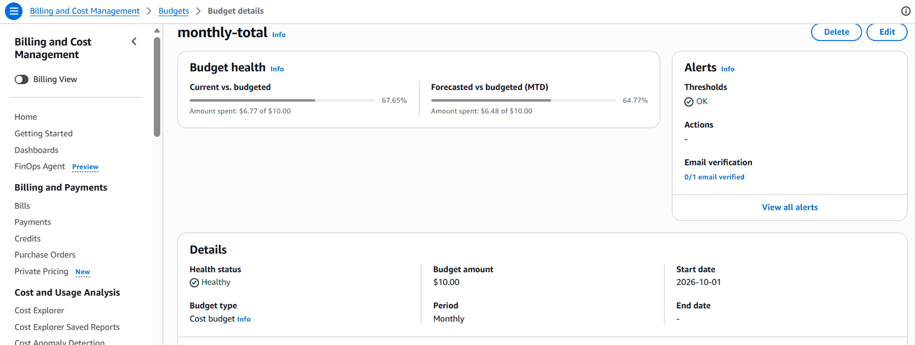

08 — Disaster recovery and failover

1. What can fail, and what happens
Failure | Detection | Recovery | Time | Data loss
a pod crashes | probes | Kubernetes restarts / replaces it; other replicas keep serving | seconds | none
a node disappears | Kubernetes | pods rescheduled; PDB keeps one copy | 1–2 min | none
a bad release | smoke test per cloud | Helm rolls that cloud back, pipeline stops, Slack | ≤ 8 min | none
a standby cloud is lost | Cloudflare pool alert | nothing urgent — GCP serves everyone; rebuild with up.yml | — | none
the primary (GCP) is lost | Cloudflare monitor (60 s) | automatic: Cloudflare → Worker → GitHub Actions wakes Azure and AWS; the first healthy pool takes the traffic | RTO 3 min 42 s (measured) | none (shared database)
the database (Atlas) is lost | /api/health fails in every cloud, MernServiceDown | restore the newest encrypted backup into a new cluster (runbook §4.3) | ≈ 1 h (manual) | RPO ≤ 24 h — since the last nightly backup (between sessions no cluster runs, so nothing is written)
one backup copy is lost or corrupt | restore drill per source | use one of the other two copies | minutes | none
a registry is down | CI warning | other registries still get the image; re-run fills the gap | — | none

2. Failover: the stopped-standby model
Failover sequence
- Cloudflare’s load balancer has three pools in failover order gcp → azure → aws and checks GET /api/health on each every 60 s. /api/health is a deep check: the API gateway asks every backend’s /ready, which checks MongoDB — so “healthy” means “can really serve a shopper”.
- Azure and AWS normally sleep (AKS stopped, EKS node group at 0). All their configuration — cluster, add-ons, shop, secrets, DNS, pool — stays in place, like a stopped EC2 instance.
- When the gcp pool turns unhealthy, a Cloudflare notification policy calls the Worker mern-failover (https://mern-failover.<subdomain>.workers.dev). The Worker checks a shared secret and starts the GitHub workflow platform-automation/.github/workflows/failover-wake.yml with a fine-grained token stored in GCP Secret Manager → Worker secret binding.
- The workflow logs in keylessly with identities that may only start AKS or resize the node group, wakes both standbys in parallel, and stops if there is nothing to wake.
- The first standby that answers /api/health with 200 takes the traffic (AWS woke in 2 min 48 s, Azure in ≈ 6 min in the drill).
Principle: the failover control plane (Cloudflare + GitHub Actions) does not live in the thing that fails (GCP).

What survives a GCP outage
Capability | During a GCP outage
Shop for customers | ✅ served by Azure/AWS after the automatic wake-up
Image builds (CI) | ✅ GitHub Actions; ECR/ACR still receive images (v2.2.0 tolerates Artifact Registry being down)
Deployments (CD) | ⚠️ Jenkins runs in GKE → use break-glass ansible-playbook playbooks/deploy.yml
Alerts | ✅ Azure/AWS Alertmanagers post to Slack directly; Cloudflare pool alerts
Central Grafana | ❌ lives in GKE → use each cloud’s Prometheus/Loki directly until GCP is back
Nightly backup | ❌ job runs in Jenkins → take a manual backup if the outage is long
Secrets | ✅ each cloud has its own vault (copies written by global-platform)

3. Backup and restore
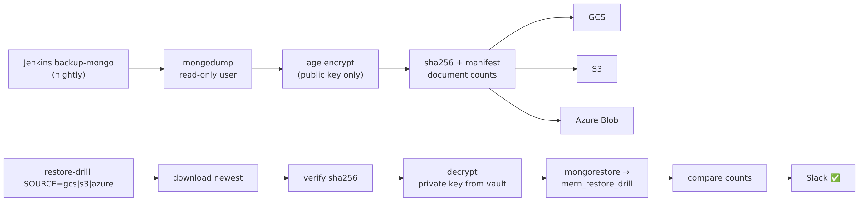
Backup and restore
 | Backup (backup-mongo, nightly while the platform runs, or on demand) | Restore drill (restore-drill SOURCE=gcs\|s3\|azure)
Database access | Atlas user backup-ro (read-only) | Atlas user restore-drill (only database mern_restore_drill)
Encryption | age with the public key only — the job can encrypt but never decrypt | private key read from the vault, deleted after the job
Integrity | SHA-256 + manifest with document count per collection | checksum must match; every collection’s count must match
Storage | GCS, S3, Azure Blob — the job fails unless all three uploads succeed | newest copy from the chosen cloud
Identity | write-only per bucket (Azure: Put Blob over REST because the identity may not even read) | read-only per bucket
Result | Slack 💾 backup-mongo #N: <name> stored in GCS + S3 + Azure Blob | Slack ✅ restore-drill #N: <name> from <source> restored and verified
The private key exists in GCP Secret Manager, Azure Key Vault and AWS SSM (outside /mern/, so no cluster can read it) and in a password manager — a backup can be restored even if GCP is gone completely.
Example manifest (final test): mern_ecommerce, 14,711 bytes, products 100, orders 13, carts 13, brands 10, categories 10, contacts 8, users 5, reviews 2, merchants 1, wishlists 1.

4. Runbooks

4.1 GCP is down (real outage)
- Check Cloudflare → Load Balancing: mern-gcp critical; Slack shows “pool unhealthy”.
- Watch GitHub → platform-automation → Actions → Failover – wake standbys. If it did not start within 5 minutes, wake by hand: ansible-playbook playbooks/wake.yml -e cloud=azure (and aws).
- Confirm https://<domain> answers and azure./aws.<domain>/api/health is ok.
- Releases during the outage: ansible-playbook playbooks/deploy.yml -e service=… -e tag=….
- When GCP is back and healthy, Cloudflare returns traffic to it automatically (failover order). Put the standbys back to sleep: ansible-playbook playbooks/standby.yml.

4.2 A whole cloud must be rebuilt
The cloud’s foundation (registry, vault, backups) is permanent and in Terraform state; clusters are rebuilt every session anyway. Run ansible-playbook playbooks/up.yml — the guarded plan shows exactly what will be created.

4.3 The database is lost
- Create a new Atlas cluster (or project) and update atlas_project_id, atlas_cluster_name, mongo_host in global-platform/variables.tf.
- terraform apply in global-platform → new per-cloud users and connection strings in all three vaults; External Secrets refreshes them (restart the deployments to apply at once).
- Restore the newest backup into the real database: run the restore steps by hand with a user that may write mern_ecommerce — download the newest archive (scripts/dr/download-latest.sh <gcs|s3|azure>), verify its SHA-256 against the manifest, decrypt with the private key from the vault (age -d -i key.txt), then mongorestore --uri "<uri>" --gzip --archive=<file> --nsInclude 'mern_ecommerce.*'.
- Check the document counts against the manifest, then /api/health in every cloud.

4.4 Prove it regularly
ansible-playbook playbooks/drill-restore.yml # all three backup copies restore and match
ansible-playbook playbooks/drill-failover.yml # primary fails, standbys wake, RTO measured

5. Drill results (final test, 30 Oct 2026)
Drill | Result
Backup mern-20261030T212438Z | stored in GCS + S3 + Azure Blob
Restore drill | gcs: SUCCESS · s3: SUCCESS · azure: SUCCESS — “Restore drill PASSED”
Failover drill (automatic wake-up) | shop down after 15 s → standbys woken by Cloudflare → Worker → GitHub Actions → shop back; RTO 3 min 42 s (target 20 min); MernServiceDown raised in GCP
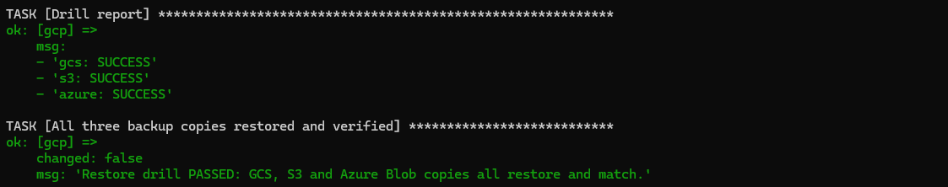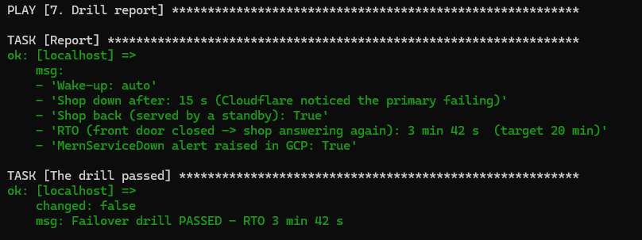

09 — Final end-to-end test report
When: 30 October 2026 14:55 UTC → 31 October 2026 (teardown) Who: Rishav Mukhopadhyay (operator) — commands from WSL Ubuntu / PowerShell, evidence by screenshot Scope: everything at once — start from code, run the shop in three clouds, release through CI/CD, monitor, sleep the standbys, back up and restore, fail over, tear down.

Summary
Part | Test | Result
A | Permanent foundations: repos, CI, registries, backups, state, identities, budgets | ✅ all present
B | Session start with up.yml (3 clusters in parallel) | ✅ failed=0 everywhere, 23 min 13 s ¹
C | Shop, clusters, global layer and database in all three clouds | ✅ 6/6 services ready ×3, /api/health ok ×3
D | One merge → CI → same image in 3 registries → Jenkins → 3 clouds | ✅ live in gcp, azure, aws in 4 min 57 s ²
E | Dashboards, logs, alert → Slack → resolved, cost | ✅
F | Standbys to sleep; Jenkins skips them | ✅ (AWS sleep slow — issue 4)
G | Backup to 3 clouds · restore from 3 clouds · automatic failover | ✅ 3/3 restores · RTO 3 min 42 s
H | Teardown with down.yml | ✅ after manual fixes (issues 5–6)
¹ GKE and AKS already existed from the first attempt (see issue 1); EKS was built from scratch. ² Zero downtime during this deploy was not measured — the probe was stopped before the deploy began (see §D).

Issues found during the test
# | Issue | Handled
1 | AWS SSO session expired → AWS dropped out of the first up.yml, then the global layer failed | aws sso login, re-run — Troubleshooting
2 | Operator’s public IP changed twice (home ↔ phone hotspot) → cluster APIs and Atlas API refused | IP updated in tfvars, Atlas key, clusters re-applied — Runbook §6
3 | Helm chart downloads timed out — one GitHub CDN address unreachable from the ISP | address pinned — Troubleshooting
4 | AWS standby sleep stuck ~30 min (PDB drain); Azure stop refused during an in-progress start | manual drain / wait — see Limitations
5 | AWS NLB left behind → down.yml safety stop kept EKS | NLB, target group, security groups deleted by hand, re-run
6 | Atlas IP access list contained a manual 0.0.0.0/0 | removed

A. Permanent foundations
These exist between sessions and cost (almost) nothing.
GitHub organisation and branch protection
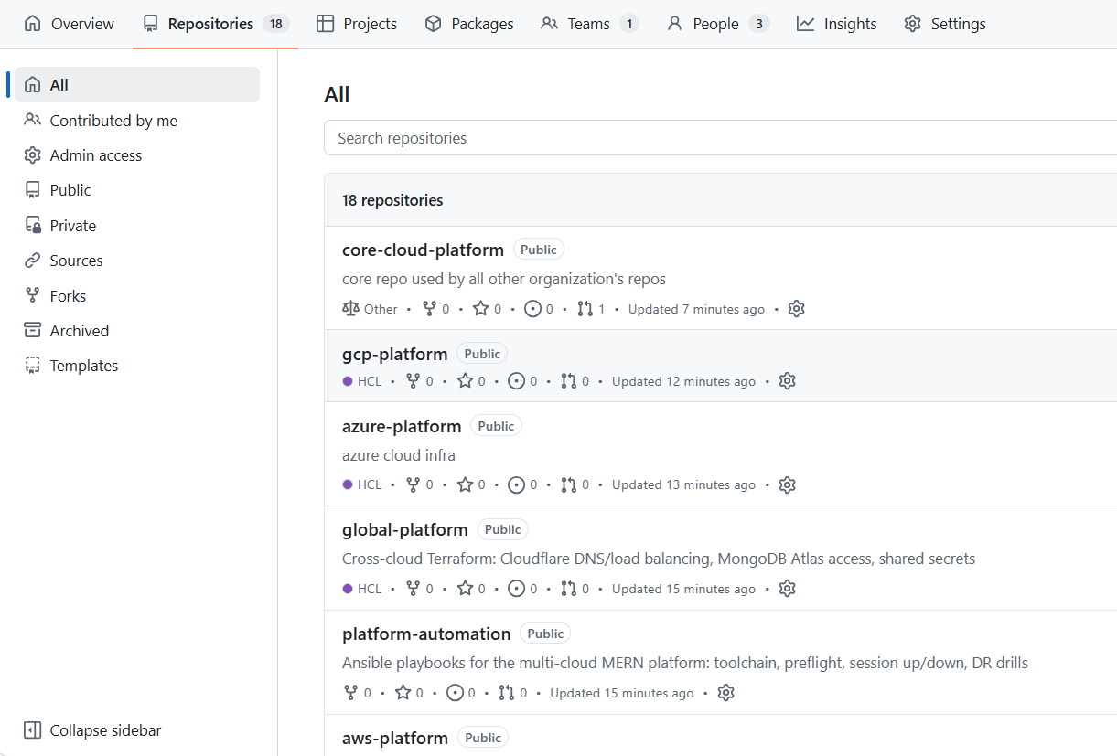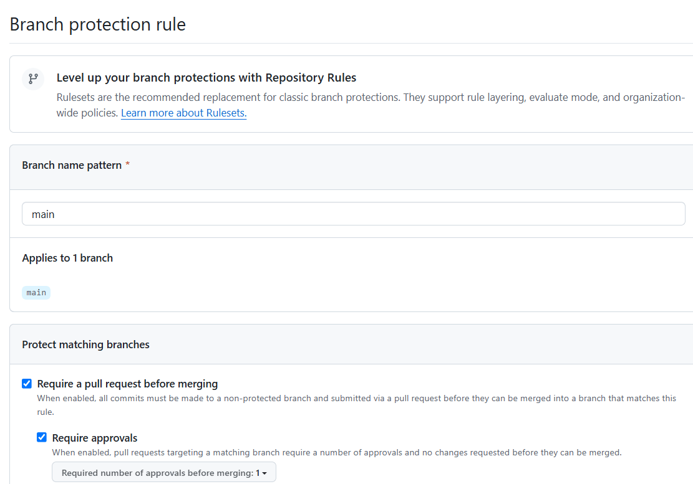
CI run, security scan and shared workflows
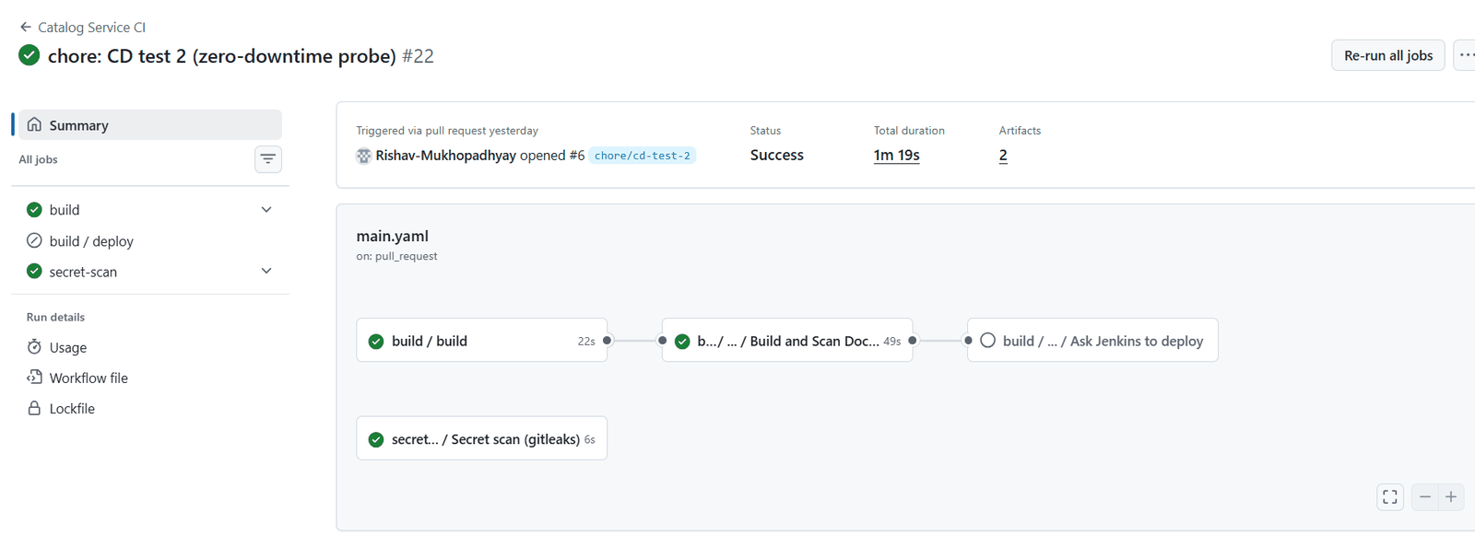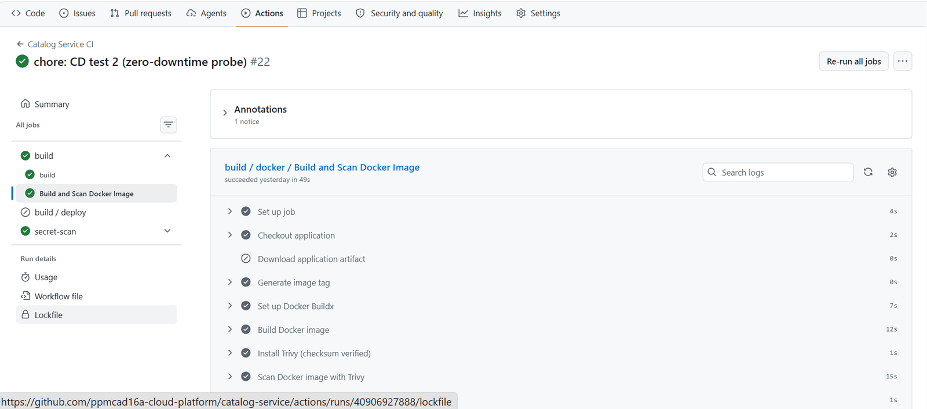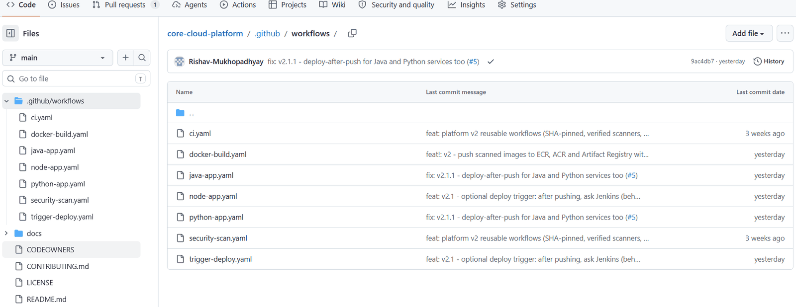
The same images in three registries
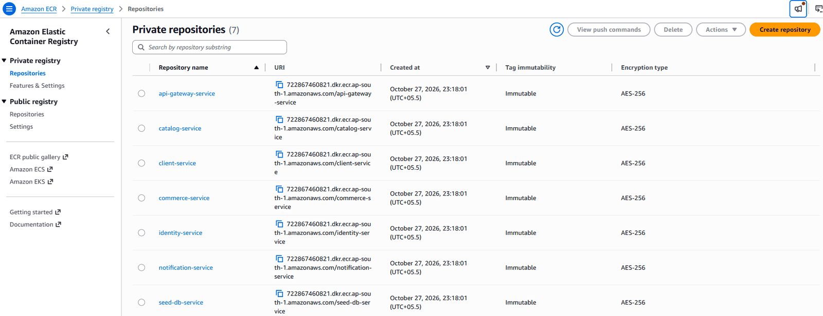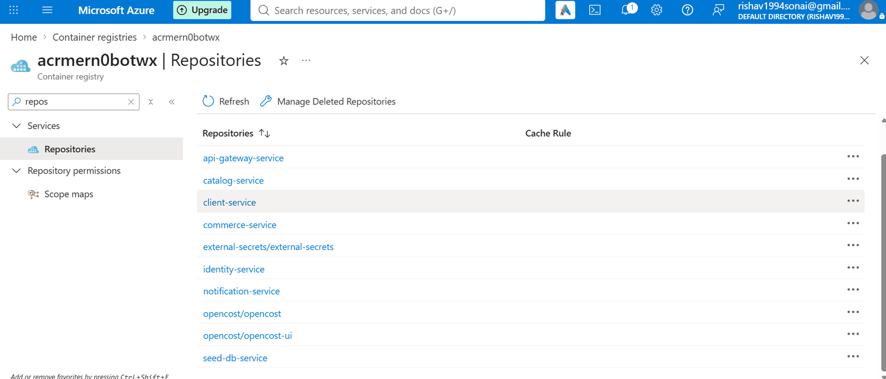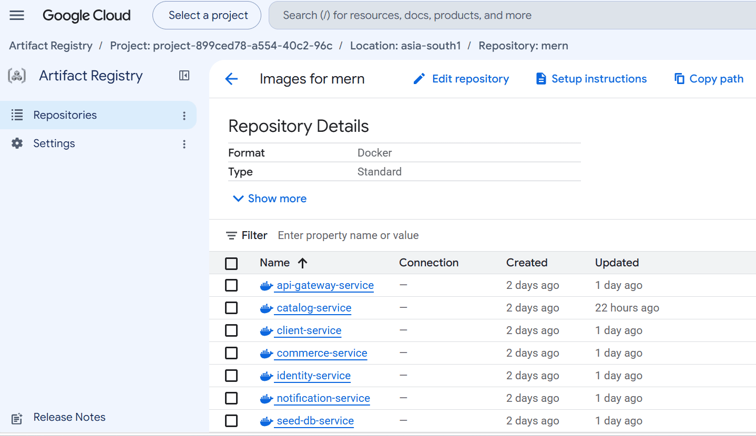
Encrypted backups in three clouds
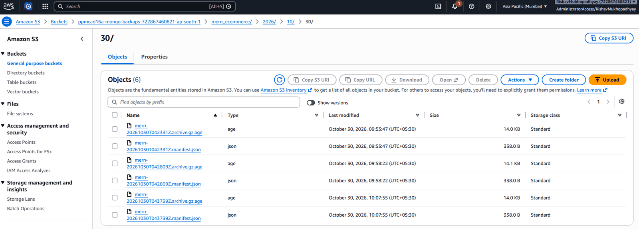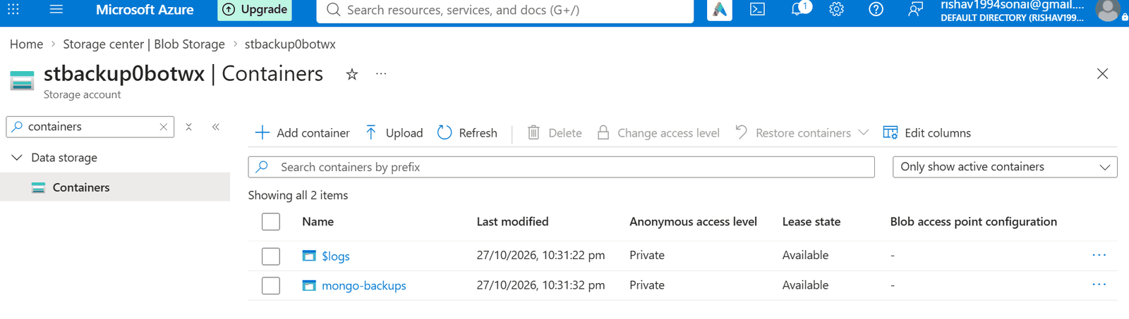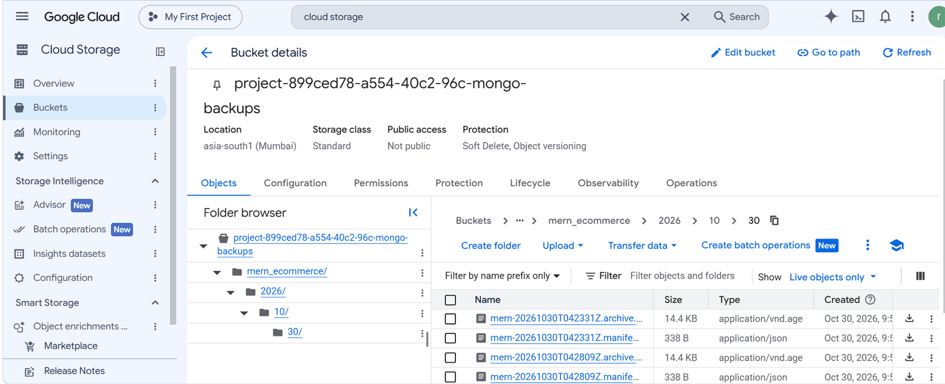
Terraform state (versioned)
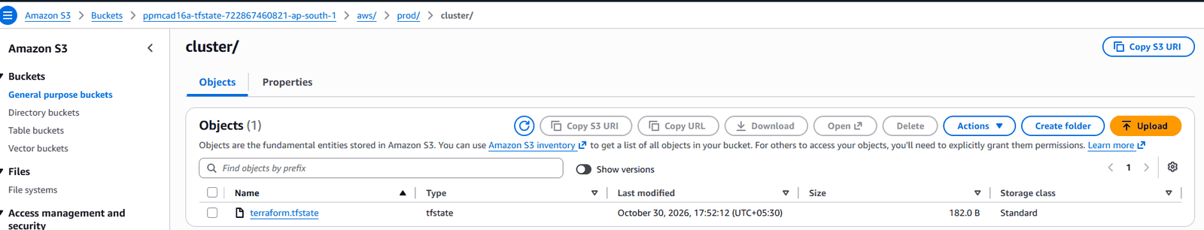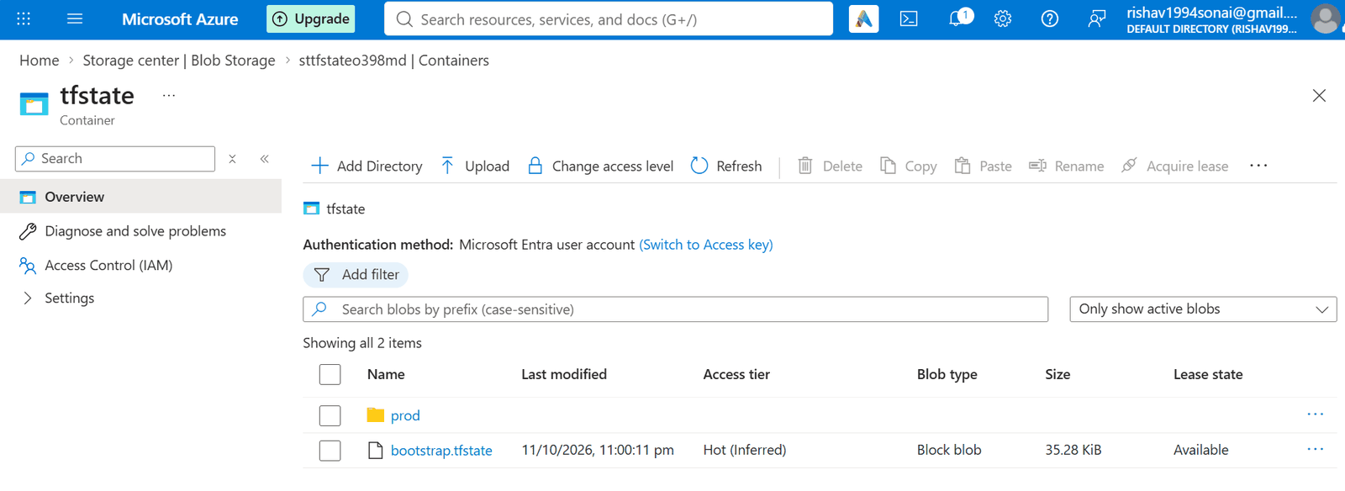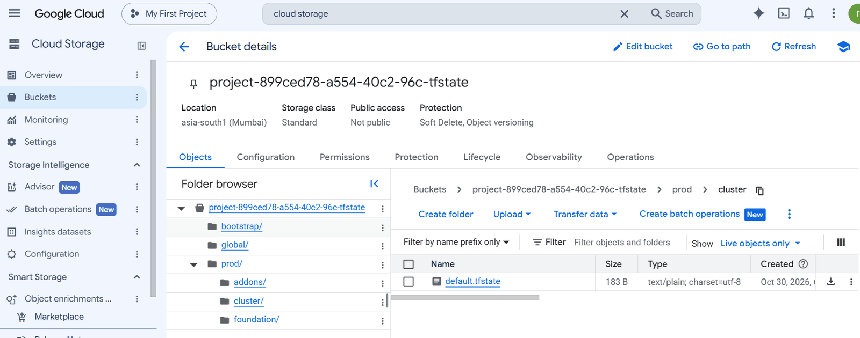
Keyless identities
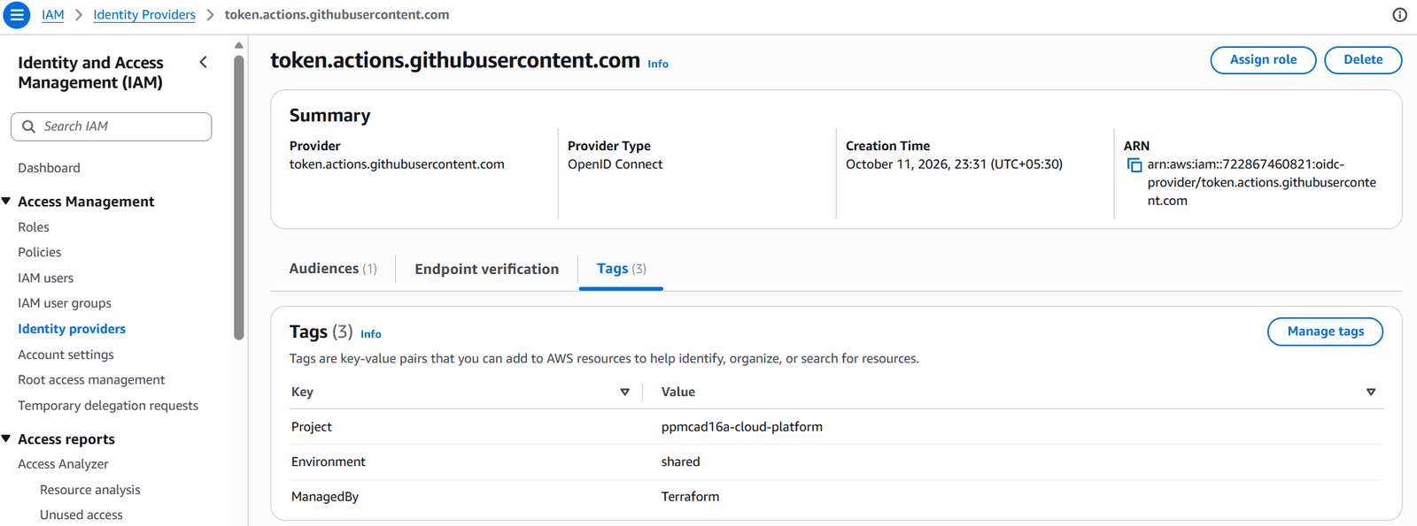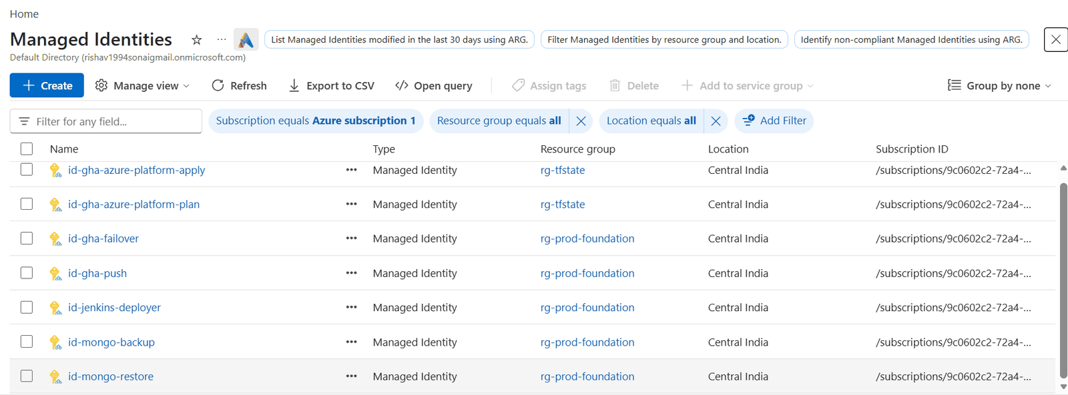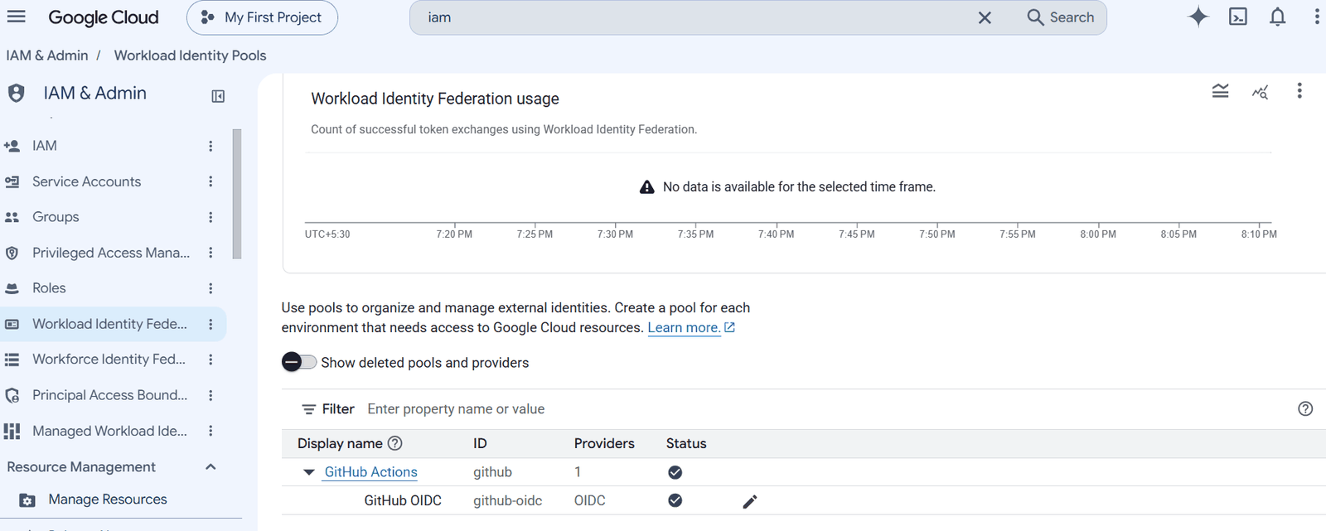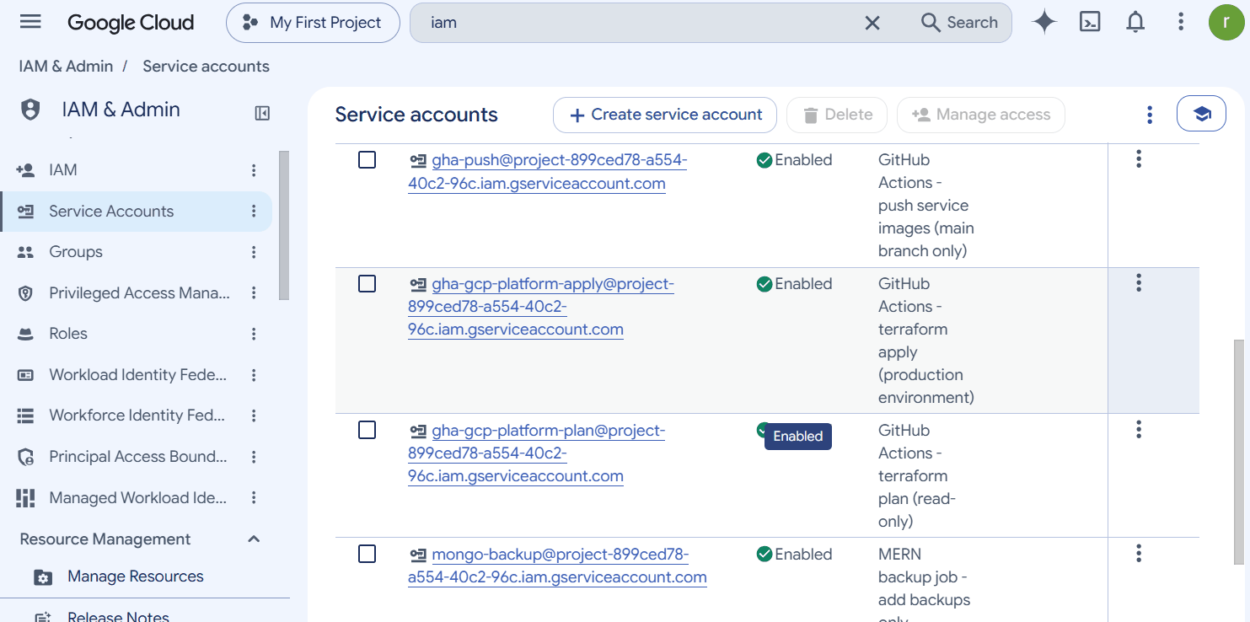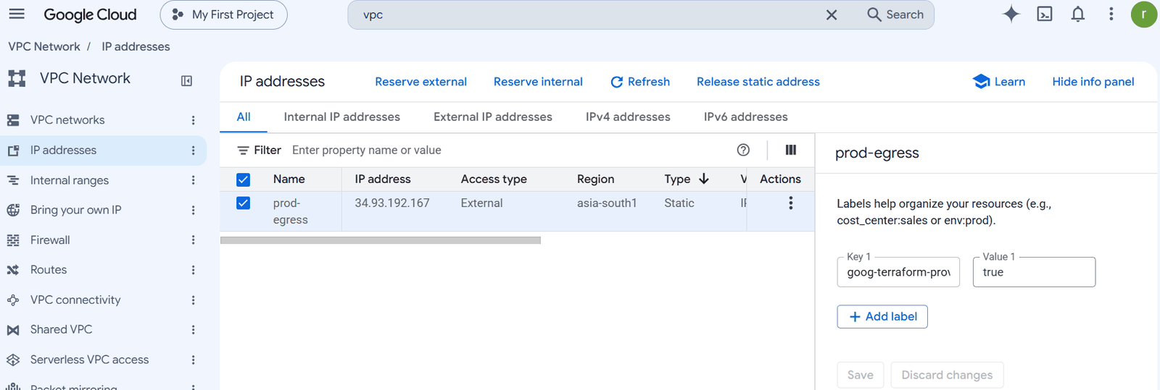
Budgets
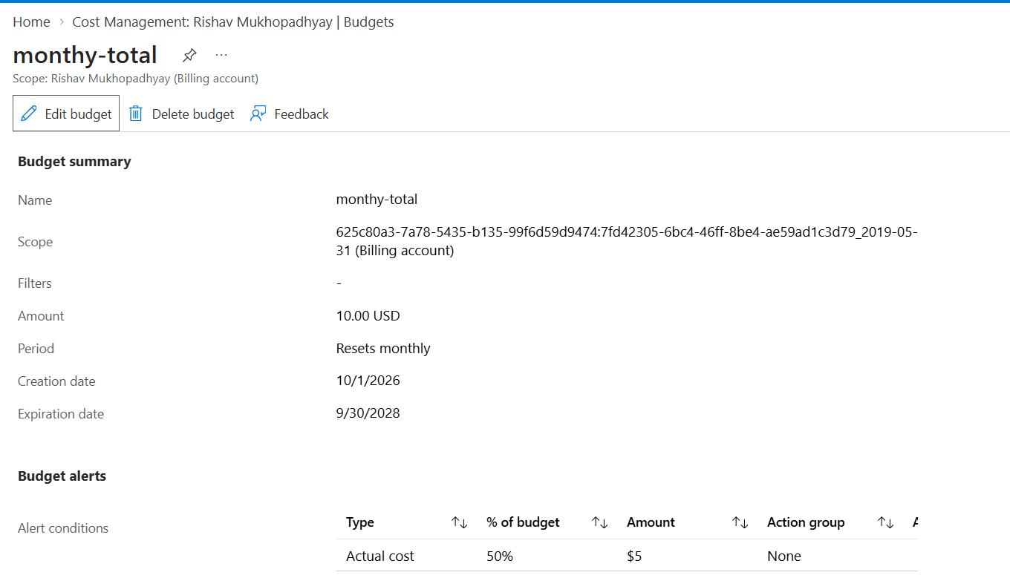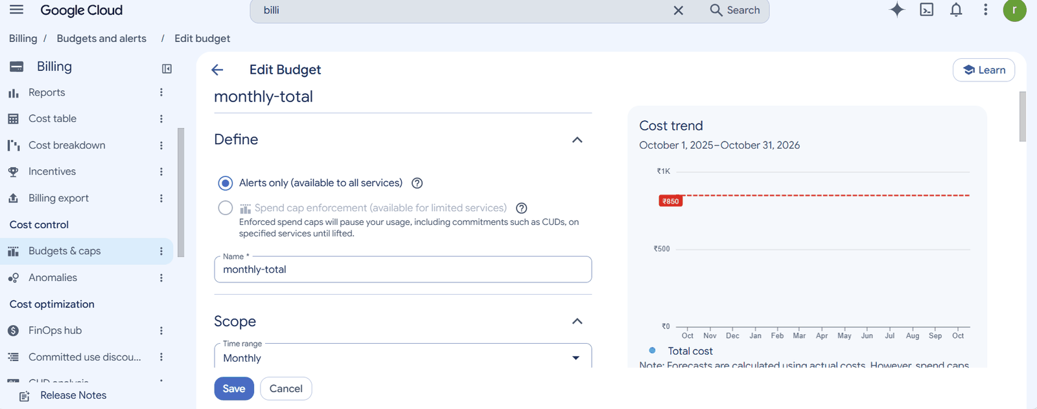

B. Session start (up.yml)
ansible-playbook playbooks/up.yml -e keep_awake=true (standbys kept awake for the photos).
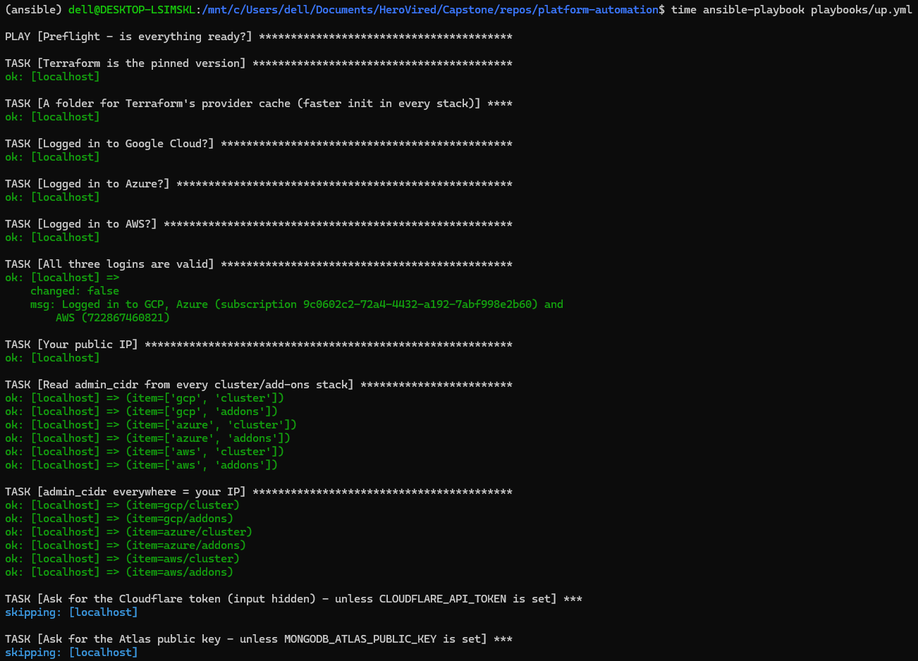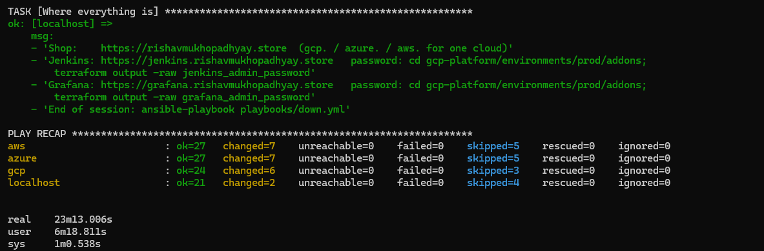

C. Everything running
Inside the clusters
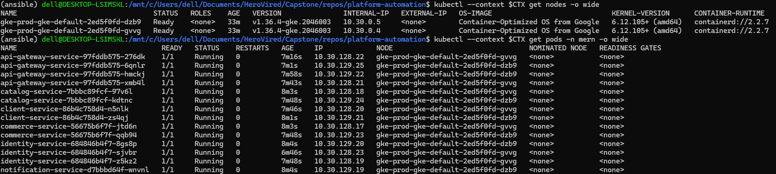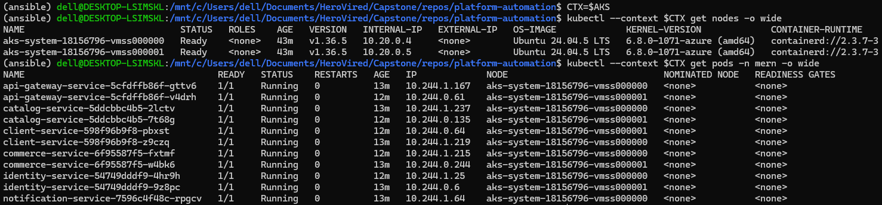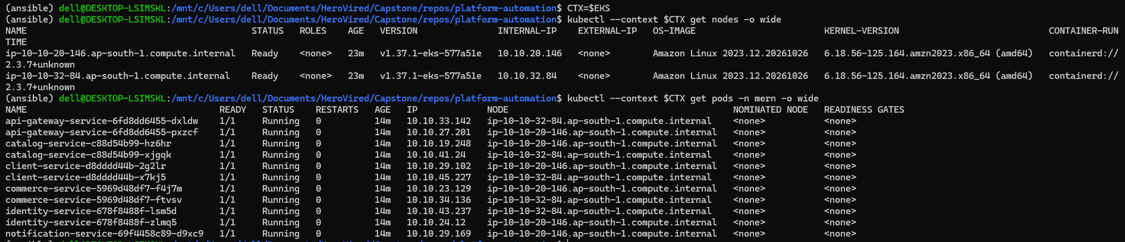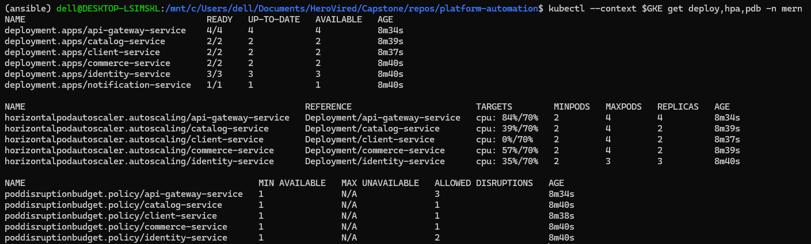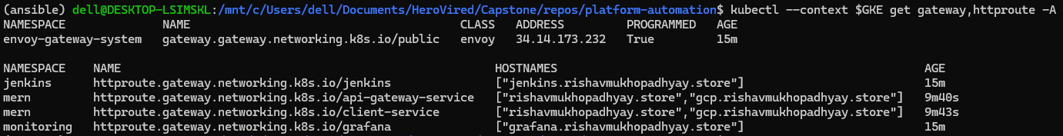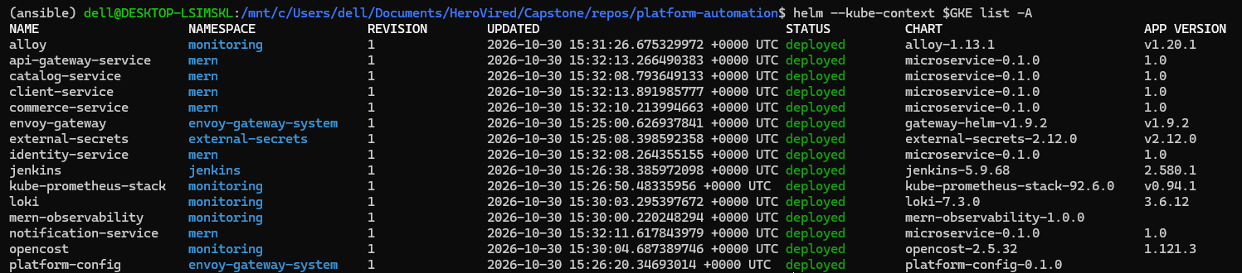
The shop — sign up, browse, cart, order; the same user and order are visible from every cloud (one shared database).
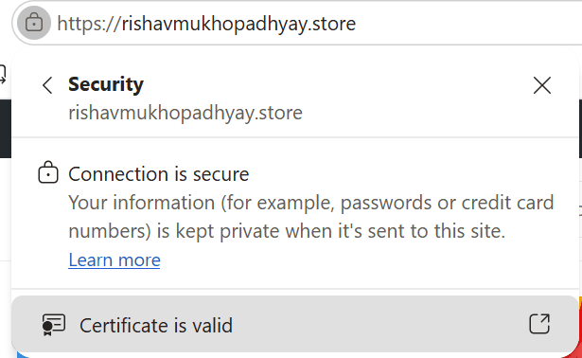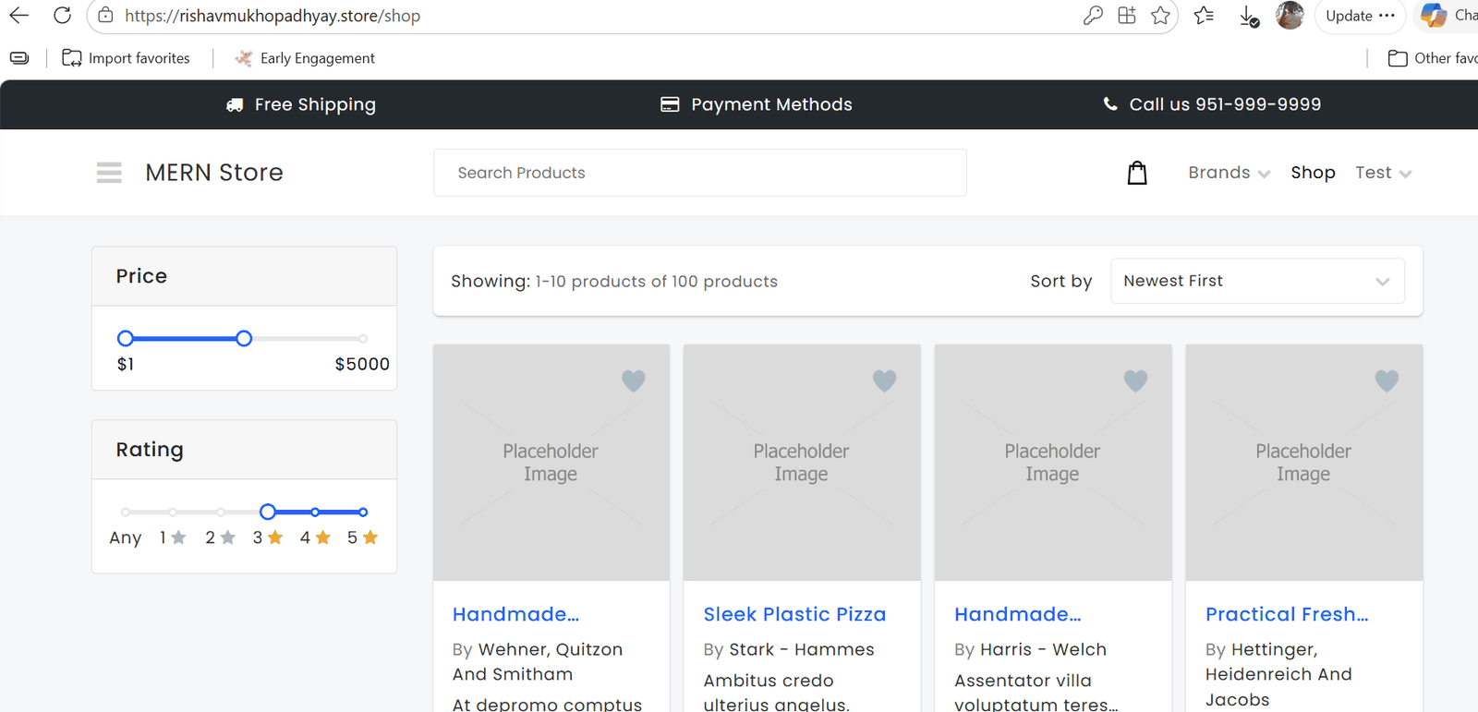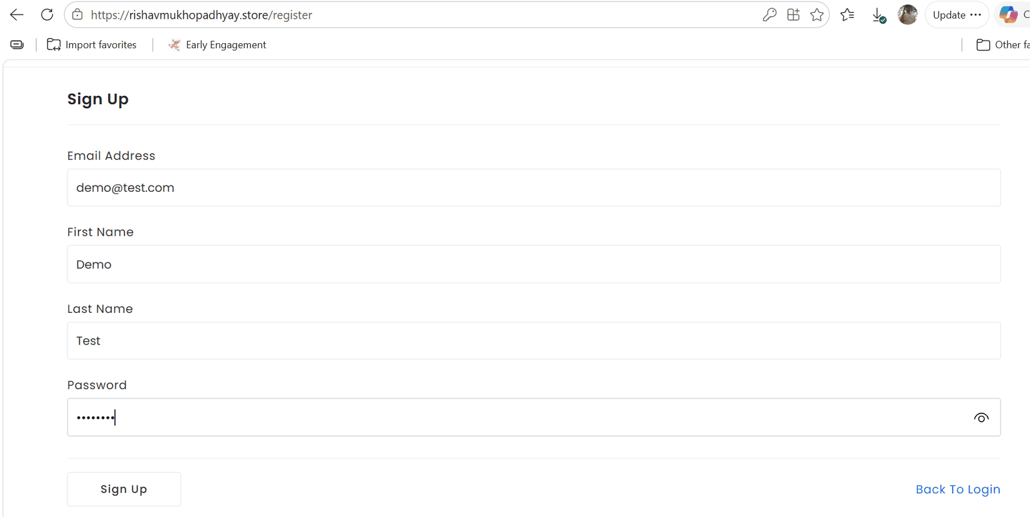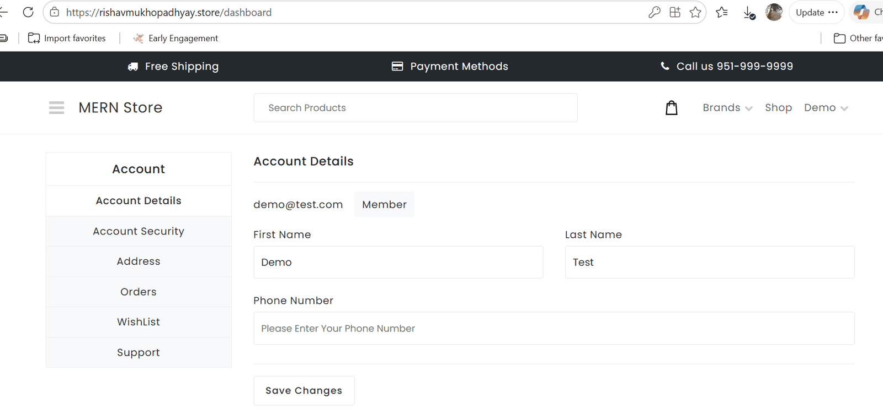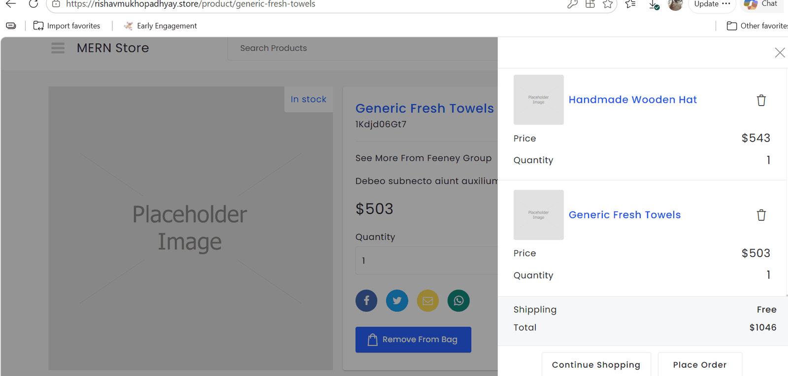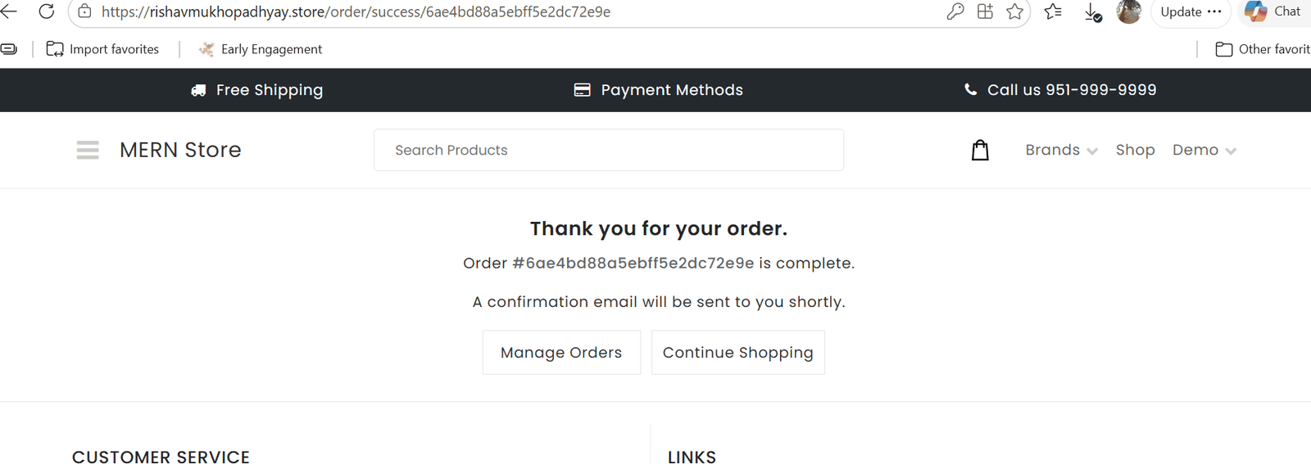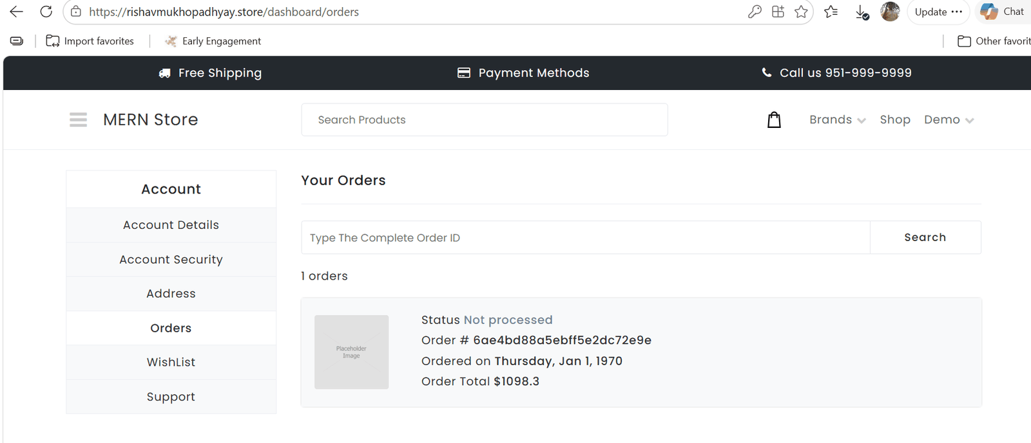
Cloud consoles
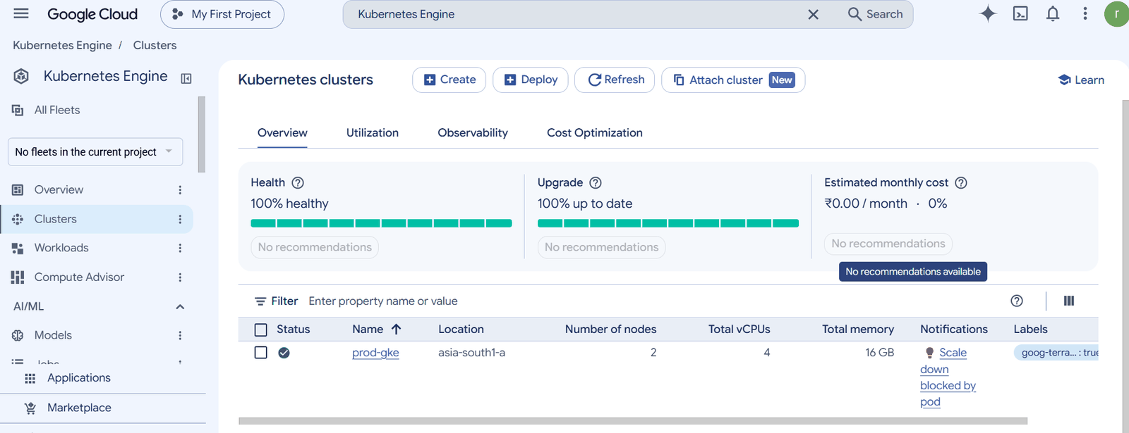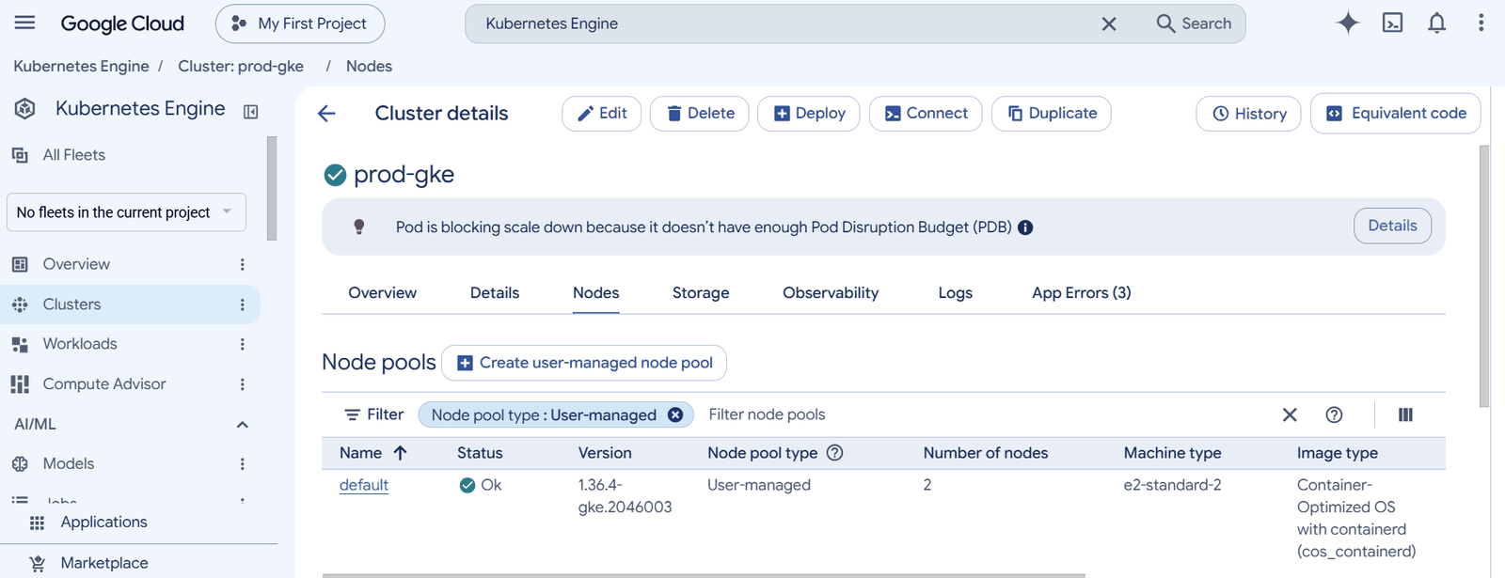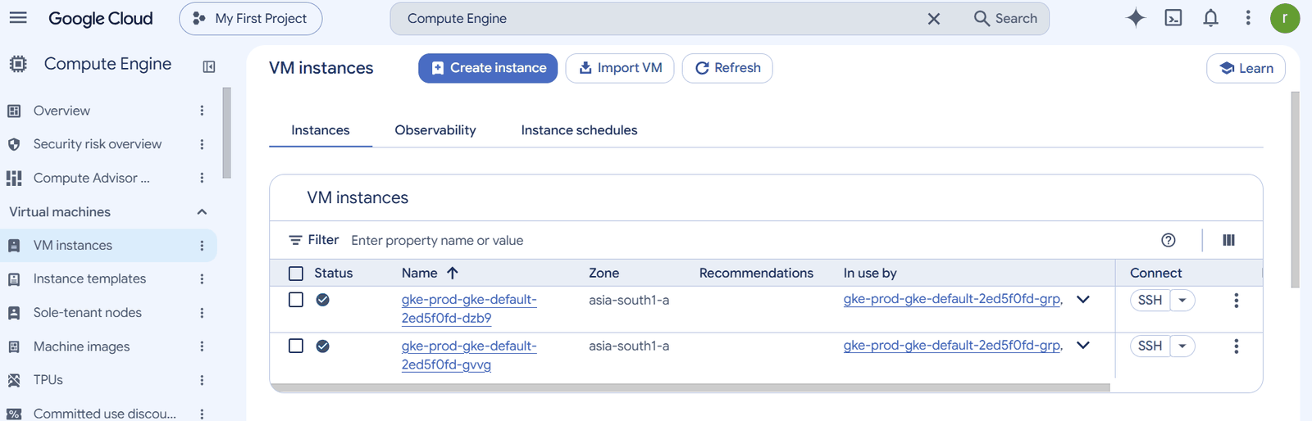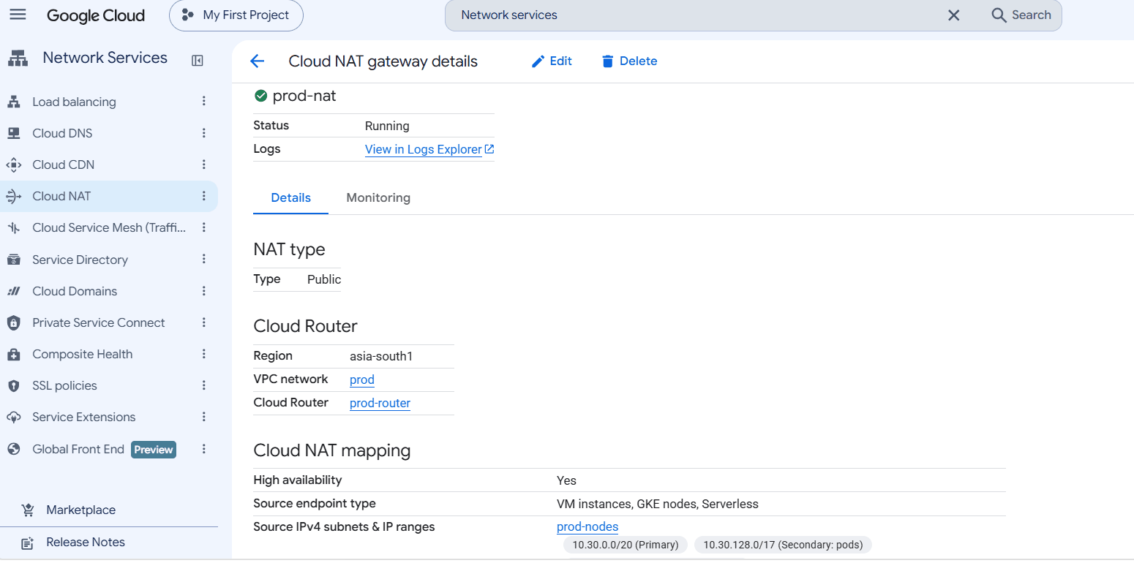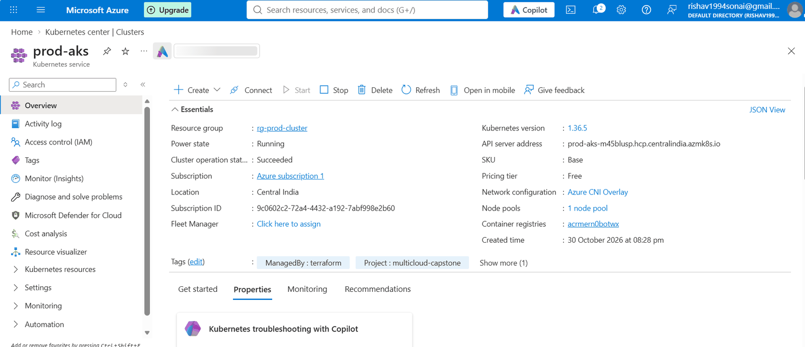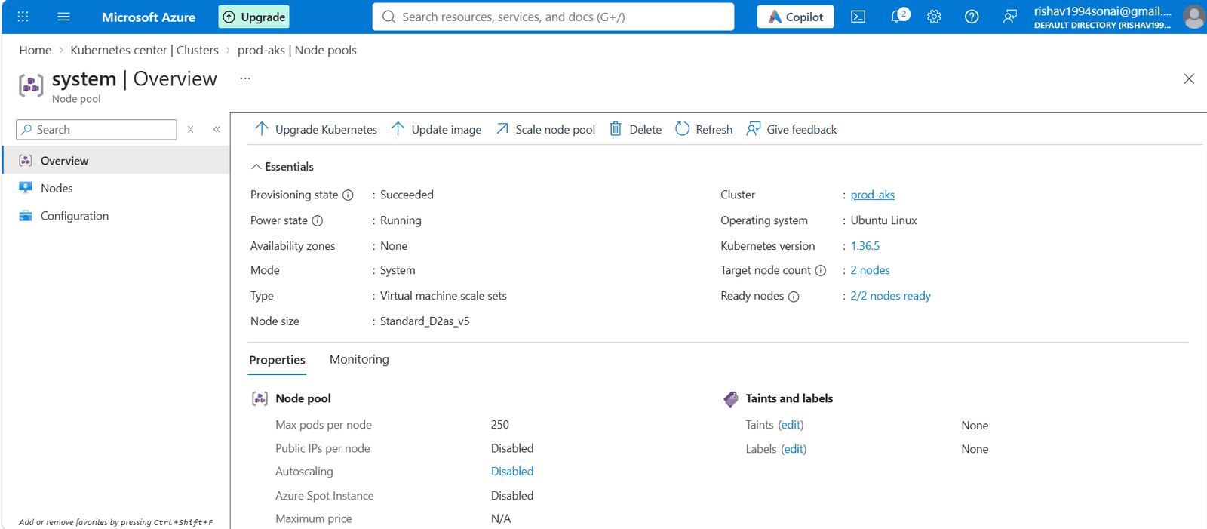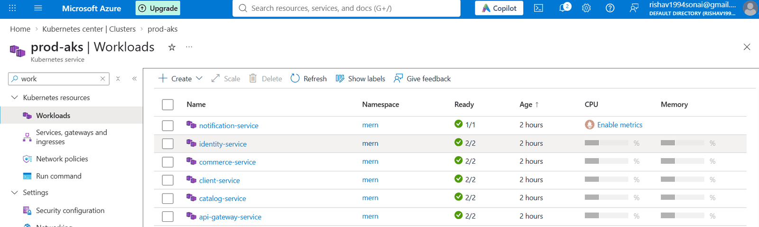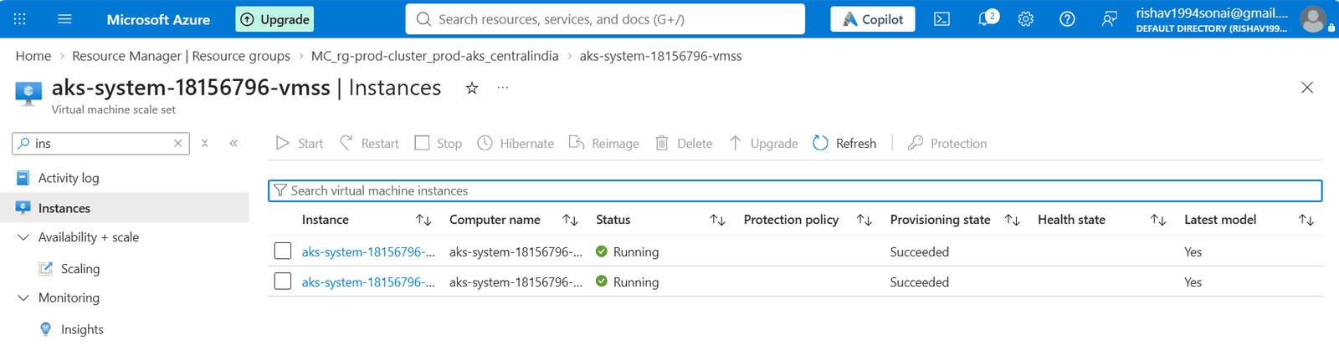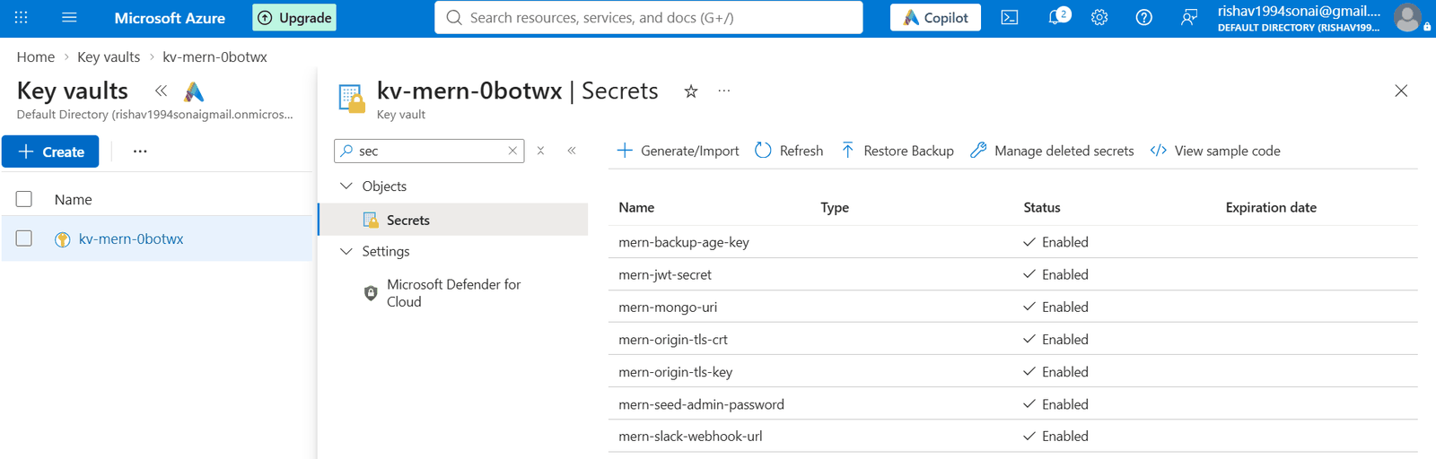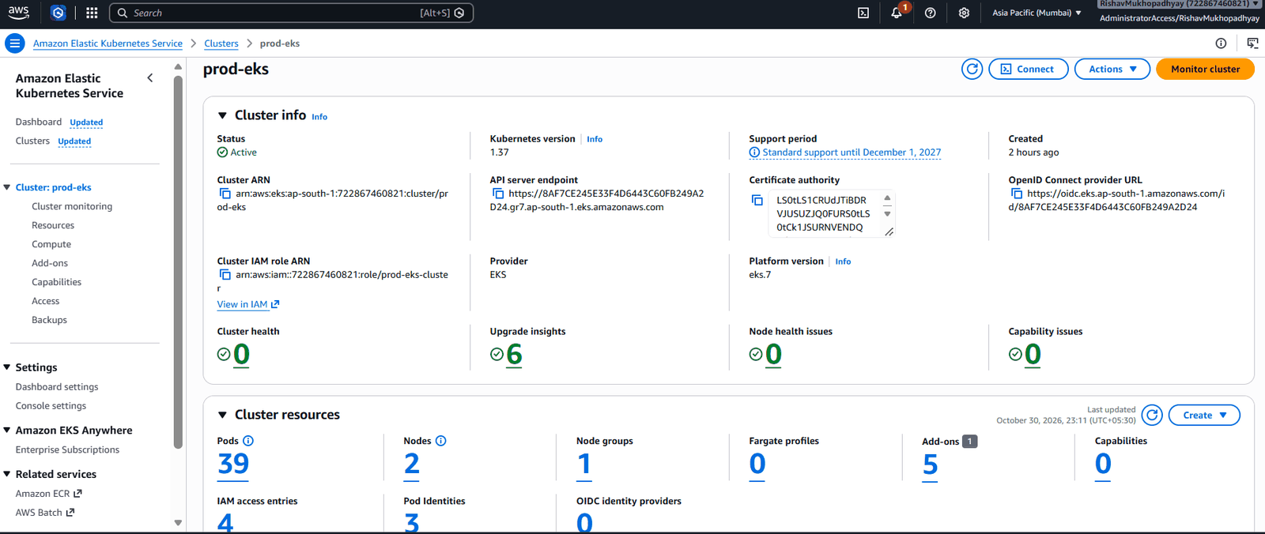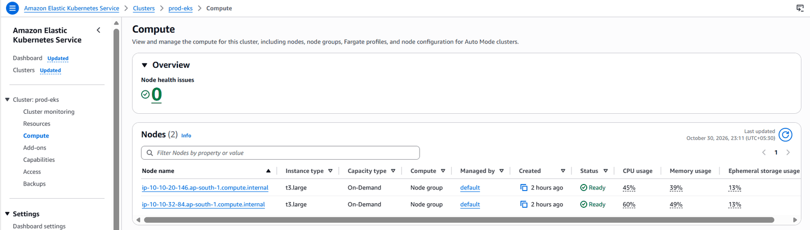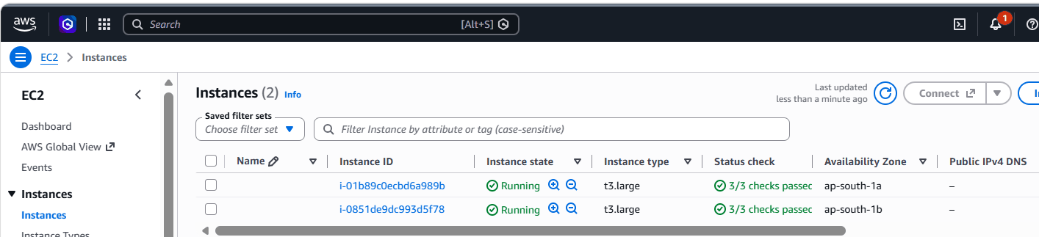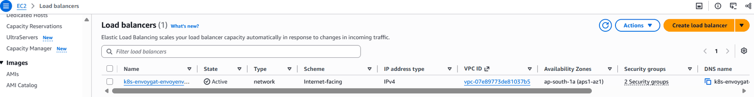
Global layer and database
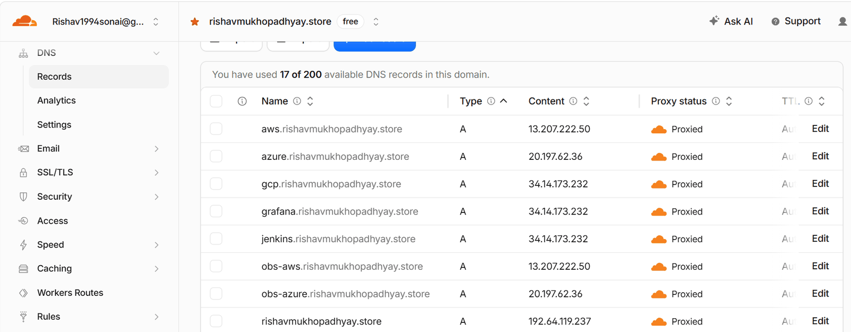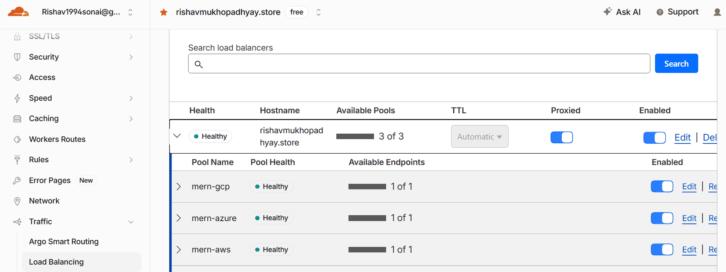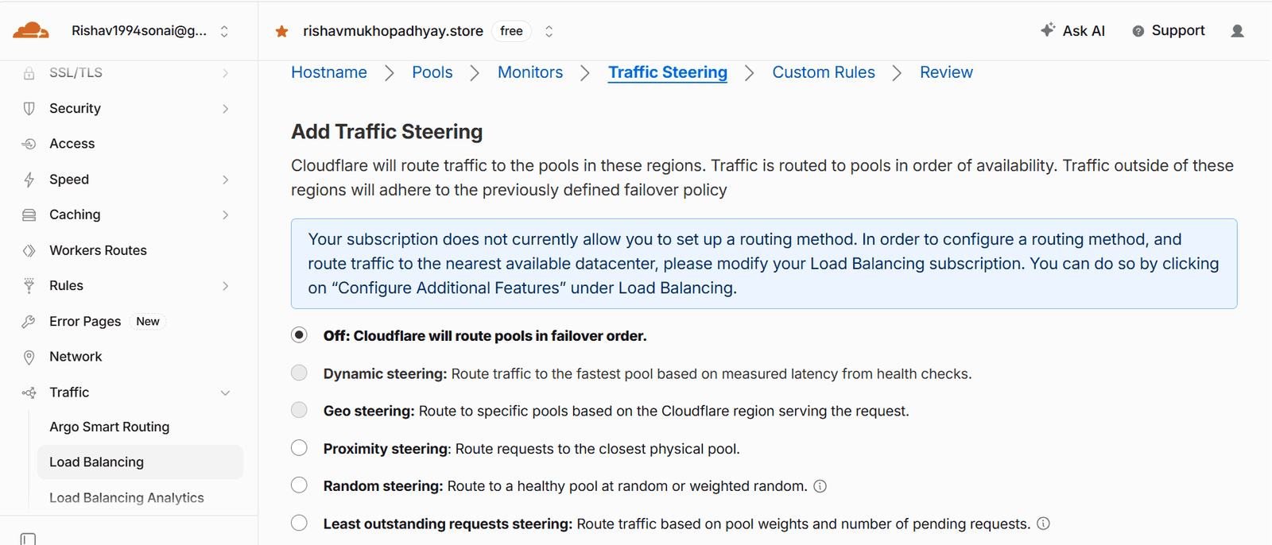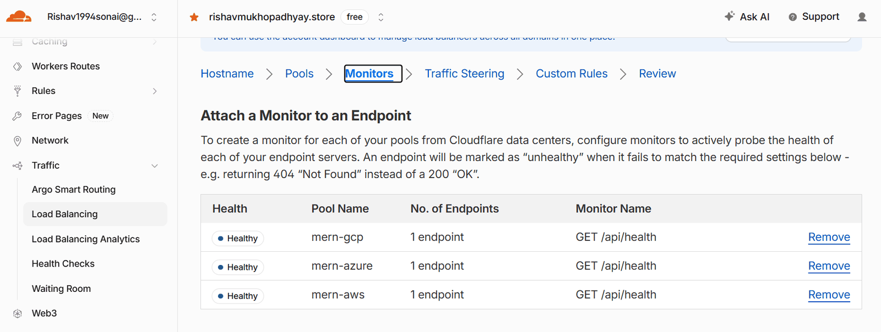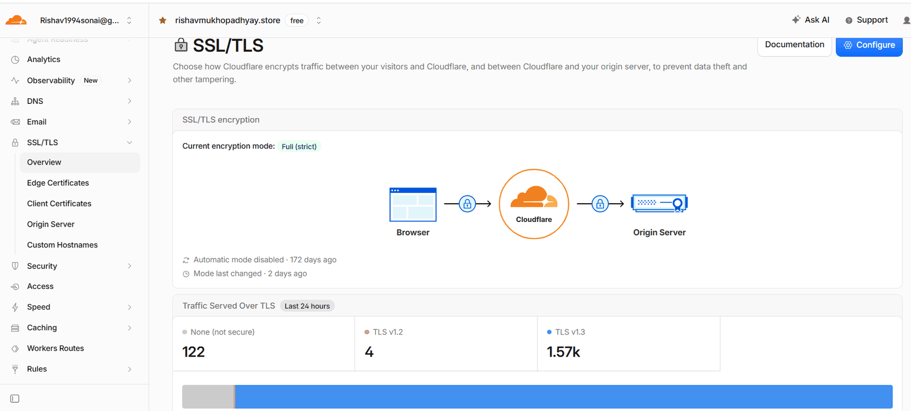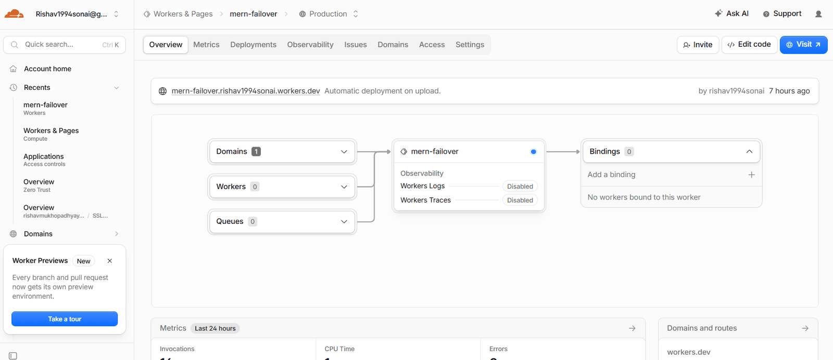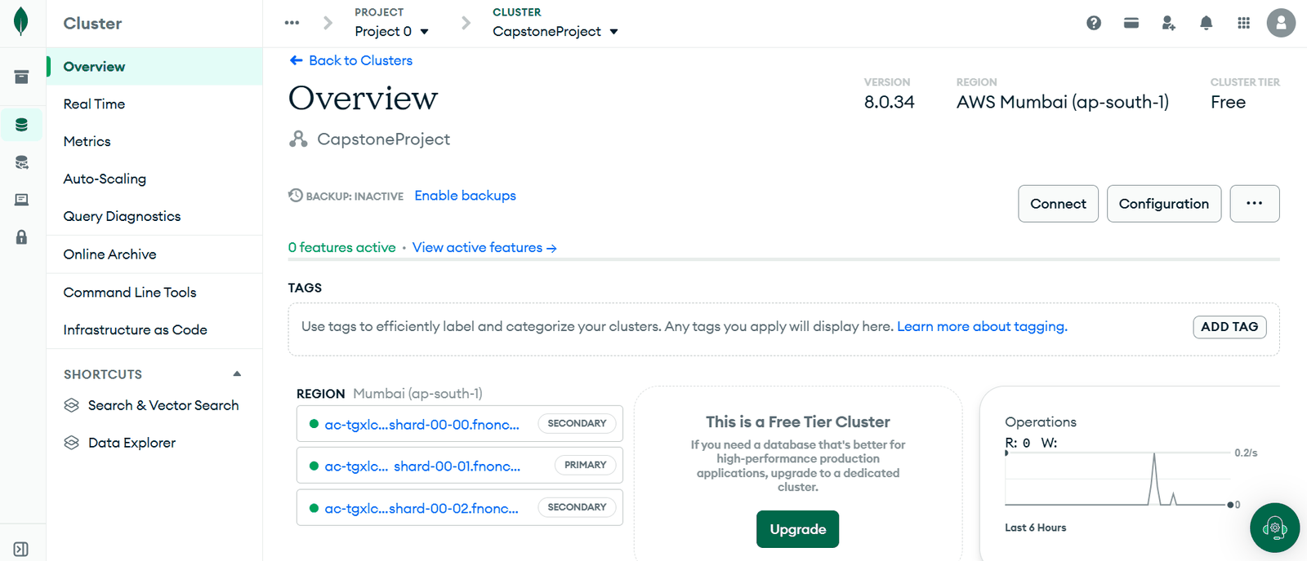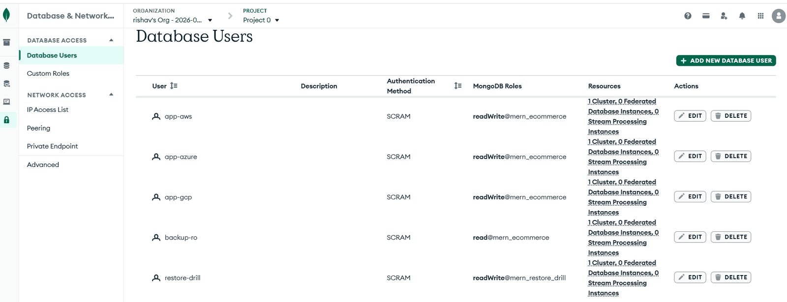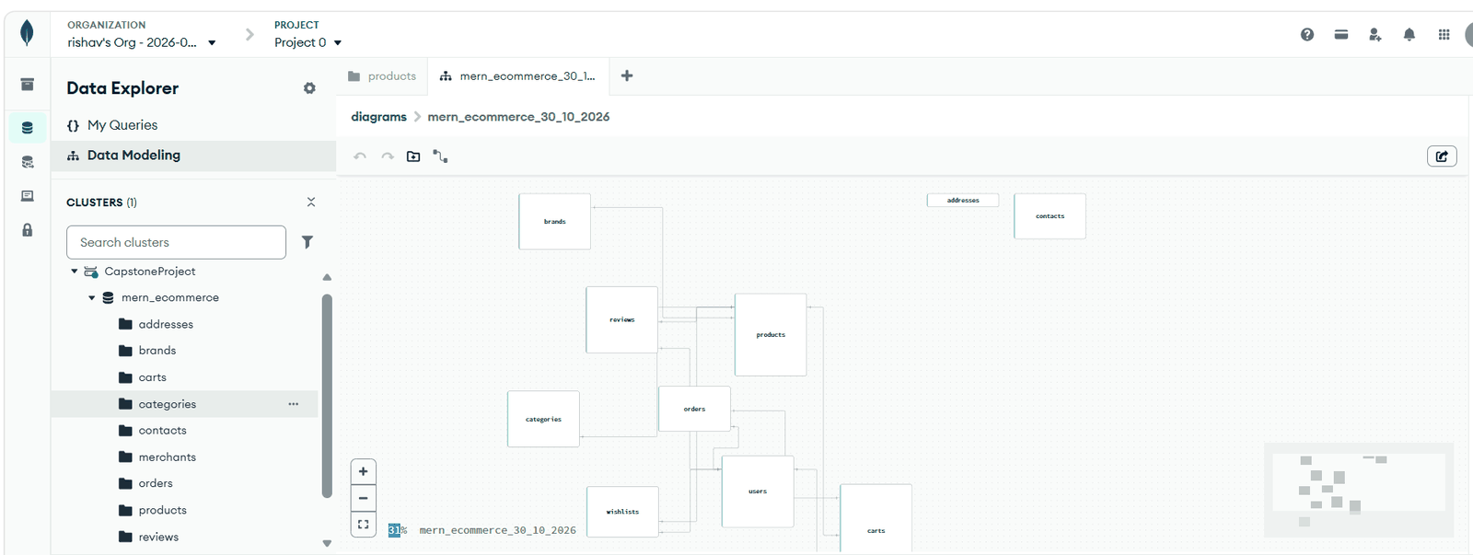

D. CI → CD: one merge, three clouds
A one-line documentation change in catalog-service (PR #7) went through the whole pipeline.
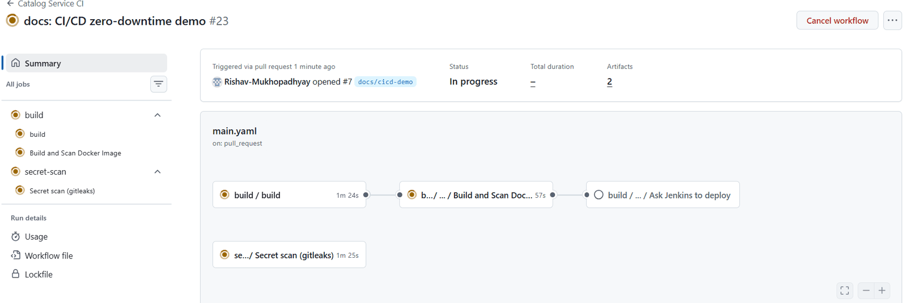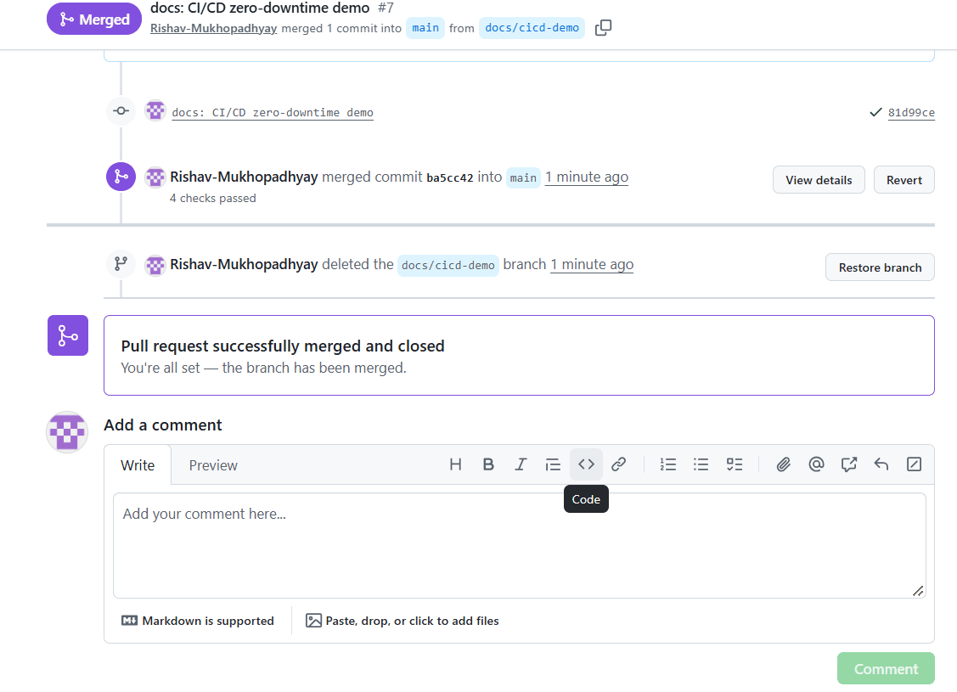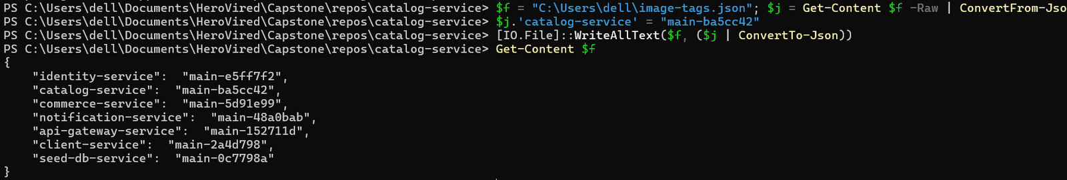
Zero-downtime measurement. The probe below asks each cloud for /api/category/list twice in parallel, continuously, and counts every answer that is not 200. In this test it ran from 18:09 to 18:10 UTC, but the deploy started at 18:19 UTC, so its “0 failed” result is not evidence for this deploy and is not shown. Zero downtime was demonstrated on 29 Oct 2026 (catalog-service PR #6, 0 failed requests). To repeat the measurement, start the probe before merging and stop it only after Slack reports live in gcp,azure,aws:
#!/bin/bash
# zdt.sh — zero-downtime probe. Ctrl+C prints the totals.
URL_PATH=/api/category/list; LOG=~/zdt-$(date +%H%M).csv; echo "time,cloud,code" > "$LOG"
worker() { while true; do code=$(curl -s -o /dev/null -w '%{http_code}' --max-time 10 "https://$1.rishavmukhopadhyay.store${URL_PATH}"); echo "$(date +%T),$1,${code}" >> "$LOG"; done; }
count() { grep -c ",$1," "$LOG"; }; failed() { grep ",$1," "$LOG" | grep -vc ',200$'; }
for c in gcp azure aws; do worker "$c" & worker "$c" & done
trap 'kill $(jobs -p) 2>/dev/null; for c in gcp azure aws; do echo "$c: $(count $c) requests, $(failed $c) failed"; done; exit' INT
while true; do sleep 10; l="$(date +%T)"; for c in gcp azure aws; do l="$l | $c $(count $c) req, $(failed $c) failed"; done; echo "$l"; done

E. Monitoring, alerts and cost
Dashboards and logs
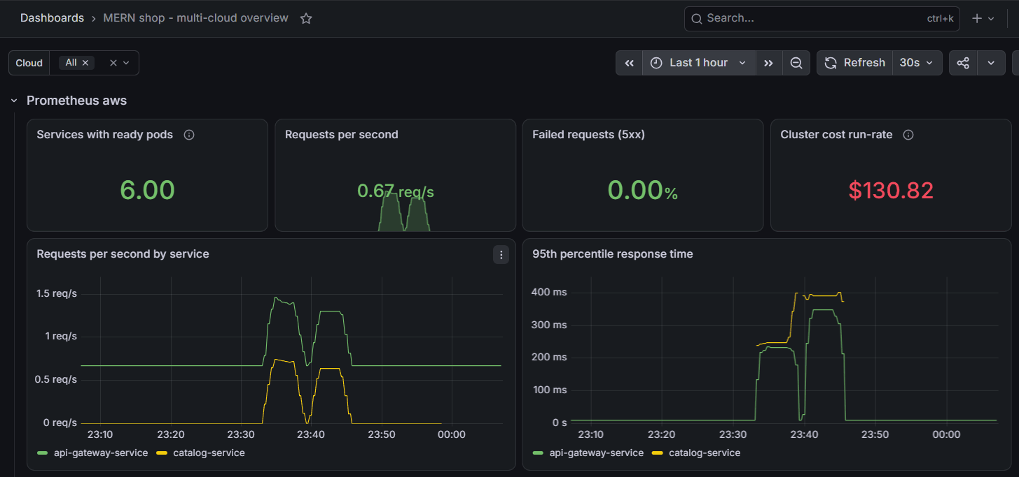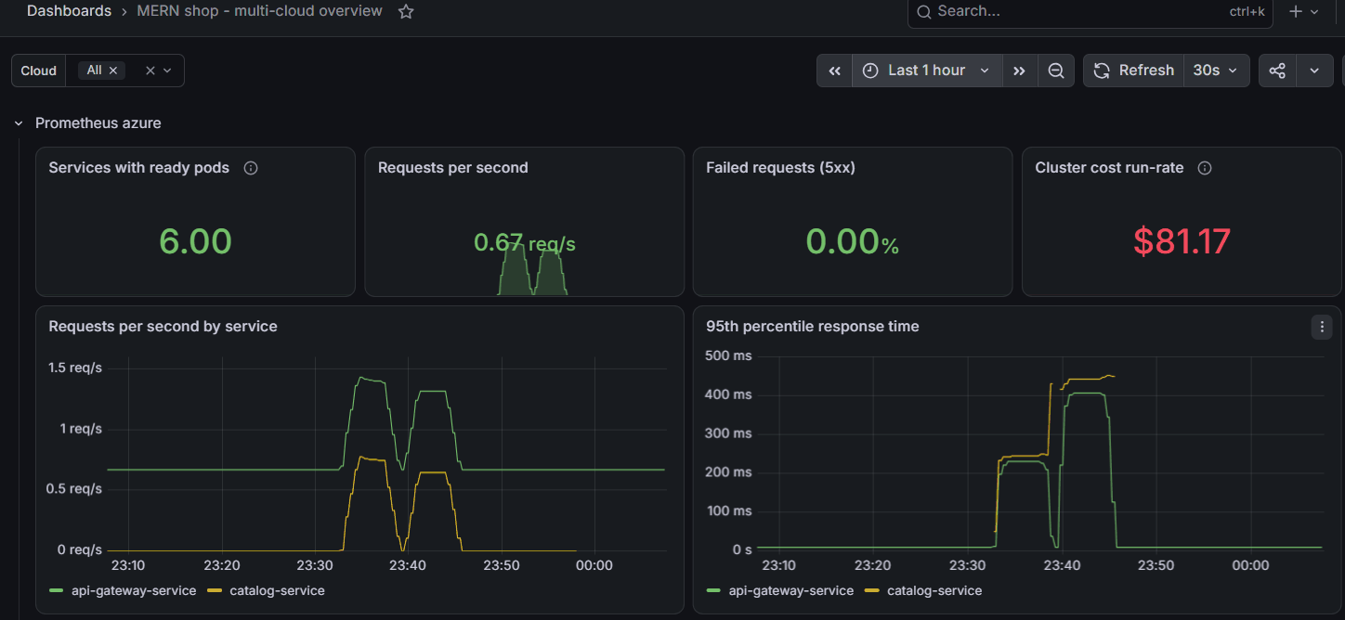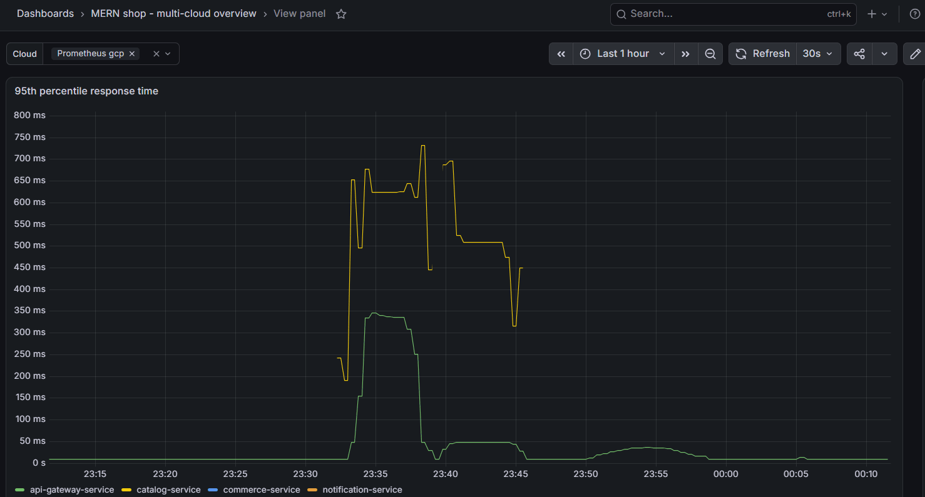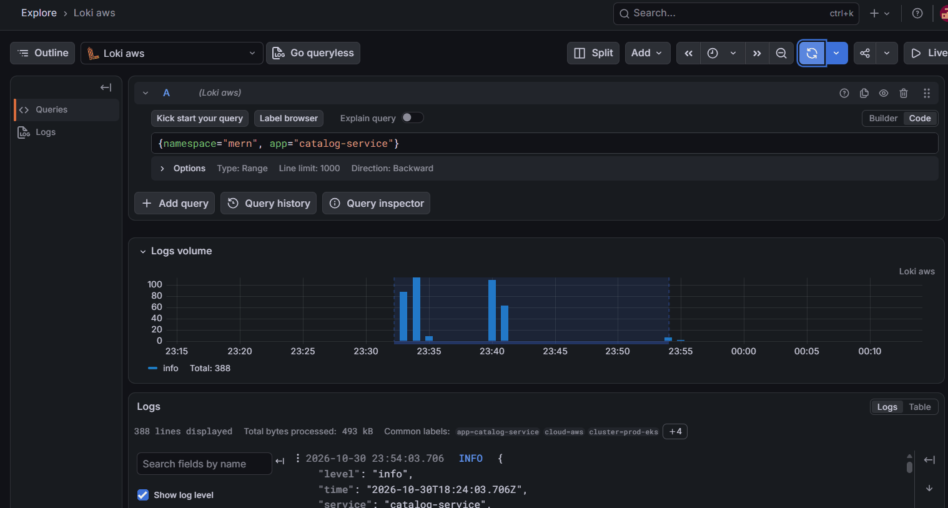
Alert test: catalog-service scaled to 0 in AWS → the AWS pool turned critical, Slack received the Cloudflare pool alert and MernServiceDown — aws; the shop stayed up (served by GCP). Scaled back → RESOLVED.
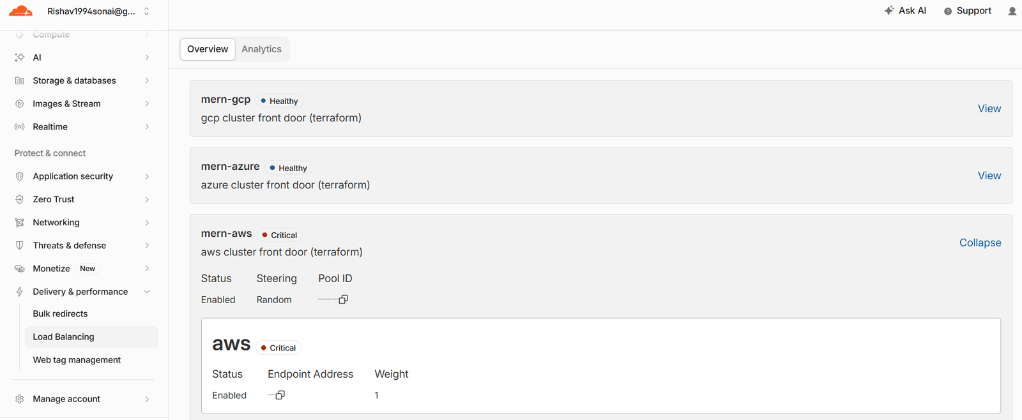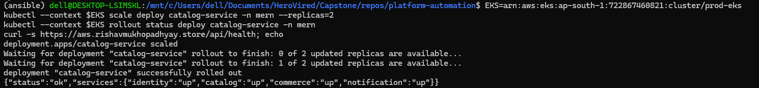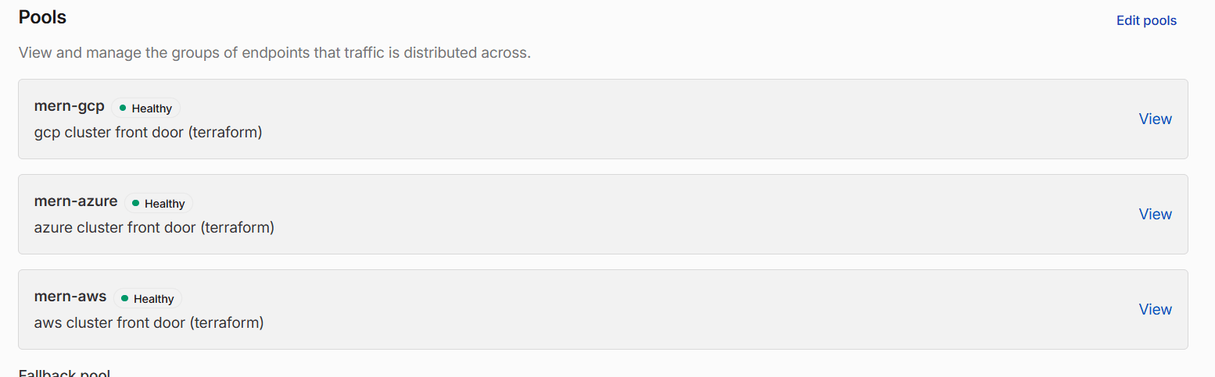
Cost
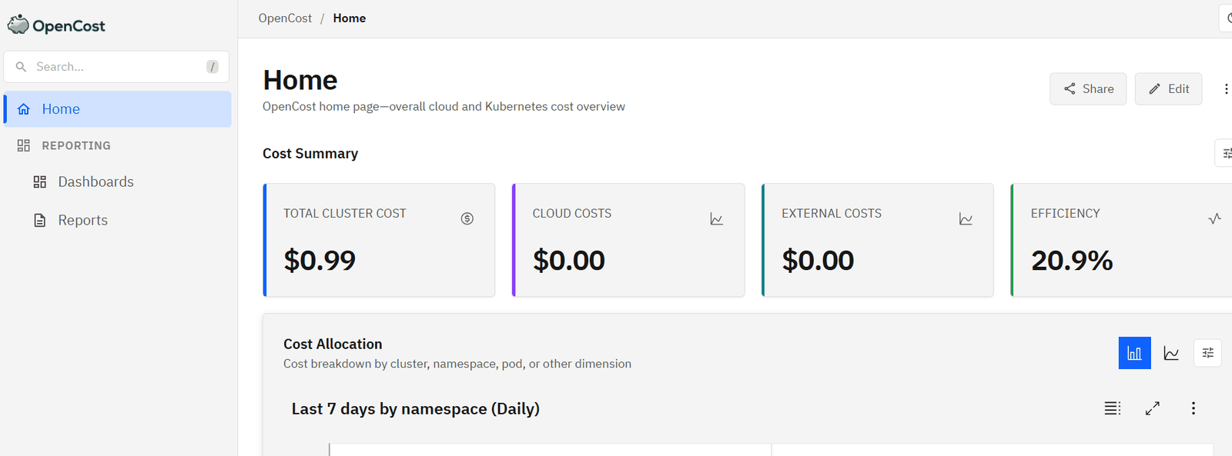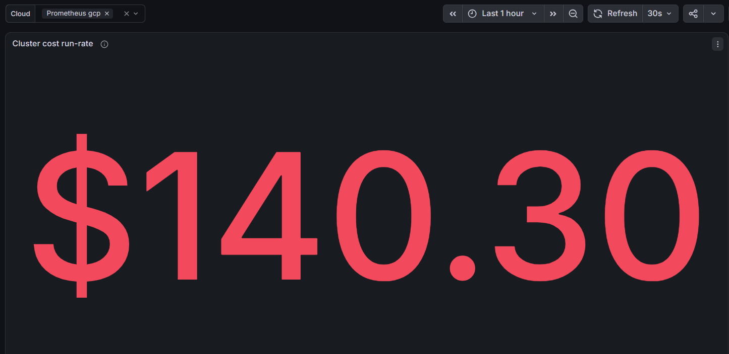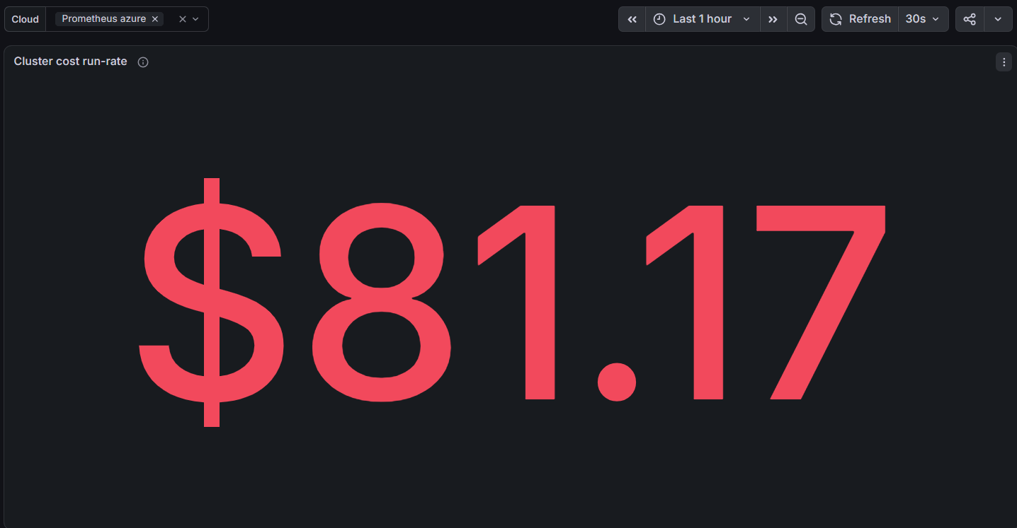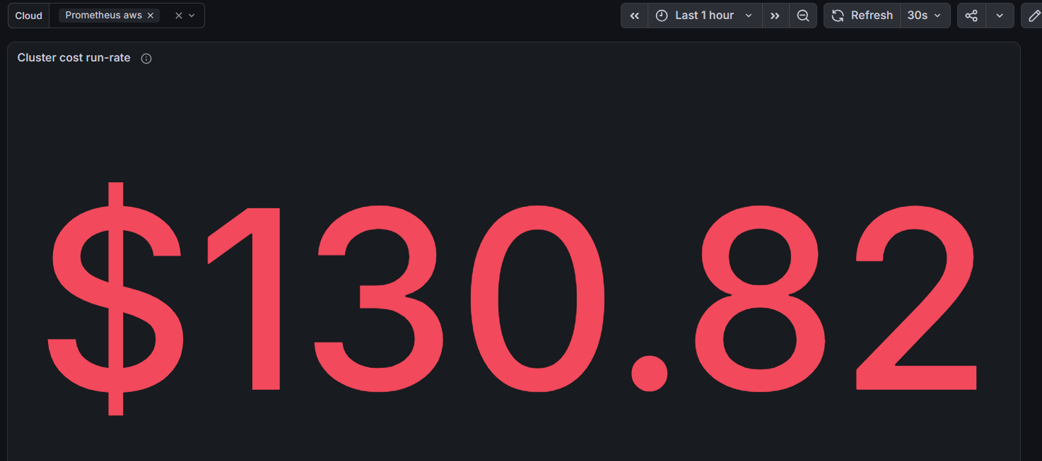

F. Standbys asleep
ansible-playbook playbooks/standby.yml: AKS stopped, EKS node group at 0, GKE still serving.
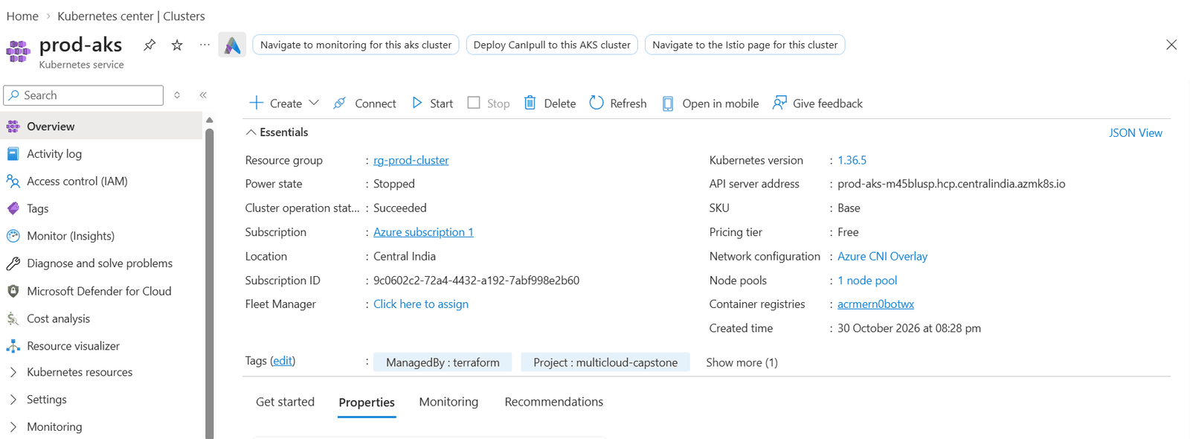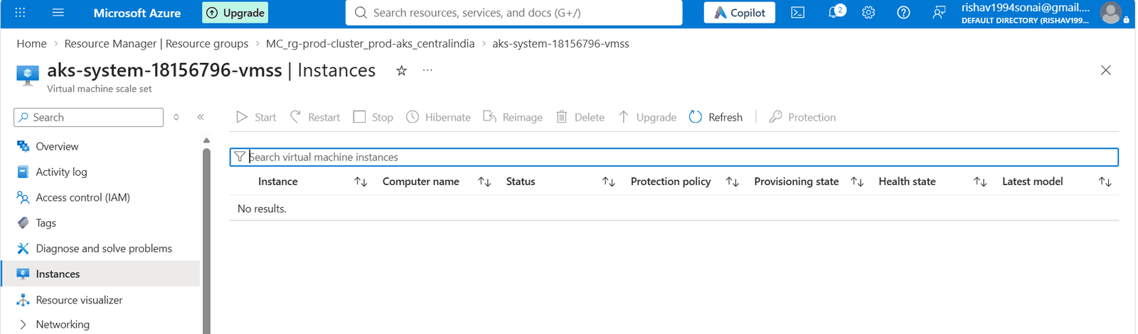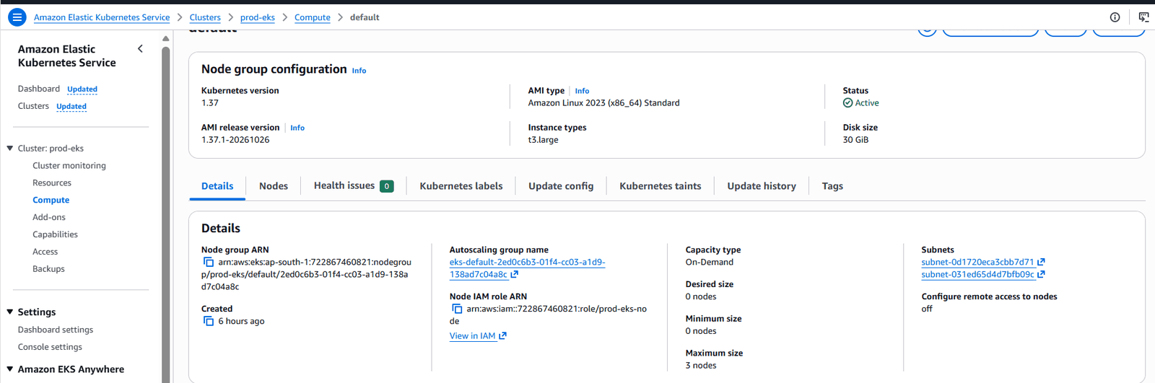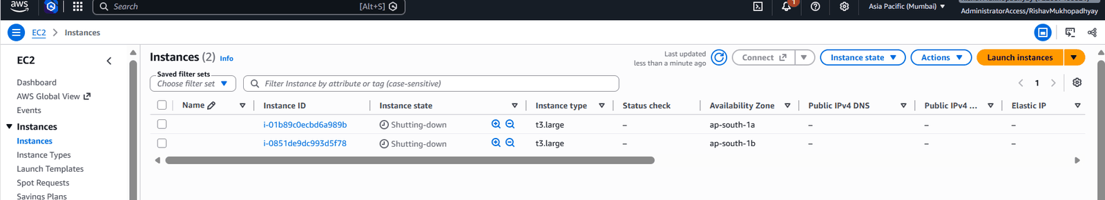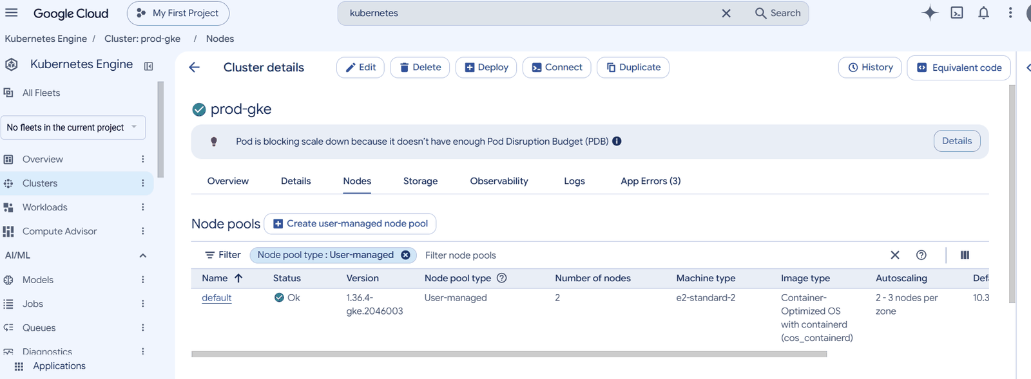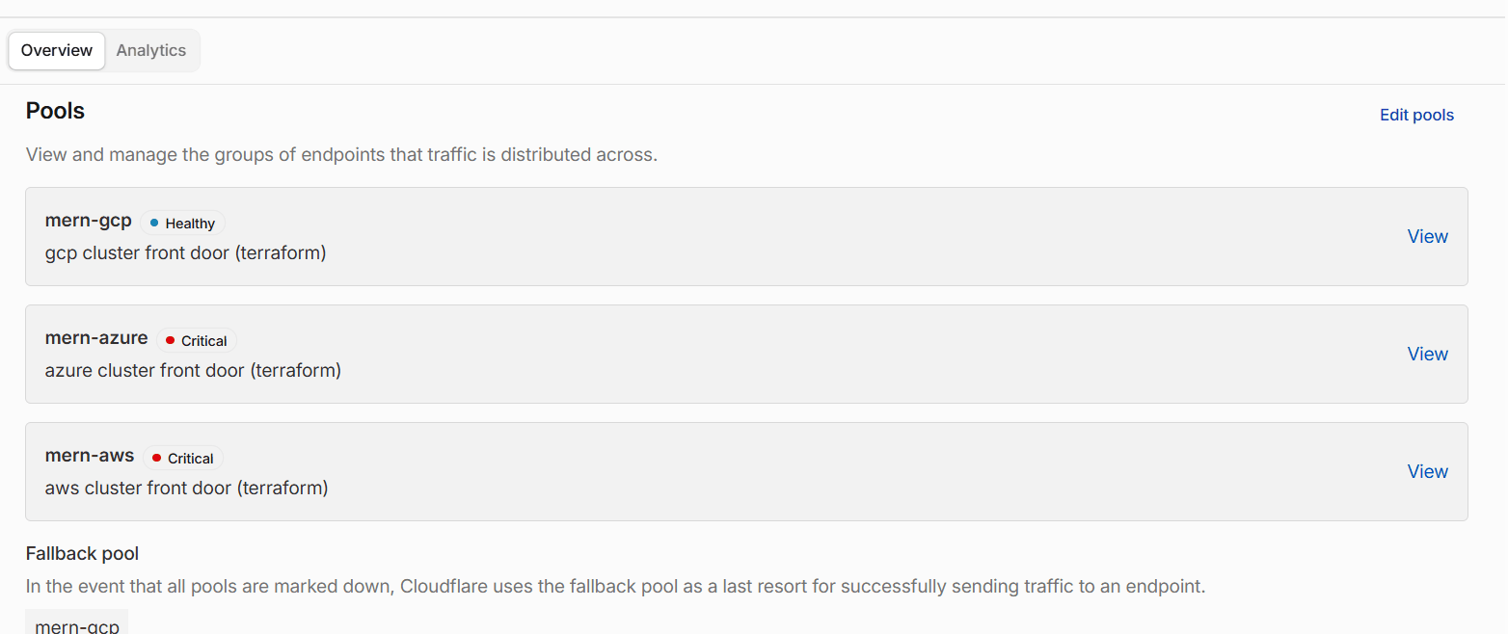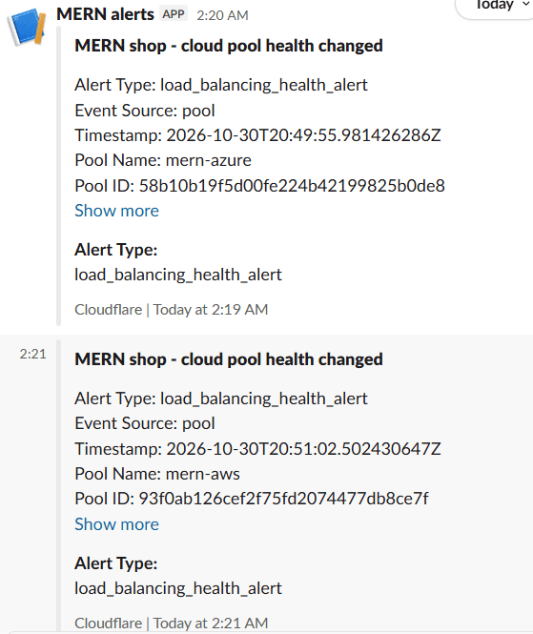
Jenkins deploy-mern with the running tag: GCP deployed, Azure and AWS skipped as sleeping standbys.
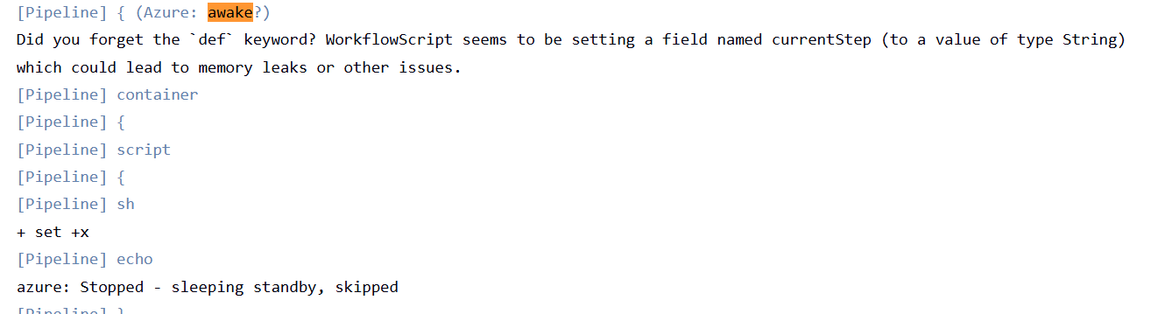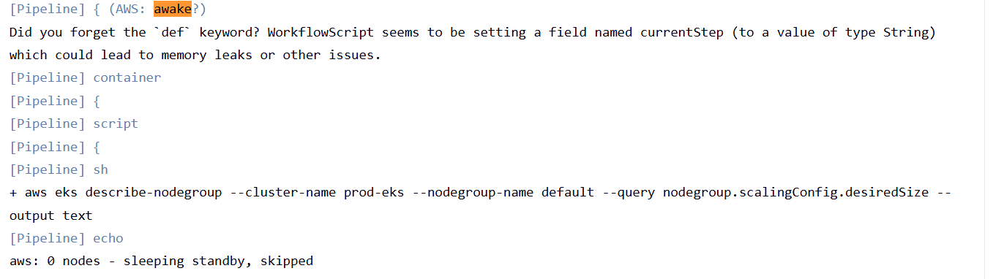

G. Disaster recovery

G1. Backup to three clouds
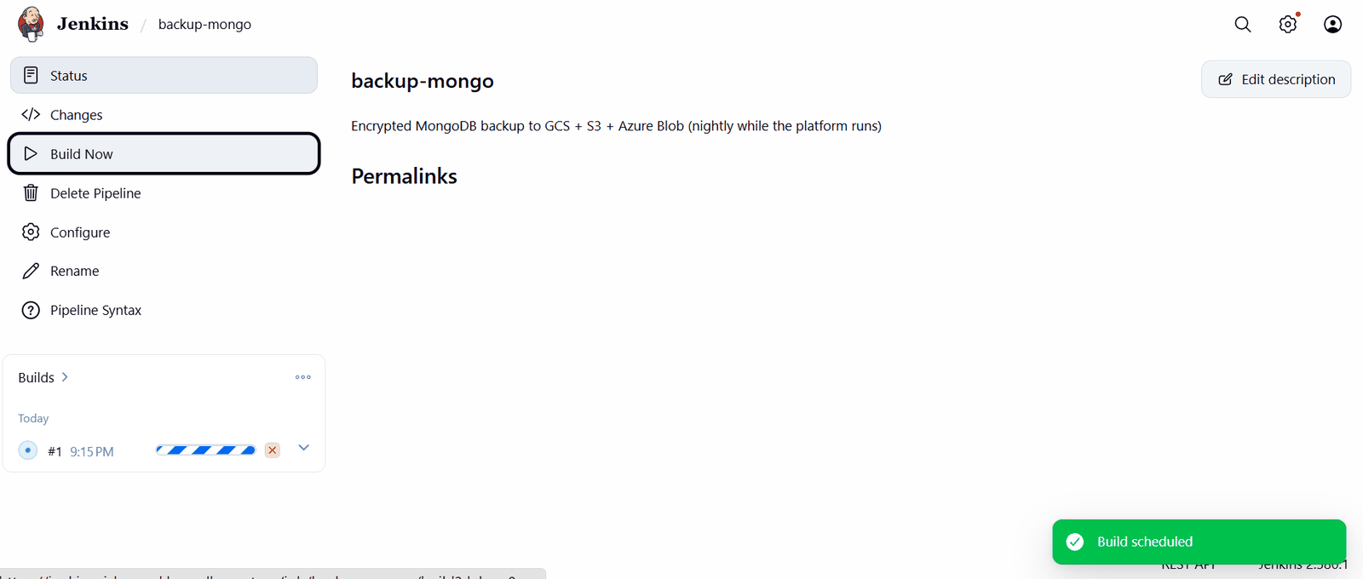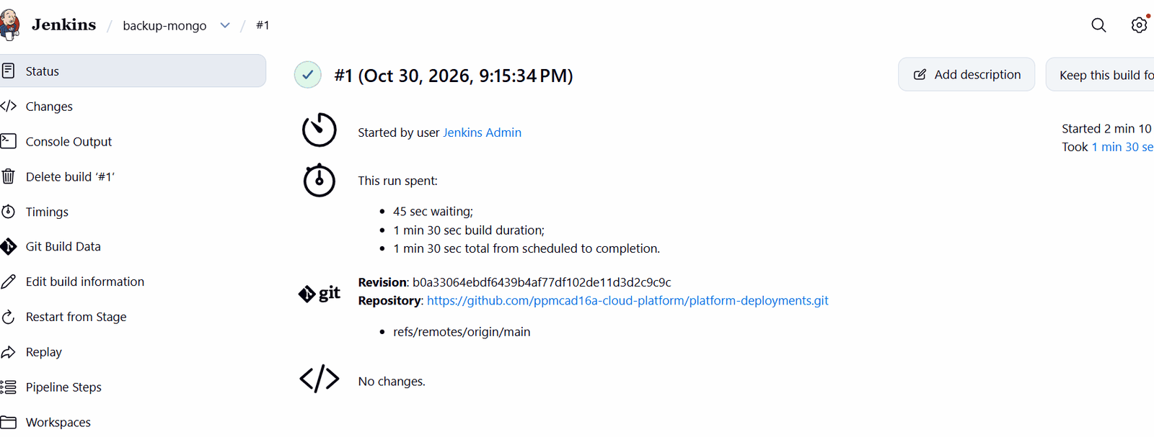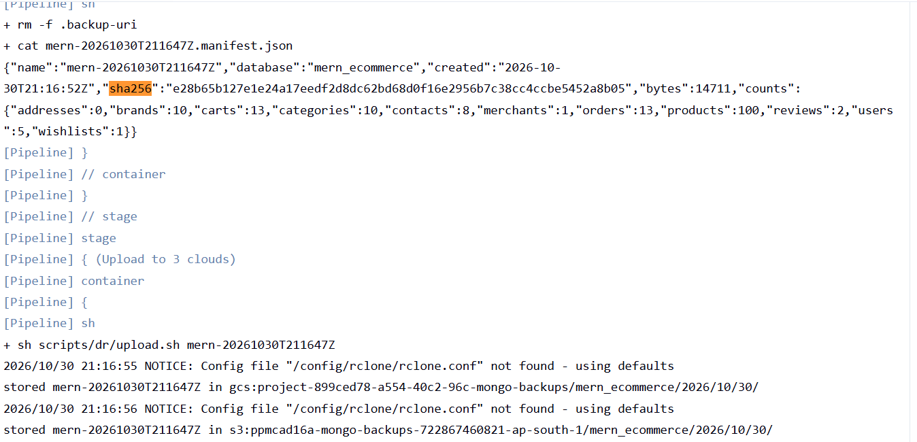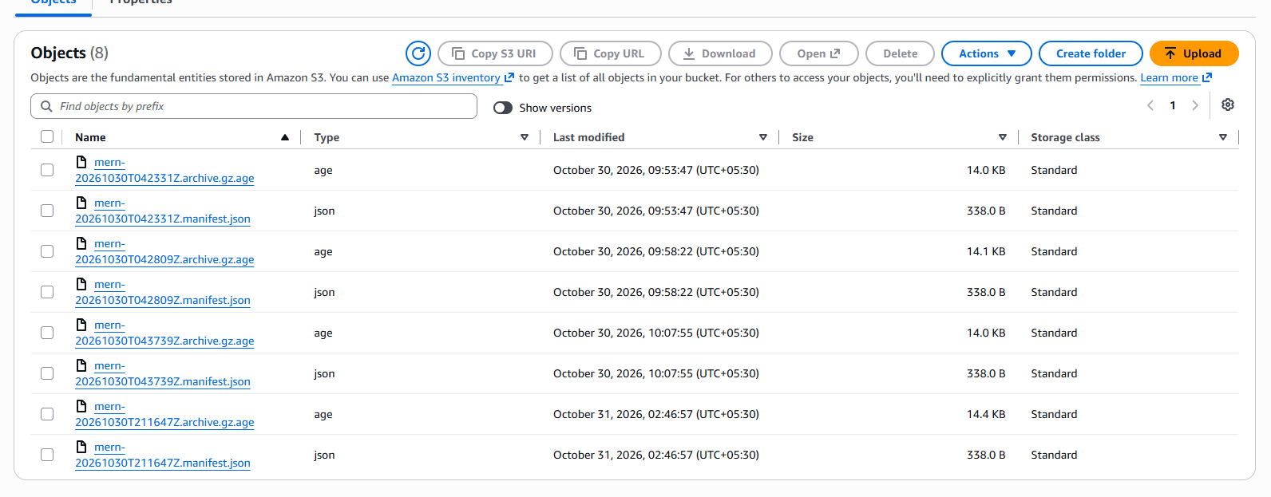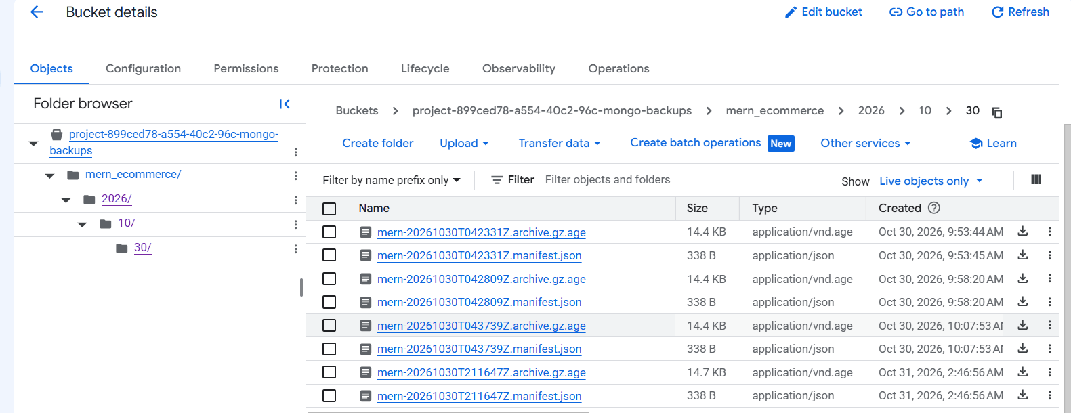

G2. Restore drill from three clouds
ansible-playbook playbooks/drill-restore.yml
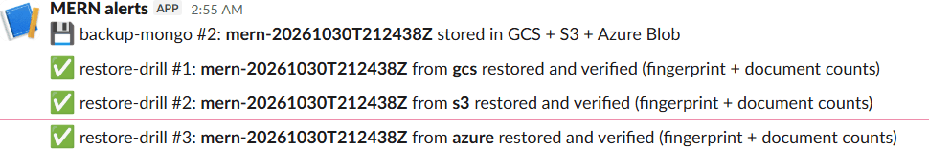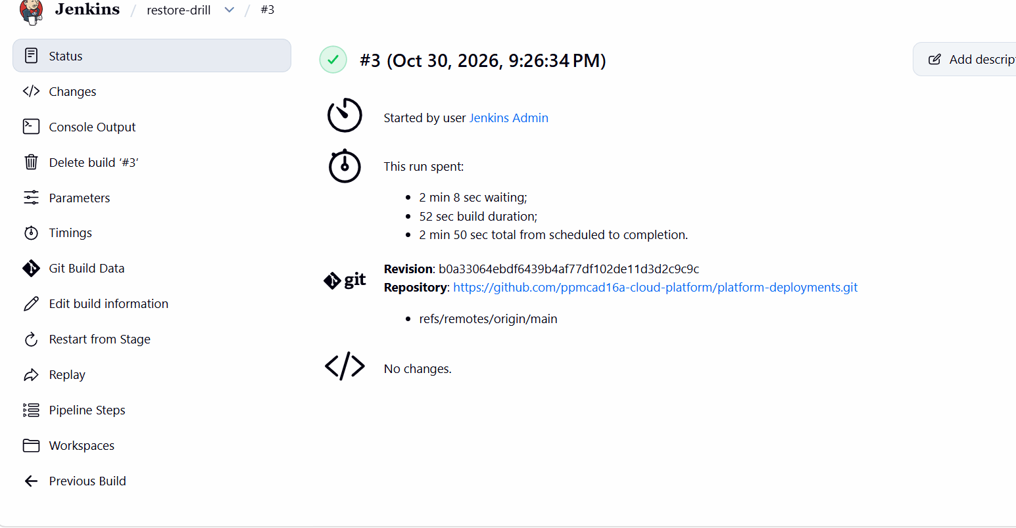

G3. Failover drill: GCP goes down
ansible-playbook playbooks/drill-failover.yml — GCP’s gateway scaled to 0 while both standbys slept; the wake-up was automatic (Cloudflare → Worker → GitHub Actions).
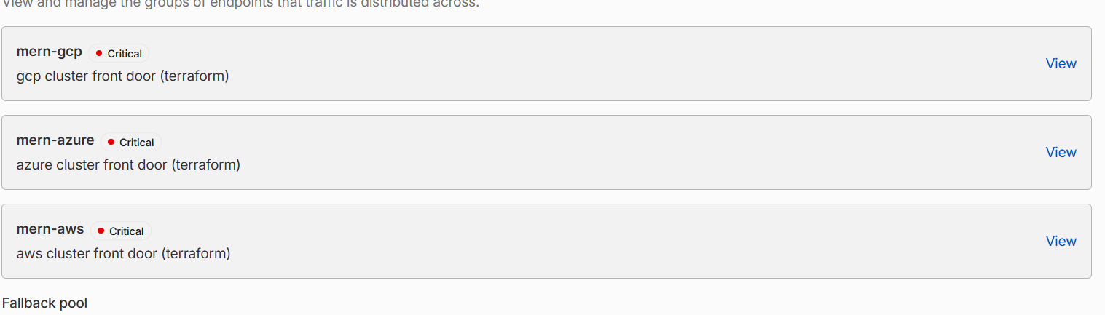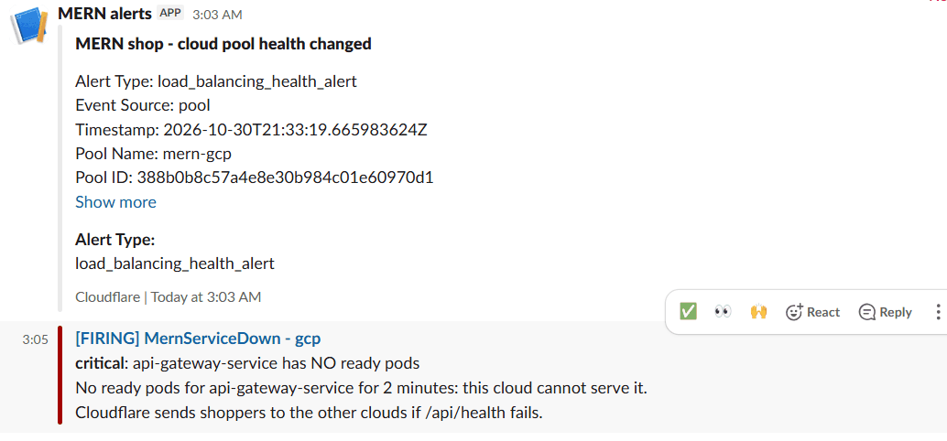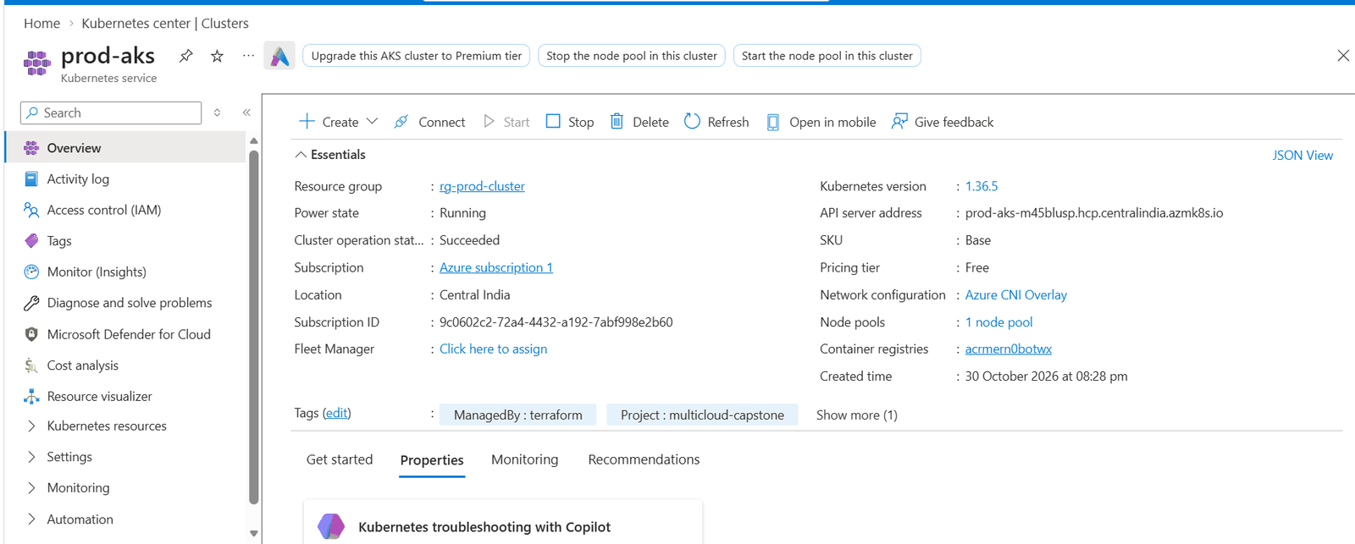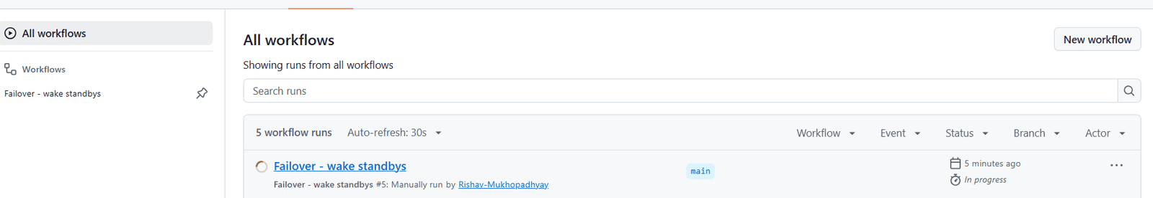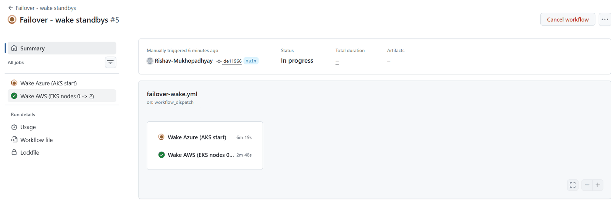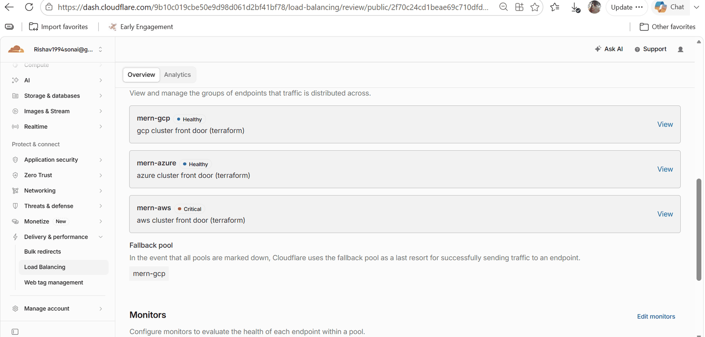

H. Teardown
ansible-playbook playbooks/down.yml — wake standbys → add-ons destroy → state empty → leftover check → cluster destroy, AKS/EKS first, GKE last, then the global layer.
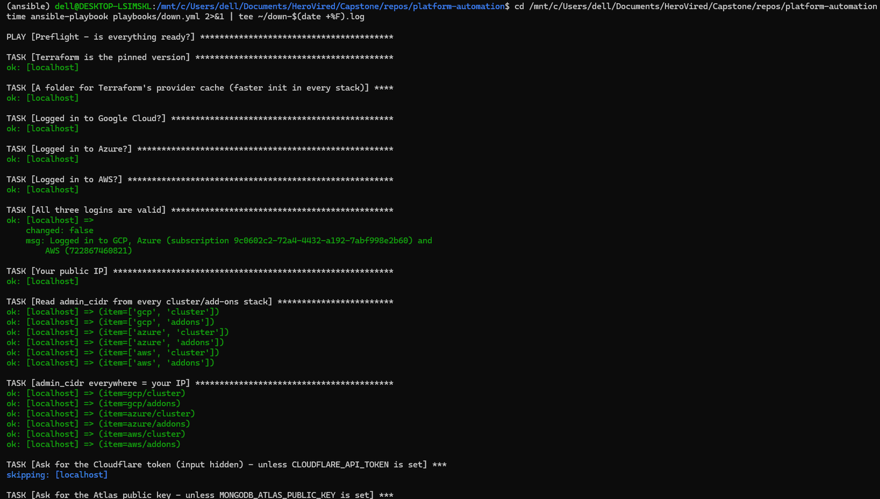
down.yml preflight
The teardown needed four runs because of issues 1–3 and 5 above; each stopped safely with nothing half-deleted. Final state: see the end-of-session check in Runbook §2.

10 — Troubleshooting
Every entry below happened to us. Format: symptom → cause → fix.

Sessions (up.yml / down.yml) and WSL

WSL downloads time out after 30 s
Symptom: terraform plan/destroy of an add-ons stack fails with Error locating chart … release-assets.githubusercontent.com … context deadline exceeded (Client.Timeout exceeded while awaiting headers); only some runs fail. Cause: one of GitHub’s four download addresses (185.199.109.133) was unreachable from the home ISP. Each download picks an address at random; Helm’s client waits 30 s on the dead one. Windows browsers hide the problem by retrying the next address quickly. Diagnose:
for ip in 185.199.108.133 185.199.109.133 185.199.110.133 185.199.111.133; do
curl -s -o /dev/null -w "$ip %{time_connect}s rc=%{exitcode}\n" --max-time 8 \
--resolve release-assets.githubusercontent.com:443:$ip https://release-assets.githubusercontent.com/; done
Fix: pin a working address for the session: echo "185.199.108.133 release-assets.githubusercontent.com objects.githubusercontent.com raw.githubusercontent.com" | sudo tee -a /etc/hosts (WSL rewrites /etc/hosts at restart). Lesson: we first suspected WSL’s DNS relay — measuring connect time per address found the real cause.

AWS steps fail with refresh cached SSO token failed … InvalidRequestException
Cause: the AWS SSO session expired. aws sts get-caller-identity can still pass on cached short-term keys while Terraform cannot renew them, so a failed host drops out of the play and the global layer fails later. Fix: aws sso login --profile HeroviredProfile at the start of every session, then re-run the playbook.

Your IP changed mid-session — kubectl dial tcp …:443: i/o timeout, Atlas IP_ADDRESS_NOT_ON_ACCESS_LIST
Cause: home/hotspot IPs change; the cluster APIs and the Atlas API key only accept the old one. Fix: Runbook §6 — update the six terraform.tfvars, the Atlas API key access list, then re-apply the cluster stacks.

down.yml stops: “Something the add-ons created is still there (k8s-envoygat-…)”
Cause: the AWS Load Balancer Controller was removed before it deleted Envoy’s NLB. The safety stop keeps the cluster so nothing is orphaned. Fix: wait 5 min and re-run, or delete the NLB, its target group and the two k8s-* security groups by hand (Runbook §7).

AWS standby “asleep” but EC2 instances keep running for up to 30 min
Cause: scaling the node group to 0 drains the nodes; PodDisruptionBudgets (minAvailable: 1) refuse to evict the last copy while every node is going away; the termination hook times out after 30 min. Fix: kubectl drain -l eks.amazonaws.com/nodegroup=default --disable-eviction --force --ignore-daemonsets --delete-emptydir-data.

az aks stop → OperationNotAllowed … in-progress start managed cluster operation
Cause: a standby woken by the failover drill was still starting when the drill put it back to sleep. Fix: wait for provisioningState = Succeeded, then stop.

Never run terraform destroy -refresh=false on add-ons
What happened: with a stale GKE token the Helm provider skipped the uninstalls but the state was emptied — releases kept running with no state. Fix: restored the previous state version from the versioned bucket (gcloud storage cp "<obj>#<generation>" <obj>) and destroyed normally. State buckets are versioned exactly for this.

Global teardown blocked by an “update” of cloudflare_notification_policy_webhooks.slack
Cause: the provider plans an update on every run (read-only fields come back empty). Fix: the teardown guard allows [delete, update] for the global stack — never create or replace.

Ansible ANSIBLE_CONFIG ignored / play names with inventory variables fail / strict booleans
Cause: an old export in ~/.bashrc; Ansible 2.21 does not template play names with host variables and requires real booleans in when/until. Fix: sed -i '/ANSIBLE_CONFIG/d' ~/.bashrc; plain-text play names; write conditions like x is defined and x is not none.

CI/CD
Symptom | Cause | Fix
Not authorized to perform sts:AssumeRoleWithWebIdentity | trust expects GitHub’s immutable subject (org id + repo id) | use repo:<org>@<org-id>/<repo>@<repo-id>:ref:refs/heads/main
PR shows “no checks” / startup_failure | caller passes an input the referenced @v2 does not know yet | merge + tag core-cloud-platform first, then re-run
base branch policy prohibits the merge right after gh pr create | checks not registered yet | gh pr merge --squash --delete-branch --auto
Trivy fails on a new CVE | vulnerability published after the last build | update the package; never disable the gate
docker login to ECR gives 400 in Windows PowerShell 5.1 | PS 5.1 pipe re-encodes the token | cmd /c "aws ecr get-login-password … \| docker login … --password-stdin …"
Jenkins awk: command not found | azure-cli image has no awk | use grep/cut/tr
a token visible in a Jenkins log | sh runs with set -x | set +x before commands that use tokens; delete the build
Helm context deadline exceeded, then cannot re-use a name on AKS | images from ghcr.io pulled very slowly in Azure | mirror the images into ACR (up.yml does it)
failover Worker gets 403 from GitHub | fine-grained PAT waiting for org-owner approval | approve it in the org settings

Data and security
Symptom | Cause | Fix
Atlas IP access list contains 0.0.0.0/0 | added by hand in early local development | removed on 31 Oct 2026; only Terraform-managed cluster IPs should remain
backup upload to Azure: 403 on HEAD | rclone reads before writing; the identity is write-only | upload with two REST Put Blob calls (upload-azure.sh)
backup to GCS: bucket check refused | rclone tries to create/check the bucket | RCLONE_CONFIG_GCS_NO_CHECK_BUCKET=true
orphaned AWS EBS volumes after teardown | the EBS CSI policy was detached before the volumes were deleted | depends_on on the policy attachment + leftover check in down.yml
terraform init -upgrade pulled a brand-new provider | upgrade ignores the lock file | always plain terraform init; adopt versions ≥ 14 days old

11 — Limitations and possible improvements
An honest list of what the platform does not do yet, why, and what we would do next.

Known limitations
# | Limitation | Impact | Mitigation today
1 | One shared database (MongoDB Atlas M0, single region in AWS Mumbai) | the database is a shared dependency for all three clouds; the problem statement’s “replicate databases across clouds” is met by encrypted copies, not live replication | nightly encrypted backups in GCS, S3 and Azure Blob + restore drills; RPO ≤ 24 h
2 | Terraform is applied by Ansible from the admin laptop, not by a GitHub Actions pipeline | the problem statement asks for CI/CD of Terraform; changes are reviewed in pull requests but applied by hand | every apply is guarded (plan → check change types → apply that plan); the GitHub plan/apply identities already exist in each bootstrap/
3 | Jenkins and the central Grafana run in GKE (the primary) | during a GCP outage there is no automatic deploy and no central dashboard | break-glass deploy.yml; each cloud’s Alertmanager still alerts Slack
4 | Backups run only while the platform is up (Jenkins cron) | no backups between sessions (nothing is written then either) | backup-on-demand job; take one before down.yml if data changed
5 | notification-service keeps Socket.IO chat state in memory | runs as 1 replica per cloud; a restart drops open chat sessions | —
6 | Waking a standby takes minutes (RTO 3 min 42 s, Azure ≈ 6 min) | a GCP outage is visible to shoppers for a few minutes | deliberate cost trade-off (−60 % node cost)
7 | Failover Worker uses a fine-grained personal access token | a long-lived secret (scoped to one repo, actions:write) | stored only in GCP Secret Manager and as a Worker secret
8 | No Cloudflare WAF custom rules / rate limiting | only Cloudflare’s built-in DDoS protection | origins accept only Cloudflare IPs
9 | Standby sleep issues found in the final test | AWS sleep can take 30 min (PDB drain); stopping an AKS that is still starting fails | manual commands in the runbook
10 | Teardown can leave an AWS NLB behind | down.yml stops safely; manual cleanup needed | leftover check + runbook §7
11 | Zero downtime proven on 29 Oct 2026, not in the final test | the final-test probe stopped before the deploy started | repeat the CI/CD test with the probe running for the whole deploy

Possible improvements
Priority | Item | Why
1 | Fix standby sleep: drain AWS nodes with --disable-eviction and wait until instances are terminated; wait for an in-progress AKS start before stopping | correct “asleep” state, no hidden cost
2 | Order the AWS add-on teardown so the LB Controller removes Envoy’s NLB before it is uninstalled | down.yml without manual cleanup
3 | Preflight checks for the Atlas API key access list, the current IP and GitHub download reachability; correct per-cloud task labels | catch problems in seconds instead of mid-run
4 | Terraform plan on every pull request and apply after approval via GitHub Actions (identities exist) | full GitOps for infrastructure
5 | Replace the PAT with a GitHub App installation token | no long-lived personal token
6 | Atlas on a dedicated tier with multi-region / multi-cloud nodes | live database replication across clouds
7 | Move Jenkins (or a second runner) and Grafana out of the primary cloud | CD and central monitoring survive a GCP outage
8 | Redis adapter for Socket.IO | notification-service can scale beyond 1 replica
9 | Cloudflare WAF managed rules and rate limiting (paid plan) | application-layer protection

