Documentation

OMEGA2000 Observing Utilities

René Fassbender • June2003

Contents

General Remarks

- Focus Routine

- Observing Macros
  - Normal observations
  - Observations of extended objects

- Flatfields

- Tip-Tilt Determination

Hyperlinks

General_Remarks
1) Focus_Routine
2) Observations
a) Normal_observations
b) Observations_of_extended_objects
3) Flatfields
4) Tip_Tilt_Determination

General Remarks:

• All functions are MIDAS procedures and have to be called from an active MIDAS session. The context “omega2k.ctx” has to be set for the definition of the utility short-cut commands o2k/command.

• All routines can be paused during the data acquisition process by pushing the PAUSE-button in the instrument GUI. The data acquisition is continued by pushing the PAUSE-button a second time.

• All routines can be aborted during the data acquisition process be pushing the ABORT-button in the instrument GUI. The routines check after every image whether the data acquisition has been aborted, i.e., it can take up to a full integration time before the macro is actually aborted. During data acquisition, the macros should only be terminated using the ABORT-button; Ctrl-C would possibly cause instrumentation problems. Outside the data acquisition loop, Ctrl-C can be used to abort the current MIDAS routine.

• All routines use the environment variable O2K_UTIL which points to the directory o2k_utilities. All paths are defined relative from this top level directory.

- Focus Routine

Quick Start:

!+++++++++++++++++++++++++++++++++++++++++++++++++++++++++++++++++++++++++++++++
! .COPYRIGHT (C) MPIA
! .IDENT omega_focus.prg
!
! .CALL o2k/focus [root] [start_index] [focus,step] [ima_number]
! [itime_total,single] [action_flag] [object_number] [boxsize]
!
! .PARAMETERS P1=root: root name for images, if omitted filename in GUI is used
! (for auto-name-finding-->4 digits before .fits are expected)
! P2=index: index of first image in series --> ima_name = root0001
! P3=focus [focus,step]: estimated focus value, stepsize
! both in microns
! P4=number: number of images for focus series
! P5=itime [total,single]: total integration time, single int_time
! P6=action: action_flag,graph_output
! action_flag --> 0=take images, anylize, focus telescope
! 1=analize only
! 2=analize and focus telescope
! 3=take images and analize
! graph_output--> 0=only final graph is shown
! 1=show all 4 graphs
! P7=objects: number of objects for find_object routine
! P8=boxsize: total boxsize in arcsecs around found objects
!
! .PURPOSE A procedure that determines the best focus for OMEGA2000
! .ENVIRONMENT MIDAS
! .AUTHOR Rene Fassbender
! .KEYWORDS telescope focus
! .COMMENTS PRG has to be started in directory where images are stored
! This version uses an automatic "find object" routine
! I in addition, the selection proccess is automated
! Three selections will be used:
! 1) object classification of "find_object"
! 2) check for saturated objects
! 3) galaxy check with an intensity plot
! The final plot is saved under: ‘masterframe’_plot.ps.
!
! The routine can also be called in a different way:
! @@ O2K_UTIL:/obs_macros/Focus/omega_focus
!+++++++++++++++++++++++++++++++++++++++++++++++++++++++++++++++++++++++++++++++

Function Call:
o2k/focus [root] [start_index] [focus,step] [ima_number] [itime_total,single]
[action_flag] [object_number] [boxsize]

Remark: “o2k/focus” is an OMEGA2000-context command which calls the routine “omega_focus.prg”. The focus routine can also be called without the context command in the following way: @@ O2K_UTIL:/obs_macros/Focus/omega_focus

Defaults:
root = automatic take name from GUI
(start_index = 0001 only if not automatic)
focus = 24000,200 estimated focus=24000 microns, step size=200
number = 7 take 7 images
itime = 20,2 20 secs total integration, 2 secs single integration
action = 0,1 take, analyze, and move focus ; show all graphics
objects = 40 search about 40 objects
boxsize = 18 total boxsize in arcsecs around objects for analysis

Examples:
• o2k/focus focus=23500,200 number=7 itime=10,1

Use 7 different focus positions centered around 23500 microns with offsets of 200 microns. The total integration time per image is 10 seconds, which consist of 10 co-added 1 second exposures. The image name in the GUI is used for the filenames.

• o2k/focus foc_H 4 24000,200 7 20,2 1

Use the seven images with names foc_H0004.fits – foc_H0010.fits for the focus analysis only. The best estimated focus was 24000 microns. The integration time is in this instance only used to compute a saturation cutoff for the object selection.

• o2k/focus help
Shows help text.

• o2k/focus prompt
Inquires all parameters interactively.

Parameters:
external (command line parameters)

P1 = root
Root name of all relevant images. The full image name is expected to consist of the root and a 4 digit index, e.g., foc_H0001.fits with root=foc_H. The indices of the input images must be consecutive numbers.
If no root is specified, the current image name in the instrument GUI is used as filename. This mode is only possible if new focus test exposures are taken.

P2 = index
Index of the first image, i.e., the image with the lowest focus setting.

P3 = focus [estimated focus, step size]
Best estimated focus in microns and focus offsets between two test exposures in microns.

P4 = number
Total number of images for the focus analysis. The input has to be a odd number larger than 3. If an even number is specified, it will be converted to the next odd number.

P5 = itime [total integration time per image, single integration time]
Integration times in seconds. The first number specifies the total integration time per image, the second one the integration per single exposure, which will be co-added to yield one integrated image.

P6 = action [action_flag, graphics_output]
Two integers that specify the action taken and the feedback to the user:
action_flag = 0 → all actions carried out: image taking, analysis, best focus adjustment
1 → do only image analysis; no instrument and telescope commands sent
2 → analyze images and adjust focus to the best setting
3 → take images and analyze

graphics_output = 0 → show only final graph
1 → show all graphs including the selection process

P7 = objects
Approximate number of objects to be searched for and analyzed. The default value of 40 is appropriate for fields with enough stars. For sparse fields, the parameter may be set to lower values.

P8 = boxsize
Total boxsize in arcseconds around objects for the objects analysis. The default value should be working in most cases.

internal
The routine contains three internal parameters which are defined at the beginning of the routine:
Pixel saturation: Maximum count level per single image exposure in the linear detector regime.
Minimum and maximum galaxy cutoff parameters: The empirical FWHM cutoff parameters for the final object selection step.

Functionality:
The following flow chart demonstrates the principal structure of the focus routine:

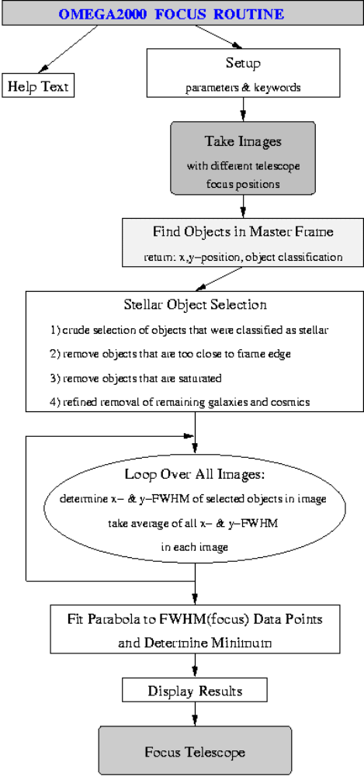
Graphics output:
A total of 4 graphs is plotted during the object analysis process:
- A x- and y-FWHM histogram of all found objects
- An FWHM vs. Intensity plot with the used cutoffs
- The FWHM histogram of the selected objects
- The final plot with the x- and y-focus parabola and values for the best focus and the seeing. This plot is automatically saved as .ps file, with the filename corresponding to the name of the masterframe.

The first three graphs can be suppressed be setting the graphics_output flag to 0.

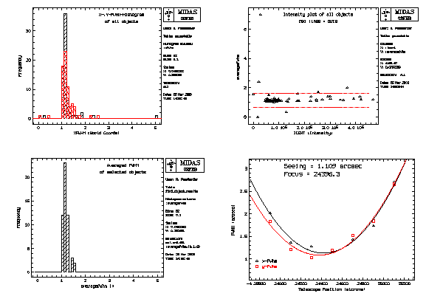

- Observations

Two different observing macros are provided: One for dithered observations of “sparse” fields, with sky determination from the science frames, and a second macro for alternate observations of an extended object and a designated sky field.

  - Normal observations

Quick Start:

!++++++++++++++++++++++++++++++++++++++++++++++++++++++++++++++++++
! .COPYRIGHT (C) MPIA
! .IDENT dither_pointing.prg
!
! .CALL o2k/dither icatalog itime=[tot_pointing,tot_single,single] object
! start_pos pointing offsets
! .PARAMETERS
! P1=icatatlog = name of image catalog for images
! P2=itime=intergration time in seconds:
! tot_pointing,tot_single,single
! tot_pointing = total integration time for pointing
! tot_single = total integration time for one image
! single = integration time of a single readout
! P3:object = object name for identifier
! P4:start_pos = continue dither pattern at this position
! (telescop has to be in position n-1)
! P5:pointing = pointing number to be stored in descriptor POINT_NO
! P6:offsets = flag for integer or non-integer pixels offsets
! 0 = integer pixel offsets ; 1 = non-integer offsets
!
! .PURPOSE A procedure to take dithered images for one pointing
! with OMEGA2000
! .ENVIRONMENT MIDAS
! .AUTHOR Rene Fassbender
! .KEYWORDS dithering, pointing
! .COMMENTS An image catalog is opened, which will contain all images taken.
! The procedure will use the image names, filter etc specified in the
! GUI. At the current observing position, a dithered image pattern
! for the specified total integration time will be taken. A single
! dither pattern contains 20 observing positions, after that the
! pattern will be repeated with a slight offset for the first image.
! The area with no overlap is maximally 25 arcsecs on each side.
!
!+++++++++++++++++++++++++++++++++++++++++++++++++++++++++++++++++

Function Call:
o2k/dither icatalog itime=[tot_pointing,tot_single,single] object
start_pos pointing offsets

Remark: The actual routine is called “dither_pointing.prg” and can also be called by:
@@ O2K_UTIL:/obs_macros/dither_pointing.

Defaults:
icatalog no default
itime no default
object_identitfier no default
start_pos = 1 start at first dither position
pointing = 1 pointing identification number for header
offsets = 0 use pixel integer offsets for the dither pattern

Examples:
• o2k/dither QSO_H 3600,30,5 “quasar at z=1.5” ? 4
Take 5 second exposures and add them up in memory to 30 second integrated images. The total integration time is 3600 seconds. The dither pattern starts at the default start position, the descriptor POINT_NO will contain the value 4. The name of the image catalog created is “QSO_H.cat”, the descriptor IDENT of all images will contain “quasar at z=1.5”.

• o2k/dither icat=field_A itime=1000,20,2 object=”field A” start_pos=35 pointing=8 offsets=1
Take 2 second exposures and add them up in memory to 20 second integrated images. The total integration time is 1000 seconds. The dither pattern continues at position 35, with non-integer dither offsets. The descriptor POINT_NO will contain the value 8. The name of the image catalog created is “A_field.cat”, the descriptor IDENT of all images will contain “field A”.

• o2k/dither help
Help text.

Parameters:
external

P1 = icatalog
Name of image catalog that contains a list of all taken images. The name of the image catalog is automatically passed on to the pipeline and can be used for online data reduction. If no online or further pipeline reduction is desired, this parameter is just a dummy. For online reductions, the icatalog parameter should by specified with distinct names to prevent pipeline reduction of the wrong data set.

P2 = itime [tot_pointing,tot_single,single]
Integration times in seconds.
tot_pointing is the total integration time for the pointing. This parameter determines the final limiting magnitude of the pointing. Tot_pointing/tot_single images are take at different dither positions.
tot_single is the time for one integrated image, which is equivalent to the integration time at a one dither position. Tot_single/single exposures are added up in memory before the final single image with an integration time of tot_single-seconds is saved on disk.
Single is the a single exposure integration time. This parameter is to be optimized for each filter to allow background limited observations while being within the linear detector regime.
Note: To prevent truncation errors when calculating the number of repetitions, tot_pointing should be a multiple of tot_single, and tot_single should be a multiple of single.

P3 = object_identitfier
Character string for the IDEND descriptor. If blanks are contained, the string should be enclosed in “ ”.

P4 = start_pos
Start position of the dither sequence. This parameter allows the continuation of the dither pattern at a specified position after an interruption. The telescope is expected to be in the (start_pos-1)th position, from where the dither pattern is continued with the next position.

P5 = pointing
Identification integer for the descriptor POINT_NO. Can be used for easier data identification.

P6 = offsets
Flag for dither offset mode.
offsets=0 → the offsets will integer multiples of the pixel scale
offsets=1 → non-integer offsets are used for the dither offsets.
The standard mode should be integer offsets because it facilitates a later summation of several images by appropriate xy-shifting.

internal
The keyword file_path defined as the first keyword in the PRG contains the path information for the pipeline auxiliary files. In online-mode, the pipeline searches this path for all relevant information.
Dither Pattern:
The dither pattern in the figure below is used for all observations. The actual pattern consist of 20 different positions (blue stars) with typical offsets of 20-30 arcsecs. After 20 images, the origin is shifted by 5-10 arcsec (red diamonds) before the blue pattern is started again. This way, 400 different positions are defined, after which the pattern starts back at position 1.
Note: The positions of the primary dither pattern (blue stars) are all within a square of 20 arcsecs radius from the origin, the shifted origins for the secondary pattern (red diamonds) are within a square of radius 5 arcsecs from the origin. Thus, the maximal “waste” area at the edge, where not all images overlap, is 25 arcsecs at each side. The effective central observing area, where all images overlap, is a minimum of 14.5x14.5 arcminutes for any number of dither positions used.

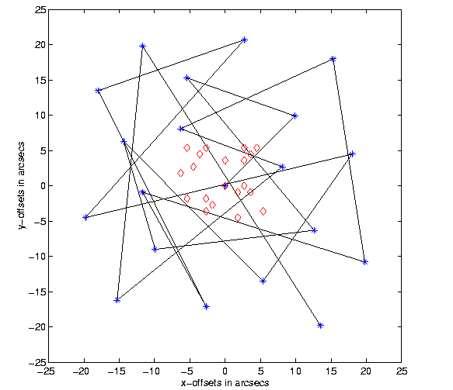

Comments:
The observing macro prepares the online pipeline data reduction. The name and path of the image catalog and the integration time are stored in auxiliary files, which can be accessed by the pipeline. The image catalog is updated with the name and path of the latest image after every integration.

b) Observations of extended objects

Quick Start:

!++++++++++++++++++++++++++++++++++++++++++++++++++++++++++++++++++
! .COPYRIGHT (C) MPIA
! .IDENT sky_pointing.prg
!
! .CALL
! o2k/sky_point icatalog itime=[tot_pointing,tot_single,single,tot_single_sky]
! move direction object start_pos pointing offsets
!
! .PARAMETERS
! P1=icatatlog : name of image catalog for images
! P2=itime : intergration time in seconds:
! tot_pointing,tot_single,single
! tot_pointing = total integration time for pointing
! tot_single = total integration time for one image
! single = integration time of a single readout
! tot_single_sky = total integration time for sky exposure [default=tot_single]
! P3=move : arcmin from object to move telescope to
! P4=direction : direction for sky --> N,S,W,E or ALL
! all will use 8 different direction at "move distance"
! P5:object = object name for identifier
! P6:start_pos = continue dither pattern at this position
! (telescop has to be in position n-1)
! P7:pointing = pointing identication number for descriptor POINT_NO
! P8:offsets = flag for integer or non integer pixel offsets
! 0 = integer pixel offsets ; 1 = non-integer offsets
!
! .PURPOSE A procedure to take alternately dithered images and sky
! with OMEGA2000
! .ENVIRONMENT MIDAS
! .AUTHOR Rene Fassbender
! .KEYWORDS dithering, pointing, sky
! .COMMENTS An image catalog is opened, which will contain all images taken.
! The procedure will use the image names, filter etc specified in the
! GUI. At the current observing position, a dithered image pattern
! for the specified total integration time will be taken.
! After each saved image (tot_single secs) the telescope is moved
! to the designated sky position. A sky image is taken with the
! designated integration time and the same dither pattern. A single
! dither pattern contains 20 observing positions, after that the
! pattern will be repeated with a slight offset for the first image.
! The area with no overlap is maximally 25 arcsec on each side.
! The pattern can be continued at position 'start_pos'
!
!++++++++++++++++++++++++++++++++++++++++++++++++++++++++++++++++++
Function Call:
o2k/sky_point icatalog itime=[tot_pointing,tot_single,single,tot_single_sky] move direction object start_pos pointing offsets

Remark: The actual routine is called “sky_pointing_new.prg” and can also be called by:
@@ O2K_UTIL:/obs_macros/sky_pointing_new.

Defaults:
icatalog no default
itime no default
move = 30 sky position is at a distance of 30 arcmin from object
direction = all use 8 different sky positions around object
object_identitfier no default
start_pos = 1 start at first dither position
pointing = 1 pointing identification number for header
offsets = 0 use pixel integer offsets for the dither pattern

Examples:
• o2k/sky_point M51 3600,30,5 20 N “M51 in J” ? 2

Take 5 second exposures and add them up in memory to 30 second integrated images. The total integration time for the object is 3600 seconds. The integration time for the sky observations is not specified, thus the same values as for the object are used. The sky images are taken 20 arcmin North of the object. The dither pattern starts at the default start position, the descriptor POINT_NO will contain the value 2. The name of the image catalog created is “M51.cat”, the descriptor IDENT of all images will contain “M51 in J”.

• o2k/sky_point icat=field_A itime=1000,20,2,10 move=10 direction=ALL object=”field A” start_pos=35 pointing=8 offsets=1

Take 2 second exposures and add them up in memory to 20 second integrated images. The total integration time for the object is 1000 seconds. The total integration time for a single sky image is set to 10 seconds, thus five 2-second exposures are co-added in memory for the sky. The sky images are taken 10 arcmin away from the object at 8 different positions. The dither pattern starts at position 35 with non-integer pixel offsets, the descriptor POINT_NO will contain the value 8. The name of the image catalog created is “field_A.cat”, the descriptor IDENT of all images will contain “field A”.

• o2k/sky_point help
Help text
Parameters:
external
Compared to the macro for normal observations, three additional parameters have to be specified for observations of extended objects: the distance and direction of the designated sky field from the object and the integration time for a single sky exposure.

P1 = icatalog
Name of image catalog that contains a list of all taken images. The name of the image catalog is automatically passed on to the pipeline and can be used for online data reduction. If no online or further pipeline reduction is desired, this parameter is just a dummy. For online reductions, the icatalog parameter should by specified with distinct names to prevent pipeline reduction of the wrong data set.

P2 = itime [tot_pointing,tot_single,single, tot_single_sky
Integration times in seconds.
tot_pointing is the total integration time for the pointing. This parameter determines the final limiting magnitude of the pointing. Tot_pointing/tot_single images are take at different dither positions.
tot_single is the time for one integrated image, which is equivalent to the integration time at a one dither position. Tot_single/single exposures are added up in memory before the final single image with an integration time of tot_single-seconds is saved on disk.
single is the a single exposure integration time. This parameter is to be optimized for each filter to allow background limited observations while being within the linear detector regime.
tot_single_sky is the total integration time for a single integrated sky exposure. If this parameter is omitted, the object integration times will also be used for the sky. The total integration time for sky observations is the fraction tot_single_sky/ tot_single of the total object observation time.
Note: To prevent truncation errors when calculating the number of repetitions, tot_pointing should be a multiple of tot_single, and tot_single should be a multiple of single. The single exposure time single is also used for the sky observations, thus tot_single_sky should also be a multiple of single.

P3 = move
Distance of sky field from object in arcminutes.

P4 = direction
Direction from object for the designated sky field. Can be set to N, S, W, E for a designated sky field North, South, West, or East of the object. If set to ALL, 8 different sky positions located around the object at the specified distance are used.

P5 = object_identitfier
Character string for the IDEND descriptor. If blanks are contained, the string should be enclosed in “ ”.

P6 = start_pos
Start position of the dither sequence. This parameter allows the continuation of the dither pattern at a specified position after an interruption. The telescope is expected to be in the (start_pos-1)th position, from where the dither pattern is continued with the next position.

P7 = pointing
Identification integer for the descriptor POINT_NO. Can be used for easier data identification.

P8 = offsets
Flag for dither offset mode.
offsets=0 → the offsets will integer multiples of the pixel scale
offsets=1 → non-integer offsets are used for the dither offsets.
The standard mode should be integer offsets because it facilitates a later summation of several images by appropriate xy-shifting.

internal
The keyword file_path defined as the first keyword in the PRG contains the path information for the pipeline auxiliary files. In online-mode, the pipeline searches this path for all relevant information.

Functionality:
The dither pattern presented in a) Normal Obseravations is applied simultaneously to the object and the sky observations. The sky field is specified by a distance from the object and by a direction. If the direction is set to ALL, 8 different sky positions are used: the four below, plus the 4 intermediate positions.

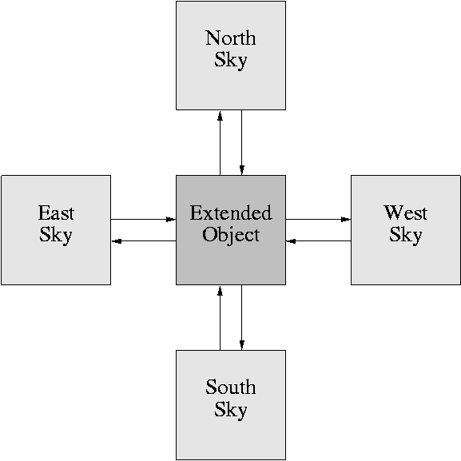

Comments:
• When the observing macro is started, the telescope has to point at the object.

• The observing macro prepares the online pipeline data reduction. The name and path of the image catalog and the integration time are stored in auxiliary files, which can be accessed by the pipeline. The image catalog is updated with the name and path of the latest image after every integration.

- Flatfields

Quick Start:

!++++++++++++++++++++++++++++++++++++++++++++++++++++++++++++++++++
! .COPYRIGHT (C) MPIA
! .IDENT flatfields.prg
!
! .CALL o2k/domeflats level images object lamp_start
!
! .PARAMETERS P1 = level: total countlevel of all images
! P2 = images: flag for image saving --> 0=only one sum image is saved
! 1=all single images are saved
! P3 = object =:object name for identifier
! P4 = lamp_start: flatfield lamp to be tested first: 1-5
! for lamp 5: 5,level = 0,..,9
!
! .PURPOSE Take dome flatfields with OMEGA2000
! .ENVIRONMENT MIDAS
! .AUTHOR Rene Fassbender
! .KEYWORDS flatfields
! .COMMENTS Note: The flatfield lamp GUI "ffl" has to be inactive when
! starting the PRG
!
!++++++++++++++++++++++++++++++++++++++++++++++++++++++++++++++++++

Function Call:
o2k/domeflats level images object lamp_start

• Images are taken at the current telescope position. The files will have the names specified in the instrument GUI.

Defaults:
Level → no default, has to be specified
Images = 1 → all images are saved
Object → object identifier has to be specified
Lamp_start = 5,5 → start with low level lamp

Examples:
• o2k/domeflats 500000 1 “dome flatfields” 3

Writes out all dome flats with object identifier “dome faltfields”. The combined count level of all images will be approximately 500,000. Flatfield lamp 3 will be tested first.

• o2k/domeflats level=100000 images=0 “dome flatfields”

Only one final image with a count level of 100,000 is written to disk.

• o2k/domeflats help
Help text.

Parameters:
external

P1 = level
Total combined count level of all images. The integration times and the flatfield lamps are automatically adjusted to yield the given count level in the most time efficient way.

P2 = images
Flag for the image saving mode: images=0 → only one sum image is saved
Images=1 → all single images are saved

P3 = object
Object identifier for the descriptor “IDENT”. Has to be enclosed in “ ” if it contains any blanks.

P4 = lamp_start
Flatfield lamp which is tested first. The lamp is automatically adjusted to a more appropriate one if the count levels are not reasonalble.

internal
The five relevant internal parameters specifying the targeted count levels are defined at the beginning of the keyword definitions:
best_level: Aimed at count level for a single exposure. The integration time is scaled to approximately yield this count level.
good_level: Target interval for test exposure. If achieved, the integration time is scaled to yield “best_level”.
ok_level: Interval outside which a different flatfield lamp is needed.

Functionality:
The routine takes short-integration test images with a given flatfield lamp. The average count level is analyzed and compared to the internal target levels. If an appropriate count level was measured, the dome flatfield acquisition starts with this flatfield lamp until the aimed at countlevel is reached. If the initial flatfield lamp is not reasonable because the flux is too high or too low, a more appropriate lamp is tested until the proper lamp is found.

- Tip-Tilt Determination

The tip-tilt determination routine is based on an old version of the omega_focus routine and needs some preparation steps before it can be properly used. Since the detector tip-tilt is only determined a few times and is not a general user task, the routine is not optimized for user-friendliness. The different steps for obtaining a local focus mask are:

Preparation:
• The tilt-routine does not take images. Focus images have to be taken with the normal omega focus routine described in 1).

• The .fits focus images have to be converted into .bdf format with filenames consisting of a 5 character root name and a 3 digit index, e.g., focus001.bdf or foc_K097.bdf. The relevant images have to have consecutive indices. The conversion can be done be editing the file: $O2K_UTIL/obs_macros/Tilt/make_bdf.prg.

• The internal parameters for pixel saturation and the stellar cutoff can be adjusted to optimize the output quality.

Function Call:
The function call
o2k/tilt
will prompt the relevant parameters: estimated focus value, number of images, step size, name of first image (in the above format), name of master image = image with the estimated focus (in the above name format), number of objects, and boxsize.

Note: The use of the default value for boxsize is suggested (it is specified in pixels). The default for the number of objects is 200, which is the maximum the search routine can handle.

Example:
o2k/tilt
typical inputs at the prompt would be:
24000 → estimated focus
7 or 9 → number of images
200 → stepsize
focus001 → name of first image with full name focus001.bdf
focus004 → name of masterframe if 7 images were used
default → object number
default → boxsize

• The results are stored in the output frame tilt_frame.bdf, which contains the local focus deviation compared to the average focus over the field-of-view. The average is set to the arbitrary value 100,000, the deviations are given in microns. Appropriate cuts are thus [99900,100100].

• If focus series at different telescope positions exist, i.e., the stars are at different detector locations, the results can be combined into one output frame with a larger number of data points. This can be achieved be editing the file: $O2K_UTIL/obs_macros/Tilt/master_tilt.prg,
which combines the results from two tilt measurements. Before it can be used a master tilt frame, e.g., master_tilt.bdf, has to be created.

Functionality:
The tilt routine is determining the local focus position according to the algorithm described in 1) (without the telescope and instrument parts). The local deviation of the focus from the average over the field-of-view is plotted in an output frame.

