Documentation

OMEGA2000 Data Reduction Pipeline

René Fassbender • June2003

Contents

- General Remarks
- Quick Start
- User Guide
  - Function call
  - Defaults
  - Examples
  - Parameters
- Online Mode
  - Online reduction scheme
  - Pipeline online mode
  - Working with online reduced data
- Predefined Modes
- Functionality
  - Overview
  - Sky determination
  - Summation process
- Take Home Guide
- Internals
  - Compiling
  - Internal Parameters
  - Modules
Hyperlinks

- General_Remarks
- Quick_Start
- User_Guide
    - Function_Call
    - Defaults
    - Examples
    - Parameters
    - Calibration_File
- Online_Mode
    - Online_Reduction_Scheme
    - Pipeline_Online_Mode
    - Working_with_online_reduced_data
- Predefined_Modes
- Functionality
    - Overview
    - Sky_Determination
    - Summation_Process
- Take_Home_Guide
- Internals
    - Compiling
    - Internal_Parameters
    - Modules

1) General Remarks:

• The OMEGA2000 pipeline is a MIDAS application program written in C, which is called from a MIDAS procedures. Thus, an active MIDAS session is required and the context “omega2k.ctx” has to be set for the definition of the utility short-cut commands o2k/command.

• Several pipeline parts use the environment variable O2K_UTIL which points to the directory o2k_utilities. All paths are defined relative from this top level directory.

2) Quick Start:

!++++++++++++++++++++++++++++++++++++++++++++++++++++++++

!

!.IDENT OMEGA_pipeline.prg

!

!.CALL o2k/pipeline [image_cat] [frames] [sky_mode] [sum] ...

! ...[kappa_sum] [cuts] [flags] [flatfiels]

!

!.PARAMETERS

! 1) image_cat: name (and path if not local) of image catalog to be reduced ;

! automatic = online reduction with auto-icat extraction

! label: ICATALOG

! 2) frames: # of frames used for sky determination before/after target

! label: FRAMES

! 3) sky_mode: mode for the sky determination

! 0,n = minimum mode: take average of n smallest values as sky

! 1 = median mode: take real median as sky

! 2,k = outlier mode: elimate outliers first (more than k sigma), then

! take median as sky

! label: MODE Ex: mode=min,4 or mode=2,3.5

! 4) sum: [n_average, action_flag, sum_save_flag]

! parameters for summation of single images

! n_average =# of images for which median is taken in sum_process

! action_flag: 0 = do reduction + summation of images;

! 1 = summation only ; 2 = reduction only

! sum_save_flag: 0 = write out every n_th sum-frame;

! 1 = save only final master_sum;

! 2 = save @ end: master_sum + real_sum + difference

! label:SUM

! 5) kappa_sum: parameter for the cosmics removal. In the summation process

! all values > med_level+(kappa_sum*sigma) are clipped off

! label: KAPPA_SUM

! 6) cuts: values for LHCUTS of output frames in units of sigma

! label: CUTS Ex: 1,3 means CUT_MIN=med -1*sigma; CUT_MAX=med+3sigma

! 7) flags: [save , position , screen_output]

! a) save: flag for sky saving

! 0 = sky will not be saved; 1 = sky for each frame will be saved

! b) position: flag for position where flatfield correction takes place

! 0 = no correction; 1 = correction at start; 2 = correction at end

! c) screen_output: flag for the amount of pipeline feedback on screen

! 0=no output (log only); 1=display output

! label:FLAGS

! 8) flatfield, badpixelmask, dark_frame: names of flatfield,

! bad-pixel-mask and dark_frame to be used for reduction

! OR path and name of ascii file which contains the calibration frames.

! A filename is indicated by a preceding "&".

! Example: flatfield=&/disk-a/o2k/calibration.cal

! label: FLATFIELD

!

!.AUTHOR Rene Fassbender, MPIA - Heidelberg

!.ENVIRONMENT MIDAS

!.MODULE OMEGA2000 Pipeline

!.KEYWORDS IR pipeline

!.PURPOSE do pipeline setup and call OMEGA_pipeline.exe

!.COMMENTS

!----------------------------------------------------------------------------------------

3) User Guide:

Function Call:

o2k/pipeline [image_cat] [frames] [sky_mode] [sum]

[kappa_sum] [cuts] [flags] [flatfiels]

Remark: “o2k/pipeline” is an OMEGA2000-context command which calls the routine “OMEGA_pipeline.prg”. The pipeline can also be called without the context command in the following way: @@ O2K_UTIL:/pipeline/PRGs/OMEGA_pipeline

Defaults:

icat = automatic use image catalog created by current observing macro session
frames = 3 use 3 image on either side of a masterframe for the sky determination, i.e., determine sky from a total of 7 images
mode = 1 fast median mode
sum = 7,0,0 [n_average, action_flag, sum_save_flag]. Use 7 images for the sum-reference frame determination; do single image reduction + summation ; write out every 7th sum frame
kappa_sum = 10 eliminate all cosmics that are above a 10 sigma cutoff
cuts = 3,10 set cuts of reduced images to
[median–3*sigma ; median+10*sigma]

flags= 0,1,2 [save , position , screen_output] Do not save sky frames ; do full detector calibration at start ; display screen output
flatfield = std_cal_file use the standard calibration ascii file to look for the relevant calibration frames

Examples:

• o2k/online

Standard pipeline online mode. No parameters needed. The function has to be called after the observations have started. The image catalog created by the observing utility is used. The sky is determined from 5 frames with the fast median mode. The superimposed images are written to disk after every 7th image. The kappa_sum cosmics-clipping parameter is set to 10.

• o2k/pipeline june10_obs 3 2,5 5,0,1 10 2,5 0,1,0 &/disk-a/o2k/cal_file.cal

Reduce the image catalog “june10_obs.cat”. Use 3 images on either side, i.e., a total of 7 images, for the sky determination in outlier mode (=2), with outlier clipping 5 sigma above the median level. Use 5 images for the reference sum frame, do reduction and summation, and save only the final master sum frame. Remove cosmics that are above a 10 sigma threshold. The cuts for the final frames are set to [median-2sigma,median+5sigma]. The modeled sky will not be saved, all calibrations are done at the beginning, suppress any screen output. Use the ascii file “/disk-a/o2k/cal_file.cal” to read in the paths and names of the calibration files.

• o2k/pipeline icat=obs_B frames=2 mode=0,2 sum=?,2

Do only single image reduction of the image catalog “obs_B.cat”. Use the minimum mode, with averaging of the 2 smallest values, and sky determination from 5 frames (=2 on either side). The calibration frames are read in from the default calibration file, according to the filter used.

• o2k/pipeline icat=automatic frames=2 mode=1 sum=9,0,2 kappa_sum=8 flatfield=norm_flat.fits,bpm_std.fits,/disk-a/o2k/dark_fame.fits

Use the current image catalog of the ongoing observations. The sky is determined from 2*2+1=5 frames in the fast median mode. The reference image for the summation is computed every 9 images, single image reduction and summation is done, and the final cosmics cleaned sum image as well as the real, uncorrected sum image and the difference image are saved. The cosmics clipping parameter is set to 8*sigma above the median. The flatfield “norm_flat.fits” and the bad pixel mask “bpm_std.fits” are in the local directory, the dark current frame is stored in “/disk-a/o2k/dark_fame.fits”.

• o2k/pipeline help
Shows help text.

Parameters:
external (command line parameters)

P1 = image_catalog
Name (and path if not local) of image catalog which contains all images to be reduced.
If icat=automatic, the online reduction is activated, i.e., the image catalog created by the currently running observing macro is used and the data is reduced in real time.
LABEL: icatalog=

P2 = sky_frames
Number of frames on either side of a master frame for the sky determination. Thus, the total number of frames used for the sky is (2*sky_frames + 1).
LABEL: frames=

P3 = sky_mode [mode, specifier]
Mode for the sky determination. 3 different sky modes are available: minimum mode, fast median mode, and the outlier clipping mode. The modes can be specified via an integer flag or via a string identifier. The minimum and outlier mode have a second specifier.
- Minimum mode: mode=0,n or mode=min,n ; n is an integer specifying how many of the smallest values are averaged. n=1 is the real minimum, n=2 takes the average of the 2 smallest values and so on.
- Median mode: : mode=1 or mode=med . Takes the median of each pixel column.
- Outlier clipping mode : : mode=2,k or mode=out,k ; k a real number specifiying the clipping threshold as k*sigma above the median. All outliers are clipped off before the median of the remaining values is taken.
LABEL: mode=

P4 = sum_parameters [n_average, action_flag, sum_save_flag]
Parameters for the summation of single images.
n_average: integer specifying from how many images the reference sum frame is calculated. If the sum_save_flag is set to 0, an updated summation image is written to disk every n_average images.
action_flag: Specifies the data reduction action.
0 = do reduction and summation of all images in image catalog
1 = do summation only, i.e., the input images are already reduced
2 = do single image reduction only, i.e., the images are not superimposed.
sum_save_flag: Specifies what sum images are saved on disk.
0 = every updated sum is written to disk every n_average images
1 = only the final master sum is written to disk
2 = the final sum and the real, “dirty” (without cosmics removal) sum and the difference of the first to are written to disk.
Name conventions of the sum images:
sum_icat.fits → for the cosmics cleaned master sum image
cut_sum_icat.fits → for the cut out cosmics cleaned sum
ave_icat.fits → for the real, “dirty” sum image
dif_icat.fits → for the difference image: ave – sum
If intermediate summation results are saved on disk a prefix index is added: 2_sum_icat.fits, 3_ sum_icat.fits,…; the last of these frames is cut out, e.g., cut_7_ sum_icat.fits
LABEL: sum=

P5 = kappa_sum
Cosmics clipping parameter. All values above (median + kappa_sum*sigma) are classified as comics and removed. kappa_sum is a real number.
LABEL: kappa_sum=

P6 = cuts [min,max]
Cuts for the final frames. The descriptor LHCUTS is set to
[median-min*sigma , median+max*sigma].
LABEL: cuts=

P7 = flags [sky_save, calibration_position, screen_output]
Integer flags.
sky_save: determines whether the modeled sky is saved or not.
0 = sky is not saved
1 = the sky for each input frame is saved with name: sky_imagenam.fits
calibration_position: position where flatfielding and calibration takes place.
0 = no calibration is done.
1 = all calibrations (bad pixel correction, dark current subtraction, and flatfield correction)are done at the beginning of the reduction process
2 = do flatfielding at the end of the single image reduction ; bad pixel correction and dark current subtraction are still done at beginning.
screen_output: specification of the amount of screen output.
0 = screen output is suppressed, the feedback is only saved in the log-file
1 = the pipeline feedback is displayed on the screen
LABEL: flags=

P8 = calibration frames
Specification of the calibration frames. The calibration frames (flatfield, bad pixel mask, dark current frame) can be specified in 3 different ways:
- no specification (=default): the standard calibration ascii file is used to extract the calibration frames
- &/path/filename: an ascii calibration file is specified. A filename is indicated by a preceding “&”, e.g., flatfield=&/disk-a/o2k/cal_file.cal. For the calibration file format see below.
- [flatfield,bad_pixel_mask,dark_current_frame]: the calibration frames are directly specified. If they are nor located in the local directory, the path has to be specified
LABEL: flatfield=

internal (in PRG)
OMEGA_pipeline.prg contains a few internal parameters that are used as defaults and the online mode. The corresponding keywords are specified in section 3 PIPELINE SETUP:
file_path: Has to contain the same path information as the file_path keyword in the observing macos. The keyword is needed for the online mode to allow communication to the current observing macros.
cal_file: Keyword containing the path and name of the default ascii calibration file.

Calibration File:
In P8=calibration frames, the name of an ascci calibration file can be specified (see above). The calibration file has to fulfill the following format conventions:

Demo file:

!++++++++++++++++++++++++++++++++++++++++++++++++++++++++++++++++++
!
!.IDENT calibration.cal
!
!.AUTHOR Rene Fassbender, MPIA - Heidelberg
!.ENVIRONMENT MIDAS
!.MODULE Calibration file
!.KEYWORDS IR pipeline
!.PURPOSE list name and path of calibration files to be used
!.COMMENTS CONVENTIONS: lines starting with ! are comments.
! Lines with calibration frame information have to start with a standard
! indetifier: BPM for the bad pixel mask, DARK for the dark current frame,
! and FLAT or the filter name for the different flatfields.If FLAT is present,
! the specified frame used as flatfield,i.e., FLAT has priority over FILTER.
! NOTE: The filter names
! have to be identical to the its specification in the descriptor FILTER.
! The identifier is followed by " = " and the calibration file name with
! path information.The names with the path should not exceed 80 characters.
! Specification of flatfields: If the identifier "FLAT = " exists, the given
! file will be used by the pipeline. If FLAT is not present, the appropriate
! flatfield is automatically selected using the FILTER name.The FILTER names
! are expected to be 10 characters long followed by " = ". If the name is
! shorter, blanks have to fill up the remaining positions.
! Maximally 100 lines are read in.
!
!.VERSION 1.00 12.06.03
!----------------------------------------------------------------------------------------

! Bad Pixel Mask
BPM = O2K_UTIL:/pipeline/CAL/bpm_part_blown.fits

! Dark Current Frame
DARK = O2K_UTIL:/pipeline/CAL/dark_current.fits

! Flatfield with priority
!!FLAT = O2K_UTIL:/pipeline/CAL/FLATS/H_flat_best_f.fits

! Flatfields for all filters for automatic selection
!234567891 = path+name
J = O2K_UTIL:/pipeline/CAL/FLATS/H_flat_best_J.fits
H = O2K_UTIL:/pipeline/CAL/FLATS/H_flat_best_H.fits
K = O2K_UTIL:/pipeline/CAL/FLATS/H_flat_best_K.fits
K-PRIME = O2K_UTIL:/pipeline/CAL/FLATS/H_flat_best_Kpr.fits
NB1237 = O2K_UTIL:/pipeline/CAL/FLATS/H_flat_best.fits

4) Online Mode:

Online Reduction Scheme:

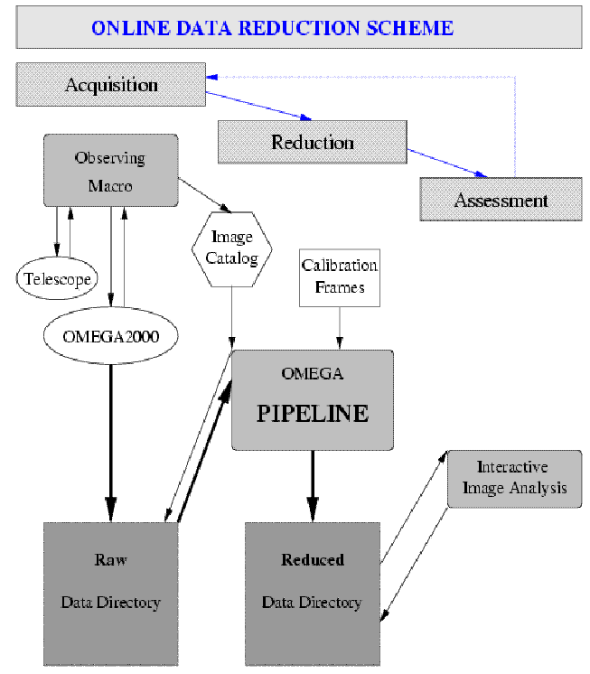

Pipeline Online Mode:
Once an observing macro has been started and has taken at least one image, the pipeline can be started in online mode for the real time data reduction.
There are two ways to run the pipeline in online mode:
- Use the predefined command:
o2k/online without any parameters
This command uses the in catalog information provided by the observing macro and the default calibration file. It is using the fast median method with a total of 5 frames for the sky determination. The intermediate summation results are written to disk every 7th image.
Note: For this command , the internal PRG parameters (see above) have to be set up properly.

- Use the normal pipeline command with online specifications:
The pipeline is started in online mode by setting the image catalog paramerter to “automatic”.
o2k/pipeline icat=automatic + other parameters
This command also uses the in catalog information provided by the observing macro, but all other parameters can be specified by the user.

Working with online reduced data:
Each new output data frame is created by the pipeline in the following way:
- Create a plain image without any data
- Write output data into the new frame
- Close output image
This implies that the output frames are visible in the reduced data directory after step 1), while the pipeline is still working with the opened frame. The output data frame is only save to use after the frame has been closed in step 3). If the data frame were opened and used by another application between step 1) and 3), serious software trouble would occur. Most likely the pipeline and the other MIDAS session trying to open the unclosed frame would crash.
Thus, a few precautions should be met to be on the save and prevent a session crash:
• The screen output contains the information on what frames have been closed. These images are save to access with other applications.
• The intermediate summation results are saved on disk after every n_th frame. Before a new output frame is created, the old one is closed. Thus, the summation frame with the currently highest index “index_sum_icat.fits” is critical and should not be opened. However, the summation frame with an index 1 lower than the highest can be accessed and opened by other applications without any problems.

5) Predefined Modes:

The following examples state recommended parameter sets for different pipeline applications:

- Online reduction for normal observations:
• o2k/online without any parameters
Uses fast median mode with a total if 5 frames for the sky determination. The intermediate summation result is written to disk every 7th frame.

- Online reduction for observations of extended objects:
• o2k/pipeline icat=automatic frames=2 mode=0,1 sum=7,0,0
Uses the fast true minimum method for the sky determination with a total of 5 frames. The intermediate summation result is written to disk every 7th object frame.

- High quality reduction for normal observations:
• o2k/pipeline icat=user_specified frames=3 (or 4) mode=2,3 sum=7,0,2
Uses the outlier clipping method for the sky determination with a total of 7 or 9 frames. Only the final summation frames are written to disk.

- Improved quality reduction for observations of extended objects:
• o2k/pipeline icat= user_specified frames=3 mode=0,3 sum=7,0,2
Uses the minimum method with averaging of the 3 smallest values for the sky determination with a total of 7 frames. Only the final summation frames are written to disk.

6) Functionality:

Overview:

The following flow chart shows the overall structure of the pipeline system:

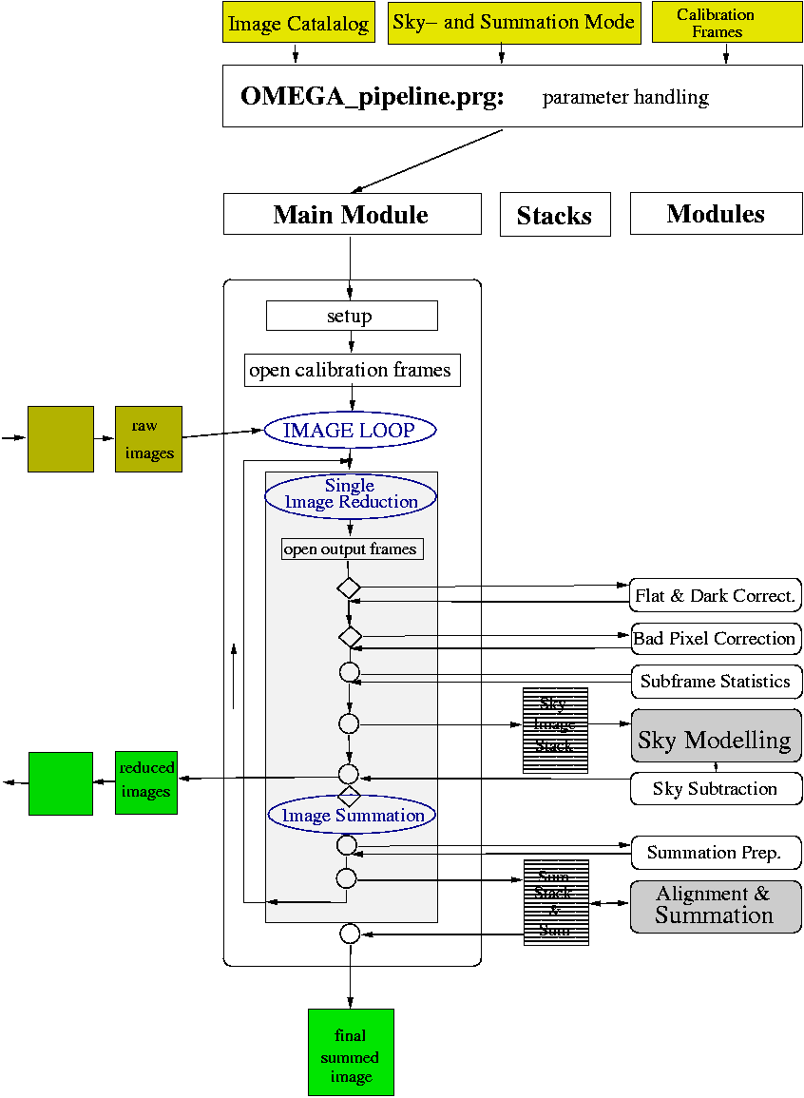
Sky Determination:

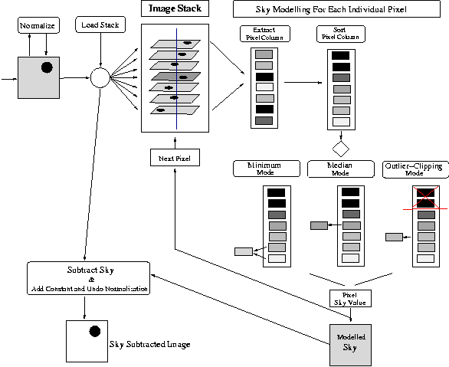

Summation Process:

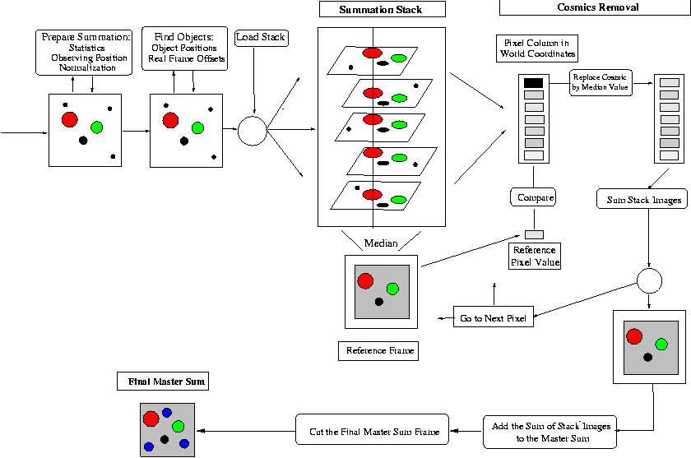

7) Take-Home Guide:

• take the directory $O2K_UTIL/pipeline with all subdirectories home and install it on your computer system
• copy the context file omege2k.ctx for the definition of shortcut commands
• define the environment variable O2K_UTIL as the path of the directory where /pipeline is stored
• set the MIDAS context omege2k.ctx the command set/context
• if recompilation is to be done, the first line of makefile
(starting with CC= ) under $O2K_UTIL/pipeline/C_code/makefile has to be edited to specify the C-compiler on your system

8) Internals:

Compiling:

On the OMEGA2000 server FIRE35:
• go to the directory containing the source code: $O2K_UTIL/pipeline/C_code
• call make to recompile the full pipeline
• to recompile a single module call: make module.o

On other machines:
• the proper system C-compiler has to be defined in makefile by editing the first line of makefile (starting with CC= ) under $O2K_UTIL/pipeline/C_code/makefile

Internal Parameters:

The pipeline system includes two parameter header files for internal system parameters.
Detector related parameters are defined in the file O2000_para.h, pipeline related parameters are defined in pipe_para.h.

Detector related parameters:
This file has to be replaced if the pipeline is to be used for a different detector:

/* OMEGA2000 Detector Constants */

Name Value Comment
TOT_PIX 4194304 /* =2048*2048 TOTal number of PIXels on detector*/
PIX_AXIS 2048 /* PIXels per AXIS = 2048 */
PIX_SIZE 18 /* PIXel SIZE of detector is 18 microns */
PIX_SCALE 0.45 /* PIXel SCALE is 0.45 arcsec/pix */
FIELD_OF_VIEW 15.4 /* FIELD OF VIEW is 15.4*15.4 arcmin */

DELTA_REJECTION 3 /* arc_minutes beyond which incoming frames are rejected from summation process: in RA and DEC */
If the coordinates of a frame differ more than the above value from the first frame in the catalog (=masterframe), the frame is rejected is not superimposed to the other images.

/* specified statistics window*/
/* all statistical properties are determined in this subframe * /
X_START 700 /* x-start-coordinate in pixels */
X_END 900 /* x-end-coordinate in pixels */
Y_START 700 /* y-start-coordinate in pixels */
Y_END 900 /* y-end-coordinate in pixels */

Pipeline related parameters:

Name Value Comment
With the detector parameter, a different detector file can be included.
DETECTOR 0 /* Define Detector: 0 = OMEGA2000 ; 1 = OMEGA_PRIME */

/* Parameters for SINGLE IMAGE REDUCTION */
SKY_FRAMES_MAX 7 /* maximun allowed number of frames before and after
/* main frame used for sky */
/* # of stack levels = 2*SKY_FRAMES_MAX + 1 */
This parameters defines the RAM-allocation. Disk space will be allocated for all frames.

/* Parameters for SUMMATION PROCESS */
N_AVERAGE_MAX 11 /* maximum allowed number of total frames for median process during image summation */
This is the second parameters defining the RAM-allocation. Disk space will be allocated for all frames.

N_AVERAGE_DEFAULT 5 /* default value for N_AVERAGE */
NORM_LEVEL 100000 /* count level that all images are normalized to */
/* before summation */

/* Debugging parameter for additional function output */
DEBUG 3 /* 0=only normal output ; 1=additional output from OMEGA_pipe; 2=badpixel_correction ; 3=find_object*/

/* Turn dark current subtraction on and off */
DARK_SUBTRACTION 1 /* 0=off ; 1=do dark current subtraction */

/* TUNABLE PARAMETERS */
WAIT_MAX 10 /* maximal wait time for next image in online reduction mode in units of 1/4*integration_time */

N_OBJECT 60 /* number of objects to be found for findobj-routine */
/* has to be within [1,100] */

SEARCH_RADIUS 20 /* maximum search radius in pixels for the matching of objects */
/* the object will be searched within this radius around */
/* the expected position in steps of 5*/
/* corresponds to the maximum tolerated pointing error of the telescope */

SEARCH_STAR 2 /* pixel radius from intensity center of a cosmics candidate */
/* were there is searched for star flux. If >”COSMICS_CUT */
/* pixels” are found, the value is taken as star value */

/* Parameters used in find_object.c to identify objects */
THRESH_MAX 3 /* maximal set threshold in units of the background */
ANA_RAD 8 /* pixel radius around intensity maximum in which star */
/* is analyzed by subfunction Analyze*/
FWHM_MIN 0.5 factor for minimal fwhm selection:fwhm > fwhm_master * fact
FWHM_MAX 1.5 /* factor for maximal fwhm selection */

INTENSITY_MIN 0.4 /* factor for object selection: object is accepted, if */
INTENSITY_MAX 2.5 /* total insity > MIN*masterframe_inten < MAX*masterint */
/* if background changes, the scale factors change */
/* --> should be set to allow for variations */

OFFSET_CUT 3 /* maximum pixel difference from median offset to be accepted
/* as the right object coordinates*/

COSMICS_CUT 4 /* minimal number of pixels above background to be ac- */
/* cepted as object. Used in find_object & elaborate_sum */

FWHM_CUT 4 /* maximal fwhm in arcsecs to pass the first object */
/* selection ; objects > are classified as extended */

BACK_CUT 3 /* # of stddev above background to be accepted as object */

Modules:

