Flocking simulation:

Introduction:
A simulation of flocking, using a algorithm of O(n^2).

Run Example:

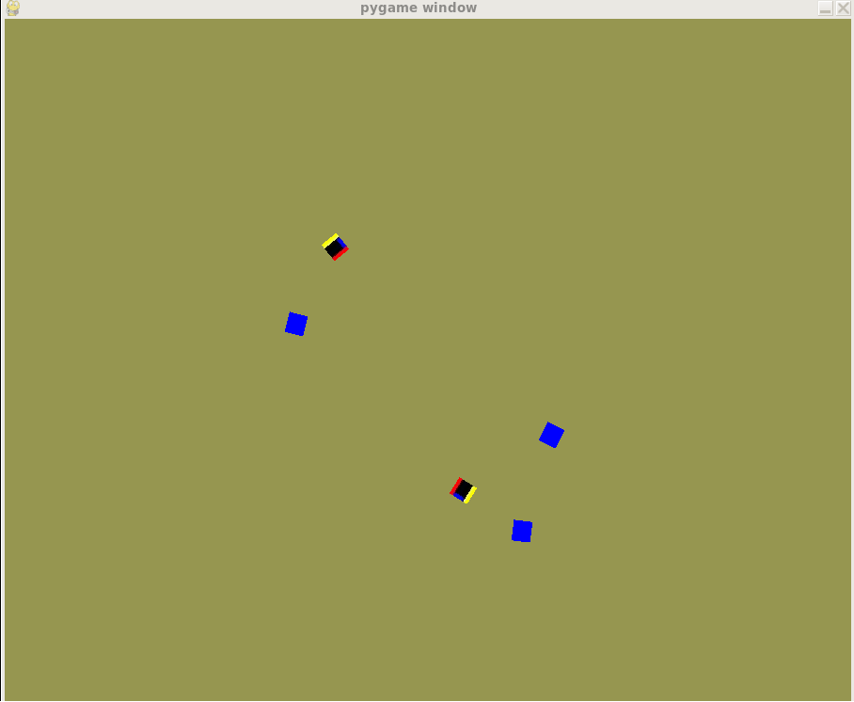

Details of figure:
- state : Wandering/ Leader
Positive direction: Blue point

- State: flocking
detail: constant velocity magnitude , 10 (pixes/loop)

3. State: catching up
detail: speeding up velocity , 16 (pixes/loop)

4. State: avoiding
detail: try to avoid crash into each other when too near

