Clustering Algorithm

홍준성 Hong JuneSung

April 26, 2019

1. **Introduction**

Cluster analysis or clustering is the task of grouping a set of objects in such a way that objects in the same group (called a cluster) are more similar (in some sense) to each other than to those in other groups (clusters). It is a main task of exploratory data mining, and a common technique for statistical data analysis, used in many fields, including machine learning, pattern recognition, image analysis, information retrieval, bioinformatics, data compression, and computer graphics.

The notion of a "cluster" cannot be precisely defined, which is one of the reasons why there are so many clustering algorithms. There is a common denominator: a group of data objects. However, different researchers employ different cluster models, and for each of these cluster models again different algorithms can be given. The notion of a cluster, as found by different algorithms, varies significantly in its properties. Understanding these "cluster models" is key to understanding the differences between the various algorithms.

1. **Data description**

I downloaded the image ‘house.ppm’ to use from website( <http://cs.joensuu.fi/sipu/datasets/>).

Later, I converted the file format ppm to a jpeg on website(<https://convertio.co/kr/ppm-jpeg/>) because the ppm format file was new to me.

And then I can get ‘house.jpeg’ file.

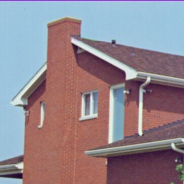

(house.jpeg)

1. **Description of the selected method**

Centroid models: for example, the k-means algorithm represents each cluster by a single mean vector.

K-means clustering uses a non-hierarchical clustering method, which gives you the advantage of fast processing of large volumes of data because of its small calculations.

The algorithms of K-means clustering are as follows:

Randomly select the K cluster center set by the analyst

Assign an observation to the nearest cluster center and calculate a new cluster center

Repeat until existing and newly calculated cluster centers are equal

And I also used the program R studio

The image is made up of units called pixels, and each of these three colors, Red, Green, and Blue, have a value of 8 bits per pixel to complete the 24 bits True Color.

Of course, for black and white pictures in gray scale, the pixels will be configured with just 8 bits (0-255). The figure is then a dataset with three-dimensional values (r, g, b).

If these colors are extracted with K clusters, they can be tied together with similar colors.

In addition, segmentation allows information to be sent in a reduced scale of 1 to K index instead of 24 bits per pixel.

1. **Results**

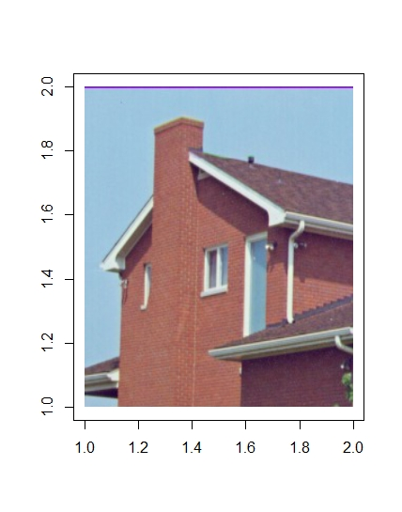

(the original picture)

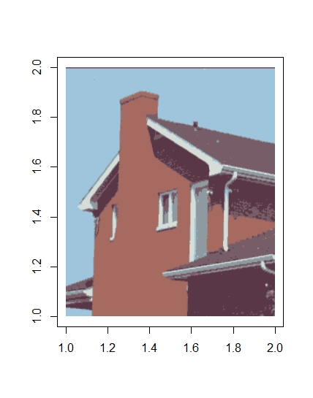

(after clustering picture)

1. **Codes**

* install.packages("jpeg")

(Installing a library for loading images)

* library(jpeg)

(load library)

* image = readJPEG('c:/house.jpeg')

(Bring in an image and put it in a variable.)

* dim(image)

(You can see that Dimension is X by X 3 (rgb).)

* plot(1:2, type="n", xlab='', ylab='')

(I made an empty plot.)

* rasterImage(image, 1, 1, 2, 2)

(Load the image to the desired size.)

* image[1,1,]

(Check the rgb value of the pixel(1,1).)

* image.dataframe = data.frame(r=as.vector(image[,,1]), g=as.vector(image[,,2]), b=as.vector(image[,,3]))

(Now the data has been transformed to apply K-means clustering.

Since the concept of horizontal or vertical in segmentation was meaningless anyway, it was transformed into a one-dimensional vector and transformed into a three-dimensional data type of (r, g, b).)

* dim(image.dataframe)

(Verifies that the exact number of data samples is equal to the number of pixels)

* head(image.dataframe)

(Check only the first part using the head function)

* kmeans.fit = kmeans(image.dataframe, centers=6, nstart=5)

(These pixels were separated by a cluster of random numbers (K=6).)

* kmeans.fit$centers

(Then, check what these segmented pixels look like.

To do so, the data is restored to the original array format.)

* kmeansCompressed.dataframe = kmeans.fit$centers[kmeans.fit$cluster,]

(each pixel's data is filled with the data from the pentroid.)

* dim(kmeansCompressed.dataframe)
* kmeansCompressed = array(kmeansCompressed.dataframe, dim(image))

(Move the dataframe type back to the array format.)

* dim(kmeansCompressed)

(Confirmation that it is again in the form of (street, vertical, 3))

* plot(1:2, type="n", xlab='', ylab='')
* rasterImage(kmeansCompressed, 1, 1, 2, 2)

(get the result picture)

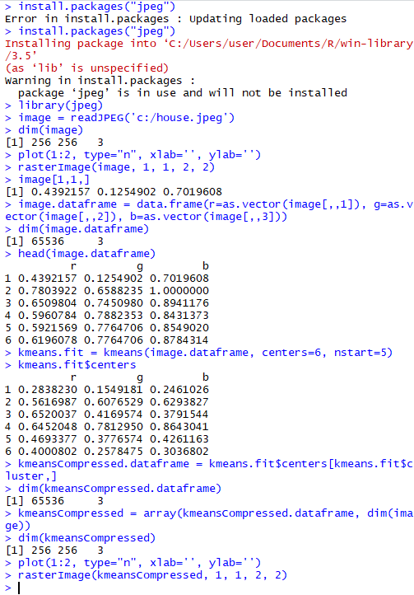

(source code picture)