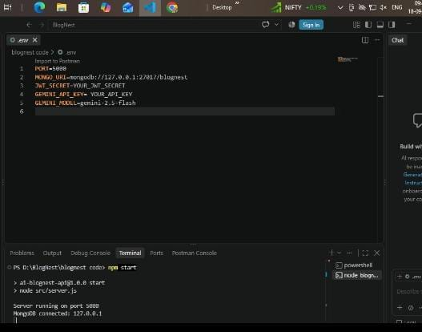

Demo video: https://drive.google.com/file/d/1kQmVD8Jj0vETvbELWPoPEZ71PxxL3Pk8/view?usp=drivesdk

