Project Overview: BlogNest (ContentGen Backend)

BlogNest is a powerful, secure, and intelligent social blogging platform designed to revolutionize content creation, community engagement, and AI-assisted writing. Built using the MERN stack (MongoDB, Express.js, React.js, Node.js), it pairs traditional community-driven blogging capabilities with advanced Generative AI to deliver a smarter, faster, and highly secure content creation ecosystem.
The application utilizes MongoDB with the Mongoose ODM for efficient data modeling, validation, and seamless database interactions. By blending automated AI tools with robust security mechanisms and human content governance, BlogNest ensures clean, high-quality, and scalable publishing.
The platform is designed around three core architectural pillars:
1. Intelligent AI-Assisted Modules
Utilizing advanced integrations with Google Gemini AI, the system provides intelligent, context-aware content generation features with minimal user effort, including:
- AI Blog Generation: Auto-generates well-structured blog posts from simple prompts or keywords.
- AI FAQ Assistance: Dynamically builds context-driven question-and-answer pairs for articles.
- AI Specialty Tools: Features tailored modules like WeatherWise Insights and FitTrack Recommendations to provide niche, smart content suggestions.
2. Enterprise-Grade Security & Governance
Security is a core aspect of the system architecture, ensuring the platform remains resilient against common web vulnerabilities.
- Stateless Authentication: Implements JWT (JSON Web Tokens) paired with secure bcrypt.js password hashing.
- Role-Based Access Control (RBAC): Restricts system operations across distinct user tiers, including Admin, Editor, Author, and Reader.
- API Hardening: Enforces input sanitization, strict request validation, rate limiting, and structured logging.
- Pre-Publication Moderation: Uses a hybrid moderation engine that screens posts via rule-based keyword analysis and heuristic scoring, flagging high-risk content for administrative approval.

3. CMS Architecture & Community Systems
Designed with a modular and scalable REST API architecture, the platform fully supports traditional Content Management System (CMS) capabilities.
- Comprehensive Blog Management: Handles advanced categorization, tagging, comment management, and media metadata processing.
- Advanced Discovery: Includes advanced search and filtering mechanisms to help users browse content efficiently.
- Community Analytics: Features an integrated admin dashboard to track user activity, system health, and data analytics trends while providing interest-based spaces for target audiences.
Scenario-Based Case Study: Empowering Content Ecosystems
Background
Priya is an independent content network manager who oversees multiple niche publication channels. As her reader base grows, she struggles to organize editorial workflows, schedule time-sensitive articles, maintain consistent category systems, and track post-performance metrics across her entire brand portfolio.
Problem
- Workflow Bottlenecks: Managing distributed drafts, tag taxonomies, and multi-layered categories manually causes content friction.
- Analytics Blindspots: Minimal visibility into real-time audience engagement and post-performance data limits strategic growth.
- Moderation Overhead: Content review pipelines, editorial approvals, and visitor comment filtering consume excessive operational time.
- Media Desynchronization: The absence of a structured system for handling asset pathways, media optimization, and associated metadata leads to broken storage links.
- Privilege Inflation: A lack of distinct, isolated permissions exposes sensitive system settings to unauthorized contributors.
Solution
The BlogNest (ContentGen Backend) resolves these operational issues by deploying an automated, AI-augmented REST API architecture that decouples content management logic from the user interface. The system implements a robust Role-Based Access Control (RBAC) matrix that isolates administrative operations, automates pre-publication content filtering via a hybrid moderation engine, and integrates Google Gemini AI to accelerate article generation and context parsing.
System Usage Model
- Author Operations: Authors authenticate securely via stateless endpoints to draft context-aware content using Gemini AI, track specific post-performance analytics, catalog assets with proper media metadata, and assign predefined category taxonomies.
- Editor & Administrator Operations: Superusers access protected routes to audit content queues, trigger manual status overrides, manage comment moderation logs, evaluate system telemetry, and dynamically upgrade user privilege levels.
- Reader Operations: General users interact with public, rate-limited retrieval routes to fetch structured content feeds, execute advanced keyword searches, and securely post comments.
Concrete Outcomes
- Velocity & Scale: Offloading editorial logic to an optimized backend minimizes delivery friction, while Google Gemini integrations cut content creation cycles in half.
- Data & Asset Integrity: Explicit Mongoose schema validations, strict input sanitization, and structured media path registration completely eliminate orphaned database records.
- Hardened Security Boundaries: JWT-driven stateless authentication coupled with precise RBAC restrictions ensures zero unauthorized configuration shifts or privilege escalation.
- Actionable Performance Insights: Centralized database tracking converts user interactions into clean, structured data streams, allowing administrators to make precise, metrics-driven scheduling decisions.
System Infrastructure Requirements
1. Software Environment Specifications
- Operating System: Cross-platform compatibility across Windows 10/11, macOS (Intel/Apple Silicon), or enterprise Linux distributions.
- Node.js Environment: Version 16.x or higher, establishing the asynchronous, event-driven runtime ecosystem for backend logic execution.
- Node Package Manager (npm): Version 8.x or higher to safely orchestrate, audit, and install third-party dependencies and framework libraries.
- Express.js: Lightweight routing web framework to construct backend RESTful entry points and middleware logic layers.
- MongoDB: Document NoSQL engine storing schemas for users, posts, categories, comments, and analytics metrics.
- Postman: API verification toolkit to assert schema validation responses across administrative route shields.
- Visual Studio Code: Integrated Development Environment (IDE) to write, debug, and manage the application source code.
2. Hardware Resource Constraints
- Processor: Intel Core i5 (8th Gen or above), AMD Ryzen 5, or an equivalent multi-core processor capable of handling concurrent asynchronous operations.
- RAM: 8 GB minimum; 16 GB recommended for running concurrent instances of MongoDB, processing layers, and developer tooling execution nodes.
- Storage: 1 GB of available disk workspace for application source files, runtime dependency packages, and local cache targets

Epic: 1 Project Architecture
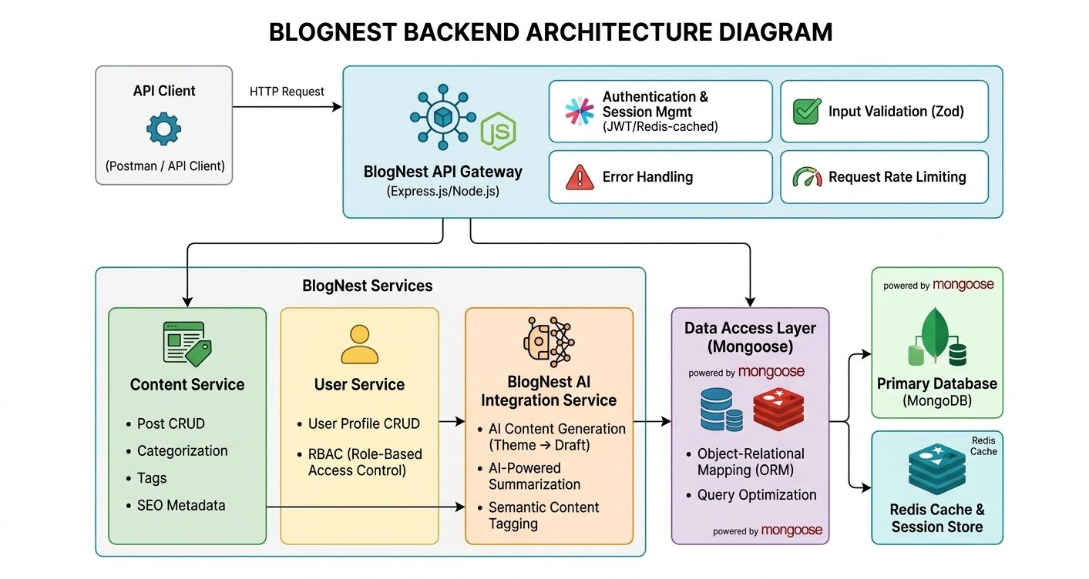

1. Entry & Security Components
- API Client: The starting point of the flow where front-end applications, mobile apps, or testing tools like Postman send HTTP requests to interact with the backend.
- BlogNest API Gateway (Express.js / Node.js): The central entry point for all incoming network traffic. It acts as a traffic controller that receives requests and routes them to the appropriate services.
- Authentication & Session Mgmt: Verifies user identity using tokens like JWT. It checks if a user is logged in and securely manages active sessions, often utilizing a fast memory store like Redis to check login states quickly.
- Input Validation (Zod): A security layer that inspects incoming data (like blog text or passwords) to ensure it matches required formats before processing, preventing bad or malicious data from breaking the server.
- Error Handling: A centralized system that catches exceptions, logs failures, and returns clean, human-readable error messages back to the user without exposing sensitive backend code.
- Request Rate Limiting: A security mechanism that limits how many requests a user can make in a given timeframe, protecting the application against spam bots and Denial of Service (DoS) attacks.
2. Core BlogNest Services
- Content Service: The core logic engine managing the actual blog entries. It handles CRUD operations (Create, Read, Update, Delete posts), assigns categories and tags, and attaches SEO metadata for search engine optimization.
- User Service: Manages user registration, profiles, and Role-Based Access Control (RBAC), ensuring standard users can only edit their own blogs while Admins can manage everything.
- BlogNest AI Integration Service: The specialized AI brain of the application. It takes user themes to auto-generate drafts, compresses long articles into short summaries, and reads text to assign relevant tags automatically.
3. Data & Storage Layers
- Data Access Layer (Mongoose): An abstraction layer utilizing an Object-Relational Mapping (ORM) approach. It translates JavaScript code into data queries that the database understands, while optimizing search performance.
- Primary Database (MongoDB): The core document-oriented database powered by Mongoose where all persistent application records—such as user credentials, profile information, and final blog posts—are securely saved.
- Redis Cache & Session Store: A high-speed, in-memory database used to store temporary data. It caches frequently read blog posts to reduce database load and ensures ultra-fast page load times for users.
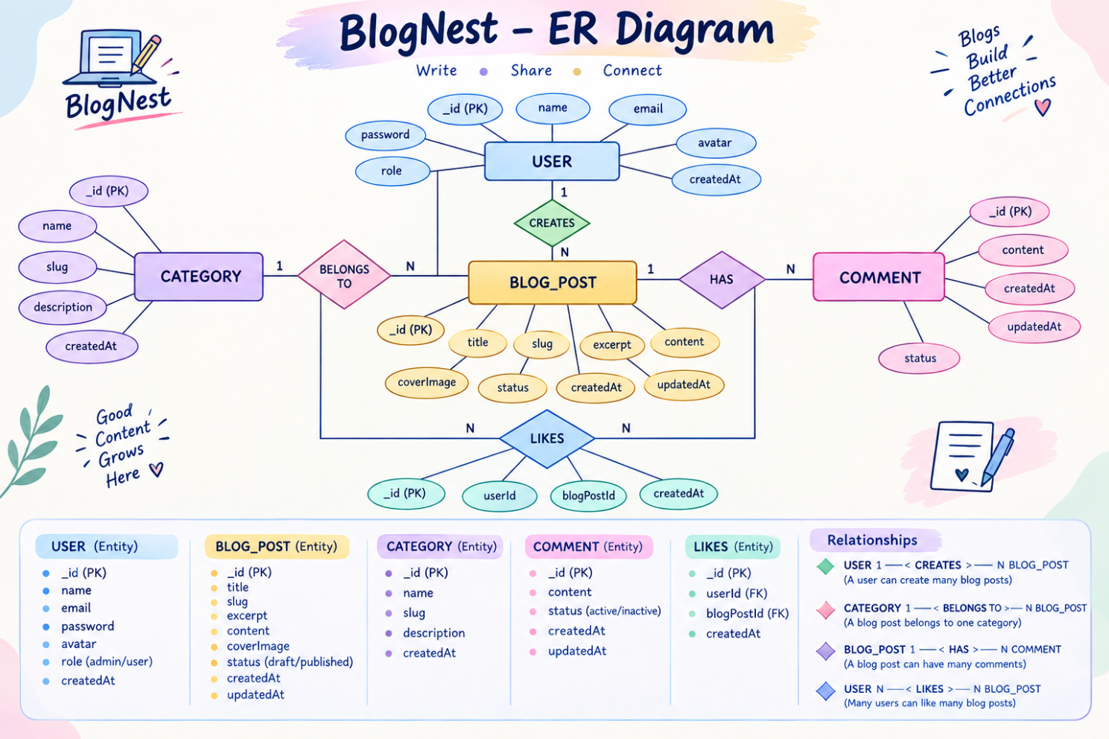
1. USER
The USER entity stores information about people who use the BlogNest system.
Attributes:
- _id (PK) – Unique identification number
- name – Name of the user
- email – Email address
- password – Login password
- avatar – User profile image
- role – Admin or user
- createdAt – Account creation date
2. BLOG_POST
The BLOG_POST entity stores the details of blog articles created by users.
Attributes:
- _id (PK) – Unique post ID
- title – Title of the blog
- slug – URL-friendly name
- excerpt – Short description
- content – Full blog content
- coverImage – Blog cover image
- status – Draft or published
- createdAt – Date of creation
- updatedAt – Last update date
3. CATEGORY
The CATEGORY entity organizes blog posts into different categories.
Attributes:
- _id (PK) – Unique category ID
- name – Category name
- slug – URL-friendly category name
- description – Category description
- createdAt – Creation date
4. COMMENT
The COMMENT entity stores comments made by users on blog posts.
Attributes:
- _id (PK) – Unique comment ID
- content – Comment text
- status – Active or inactive
- createdAt – Comment creation date
- updatedAt – Last update date
5. Relationships
- USER → CREATES → BLOG_POST:
One user can create many blog posts, while each blog post is created by a user.
Cardinality: 1 : N
- CATEGORY → BELONGS TO → BLOG_POST:
One category can contain many blog posts, while a blog post belongs to a category.
Cardinality: 1 : N
- BLOG_POST → HAS → COMMENT:
One blog post can have many comments.
Cardinality: 1 : N
- USER → WRITES → COMMENT:
One user can write many comments.
Cardinality: 1 : N
- USER → LIKES → BLOG_POST:
A user can like multiple blog posts, and a blog post can be liked by multiple users.
Cardinality: N : N
Key Structural Mappings
● User to Post (One-to-Many):
A registered user can create and publish multiple blog posts, while each post is associated with one user.
● Category to Post (One-to-Many):
A single category can contain multiple blog posts, while each blog post belongs to one category.
● User to Comment (One-to-Many):
A user can write multiple comments on different blog posts, while each comment is linked to one user.
● Post to Comment (One-to-Many):
A single blog post can receive multiple comments, with each comment belonging to one specific post.
● User to Post through Likes (Many-to-Many):
A user can like multiple blog posts, and each blog post can receive likes from multiple users.
Key Features
● Role-Based Authentication:
Secure access control ensures that only authorized users can perform specific actions based on their assigned roles.
● Blog CRUD Operations:
Users can create, read, update, and delete blog posts, including managing titles, content, images, and publication status.
● Category Management:
Blog posts can be organized into categories, making content easier to filter, search, and discover.
● Comment Management:
Users can add comments to blog posts, while the system supports comment status and moderation such as active or inactive.
● Like Functionality:
Users can like multiple blog posts, allowing the system to maintain and manage user-post interactions.
● Data Security:
Input validation and sanitization help protect the application against common security threats such as XSS and injection attacks.
● AI-Powered Blog Generation:
The system can integrate AI/LLM technology to generate structured blog content from a given topic or idea.
● Content Summarization:
AI-based summarization can convert lengthy blog content into short and meaningful summaries for quick reading.
Roles and Responsibilities
● Admin:
Has complete control over the BlogNest system. Can manage users, assign roles, remove inappropriate comments, and monitor system activities.
● Editor:
Manages the editorial process. Can review draft posts, approve content for publication, and organize or update blog categories.
● Author:
Creates and manages their own blog posts. Authors can add, edit, and update posts associated with their account.
● Reader:
Can view published blog posts and interact with the content by adding comments while logged into their account.

User flow:

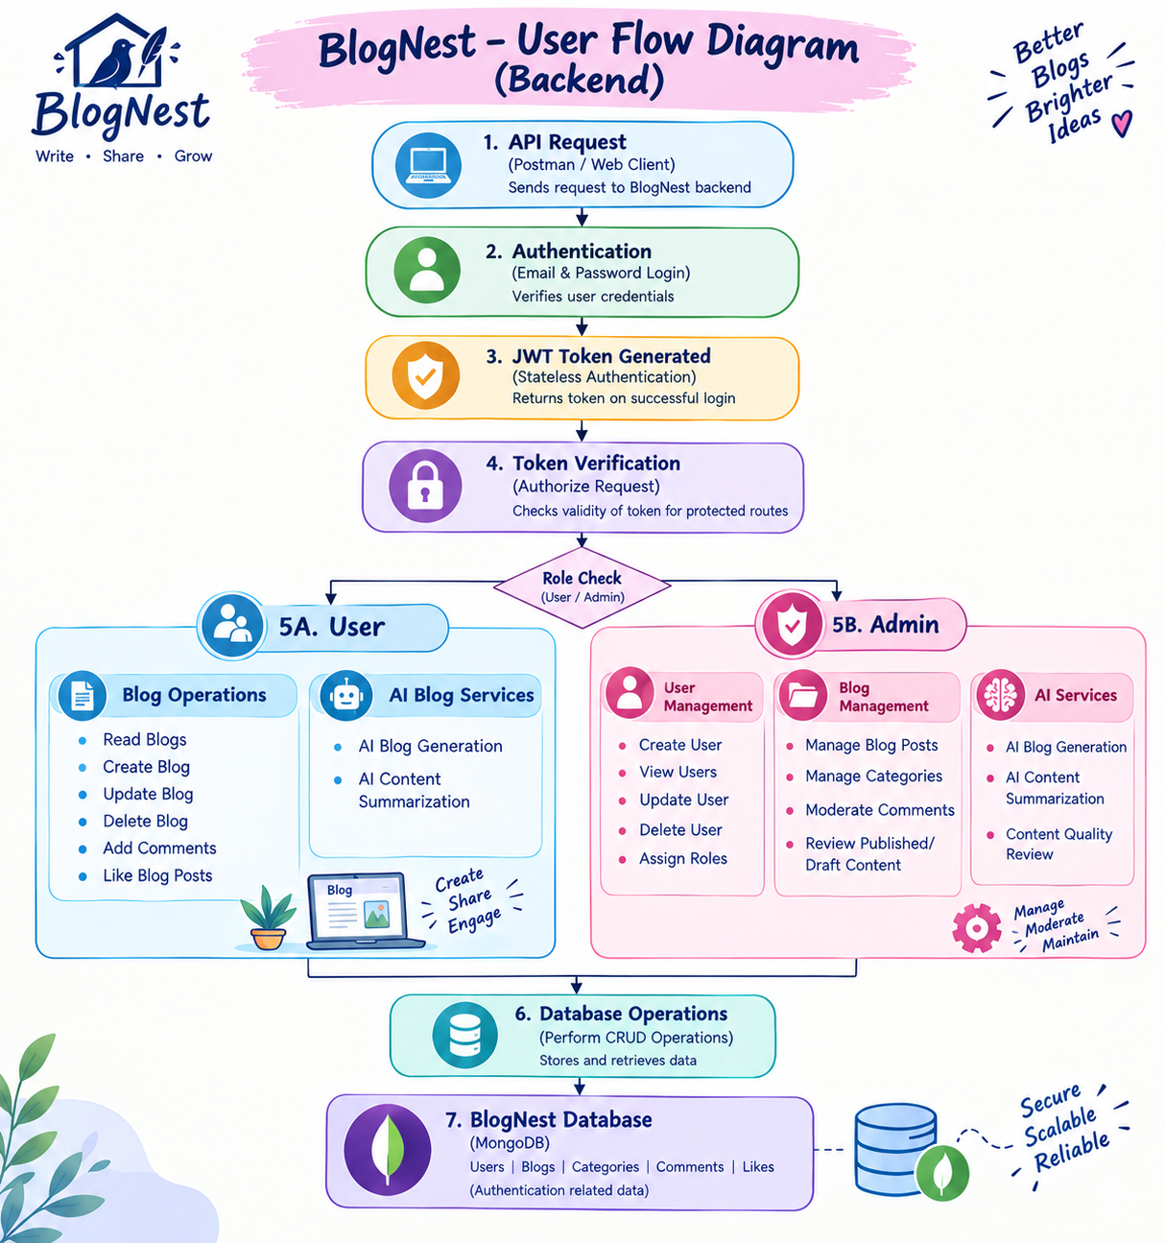

MVC Architecture Pattern

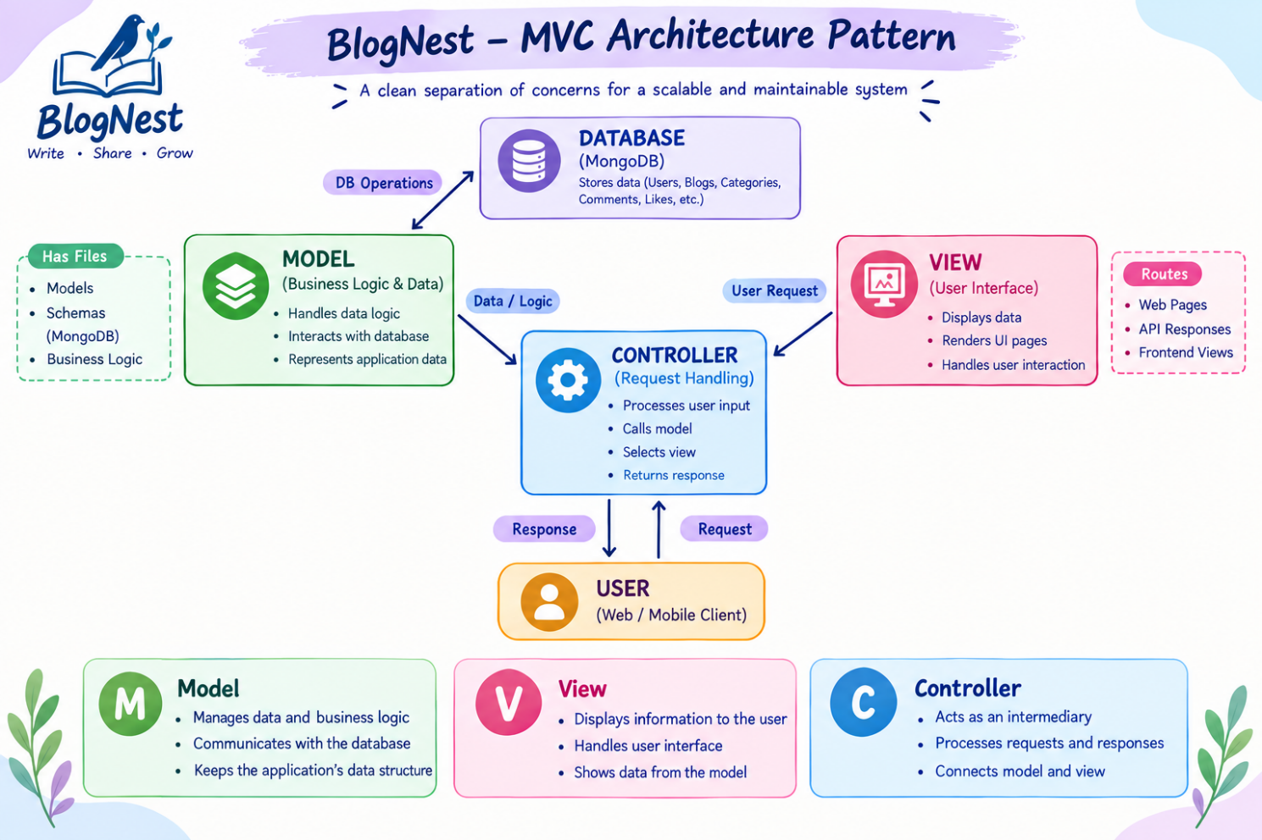

Model Layer (Data Blueprint)
The Model Layer defines and manages the structure of data used in the BlogNest application. It acts as a blueprint for storing and handling information in MongoDB.
● Mongoose Schema Definition:
Defines the fields, data types, and structure of entities such as Users, Blog Posts, Categories, and Comments.
● Data Validation:
Ensures that the entered data follows the required format and prevents invalid or incomplete data from being stored.
● Default Values:
Provides predefined values for specific fields when no value is supplied by the user.
● Database Interaction:
Connects the application with MongoDB and performs operations such as creating, retrieving, updating, and deleting records.
● Indexing:
Uses database indexes to improve the speed and efficiency of searching and retrieving blog-related data.
● Data Transformation:
Processes or formats data before it is stored in the database or returned to the application.
● Data Persistence:
After successful validation, the structured data is stored as documents inside MongoDB collections.
Controller Layer (Execution Matrix)
The Controller Layer acts as the main processing unit of the BlogNest application. It receives requests from the routes, processes the required operations, communicates with the Model Layer, and sends the appropriate response back to the user.
● Request Handling:
Receives user requests from routes such as creating, reading, updating, or deleting blog posts.
● Input Validation:
Checks whether the incoming request contains valid and required data before processing it.
● Business Logic Execution:
Processes the application logic and determines what operation needs to be performed.
● Model Interaction:
Communicates with the Model Layer to access, create, update, or delete data in MongoDB.
● Authentication & Authorization:
Verifies user access and ensures that only permitted users can perform protected operations.
● Response Generation:
Processes the result received from the Model and sends a structured JSON response to the client.
● Error Handling:
Handles invalid requests, missing data, authentication failures, and database errors with suitable responses.
View Layer (Routing Network Interface)
In the BlogNest backend, there is no traditional graphical user interface. Instead, the View Layer is represented by the API Routing Layer, which connects incoming client requests to the appropriate controller functions.
● API Routing:
Defines specific URL paths and HTTP methods for different BlogNest operations.
● Request Mapping:
Maps incoming requests to their corresponding controller handlers.
Epic2: Project Setup and Configuration
Creating project folder

1. Create a new folder with your <project name>.
2. Inside that folder create one new folders.
3. Name another one as server.
4. Now open that folder in vs code.

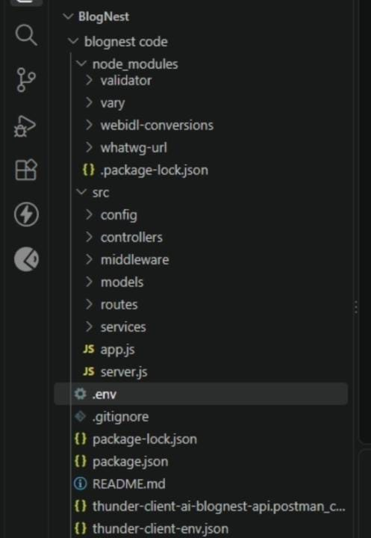

Server setup (npm init)
  - Open Server folder in terminal of VScode.
    - npm init -y
  - Create files:
    - server.js
  - Create folders:
    - models
    - controllers
    - routes

EPIC 3: Backend Development
Server.js


App.js


Epic4: Database Configuration
DB Connection:-


1. Configure MongoDB:
- Install Mongoose.
In your Node.js project directory, run:
npm install mongoose
- Create database connection.
- Create Schemas & Models.
Create Database connection:
- Now, make sure the database is connected before performing any of the actions through the backend. The connection code looks similar to the one provided below

Mongoose Schema Definitions

1. Identity Resource Document Schema (schemas/userModel.js)
- Enforces field criteria validations on incoming database creations:


Epic 5: Project Executions:
· Install Postman or ThunderClient (VS Code extension).
· Start the backend server: “npm start”

Demo video: https://drive.google.com/file/d/1kQmVD8Jj0vETvbELWPoPEZ71PxxL3Pk8/view?usp=drivesdk

CodeDrive:
https://drive.google.com/drive/folders/1hkwSciG0ayXK9coc6Aig5CzMtXC5Ru50?usp=drive_link

