Why we are not using an async worker (while we keep django-tenants)
Stack: Django 5.2, django-tenants 3.10, Gunicorn. Below is why moving to an async server (UvicornWorker/ASGI) gives no benefit while tenant isolation relies on django-tenants. Every claim cites installed-package source or the official documentation.

1. How an async worker works
An ASGI server (Gunicorn + UvicornWorker) runs one event loop per process: it accepts connections, does network I/O non-blockingly, and holds many connections cheaply. But synchronous application code cannot run on the loop itself — it would block it; Django offloads such code to a separate thread (via asgiref.sync.sync_to_async). → Django docs, Asynchronous support: https://docs.djangoproject.com/en/5.2/topics/async/

2. Even the “async ORM” is not async yet
The QuerySet a-methods are just wrappers over the sync ones. In Django source:
django/db/models/query.py:646
async def aget(self, *args, **kwargs):
return await sync_to_async(self.get)(*args, **kwargs)
(same for acreate, aupdate, adelete, afirst, … — all via sync_to_async). So the real SQL runs synchronously in a thread, not on the event loop. Officially confirmed: “underlying database operations remain synchronous … use sync_to_async()” — Django docs, Async.

3. Where and why the code “hops” to a separate thread
When an async server handles the request, the application code (views, ORM, our middleware) stays synchronous. It cannot run on the event loop: a sync call would block the loop and stall all other requests. So at the boundary “async server → sync code” Django automatically switches execution to a separate thread.
The switch point is BaseHandler.adapt_method_mode: while building the handling chain, Django sees a sync handler under an async server and wraps it in sync_to_async(..., thread_sensitive=True):
django/core/handlers/base.py adapt_method_mode():
if is_async and not method_is_async:
return sync_to_async(method, thread_sensitive=True) # approx. line 129
The crux is the flag thread_sensitive=True. It tells asgiref: run this not in an arbitrary pool thread but in one fixed thread for the whole process. This is deliberate — to keep thread-bound state intact: above all Django’s DB connections and transactions (they are thread-local). asgiref docs:
asgiref/sync.py:115 "By default, a single thread pool executor is shared" (thread_sensitive)
asgiref/sync.py:382 SyncToAsync: code "...will run in the same thread..."
Consequence: that thread is single and runs tasks one at a time. So all synchronous Django code — sync views, sync ORM, and even aget() (sync underneath, see §2) — effectively runs one request at a time per process. The event loop is free to accept new connections meanwhile, but the useful work runs sequentially on that one thread.

4. How Django middleware works
BaseHandler.load_middleware (django/core/handlers/base.py:26) builds the chain and adapts each middleware to the handler type via the same adapt_method_mode: a sync middleware under ASGI is wrapped in sync_to_async(thread_sensitive=True), and for a sync middleware to call an async view the view is wrapped in async_to_sync, which holds the single thread_sensitive thread for the whole request. → Django docs, Middleware and Async §Async middleware: https://docs.djangoproject.com/en/5.2/topics/http/middleware/ , https://docs.djangoproject.com/en/5.2/topics/async/
Consequence: a single sync link in the chain → request processing runs one request at a time (effectively 1 request per process), no matter how many async views you have.

5. Why django-tenants specifically removes the point of async
django-tenants isolates tenants via the PostgreSQL search_path, which is state of a specific connection:
django_tenants/middleware/main.py:13 class TenantMainMiddleware(MiddlewareMixin) # SYNC
django_tenants/middleware/main.py:52 connection.set_tenant(request.tenant)
django_tenants/postgresql_backend/base.py DatabaseWrapper._cursor(): runs `SET search_path` from connection.schema_name
This set/reset of the schema must happen one request at a time — otherwise tenant B would read tenant A’s data on the same connection. That is exactly why the tenant-routing middleware is synchronous (and must be).
Hence we always have a mandatory sync middleware in the chain → by §4 processing runs one request at a time on the single thread_sensitive thread (§3), and async views / async ORM add nothing because they too run on that thread (§2). So async gives no throughput win here — only overhead and sharp edges (reentrancy; transactions do not work in async on 5.2/6.0; etc.).

How it all ties to django-tenants
Everything above converges on one point precisely because of django-tenants. The general async facts — the event loop offloads synchronous code to a thread (§1); the “async ORM” actually runs SQL synchronously in a thread (QuerySet.aget() → sync_to_async(self.get), §2); at the async→sync boundary Django moves execution onto one shared thread_sensitive thread per process (BaseHandler.adapt_method_mode wraps sync handlers in sync_to_async(..., thread_sensitive=True), §3); and a single synchronous link in the middleware chain makes the whole chain run one request at a time (§4) — by themselves only describe Django mechanics, not a verdict on async. What turns them into a verdict is django-tenants’ isolation model: the tenant is selected by the PostgreSQL search_path, which is state of a specific connection, set and reset by a synchronous middleware (TenantMainMiddleware, and in our multi-DB setup ShardAwareTenantMiddleware + TenantShardRoutingMiddleware) that calls connection.set_tenant(...), while the backend’s DatabaseWrapper._cursor() issues SET search_path from connection.schema_name — and this must happen one request at a time, otherwise tenant B reads tenant A’s data on the shared connection (§5). That mandatory synchronous middleware is exactly the “single sync link” from §4 that funnels all processing onto the one thread from §3; the async views (async def) and async ORM (aget/acreate/…) from §1–§2 add nothing because they too run on that thread. So django-tenants turns the abstract limits of Django’s async stack into a concrete conclusion for us: as long as isolation rests on per-connection search_path, async infrastructure yields no benefit — which is exactly what the preceding sections demonstrate step by step.

Illustration: why the async path gives no win
Two concurrent requests under UvicornWorker + the (required) sync tenant middleware: the event loop accepts both, but processing runs one request at a time on the single thread-sensitive thread, because search_path is per-connection state that must be set/reset one request at a time.
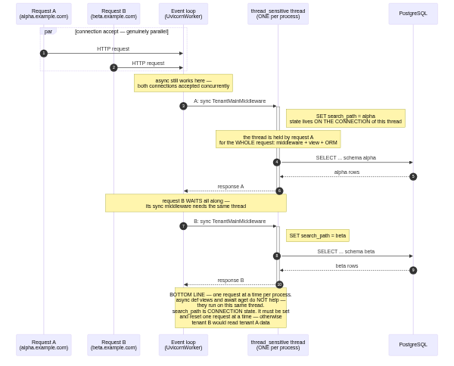
The same as a timeline — expectation vs reality vs the prefork model we chose (3 concurrent requests, 100 ms of work each):
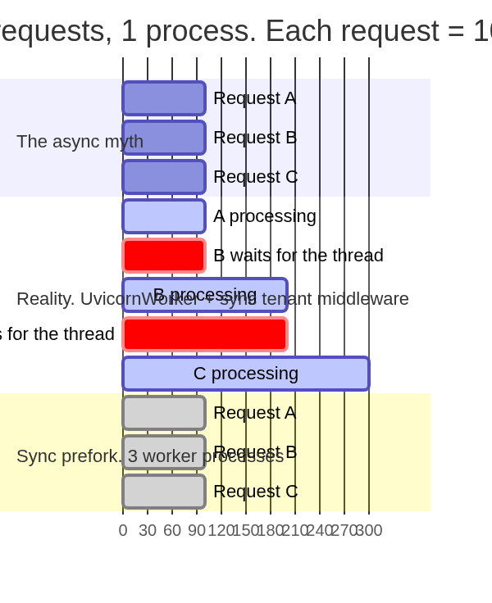

Summary
While tenant isolation relies on per-connection search_path (django-tenants), async infrastructure does not speed up request processing. So we chose synchronous prefork workers: N processes = N truly parallel requests (separate GILs, separate connections, clean per-request schema set/reset). Going async will only make sense after dropping connection-based isolation (a different tenant-storage model) — a separate architectural decision, not a free upgrade.

