<https://segmentfault.com/a/1190000009637016>

[](https://afptrack.alimama.com/clk?bid=0bb48d9a00005ae80d8c05d139fb3205&pid=mm_124884735_33830642_146292853&cid=269602&mid=254294&oid=35196&productType=1&qytInfoMTime=1525119910&e=Nu8G4MZGh%2FPL3IkfTk3f2svSYwpc2nFfiolFffqEGx3zu9POnKgOhRJ1U8hqIPVzAhjPBX0ETqGOPHD6DHXZ%2FCsA8ekmAih8c0RT515WnZSFZ1WgOeAFgg%3D%3D&k=121)

# [SegmentFault](https://segmentfault.com/)

* [首页](https://segmentfault.com/)
* [问答](https://segmentfault.com/questions)
* [**专栏**](https://segmentfault.com/blogs)
* [讲堂](https://segmentfault.com/lives)
* [标签](https://segmentfault.com/tags)
* [发现](https://segmentfault.com/a/1190000009637016##)

窗体顶端

搜索

窗体底端

* [立即登录](https://segmentfault.com/user/login)[免费注册](https://segmentfault.com/user/register)

# 在 SegmentFault，学习技能、解决问题

每个月，我们帮助 1000 万的开发者解决各种各样的技术问题。并助力他们在技术能力、职业生涯、影响力上获得提升。

窗体顶端

[免费注册](https://segmentfault.com/user/register) [立即登录](https://segmentfault.com/user/login)

窗体底端

# [用fetch与服务器进行交互时headers中content-type的配置问题以及涉及到的跨域问题](https://segmentfault.com/a/1190000009637016)

* [node.js](https://segmentfault.com/t/node.js/blogs)

* [koa.js](https://segmentfault.com/t/koa.js/blogs)

* [react.js](https://segmentfault.com/t/react.js/blogs)

[**一颗胖兔软糖**](https://segmentfault.com/u/usagi_v) 2017年06月02日发布

* 赞  |   1收藏  |  1
* **2.6k** 次浏览

最近在用react+node.js做项目的时候遇到一个问题：前端需要post给服务器的内容为json格式的（也就是content-type为application/json的格式），使用fetch()来与服务器进行交互时，设置 headers的中content-type为application/json，数据发送不到到服务器并报错如下：   
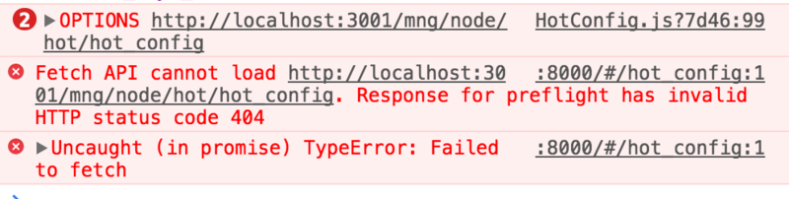

**我明明时候用的是post方法！**

然而试了很多种方法之后，在headers里添加mode:'no-cors'（意为”不跨域“）后，能提交成功，但是查看request的headers发现content-type自动变成了text-plain，这并不是服务器期望接受到的数据格式。

后来我goooooooogle了一下，在stackoverflow上看到这样一段回答：

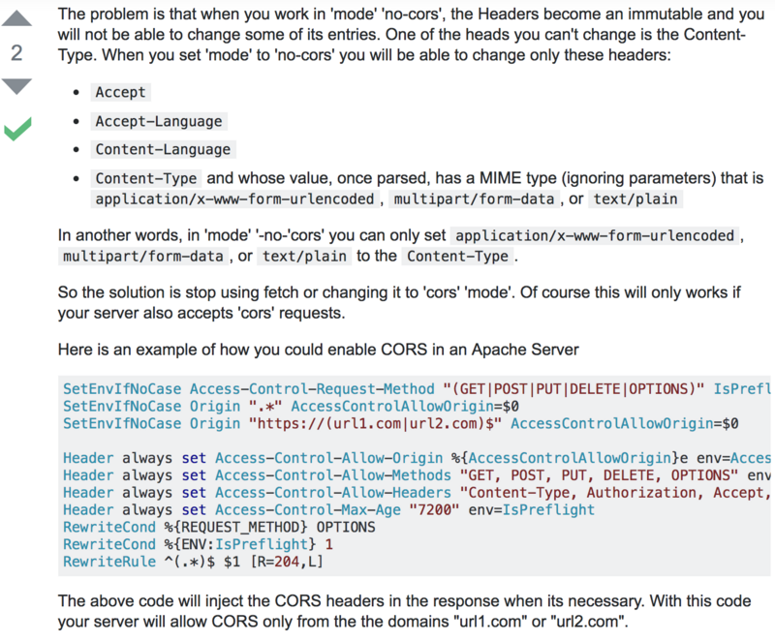

大概意思为：在'no-cors'模式下，我们不能修改content-type，而content-type的值只能是application/x-www-form-urlencoded、multipart/form-data或text/plain。

如果不设置mode，直接设置content-type为application/json，则fetch会默认这是跨域模式（mode:'cors'），在跨域POST之前，客户端会先发一条OPTIONS请求来”探探路”，如果服务器允许，再继续POST数据。对于这种OPTIONS请求，需要在服务器配置允许接受OPTIONS请求，我的配置如下：

if (ctx.request.method == "**OPTIONS**") {

ctx.response.status = 200

}

我这样写就是直接允许了所有的OPTIONS请求，也可以按照需求来判断OPTIONS请求中更详细的信息。  
当然，如果你的项目确实涉及到跨域问题，除了判断OPTIONS方法的请求之外，还需要配置一下请求头，我的node.js项目中的配置如下（使用的是KOA2框架）：

app.use(async(ctx, next) => {

ctx.set("Access-Control-Allow-Origin", "\*");

ctx.set("Access-Control-Allow-Credentials", true);

ctx.set("Access-Control-Allow-Methods", "**OPTIONS**, **GET**, **PUT**, **POST**, **DELETE**");

ctx.set("Access-Control-Allow-Headers", "x-requested-with, accept, origin, content-type");

ctx.set("X-Powered-By", ' 3.2.1');

ctx.set("Content-Type", "application/json;charset=utf-8");

if (ctx.request.method == "**OPTIONS**") {

ctx.response.status = 200

}

}

await next();

});

这样，前端就不需要再做跨域处理了。

新手上路，理解有误的请大家指正~

=============2017.6.16更新==================

nodejs中跨域header配置中的header字段，一定要跟fetch里设置的header字段一致，比如：  
在nodejs中配置头文件：

ctx**.set**("Access-Control-Allow-Headers", "x-requested-with, accept, origin, content-type");

那么，在fetch中配置content-type要写得与上述代码中的一致。nodejs中写的是content-type,fetch中就写content-type，写成contentType就不可以，会被拒绝。

* [2017年06月02日发布](https://segmentfault.com/a/1190000009637016)
* [新浪微博](javascript:void(0);)
* [微信](javascript:void(0);)
* [Twitter](javascript:void(0);)
* [Facebook](javascript:void(0);)

赞  |   1收藏  |  1

#### 你可能感兴趣的文章

* [Nodejs学习记录：用koa.js开发微信公众号](https://segmentfault.com/a/1190000012246932" \o "Nodejs学习记录：用koa.js开发微信公众号) 3 收藏，728 浏览
* [Node.js搭简单服务器与npm包管理](https://segmentfault.com/a/1190000014427046" \o "Node.js搭简单服务器与npm包管理) 3 收藏，136 浏览
* [13 款惊艳的 Node.js 框架——第1部分](https://segmentfault.com/a/1190000005183394" \o "13 款惊艳的 Node.js 框架——第1部分) 13 收藏，1.3k 浏览

**评论**

[默认排序时间排序](javascript:;)



窗体顶端



发布评论

窗体底端

关注作者

[](https://segmentfault.com/u/usagi_v)**[一颗胖兔软糖](https://segmentfault.com/u/usagi_v)**

12 声望

[](https://afptrack.alimama.com/clk?bid=0bb48d9b00005ae80d8b78643a069598&pid=mm_124884735_33830642_145440102&cid=269585&mid=254283&oid=35196&productType=1&qytInfoMTime=1525119910&e=DR%2F95FJB5LTL3IkfTk3f2q%2BYC8tIZVqzORcWrGFf4BHYI865e%2BTTnRAy%2F%2Fr0DJswAhjPBX0ETqGOPHD6DHXZ%2FCsA8ekmAih8c0RT515WnZSFZ1WgOeAFgg%3D%3D&k=121)

[](https://afptrack.alimama.com/clk?bid=0bb48d9b00005ae80d8b78643a069598&pid=mm_124884735_33830642_145440102&cid=269154&mid=253922&oid=34478&productType=1&qytInfoMTime=1525119910&e=V%2B7zkKAv5UPL3IkfTk3f2q%2BYC8tIZVqzORcWrGFf4BHYI865e%2BTTnZbCZeS7IxfzLuRratpqH3liODDozmX0cqbS5ou%2Bcrhd7gBlk0C%2B0TY8dj6cb4pSWefkEjqAj5Ew%2Bdapcbmg9EW7dGXvGiWb2H3dQH6KP1uGnmQXkC5wkBGwSFH8Hbp%2BdPDhoOcS0QRMHj5Ji57QB8MEEl2QYpmOuceSStu1Q3qxF3Quzfkt49Dqj%2BH%2FLTvBUKgzNDotEbATh4Lmt4IqPQNRRrssrjXDW7Owh7t9YKslxYMMSVZTlhSUVr5aSEf%2FGhU2B1xlY7bWEpOVMxxU2vO4vdpS2IkXD6GP%2FY0LENybEfezrvORhD6pirxp%2FkPvjt2R%2BJ6m6ngUmibPrBgINhffVDHn2iPmW0eRTkTwdD2T5FPOw6YNcurjPoT3cknsSKCyzvc0bwqdZRFipqotbMebIo8Do3kEnnJx%2BhAlJcDGM3XRuqlDHzELRDmU99lpShobGa31QjRkPjZYGSuBjg4%3D&k=525)

# 在 SegmentFault，学习技能、解决问题

每个月，我们帮助 1000 万的开发者解决各种各样的技术问题。并助力他们在技术能力、职业生涯、影响力上获得提升。

窗体顶端

[免费注册](https://segmentfault.com/user/register) [立即登录](https://segmentfault.com/user/login)

窗体底端

**产品**

[热门问答](https://segmentfault.com/questions/hottest?utm_source=sf-footer&utm_medium=footer-nav&utm_campaign=product&utm_content=footer-links-hottest-questions&utm_term=%E7%83%AD%E9%97%A8%E9%97%AE%E7%AD%94)

[热门专栏](https://segmentfault.com/blogs/hottest?utm_source=sf-footer&utm_medium=footer-nav&utm_campaign=product&utm_content=footer-links-hottest-questions&utm_term=%E7%83%AD%E9%97%A8%E4%B8%93%E6%A0%8F)

[热门讲堂](https://segmentfault.com/lives?utm_source=sf-footer&utm_medium=footer-nav&utm_campaign=product&utm_content=footer-links-hottest-questions&utm_term=%E7%83%AD%E9%97%A8%E8%AE%B2%E5%A0%82)

[最新活动](https://segmentfault.com/events?utm_source=sf-footer&utm_medium=footer-nav&utm_campaign=product&utm_content=footer-links-hottest-questions&utm_term=%E6%9C%80%E6%96%B0%E6%B4%BB%E5%8A%A8)

[技术圈](https://segmentfault.com/groups?utm_source=sf-footer&utm_medium=footer-nav&utm_campaign=product&utm_content=footer-links-hottest-questions&utm_term=%E6%8A%80%E6%9C%AF%E5%9C%88)

[找工作](https://segmentfault.com/jobs?utm_source=sf-footer&utm_medium=footer-nav&utm_campaign=product&utm_content=footer-links-hottest-questions&utm_term=%E6%89%BE%E5%B7%A5%E4%BD%9C)

[移动客户端](https://segmentfault.com/app?utm_source=sf-footer&utm_medium=footer-nav&utm_campaign=product&utm_content=footer-links-hottest-questions&utm_term=app)

**资源**

[每周精选](https://segmentfault.com/weekly?utm_source=sf-footer&utm_medium=footer-nav&utm_campaign=resource&utm_content=footer-links-weekly&utm_term=%E6%AF%8F%E5%91%A8%E7%B2%BE%E9%80%89)

[用户排行榜](https://segmentfault.com/users?utm_source=sf-footer&utm_medium=footer-nav&utm_campaign=resource&utm_content=footer-links-users&utm_term=%E7%94%A8%E6%88%B7%E6%8E%92%E8%A1%8C%E6%A6%9C)

[徽章](https://segmentfault.com/badges?utm_source=sf-footer&utm_medium=footer-nav&utm_campaign=resource&utm_content=footer-links-badges&utm_term=%E5%BE%BD%E7%AB%A0)

[帮助中心](https://segmentfault.com/faq?utm_source=sf-footer&utm_medium=footer-nav&utm_campaign=resource&utm_content=footer-links-faq&utm_term=%E5%B8%AE%E5%8A%A9%E4%B8%AD%E5%BF%83)

[声望与权限](https://segmentfault.com/repu?utm_source=sf-footer&utm_medium=footer-nav&utm_campaign=resource&utm_content=footer-links-repu&utm_term=%E5%A3%B0%E6%9C%9B%E4%B8%8E%E6%9D%83%E9%99%90)

[社区服务中心](https://segmentfault.com/community?utm_source=sf-footer&utm_medium=footer-nav&utm_campaign=resource&utm_content=footer-links-community&utm_term=%E7%A4%BE%E5%8C%BA%E6%9C%8D%E5%8A%A1%E4%B8%AD%E5%BF%83)

[开发手册](https://docs.segmentfault.com/?utm_source=sf-footer&utm_medium=footer-nav&utm_campaign=resource&utm_content=footer-links-docs&utm_term=%E5%BC%80%E5%8F%91%E6%89%8B%E5%86%8C)

**商务**

[人才服务](https://business.segmentfault.com/services?utm_source=sf-footer&utm_medium=footer-nav&utm_campaign=business&utm_content=footer-links-services-rencai&utm_term=%E4%BA%BA%E6%89%8D%E6%9C%8D%E5%8A%A1" \t "_blank)

[企业培训](https://business.segmentfault.com/services?utm_source=sf-footer&utm_medium=footer-nav&utm_campaign=business&utm_content=footer-links-services-qiyeneixun&utm_term=%E4%BC%81%E4%B8%9A%E6%9C%8D%E5%8A%A1" \t "_blank)

[活动策划](https://business.segmentfault.com/services?utm_source=sf-footer&utm_medium=footer-nav&utm_campaign=business&utm_content=footer-links-services-huodongcehua&utm_term=%E6%B4%BB%E5%8A%A8%E7%AD%96%E5%88%92" \t "_blank)

[广告投放](https://business.segmentfault.com/ads?utm_source=sf-footer&utm_medium=footer-nav&utm_campaign=business&utm_content=footer-links-ads&utm_term=%E5%B9%BF%E5%91%8A%E6%8A%95%E6%94%BE" \t "_blank)

[区块链解决方案](https://business.segmentfault.com/bc?utm_source=sf-footer&utm_medium=footer-nav&utm_campaign=business&utm_content=footer-links-bc&utm_term=%E5%8C%BA%E5%9D%97%E9%93%BE%E8%A7%A3%E5%86%B3%E6%96%B9%E6%A1%88" \t "_blank)

[合作联系](https://business.segmentfault.com/contact?utm_source=sf-footer&utm_medium=footer-nav&utm_campaign=business&utm_content=footer-links-contact&utm_term=%E5%90%88%E4%BD%9C%E8%81%94%E7%B3%BB" \t "_blank)

**关于**

[关于我们](https://about.segmentfault.com/?utm_source=sf-footer&utm_medium=footer-nav&utm_campaign=about&utm_content=about-index&utm_term=%E5%85%B3%E4%BA%8E%E6%88%91%E4%BB%AC)

[加入我们](https://about.segmentfault.com/careers.html?utm_source=sf-footer&utm_medium=footer-nav&utm_campaign=about&utm_content=about-careers&utm_term=%E5%8A%A0%E5%85%A5%E6%88%91%E4%BB%AC)

[联系我们](https://about.segmentfault.com/contact.html?utm_source=sf-footer&utm_medium=footer-nav&utm_campaign=about&utm_content=about-contact&utm_term=%E8%81%94%E7%B3%BB%E6%88%91%E4%BB%AC)

**关注**

[产品技术日志](https://segmentfault.com/blog/segmentfault" \t "_blank)

[社区运营日志](https://segmentfault.com/blog/community_admin" \t "_blank)

[市场运营日志](https://segmentfault.com/blog/segmentfault_news" \t "_blank)

[团队日志](https://segmentfault.com/blog/segmentfault_team" \t "_blank)

[社区访谈](https://segmentfault.com/blog/interview" \t "_blank)

* 微信

* [新浪微博](http://weibo.com/segmentfault" \t "_blank)

* [Github](https://github.com/SegmentFault" \t "_blank)

* [Twitter](https://twitter.com/segment_fault" \t "_blank)

**条款**

[服务条款](https://segmentfault.com/tos)

[内容许可](https://creativecommons.org/licenses/by-nc-nd/4.0/" \t "_blank)

[](https://segmentfault.com/app)

扫一扫下载 App

Copyright © 2011-2018 SegmentFault. 当前呈现版本 17.06.16  
[浙ICP备 15005796号-2](http://www.miibeian.gov.cn/)   [浙公网安备 33010602002000号](http://www.beian.gov.cn/portal/registerSystemInfo?recordcode=33010602002000" \t "_blank) 杭州堆栈科技有限公司版权所有

CDN 存储服务由 [又拍云](https://www.upyun.com/?utm_source=segmentfault&utm_medium=link&utm_campaign=upyun&md=segmentfault" \t "_blank) 赞助提供

[回顶部](https://segmentfault.com/a/1190000009637016)