**Manual Testing (using Postman)**

**Test Case I : Verify direct call to image service returns post data.**

* Post request to service : <http://localhost:8081/api/image> with data ‘{“image”:”test”}’
* Response should be ‘{“image”:”test”}’

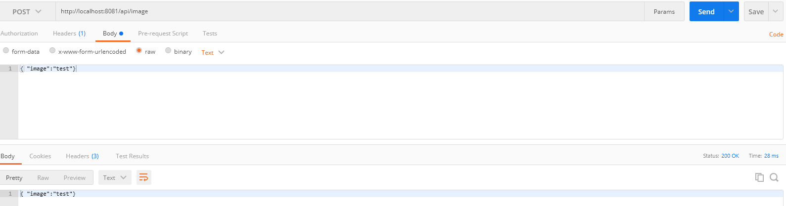

**Test Case II: Verify call to gateway app returns encoded post data.**

* Post request to gateway : <http://localhost:8083/demo/api/image> with data ‘{“image”:”test”}’
* Response should be {"image":"MTIzNA\
  + *(last character is \u003d html entity escaping should be removed for further data processing)*

