HW10 Report

Course: CMPEN472

Name: Xuhong Lin

Email: [xql5448@psu.edu](mailto:xql5448@psu.edu)

Instructor: Kyusun Choi

**1.SawTooth Waveform**

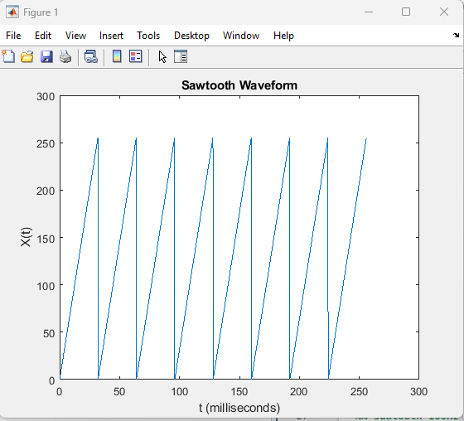

Figure1. Sawtooth Waveform with 2048 sample points

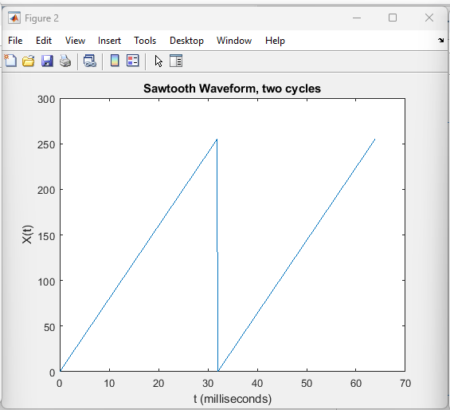

Figure2. Sawtooth Waveform with 2 single cycles

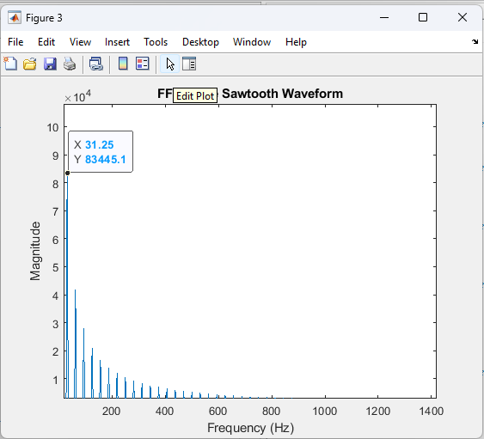

Figure 3. Sawtooth Waveform FFT

From figure 1, and 2, one single cycle of the sawtooth waveform has 256 sample points. Since each sample point has time of 125us. So the period of this sawtooth waveform will be 125us * 256 = 32ms which can be seen easily in figure 2. Therefore the frequency of this sawtooth waveform is 1/T = 1/32ms = 31.25Hz. And we can also observe the frequency domain of this waveform, the dominate frequency is 31.25Hz.

**2.Square Waveform 100Hz**

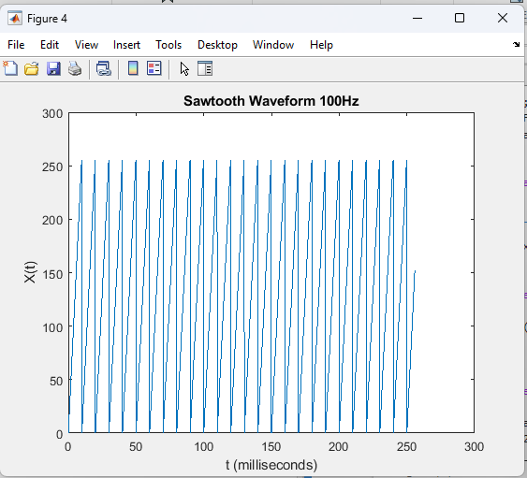

Figure 4. Sawtooth Waveform 100Hz with 2048 sample points

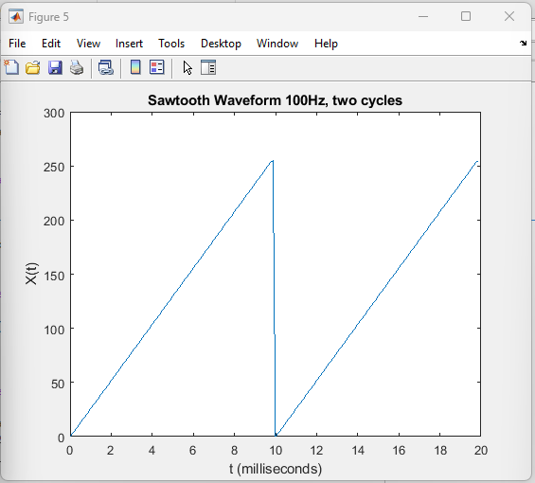

Figure 5. Sawtooth Waveform 100Hz with two single cycles

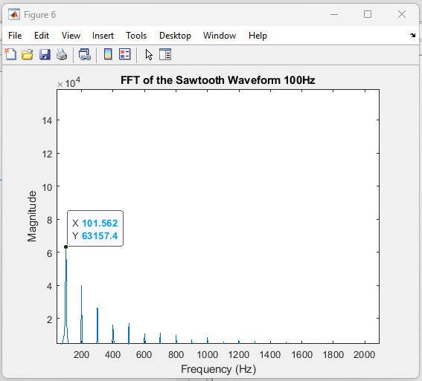

Figure 6. Sawtooth Waveform 100Hz FFT

In this sawtooth waveform, each single cycle has only 80 samples. Since the sample period is 125us. Then, the period of this sawtooth waveform is 80 * 125us = 10ms which can be observed easily in figure 5. Since the period, T, is 10ms, the frequency of this sawtooth waveform is 1/t = 1/10ms = 100Hz. And we can observe that the frequency of 101Hz is the donimate frequency signal in the FFT plot.

**3.Triangle Waveform**

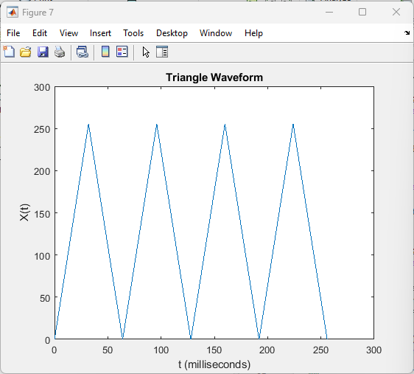

Figure 7. Triangle Waveform with 2048 sample points

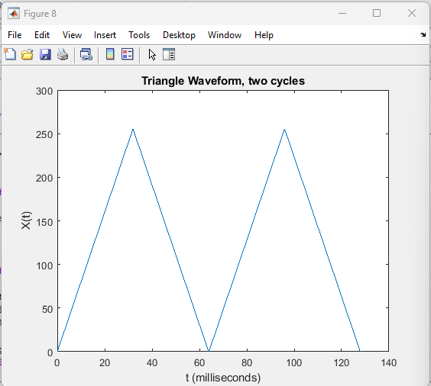

Figure 8. Triangle Waveform wiht two single cycles

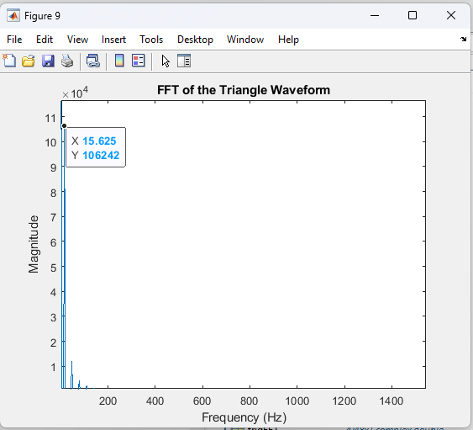

Figure 9. Triangle Waveform, FFT

One single cycle of this triangle waveform has 512 sample points. Since the sample period is 125us, the period of this triangle waveform will be 512 * 125us = 64ms which can be observed clearly in figure 8. Then, the frequency of this triangle waveform will be 1/T = 1/64ms = 15.625 Hz. And we can observe that the frequency of 15.625Hz is the donimate frequency signal in the FFT plot.

**4.Square Waveform**

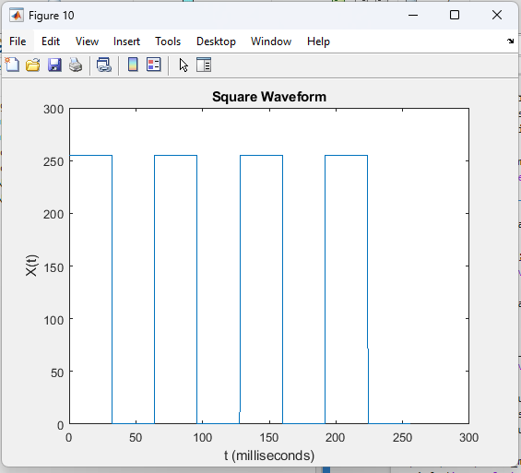

Figure 10. Square Waveform with 2048 sample points

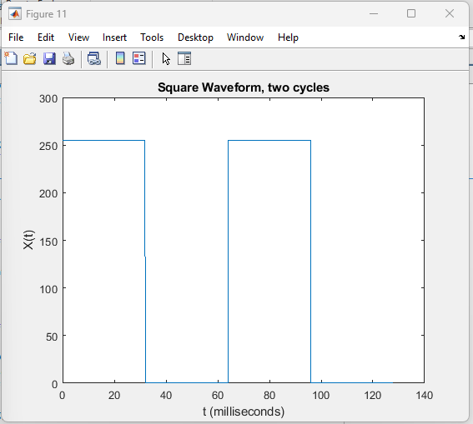

Figure 11. Square Wavefrom with two single cycles

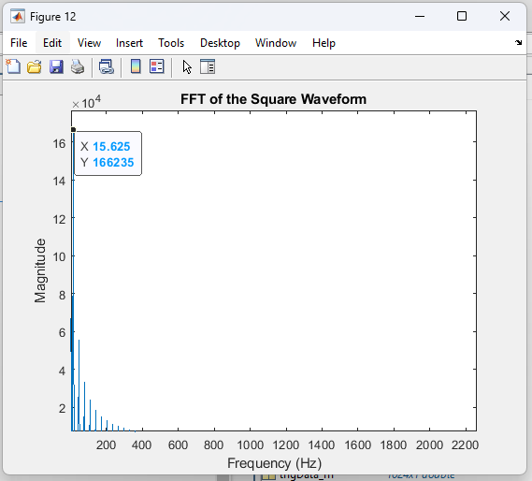

Figure 12. Square Waveform, FFT

One single cycle of this square waveform has 512 sample points. Since the sample period is 125us, the period of this square waveform will be 512 * 125us = 64ms which can be observed clearly in figure 11. Then, the frequency of this square waveform will be 1/T = 1/64ms = 15.625 Hz. And we can observe that the frequency of 15.625Hz is the donimate frequency signal in the FFT plot.

**5.Square Waveform 100Hz**

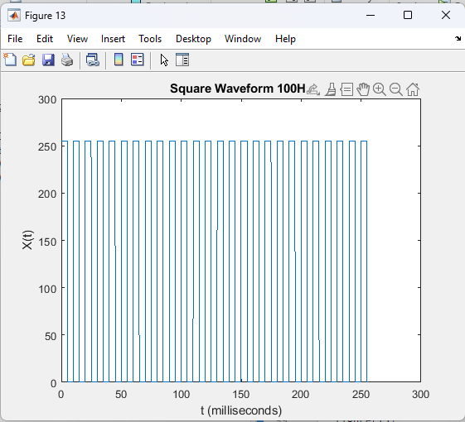

Figure 13. Square Waveform 100Hz with 2048 sample points

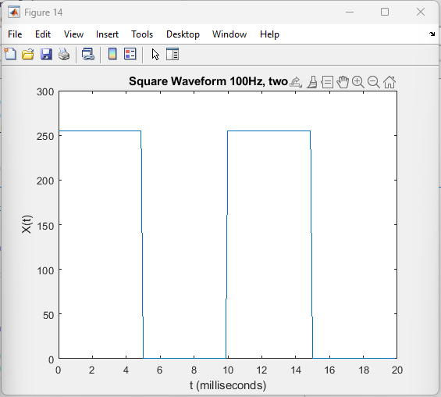

Figure 14. Square Waveform 100Hz, two cycles

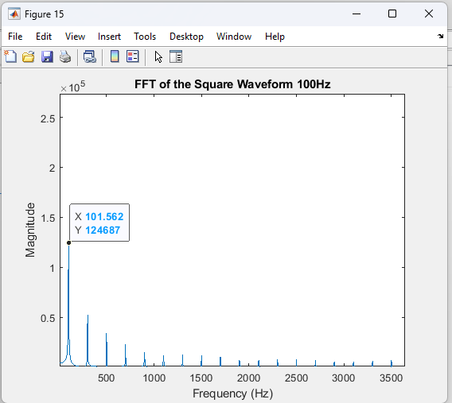

Figure 15. Square Waveform, FFT

One single cycle of this square waveform has 80 sample points. Since the sample period is 125us, the period of this square waveform will be 80 * 125us = 10ms which can be observed clearly in figure 14. Then, the frequency of this square waveform will be 1/T = 1/10ms = 100 Hz. And we can observe that the frequency of 101Hz is the donimate frequency signal in the FFT plot.