HW11 Report

Course: CMPEN472

Name: Xuhong Lin

Email: [xql5448@psu.edu](mailto:xql5448@psu.edu)

Instructor: Kyusun Choi

**1.SawTooth Waveform**

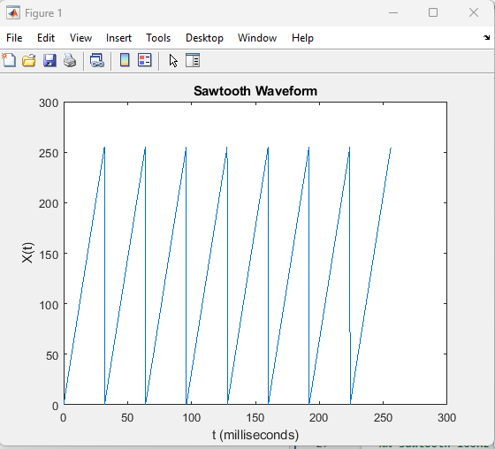

Figure1. Sawtooth Waveform with 2048 sample points

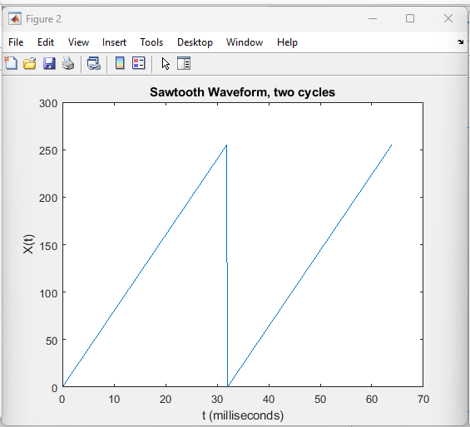

Figure2. Sawtooth Waveform with 2 single cycles

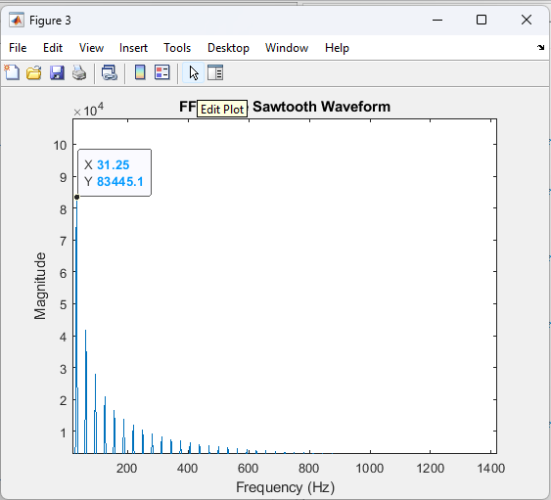

Figure 3. Sawtooth Waveform FFT

From Figures 1 and 2, one single cycle of the sawtooth waveform has 256 sample points. Each sample point has a time of 125us. So, the period of this sawtooth waveform will be 125us * 256 = 32ms which can be seen easily in Figure 2. Therefore, the frequency of this sawtooth waveform is 1/T = 1/32ms = 31.25Hz. And we can also observe the frequency domain of this waveform, the dominant frequency is 31.25Hz.

**2. Square Waveform 100Hz**

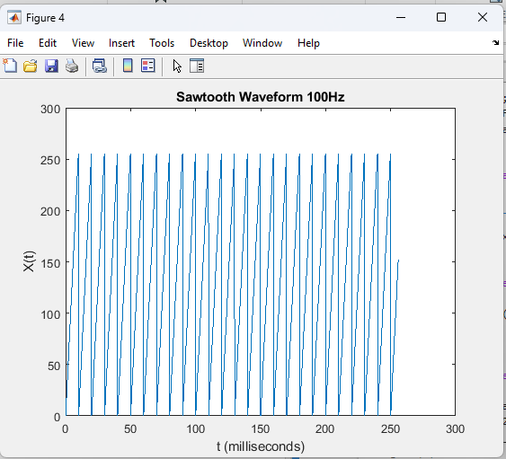

Figure 4. Sawtooth Waveform 100Hz with 2048 sample points

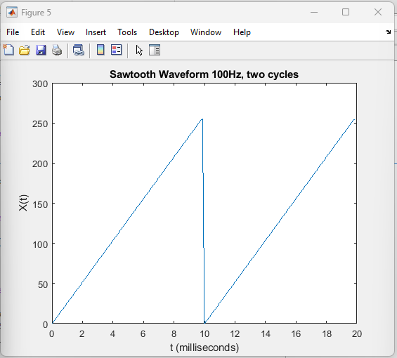

Figure 5. Sawtooth Waveform 100Hz with two single cycles

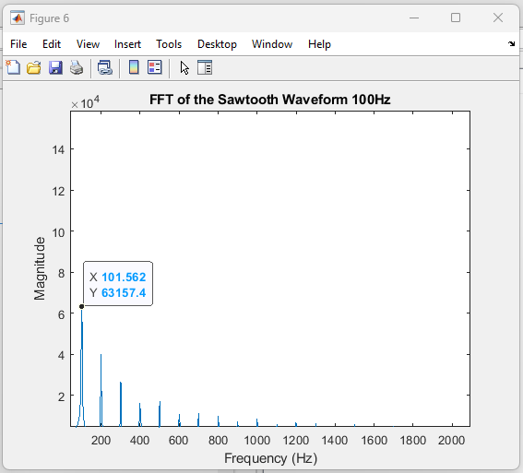

Figure 6. Sawtooth Waveform 100Hz FFT

In this sawtooth waveform, each single cycle has only 80 samples. Since the sample period is 125us. Then, the period of this sawtooth waveform is 80 * 125us = 10ms which can be observed easily in Figure 5. Since the period, T is 10ms, the frequency of this sawtooth waveform is 1/t = 1/10ms = 100Hz. And we can observe that the frequency of 101Hz is the dominant frequency signal in the FFT plot.

**3. Triangle Waveform**

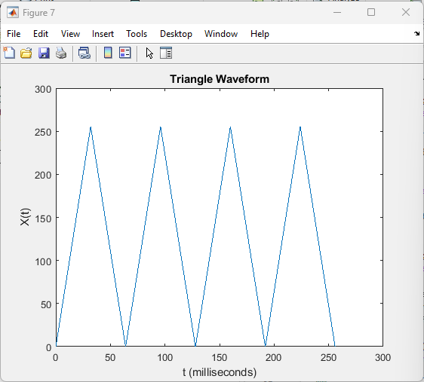

Figure 7. Triangle Waveform with 2048 sample points

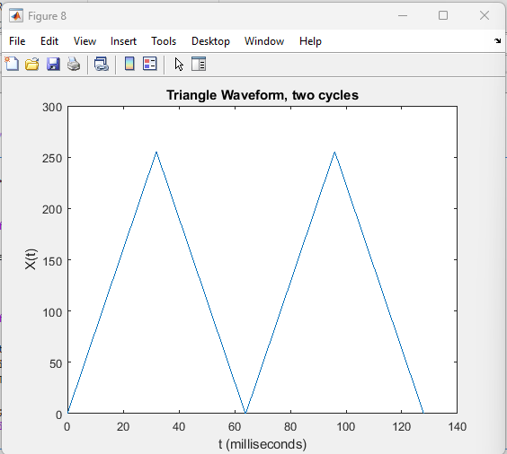

Figure 8. Triangle Waveform with two single cycles

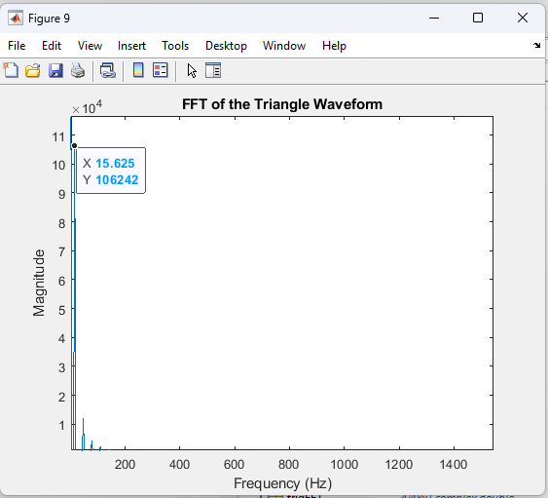

Figure 9. Triangle Waveform, FFT

One single cycle of this triangle waveform has 512 sample points. Since the sample period is 125us, the period of this triangle waveform will be 512 * 125us = 64ms which can be observed clearly in figure 8. Then, the frequency of this triangle waveform will be 1/T = 1/64ms = 15.625 Hz. And we can observe that the frequency of 15.625Hz is the dominant frequency signal in the FFT plot.

**4. Square Waveform**

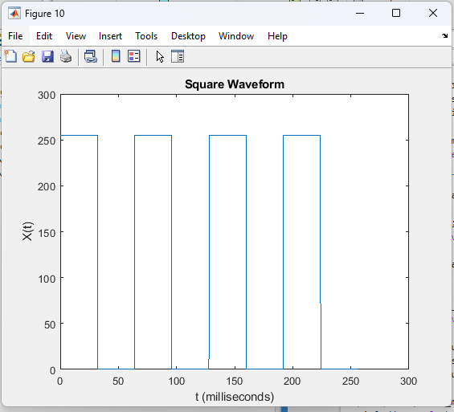

Figure 10. Square Waveform with 2048 sample points

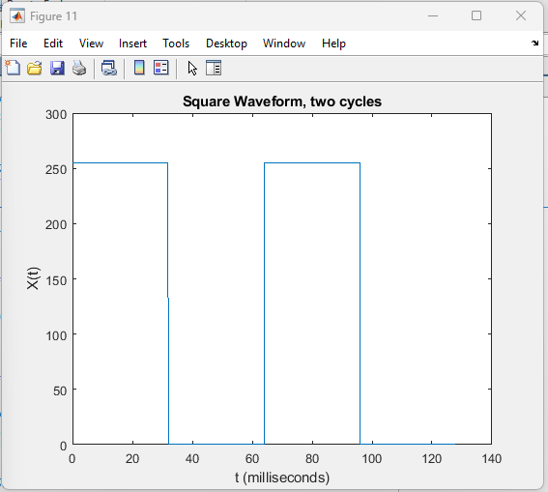

Figure 11. Square Waveform with two single cycles

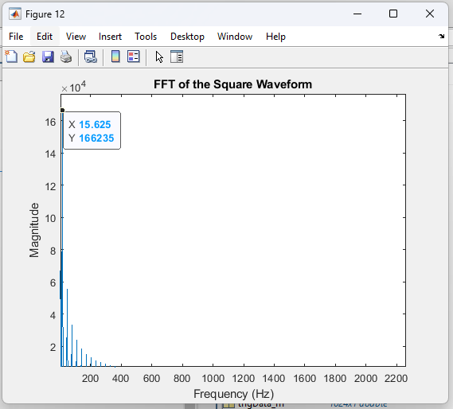

Figure 12. Square Waveform, FFT

One single cycle of this square waveform has 512 sample points. Since the sample period is 125us, the period of this square waveform will be 512 * 125us = 64ms which can be observed clearly in figure 11. Then, the frequency of this square waveform will be 1/T = 1/64ms = 15.625 Hz. And we can observe that the frequency of 15.625Hz is the dominant frequency signal in the FFT plot.

**5. Square Waveform 100Hz**

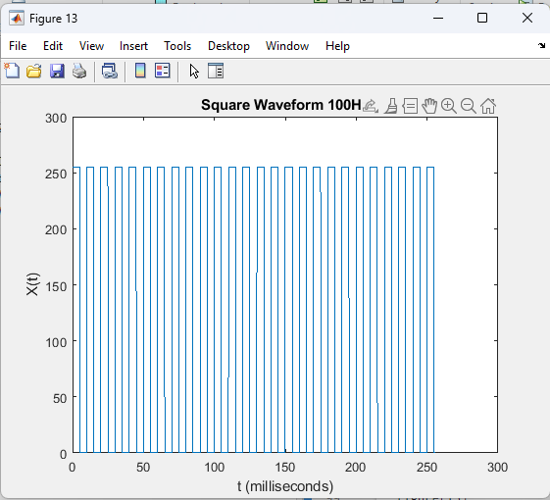

Figure 13. Square Waveform 100Hz with 2048 sample points

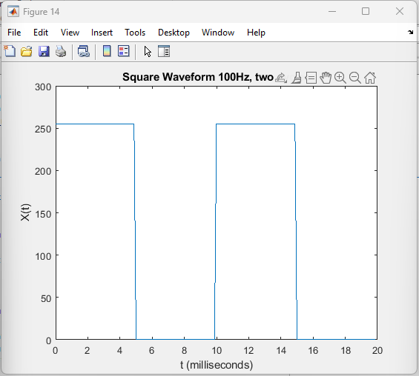

Figure 14. Square Waveform 100Hz, two cycles

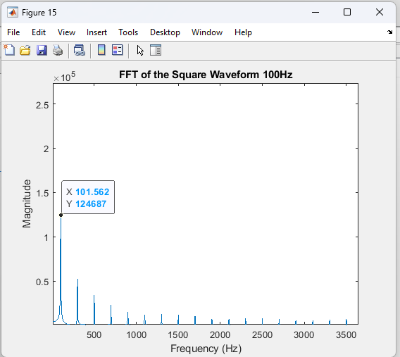

Figure 15. Square Waveform, FFT

One single cycle of this square waveform has 80 sample points. Since the sample period is 125us, the period of this square waveform will be 80 * 125us = 10ms which can be observed clearly in figure 14. Then, the frequency of this square waveform will be 1/T = 1/10ms = 100 Hz. And we can observe that the frequency of 101Hz is the dominant frequency signal in the FFT plot.

**6. ADC 100 Hz Square Waveform**

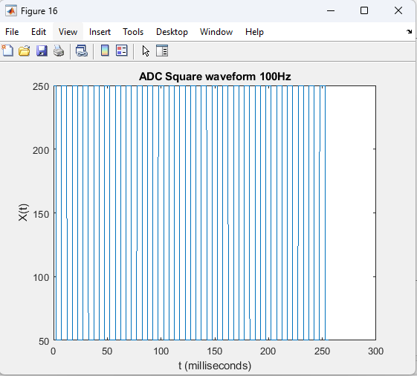

Figure 16. 100Hz Square Waveform generated from ADC

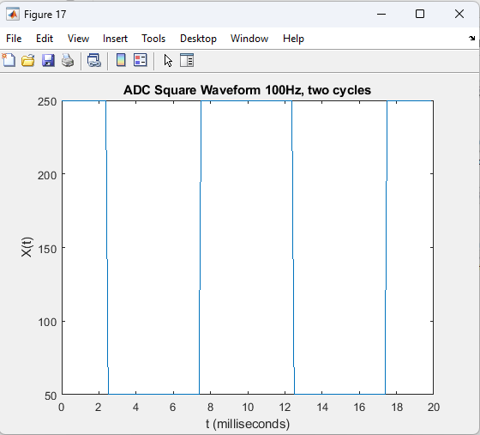

Figure 17. 2 single cycles of 100 HZ Square Waveform generated from ADC

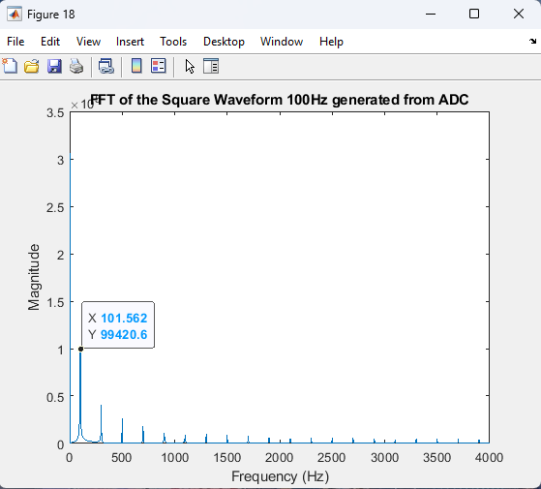

Figure 18. FFT of 100 Hz Square Waveform generated from ADC

All sample points are obtained from ADC. I sampled 2048 points based on the Timer Interrupts. Since the sample rate is 125 usecs, this 100 Hz square waveform will have 80 samples every single cycle. So, the period will be 80*125usecs = 10ms which can be seen in Figure 17. In Figure 17, there are two cycles of this waveform, the entire scale is 20 ms. Therefore, one period is 10ms as shown in the Figure. Then the frequency will be 1/T = 1/10ms = 100Hz. As we can see, the dominant frequency in Figure 18 is 101 Hz which is very close to 100 Hz.

**7. ADC 100Hz Sine Waveform**

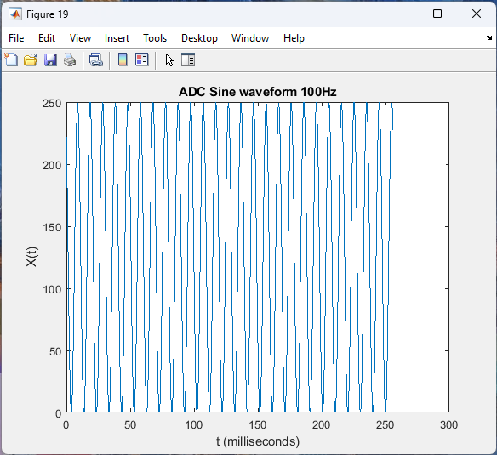

Figure 19. 100 Hz sine waveform generated from ADC

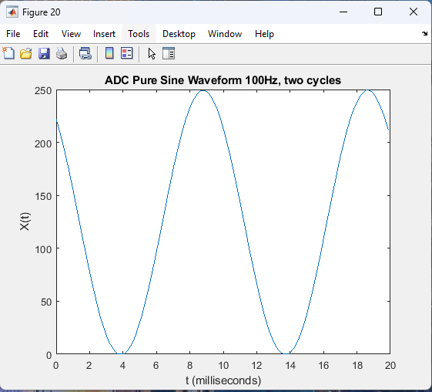

Figure 20. 2 cycles of 100 Hz sine waveform generated from ADC

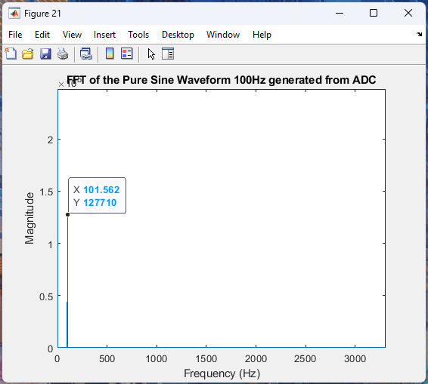

Figure 21. FFT of 100 Hz sine waveform generated from ADC

The total sample points are 2048 based on the Timer Interrupts. The sample rate of the Timer interrupts is 125 usecs. Therefore, it will have 8000 samples per second. This 100 Hz sine waveform will have 80 points per single cycle. Then, the period will be 80*125 usecs = 10ms. We can easily observe from Figure 20 that the period of this 100 Hz sine waveform is 10ms since there are 2 single cycles and the total scale time is 20ms, and the one period is 10 ms. Then, we will have the frequency that 1/T = 1/10ms = 100 Hz. We can see that the dominant frequency is 101 Hz from the FFT plot in Figure 21.

**8. ADC 100 Hz Triangle Waveform**

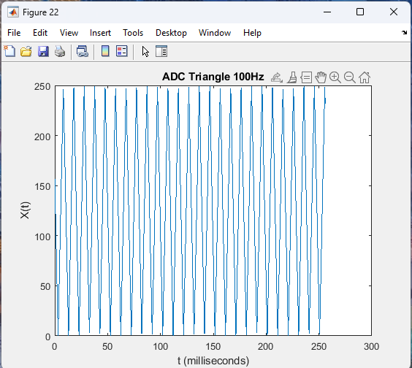

Figure 22. 100 Hz Triangle Waveform generated from ADC

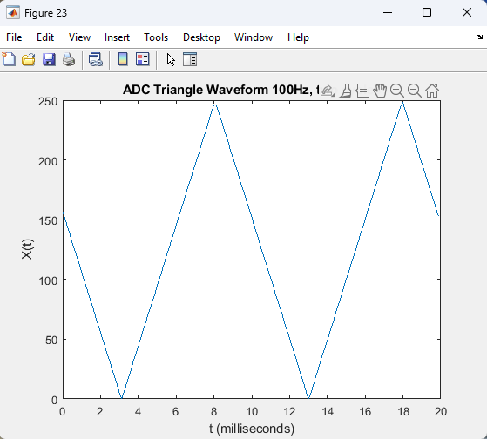

Figure 23. 2 cycles of 100 Hz Triangle Waveform generated from ADC

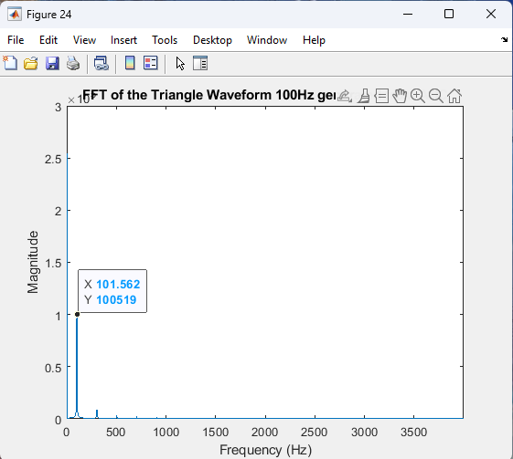

Figure 24. FFT of 100 Hz Triangle Waveform generated from ADC

The total sample points are 2048 based on the Timer Interrupts. The sample rate of the Timer interrupts is 125 usecs. Therefore, it will have 8000 samples per second. This 100 Hz Triangle waveform will have 80 points per single cycle. Then, the period will be 80*125 usecs = 10ms. We can easily observe from Figure 23 that the period of this 100 Hz Triangle waveform is 10ms since there are 2 single cycles and the total scale time is 20ms, and the one period is 10 ms. Then, we will have the frequency that 1/T = 1/10ms = 100 Hz. We can see that the dominant frequency is 101 Hz from the FFT plot in Figure 24.

**9. ADC 100Hz mixed sine waveform**

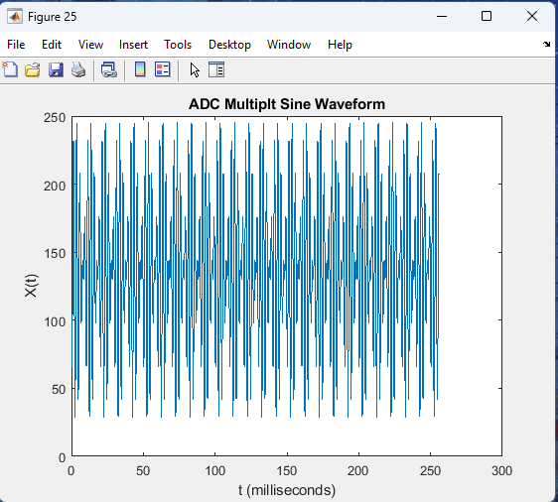

Figure 25. Mixed Sine Waveform generated from ADC

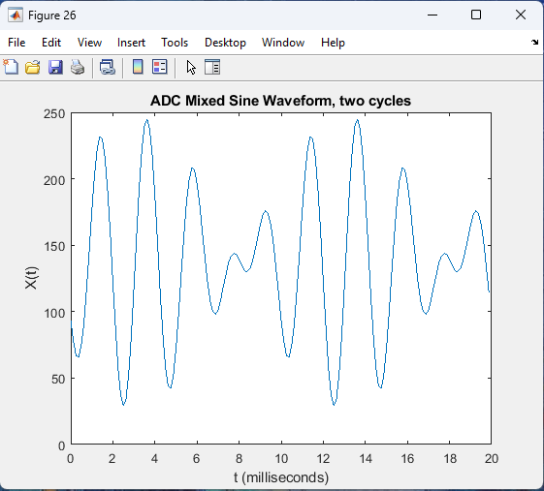

Figure 26. 2 cycles of mixed sine waveform generated from ADC

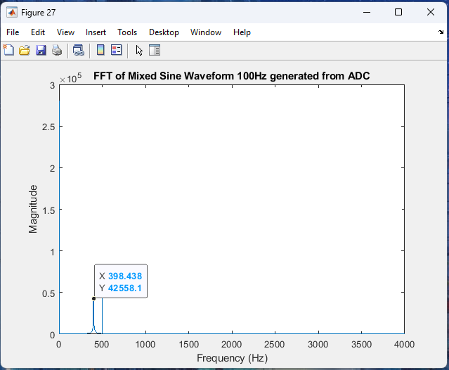

Figure 27. FFT of the mixed sine waveform that shows one frequency peak at 400 Hz

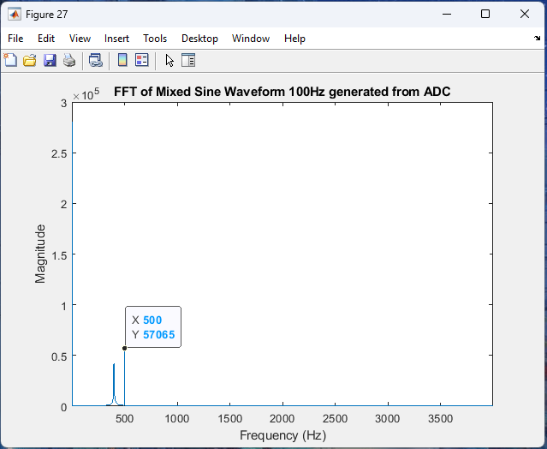

Figure 28. FFT of the mixed sine waveform that shows one frequency peak at 500 Hz

The total sample points are 2048 based on the Timer Interrupt, and we can see the plot in Figure 25. The sample rate is 125 usecs. Since we don’t know the exact frequency of this mixed signal. The magnified plot which is Figure 26 cannot show 2 single cycles. Therefore, the Figure 26 only shows the first 160 sample points. And from Figure 27 and 28 which shows the FFT of this mixed waveform shows exactly two peaks at 400 Hz and 500 Hz. From this, we can tell that the mixed signal is composed of one 400 Hz sine signal and one 500 Hz sine signal. And the period of those two signals are 0.002s and 0.0025s. Then, this mixed signal will have a combined period of 0.01s which is 100Hz in frequency. Therefore, the figure 26 indeed shows two signal cycles of this mixed waveform.