Practice 6 Report From
Xu Ziyang 22320607 375439
Today I’m not using Latex. Because there are just several picture can show my work.
My k is 7, so my system is
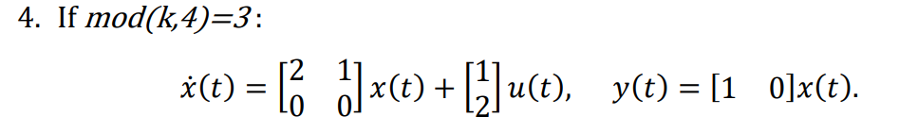
Matlab Shot:
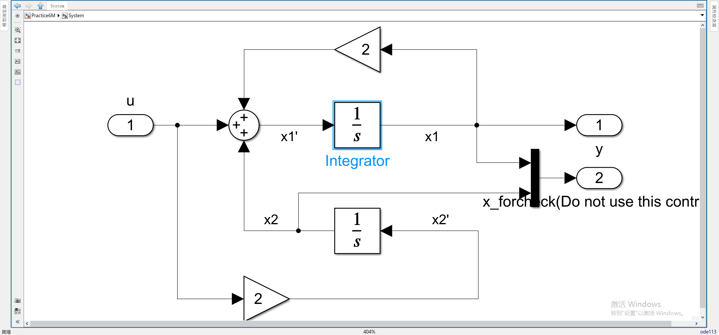
Observer Design:
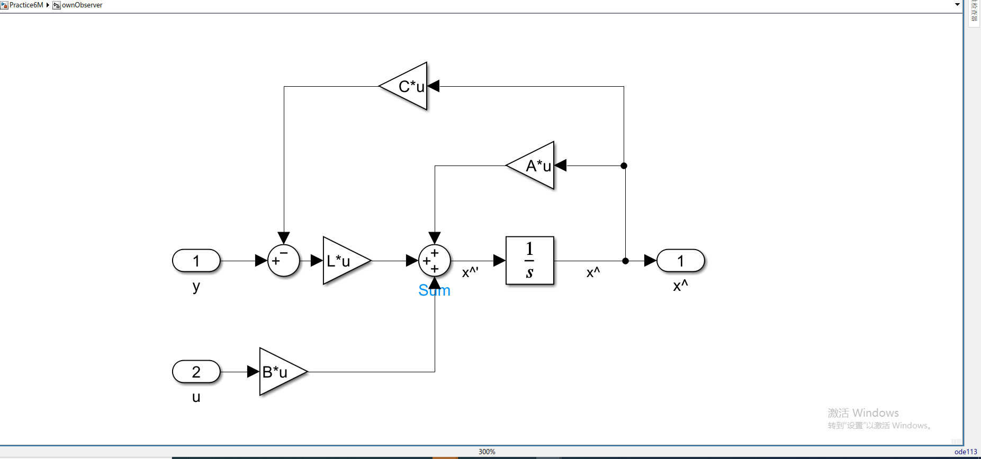
Code will show later.
Controller:
Code will show here(Including Observer Design):
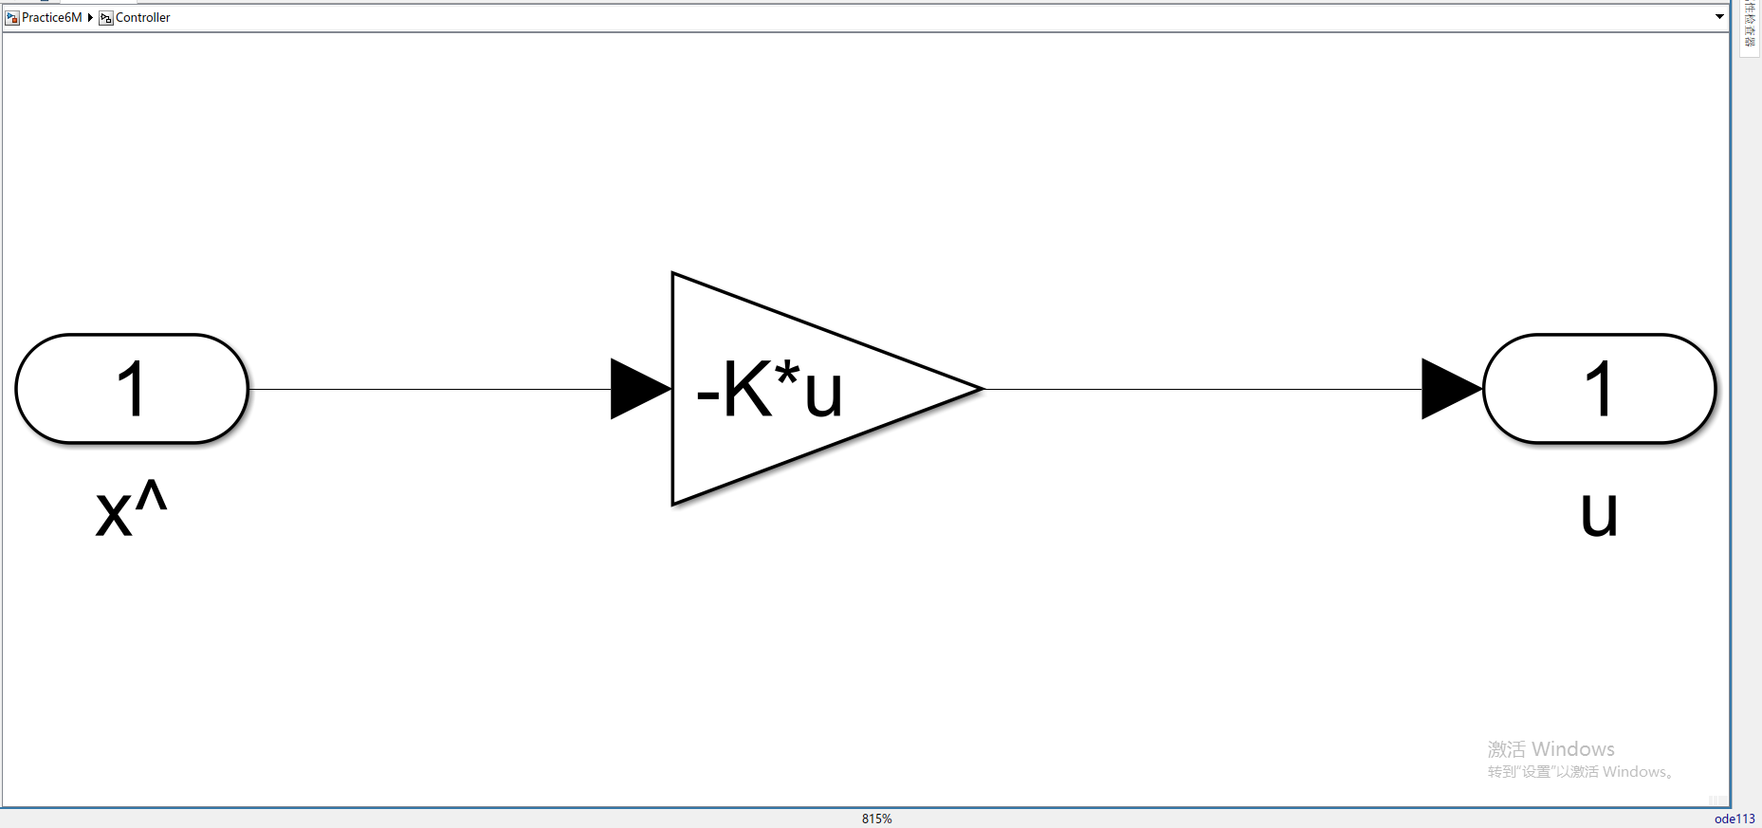
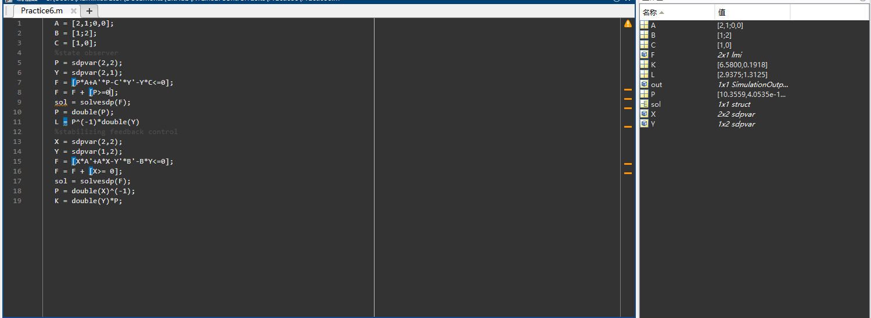
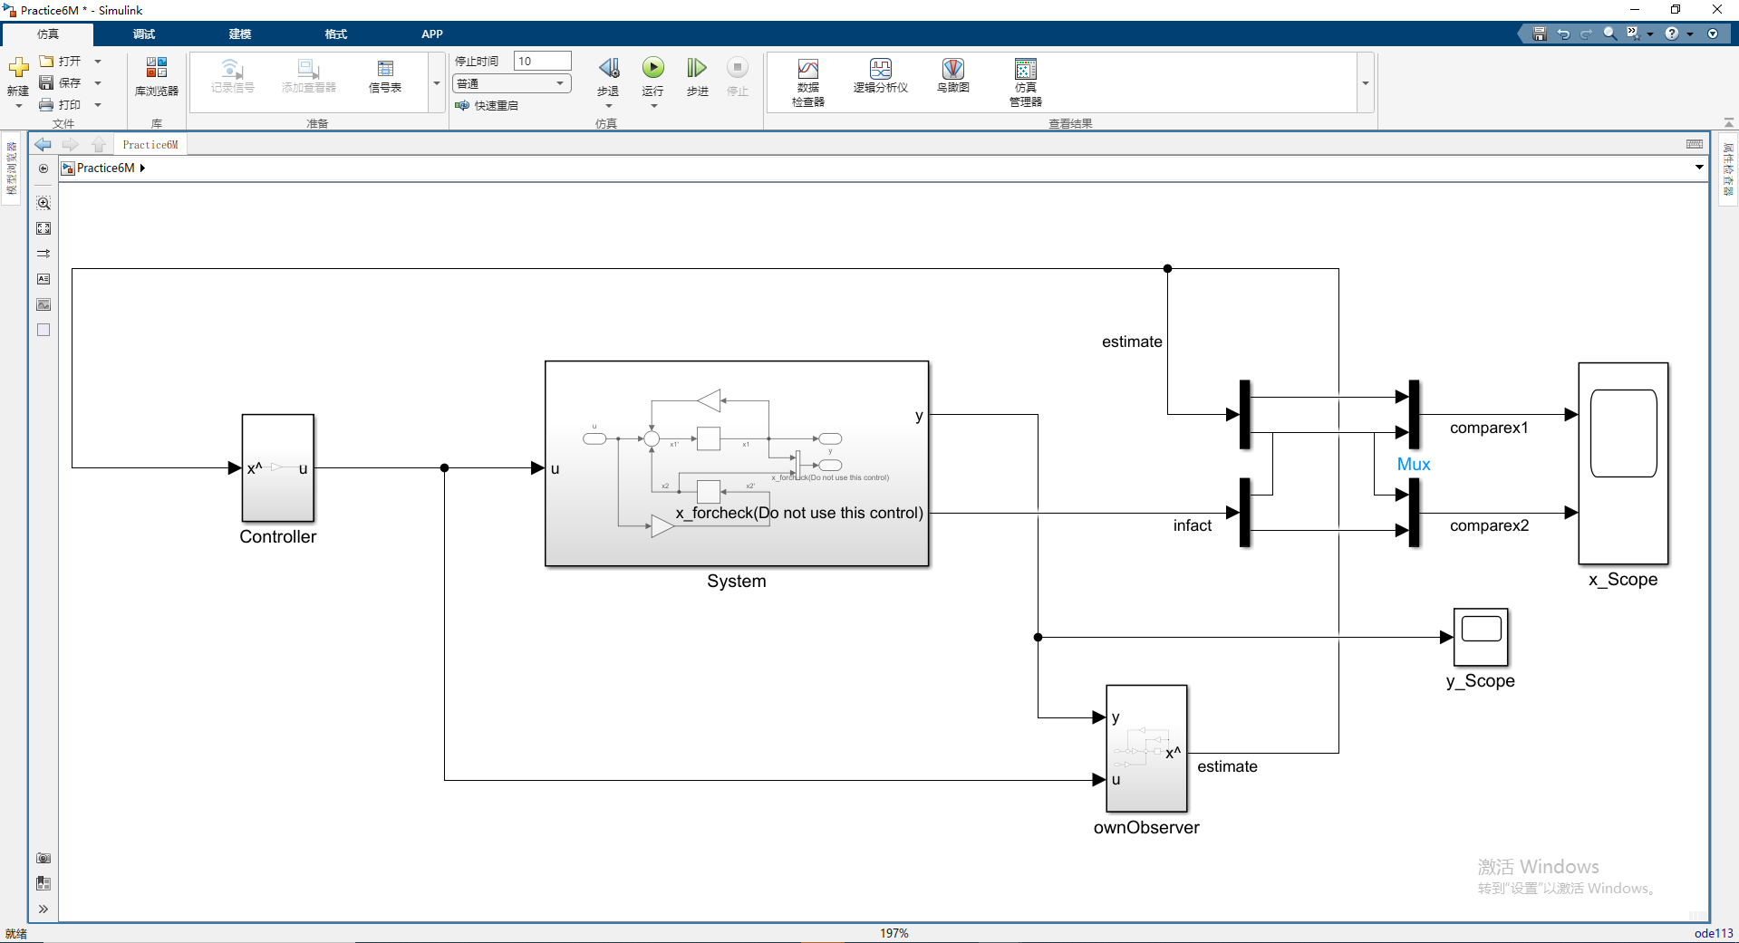
Matlab Simulink(Complete):
Inital Conditions:
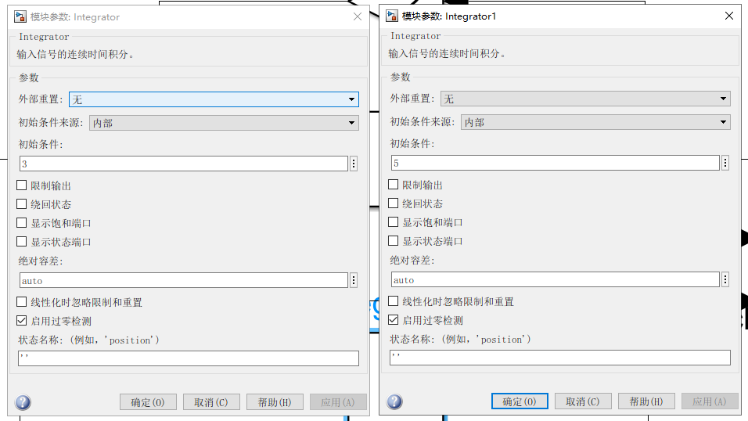
X:
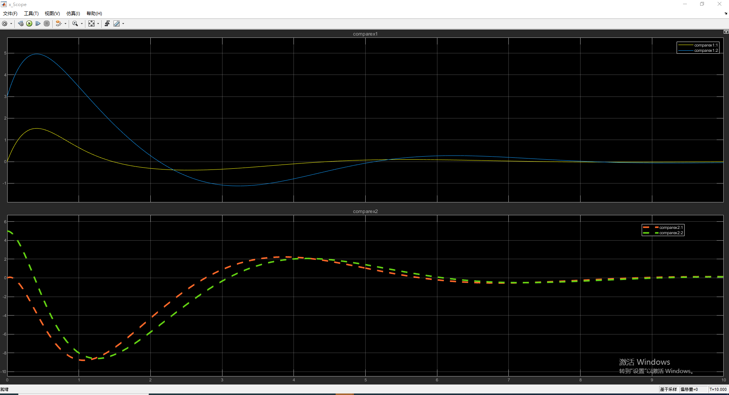

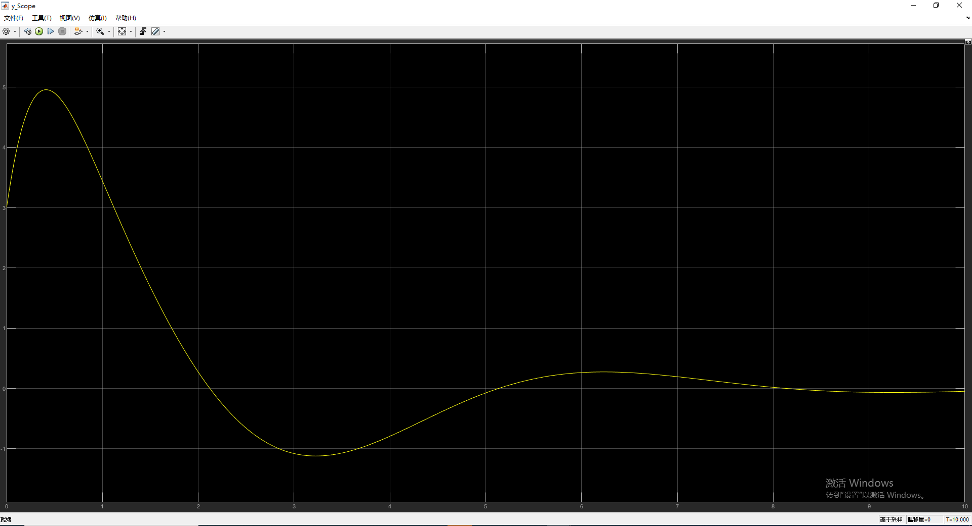
Y:

