Practice2 Report 22320607 Xu Ziyang
Overview:
1.Calculation
2.Graph
3.Model and code
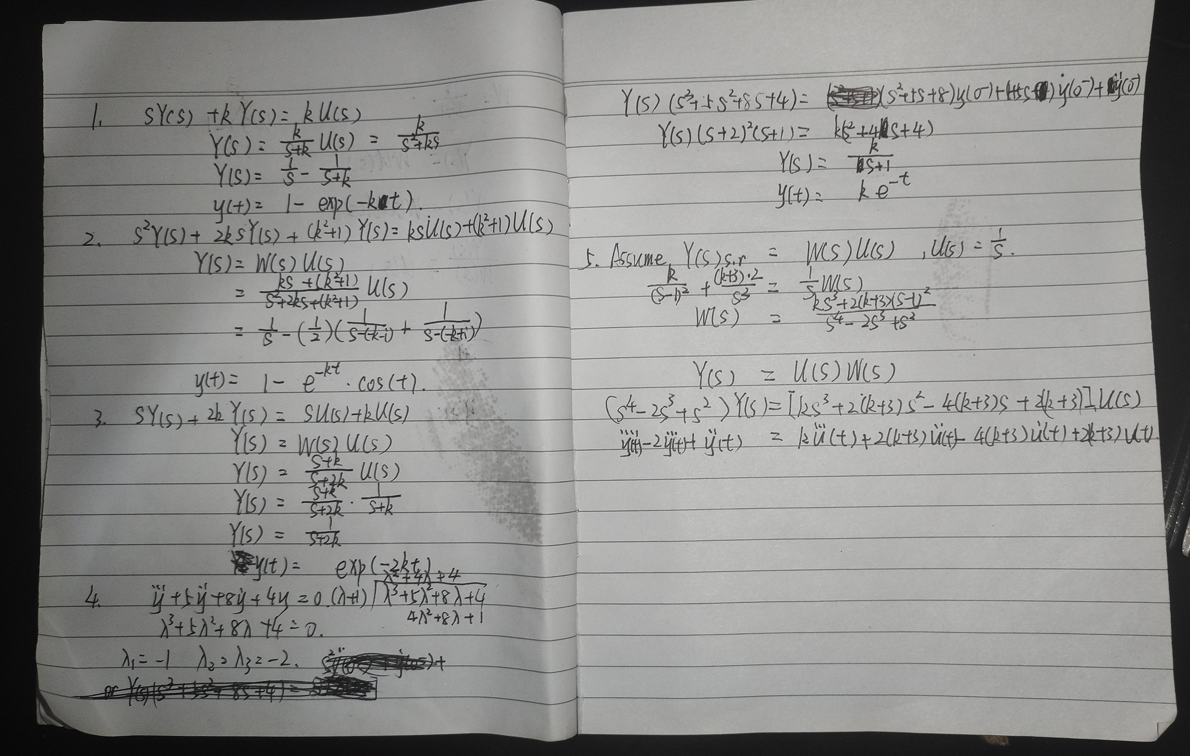
Part 1:

Part 2:
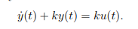
1.Step response of

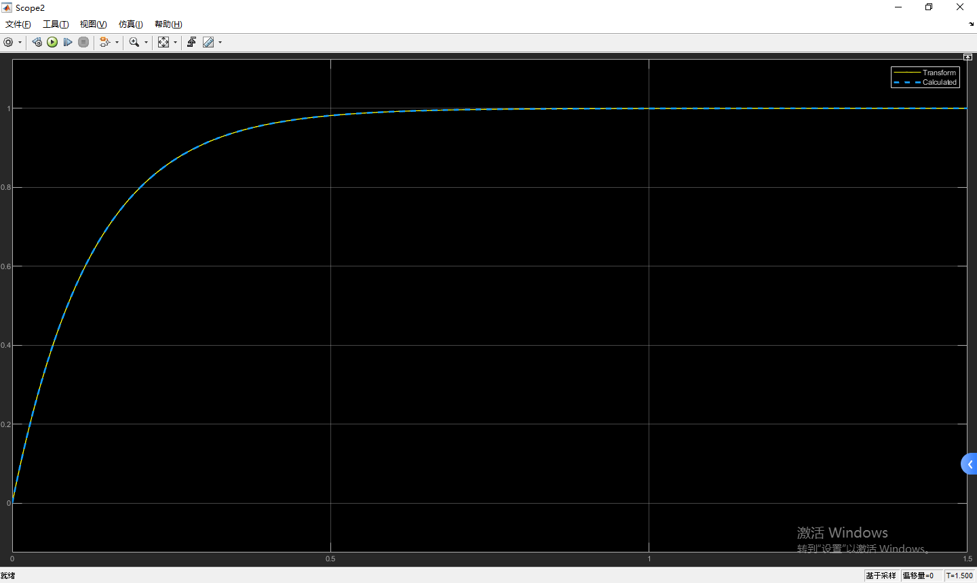
2.Step response of
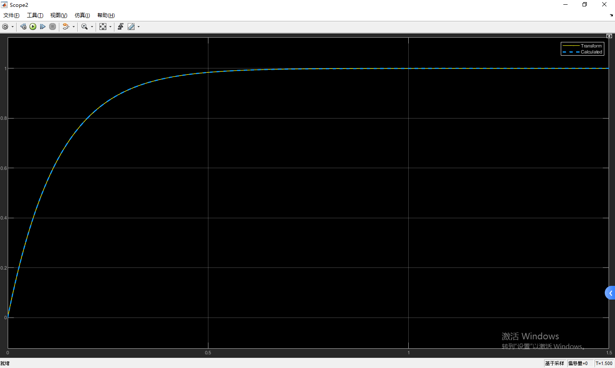
3.
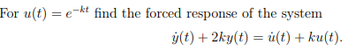

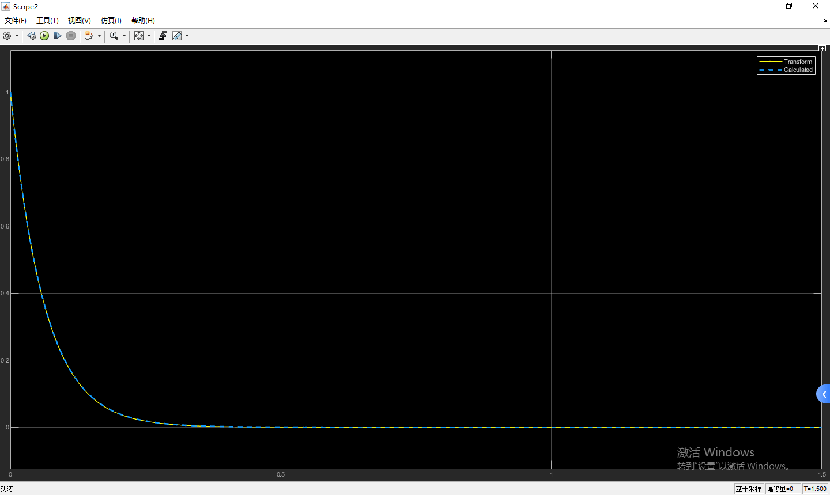
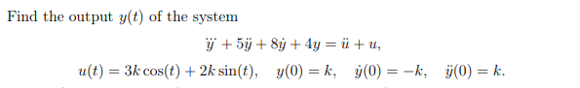
4.

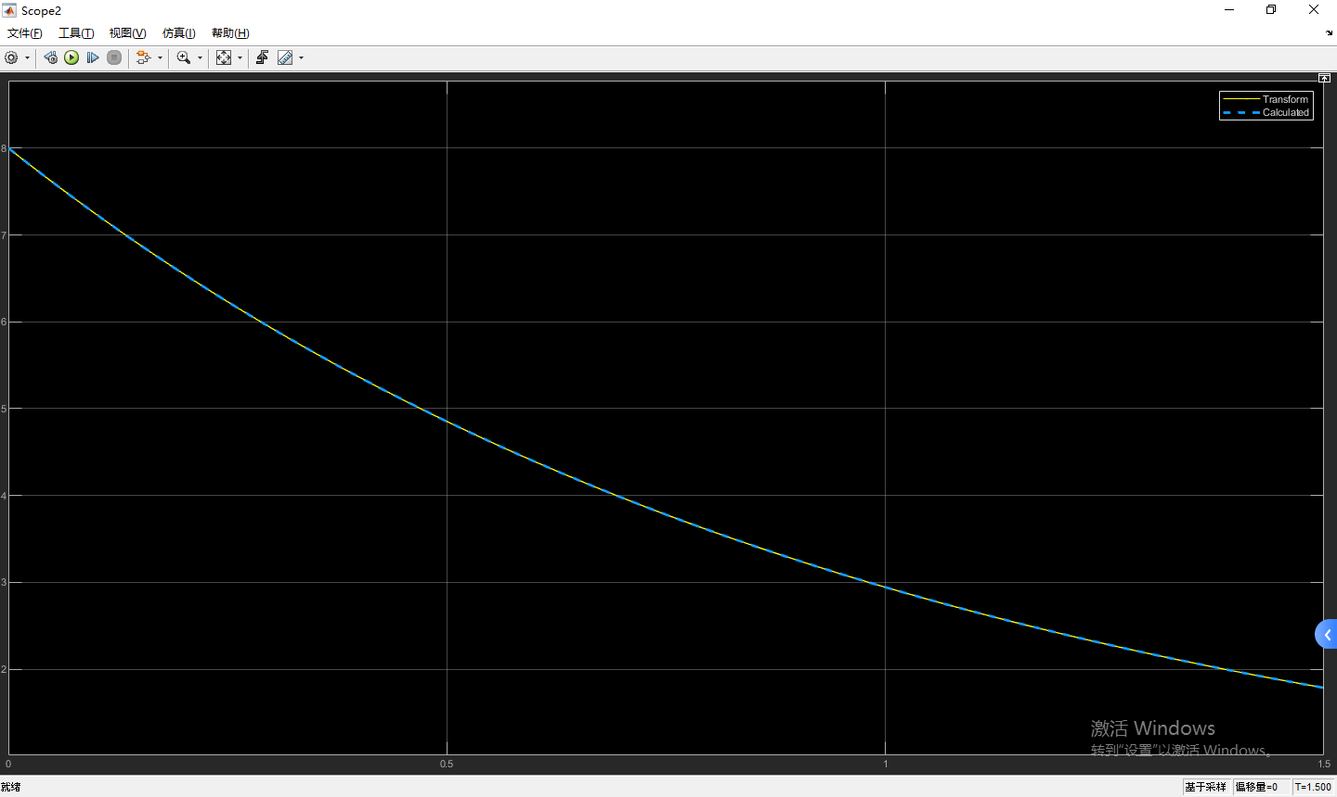
5.Assume that u(s) = 1/s.
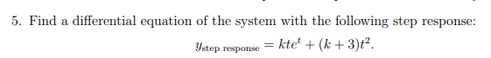

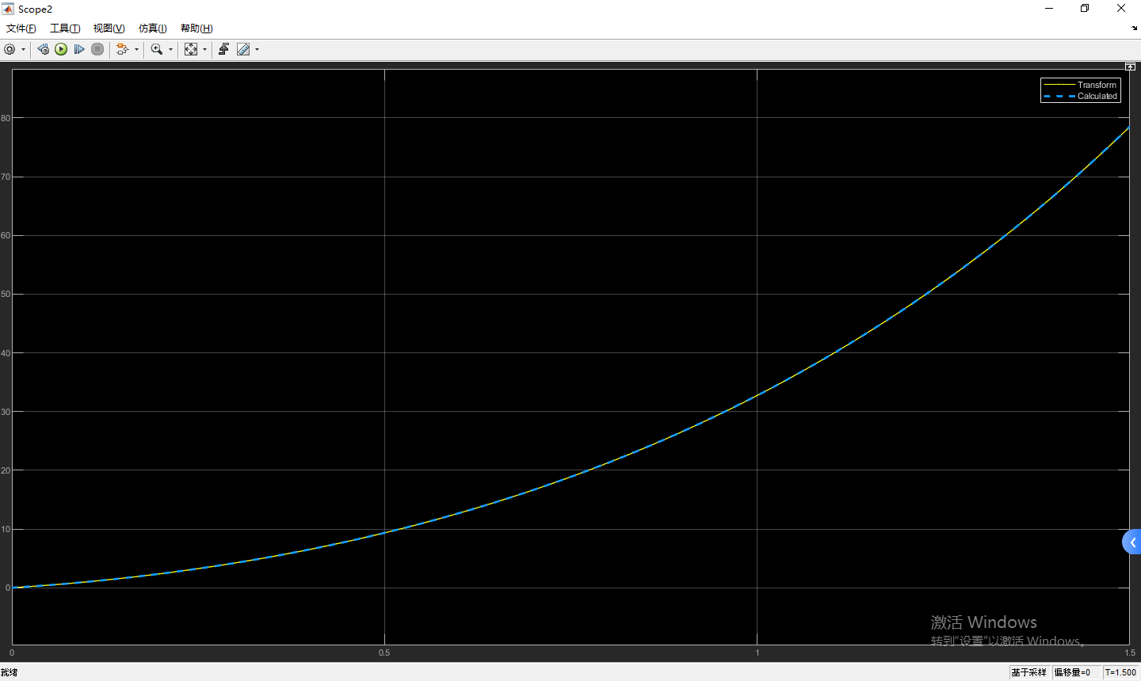
Part 3:
Model:
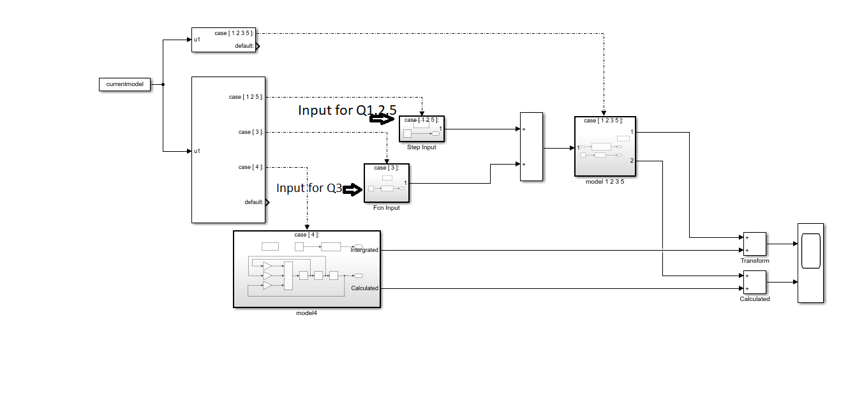
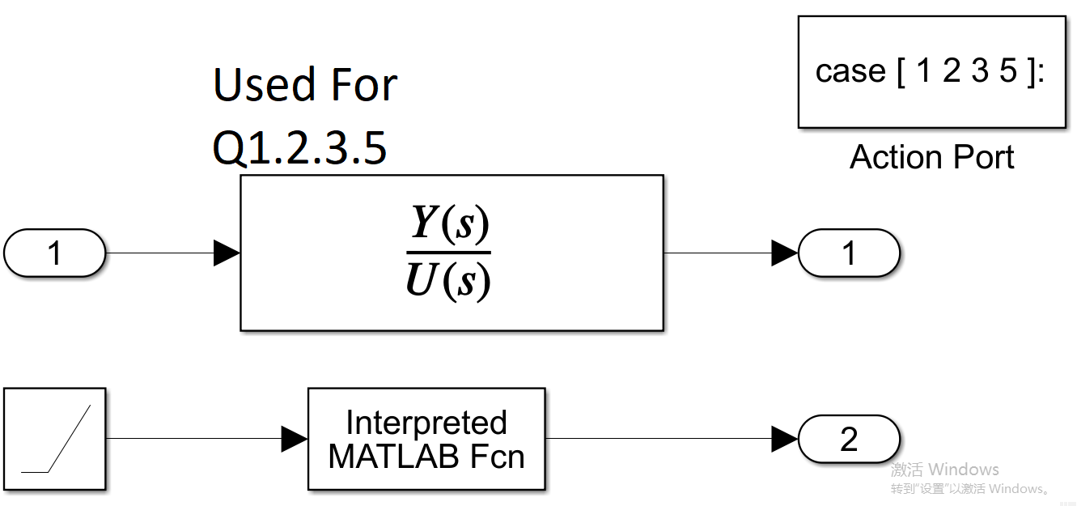
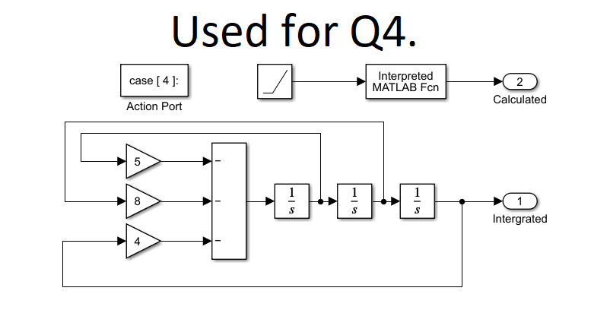
Code:
solves.m
k = 7 + 1;
eq1Solve = @(u)(1-exp(-k*u));
eq2Solve = @(u)(1-cos(u)*exp(-k*u));
eq3Solve = @(u)(exp(-2*k*u));
eq5Solve = @(u)(k*u*exp(u)+(k+3)*u^2);
currentmodel = 5;
switch currentmodel
case 1
eqSolve = eq1Solve;
argU = [k];
argD = [1,k];
InputGt2 = 0;
case 2
eqSolve = eq2Solve;
argU = [k (k^2+1)];
argD = [1 2*k k^2+1];
InputGt2 = 0;
case 3
eqSolve = eq3Solve;
argU = [1 k];
argD = [1 2*k];
InputGt2 = @(u)exp(-k*u);
case 5
eqSolve = eq5Solve;
InputGt2 = 0;
argU = [k 2*(k+3) -4*(k+3) 2*(k+3)];
argD = [1 -2 1 0 0];
end

