PRACTICE 1 Report
From Xu Ziyang, 22320607
Overview:
1.Equations and graph corresponding to each system
2.Matlab Things
3.Calculate code in Wolfram Language

Part 1:
Equation1:
y’(t) + ky(t) = 0
Which means:
y′ (t) + 7 y(t) =0
Character Equation:
λ + 7 = 0
Character Roots:
{λ = -7}
General Solution:
y = c₁e^{-7t}
Initial Condition:
y(0) = 3
Solution:
y = 3e^{-7t}
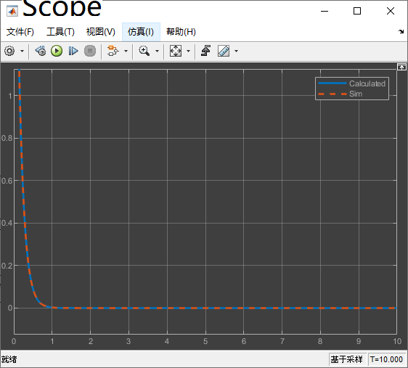
Graph:(You can see bugs with Windows, just forgive me and Microsoft…)
Equation2:
y’’(t) + (k+1)y’(t) + ky(t) = 0
Which means:
y’’(t) + 8y′ (t) + 7 y(t) =0
Character Equation:
λ² + 8λ + 7 = 0
Character Roots:
{λ = -7, λ= -1}
General Solution:
y = c₁e^{-7t} +c₂e^{-t}
Initial Condition:
y(0) = 4, y’(0) = -1
Solution:
y = 1/2*e^{-7t} (9e^{6t}-1)
Graph:
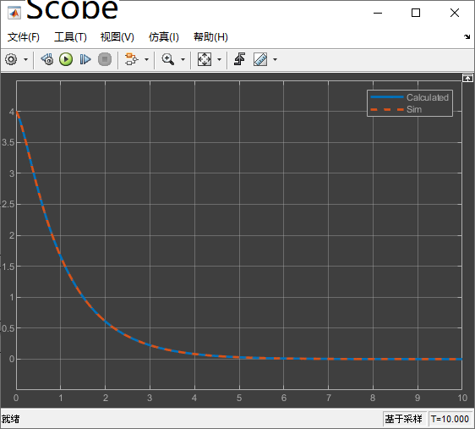

Equation3:
y’’(t) + k²y(t) = 0
Which means:
y’’(t) + 49 y(t) =0
Character Equation:
λ² + 49= 0
Character Roots:
{λ = -7i, λ= 7i}
General Solution:
y = c₁sin(7t) +c₂cos(7t)
Initial Condition:
y(0) = 0, y’(0) = -7
Solution:
y = sin(7t)
Graph:
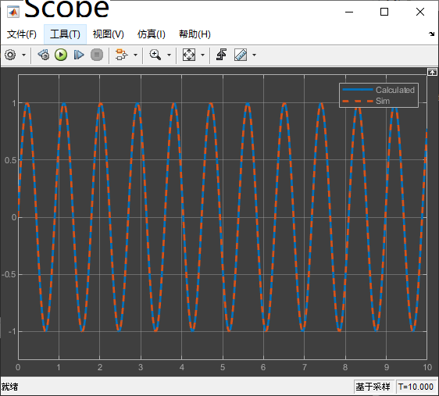

Equation4:
y’’(t) + 4y’(t) + 13y(t) = 0
Character Equation:
λ² + 4λ + 13= 0
Character Roots:
{λ = -2-3i, λ= -2+3i}
General Solution:
y = e^{-2t}(c₁sin(3t) +c₂cos(3t))
Initial Condition:
y(0) = 14, y’(0) = -7
Solution:
y = 7e^{-2t}(sin(3t) +2cos(3t))
Graph:
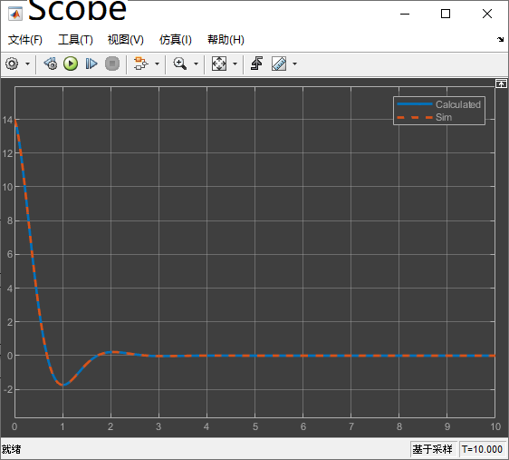

Equation5:
Notice that y(t) is not 0(t) since y(0) is not 0.
y’’(t) + ay’(t) + ky(t) = 0
Which means:
y’’(t) + ay’(t) + 7y(t) = 0
Character Equation:
λ² + aλ + 7= 0
Character Roots:
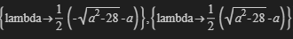
General Solution:
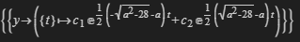
Taking a = 2*sqrt(7)(Let delta be zero):
Taking Initial Condition:
y(0) = 1, y’(0) = 0
Solution:
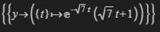
Taking a = 2*sqrt(5):
Taking Initial Condition:
y(0) = 1, y’(0) = 0
Solution:
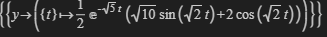
Taking a = 6:
Taking Initial Condition:
y(0) = 1, y’(0) = 0
Solution:
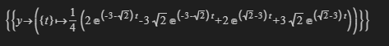

Graphs:

a=2*sqrt(7):

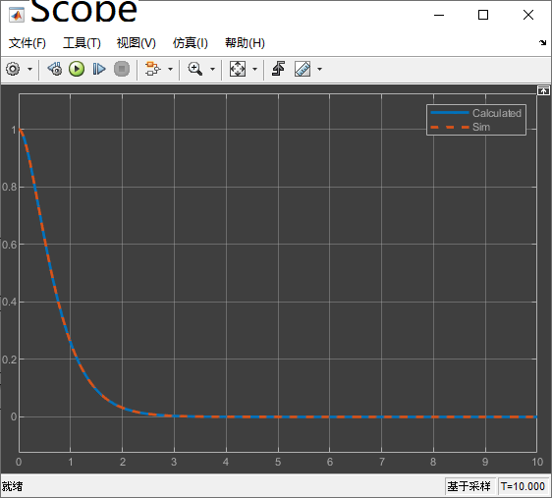

a=2*sqrt(5):
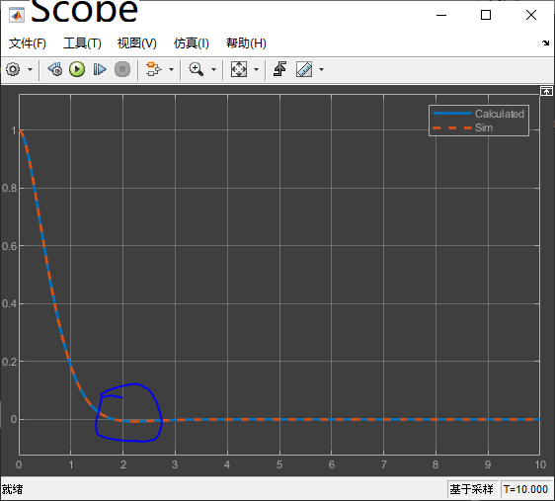
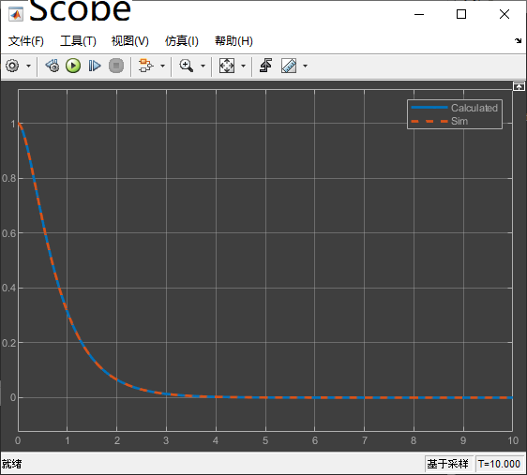
a=6:

Part 2:
Simulink Model:
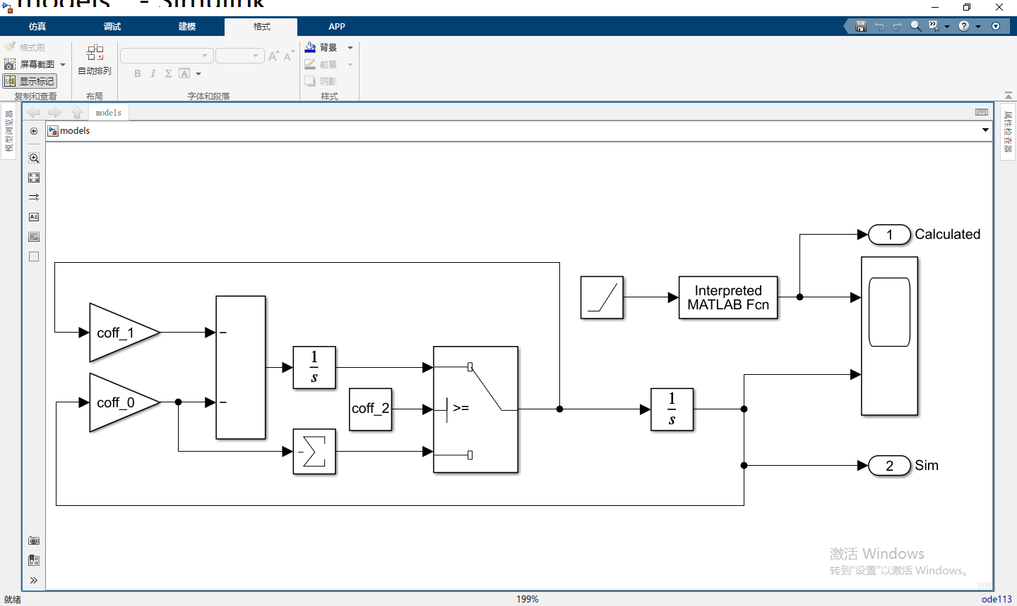
Solver Configure:
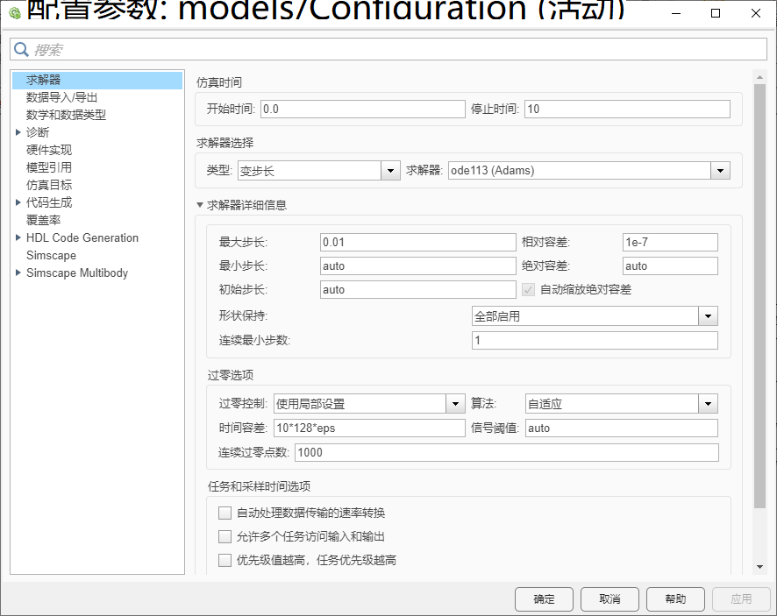
Repository:
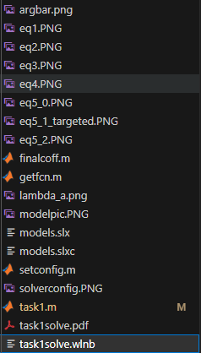
Model info:
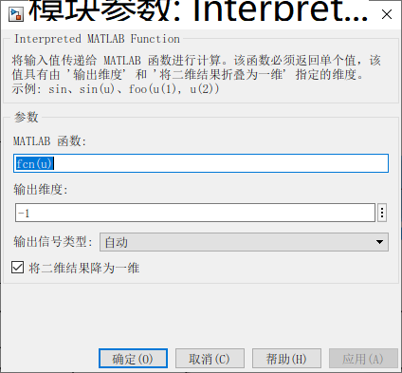
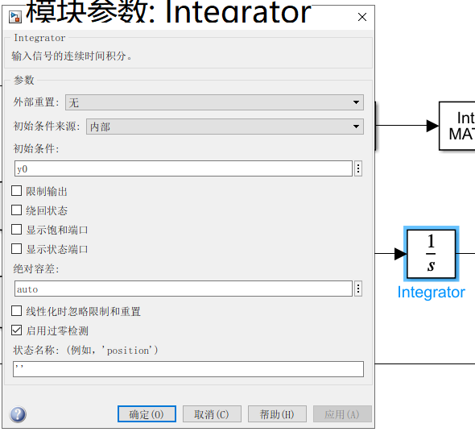
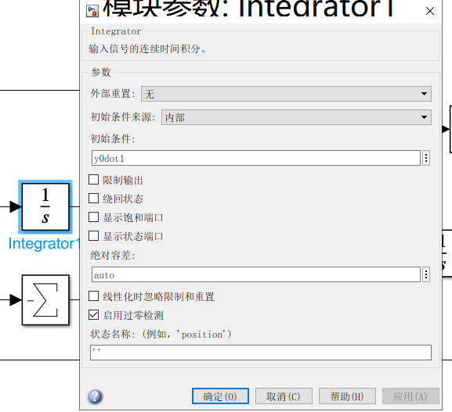

Codes(Why LibreOffice cannot copy format correctly?):
finalcoff.m:
function [coff_dot2,coff_dot1,coff_nodot] = finalcoff(modeltesting,k,a)
switch modeltesting
case 1
coff_dot1 = 1;
coff_dot2 = 0;
coff_nodot = k;
case 2
coff_dot1 = k+1;
coff_dot2 = 1;
coff_nodot = k;
case 3
coff_dot1 = 0;
coff_dot2 = 1;
coff_nodot = k^2;
case 4
coff_dot1 = 4;
coff_dot2 = 1;
coff_nodot = 13;
case 5+0
coff_dot1 = a;
coff_dot2 = 1;
coff_nodot = 7;
case 5+1
coff_dot1 = a;
coff_dot2 = 1;
coff_nodot = 7;
case 5+2
coff_dot1 = a;
coff_dot2 = 1;
coff_nodot = k;
end
end
getfcn.m:
function f = getfcn(modeltesting)
switch modeltesting
case 1
f = @(t)3*exp(-7*t);
case 2
f = @(t)exp(-7*t)/2*(9*exp(6*t)-1);
case 3
f = @(t)sin(7*t);
case 4
f = @(t)7*exp(-2*t)*(sin(3*t)+2*cos(3*t));
case (5+0)
f = @(t)exp(-sqrt(7)*t)*(sqrt(7)*t+1);
case (5+1)
f = @(t)1/2*exp(-sqrt(5)*t)*(sqrt(10)*sin(t*sqrt(2))+2*cos(t*sqrt(2)));
case (5+2)
f = @(t)1/4*(2*exp((-3-sqrt(2))*t)-3*sqrt(2)*exp((-3-sqrt(2))*t)+2*exp((sqrt(2)-3)*t)+3*sqrt(2)*exp((sqrt(2)-3)*t));
end
end

setconfig.m:
function [y0,y0dot1,a] = setconfig(modeltesting,k)
switch modeltesting
case 1
y0 = 3;
y0dot1= 0;
a = 0;
case 2
y0 = 4;
y0dot1 = -1;
a = 0;
case 3
y0 = 0;
y0dot1 = k;
a = 0;
case 4
y0 = 2*k;
y0dot1 = -k;
a = 0;
case 5+0
y0 = 1;
y0dot1 = 0;
a=sqrt(28);
case 5+1
y0 = 1;
y0dot1 = 0;
a=sqrt(20);
case 5+2
y0 = 1;
y0dot1 = 0;
a=sqrt(36);
end
end
task1.m(No tabs so it’s working):
k = 7;
modeltesting = 7;%changes for each model
[y0,y0dot1,a]=setconfig(modeltesting,k);
[coff_2,coff_1,coff_0]=finalcoff(modeltesting,k,a);
fcn = getfcn(modeltesting);

Part 3:
