Corresponding ki, kd, kp

0, 0, 1,

0, 0, 0.01,

0, 0, 0.05,

0.005, 0.1, 0.05,

0.005, 0.5, 0.05,

0.5, 0.1, 0.05,

Corresponding performance

Overshoot for row 1,2,3,4,5,6(degrees):

35 0 0 19 28 36

Steady Error for row 1,2,3,4,5,6(degrees):

0 26 0 0 -1 0

Rise time for row 1,3,4,5,6(degrees):

257ms 534ms 273ms 259ms 544ms

Settling time for row 1,2,3,4,5,6:

1335ms 2064ms 273ms 582ms 606ms 6580ms

Codes

*#!/usr/bin/env pybricks-micropython*

from pybricks.hubs import EV3Brick

from pybricks.ev3devices import (Motor, TouchSensor, ColorSensor,

                                 InfraredSensor, UltrasonicSensor, GyroSensor)

from pybricks.parameters import Port, Stop, Direction, Button, Color

from pybricks.tools import wait, StopWatch, DataLog

from pybricks.robotics import DriveBase

from pybricks.media.ev3dev import SoundFile, ImageFile

*# This program requires LEGO EV3 MicroPython v2.0 or higher.*

*# Click "Open user guide" on the EV3 extension tab for more information.*

*# Create your objects here.*

ev3 = EV3Brick()

m = Motor(port=Port.D)

sw = StopWatch()

data = DataLog(append=True,name="Data1")

def PID(past_time,present_time,target,real,ki,kp,kd,anti_over,range):

    error = target - real

    i = ki*error*(present_time-past_time)

    p = kp*error

    d = kd*error/(present_time-past_time)

    rvalue = p+i+d

    if (anti_over == False):

        return rvalue

    elif (abs(rvalue)<range):

        return rvalue

    else :

        return rvalue/abs(rvalue)*range

MAX_TIME = 10

time_present = 0

TARGET = 180

ev3.speaker.say("Beep,I'm going to run!")

data.log("target",TARGET)

data.log("time_mill","angle")

while True:

    time_last = time_present

    time_present = sw.time()

    data.log(time_present,m.angle())

    if (time_present>MAX_TIME*1000):

        break

    m.dc(PID(past_time=time_last,

             present_time=time_present,

             target = TARGET,

             real = m.angle(),

             ki=0.5,kd=0.1,kp=0.05,

             anti_over=True,

             range=7)

        /7*100)

kdata = readmatrix("k_data");

k = 2.0;

Tm = 0.6;

for i = 1:6

    data = readmatrix("Data"+i);

    target = data(1,2);

    ki = kdata(i,1);

    kd = kdata(i,2);

    kp = kdata(i,3);

    if i == 2 || i >=3

        stedyerr(i) = data(1,2) - data(end,end);

    end

    figure('Name','angle-t_graph');

    grid on;

    grid minor;

    plot(data(3:end,1)-data(3,1),data(3:end,2));

    maxangle = max(data(3:end,2));

    if i == 1 || i >=3

        oversangle(i) = maxangle - data(1,2);

    end

    ylim([0,maxangle+30]);

    hold on;

    xlabel('time,millseconds');

    ylabel('angle,degrees');

    si = sim('call_model');

    plot(si.yout{1}.Values,'r');

    print('compare'+"pic_data"+string(i),'-djpeg');

end

close all;

Real Data

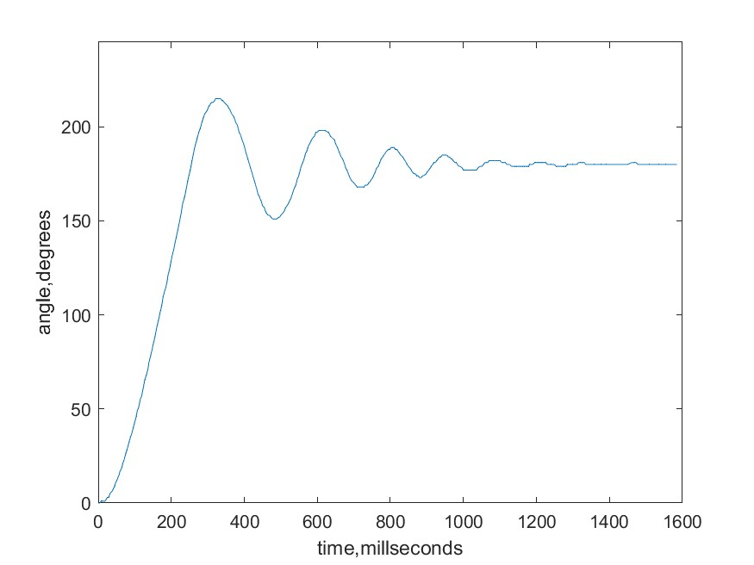

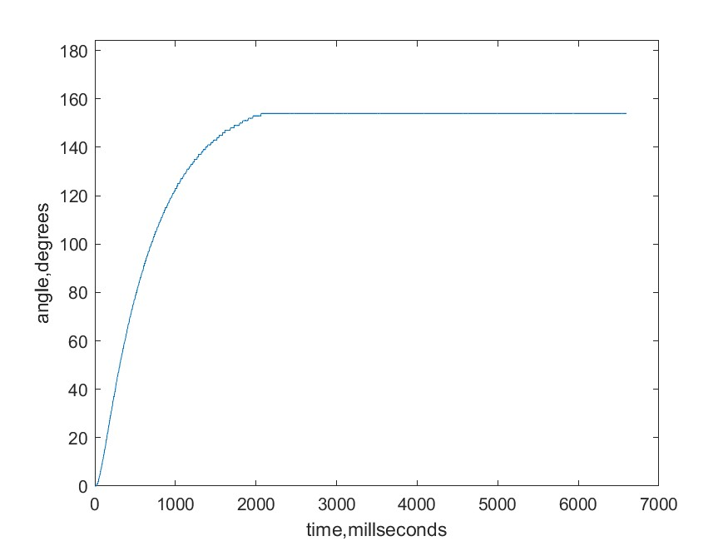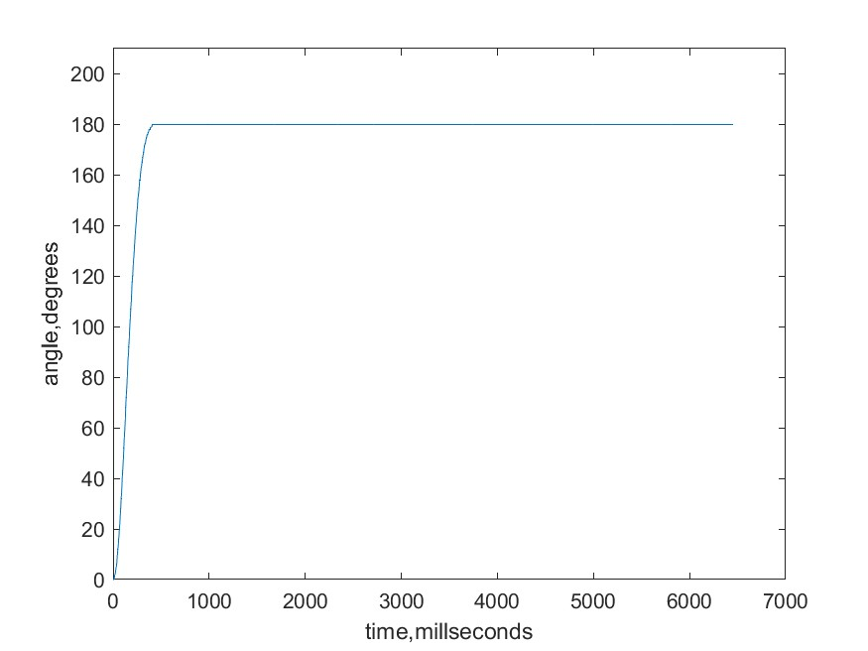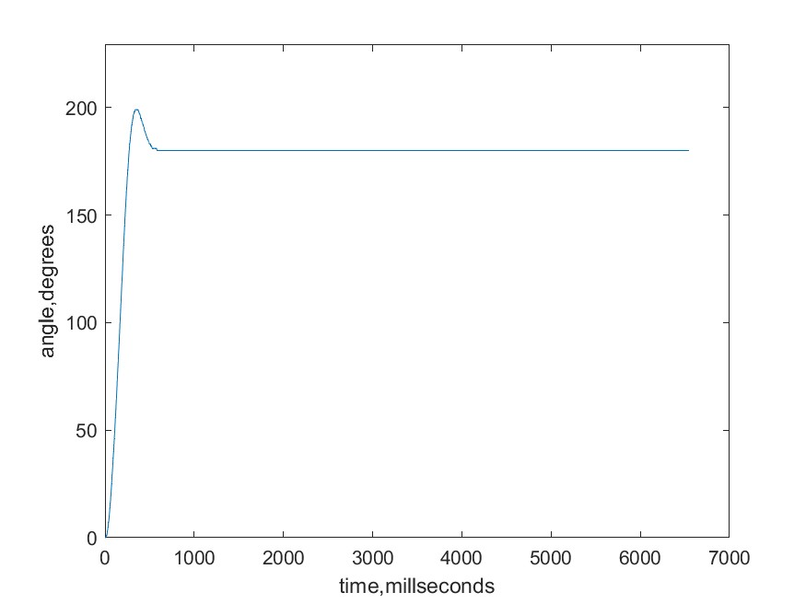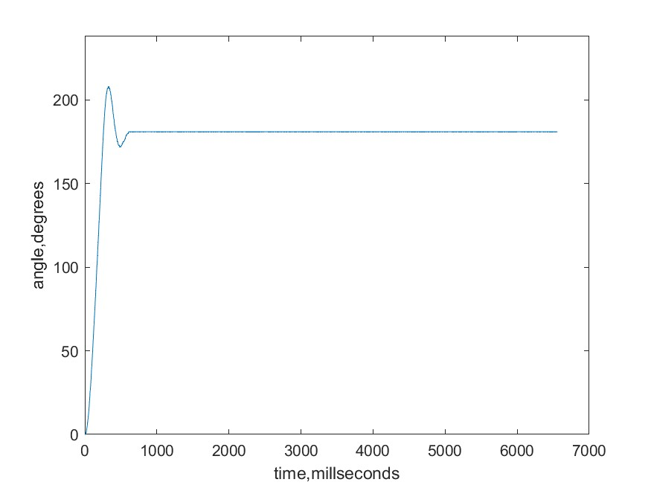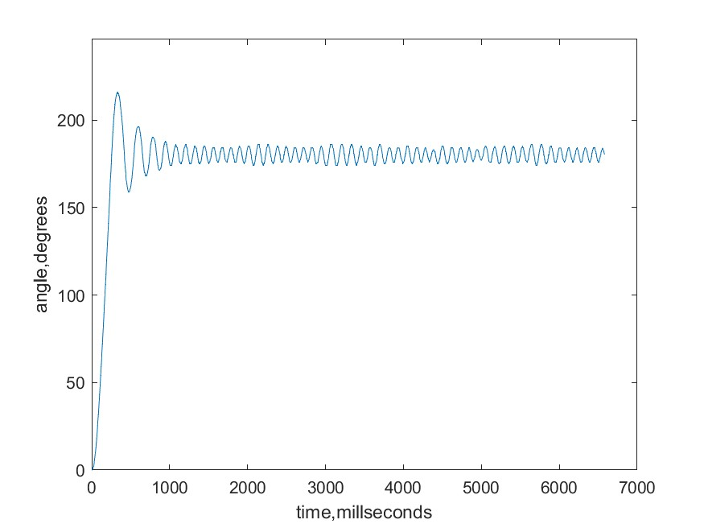

Model

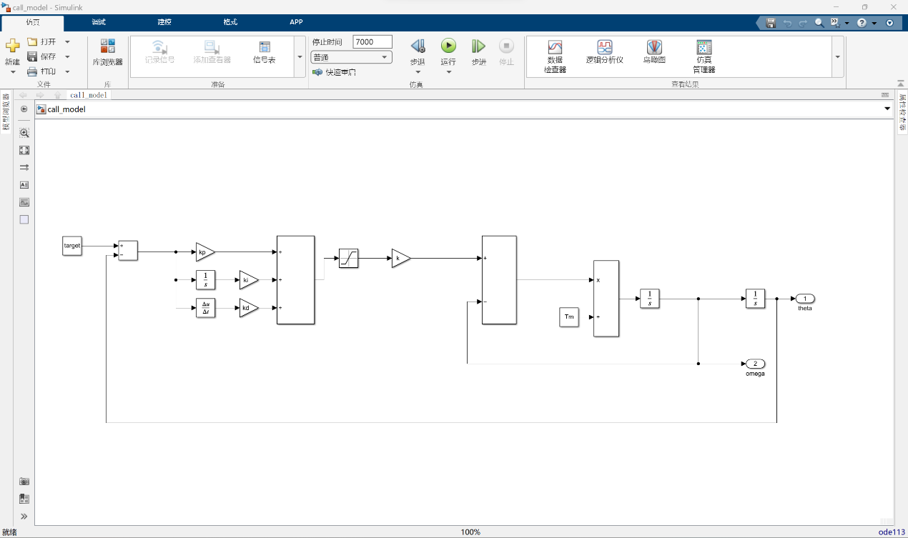

Sim(Red) vs Real

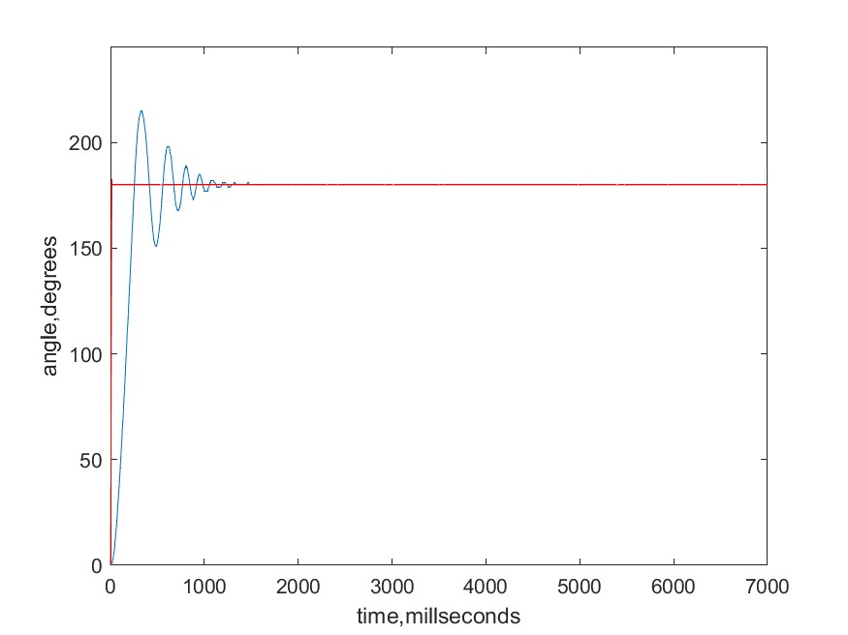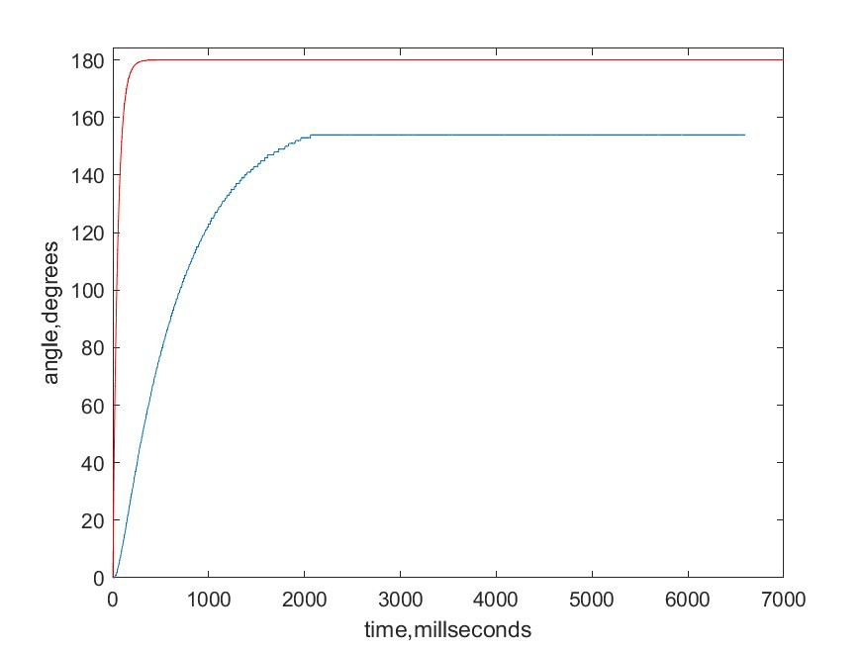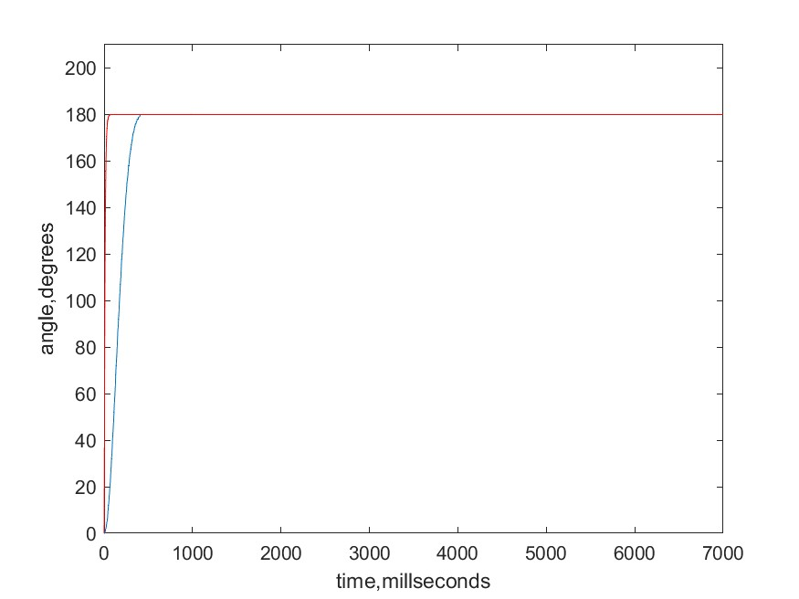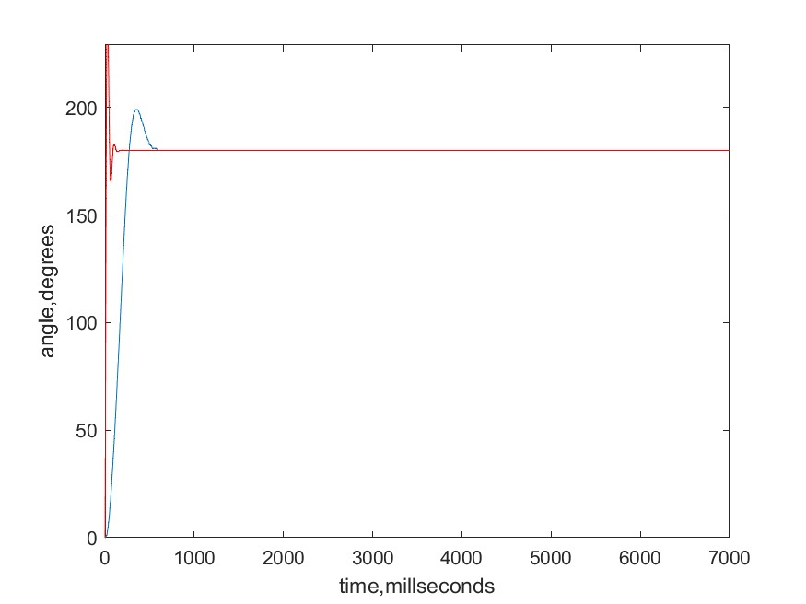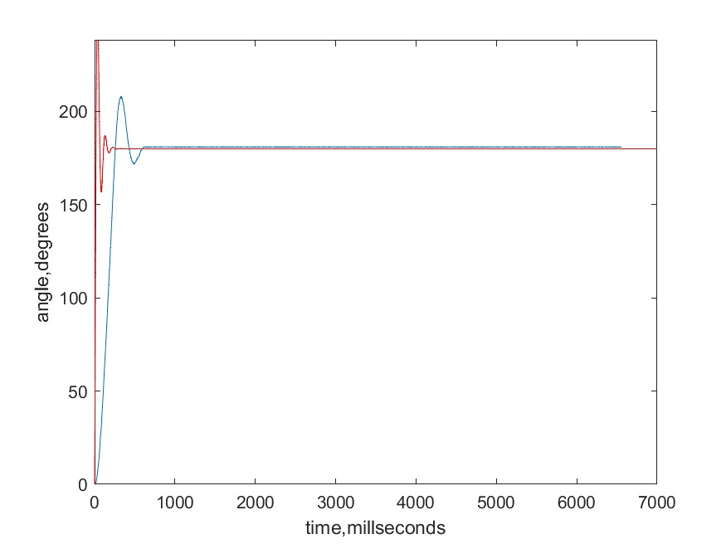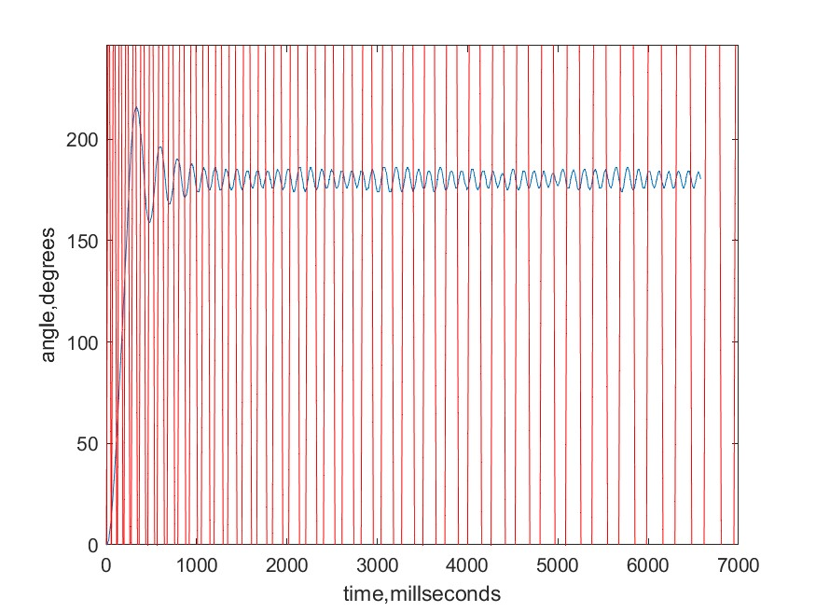

Conclusion:

Kp rises, rise time decrease, overshoot rise, steady error decrease.

Ki rises, rise time decrease, overshoot rise, steady error decrease, settling time lengthen.

Kd rises, rise time increase, overshoot decrease, settling time lengthen.

The motor has a huge friction.