PPPS-2019 Manuscript Instructions

Please read and follow all instructions to insure your manuscript can be published

Instructions:

- Format your manuscript using the template starting on page 2 of this file
  - If your manuscript does not match this format, it will not be published
  - The title of your manuscript must match the title of your presentation at the conference
- Convert your manuscript to pdf. Embed all fonts. See Appendix B of this template file for instructions.
- Submit manuscript here: https://indico.cern.ch/event/727938/
- Complete and submit copyright form
  - YOUR PAPER CANNOT BE PUBLISHED WITHOUT A COPYRIGHT FORM

Important considerations:

- If you do not attend and present at PPPS-2019, you do not qualify to submit a proceedings paper.
- Your manuscript will be checked for plagiarism against all web searchable content. Manuscripts that are not original work will not be published.
- If you plan to submit similar work to a peer reviewed journal, please remember that paper cannot be a copy of this conference proceedings paper as it will also undergo plagiarism checking.

PREPARATION OF PAPERS FOR THE
2019 IEEE PULSED POWER CONFERENCE ∗

G. Londonξ, P. Auckland, H. Washington
XYZ Institute, PO Box 1234, Mail Stop H-567

Anywhere, State, Country

Abstract

This is the same manuscript format has been used for all of the Pulsed Power Conferences since the 2007 Pulsed Power & Plasma Science Conference. This format provides a more uniform appearance and allows electronic publishing on DVDs. The use of electronic publishing imposes certain requirements on authors. Several other conferences have adopted similar standards for electronic publication of their proceedings. This document describes the requirements for preparation of electronic files that are to be submitted to the Conference for publication in the proceedings. Please note conventions for title placement, section, subsection, figure, and table numbering.
Your ability to follow the general guidelines and specific styles will result in fewer formatting costs and delays, as well as a more professional-looking finished paper in the final DVD.

SUBMISSION OF PAPERS TO PPC-2019

The preferred software for manuscript composition is Microsoft Word. Papers must be prepared following the formatting instructions in this file, and converted to PDF format prior to submission. The website will only accept PDF formatted files. Papers must be submitted using the on-line submission system accessed via the web site: https://indico.cern.ch/event/727938/. Remember to maintain backup electronic copies of the text and graphics used to create the PDF file in case errors are found in the submitted PDF.

NOTE: it is the submitting authors' responsibility to ensure the transportability of the electronic files and the quality and consistency of their manuscripts.

MANUSCRIPTS

Authors are advised to carefully follow these guidelines. Submissions that deviate could possibly be rejected from the Conference Proceedings.

- Length
The contributed oral and poster papers may be up to 4 pages in length. Invited oral up to 6 pages, and Plenary papers up to 8 pages in length.
Please be mindful that contributions to the Special Issues in the Transactions in Plasma Science are expected to be expanded versions of the conference manuscripts.

- General Layout
These instructions are formatted in a typical implementation of the requirements. Manuscripts should be prepared for single-sided paper submission and have:
Either A4 (21.0 x 29.7 cm) or U.S. letter size (8.5 x 11.0 inches);
- Single-spaced text (block/full justified) in two columns of 82.5 mm (3.25 in.) each with 5.3 mm (0.2 in.) separation.
- The text located within the margins as specified in Table 1.

Table 1. Margin specifications.
Margin | A4 Paper | US Letter Paper
Left | 20 mm | 20 mm (0.79 inch)
Right | 20 mm | 26 mm (1.00 inch)
Top | 37 mm | 19 mm (0.75 inch)
Bottom | 26 mm | 26 mm (1.00 inch)

The layout of the text on the page is illustrated in Fig. 1. Note that the paper’s title and author list should be centered across the full page. Tables and figures may span from left margin to right margin (170 mm), if necessary.
The reasons for the strict margin guidelines are as follows. We work in an international field. Some readers of your paper may want to print it on U.S. Letter paper (8.5 X 11 in.), while others will use A4 (21.0 X 29.7 cm). Of these two paper types, A4 is taller while Letter is wider; the margins have been selected so that the result will look professional when printed to either type of paper.
The precise means of dealing with this paper size problem was worked out by Leif Liljeby for EPAC'98 [1]. It involves using Acrobat tools to crop the PDF file page size to the minimum dimensions of A4 and U.S. Letter paper (i.e., A4 width and U.S. letter height, 28.2 X 17.0 cm), which is possible without loss of information when the appropriate margins are used. In this case, most printer drivers will automatically center the text area for either paper type.

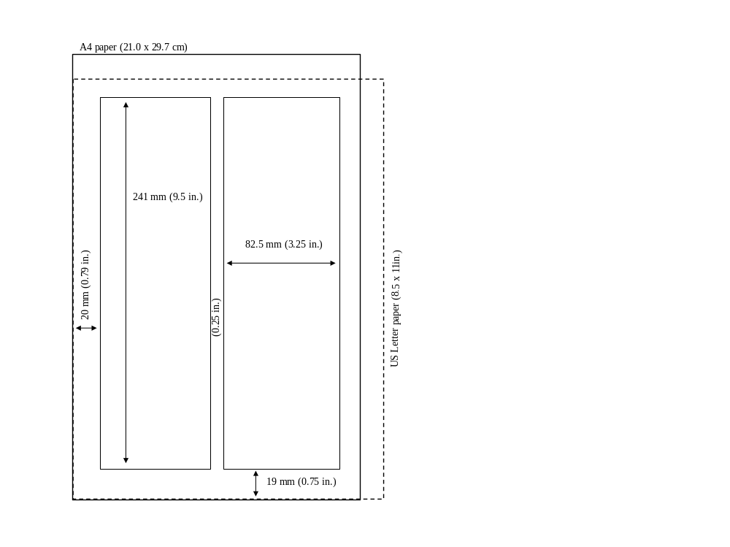
Figure 1. Layout of papers for publication in the Proceedings of PPC 2017.

- Fonts
The DVD version of the proceedings will consist of PDF files produced with Adobe Acrobat® software. To produce PDF files with good results, use only Times (in Roman, bold, or italic) and Symbol fonts from the standard set of fonts. Problems have arisen at previous conferences concerning Cyrillic and Asian fonts. Please do not deviate from our specified font and note carefully whether any have been used, particularly in figures. All contributions should use 10-pt fonts for the normal text.

- Title and Author List
The title should use 14-pt bold uppercase letters and be centered horizontally on the page. The names of the authors should be listed in 12-pt, bold, upper and lowercase letters, grouped by affiliation, if possible. Their organizations/affiliations and mailing addresses should be listed in 12-pt italic upper and lower case letters. Please list the principal author first in the author list. If additional space is required, an acceptable format is to list the principal author’s affiliation in the author list and footnote the remaining affiliations (see subsection J).

- Section Headings
The first section heading is "Abstract" in 12-pt italic (not bold). Subsequent section headings should be numbered in Roman Numerals followed by a period (e.g., I., II., III., etc.), using 12-pt bold uppercase letters. Headings are to be centered in the column and separated from the preceding section with a double-space under normal conditions. Use care in your layout. If necessary, use additional spaces between sections, figures, and tables to ensure that automatic formatting does not leave a section heading “dangling.”

- Subsection Headings
Secondary headings should be sequenced in uppercase Roman letters followed by a period, e.g., A., B., C., etc. The first letter of each major word is capitalized. Tertiary headings are enumerated by Arabic Numerals followed by parenthesis, e.g., 1), 2), 3), etc. Quaternary section headings are rarely necessary, but use an identical format as tertiary headings with the exception that lower case Roman letters are used in place of the numbers, e.g., a), b), c), etc. Use 10-pt bold italic letters for first set of subsection headings, left justified in the column. Single space between subsections. Double-space between subsections and sections. For Tertiary and Quaternary subsection headings, use the same instructions, except not bold. Again, use care in your layout, inserting additional spaces to ensure that automatic formatting does not leave the subsection heading "dangling" (see Subsection D).

- Body or Paragraphs, Indentation
Indent the first line of each new paragraph. Please do NOT use spaces or hanging indents; Use the Tab key to indent 3 mm (0.12 in.). There should not be additional spaces between paragraphs within each section. Use full justification, letting the text wrap – no hard returns except when starting a new paragraph. Use the base font already indicated (10pt). Do NOT double space between paragraphs. However, double space before starting a new heading, single space before a new sub-head.

Figures/Graphics, Tables, and Equations
1) Figures/Graphics
Place figures as close to the place of their mention in the text as possible. Lettering should be large enough to reproduce clearly, using only the approved fonts. All figures must be given sequential numbers (1, 2, 3, etc.). A caption must be placed below the figure being described, using 10-pt type, fully justified in the column, with no indentation. A period (no dash) is to be used after the figure number, e.g., "Figure 1."

Embed each graphic in your document. Also remember to maintain a separate copy of the graphic file as a backup in case there are errors found in the submitted PDF. Include a centered caption for the graphic and place it at the bottom of the graphic (i.e., Figure 1.). Use a Tab to indent after the Figure reference.
If your graphic exists in hard copy only, or you are unable to embed your graphic in your word processing file, please contact the conference organizers or webstracts.com for assistance.
Be sure to type the captions in the body of your paper
as you want them to read.

2) Tables
Place tables as close to the place of their mention in the text as possible. Lettering in tables should be large enough to reproduce clearly, using only the approved fonts. All tables must be given sequential numbers (1, 2, 3, etc.). A caption must be placed above the table being described, using 10-pt type, fully justified in the column, with no indentation. A period (no dash) is to be used after the table number, e.g., "Table 1."
When possible, use a table editor or tabs to create tables. Please do NOT use spaces to align the columns of your table. Also, do NOT use the “columns” feature to create tables. Identify each table with a bold numeric reference and center it at the top of your table (i.e., Table 1). Use a Tab to indent after the table reference. When possible the table data should be centered within the column. (See Table 1 in this document for reference.) If you have a table that spans across two columns, try to place your table at the top or bottom of a page to avoid splitting the page.

3) Equations
All equations separated from the paragraph text need a number. Place the number flush with the right margin of the column (e.g., see Eq. (1)). Reference to a figure or equation in the text can be done by abbreviation (e.g., "Fig. 1" or "Eq. (1)"), as in our example.

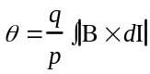 (1)

I. References
All bibliographical references should be numbered and listed at the end of the paper in the last section (assuming the case where there are no appendices) called "References." (See Heading V.) Use complete citations with titles. When referring to a reference in the text, place the corresponding reference number in square brackets [1]. The references should be listed using 10-pt type. The citation style is shown in Appendix A.

Footnotes
Footnotes on the title and author list may be used for acknowledgements, affiliations, and e-mail addresses. A nonnumeric sequence of characters (such as *, +, ++, etc.) should be used. All other footnotes should be included in the reference section and should use the normal numeric sequencing.

Symbols and Acronyms
The use of the International System of Units (SI units) is advocated. Units should be written using the Roman font, not the italic font, such as the J in Eq. (2). Acronyms should be defined the first time they appear.

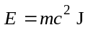 (2)

PAGE NUMBERS

Do not include page numbers electronically on the page. The editing team will add the actual pagination of the entire proceedings during production.

SUMMARY

We have described a standard for paper submission to the 2013 IEEE Pulsed Power & Plasma Science Conference. It is imperative that the authors carefully follow these guidelines.

REFERENCES

[1] L. Liljeby, C. Petit-Jean-Genaz, and J. Poole, "Preparation of Papers for EPAC'98," Stockholm, (1998)

APPENDIX A

A. References
Examples of standard bibliographical references are as follows:

Books:
[1] O. T. Zimmennan and I. Lavine, Conversion Factors and Tables. Dover, NH: Industrial Research Service, 1961.
[2] G. O. Young, "Synthetic structure of industrial plastics," in Plastics, Vol. 3, Polymers of Hexadromicon, J. Peters, Ed., 2nd ed. New York: McGraw Hill, 1964, pp. 15-64.

Periodicals:
[3] M. A. McHenry and D. C. Chang, "Coupled-mode theory of two non-parallel dielectric wavelengths," IEEE Trans. Microwave Theot-v Tech., vol. 43, pp. 1469-1475, Nov. 1994.

Articles from published conference proceedings:
[4] D. B. Payne and J. R. Stem, "Wavelength-switched passively coupled single-mode optical network," in Proc. IOOC-EOOC #85, 1985, p. 585.

Papers presented at conferences (unpublished):
[5] D. Ebehard and E. Voges, "Digital single sideband detection for interferometric sensors," presented at 2#nd# Int. Conf. Optical Fiber Sensors, Stuttgart, F. R. G., 1984.

Technical reports:
[6] E. E. Reber, R. L. Mitchell, and C. J. Carter, "Oxygen absorption in the earth's atmosphere," Aerospace Corp., Los Angeles, CA, Tech. Rep. TR-0200 (4230-46)-3, Nov. 1968.

B. References-Electronic Sources
The guidelines for citing electronic information offered below subscribes to the International Standards Organization (IS) documentation system.

Journal Articles:
Author, Title, Journal [Type of medium], volume (issue), pagination if given, (year, month). Available: Directory: File:

Example:
[1] R. Lazarus, "Self-similar solutions for converging shocks and collapsing cavities," IEEE Trans. Plasma Sci., [Online], vol. 21, (no. 4), pp. 876-880, (Aug. 1993), Available: http://www.halcyon.com Directory: pub/journals File: 21ps04-lazarus.

Material Obtained Through Loose-Leaf, Computer, or Information Services
References to material obtained through computer services or information services are treated like first references to original printed material except that the usual information is followed by the name of the service, the name of the service provider, and the accession or identifying numbers within the service.

Example:
[2] R. J. Vidmar, "On the use of atmospheric plasmas as electromagnetic reflectors," IEEE Trans. Electromag, Cornpat., vol. 21, (no. 3), pp. 238-244, (Aug. 1992). Dialog, ERIC, ED 152318.

Computer Programs and Electronic Documents:
The ISO recommends that capitalization follow the accepted practice for the language or script in which the information is given.

Example:
[3] S. H. Gold, "Study of gain in C-band deflection cavities," in Computer Knowledge [electronic bulletin board], s.1. July 2, 1993-; [cited Dec. 12, 1993], Available listserv@NETFIN.BITNET
[4] R. Chew, "A comparison of RF electrode models," in MD Net [database online], Bethesda, MD; National Library of Medicine, 1994 [cited Nov. 1994]. Identifier no. D000162 [52 lines].
[5] D. Shamlo, "Electronic marketing and identifying techniques," in Electronic Guide [database online]. New York: Computer Wire, 1989-[updated May 23, 1989; cited March 12, 1992]. Accession no. 004082; No=RE436. 4 screens. Available from DIALOG Information Services, Inc., Palo Alto, CA.

APPENDIX B

A. Converting your manuscript to .pdf for uploading:

When converting your .doc file to a .pdf, please ensure
that the fonts are embedded. In Word, 1) select the Acrobat tab. 2) Click on the Preferences button near the
upper left, then select Advanced Settings in the pop up window. 3) Choose the “Fonts” folder at the upper left. 4)
Next, do two things: First, check the checkbox labeled “Embed all fonts”. Second, make sure that the textbox under “Never Embed:” is completely empty. 5) Save these settings; you are now ready to convert your Word file into a PDF file.

 Work supported in part by the US Dept of Agriculture under contract number DOA-8910
 email: G.London@doa.lu.gov

