S – Single Responsibility Principles:
- “There should not be more that one reason for a class get Change”
- Every class must have single responsibility and should be entirely encapsulated by the class.

O – Open Close Principles:
- “Software entities (Class,module,funcation) must be Open for extension but Close for Modification”
- Any new functionality must be added as new Class or new Method without changing the existing code.(Bug Fix is a different Case)

L – Liskov’s Substitution Principles:
- “In Class hierarchies, subclass should be complete substitutable for their base Class.”
- Must make sure the derived class are extending the base classes without changing their behaviors.
- Design by Contract(DbC)

I-Interface Segregation principle:
- “Client should not be forced to depend upon the interfaces which they do not use. ”
- Many Client Specific Interface are better than one general purpose interface.
- Aim is to split the interfaces, which are very large into small and SPECIFIC, so the client known methods only which there are interested.

D- Dependency Inversion Principle:
- “Depend on abstraction, not on concretions” .
- High level module should not depend on the low level module. High level module must not use the directly use the low-level module.
- High level must use the low level indirectly thorough the interface of the low level (Run time polymorphism)

What is Design Patterns?
- General repeatable solution for a Commonly occurring problem in software Design
- Its ‘n a finished design that can be transformed directly into code.

Singleton Design Pattern
- Ensure a class has only one instance, and provide a global point of access to it.
- Encapsulated "just-in-time initialization" or "initialization on first use".
- If the Single tone object depend on the other singleton object the Order of Creation of the singleton is important
- When a Singleton class is inherited, make sure the subclass constructor is private.
- Lazy loading – Object are created, when its request for first time.
Structure:
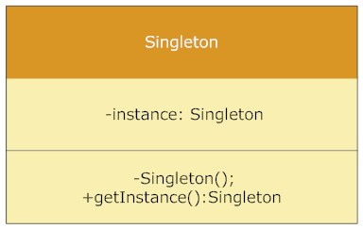
Singleton Class Diagram
- Static member : This contains the instance of the singleton class.
- Private constructor : This will prevent anybody else to instantiate the Singleton class.
- Static public method : This provides the global point of access to the Singleton object and returns the instance to the client calling class.

Implementation Example: Lazy initialization
public class SingletonExample {

// Static member holds only one instance of the
// SingletonExample class
private static SingletonExample singletonInstance;

// SingletonExample prevents any other class from instantiating
private SingletonExample() {
}

// Providing Global point of access
public static SingletonExample getSingletonInstance() {
if (null == singletonInstance) {
singletonInstance = new SingletonExample();
}
return singletonInstance;
}

public void printSingleton(){
System.out.println("Inside print Singleton");
}
}

