1. Waterfall Model
2. Incremental Model
3. Agile Model
4. Rapid Application Development model
Waterfall Model:
In a waterfall model, each phase must be completed fully before the next phase can begin. At the end of each phase, a review takes place to determine if the project is on the right path.
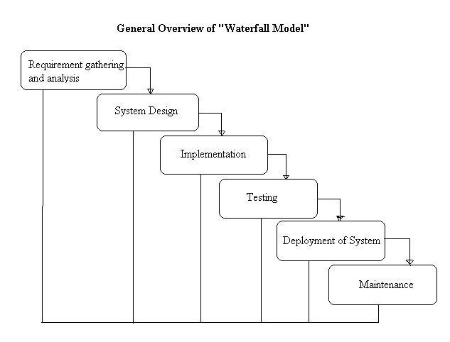
Advantages of waterfall model:
- Simple and easy to understand and use.
- Easy to manage due to the rigidity of the model – each phase has specific deliverables and a review process.
- Phases are processed and completed one at a time.
- Works well for smaller projects where requirements are very well understood.
Disadvantages of waterfall model:
- Once an application is in the testing stage, it is very difficult to go back and change something that was not well-thought out in the concept stage.
- No working software is produced until late during the life cycle.
- High amounts of risk and uncertainty.
- Not a good model for complex and object-oriented projects.
- Poor model for long and ongoing projects.
- Not suitable for the projects where requirements are at a moderate to high risk of changing.
When to use the waterfall model:
- Requirements are very well known, clear and fixed.
- Product definition is stable.
- Technology is understood.
- There are no ambiguous requirements
- Ample resources with required expertise are available freely
- The project is short.
Incremental Model:
In incremental model the whole requirement is divided into various builds. Multiple development cycles take place here, making the life cycle a “multi-waterfall” cycle. A working version of software is produced during the first module, so you have working software early on during the software life cycle. 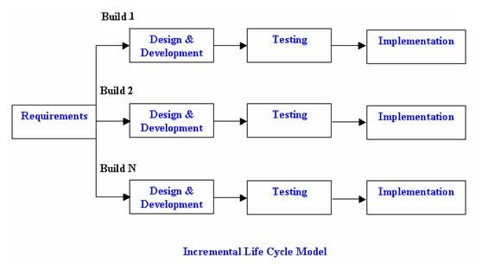
Advantages of Incremental model:
- Generates working software quickly and early during the software life cycle.
- More flexible – less costly to change scope and requirements.
- Easier to test and debug during a smaller iteration.
- Customer can respond to each built.
- Lowers initial delivery cost.
- Easier to manage risk because risky pieces are identified and handled during it’d iteration.
Disadvantages of Incremental model:
- Needs good planning and design.
- Needs a clear and complete definition of the whole system before it can be broken down and built incrementally.
- Total cost is higher than waterfall.
When to use the Incremental model:
- Requirements of the complete system are clearly defined and understood.
- Major requirements must be defined; however, some details can evolve with time.
- There is a need to get a product to the market early.
- A new technology is being used
- Resources with needed skill set are not available
- There are some high risk features and goals.
Agile Model:
Agile development model is also a type of Incremental model. Software is developed in incremental, rapid cycles.
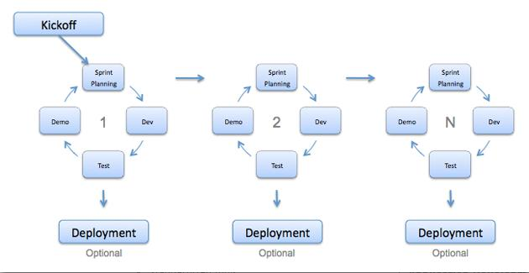
Advantages of Agile model:
- Customer satisfaction by rapid, continuous delivery of useful software.
- People and interactions are emphasized rather than process and tools. Customers, developers and testers constantly interact with each other.
- Working software is delivered frequently (weeks rather than months).
- Face-to-face conversation is the best form of communication.
- Close, daily cooperation between business people and developers.
- Continuous attention to technical excellence and good design.
- Regular adaptation to changing circumstances.
- Even late changes in requirements are welcomed
Disadvantages of Agile model:
- In case of some software deliverables, especially the large ones, it is difficult to assess the effort required at the beginning of the software development life cycle.
- There is lack of emphasis on necessary designing and documentation.
- The project can easily get taken off track if the customer representative is not clear what final outcome that they want.
- Only senior programmers are capable of taking the kind of decisions required during the development process. Hence it has no place for newbie programmers, unless combined with experienced resources.
When to use Agile model:
- When new changes are needed to be implemented. The freedom agile gives to change is very important. New changes can be implemented at very little cost because of the frequency of new increments that are produced.
- To implement a new feature the developers need to lose only the work of a few days, or even only hours, to roll back and implement it.
- Unlike the waterfall model in agile model very limited planning is required to get started with the project. Agile assumes that the end users’ needs are ever changing in a dynamic business and IT world. Changes can be discussed and features can be newly effected or removed based on feedback. This effectively gives the customer the finished system they want or need.
- Both system developers and stakeholders alike, find they also get more freedom of time and options than if the software was developed in a more rigid sequential way. Having options gives them the ability to leave important decisions until more or better data or even entire hosting programs are available; meaning the project can continue to move forward without fear of reaching a sudden standstill.
Rapid Application Development model:
RAD model is Rapid Application Development model. It is a type of incremental model. In RAD model the components or functions are developed in parallel as if they were mini projects.
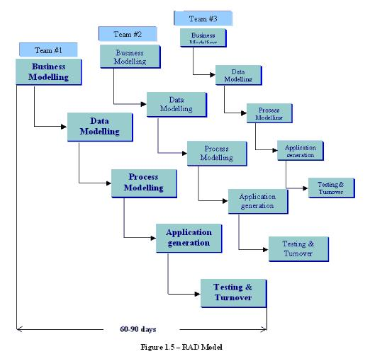
Advantages of the RAD model:
- Reduced development time.
- Increases reusability of components
- Quick initial reviews occur
- Encourages customer feedback
- Integration from very beginning solves a lot of integration issues.
Disadvantages of RAD model:
- Depends on strong team and individual performances for identifying business requirements.
- Only system that can be modularized can be built using RAD
- Requires highly skilled developers/designers.
- High dependency on modeling skills
- Inapplicable to cheaper projects as cost of modeling and automated code generation is very high.
When to use RAD model:
- RAD should be used when there is a need to create a system that can be modularized in 2-3 months of time.
- It should be used if there’s high availability of designers for modeling and the budget is high enough to afford their cost along with the cost of automated code generating tools.
- RAD SDLC model should be chosen only if resources with high business knowledge are available and there is a need to produce the system in a short span of time (2-3 months).

