**Software Requirements**

**Specification**

**for**

**VOTE**

Version 1.0 approved

**prepared by**

Prabhpreet Singh Sodhi Indian Institute of Technology, Kharagpur

Sahil Singh Indian Institute of Technology, Kharagpur

# 8th February, 2019

**T able of Contents:**

* 1. **Category**
  2. **Purpose**
  3. **Scope**
  4. **Introduction**
     1. **Existing System**
     2. **Proposed System**
  5. **Advantages**
     1. **Benefits to Elected Representatives**
     2. **Benefits to people**
     3. **Benefits to contractors**
  6. **Requirements**
     1. **Functional Requirements**
     2. **Non-functional Requirements**
  7. **Software Tools**
  8. **Deployment**
  9. **Hardware Specifications**
  10. **Economics**
  11. **Marketing**
  12. **Distribution**
  13. **Proposed Plan of Action**
  14. **Challenges to overcome**
  15. **Limitations and Future Scope**

**Project Title-**

**VOTE: Voice of the Electorate**

* 1. **Category:** Android Application

# Purpose:

The purpose of developing this application is to provide a common virtual platform to the people for voicing out their concerns directly to the elected representatives of the concerned constituency, and for their efficient and

cost-effective solution by the best bidder.

# Scope:

The aim of this application is to facilitate the effective solution of the

day-to-day problems faced by the people, which often see a delayed response by the authorities, by bringing the elected representatives and the people, along with the contractors interested in solving the issue to a common platform. It can be implemented in all democratically functioning states, for providing a transparent and active platform of grievance removal.

# Introduction:

The utility of this application can be best understood by comparing the existing system with the proposed system:

### Existing System:

The process of getting even minor public works done by the authorities is relatively cumbersome and time consuming, which generally involves sufficient manual intervention from lodging the complaint to getting the job done. Further,

there is practically no proper method to make the concerned authorities aware of the number of people getting affected by a particular issue i.e. the scale of the problem. Besides, there is no proper quantitative measure available to the people for measuring the performance and response-time of their elected representatives at large.

### Proposed System:

Our goal is to make the process of grievance removal more transparent and less cumbersome, while simultaneously saving on time required to lodge such complaints.

After careful analysis of the scenario, we present the following modules in our application:

* + - * **Representative Registration:** Constituency-wise registration of the elected representatives.
      * **Electorate Registration:** Constituency-wise registration of the voters of the area.
      * **Grievance Portal:** Members of the electorate can lodge their complaints by choosing the respective categories of sub-area, domain of complaint (water, electricity, etc.), severity, etc. Similar complaints will be merged together to avoid duplicity.
      * **Redressal Portal:** The concerned representative can view all the complaints lodged so far, and take appropriate actions.
      * **MP/MLA Report Card:** It will display the fraction of issues solved by the concerned representative, along-with other parameters of performance such as average time taken in solving an issue, etc.
      * **Contractor Portal:** It will include a list of registered contractors, which can make bids to solve any given issue. The most competent bid can be made to work on the same, thereby reducing the pressure on government agencies.

**Complainant**

Lodge Complaints

**Complaint Portal**

**Grievance Redressal Portal**

View Complaints & Transfer to respective agencies

**Elected Body**

**Contractor Portal**

View & bid on Issues

Have a clear & Transparent view over the whole process

**Contractor**

**Diagrammatic Illustration**

**All Users**

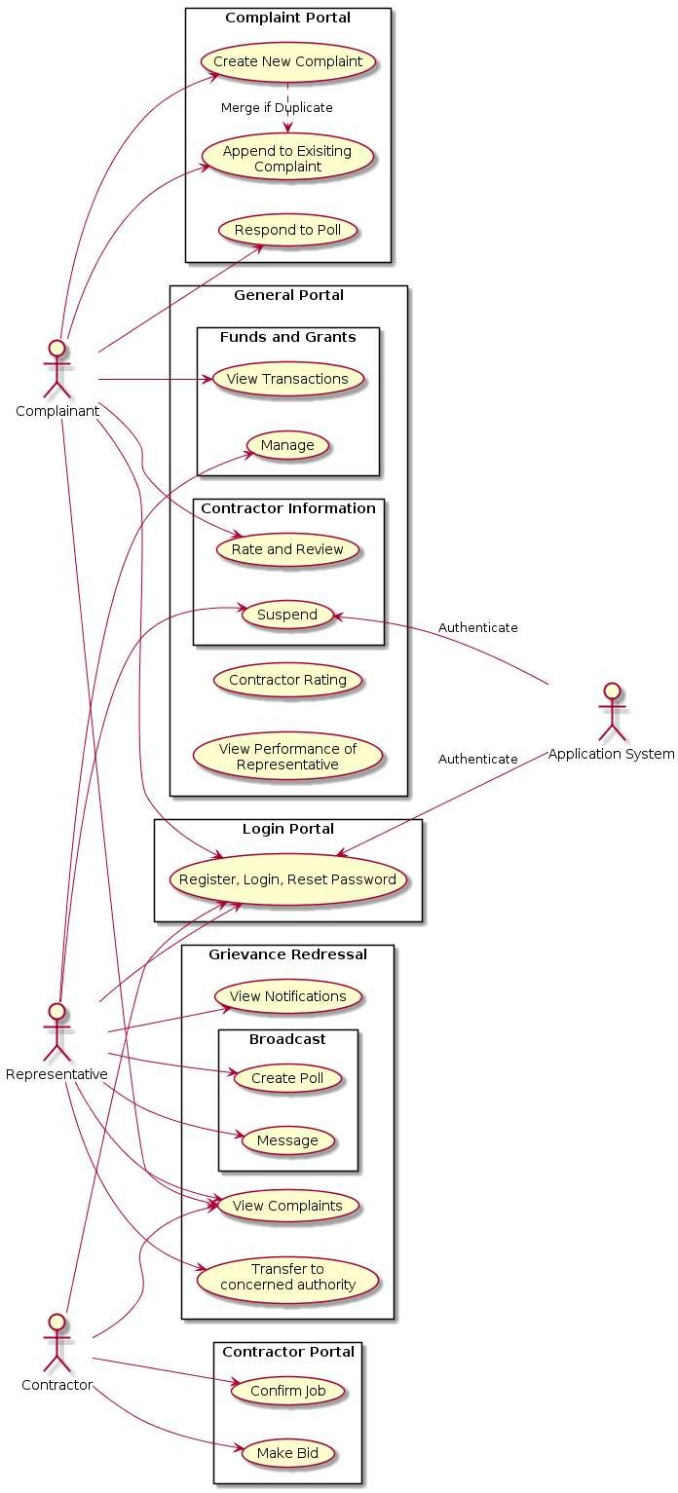

## Use-case Diagram

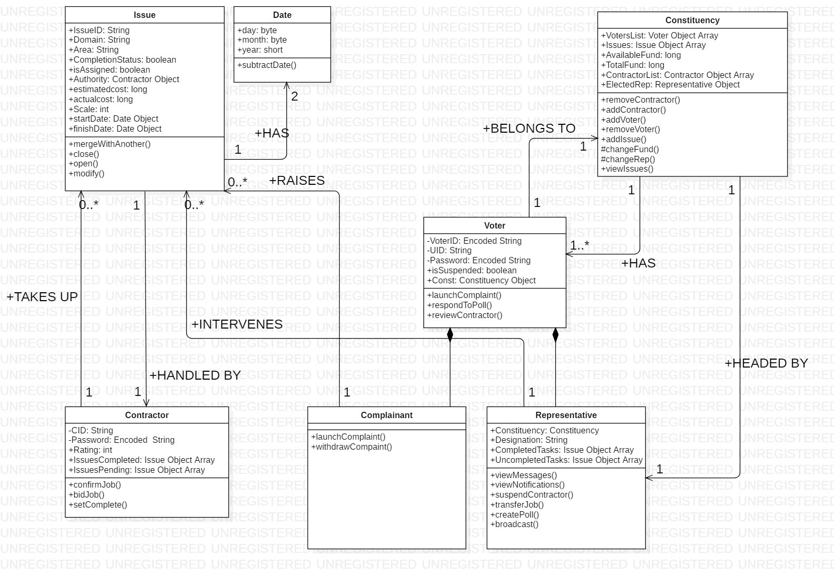

**Class Diagram**

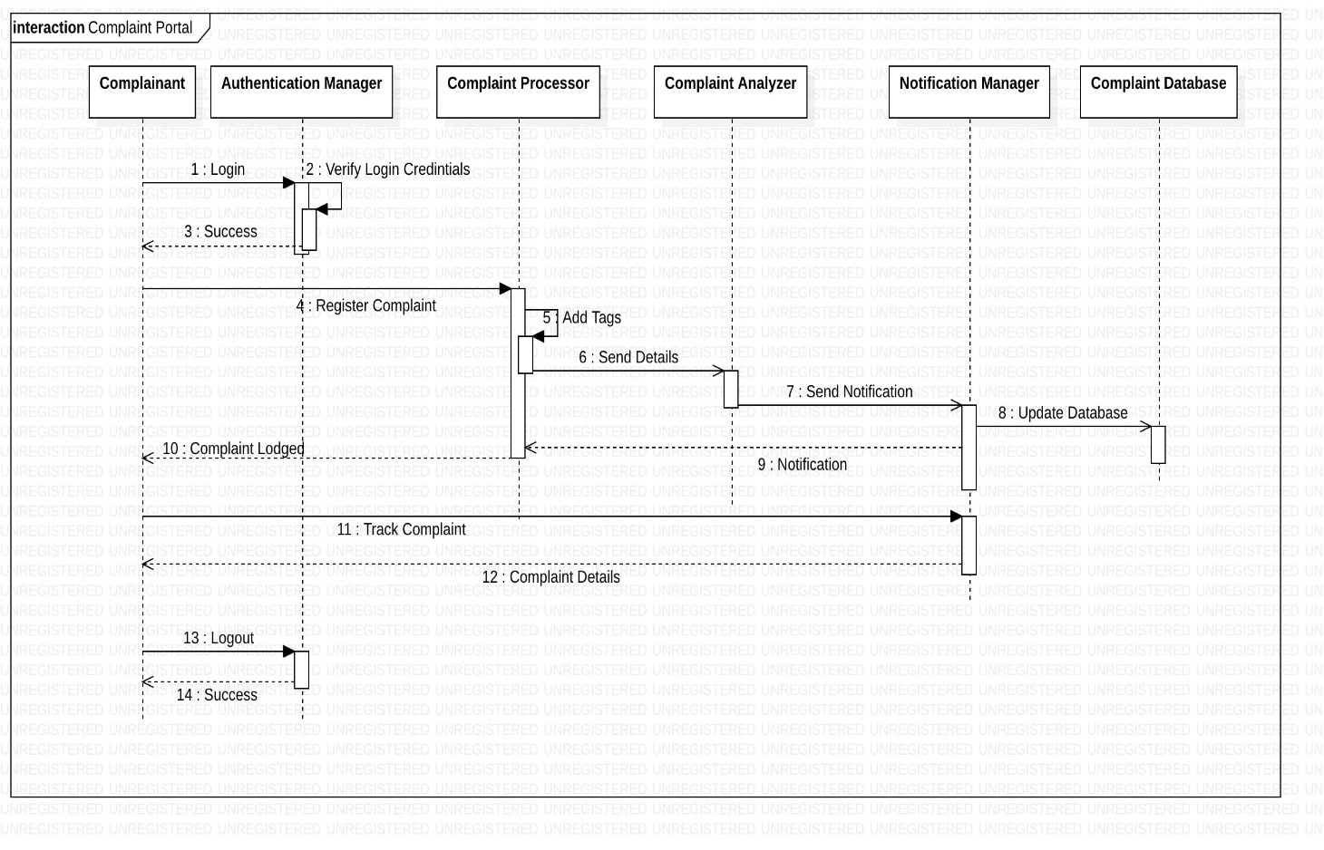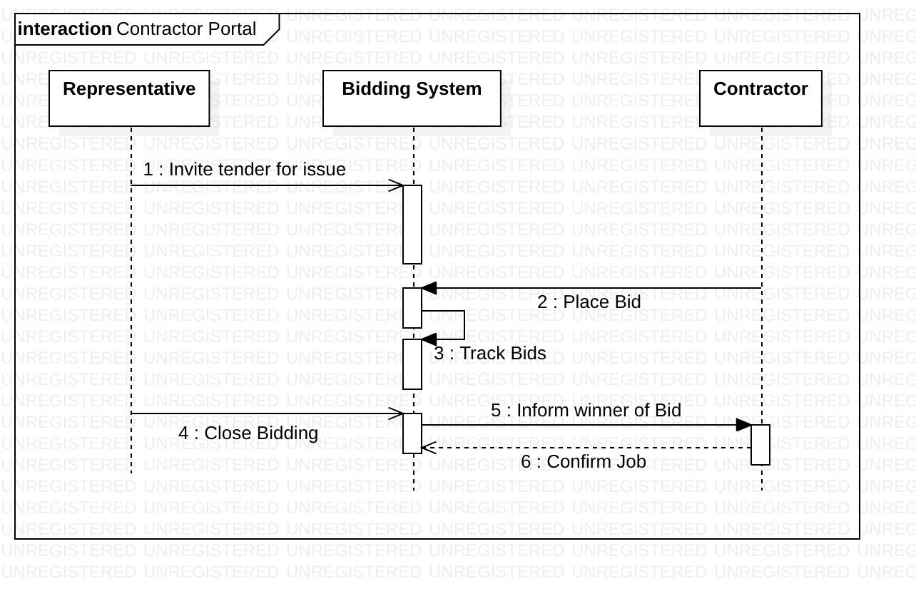

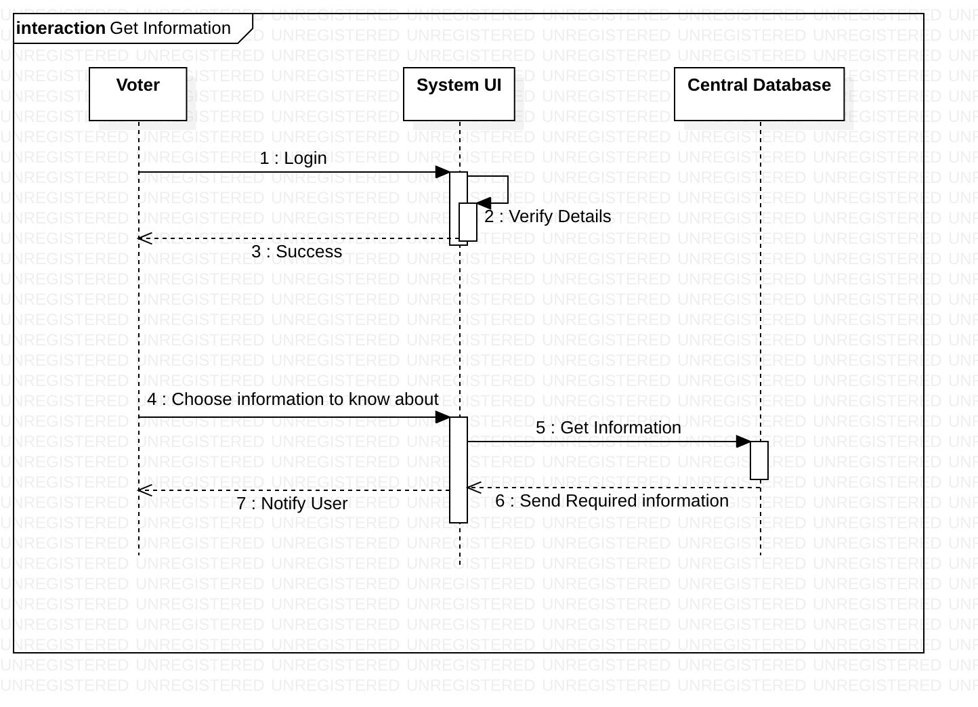

**Sequential Diagrams**

* 1. **Advantages:**

The proposed system offers several state-of-the-art benefits and improvisations to the way public affairs are handled.

### Benefits to Elected Representatives

* + - * Better management of issues concerning theconstituency
      * Better and cost-effective management of funds and grants
      * Better identification of under-developed regions of his/her constituency

### Benefits to People

* + - * Timely removal of grievances
      * Objective measure of competence of various representatives
      * Hassle-free system to get public works done
      * Transparency in expenditure of government funds

### Benefits to Contractors

* + - * Increased scope of business
      * No long delays in granting of tenders
      * Corruption-free and transparent business environment
      * Can contribute productively to the common welfare of the people

# Requirements:

### Functional Requirements

* ***Login and Registration Portal:***
  + Allotment of username on the basis of Voter ID to avoid duplicate accounts.
  + Password Encryption to avoid stealing of passwords.
  + Each voter and representative can be registered from at most one constituency.
  + Contractors to be given UIDs (Unique Identifiers) to avoid fake tenders.
  + **Input**: Personal details such as Name, Address, VoterID, etc.
  + **Output**: Unique Username for future login

### Complaint Portal (for People):

* + New issue portal:
    - Mechanism to lodge new complaints
    - **Input:** Details about the problem such as sub-division, locality, domain and severity, etc.
    - **Output:** Complaint ID, and updated list of complaints
  + Existing issue portal:
    - Mechanism to view, upvote and remark on an already raised issue
    - Mechanism to merge similar issues together to avoid duplicate complaints
    - **Input:** Actions such as upvote and comment on an already existing issue, or details about the problem if the user is creating a duplicate complaint
    - **Output:** Updated parameters of the issue, directly or indirectly by merging the duplicate complaint with the original one

### Grievance Redressal Portal (for government representative):

* + View Complaints:
    - Obtain details of complaints being raised in different domains in the constituency
  + Transfer of Issue to Contractor:
    - Representative can choose the best and most competent contractor to transfer the issue for its resolution.
    - **Input**: The chosen contractor
    - **Output**: Status update on the issue with details of contractor and estimated time
  + Notifications and Broadcast Tab:
    - To view notifications from associated electorate
    - Broadcast important messages effectively to masses
    - **Input:** Message to be broadcasted
    - **Output:** Message or poll notification is broadcasted to all users

### Contractor Portal:

* + Make Bid Portal:
    - Choose an issue to bid on
    - **Input**: Issue chosen, estimated cost and time
    - **Output**: Details sent to Representative
  + Confirmation Portal:
    - Confirm tender if chosen for a job
    - **Input:** Confirmation Details
    - **Output:** Issue status updated

### General Features:

* + Representative report card:
    - Display various performance parameters of the representative giving a measure of how the issues are being handled
    - Can be viewed by all voters
    - **Input:** None (Data is collected with every issue raised automatically)
    - **Output:** Performance card of the representative
  + To facilitate transparent utilization of funds, amount bid by the contractors will be visible to the people in the constituency
  + Behavioral code of conduct to promote healthy environment. Violators will be warned.

### Non-functional requirements

* + - * Secure storage and access of sensitive data such as Voter ID number, etc. to ensure the data security of the people enrolled.
      * Better component design to get maximum efficiency, to ensure the ability of the system to run on a wide variety of platforms and hardware environments.
      * System must be interactive to enable it to be used effectively by the common masses.
      * Lags in performance must be minimized to boost efficacy of the system as a whole.

# Software Tools:

* Android Studio
* Java
* Extensible Markup Language (XML)
* SQLite

# Deployment:

* Any device with Android operating system with API 15 or higher (though some features require minimum API 21)

# Hardware Used:

* A Personal Computer with Windows/Linux OS
* GPU

# Economics:

Since the development of this project does not require any special hardware, and is being developed solely for learning purposes, it will be supplied at no cost.

On a personal note, we specifically chose this problem statement to build a system which can be put to practical use for the welfare of the country, and hence, it will be made open-source after the development and testing phase.

# Marketing

We have listed the numerous advantages the software offers in comparison to the existing non-digital solution, which we believe are sufficient to draw the attention of the masses. Further, as the software will be a free of cost open-source application, it can be put to use anywhere and everywhere it is found useful without any permission from the developers. Due to economic restraints, we have not planned any specific commercialized marketing plan as of yet.

But, informing various levels of government about its utility, describing the various novel features (already mentioned) it offers, is surely on the cards.

# Distribution:

We can use various digital application distribution services such as Google Play Store, Amazon App Store, Mobogenie Market, etc. for its effective distribution.

# Proposed Plan of Action:

|  |  |  |  |  |  |  |
| --- | --- | --- | --- | --- | --- | --- |
| **WEEK 1** | | **WEEK 2** | **WEEK 3** | **WEEK 4** | **WEEK 5** | **WEEK 6** |
|  | 01/03 to 08/03 | 08/03 to 15/03 | 15/03 to 22/03 | 22/03 to 29/03 | 29/04 to 05/04 | 05/04 to 12/04 |
| **Task No.** | T1 | T2 | T3 | T4 | T5 | T6 |
| **Task Details** | Design Login and Registration Portal | Design Complaint Portal | Design Grievance Redressal Portal | Design Contractor Portal | Link all 3 portals together | Testing Phase |
| **Dependen cies** | None | T1 | T1 | T1 | T2, T3, T4 |  |

## Final Submission: 12/04/2019

* 1. **Challenges in Development:**
* To make a light-weight application that works well without a lot of hardware and processing requirements, for better penetrability
* Make the application interface simple enough to be understood by the less educated masses
* Work in accordance with the planned schedule

# Limitations and Future Plans:

### Local Language Support:

Since a large section of Indians cannot communicate or understand English, especially in the rural areas, the system cannot be put to efficient use unless it is made available in different languages spoken across the country such as Hindi, Bengali, Telugu, Tamil, Punjabi, Marathi, Gujarati, etc.

### Voice control:

Since a considerable section of our population is illiterate, extending this system to provide full-fledged voice navigation is on the cards.

### Approval:

The project cannot be put to effective use unless the government representatives approve of this as an official mechanism of grievance redressal.

### Image Processing based voter information retrieval:

Considering a major chunk of our population is illiterate, for account creation, an image processing based solution is on the cards, where a user can simply upload a soft-copy of his/her voter card, for account creation instead of manually entering all the details.