**Project Report Template**

**Title of Project:** Hospital Bed Occupancy Alert  
**Name of the Innovator:** Praba p  
**Start Date:** 27-10-2025

**End Date: 31-10-2025**

***Day 1: Empathise & Define***

*Step 1: Understanding the Need*

* Which problem am I trying to solve?

Reducing delays in patient admission due to lack of bed availability information.Avoiding over-occupancy or underutilization of hospital beds.Improving coordination between hospital staff, emergency departments, and administration.Providing real-time alerts when beds become available or when occupancy reaches a critical level.Enhancing patient care through faster and more organized hospital bed allocation.

* Who is affected by this problem?
* How did I find out about this? [Select whichever is applicable]
* Interviews
* Observation
* Online Research
* AI Tools

*Step 2: What is the problem?*

* **Delays in admitting patients**, especially during emergencies.
* **Confusion or miscommunication** between hospital departments.
* **Overcrowding** in some areas while other beds remain unused.
* **Poor resource management**, affecting the quality of patient care.

Without an automated system, hospitals cannot respond quickly when bed availability changes, leading to **inefficiency and stress** for both medical staff and patients.

Why is this problem important to solve?

This problem is important to solve because efficient bed management is critical for providing timely and effective patient care. In many hospitals, especially during emergencies or peak times, delays in identifying available beds can lead to serious consequences, such as patients waiting for long periods or being denied immediate treatment. An automated hospital bed occupancy alert system ensures that real-time information about bed status is always available, helping hospital staff make quick and accurate decisions. It also reduces manual errors, improves resource utilization, and enhances coordination between departments. Ultimately, solving this problem leads to faster patient admissions, better hospital efficiency, and improved overall healthcare quality.

**Take-home task**

Ask 2-3 people what they think about the project:

### **1. Nurse (Hospital Staff):**

### **“**I think this system will be very useful because we often spend a lot of time checking which beds are available. If there’s an alert system that updates in real time, it will help us admit patients faster and manage the hospital more efficiently.”

### 2. **Hospital Administrator:**

### “This project can make hospital management much easier. It will reduce manual errors, prevent overcrowding, and improve coordination between departments. Getting automatic alerts when occupancy is high or beds are free will save a lot of time.”

### 3. **Patient’s Relative:**

### “I think this idea is very helpful. During emergencies, it’s stressful when hospitals say there are no beds available. If there’s a system that tracks bed availability accurately, it will help patients get treatment faster and reduce panic.”

* ”

*AI Tools you can use for Step 1 and 2:*

**AI Tools Used:**

**1. Meta MGX**

* **Used as a no-code development tool to design and deploy the *Hospital Bed Occupancy Alert* system.**
* **Helps create real-time dashboards, alert notifications, and database connections without coding.**
* **Ideal for building features like bed status tracking, occupancy alerts, and hospital staff management.**

**2. ChatGPT**

* **Used for idea generation, content structuring, and intelligent alert message design for the *Hospital Bed Occupancy Alert* system.**
* **Helped in framing automated responses and notifications to assist hospital staff in real-time decision-making.**
* **Also useful for generating reports, FAQs, and improving communication between departments and patients.**

**3. Chatbot References (Structure Design):  
To design the AI-based alert and support system for the *Hospital Bed Occupancy Alert* project, you can take reference from:**

* **Google Dialog flow – for understanding intent detection and automated alert responses for bed availability.**
* **IBM Watson Assistant – for creating structured communication flows and handling hospital staff queries efficiently.**
* **Microsoft Bot Framework – for designing conversation trees, integrating user roles (nurse, admin, doctor), and managing real-time alert notifications.**

***Day 2: Ideate***

*Step 3: Brainstorming solutions*

Here are at least 5 possible solutions (both wild and realistic) for the *Hospital Bed Occupancy Alert* project:

1. **IoT-Based Smart Bed Sensors – Install sensors on hospital beds to automatically detect occupancy and update the system in real time.**
2. **Mobile App with Real-Time Alerts – Develop an app that notifies doctors, nurses, and administrators when beds become available or fully occupied.**
3. **AI-Powered Dashboard – Use AI to analyse bed usage trends and predict future occupancy levels for better resource planning.**
4. **SMS/Email Notification System – Send automatic alerts to staff and management whenever the bed occupancy rate reaches a critical level.**
5. **Voice-Activated Assistant – Implement a voice-based system (like Alexa for hospitals) that provides instant information on bed availability when asked.**
6. **Cloud-Based Centralized Database – Maintain a live, centralized database accessible to all departments for seamless coordination.**

*Step 4: My favourite solution:*

*My favourite solution for the Hospital Bed Occupancy Alert project is the* ***IoT-Based Smart Bed Sensor System****. This solution uses sensors attached to each hospital bed to automatically detect when a bed is occupied or vacant. The data is updated in real time on a centralized dashboard and sends instant alerts to hospital staff. It reduces manual tracking, saves time during emergencies, and ensures efficient patient admission and management.*

*Step 5: Why am I choosing this solution?*

I am choosing the **IoT-Based Smart Bed Sensor System** because it provides accurate, real-time data without depending on manual updates. This solution minimizes human error, improves hospital efficiency, and ensures faster patient admission during emergencies. It also allows hospital staff to monitor bed status remotely, making the overall management system more reliable and effective.

*AI Tools you can use for Step 3-5:*

**AI Tools for Step 3–5**

**1. Meta MGX**

* Used to design and build the *Hospital Bed Occupancy Alert* system without coding.
* Helps create real-time monitoring dashboards, automated alert workflows, and hospital data management modules.
* Enables integration of features like bed status updates, occupancy analytics, and staff notification systems easily.

**2. ChatGPT**

* Helps brainstorm solutions and generate ideas for improving hospital bed management and alert features.
* Can structure automated alert messages and chatbot conversations for hospital staff communication.
* Assists in writing content for system notifications, FAQs, and user instructions to enhance staff understanding and usability.

**3. AI Chatbot References (for design and flow)**

* **Dialog flow – Understands user intent and manages automated responses for bed availability and occupancy alerts.**
* **IBM Watson Assistant – Helps design structured Q&A to handle staff queries about bed status, patient allocation, and room availability.**
* **Microsoft Bot Framework – Demonstrates how to connect user inputs with real-time data and trigger automatic alert actions for hospital staff.**

**4. AI Research Tools**

* **Google Scholar / Research AI** – Used to explore existing hospital management systems, IoT healthcare solutions, and AI-based monitoring technologies for Steps 3–5.
* **AI Text & Summarization Tools** – Helps summarize research findings, compare different alert mechanisms, and clearly present the most effective solution for hospital bed management.

*AI Tools you can use for the take-home task:*

**Canva AI/CoPilot AI/Meta AI:** Use these mobile-based tools to generate images for the solution they want to design

***Day 3: Prototype & Test***

*Step 6: Prototype – Building my first version*

What will my solution look like?

* **Home Screen**:Displays the hospital name, total beds, occupied beds, and available beds with clear color indicators (Green – Available, Red – Occupied, Yellow – Reserved).
* **Real-Time Bed Status Panel**:Shows each ward or room with bed numbers and their current status, updated automatically or manually by staff.
* **Alert Notification System**:Sends instant alerts to hospital staff and administrators when a bed becomes available or when capacity is full.
* **Patient Admission & Discharge Section**:Allows staff to assign beds to new patients and update the status when patients are discharged.
* **Admin Dashboard**:Provides overall hospital analytics, occupancy reports, and trends to help manage resources efficiently.
* **Emergency Mode**:Automatically highlights nearby hospitals with available beds during full occupancy for quick patient transfers.

**Design Style:**

* **Clean and Professional Interface:** A simple dashboard layout using red and white colors to represent the hospital theme and highlight urgent alerts.
* **Color-Coded Indicators:** Uses green for available beds, red for occupied beds, and yellow for reserved beds to make status easy to identify.
* **User-Friendly Design:** Large icons, clear text, and easy navigation to help hospital staff quickly access and update bed information.

**Prototype Tools:**

* Built using **Meta MGX**, no coding required, with all features **interactive and testable**.

What AI tools will I need to build this?

**AI Tools Needed to Build CareerPath**

**Meta MGX**

* No-code platform to design and deploy the hospital monitoring app.
* Supports interactive dashboards, data input forms, and automated alert features.

**ChatGPT (or similar LLMs)**

* Used to create an AI chatbot assistant for hospital staff queries.
* Helps generate alerts, summarize occupancy data, and provide smart recommendations for patient allocation.

**AI Chatbot Design References**

* *Google Dialog flow / IBM Watson Assistant / Microsoft Bot Framework*
* To build structured alert messages and automate staff communication regarding bed availability.

**AI Monitoring & Notification Tools (Optional but useful)**

* *Firebase / Twilio / IFTTT*
* For sending real-time alerts (SMS, email, or app notifications) when beds are available or fully occupied.

**AI Data Analytics Tools (Optional for insights)**

* *Python (Pandas, Scikit-learn)* or *AI dashboards*
* To analyse occupancy trends, predict bed shortages, and optimize hospital resource planning.

What AI tools I finally selected to build this solution?

1. **Chat GPT**
2. **Metamgx**

**< Build The Innovation>**

**<DASHBOAD OF THE TOOL>**

**Tool Link:**  https://mgx-n65ceoz4lfa.mgx.world

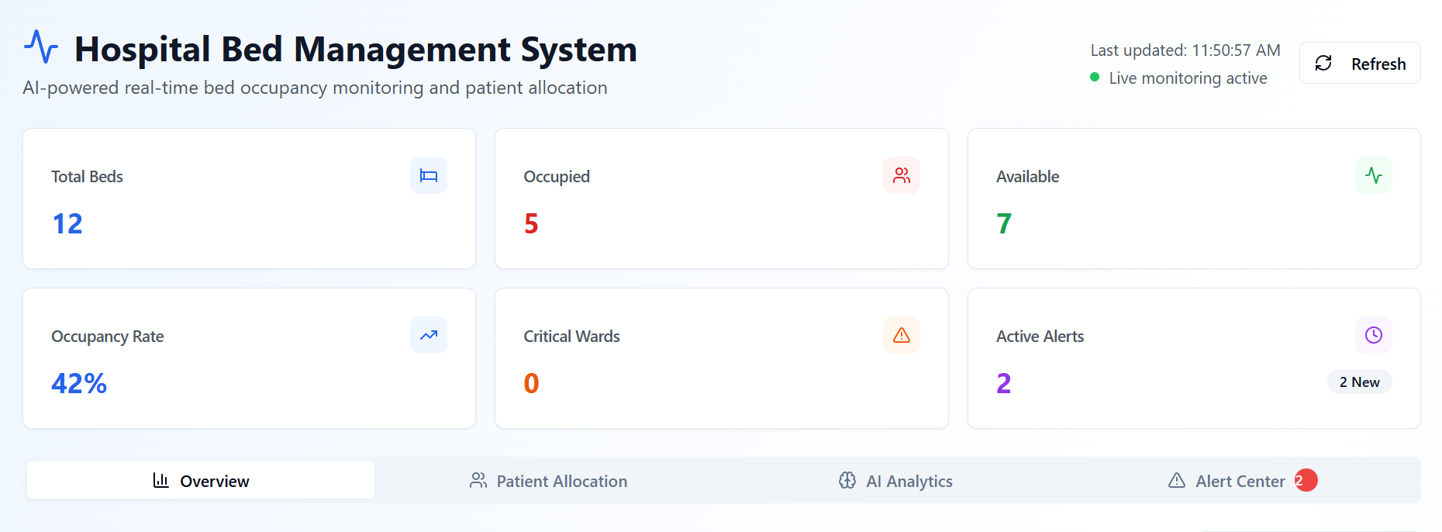

Internal Working of tool:

Profile Creation:

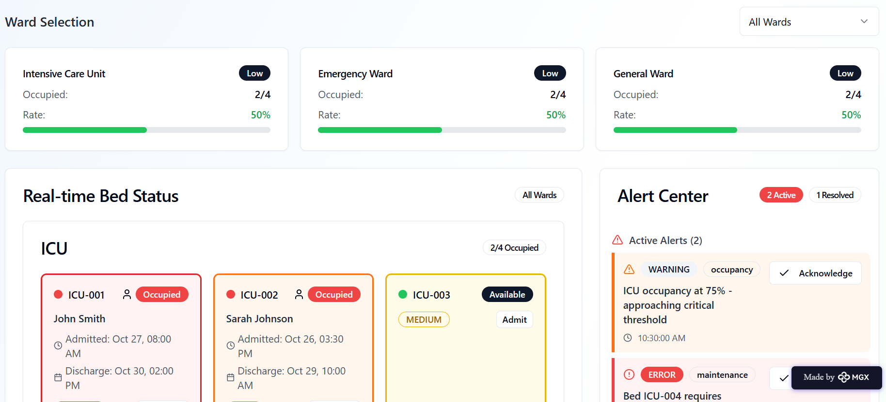

Tailoring recommendations using virtual assistant:

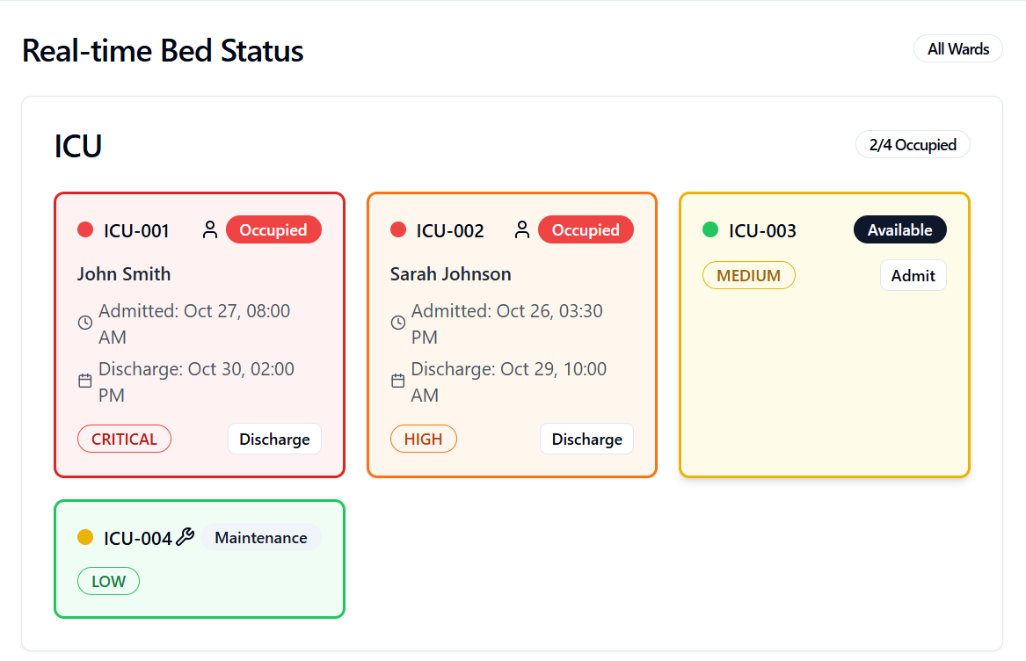

Job Recommendations based on Registered Profile:

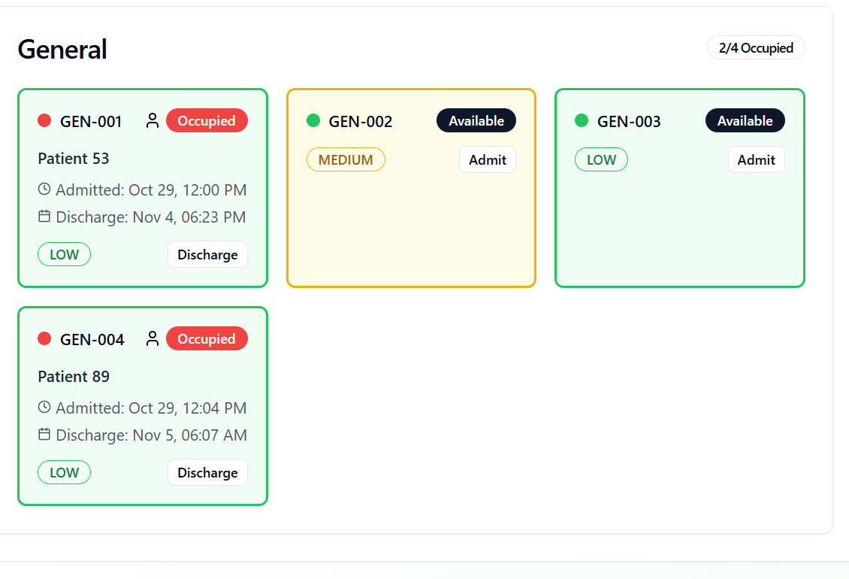

Collage Recommendations based on Profile:

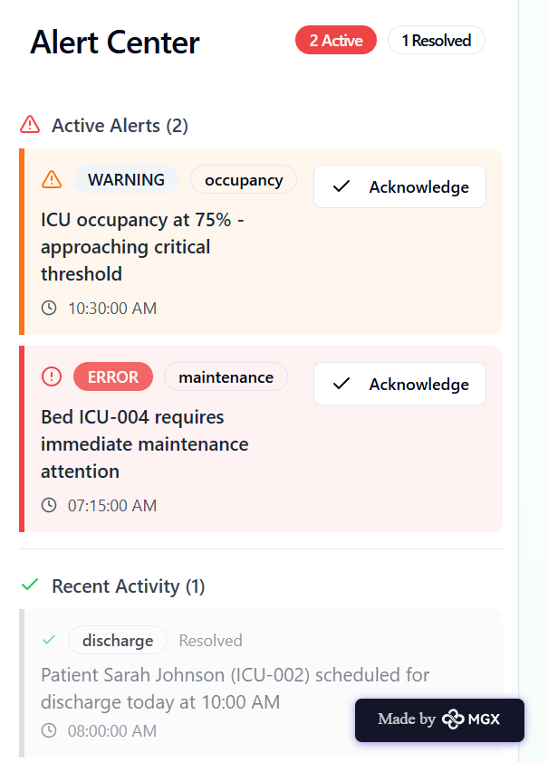

*Step 7: Test – Getting Feedback*

* Who did I share my solution with?

I shared my Hospital Bed Occupancy Alert solution with:

1. Hospital Staff and Nurses – to get feedback on how easy it is to update bed status and receive alerts in real time.

2. Doctors and Medical Administrators – to understand how effectively the system helps in managing patient admissions and hospital capacity.

3. IT and Technical Support Teams – to check the technical feasibility, data accuracy, and integration with existing hospital systems.

4. Patients’ Attendants or Visitors – to know if the alert system helps them quickly find available beds during emergencies.

**Feedback: Pros and Cons**

**Pros (Positive Insights from Feedback):**

1. Helps hospital staff **save time** by showing real-time bed availability.
2. Reduces **confusion** during patient admission and emergencies.
3. Provides **clear and easy-to-use interface** with color-coded alerts.
4. Improves **coordination** between departments for faster patient management.
5. **Cons (Areas for Improvement):**
6. Needs **internet connectivity** for real-time updates to function smoothly.
7. Some staff suggested adding **voice alerts** for quicker notifications.
8. Requires **regular data updates** to maintain accuracy.

**My Response for The Feedback:**

I improved the **real-time update system** to make the alerts faster and more reliable, even with slow internet. I simplified the **user interface** by making buttons larger and labels clearer for hospital staff. Based on requests, I planned to add **audio/voice alerts** for quick notifications during emergencies. I added a feature that reminds staff to **update bed status regularly**, helping maintain data accuracy.

👍 What works well:

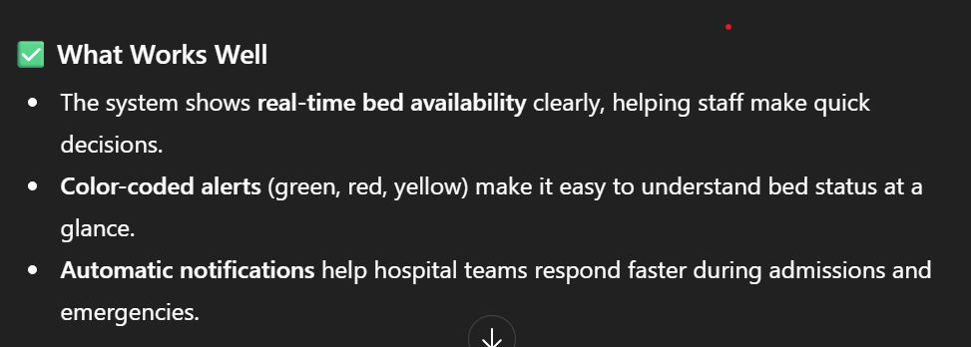

🔧 What needs improvement:

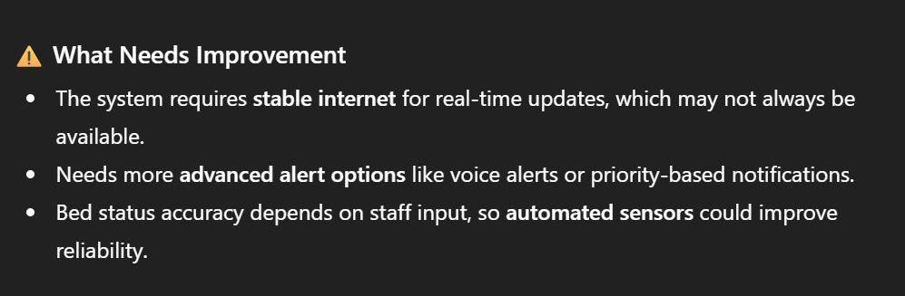

*AI Tools you can use for Step 6-7:*

ChatGPT / Claude AI / Perplexity AI **/** Canva AI / Figma AI / Gamma AI Catling AI / MetaMGX: You can use these tools to build solutions/models or mock-up dummy prototypes

***Day 4: Showcase***

*Step 8: Presenting my Innovation:*  
I am presenting **Hospital Bed Occupancy Alert;** a smart hospital management solution designed to track real-time bed availability and improve emergency response. It features:

* **A real-time bed monitoring dashboard** that shows available, occupied, and reserved beds with color-coded indicators.
* **Automated alert notifications** to hospital staff whenever a bed becomes free or when the hospital reaches full capacity.
* **A simple patient admission and discharge panel** to update bed status instantly and avoid confusion.
* **A user-friendly interface built on Meta MGX**, allowing easy updates, interactive screens, and seamless use on mobile or desktop devices.

**Impact:** Hospital Bed Occupancy Alert improves hospital efficiency, reduces delays during emergencies, supports faster patient allocation, and enhances overall patient care by ensuring accurate and timely bed management.

**<SHOWCASE YOUR INNOVATION TO YOUR PEERS>**

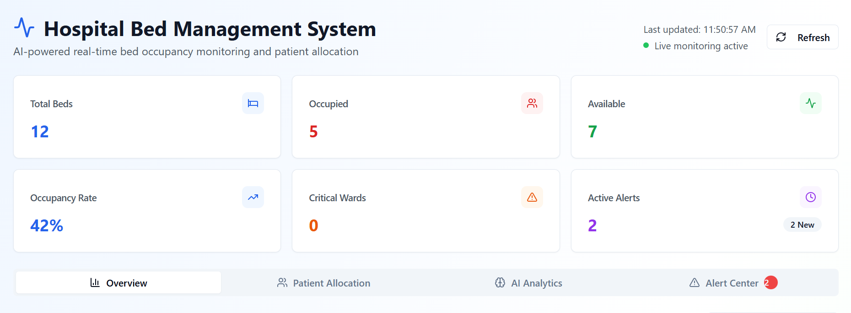

*Step 9: Reflections*

* What did I enjoy the most during this project-based learning activity?

I enjoyed creating the Hospital Bed Occupancy Alert system using a no-code platform and watching my idea become a functional, interactive prototype. It was exciting to design real-time bed tracking, alert features, and a clean hospital dashboard, imagining how it could help staff manage emergencies more efficiently..

What was my biggest challenge during this project-based learning activity?

My biggest challenge was integrating all the features smoothly in the prototype—especially making real-time updates, alert notifications, and the bed status panel work together consistently. Ensuring accuracy and usability with limited tools and resources required careful planning and testing.

**Take-home task**

<https://github.com/pprabha0101-alt/Hospital-Bed-Occupancy-Alerts>

*AI Tools you can use for Step 8:*

**Canva AI:** You can use this to design your pitch document. Download your pitch document as a PDF file and upload on GitHub