CS 6240: Final Project Report

Title: Analysis of Graph Connectivity
Team :Laxmiprasad G Veerabhadrappa

Introduction:

Six Degrees of Separation is a theory that everyone is just 6 or fewer steps away to anyone in the world on any social network like Twitter, FaceBook or by method of introduction. This theory is unproven and not all computer networks satisfy it. Six degrees theory analyzes a real world scenario and can determine how connected a network is, which can help in solving social networking problems.

Our project is about analysis of the connectivity of a social graph. Our aim is to analyze this with 2 concepts : Six Degrees of Separation theory and K-Means clustering.

- We aim to prove the Six Degrees of Separation theory on the Twitter social graph.
- By use of K-Means Clustering we aim to find the number of persons

Include brief highlights of the project. How we solved it (how we did it).

Data:

The dataset we have used is the Twitter social graph. The data set contains the social graph of Twitter website. It is stored in CSV format in 2 files – nodes and edges. Nodes are integer values which are the numeric IDs for users. Edges are directed representing friendship/followers between users.

Number of Nodes: 11,316,811 Number of Edges: 85,331,846

Format of row in edges file:
1,2
where 1 is friends with 2 implies also that 2 is friends with 1.

Samples of Data:

Edges:

703,3109655

703,188707

703,16482

703,2541

703,8762946

Technical Discussion:

TASK 1: Average Degree of Separation

Purpose:
The main aim is to find the average of degrees of all possible nodes in a graph for a given source. This is basically Breadth-First Search algorithm on the graph.

Main Idea:
The idea is to execute a MapReduce program which analyses the adjacency list to give the nodes at one level and iteratively call this MapReduce program for 6 levels. At each level along with the adjacency list we also store the distance traveled, color of the node. These parameters help in evaluating the result in consecutive steps:

ID EDGES | DISTANCE | COLOR

At the initial step, the distance for source node will be 0 and for all other nodes will be infinity or Integer.MAX_VALUE. The color for source will be GRAY and all others will be WHITE.

At every iteration, the mapper will emit every adjacent node with edges as null, color as GRAY and distance = distance(input) + 1. The input node will also be emitted with the color BLACK.

At every iteration, the reducer will combine the results in the values list to emit a single set of data for the key node. From the list of values, we choose the edges which is non-null set of edges, distance which is minimum and color which is darkest. Thus, at reduce call we emit the key node id and its newly found parameters.

Psuedo Code:

Driver Program:

1. Pre Processing: simple MR job to convert input to adjacency list
2. iteration = 1
3. while (iteration <= 6)
status = BFS MR job (previous iteration output as input)
if (status)
iteration ++
else
exit(with error message)
4. Post Processing: simple MR job to compute average of degrees calculated in BFS

BFS Program:

map(node n){
for every node v in n.adjacent
{
v.distance = n.distance + 1
v.color = GRAY
emit(v.id , v.line)
}
n.color = BLACK
emit(n.id, n.line)
}

reduce(key, values){
distanceMin = min distance from all values
colorMax = highest/darkest color from all values
edges = adjacencylist of non-null length

Node n = createNode(distanceMin, colorMax, edges)
emit(key, n.line)
}

Files:
1. Driver Program – SixDegreesDriver.java
2. Pre Processing – AdjacencyList.java
3. BFS Map-Reduce Program – BFSMapReduce.java
4. Enumeration for Colors – Colors.java
5. Post Processing – LevelData.java
6. Custom Class for Nodes of Graph – Node.java

Concrete Results:

(1) Properties of Data:

The input is in format of edges in CSV file format. The total amount of data is as follows:

File Size : 1.3 GB
Number of Nodes: 11,316,811
Number of Edges: 85,331,846
Missing Values: No

(2) Report of the Results:

Average Degree of Separation: 3.4136744

Maximum Level in BFS: 6

Comparison of Run-Time for Six Degrees Task on EMR:

 | Small Machine (m1.small) 5 | Large Machine (m1.large) 5
Six Degrees | 1 hr 1 min | 28 min 39 sec
Division of Tasks in Six Degrees
Pre Processing | 7 min 34 sec | 3 min 5 sec
BFS Task | 46 min 9 sec | 21 min 1 sec
Post Processing | 1 min 12 sec | 54 sec

Comparison of Run-Time on Local:

 | Local Machine | Hadoop on Local (Psuedo-Mode)
Six Degrees | 1 hr 7 min | 1 hr 15 min

(3) Observations:

- The data does definitely satisfy the Six Degrees of Separation theory. This is supported by the details in above point. All the nodes fall within 1-6 distance from source node and also, the average degree of separation is lesser than 6.
- We can also conclude that the graph well connected, since the average is not only less than but is close to 3. Thus, on an average any two people are just 3 hops away.
- The Six Degrees program takes twice the time to run on small machines compared to large machines. Also, within entire Task 1, the BFS program takes maximum time to run since it run for 6 iterations.
- Large machines provide better load balancing and distribution. This is evident in the number of default map tasks. For small machine, default are 20 but there are 21 map tasks required hence the 21st map task slows down or halts the start of reduce tasks till it is complete. Where as, in the large cluster the number of default map tasks are 30 hence all the map tasks are finished in one go.

Special Analysis:

bfs on local takes very long time, emr improves performance by large factor
contrary to intuition that parallel bfs would need more time since large intermediate results and multiple iterations , still runs faster

TASK 2: K-Means Clustering of Number of Friends

Purpose:
The main aim in this task is to find clusters of persons based on their implicit property i.e. number of friends they have. For this analysis we consider first-degree friends.

Main Idea:
The idea is to start with a predefined set of centers (K centers) which are defined based on the property for which we are measuring. Here, it is the number of friends.

Each record is assigned to the cluster with the
closest center. This is done by calculating the Euclidean distance between record r and center c. Since we have only number of friends as property, this distance will c – r.numberOfFriends.

Repeat the above until centers do not change (convergence):

1. Form K clusters by assigning every object to its nearest center
2. Recompute center of each cluster by taking average of the values in that cluster

Convergence is an important criteria to be decided and we have implemented this by checking different conditions for different ranges. For range of 10,000 above, it checks the 4 most significant digits. For range of 1000, it checks all 4 digits and for range close to 10 it checks the digit after decimal point.

Psuedo Code:

Driver Program:

1. Pre Processing: simple MR job to convert input to adjacency list
2. iteration = 0; initialize centers = {35000, 2500, 10}
3. while (! converges())
status = Kmeans MR job()
if (status)
iteration ++
else
exit(with error message)

K-Means Program:
Mapper Class level:

setup(){
centers[] = read 3 center from the 3 files
}

map(record r){
min = Interger.Max_Value
current = r.friends
index = 0
for every c(i) in centers
{
dist = c - current
if (dist<min)
{
min = dist
index = i
}
}
emit(index, record r)
}

reduce(key, values){
sum = 0
count = 0
for (every v in values)
{
sum = sum + v.friends
count++
}
avg = sum / count
prev[key] = read from current centers file
write to prev file ← prev[key]
write to current centers file ← avg
emit (avg, values)
}

Files:
1. K Means Driver Program -
2. Friends Calculation -

Concrete Results:

(1) Properties of Data:

The input is the adjacency list result from pre-processing stage in Six Degrees program. The total amount of data is as follows:

File Size : 1.1 GB
Number of Nodes: 11,316,811
Missing Values: No

(2) Report of the Results:

K-Means Result Table:

Center Id | Cluster Center after K-Means | Number of Nodes in Cluster
1 | 38294.812 | 699
2 | 3146.1597 | 7815
3 | 6.699 | 11308297

Comparison of Run-Time for K-Means Task:

 | Local Machine | EMR – Large (m1.large) 5
K Means Program |  | 38 min 48 sec

Graph:

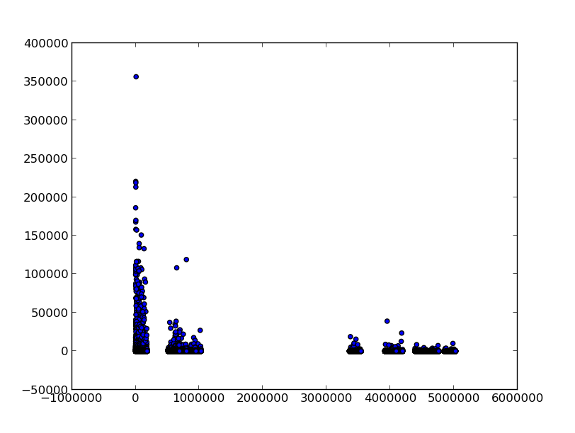

(3) Observations:

- Popularity : The data obtained in K-Means clustering shows that there are very few people who have a large number of friends (Cluster center : 38294). These nodes will represent mostly celebrities.

Special Analysis:

bfs on local takes very l

Challenges:

Parallel BFS Algorithm:
- We spent a major amount of time in coming up with an algorithm for performing BFS in parallel.
- The Single Source Shortest Path algorithm taught in class was not a solution for the Six Degrees problem since the distance between edges is not variable. Plus, we need to maintain level information as well as what nodes have been traversed at a level so that we do not traverse it again.
- After reading research papers and graph algorithms theory, we were able to implement algorithm using colors for maintaining traversal history and distance as levels.

Hadoop Psuedo mode on Local Machine:
- We set up an environment for running Hadoop on local machine which provides a psuedo parallel environment for Map Reduce programs.
- Though this was not a part of requirements for running the Map Reduce programs, we were able to use this setup to test our code before running on AWS.
- Since the intermediate results generated in BFS algorithm is very large (on the same scale of the input file), this method provided a way of debugging the issues on the entire dataset while writing the algorithm for BFS.

Conclusion:

Briefly summarize your main results and contributions and point out possible extensions or

alternatives that might be worth exploring in future work. The conclusions should be about 0.5 to 1 page
in this document’s format.

References:

1. John and Cailin Blog : http://www.johnandcailin.com/blog/cailin/breadth-first-graph-search-using-iterative-map-reduce-algorithm

2. Professor Mirek Riedewald : Lecture Slides

3. Wikipedia : http://en.wikipedia.org/wiki/Six_degrees_of_separation

