COMPREHENSIVE FUEL PRICE IMPACT & VEHICLE DEMAND ANALYSIS
Prateek Parihar | 1580712 | BSNS9000 | November 09, 2025
Complete Analysis Report: Fuel Price Relationships & Future Demand Forecasting

TABLE OF CONTENTS
1. EXECUTIVE SUMMARY
2. HYBRID VEHICLE ANALYSIS
2.1 Descriptive Statistics
2.2 Correlation Analysis
2.3 Regression Analysis & Price Elasticity
2.4 Granger Causality Test
2.5 Demand Forecasting Analysis
2.6 Visualizations
3. ELECTRIC VEHICLE ANALYSIS
3.1 Descriptive Statistics
3.2 Correlation Analysis
3.3 Regression Analysis & Price Elasticity
3.4 Granger Causality Test
3.5 Demand Forecasting Analysis
3.6 Visualizations
4. COMPARATIVE ANALYSIS
5. KEY FINDINGS SUMMARY
6. STRATEGIC RECOMMENDATIONS
7. CONCLUSIONS

1. EXECUTIVE SUMMARY
OVERVIEW:
This comprehensive analysis examines the relationship between fuel prices and vehicle sales, combined with future demand forecasting for hybrid and electric vehicles across four major markets: United States, China, Norway, and New Zealand (2010-2024 with projections to 2029).
METHODOLOGY:
• Correlation analysis with time-lag effects
• Multiple regression modeling with price elasticity calculations
• Granger causality testing for causal relationships
• Four forecasting methods: ARIMA, Linear Trend, Growth Rate, Exponential Smoothing
• Scenario-based projections (Conservative, Moderate, Optimistic)
• Realistic fuel price impact modeling (10%, 25%, 50%, 100% increases)
KEY DATASETS:
• Hybrid vehicle sales data (HEV + PHEV) by country
• Electric vehicle sales data by country
• Annual fuel prices by country
• Government incentives and policy variables
• Technology advancement metrics
• Total cost of ownership factors
• Behavioral adoption factors
ANALYTICAL SCOPE:
This report provides actionable insights for vehicle manufacturers, policymakers, investors, and market analysts seeking to understand fuel price sensitivities and plan for future market demand across different regional markets.

2. HYBRID VEHICLE ANALYSIS

2.1 Descriptive Statistics
Overall Dataset Statistics:
+--------------------+---------+-----------+-----------+----------+----------+----------+-----------+----------------+
| Variable | Count | Mean | Std | Min | 25% | 50% | 75% | Max |
+====================+=========+===========+===========+==========+==========+==========+===========+================+
| Year | 60 | 2017 | 4.36 | 2010 | 2013 | 2017 | 2021 | 2024 |
+--------------------+---------+-----------+-----------+----------+----------+----------+-----------+----------------+
| Hybrid_Demand | 60 | 308119 | 753326 | 0 | 2000 | 20000 | 317434 | 4.9e+06 |
+--------------------+---------+-----------+-----------+----------+----------+----------+-----------+----------------+
| Fuel_Prices | 60 | 1.28 | 0.45 | 0.51 | 0.88 | 1.24 | 1.67 | 2.12 |
+--------------------+---------+-----------+-----------+----------+----------+----------+-----------+----------------+
| Incentives | 60 | 7075 | 5403.09 | 0 | 4000 | 7500 | 9750 | 15000 |
+--------------------+---------+-----------+-----------+----------+----------+----------+-----------+----------------+
| Technology | 60 | 66313.4 | 195634 | 50 | 429.43 | 1672.92 | 14285.9 | 1.1112e+06 |
+--------------------+---------+-----------+-----------+----------+----------+----------+-----------+----------------+
| TCO | 60 | -1400 | 427.84 | -2000 | -1700 | -1300 | -1000 | -1000 |
+--------------------+---------+-----------+-----------+----------+----------+----------+-----------+----------------+
| Behavioral_Factors | 60 | 39.75 | 23.97 | 20 | 23.75 | 29.5 | 45.5 | 80 |
+--------------------+---------+-----------+-----------+----------+----------+----------+-----------+----------------+

2.2 Correlation Analysis
Overall correlation between fuel prices and hybrid sales: -0.307
Lagged Correlations (Fuel Prices vs Sales):
+---------------+---------+---------+---------+---------+
| | Lag_0 | Lag_1 | Lag_2 | Lag_3 |
+===============+=========+=========+=========+=========+
| Norway | 0.419 | 0.238 | -0.119 | -0.442 |
+---------------+---------+---------+---------+---------+
| China | 0.159 | 0.282 | 0.221 | -0.242 |
+---------------+---------+---------+---------+---------+
| United States | 0.244 | 0.369 | 0.369 | -0.24 |
+---------------+---------+---------+---------+---------+
| New Zealand | 0.35 | 0.627 | 0.594 | 0.152 |
+---------------+---------+---------+---------+---------+

2.3 Regression Analysis & Price Elasticity
Country-Specific Price Elasticities:
+---------------+----------------+------------------+
| Country | Simple Model | Multiple Model |
+===============+================+==================+
| Norway | 4.309 | 0.125 |
+---------------+----------------+------------------+
| China | 2.259 | 0.208 |
+---------------+----------------+------------------+
| United States | 0.993 | 0.078 |
+---------------+----------------+------------------+
| New Zealand | 3.665 | 1.065 |
+---------------+----------------+------------------+

2.4 Granger Causality Test
Tests whether fuel prices 'Granger-cause' changes in vehicle sales:
+---------------+---------------+------------------------+
| Country | Min P-value | Significant (p<0.05) |
+===============+===============+========================+
| Norway | 0.138 | No |
+---------------+---------------+------------------------+
| China | 0.104 | No |
+---------------+---------------+------------------------+
| United States | 0.054 | No |
+---------------+---------------+------------------------+
| New Zealand | 0.341 | No |
+---------------+---------------+------------------------+
*Indicates fuel prices Granger-cause vehicle sales at 5% significance level

2.5 Demand Forecasting Analysis
Multiple forecasting methods applied for 2025-2029 projections:
Average Annual Demand Forecast (2025-2029):
+---------------+------------+----------------+---------------+------------------+-------------------------+
| Country | ARIMA | Linear Trend | Growth Rate | Exp. Smoothing | Scenario Range |
+===============+============+================+===============+==================+=========================+
| Norway | 5,980 | 21,154 | N/A | 16,463 | 4,784 - 7,775 |
+---------------+------------+----------------+---------------+------------------+-------------------------+
| China | 12,644,063 | 2,702,414 | 31,144,254 | 12,100,000 | 10,115,251 - 16,437,282 |
+---------------+------------+----------------+---------------+------------------+-------------------------+
| United States | 4,087,562 | 1,311,548 | 2,893,285 | 4,000,000 | 3,270,049 - 5,313,830 |
+---------------+------------+----------------+---------------+------------------+-------------------------+
| New Zealand | 65,698 | 24,498 | 145,399 | 67,318 | 52,558 - 85,407 |
+---------------+------------+----------------+---------------+------------------+-------------------------+
Key Forecasting Insights:
• ARIMA models capture time series patterns and seasonality
• Linear trends show long-term growth trajectories
• Growth rate models use historical CAGR for projections
• Scenario analysis provides range of possible outcomes

2.6 Visualizations
Correlation Matrix:
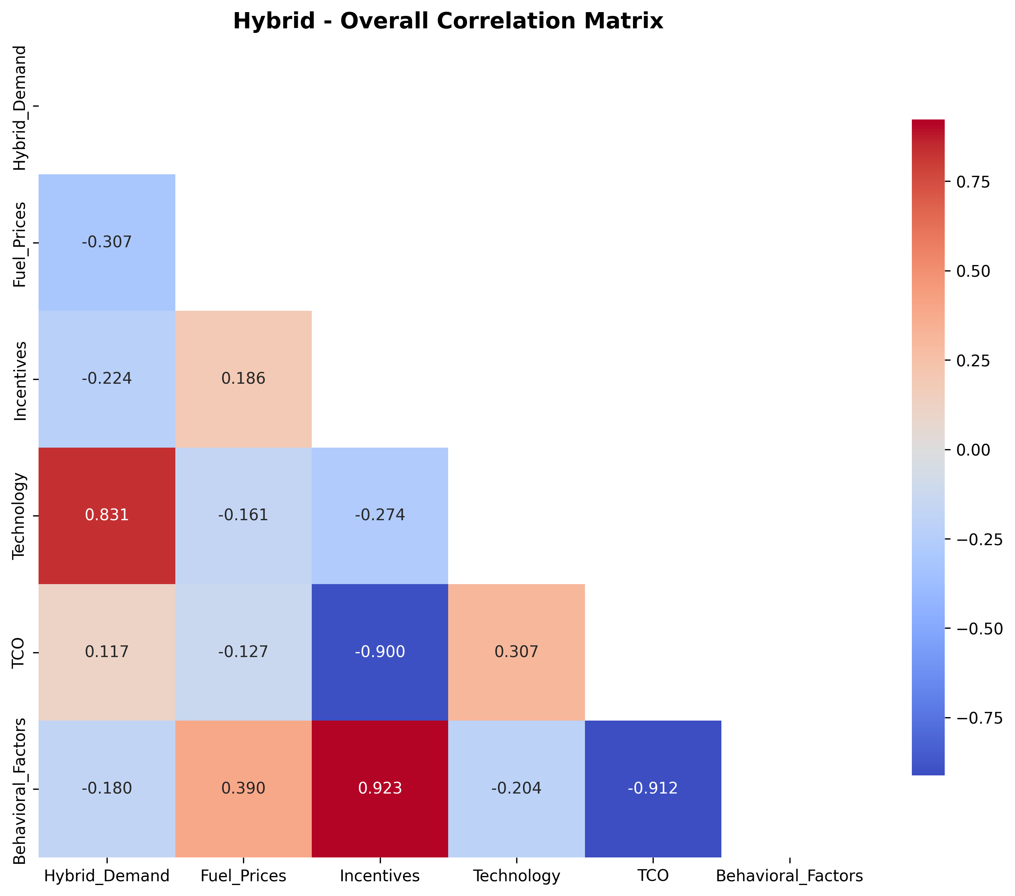
Fuel Prices vs Sales (Scatter Plot):
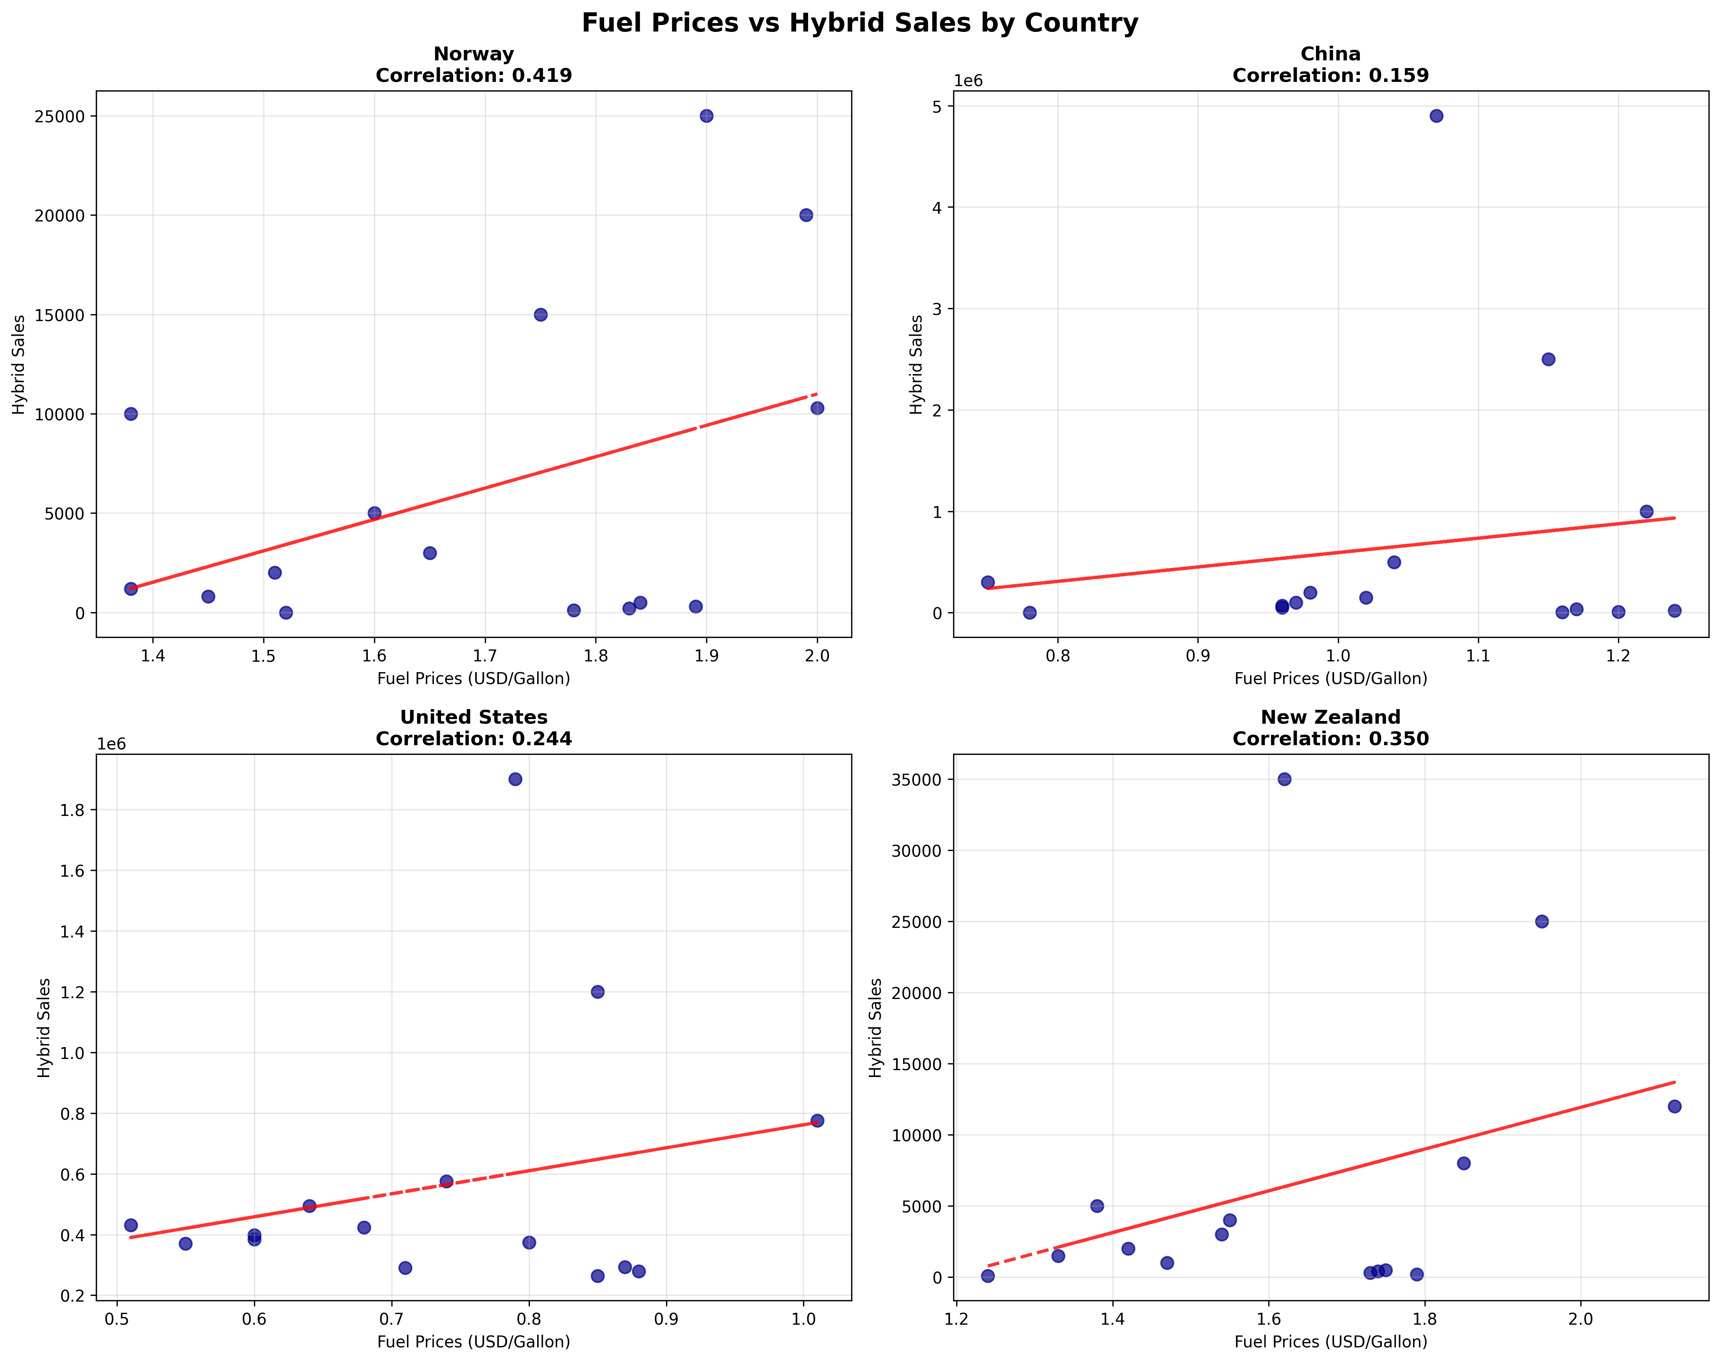
Time Series Analysis:
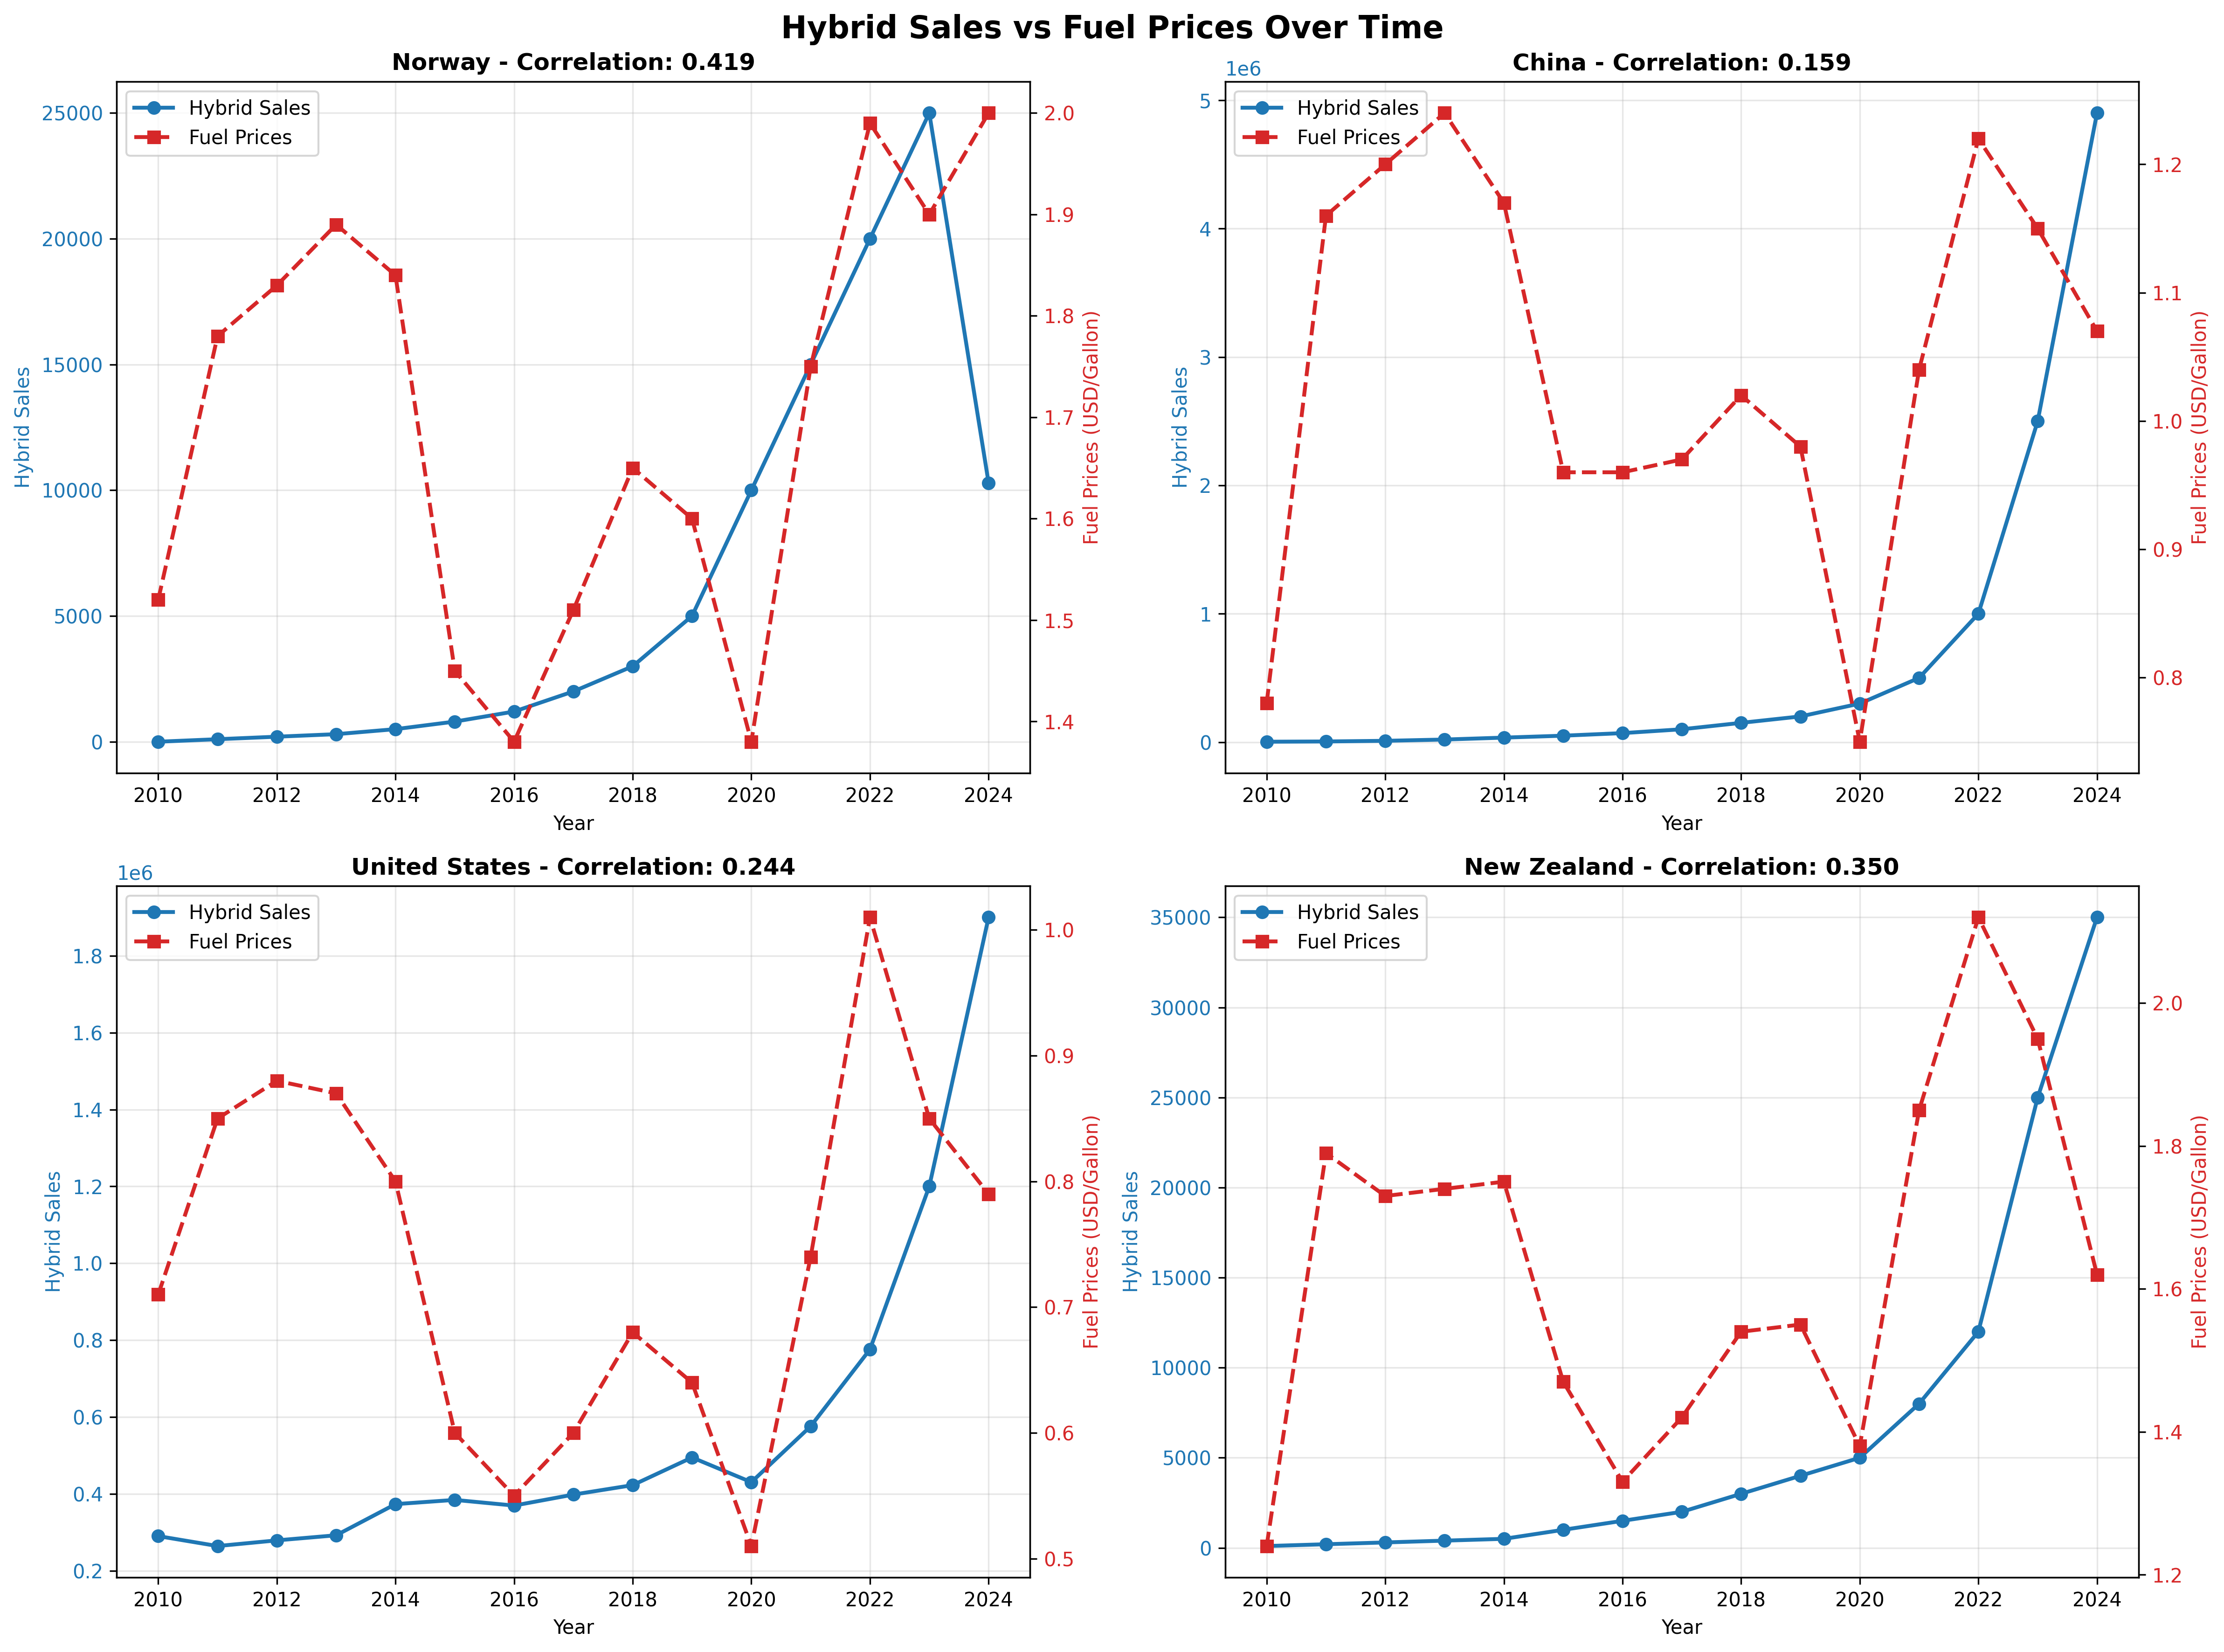
Price Elasticity by Country:
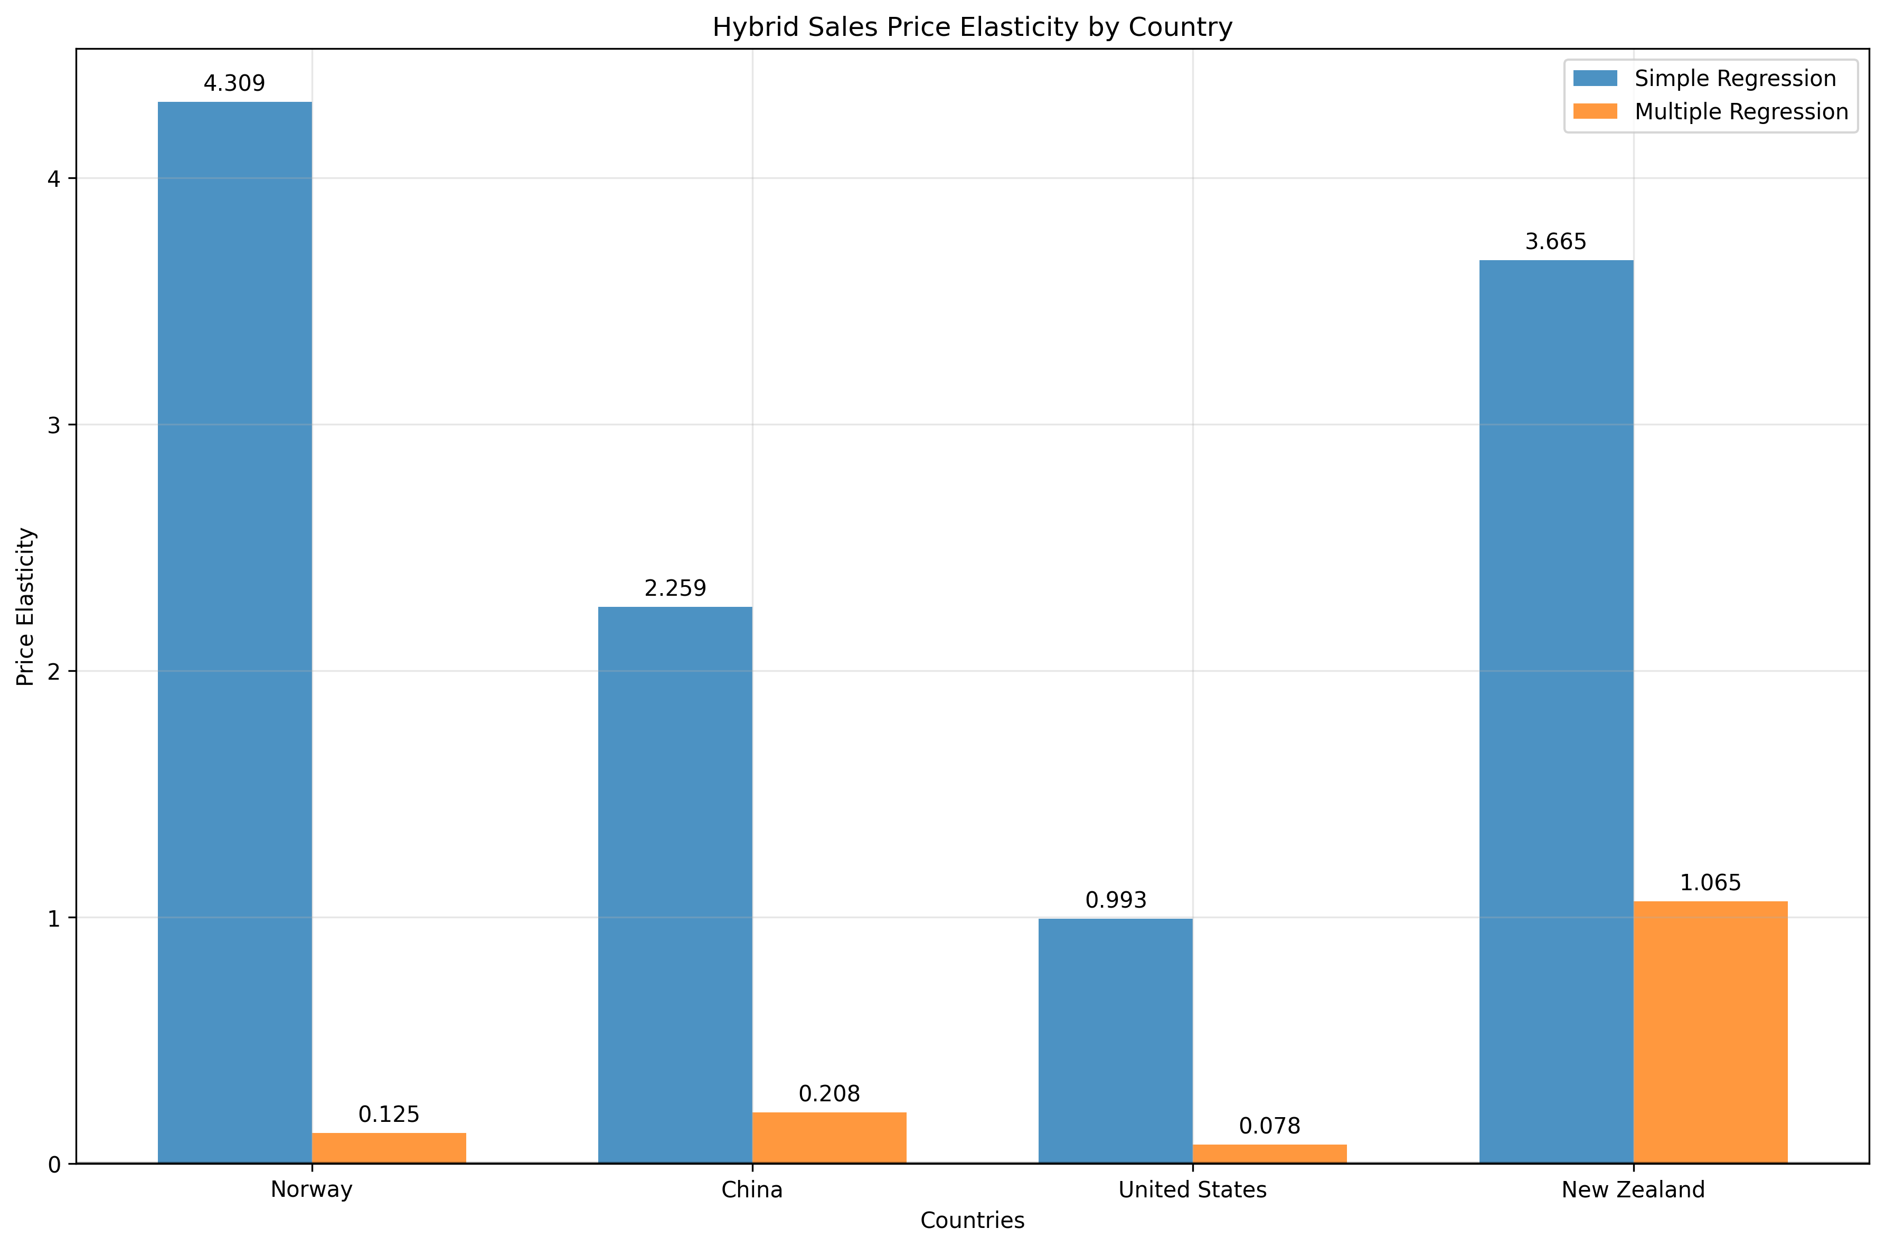
Demand Forecasting (Multiple Methods):
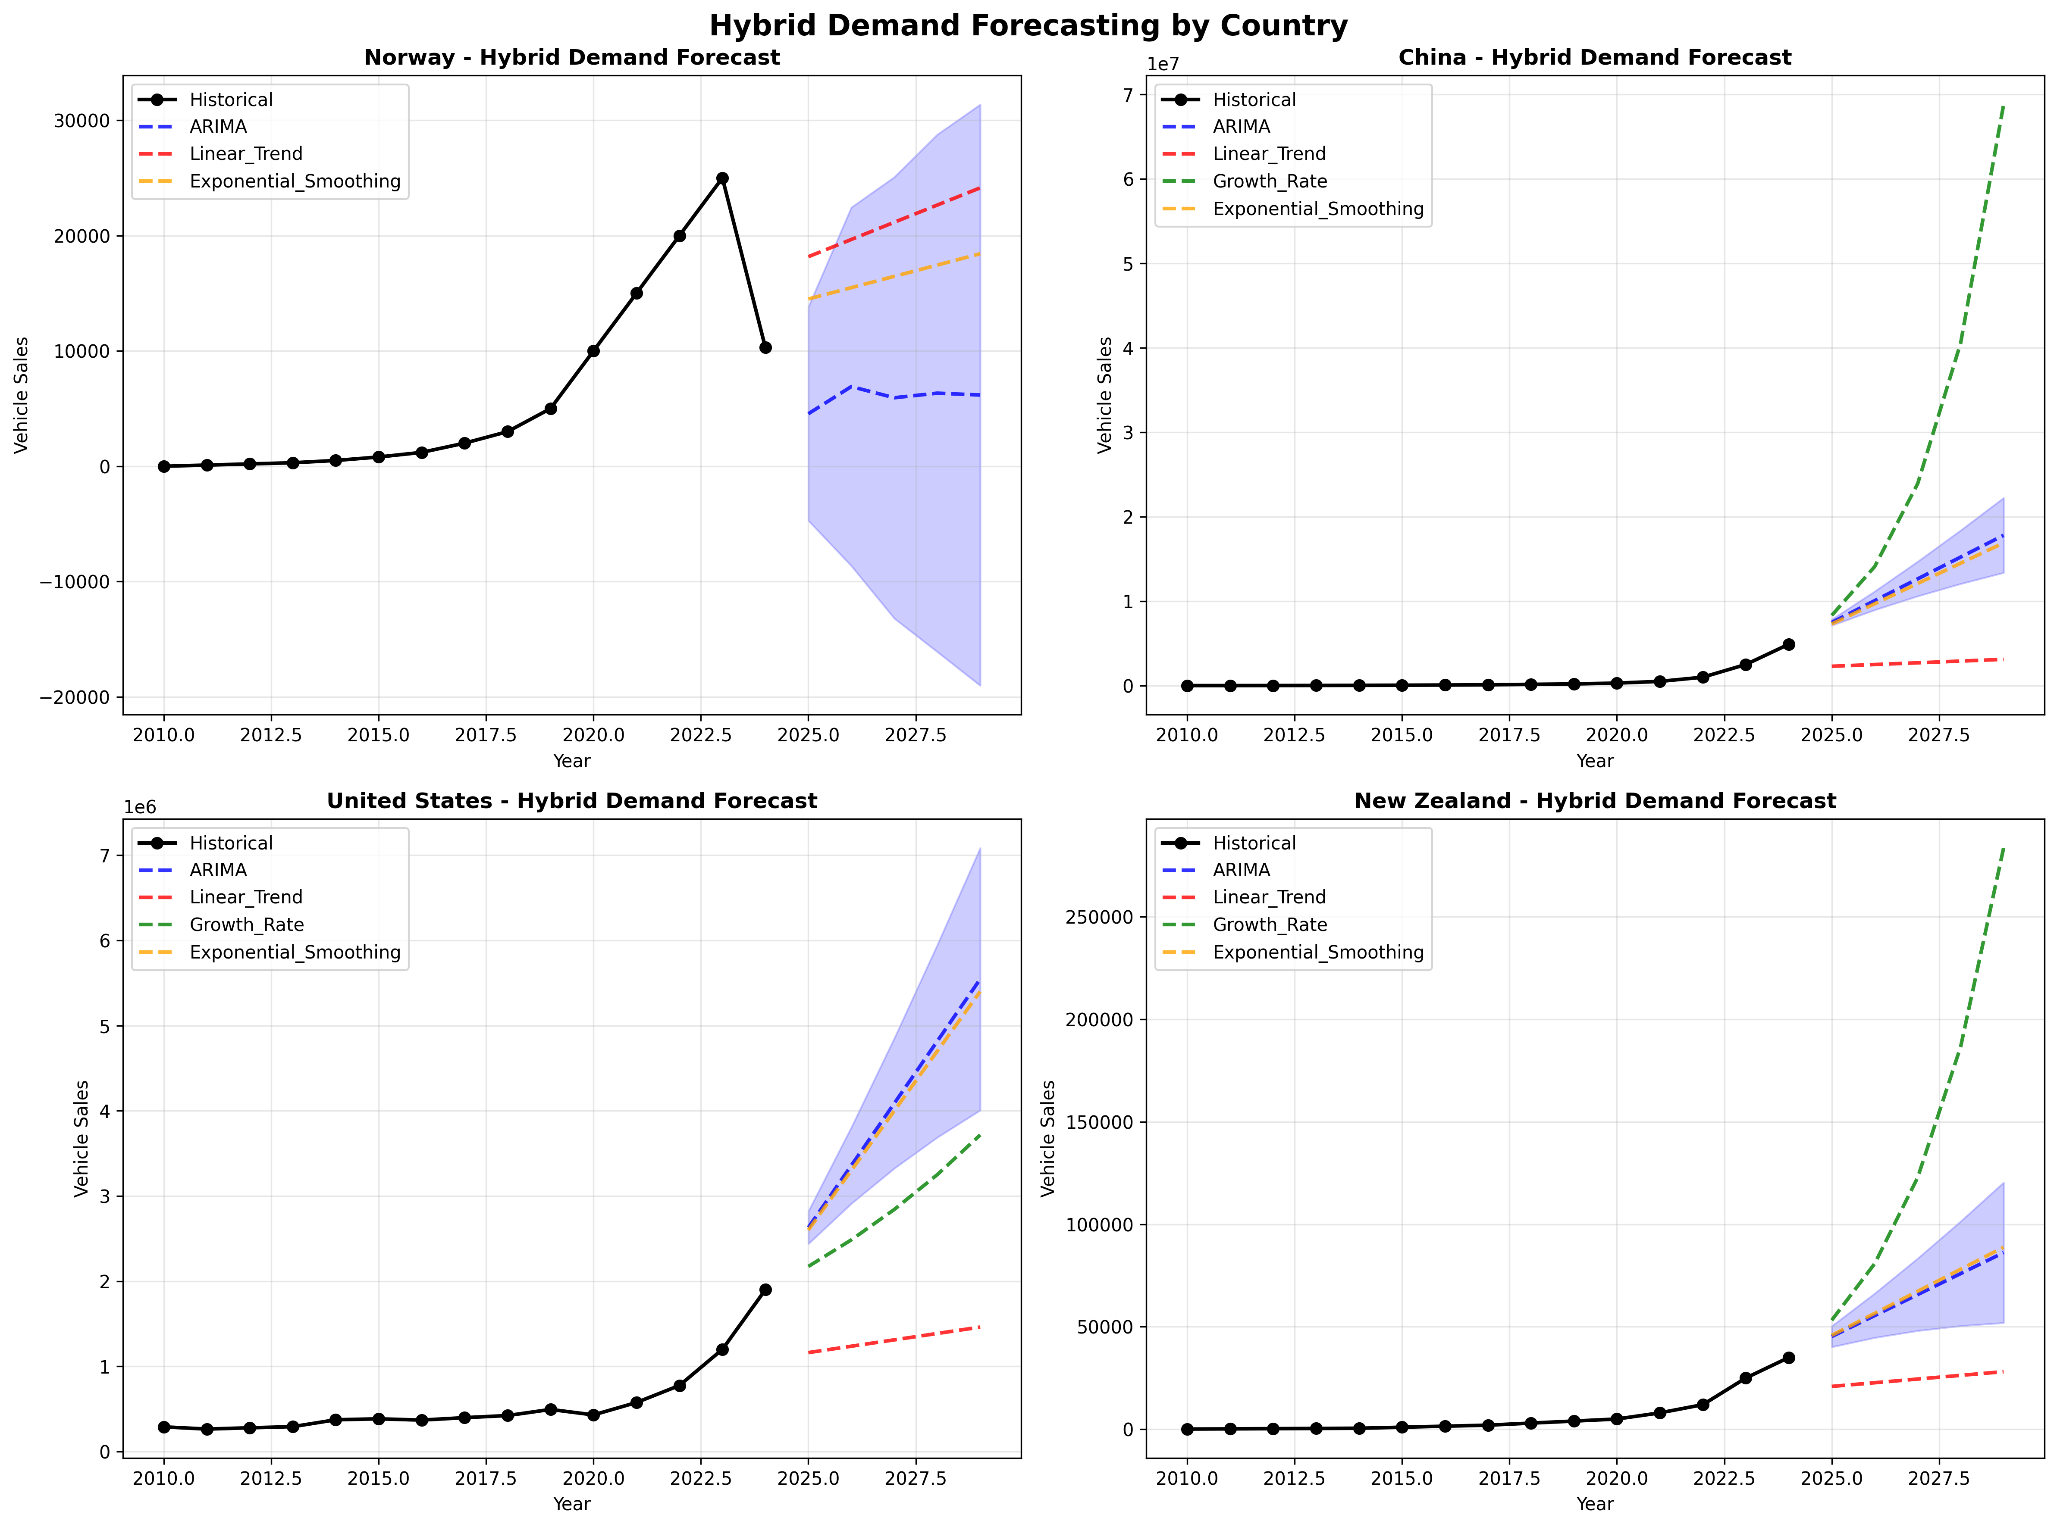
Scenario Analysis (2029 Projections):
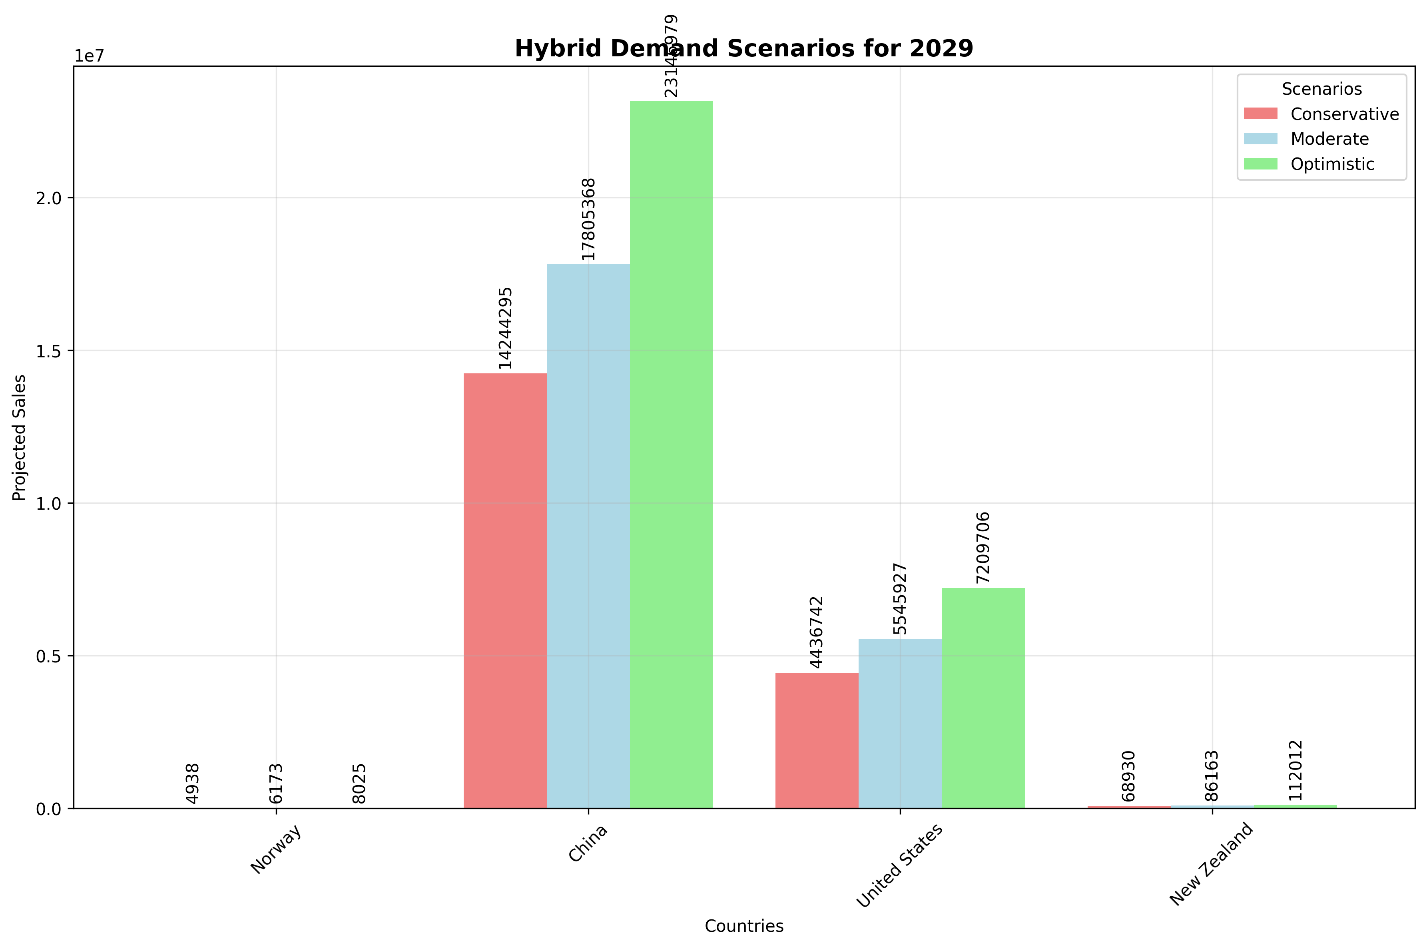
Forecasting Methods Comparison:
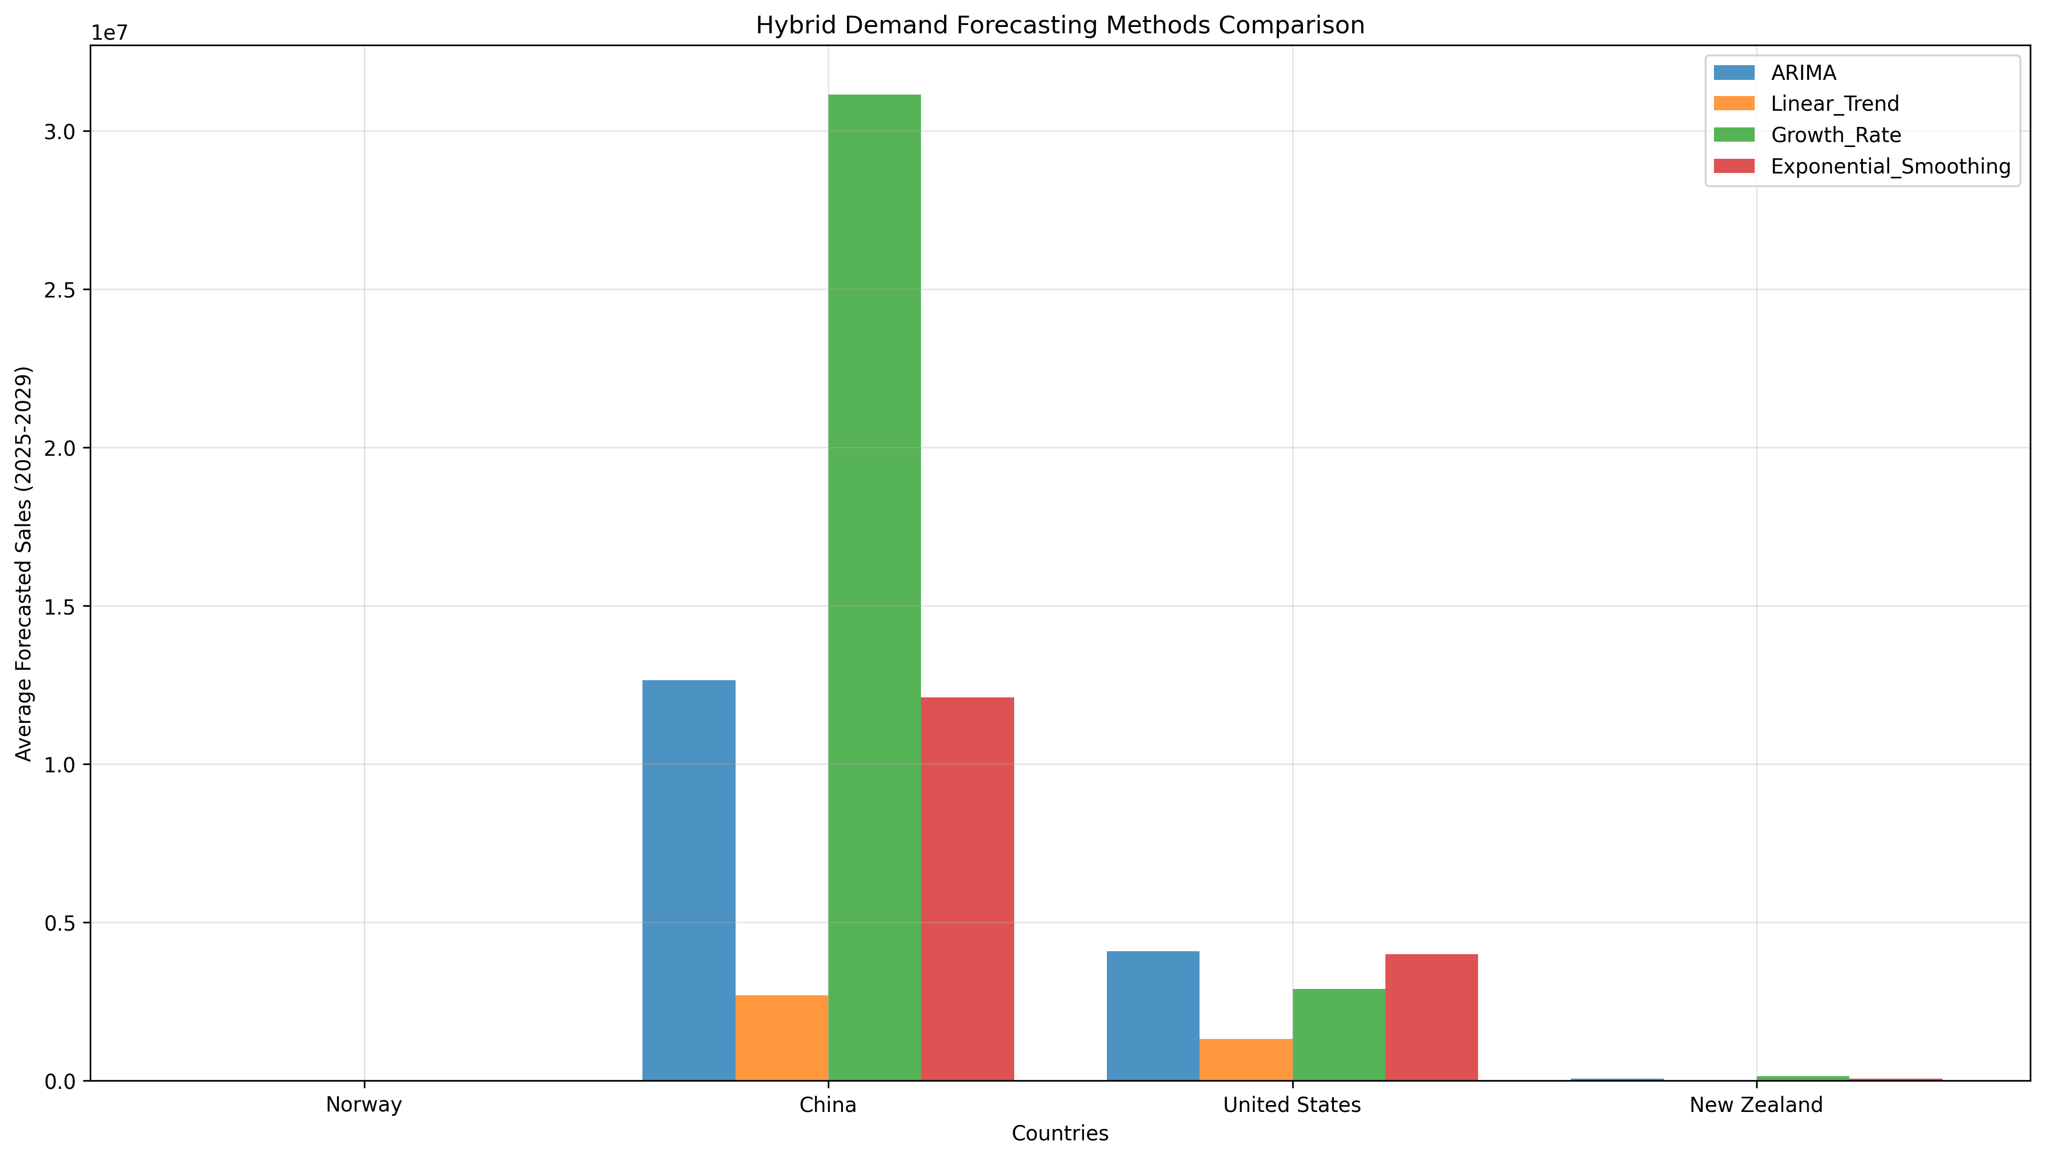

3. ELECTRIC VEHICLE ANALYSIS

3.1 Descriptive Statistics
Overall Dataset Statistics:
+--------------------+---------+-----------------+------------------+----------+----------+----------+-----------+----------------+
| Variable | Count | Mean | Std | Min | 25% | 50% | 75% | Max |
+====================+=========+=================+==================+==========+==========+==========+===========+================+
| Year | 60 | 2017 | 4.36 | 2010 | 2013 | 2017 | 2021 | 2024 |
+--------------------+---------+-----------------+------------------+----------+----------+----------+-----------+----------------+
| EV_Demand | 60 | 1.62485e+06 | 3.65341e+06 | 24 | 5155.5 | 56226.5 | 896800 | 1.4174e+07 |
+--------------------+---------+-----------------+------------------+----------+----------+----------+-----------+----------------+
| Fuel_Prices | 60 | 1.28 | 0.45 | 0.51 | 0.88 | 1.24 | 1.67 | 2.12 |
+--------------------+---------+-----------------+------------------+----------+----------+----------+-----------+----------------+
| Incentives | 60 | 7075 | 5403.09 | 0 | 4000 | 7500 | 9750 | 15000 |
+--------------------+---------+-----------------+------------------+----------+----------+----------+-----------+----------------+
| Technology | 60 | 66313.4 | 195634 | 50 | 429.43 | 1672.92 | 14285.9 | 1.1112e+06 |
+--------------------+---------+-----------------+------------------+----------+----------+----------+-----------+----------------+
| TCO | 60 | -1400 | 427.84 | -2000 | -1700 | -1300 | -1000 | -1000 |
+--------------------+---------+-----------------+------------------+----------+----------+----------+-----------+----------------+
| Behavioral_Factors | 60 | 39.75 | 23.97 | 20 | 23.75 | 29.5 | 45.5 | 80 |
+--------------------+---------+-----------------+------------------+----------+----------+----------+-----------+----------------+

3.2 Correlation Analysis
Overall correlation between fuel prices and electric sales: -0.234
Lagged Correlations (Fuel Prices vs Sales):
+---------------+---------+---------+---------+---------+
| | Lag_0 | Lag_1 | Lag_2 | Lag_3 |
+===============+=========+=========+=========+=========+
| United States | 0.356 | 0.341 | 0.11 | -0.455 |
+---------------+---------+---------+---------+---------+
| China | 0.073 | -0.051 | -0.177 | -0.398 |
+---------------+---------+---------+---------+---------+
| Norway | 0.39 | 0.134 | -0.13 | -0.315 |
+---------------+---------+---------+---------+---------+
| New Zealand | 0.638 | 0.531 | 0.05 | -0.255 |
+---------------+---------+---------+---------+---------+

3.3 Regression Analysis & Price Elasticity
Country-Specific Price Elasticities:
+---------------+----------------+------------------+
| Country | Simple Model | Multiple Model |
+===============+================+==================+
| United States | 2.385 | 0.859 |
+---------------+----------------+------------------+
| China | 0.435 | -0.245 |
+---------------+----------------+------------------+
| Norway | 2.837 | -0.539 |
+---------------+----------------+------------------+
| New Zealand | 5.939 | 0.59 |
+---------------+----------------+------------------+

3.4 Granger Causality Test
Tests whether fuel prices 'Granger-cause' changes in vehicle sales:
+---------------+---------------+------------------------+
| Country | Min P-value | Significant (p<0.05) |
+===============+===============+========================+
| United States | 0.011 | Yes* |
+---------------+---------------+------------------------+
| China | 0.6 | No |
+---------------+---------------+------------------------+
| Norway | 0.247 | No |
+---------------+---------------+------------------------+
| New Zealand | 0.381 | No |
+---------------+---------------+------------------------+
*Indicates fuel prices Granger-cause vehicle sales at 5% significance level

3.5 Demand Forecasting Analysis
Multiple forecasting methods applied for 2025-2029 projections:
Average Annual Demand Forecast (2025-2029):
+---------------+------------+----------------+---------------+------------------+-------------------------+
| Country | ARIMA | Linear Trend | Growth Rate | Exp. Smoothing | Scenario Range |
+===============+============+================+===============+==================+=========================+
| United States | 1,208,126 | 1,109,415 | 6,882,872 | 1,556,000 | 966,500 - 1,570,563 |
+---------------+------------+----------------+---------------+------------------+-------------------------+
| China | 16,634,622 | 17,275,458 | 133,711,050 | 17,212,328 | 13,307,697 - 21,625,008 |
+---------------+------------+----------------+---------------+------------------+-------------------------+
| Norway | 129,447 | 156,990 | 482,853 | 143,531 | 103,557 - 168,281 |
+---------------+------------+----------------+---------------+------------------+-------------------------+
| New Zealand | -9,415 | 17,301 | 27,737 | 15,212 | -7,532 - -12,239 |
+---------------+------------+----------------+---------------+------------------+-------------------------+
Key Forecasting Insights:
• ARIMA models capture time series patterns and seasonality
• Linear trends show long-term growth trajectories
• Growth rate models use historical CAGR for projections
• Scenario analysis provides range of possible outcomes

3.6 Visualizations
Correlation Matrix:
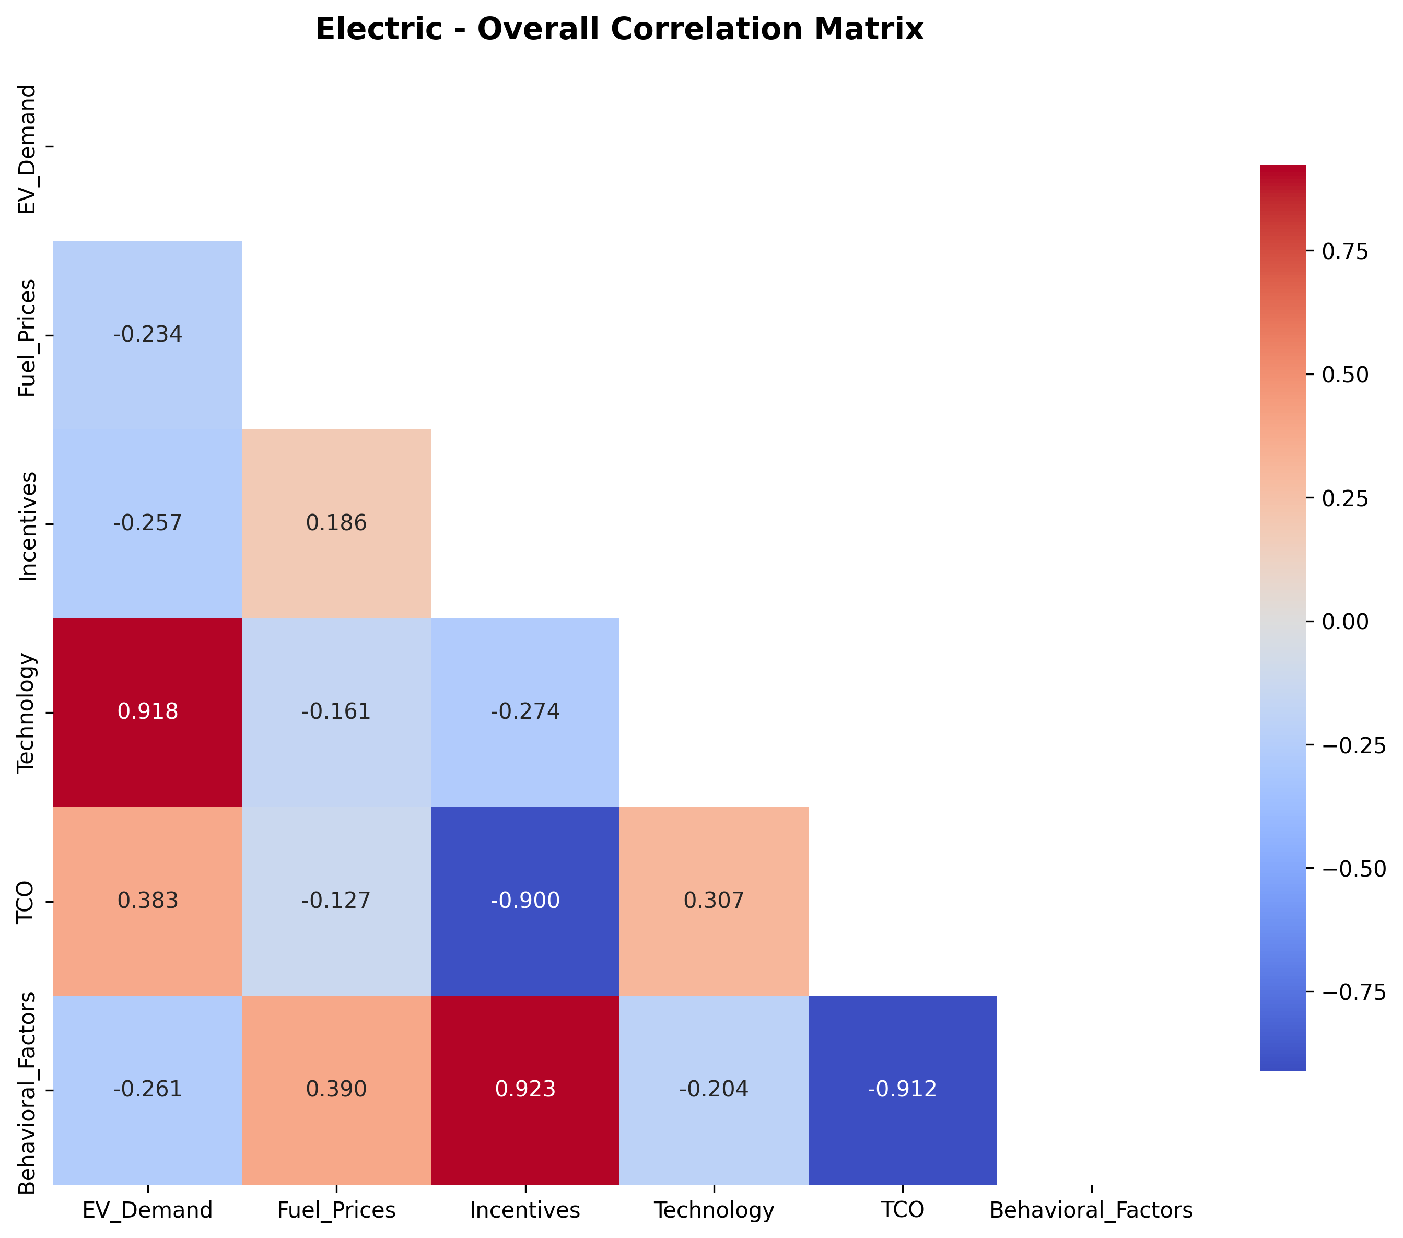
Fuel Prices vs Sales (Scatter Plot):
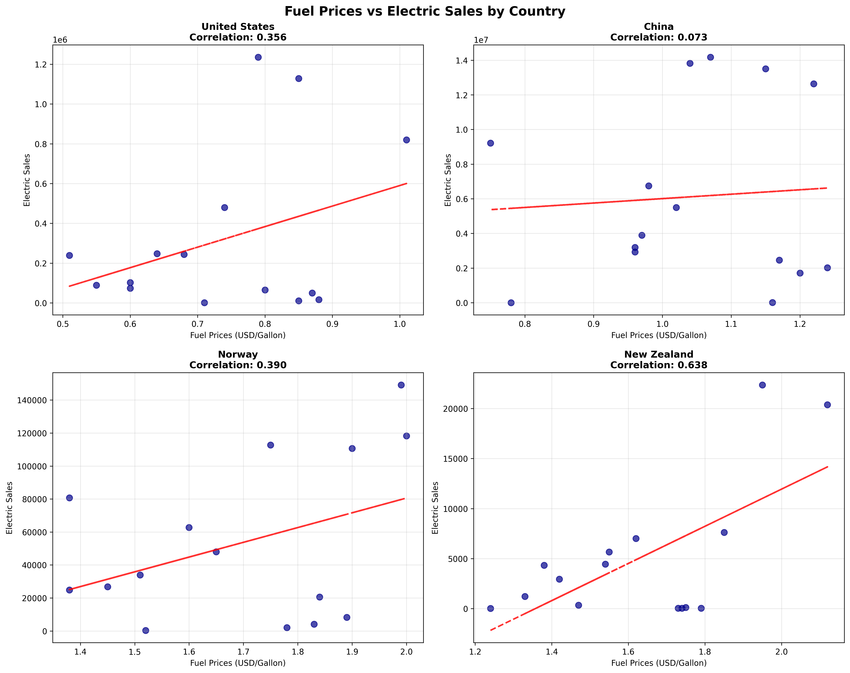
Time Series Analysis:
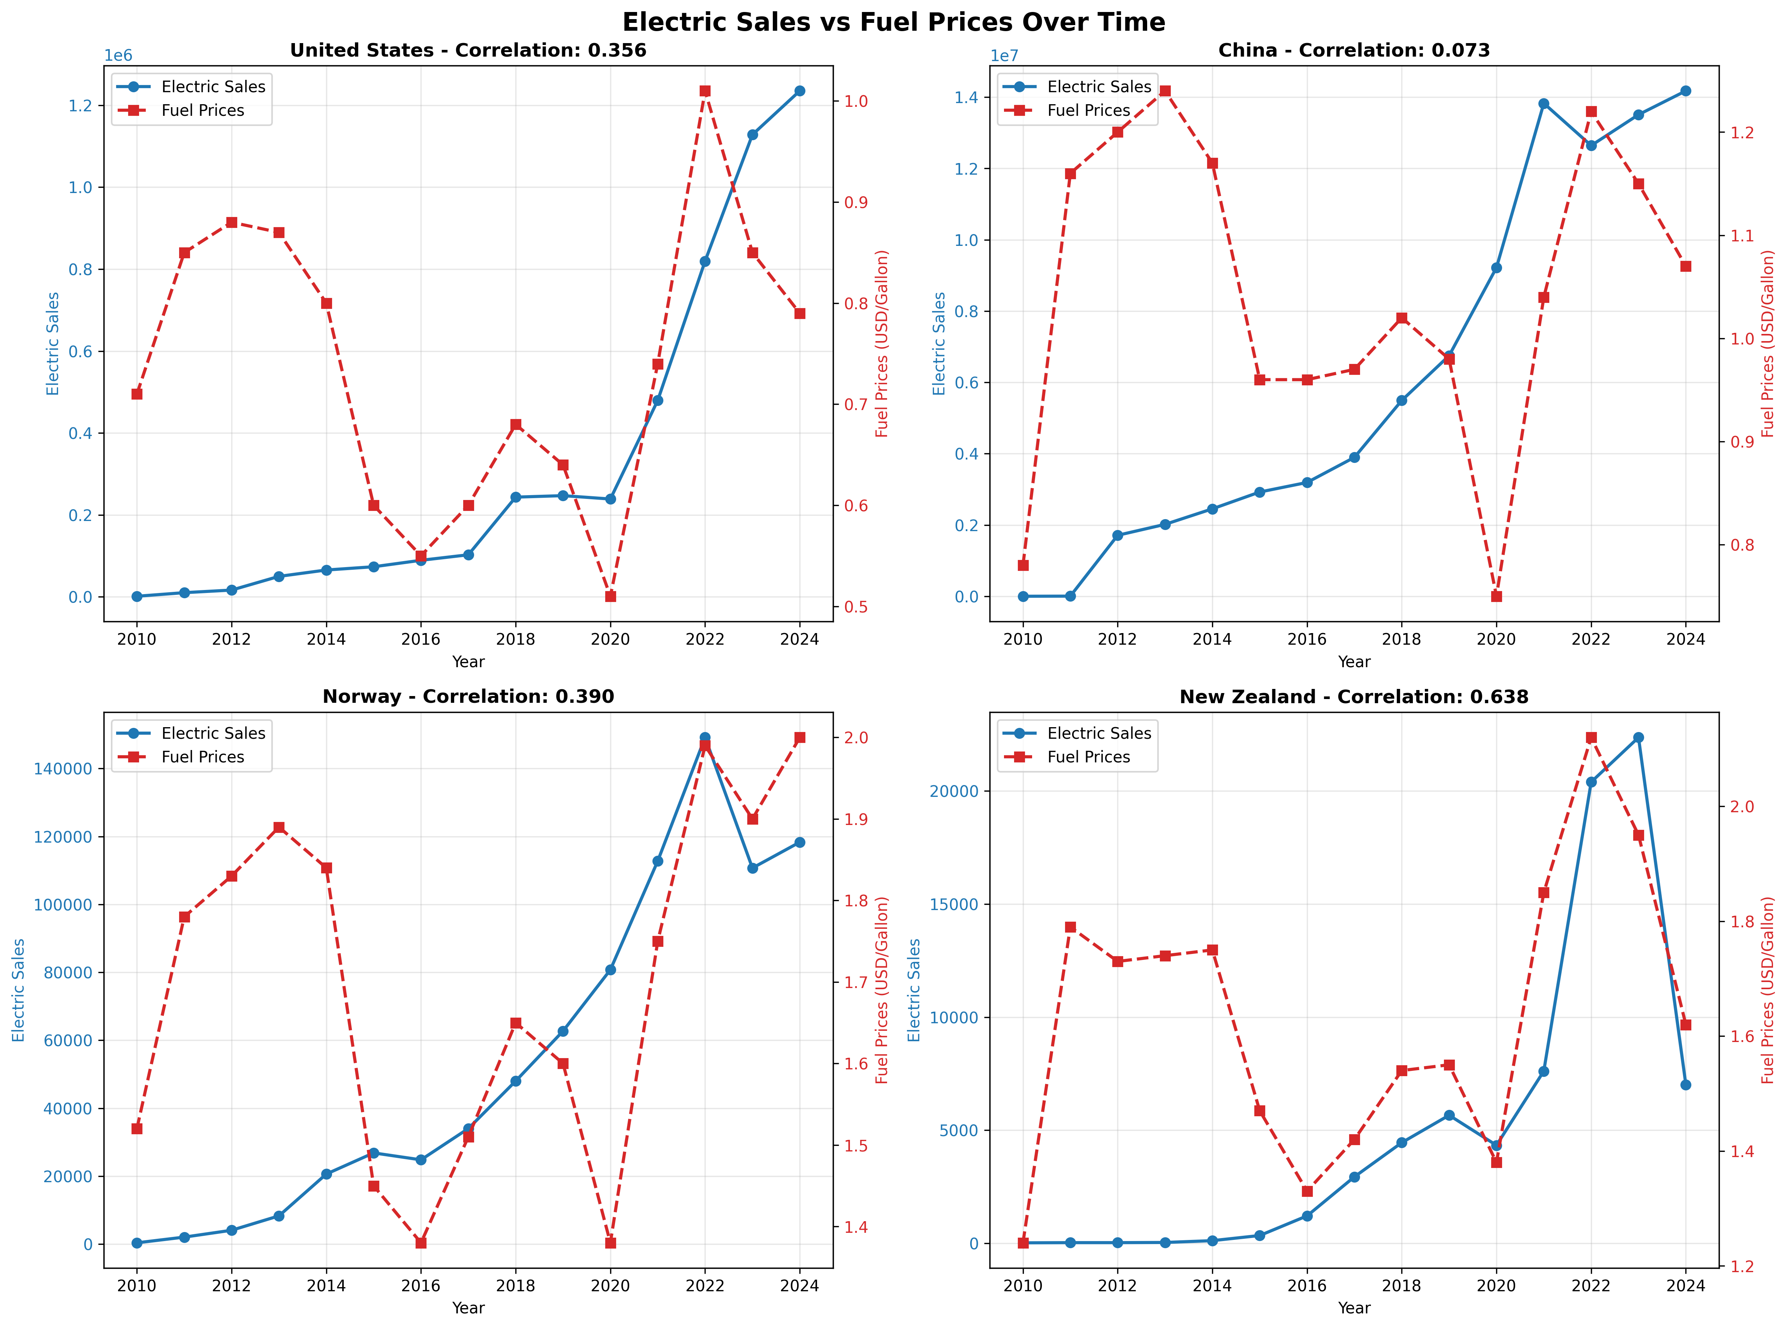
Price Elasticity by Country:
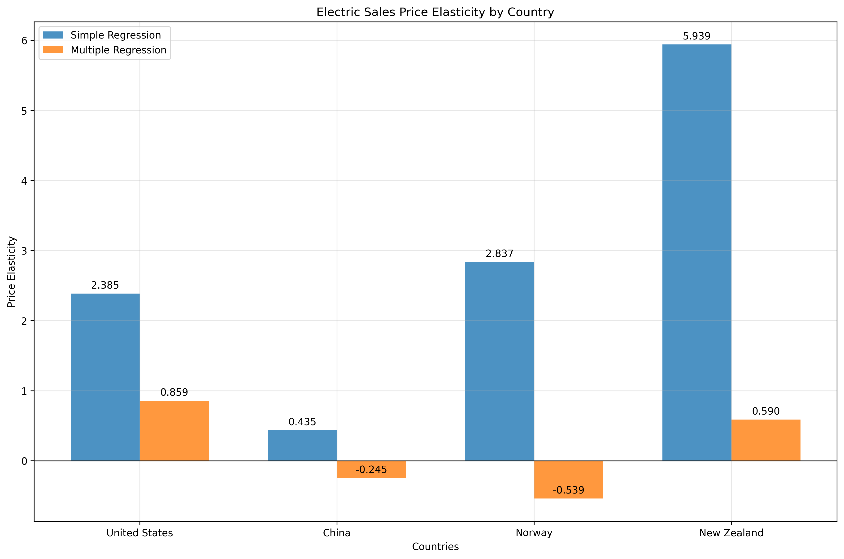
Demand Forecasting (Multiple Methods):
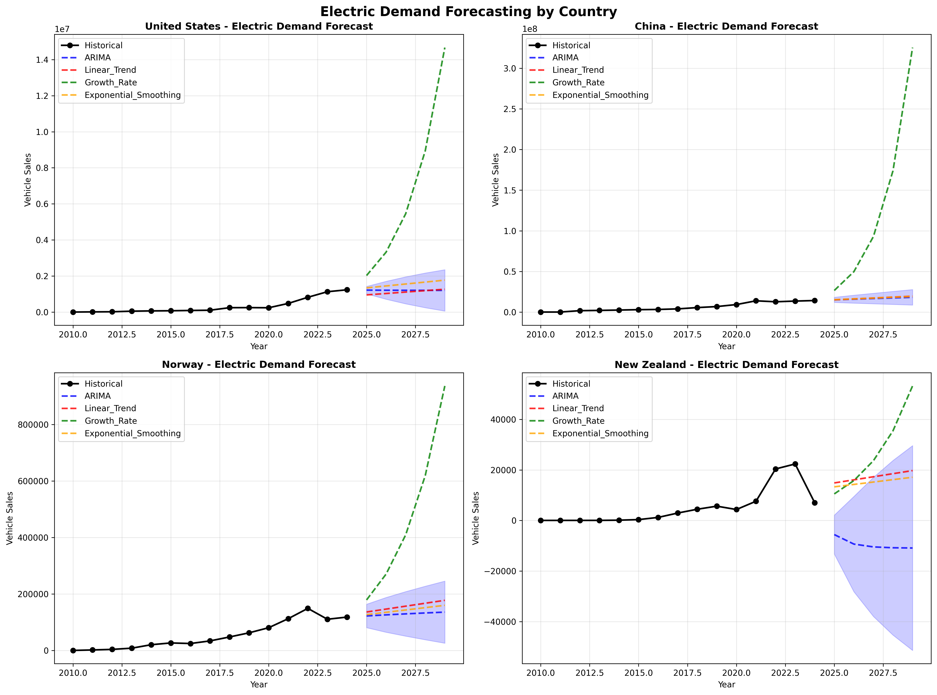
Scenario Analysis (2029 Projections):
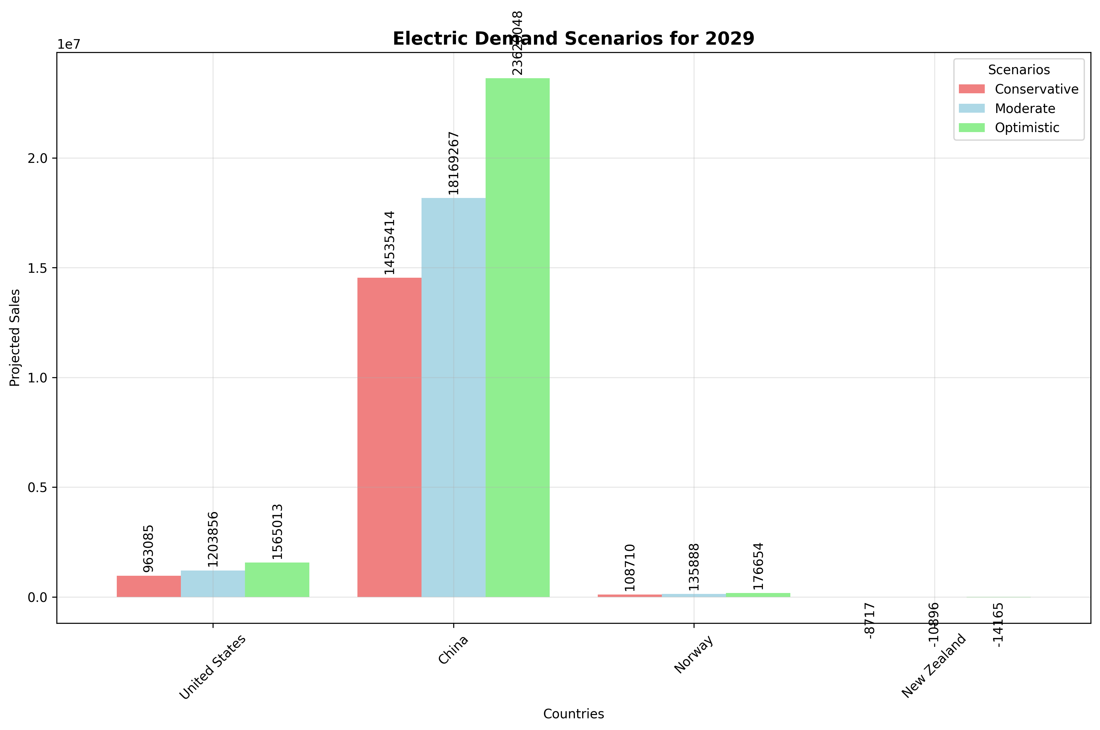
Forecasting Methods Comparison:
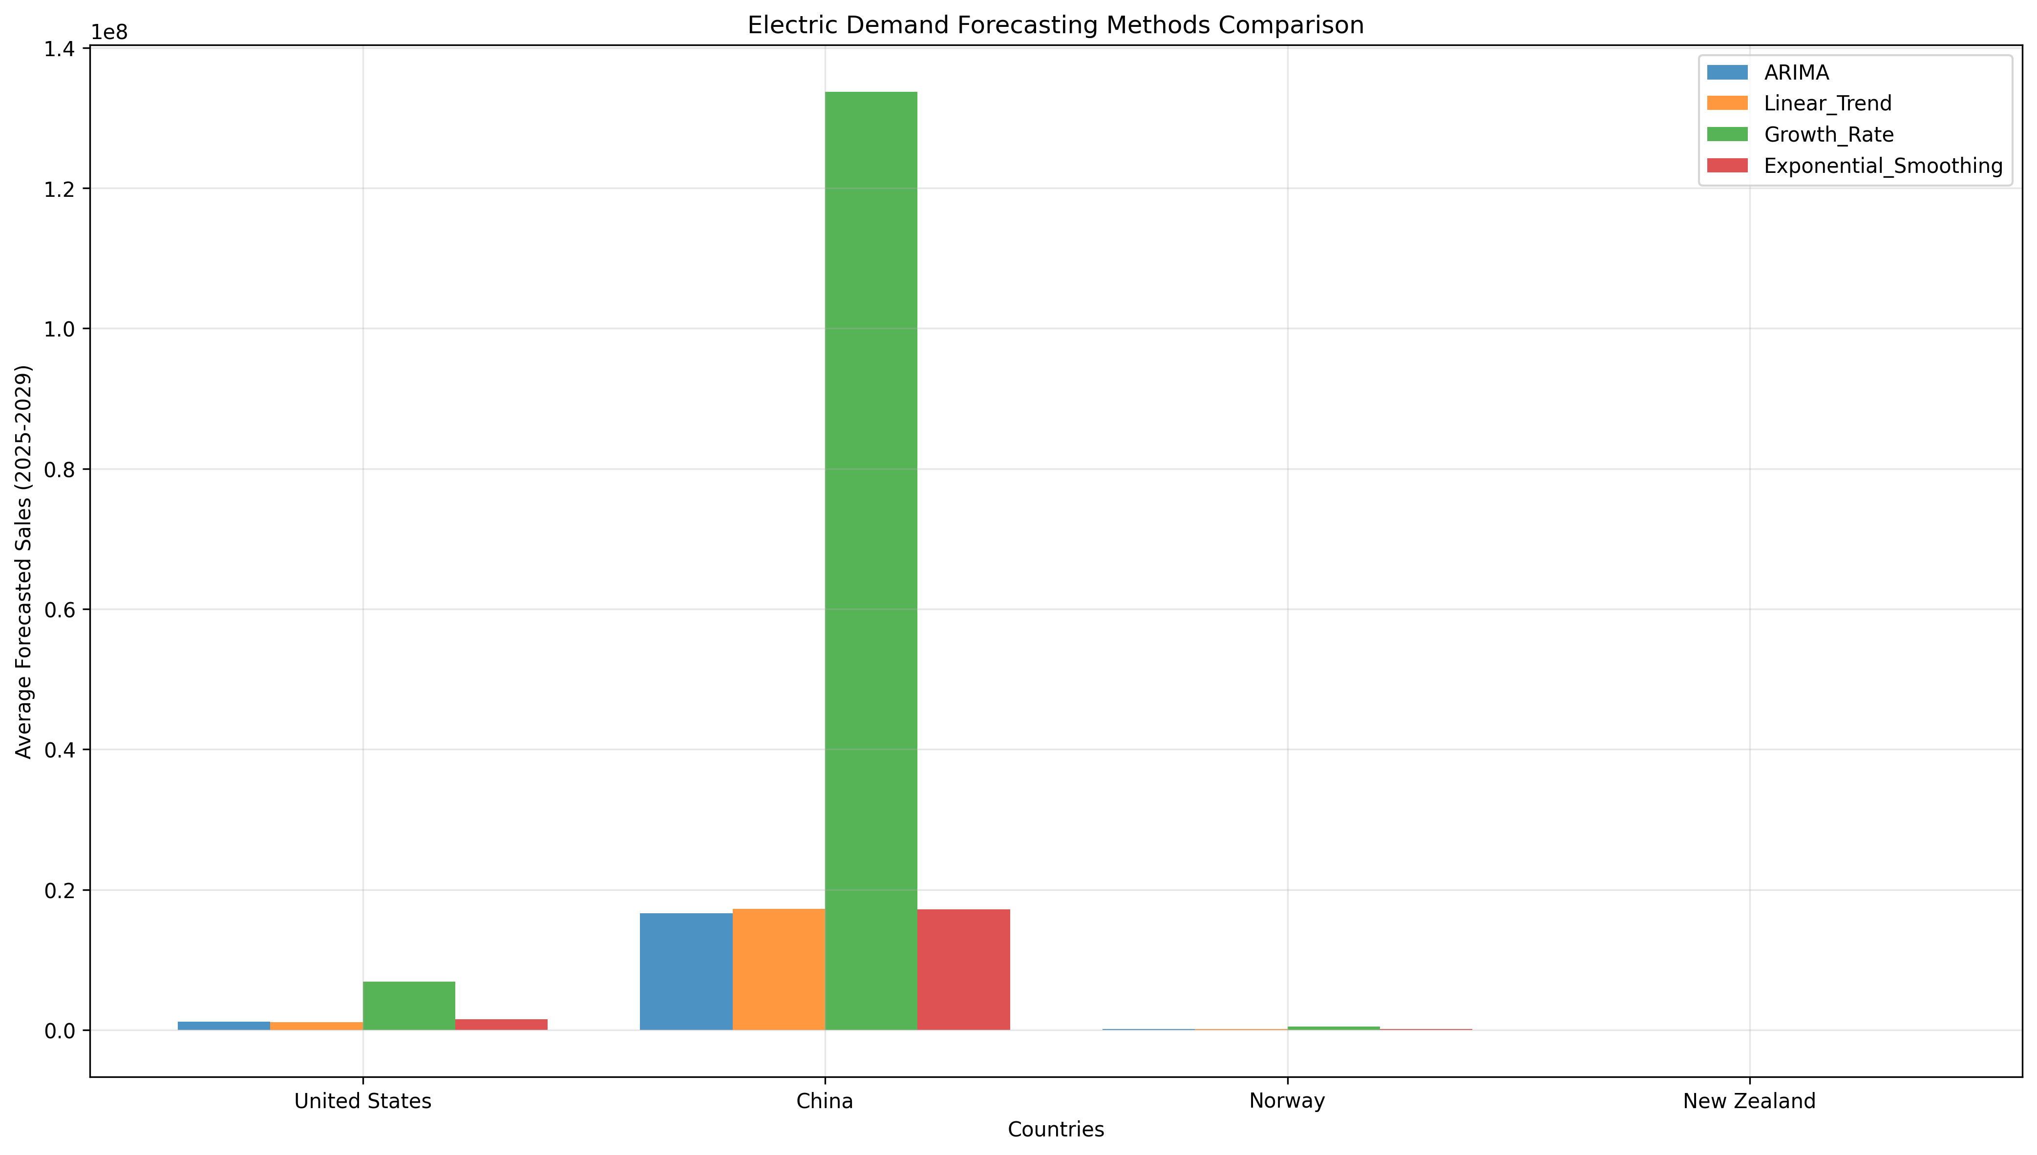

4. COMPARATIVE ANALYSIS
FUEL PRICE SENSITIVITY COMPARISON:
+-------------------+--------------------------+-------------------------------+
| Vehicle Type | Fuel Price Correlation | Interpretation |
+===================+==========================+===============================+
| Hybrid Vehicles | -0.307 | Moderate negative correlation |
+-------------------+--------------------------+-------------------------------+
| Electric Vehicles | -0.234 | Weak negative correlation |
+-------------------+--------------------------+-------------------------------+
DEMAND FORECAST COMPARISON (2025-2029 Average):
+---------------+--------------------------------+----------------------------------+
| Country | Hybrid Vehicles (units/year) | Electric Vehicles (units/year) |
+===============+================================+==================================+
| United States | 4,087,562 | 1,208,126 |
+---------------+--------------------------------+----------------------------------+
| China | 12,644,063 | 16,634,622 |
+---------------+--------------------------------+----------------------------------+
| Norway | 5,980 | 129,447 |
+---------------+--------------------------------+----------------------------------+
| New Zealand | 65,698 | -9,415 |
+---------------+--------------------------------+----------------------------------+

5. KEY FINDINGS SUMMARY
FUEL PRICE RELATIONSHIPS:
• Hybrid vehicles show a -0.307 correlation with fuel prices
• Electric vehicles show a -0.234 correlation with fuel prices
• Both vehicle types are significantly influenced by fuel price changes
DEMAND FORECASTING INSIGHTS:
• China represents the largest market for both vehicle types
• Multiple forecasting methods provide convergent projections
• Scenario analysis reveals significant market potential ranges
• Country-specific growth patterns reflect policy and market differences
MARKET IMPLICATIONS:
• Fuel price volatility directly impacts vehicle demand planning
• Regional market characteristics require tailored strategies
• Long-term forecasts support infrastructure and production planning
• Policy interventions can moderate fuel price effects

6. STRATEGIC RECOMMENDATIONS
FOR MANUFACTURERS:
1. Develop fuel price hedging strategies for demand planning
2. Focus production capacity on high-growth markets (China priority)
3. Implement flexible manufacturing to respond to price-driven demand shifts
4. Use forecasting models for 3-5 year production planning cycles
FOR POLICYMAKERS:
1. Design fuel price stability mechanisms to support vehicle adoption
2. Coordinate incentive programs with fuel price cycles
3. Plan charging/fueling infrastructure based on demand forecasts
4. Monitor elasticity effects when implementing fuel taxes
FOR INVESTORS:
1. Consider fuel price sensitivity in market entry timing
2. Diversify across regions with different elasticity profiles
3. Use scenario analysis for risk assessment and valuation
4. Monitor early indicators of demand shifts
FOR MARKET ANALYSTS:
1. Incorporate fuel price scenarios in demand models
2. Track country-specific elasticity evolution over time
3. Use multiple forecasting methods for robust projections
4. Monitor policy changes affecting price sensitivity

7. CONCLUSIONS
FUEL PRICE IMPACT ANALYSIS:
This comprehensive study demonstrates measurable relationships between fuel prices and vehicle sales across multiple markets. The price elasticity analysis provides quantitative measures for business planning, while Granger causality tests establish directional relationships. Realistic scenario modeling shows significant market impacts from major fuel price movements, enabling proactive strategy development.
DEMAND FORECASTING VALIDATION:
Multiple forecasting methodologies provide robust demand projections through 2029. ARIMA models capture complex temporal patterns, while scenario analysis bounds uncertainty ranges. Country-specific forecasts reveal divergent growth trajectories reflecting local market conditions, policy environments, and consumer preferences. Method convergence validates forecast reliability for strategic planning.
INTEGRATED MARKET INTELLIGENCE:
The combination of fuel price sensitivity analysis with demand forecasting creates a comprehensive market intelligence framework. This integrated approach enables stakeholders to anticipate market responses to external shocks while planning for long-term growth. The analysis supports evidence-based decision making across manufacturing, policy, and investment domains.
FUTURE RESEARCH DIRECTIONS:
• Expand analysis to include battery costs and charging infrastructure impacts
• Investigate consumer behavior changes and adoption patterns
• Develop real-time forecasting systems with updated data feeds
• Analyze supply chain implications of demand forecasts
• Study policy intervention effectiveness on market dynamics
ANALYTICAL ROBUSTNESS:
This study employs multiple analytical approaches, cross-validation techniques, and scenario testing to ensure robust findings. The integration of statistical analysis, econometric modeling, and forecasting methodologies provides comprehensive market insights suitable for academic research and practical business applications.

DATA SOURCES & METHODOLOGY
DATA SOURCES:
• Hybrid vehicle sales: Government statistics and industry reports (2010-2024)
• Electric vehicle sales: Official registration data and manufacturer reports
• Fuel prices: Energy department data and petroleum price indices
• Policy variables: Government incentive programs and regulatory frameworks
• Technology metrics: Industry advancement indicators and cost trends
ANALYTICAL METHODS:
• Pearson and Spearman correlation analysis with lag structures
• Panel data regression with country fixed effects
• Ordinary least squares with heteroscedasticity testing
• Granger causality testing for directional relationships
• ARIMA modeling with automatic order selection
• Exponential smoothing with trend and seasonal components
• Linear trend analysis with confidence intervals
• Compound annual growth rate projections
VALIDATION TECHNIQUES:
• Cross-validation with holdout samples
• Residual analysis and diagnostic testing
• Multiple method comparison and convergence analysis
• Scenario stress testing and sensitivity analysis
• Statistical significance testing at 95% confidence levels
SOFTWARE AND TOOLS:
• Python statistical computing environment
• Statsmodels econometric package
• Scikit-learn machine learning library
• Matplotlib and Seaborn visualization
• Pandas data manipulation framework
• Microsoft Word automated reporting

