Database Diagram:

This diagram explains our entire database schema, with their attributes, attribute types, and keys as well

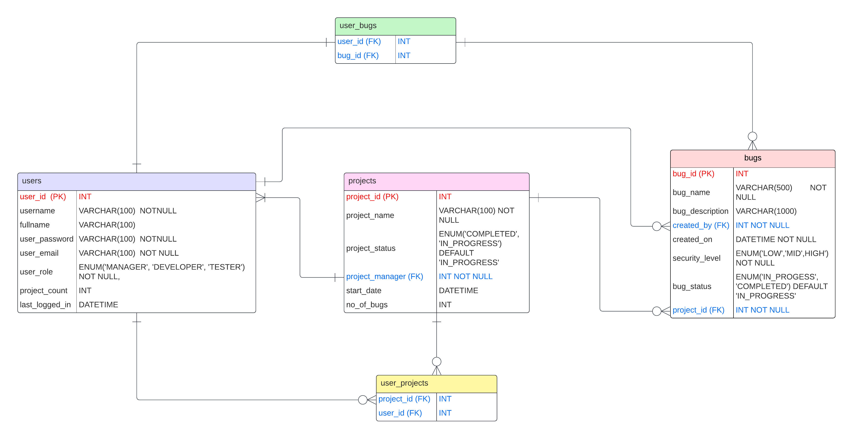

Entity-Relationship Diagram:

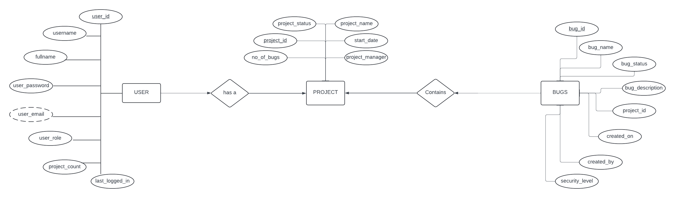

Data Flow Diagram:  
