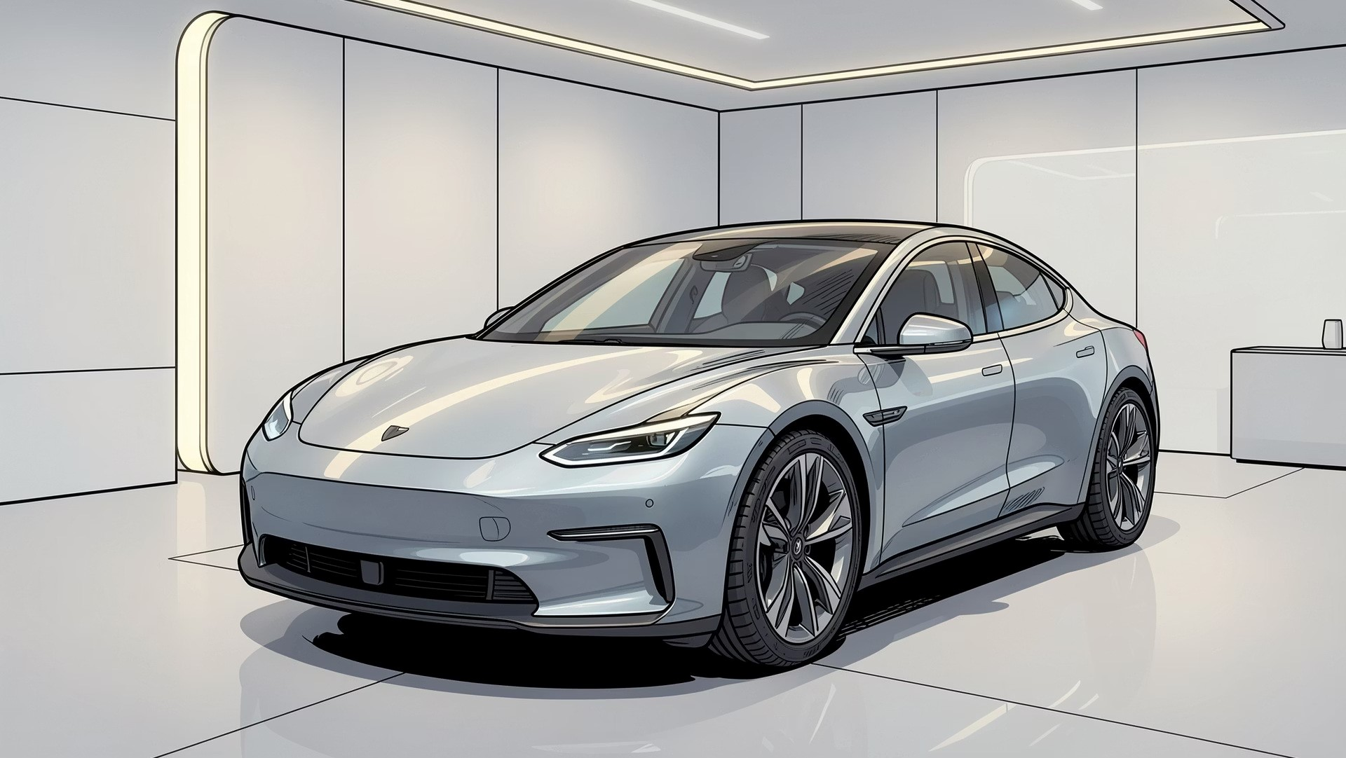
Understanding Automobile Systems
An In-Depth Guide to the Future of
Mobility
Welcome to the comprehensive exploration of automotive technology. From traditional combustion engines to revolutionary
electric powertrains, understand the systems driving India and the world forward.

CORE SYSTEMS
Introduction to Automobile Systems
An automobile is a complex integration of multiple sub-systems working in perfect harmony to deliver safety, control,
comfort, and propulsion.
Propulsion
Generates power using thermal or
electrical energy to move the vehicle.
Control & Steering
Manages direction, stability, and
braking to ensure occupant safety.
Chassis & Suspension
Provides structural integrity and
absorbs road shocks for a smooth ride.
Internal Combustion Engine (ICE) Working
For over a century, the Internal Combustion Engine (ICE) has been the heart of global transport. It relies on the controlled

combustion of fossil fuels to generate mechanical energy.
01
Intake
The piston moves downward, drawing a mixture of fresh air

and fuel into the cylinder chamber.
02
Compression
Valves close, and the piston rises to compress the air-fuel

mixture, raising its temperature.
03
Power
A spark plug ignites the compressed mixture, causing an

explosion that forces the piston down violently.
04
Exhaust
The exhaust valve opens, and the piston sweeps upward to

push out the burnt gases.
Electric Vehicle (EV) Architecture
EVs simplify the traditional powertrain by replacing hundreds of moving parts with a highly efficient, quiet, and reliable

electrical drivetrain system.
Traction Battery Pack
Stores electrical energy in Lithium-
ion cells to power the vehicle.
Power Inverter
Converts stored DC power from the

battery into AC power for the motor.
Electric Motor
Converts electrical energy into

instant mechanical torque to turn

the wheels.
ICE vs. EV: Comparative Analysis
Understanding the core differences helps us appreciate the massive shift happening in global automotive manufacturing and
environmental policy.
Feature
ICE Vehicles
Electric Vehicles
Efficiency
Low (~20% to 30%)
High (~75% to 90%)
Tailpipe Emissions
High CO2 and Pollutants
Zero Direct Emissions
Moving Parts
Over 2,000 components
Under 20 key components
Acceleration Torque
Delayed (builds with RPM)
Instantaneous Torque
INDIA MARKET INSIGHTS
Advantages of EVs for India
India stands to gain immensely from electric mobility, directly impacting urban air quality, macroeconomics, and household

transportation budgets.
Economic Savings
Drastically reduces India's heavy

reliance on expensive crude oil

imports, saving billions in foreign

exchange.
Lower Operational Costs
Electricity is much cheaper than

petrol or diesel per kilometre, while

zero engine oil changes lower

maintenance costs.
Zero Tailpipe Emissions
Combats severe urban air

pollution in major Indian cities,

fostering a healthier living

environment.

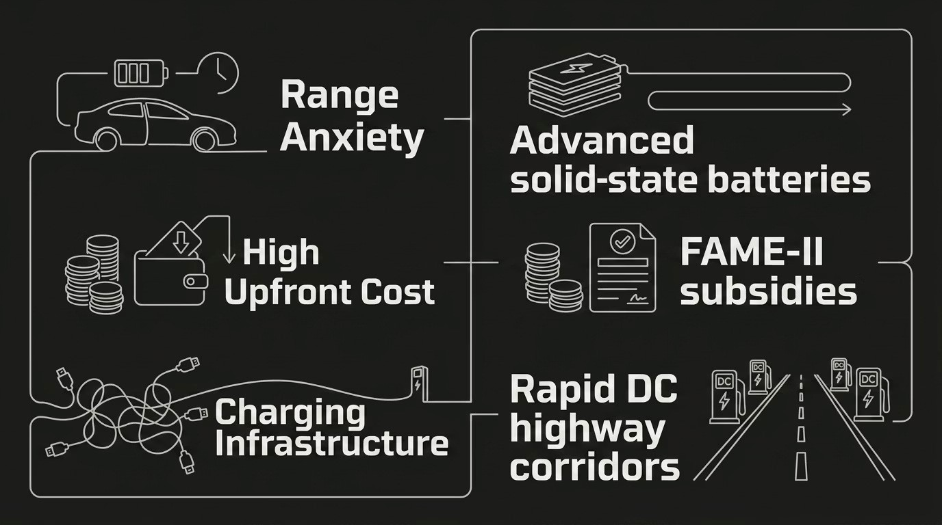
Challenges & Solutions in EV Adoption
Transitioning to electric mobility is not without hurdles. However, strategic government policies and rapid technological
advancements are solving these critical pain points.

Interactive EV Powertrain Block Diagram
This diagram visualises the direct energy flow within an electric vehicle from the charging port to the driven wheels during

acceleration.
Transmission Differential
Electric Motor
Power Inverter
Battery Pack
The inverter acts as the brain, adjusting the frequency of electrical current to control speed and torque based on accelerator

pedal inputs.
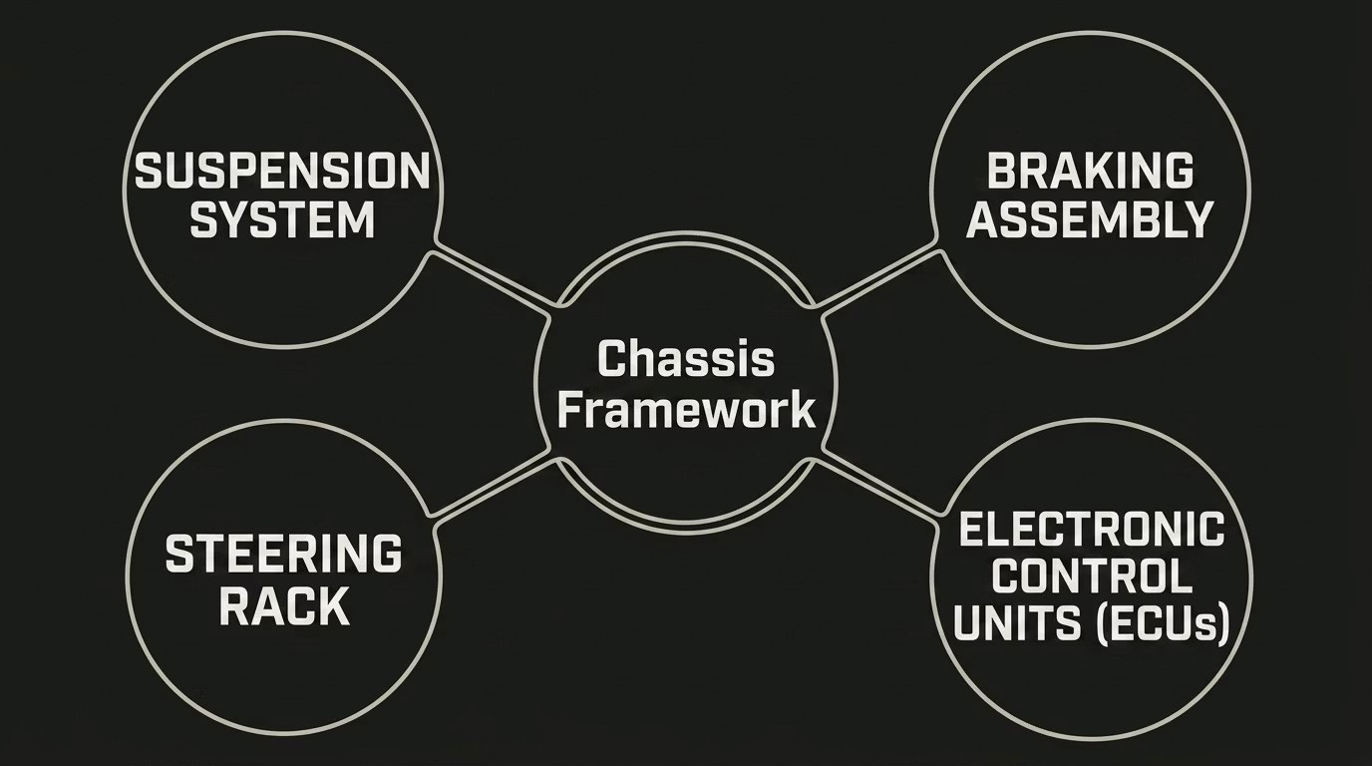
Detailed Automobile System Layout
Modern vehicles integrate electrical, mechanical, and safety systems into a unified rolling chassis framework that protects
and transports passengers.

