STUDENT ENROLLMENT & COURSE MANAGEMENT SYSTEM
PROJECT DOCUMENTATION
TEAM LEADER: P.Subasri
TEAM MEMBERS: R.Susanna, Thanigaivel, Thamizhselvan

1. ABSTRACT
The Student Enrollment & Course Management System is a simple web-based system used to manage student registration, course details, and course enrollment. It reduces manual work and stores student and course information in a centralized database. Students can register, view available courses, and enroll in courses. Administrators can manage students, courses, and enrollment records.

2. INTRODUCTION
The system is developed to make the student enrollment process simple, fast, and accurate. It provides an easy way to maintain student details and course information and helps administrators manage enrollment records efficiently.

3. OBJECTIVES
• To simplify student registration and enrollment.
• To manage student details efficiently.
• To maintain course information.
• To reduce paperwork and manual errors.
• To provide quick access to enrollment records.
• To improve course management.

4. EXISTING SYSTEM
In the existing manual system, student and course details are maintained using paper forms or separate files. This requires more time and may cause data entry errors, duplication, and difficulty in searching records.

5. PROPOSED SYSTEM
The proposed system computerizes student registration, course management, and enrollment. Students can register and select courses, while administrators can manage student, course, and enrollment information through the system.

6. MODULES
1. Student Registration – Stores student personal and contact details.
2. Student Login – Provides secure access for registered students.
3. Course Management – Allows the administrator to add, update, view, and delete courses.
4. Course Enrollment – Allows students to select and enroll in courses.
5. Enrollment Management – Allows the administrator to view and manage enrollment records.

7. SOFTWARE REQUIREMENTS
Operating System: Windows / Linux
Front End: HTML, CSS, JavaScript
Back End: Python / PHP / Java
Database: MySQL
Browser: Google Chrome / Microsoft Edge
Development Tool: VS Code / PyCharm / Eclipse

8. HARDWARE REQUIREMENTS
Processor: Intel Core i3 or above
RAM: 4 GB or above
Hard Disk: 250 GB or above
Keyboard and Mouse
Monitor

9. DATABASE DESIGN
Student Table: Student_ID, Name, DOB, Gender, Email, Phone, Address, Password.
Course Table: Course_ID, Course_Name, Description, Duration, Credits, Capacity.
Enrollment Table: Enrollment_ID, Student_ID, Course_ID, Enrollment_Date, Status.

10. WORKING PROCESS
Student Registration → Login → View Available Courses → Select Course → Submit Enrollment → Store Enrollment Details → Admin Management.

11. ADVANTAGES
• Easy to use
• Saves time
• Reduces paperwork
• Reduces manual errors
• Centralized data storage
• Easy course enrollment
• Easy record management

12. FUTURE ENHANCEMENTS
• Online fee payment
• Email/SMS notifications
• Mobile application
• Attendance management
• Online examination
• Certificate generation
• Course recommendation system

13. CONCLUSION
The Student Enrollment & Course Management System provides a simple and efficient way to manage student registration, courses, and enrollment records. It reduces manual work, improves accuracy, and makes the enrollment process easier for both students and administrators.

14. PROJECT SCREENSHOTS
Screenshot 1 – Project Dashboard
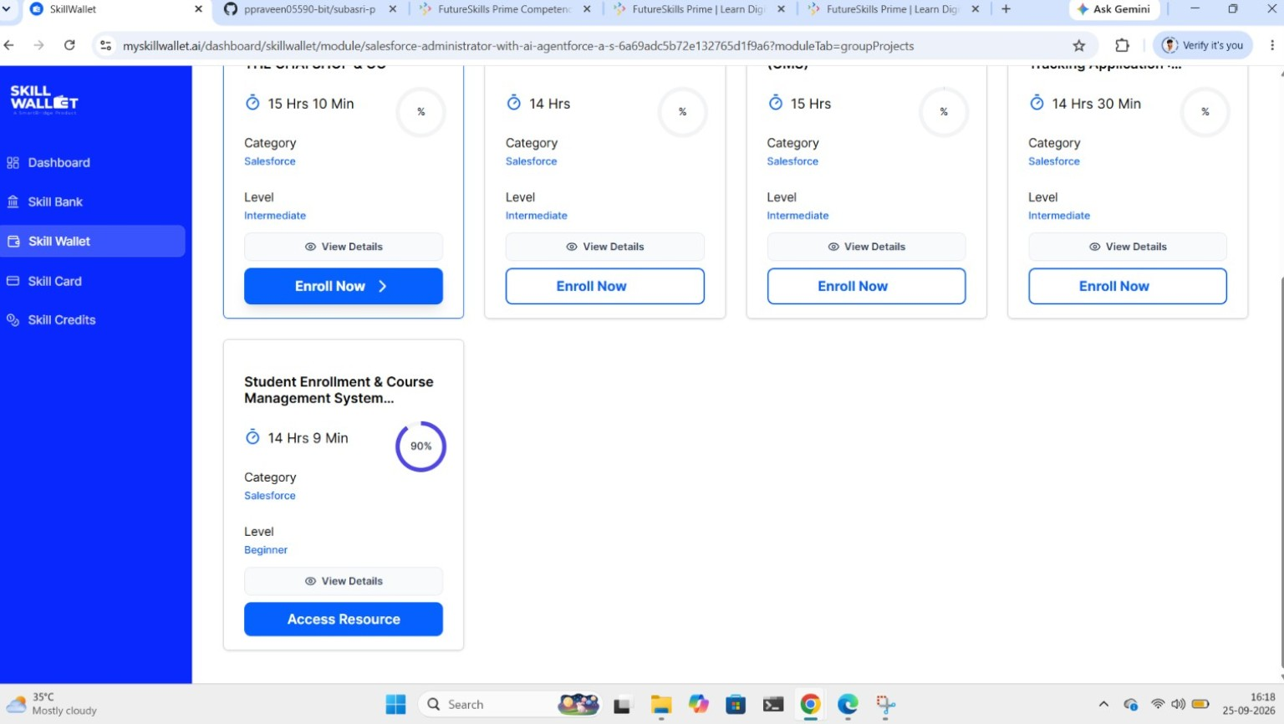

Screenshot 2 – Team Members
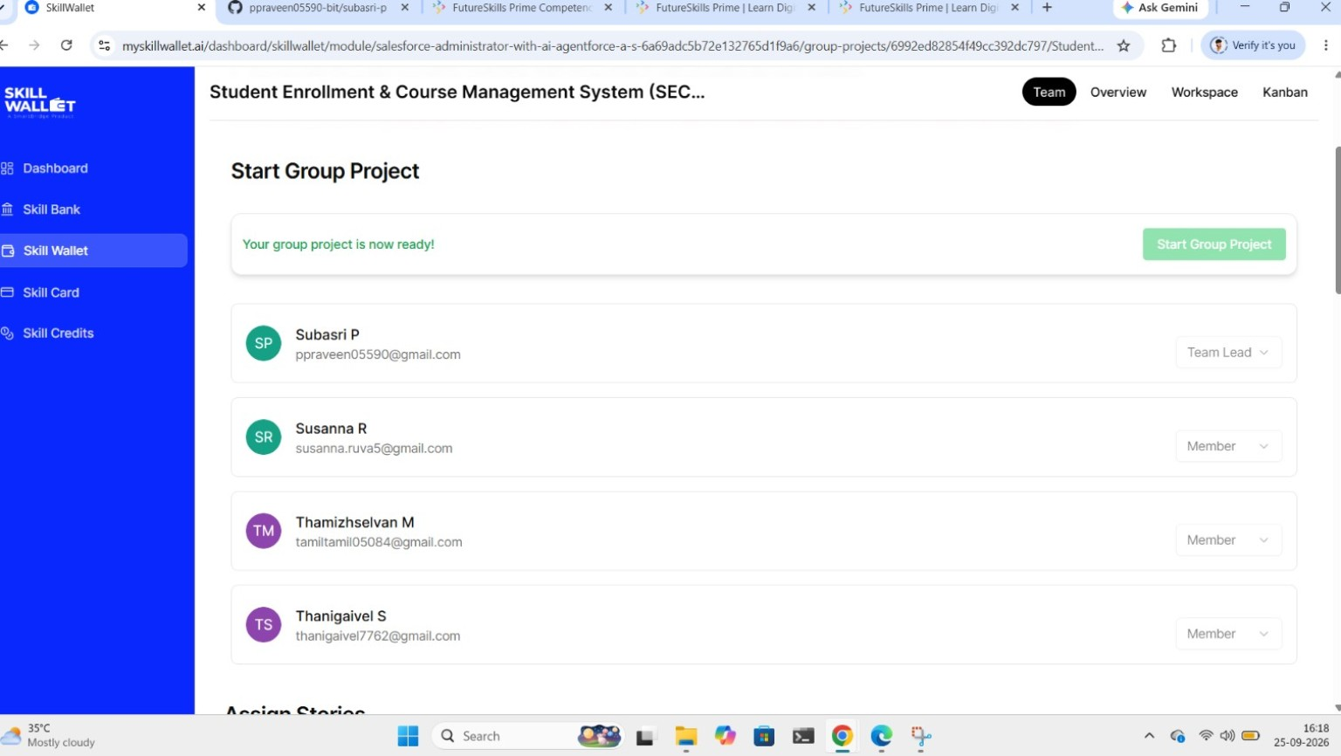

Screenshot 3 – Project Overview
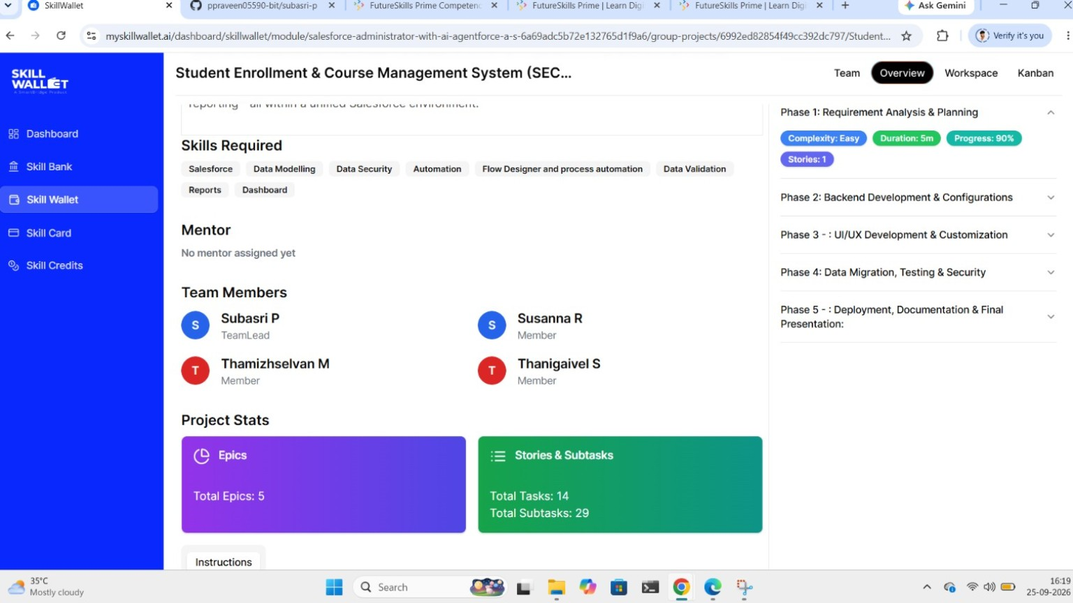

Screenshot 4 – Workspace and Project Progress
