**Team Budget Planner**

**Project and developer details**

**Project objective:**

As a developer, write a program using JavaScript to decide the budget of a specific team.

**Background of the problem statement:**

As a developer, you are assigned to a project. You need to develop a website where program managers of a specific team will add details of professional deals they want to have with vendors. The finance team will check expenses of those teams and will decide their annual budget.

You must use the following:

● Visual Studio Code: An IDE to code for the application

● JavaScript: A programming language

● Git: To connect and push files from the local system to GitHub

● GitHub: To store the application code and track its versions

● JavaScript concepts: Functions, prototypes, primitives, objects, IIFEs, promises, async, and webpack

Following requirements should be met:

● Versions of the code should be tracked on GitHub repositories

● Team Budget Planner should work properly

**Developer Details**: P Praveen Kumar

Ppraveen62.ppk@gmail.com

9502646206

budget.html:

<!DOCTYPE html>

<html lang="en">

<head>

    <meta charset="UTF-8">

    <meta http-equiv="X-UA-Compatible" content="IE=edge">

    <meta name="viewport" content="width=device-width, initial-scale=1.0">

    <link rel="stylesheet" href="https://cdn.jsdelivr.net/npm/bootstrap@4.6.2/dist/css/bootstrap.min.css"

        integrity="sha384-xOolHFLEh07PJGoPkLv1IbcEPTNtaed2xpHsD9ESMhqIYd0nLMwNLD69Npy4HI+N" crossorigin="anonymous">

    <script src="https://cdn.jsdelivr.net/npm/jquery@3.5.1/dist/jquery.slim.min.js"

        integrity="sha384-DfXdz2htPH0lsSSs5nCTpuj/zy4C+OGpamoFVy38MVBnE+IbbVYUew+OrCXaRkfj"

        crossorigin="anonymous"></script>

    <script src="https://cdn.jsdelivr.net/npm/bootstrap@4.6.2/dist/js/bootstrap.bundle.min.js"

        integrity="sha384-Fy6S3B9q64WdZWQUiU+q4/2Lc9npb8tCaSX9FK7E8HnRr0Jz8D6OP9dO5Vg3Q9ct"

        crossorigin="anonymous"></script>

    <script src="C:\Users\BALA\Documents\VS Code Frontend\BudgetWebsite\js\budget.js"></script>

    <link rel="stylesheet" href="C:\Users\BALA\Documents\VS Code Frontend\BudgetWebsite\css\budget.css" />

    <title>Budget</title>

</head>

<body>

    <div class="jumbotron">

        <h1 class="display-3">Budget Planner</h1>

    </div>

    <div class="heading">

        <div class="cul1">

            <h2>Budget</h2>

            <img src="C:\Users\BALA\Documents\VS Code Frontend\BudgetWebsite\images\indian-rupee.jpg" width="60"

                alt="" />

            <p class="amount">Rs <span id="budgetAmount">0</span></p>

        </div>

        <div class="cul2">

            <h2>Expenses</h2>

            <img src="C:\Users\BALA\Documents\VS Code Frontend\BudgetWebsite\images\indian-rupee.jpg" width="60"

                alt="" />

            <p class="amount">Rs <span id="expensesAmount">0</span></p>

        </div>

        <div class="cul3">

            <h2>Balance</h2>

            <img src="C:\Users\BALA\Documents\VS Code Frontend\BudgetWebsite\images\indian-rupee.jpg" width="60"

                alt="" />

            <p class="amount">Rs <span id="balanceAmount">0</span></p>

        </div>

    </div>

    <section>

        <div class="submit">

            <h6>Enter your Budget <input type="number" id="budget" name="budget" value=0> <button

                    onclick="addBudget()">Ok</button></h6><br>

            <h4>Add Expenses</h4><br>

            <h6>Enter your Expense Name <input type="text" id="expenseName" name="expenseName" value="Room Rent" required> Enter

                Amount <input type="number" id="expenseAmt" name="expenseAmt" value=0 required> <button

                    onclick="addExpense()">Add</button></h6>

        </div>

        <div class="list">

            <table class="table">

                <thead>

                    <tr id ="tablehead">

                        <th>Expense Name</th>

                        <th>Expense Amount</th>

                        <th>Delete</th>

                    </tr>

                </thead>

                <tbody id="tbody">

                </tbody>

            </table>

        </div>

    </section>

    <footer class="bg-light text-center text-lg-start">

        <!-- Copyright -->

        <div class="text-center p-3" style="background-color:rgb(7, 2, 19); color: white;">

            © 2020 Copyright:

            <a class="text-dark" href="https://github.com/ppraveen62/Budgeting-web-app-proj-javascript--bootstrap.git">PPK</a>

        </div>

        <!-- Copyright -->

    </footer>

</body>

</html>

budget.css:

        .jumbotron {

            margin-bottom: 0%;

            background-color: rgb(7, 2, 19);

            color: whitesmoke;

            padding:5px;

        }

        .heading {

            background-color: white;

            text-align: center;

        }

        .cul1 {

            padding: 20px;

            display: inline-block;

        }

        .cul2 {

            padding: 20px;

            display: inline-block;

        }

        .cul3 {

            padding: 20px;

            display: inline-block;

        }

        .amount {

            border: none;

            border-radius: 5px;

            background-color: darkslategrey;

            color: white;

            font-weight: bold;

            margin: 5px;

        }

        .submit {

            padding: 10px;

        }

        button {

            border-radius: 6px;

            background-color: darkslategray;

            color: white;

            font-weight: bold;

        }

        input {

            font-weight: lighter;

            border-radius: 5px;

            background-color: snow;

            text-align: center;

        }

        .submit {

            background-color: lightsteelblue;

            padding-left: 150px;

            padding-top: 20px;

        }

        .text-dark {

            color: white !important;

            font-weight: lighter;

        }

        .table {

            width: 50%;

            height: 100%;

            margin: auto;

            text-align: center;

            background-color: snow;

            border-collapse: unset;

            border-radius: 5px;

        }

        .list {

            background-color: lightsteelblue;

            padding: 50px;

        }

        h4 {

            font-style: italic;

            font-family: 'Gill Sans', 'Gill Sans MT', Calibri, 'Trebuchet MS', sans-serif;

            font-weight: bolder;

            color: indigo;

        }

        .display-3 {

            font-family: cursive;

            color: aliceblue;

            font-style: oblique;

            padding-left: 50px;

        }

        #tablehead{

            background-color: firebrick;

            color: whitesmoke;

        }

budget.js:

function updateBanner() {

    const budget = document.getElementById("budgetAmount").innerText;

    const expenses = document.getElementById("expensesAmount").innerText;

    document.getElementById("balanceAmount").innerHTML = budget - expenses;

}

function addBudget() {

    const budget = document.getElementById("budget").value;

    const expenses = document.getElementById("expensesAmount").innerText;

    document.getElementById("budgetAmount").innerHTML = budget;

    document.getElementById("balanceAmount").innerHTML = budget - expenses;

}

i = 0;

const bdgtlist = [[], []];

function addExpense() {

    const expName = document.getElementById("expenseName").value;

    const expAmount = document.getElementById("expenseAmt").value;

    if (/[a-zA-Z0-9]/.test(expName)==true && expAmount != 0) {

        bdgtlist[0][i] = expName;

        console.log(typeof expName)

        bdgtlist[1][i] = expAmount;

        i++;

        Showlist()

    }

    if (/[a-zA-Z0-9]/.test(expName)==false) {

        alert("Please give correct input! Name should not be Blank");

    }

    if (/[a-zA-Z0-9]/.test(expName)==true && expAmount == 0) {

        alert("Please give correct input! Amount should not be Zero");

    }

}

function Showlist() {

    document.getElementById("tbody").innerHTML = ""

    for (var j = 0; j < bdgtlist[0].length; j++) {

        var exp = bdgtlist[0][j]

        var amt = bdgtlist[1][j]

        if (exp != undefined && amt != undefined) {

            document.getElementById("tbody").innerHTML +=

                `<tr>

            <td id="exp">`+ exp + `</td>

            <td id="amt">`+ amt + `</td>

            <td id="del"><button onclick="deleteExp(`+ j + `)">&#10060;</button> </td>

        </tr>`;

        }

    }

    let totalexpAmt = 0;

    for (var j = 0; j < bdgtlist[0].length; j++) {

        if (bdgtlist[1][j] != undefined) {

            totalexpAmt += parseFloat(bdgtlist[1][j])

        }

    }

    document.getElementById("expensesAmount").innerHTML = totalexpAmt;

    updateBanner()

}

let id = 0;

function deleteExp(id) {

    bdgtlist[0].splice(id, 1)

    bdgtlist[1].splice(id, 1)

    Showlist()

}

**Opened and see the change in budget ,expenses and balances**

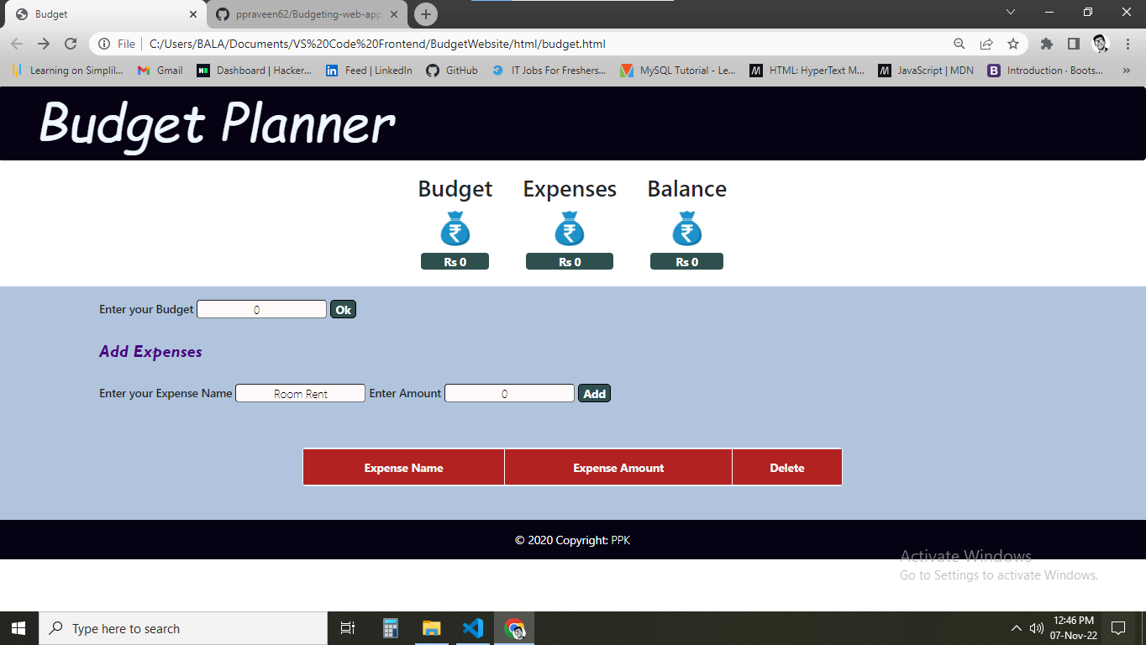

**Budget and expenses are added**

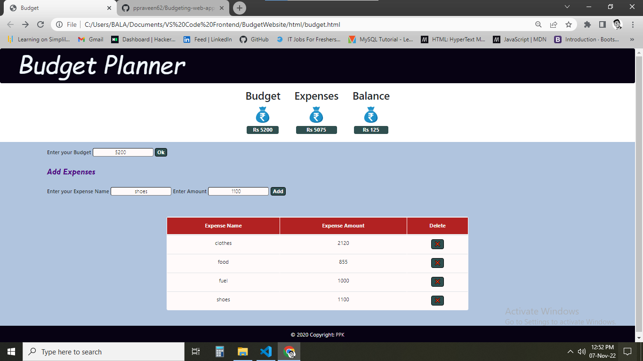

**One of the expenses deleted**

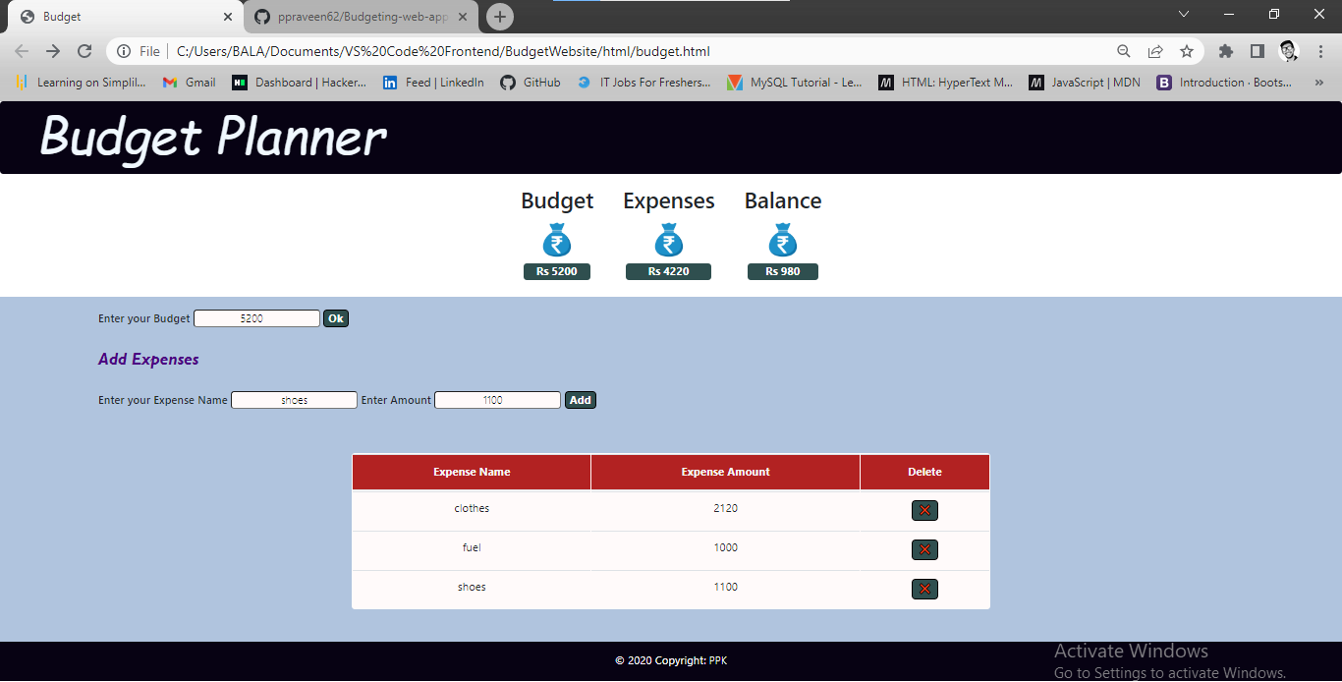

**Again with new prices added**

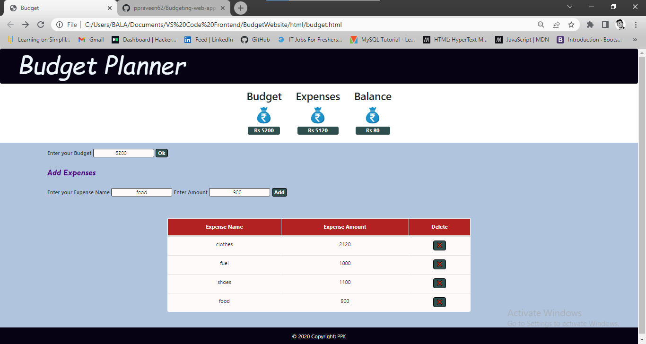

**Pushing to GitHub**

**Links to the GitHub repository to verify the project completion**

<https://github.com/ppraveen62/Budgeting-web-app-proj-javascript--bootstrap.git>

