**1.Writing code on eclipse Ide**

package L2;

import java.util.*;

import java.util.regex.Matcher;

import java.util.regex.Pattern;

interface Emails{

//employee email id's

String[] emailId= {"praveen@gmail.com","ravi65@gmail.com","kiran@yahoo.com","kk_321@gmail.com"};

}

public class emailValidation implements Emails {

static void sreachId(String id) {

int count=0;

for(String x: emailId) {

Boolean sreach = Pattern.matches(id,x);

if(sreach==true) {

count+=1;

}

}

if (count==1) {

System.out.println();

System.out.println("Match found");

System.out.println("yes, He or She is registerd Employee.");

}else {

System.out.println();

System.out.println("check ID again ! or,");

System.out.println("He/She is not registerd Employee.");

}

}

public static void main(String[] args) {

Scanner sc = new Scanner(System.in);

System.out.println("Enter the Email Id: ");

String id =sc.nextLine();

sreachId(id);

}

}

2. Executing output

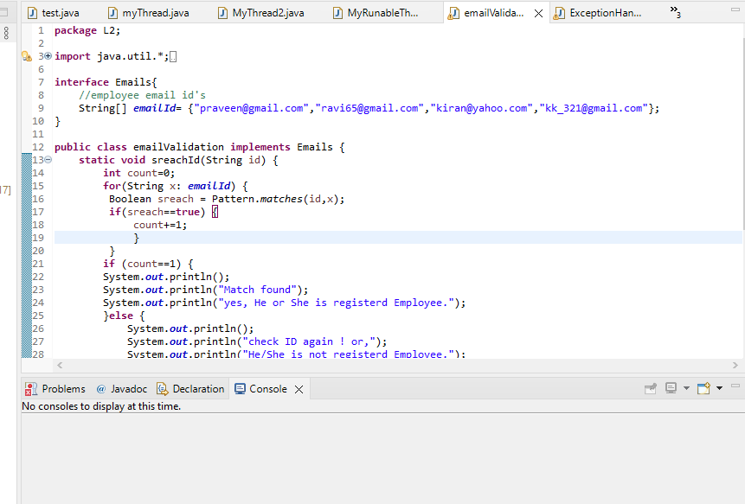

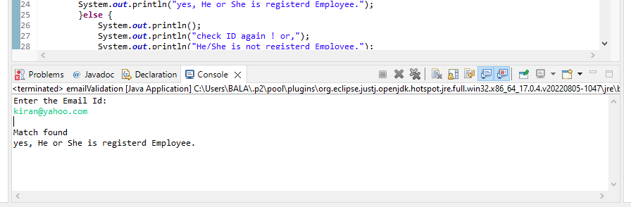

**3.Pushing in Git Hub**