**1.Writing code in eclipse**

package L1;

import java.util.Scanner;

public class calculator {

static void method() {

Scanner sc=new Scanner(System.in);

System.out.println();

System.out.println("give operator type ( + , - , / , % , *)?");

String operator = sc.next();

System.out.println("input first number:");

double a =sc.nextDouble();

System.out.println("input second number:");

double b=sc.nextDouble();

switch (operator)

{

case "+":

System.out.println(a+"+"+b+"= "+ (double)(a+b));

break;

case "-":

System.out.println(a+"-"+b+"= "+(double)(a-b));

break;

case "/":

System.out.println(a+"/"+b+"= "+(double)(a/b));

break;

case "*":

System.out.println(a+"*"+b+"= "+(double)(a*b));

break;

case "%":

System.out.println("result "+a+"%"+b+"= "+(double)(a%b));

break;

default:

System.out.println("error: wrong input");

break;

}

}

public static void main(String[] args) {

Scanner scr=new Scanner(System.in);

System.out.println("calculator");

while(true) {

method();

System.out.println();

System.out.println("type 0 (quit) || any (1-9) continue !");

int res =scr.nextInt();

if (res==0) {

break;

}

if (res!=0 ) {

System.out.println("...");

}

}

}

}

**2. Output:**

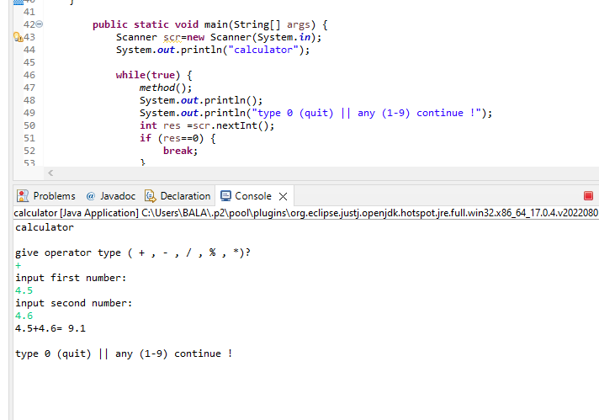

3. Pushing the code to your GitHub repositories

* Open your command prompt and navigate to the folder where you have created your files.

**cd <folder path>**

* Initialize your repository using the following command:

**git init**

* Add all the files to your git repository using the following command:

**git add .**

* Commit the changes using the following command:

**git commit . -m “Changes have been committed.”**

* Push the files to the folder you initially created using the following command:

**git push -u origin master**

