**1.Writing code on eclipse Ide**

**package L3;**

**import java.io.File;**

**import java.io.FileOutputStream;**

**import java.io.FileWriter;**

**import java.io.IOException;**

**import java.util.Scanner;**

**public class fileRWA {**

**public static void main(String[] args) throws IOException {**

**//make sure file is at the path?**

**String path="E://SiKmplilearn-//TestFile.txt";**

**//Reading**

**File ob =new File(path);**

**Scanner Reader = new Scanner(ob);**

**while (Reader.hasNextLine()) {**

**String data = Reader.nextLine();**

**System.out.println(data);**

**}**

**Reader.close();**

**//writing**

**String data="Hai Iam Praveen.";**

**FileOutputStream out=new FileOutputStream(path);**

**out.write(data.getBytes());**

**out.close();**

**//appending**

**FileWriter obj =new FileWriter(path,true);**

**obj.write(" iam appending "); //true means append**

**obj.close();**

**}**

**}**

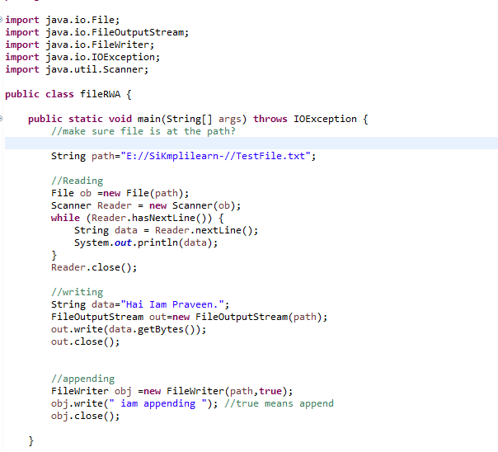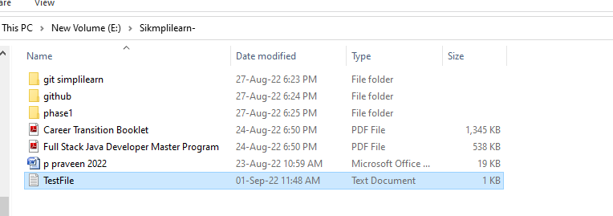

**2. Executing output**

Intial reading of output

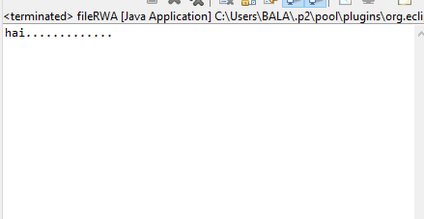

After writing and appending

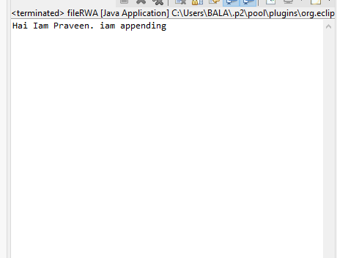

**3.Pushing in Git Hub**