**FlyAway (An Airline Booking Portal)**

**Document contains:**

* Project and developer details
* Sprints planned and the tasks achieved in them
* Algorithms and flowcharts of the application
* Links to the GitHub repository to verify the project completion
* Conclusions

**Project and developer details**

**Project objective:**

As a Full Stack Developer, design and develop an airline booking portal named as FlyAway. Use the GitHub repository to manage the project artifacts.

**Background of the problem statement:**

FlyAway is a ticket-booking portal that lets people book flights on their website.

**The website needs to have the following features:**

● A search form in the homepage to allow entry of travel details, like the date of travel, source, destination, and the number of persons.  
● Based on the travel details entered, it will show the available flights with their ticket prices.  
● Once a person selects a flight to book, they will be taken to a register page where they must fill in their personal details. In the next page, they are shown the flight details of the flight that they are booking, and the payment is done via a dummy payment gateway. On completion of the payment, they are shown a confirmation page with the details of the booking.

For the above features to work, there will be an admin backend with the following features:

● An admin login page where the admin can change the password after login, if he wishes  
● A master list of places for source and destination  
● A master list of airlines  
● A list of flights where each flight has a source, destination, airline, and ticket price  
  
The goal of the company is to deliver a high-end quality product as early as possible. 

**The flow and features of the application:**

● Plan more than two sprints to complete the application  
● Document the flow of the application and prepare a flow chart   
● List the core concepts and algorithms being used to complete this application  
● Implement the appropriate concepts, such as exceptions, collections, and sorting techniques for source code optimization and increased performance

**Developer Details**: P Praveen Kumar

Ppraveen62.ppk@gmail.com

9502646206

**Sprints planned and the tasks achieved in them**

There are three sprints for this project

Sprint-1: Studied the Features of project and prepared the flow chart and created Git Repository.

Sprint-2: created Jsp pages and written servlet java program for booking portal and All the features are being implemented.

Sprint-3: Final testing of website using different inputs and pushing it to GitHub.

Algorithms and flowcharts of the application

**Flow chart:**

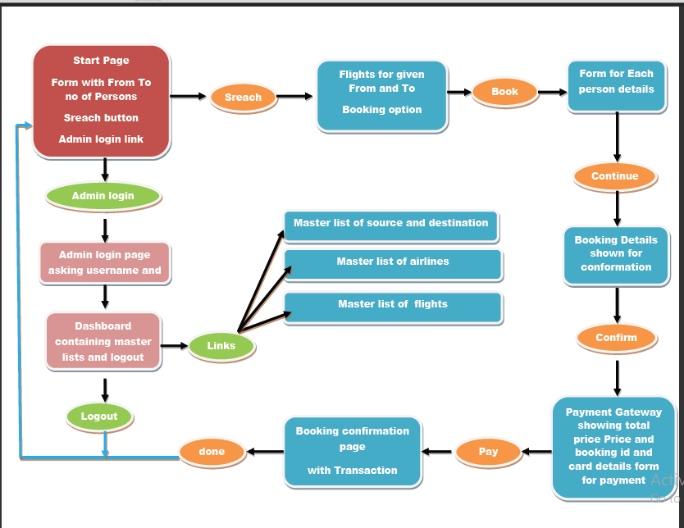

1. Home page is created using jsp.

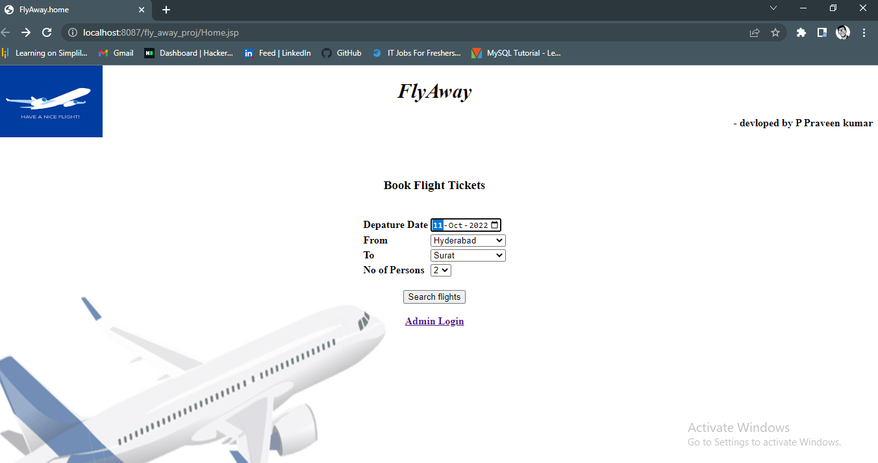

2.Given input is being verified in the servlet ,if it’s a wrong input it is being redirected to the same page. if its right all the flights are being shown for the given source and destination through database which is done by another servlet.

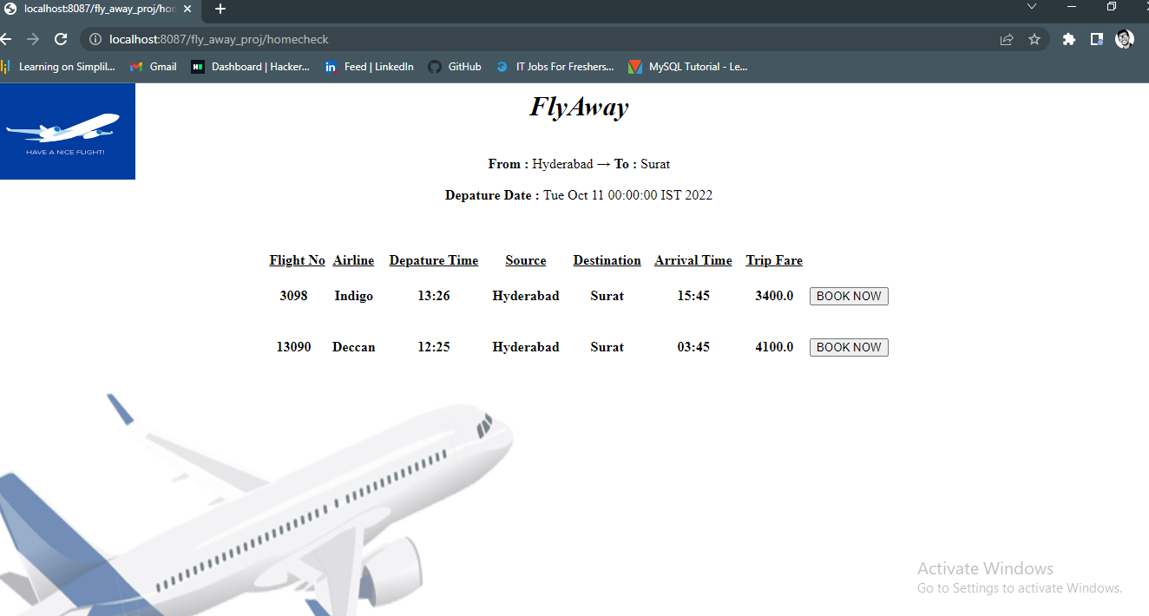

3.if flight is selected and book now button is clicked then it’s being redirected to user details page form according to the no of persons given.

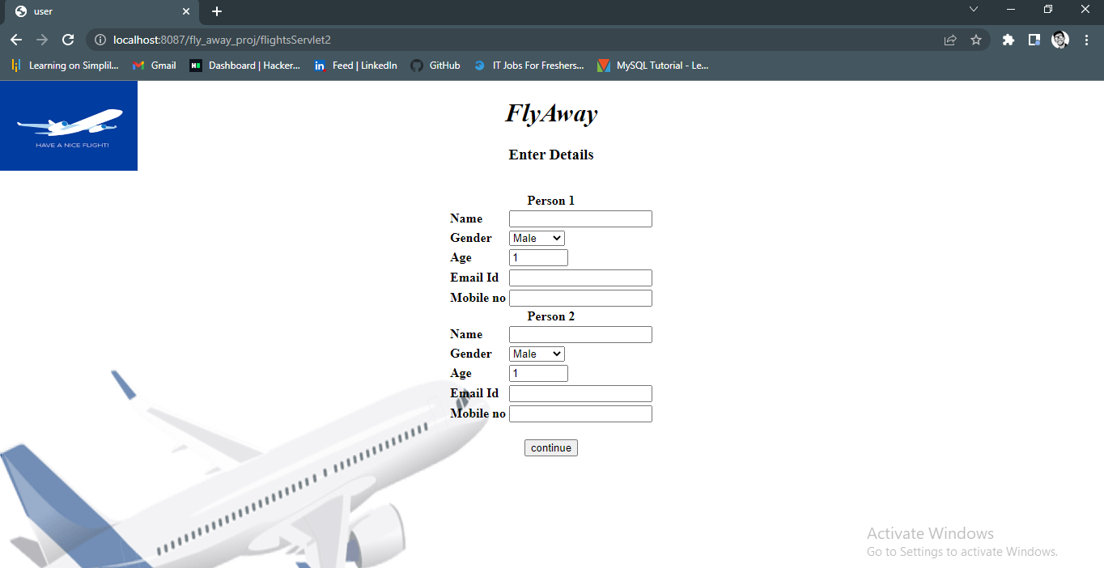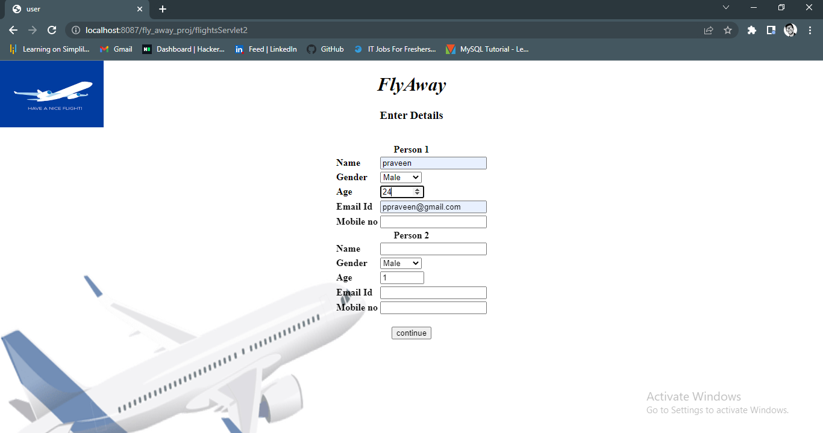

5.if data given is null or input is wrong it is being redirected to same page with some warning ,this things are done by servlet.

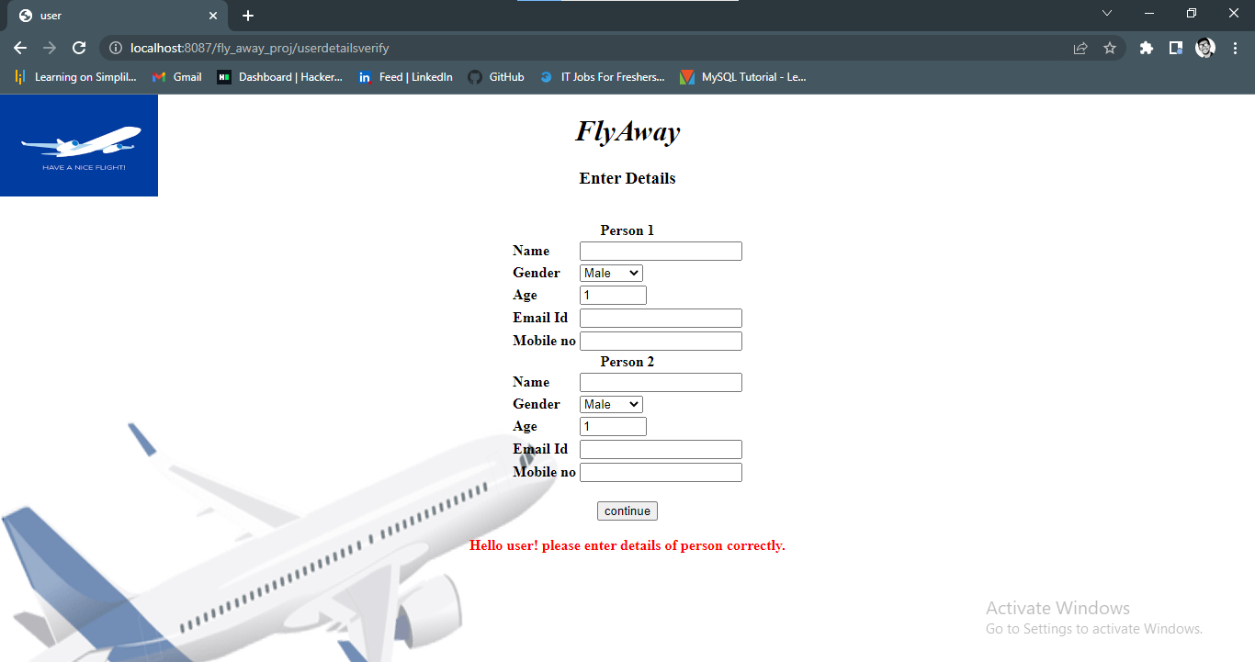

6. If data entered is not null , right and clicked on continue then a flight details are shown for confirmation.

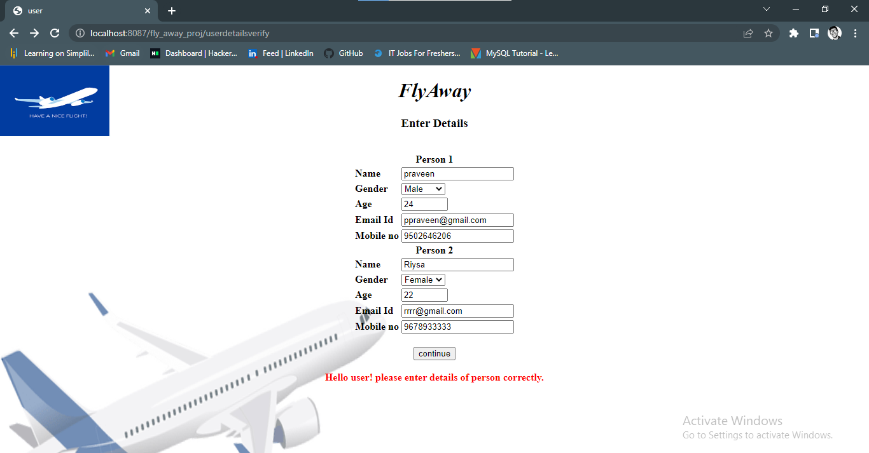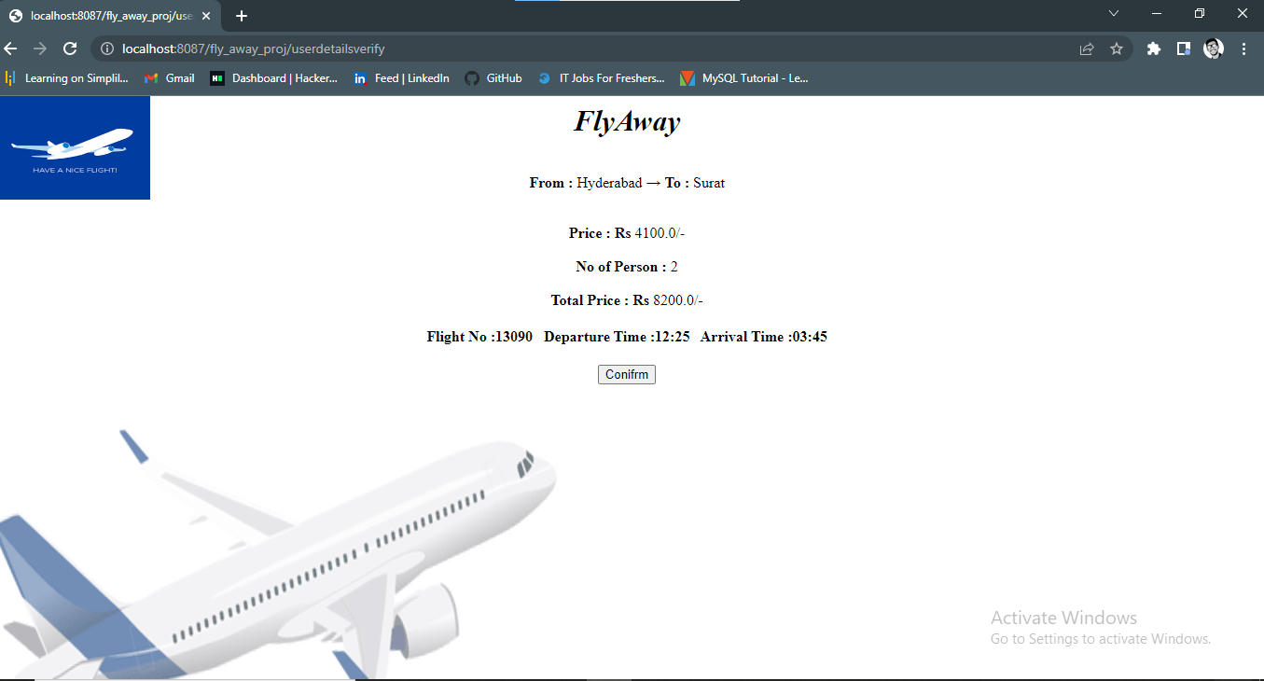

7.if confirm button is clicked and it is redirected to payment gateway page.

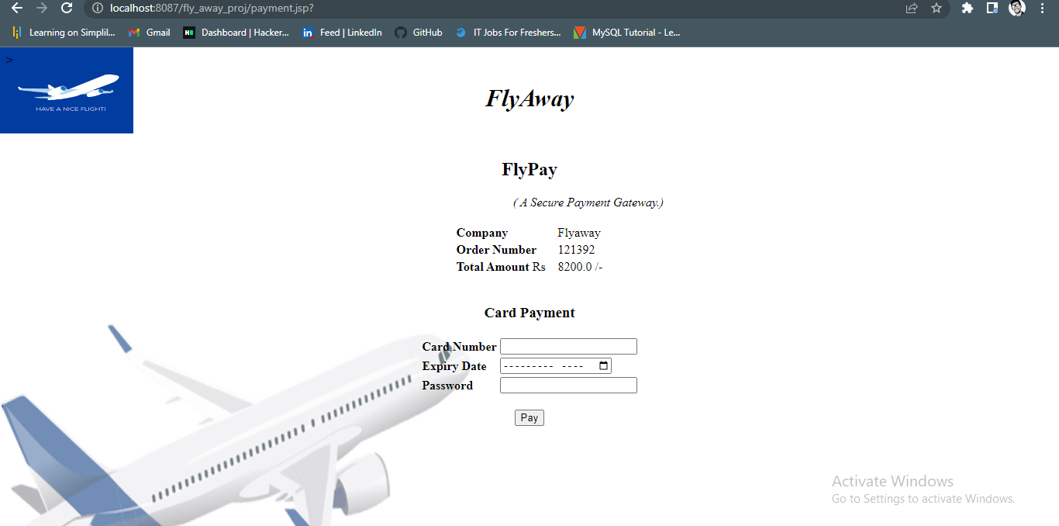

8.if wrong details are entered it redirects to same page for again entering the details and when data is correctly enterd it passes it to next page this is done using servlet.

9.In this date is not entered and clicked on pay.

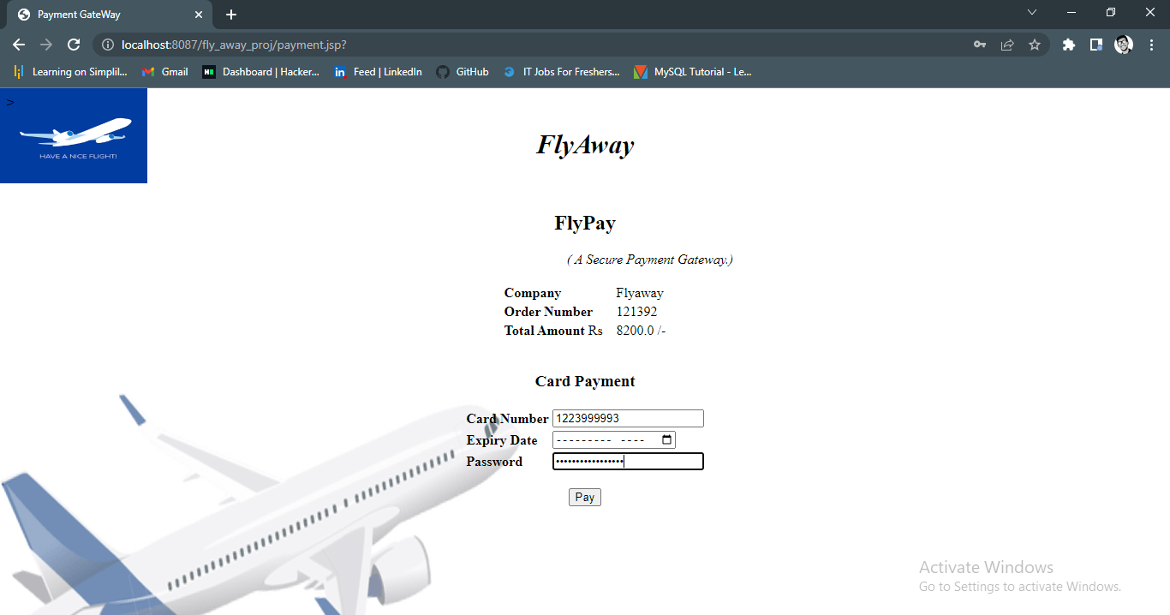

10.its shows warning on same page and a data is entered again.

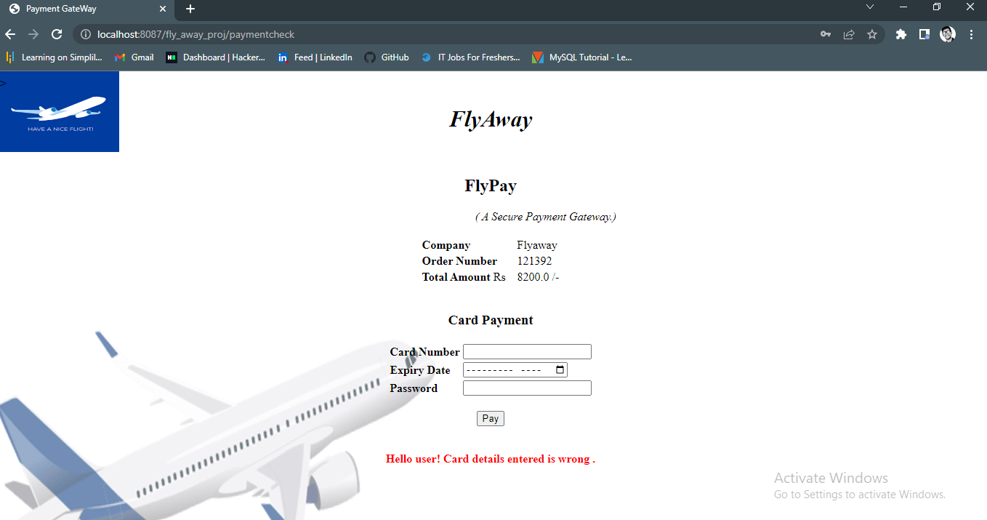

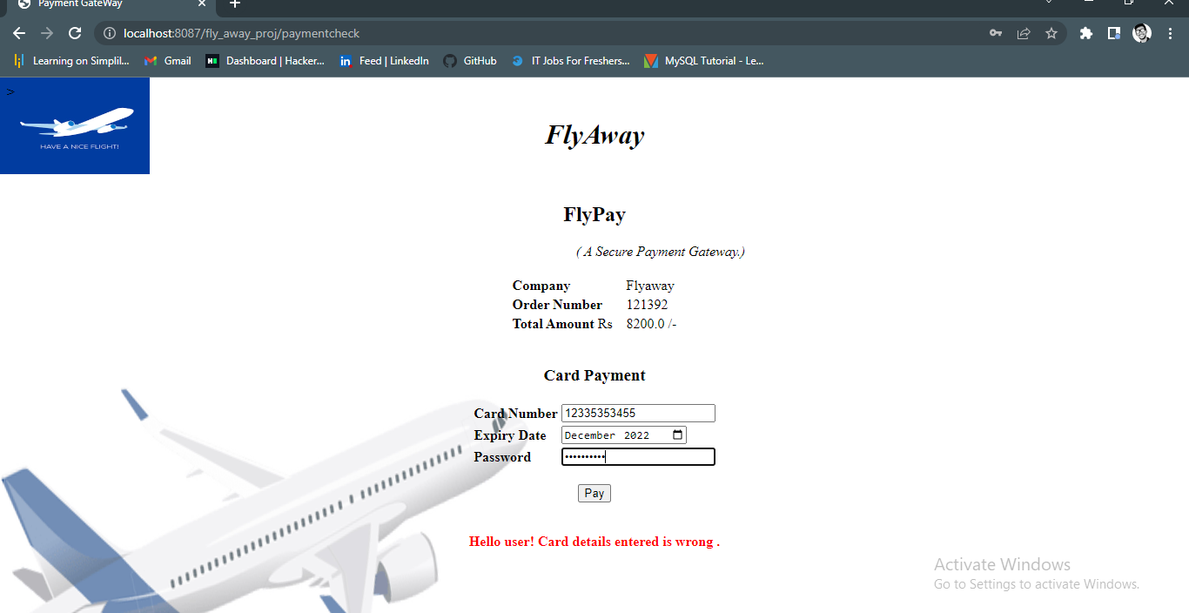

11.If pay button is clicked ,on successful transaction shows booking id and transaction id are shown in new page.

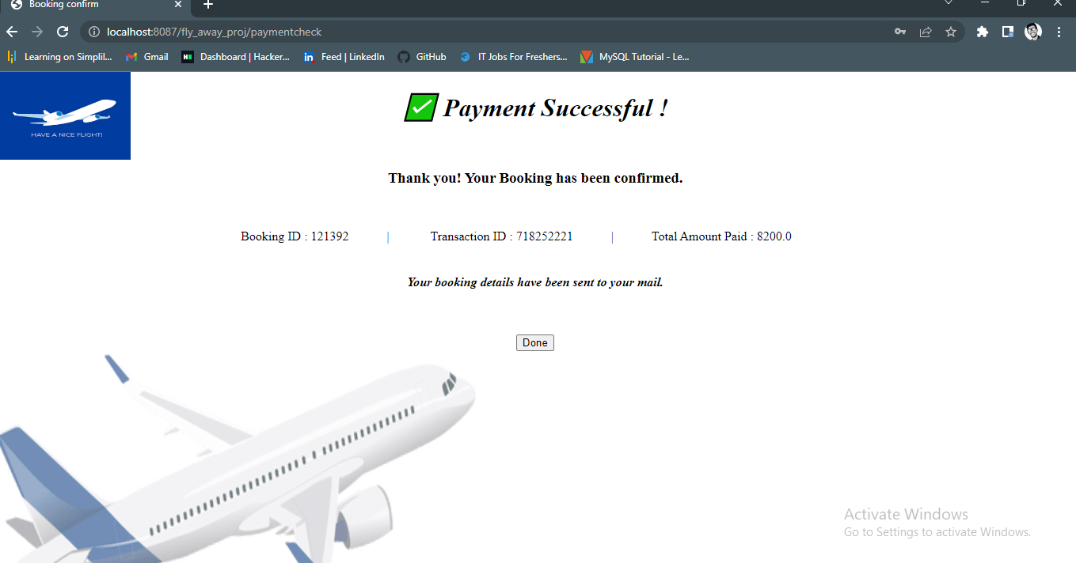

**Coming to admin part**



1. On clicking on admin login a login page is displayed.

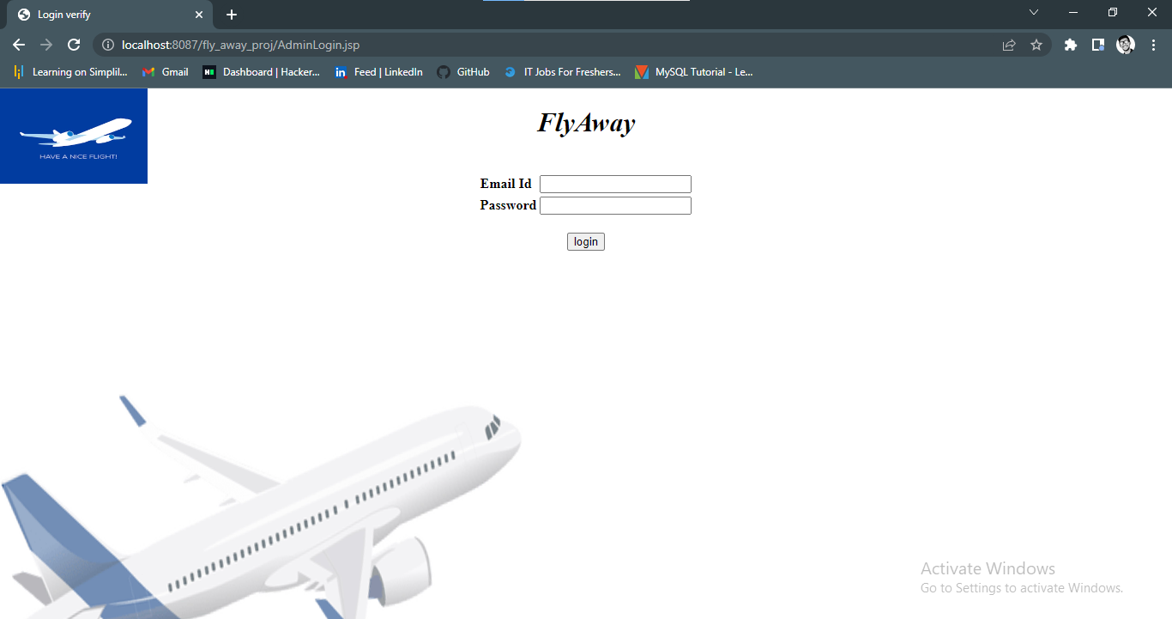

2.This data of username and password entered is being verified by the servlet through connecting to the database. If details entered is wrong then it redirects to the same page showing warning.

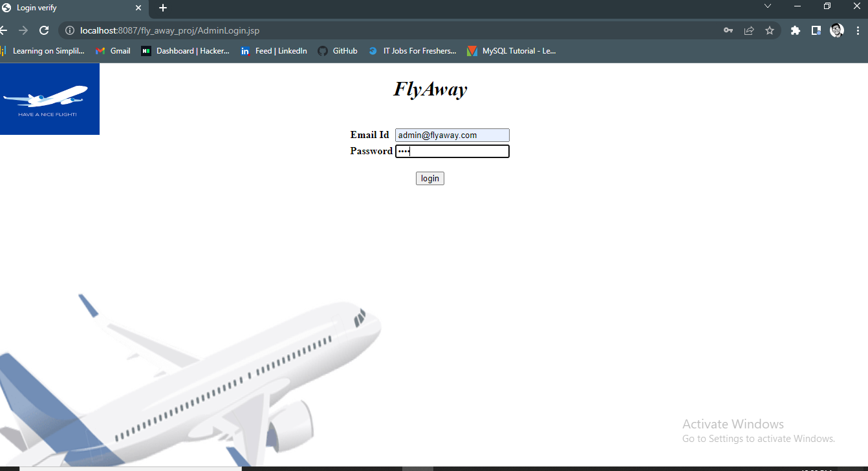

3.if data entered is matched with the database then servlet redirect to admin dashboard.

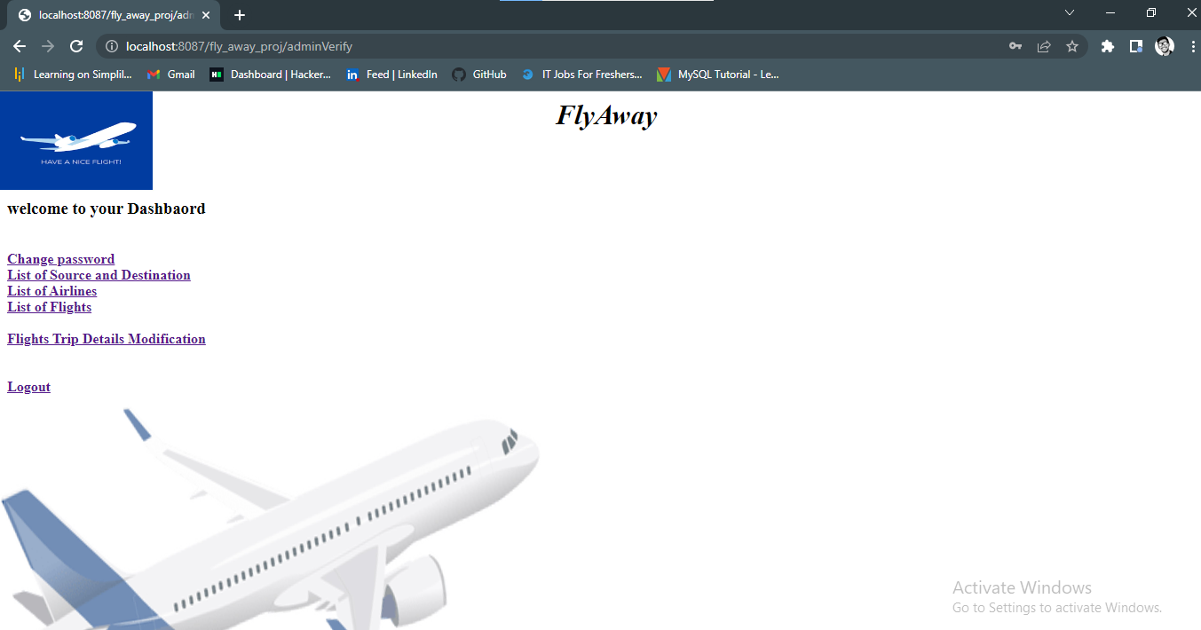

4. if password is null it shows warning if it is not null password is being updated in database

And redirected to login page showing password change.

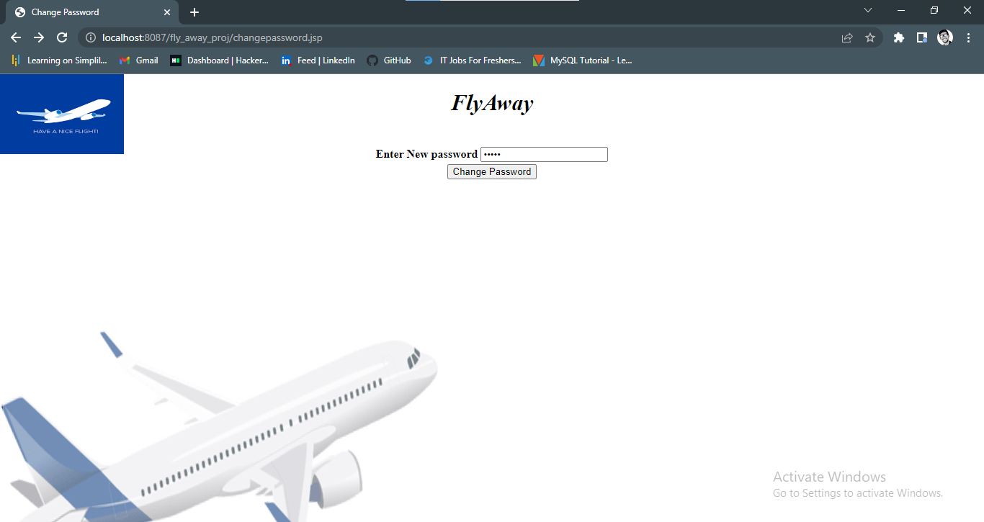

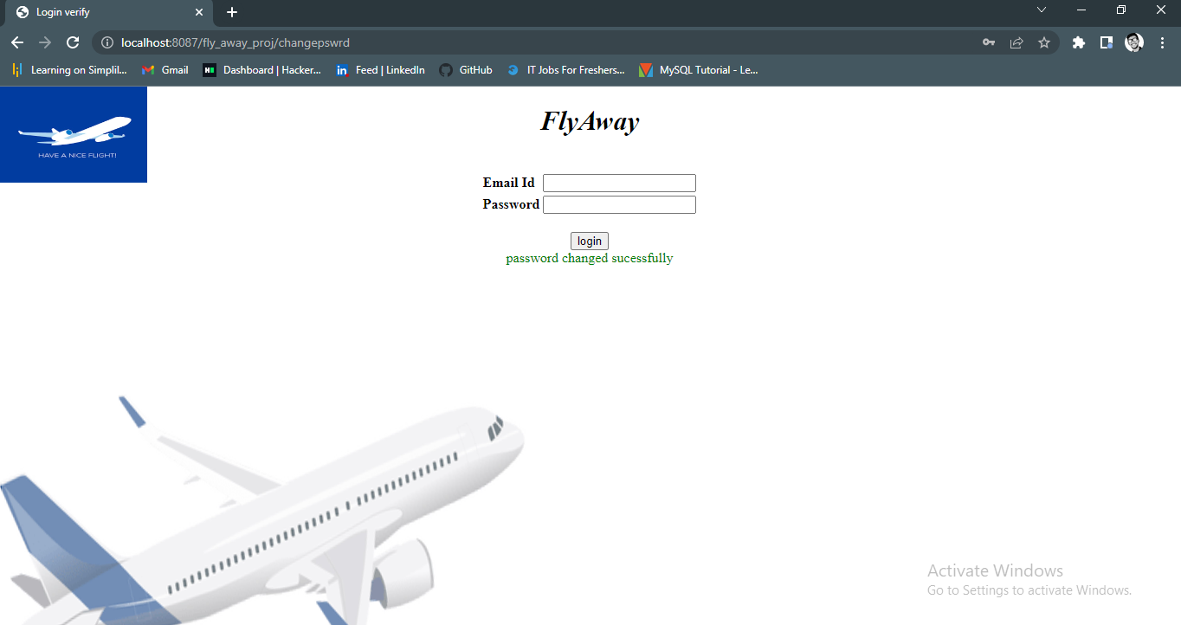

5.if list of source and destination link is clicked on dashboard the data is being fetched and shown in the page using servlet

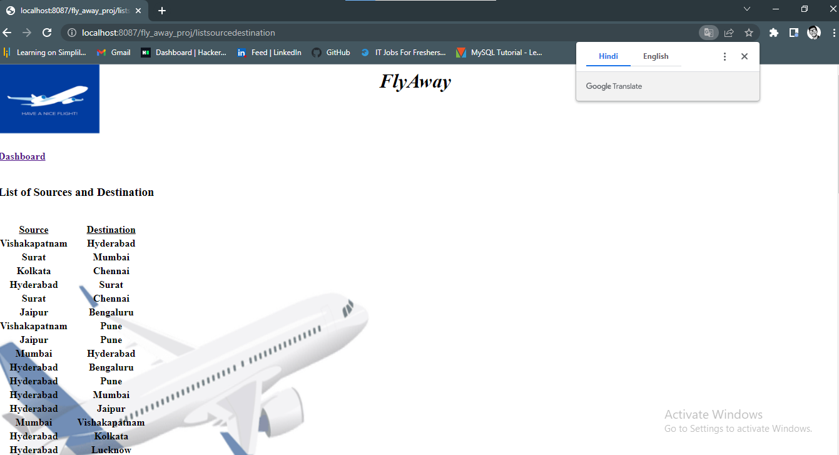

6.if list of airlines link is clicked on dashboard the data is being fetched and shown in the page using servlet

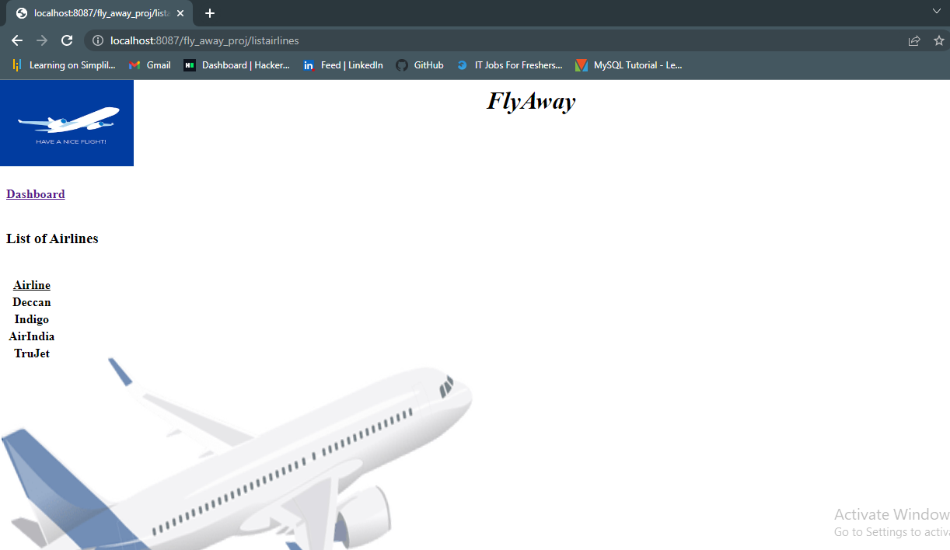

7.if list of flights link is clicked on dashboard the data is being fetched and shown in the page using servlet

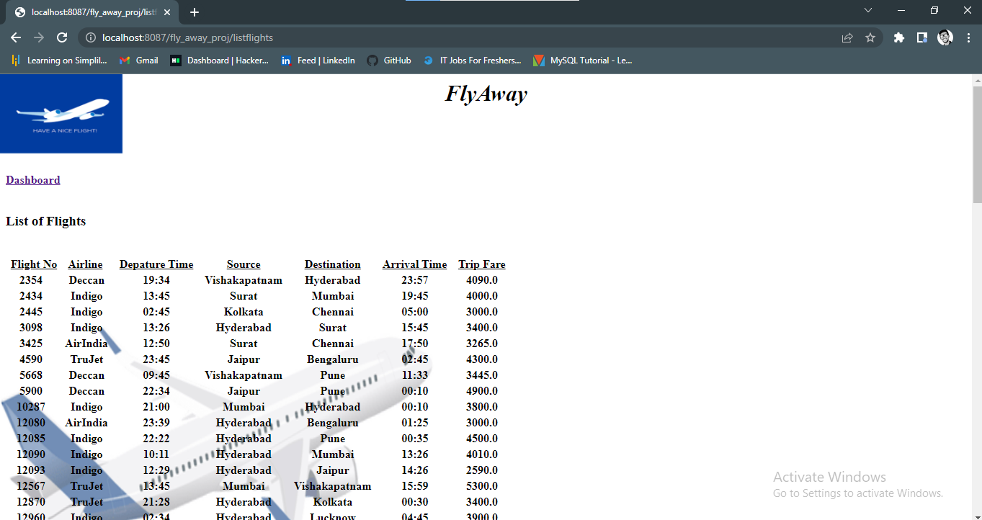

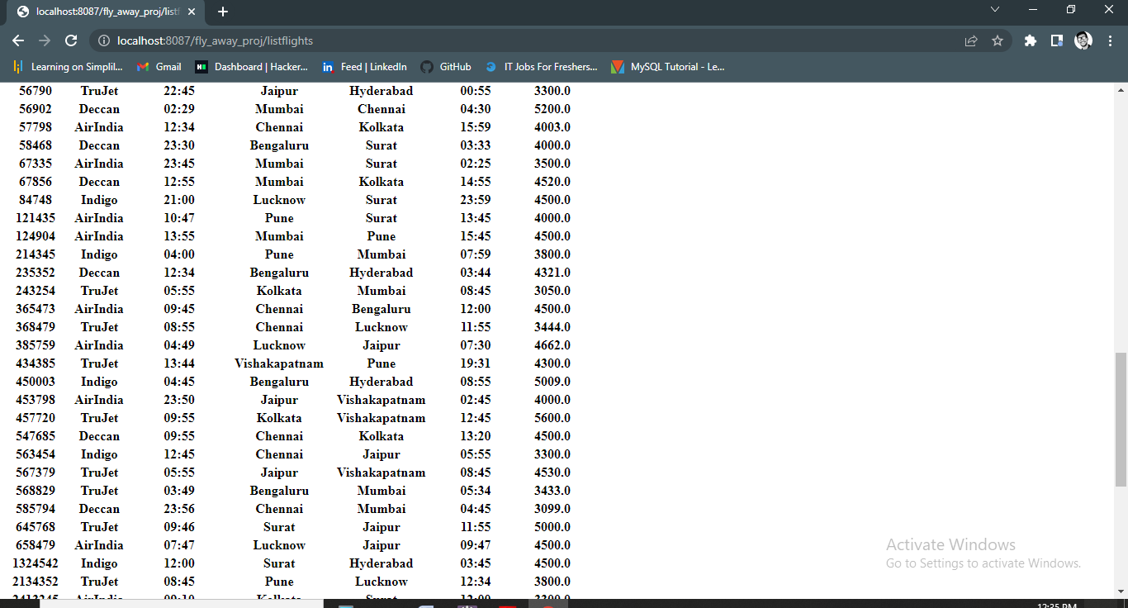

8.if list of flight trip modification link is clicked on dashboard then menu is shown for add flight deatails and delete flight details .

If this links are clicked.

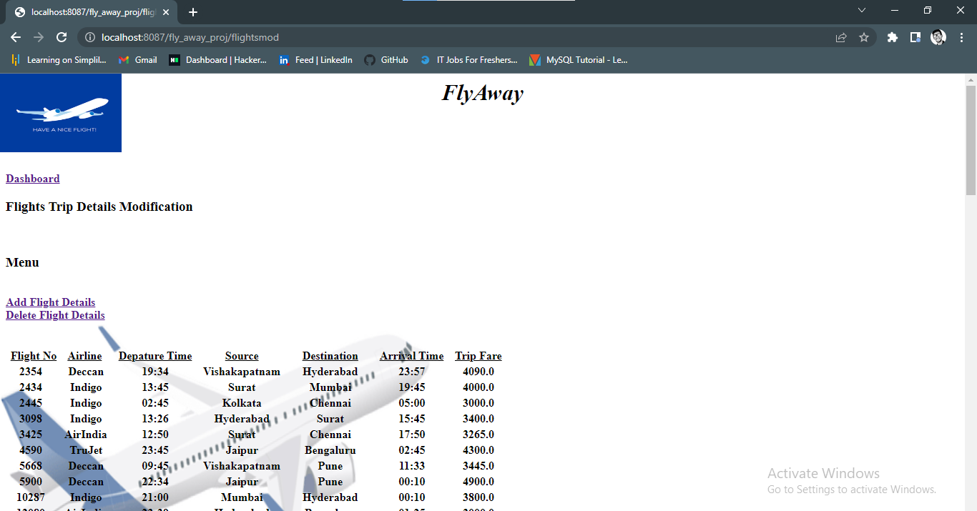

9.for adding flight details in database ,this data are being filled an clicked on add flight bbutton .

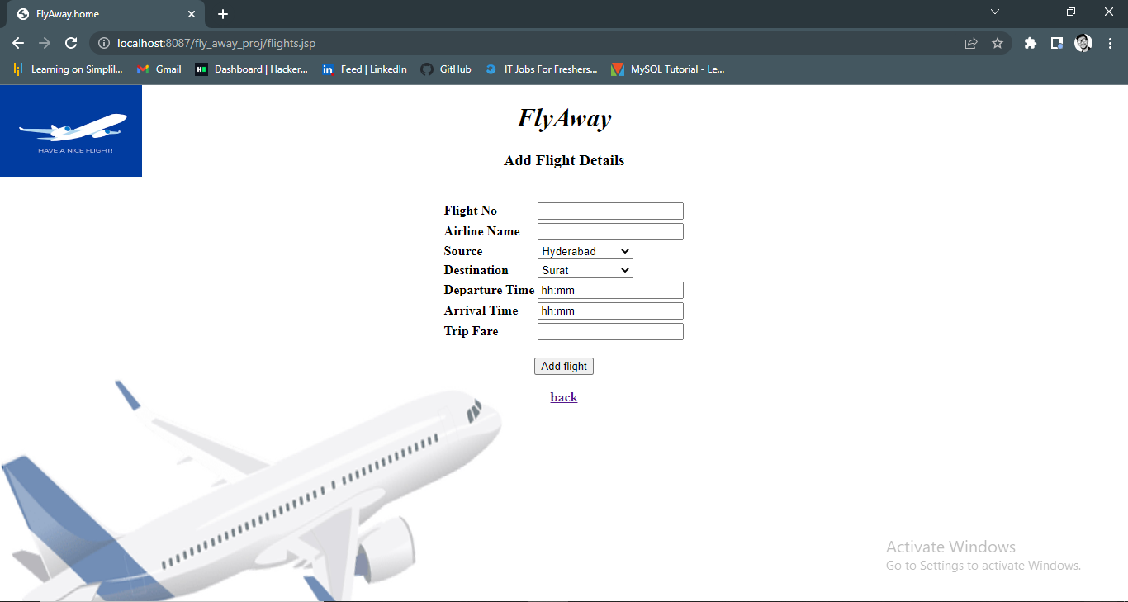

10.for deleting flight details from database ,flight no is entered.

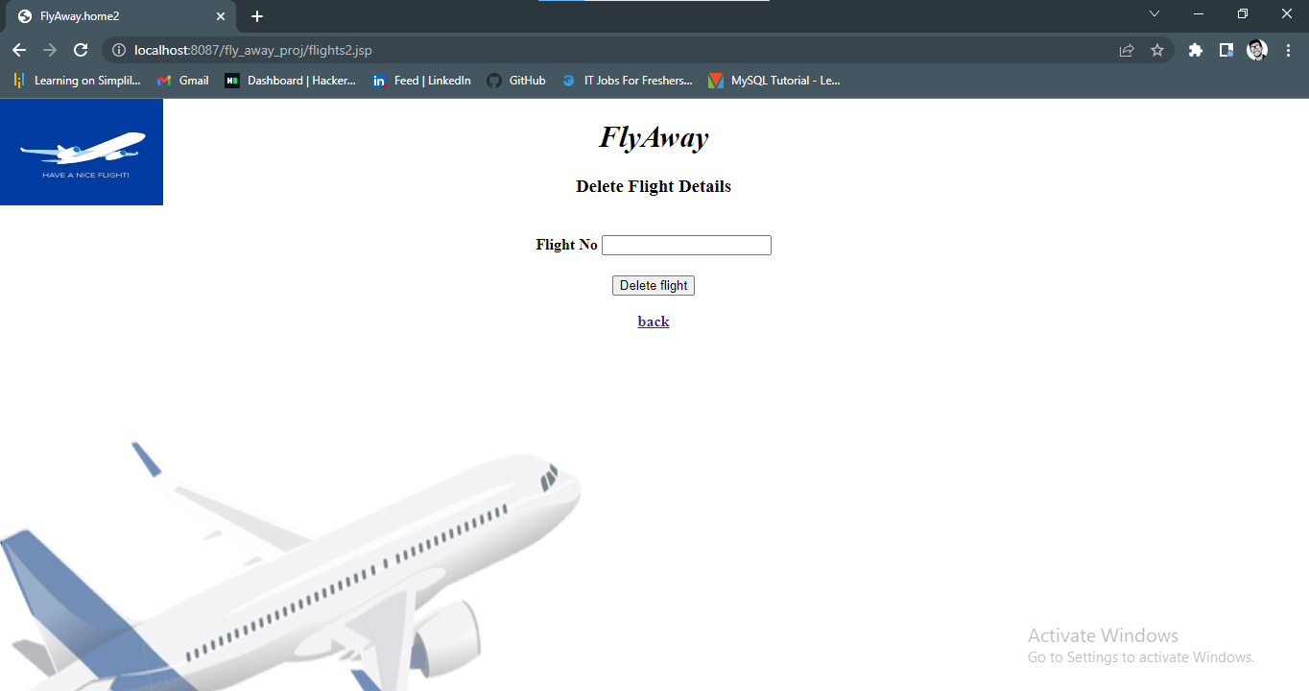

11.if logout link is clicked on dashboard it is redirected to home page.

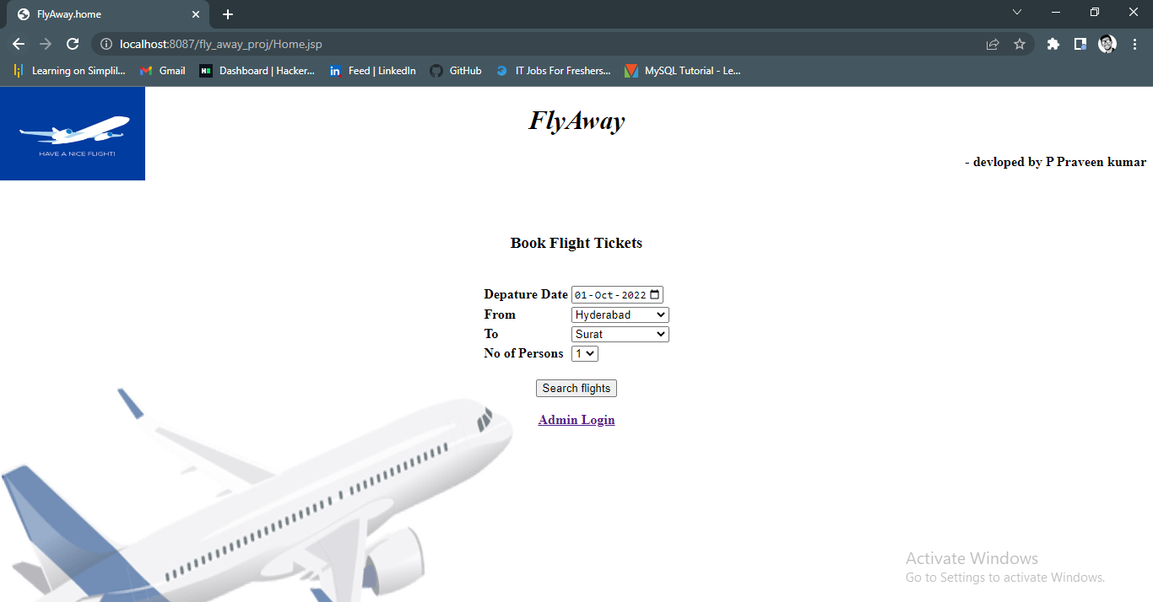

**Database**

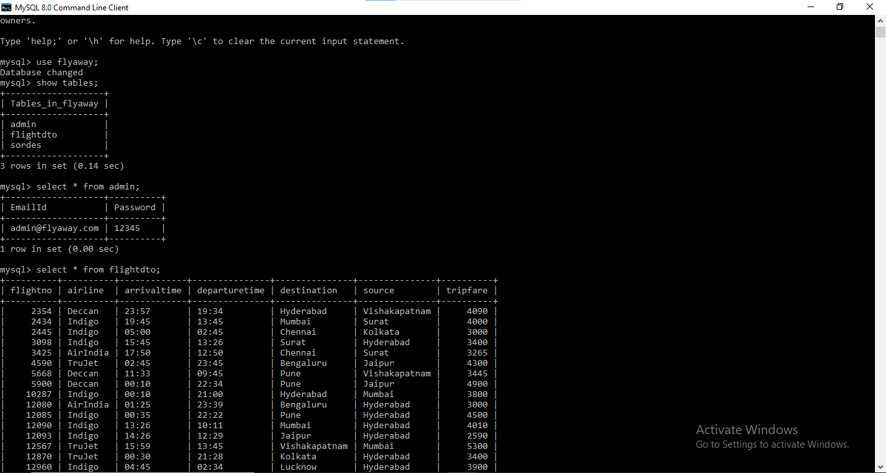

**Files**

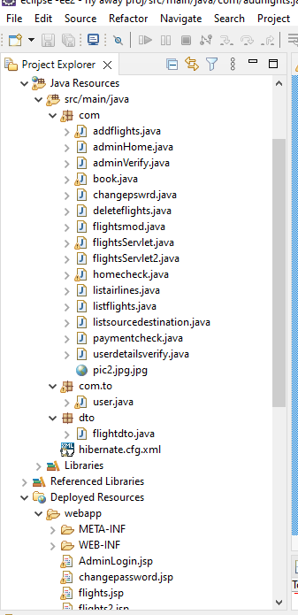

**Pushing to GitHub**

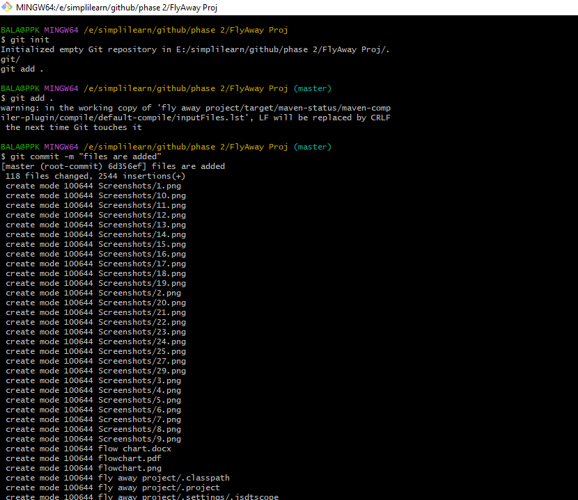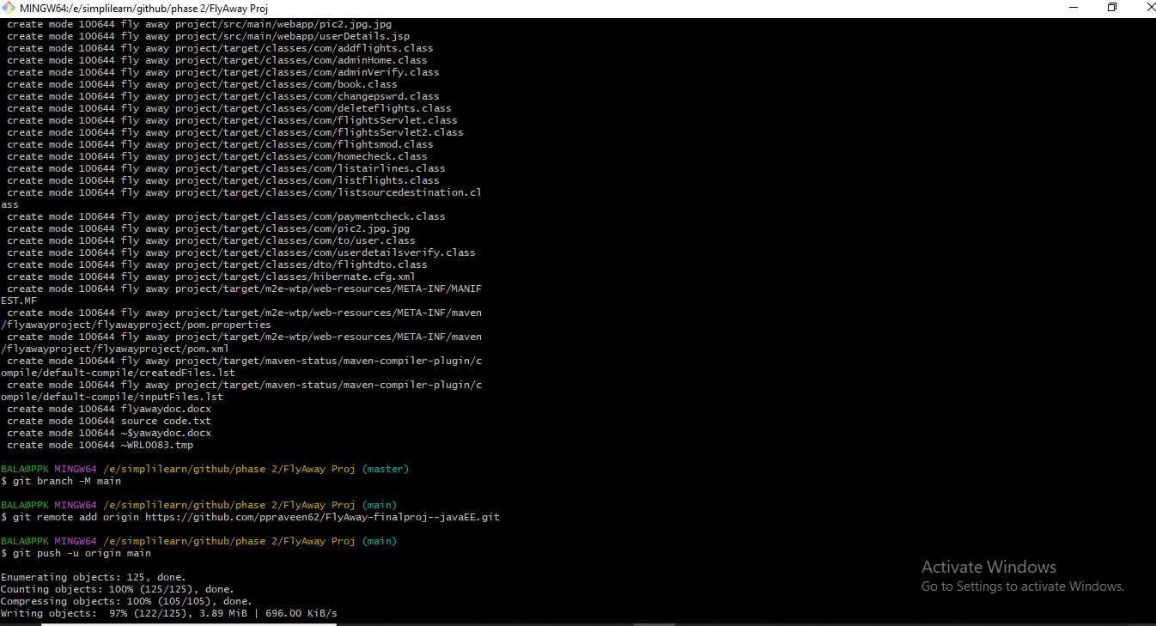

**Links to the GitHub repository to verify the project completion**

[**https://github.com/ppraveen62/FlyAway-finalproj--javaEE.git**](https://github.com/ppraveen62/FlyAway-finalproj--javaEE.git)

**Conclusion:**

The Web application is prepared according to the **provided flow and features of the application and everything followed according to the instructions.**