**Building A Restaurant Website With Bootstrap**

**Project and developer details**

**Project objective:**

Build a responsive website for a restaurant where users can read the details of the restaurant.’

**Background of the problem statement:**

You are a web developer at a service-based web development company called Kite Technologies. The company has been approached by a client who wants to build a website for their restaurant named Ming’s Diner. The website should provide the users a brief overview of the restaurant and its bestsellers, its address, as well as an option to contact the restaurant. During sprint planning, you agree to lead this project and develop the website.

The following requirements should be met:

● The website should be responsive.

● The website should have a carousel, a navbar, a CTA button, a grid, and a footer.

● The website should have a contact form.

**Developer Details**: P Praveen Kumar

Ppraveen62.ppk@gmail.com

9502646206

Ming’sDiner.html:

<!DOCTYPE html>

<html lang="en">

<head>

    <meta charset="UTF-8">

    <meta name="viewport" content="width=device-width, initial-scale=1.0">

    <title>Ming’s Diner</title>

    <link rel="stylesheet" href="https://cdn.jsdelivr.net/npm/bootstrap@4.6.2/dist/css/bootstrap.min.css" integrity="sha384-xOolHFLEh07PJGoPkLv1IbcEPTNtaed2xpHsD9ESMhqIYd0nLMwNLD69Npy4HI+N" crossorigin="anonymous">

    <script src="https://cdn.jsdelivr.net/npm/jquery@3.5.1/dist/jquery.slim.min.js" integrity="sha384-DfXdz2htPH0lsSSs5nCTpuj/zy4C+OGpamoFVy38MVBnE+IbbVYUew+OrCXaRkfj" crossorigin="anonymous"></script>

    <script src="https://cdn.jsdelivr.net/npm/bootstrap@4.6.2/dist/js/bootstrap.bundle.min.js" integrity="sha384-Fy6S3B9q64WdZWQUiU+q4/2Lc9npb8tCaSX9FK7E8HnRr0Jz8D6OP9dO5Vg3Q9ct" crossorigin="anonymous"></script>

    <link rel="stylesheet" href="C:\Users\BALA\Documents\VS Code Frontend\BuilidingArestuarntWeb\css\Ming'sDiner.css">

</head>

<body>

    <div class="container-fluid">

        <header>

            <div>

                <h1>Ming’s Dinner</h1>

                <nav class="navbar navbar-expand-md navbar-dark bg-dark">

                    <div class="collapse navbar-collapse" id="navbarSupportedContent">

                      <ul class="navbar-nav mr-auto">

                        <li class="nav-item active">

                          <a class="nav-link" href="#">Home<span class="sr-only">(current)</span></a>

                        </li>

                        <li class="nav-item">

                            <a class="nav-link" href="#">Food Odering</a>

                          </li>

                        <li class="nav-item">

                          <a class="nav-link" href="#">Restaurant Services</a>

                        </li>

                        </li>

                        <li class="nav-item">

                          <a class="nav-link" href="#">Pricing</a>

                        </li>

                      </ul>

                      <form class="form-inline my-2 my-lg-0">

                        <input class="form-control mr-sm-2" type="search" placeholder="Search" aria-label="Search">

                        <button class="btn btn-outline-success my-2 my-sm-0" type="submit">Search</button>

                      </form>

                    </div>

                  </nav>

                  <div id="carouselExampleIndicators" class="carousel slide" data-ride="carousel">

                    <ol class="carousel-indicators">

                      <li data-target="#carouselExampleIndicators" data-slide-to="0" class="active"></li>

                      <li data-target="#carouselExampleIndicators" data-slide-to="1"></li>

                      <li data-target="#carouselExampleIndicators" data-slide-to="2"></li>

                    </ol>

                    <div class="carousel-inner">

                      <div class="carousel-item active">

                        <img class="d-block w-100" src="C:\Users\BALA\Documents\VS Code Frontend\BuilidingArestuarntWeb\images\indian food.jpg" alt="First slide" height="400">

                        <div class="carousel-caption d-none d-md-block">

                            <h5>Indian Dishes</h5>

                        </div>

                      </div>

                      <div class="carousel-item">

                        <img class="d-block w-100" src="C:\Users\BALA\Documents\VS Code Frontend\BuilidingArestuarntWeb\images\itallian.jpg" alt="Second slide" height="400">

                        <div class="carousel-caption d-none d-md-block">

                            <h5>Itallian Dishes</h5>

                        </div>

                      </div>

                      <div class="carousel-item">

                        <img class="d-block w-100" src="C:\Users\BALA\Documents\VS Code Frontend\BuilidingArestuarntWeb\images\ice-cream-factory-heladeria.jpg" alt="Third slide" height="400">

                        <div class="carousel-caption d-none d-md-block">

                            <h5>Icecreams</h5>

                        </div>

                      </div>

                    </div>

                    <a class="carousel-control-prev" href="#carouselExampleIndicators" role="button" data-slide="prev">

                      <span class="carousel-control-prev-icon" aria-hidden="true"></span>

                      <span class="sr-only">Previous</span>

                    </a>

                    <a class="carousel-control-next" href="#carouselExampleIndicators" role="button" data-slide="next">

                      <span class="carousel-control-next-icon" aria-hidden="true"></span>

                      <span class="sr-only">Next</span>

                    </a>

                  </div>

        </header>

        <section>

            <div>

              <div class="s1">

                <p>Ming’s Dinner means freedom or liberation. It also means to attain the highest level of satisfaction.</p>

                <p>India is famous for its exotic cuisine prepared with artful and exquisite combinations of spices.

                  All our chefs are trained in and recruited from India – they have great knowledge of Indian cuisine

                  and a passion for the food that they prepare.</p>

                <p>At Ming’s Dinner, the chefs provide our guests with the authentic cuisine from North India,

                  famous for its savoury clay oven dishes and exotic curries.  We cater especially for families

                  and prepare each individual meal just the way you like it: mild, medium or hot.

                  We also cater for private functions, birthdays and corporate functions.</p>

                <p>Ming’s Dinner guarantees you the freshest and finest ingredients of India. We believe that

                  “The quality of food lies in the honesty of its ingredients.” All our food is prepared from scratch

                  on the premises, so no preservatives are used.  We strive to achieve the highest level of satisfaction

                  with the best quality food and excellent service.</p>

              </div>

              <div class="s2">

                <h3 id="hd">Contact Form</h3>

                <form class="cf">

                  <input type="text" id="input-name" placeholder="Name">

                  <input type="email" id="input-email" placeholder="Email address">

                  <input type="number" id="input-number" placeholder="number">

                  <textarea name="message" type="text" id="input-message" placeholder="Message"></textarea>

                  <input type="submit" value="Submit" id="input-submit">

                </form>

              </div>

            </div>

        </section>

        <footer>

            <div>

              <div class="menu1">(c)Copyright PPK

                <p>Contact us for more info</p>

                <ul><li>9502646206</li>

                    <li>ppraveen62.ppk@gmail.com</li>

                </ul>

              </div>

              <div class="menu2">

                <ul id="lis"><li><a href="#">Home</a></li>

                    <li><a href="#">Food Odering</a></li>

                    <li><a href="#">Restaurant Services</a></li>

                    <li><a href="#">Pricing</a></li></ul>

              </div>

            </div>

        </footer>

    </div>

</body>

</html>

Ming’sDiner.css:

.container-fluid{

    background-color:ghostwhite;

  }

  .carousel-inner{

    border-left:200px solid silver;

    border-right:200px solid silver;

  }

  h5{

      font-weight: bold;

  }

  h1{

      padding-left: 10px;

  }

  footer{

    background-color: rgb(43, 42, 42);

    color: white;

    padding: 10px;

  }

  .menu1{

    width:66%;

    display:inline-block;

  }

  .menu2{

    width:33%;

    display:inline-block;

  }

  #lis{

    list-style:none;

  }

  a{

    color: whitesmoke;

  }

  p{

    text-align: justify;

  }

  .s1{

    width:60%;

    display:inline-block;

    padding: 20px;

  }

  .s2{

    width:30%;

    display:inline-block;

    padding-bottom: 20px;

  }

  #hd{

    text-align: center;

  }

  .cf{

    padding: 30px;

  }

  input, textarea {

    width:100%;

  }

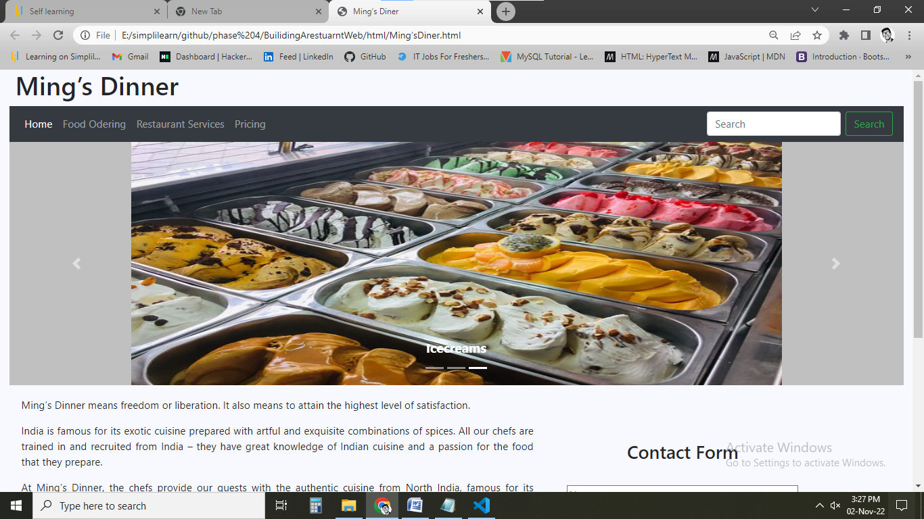

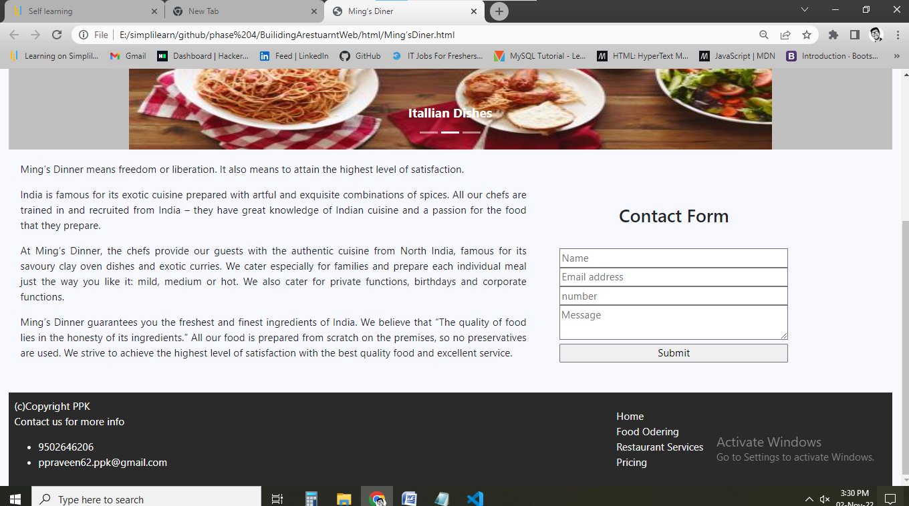

**Pushing to GitHub**

**Links to the GitHub repository to verify the project completion**

[https://github.com/ppraveen62/Mings-Diner-Bootstrap-website-proj.git](https://github.com/ppraveen62/Mings-Diner-Bootstrap-website-proj.git%09)

