**Project objective:**  
Create a servlet-based application that shows a form to enter a product ID. The product ID is then validated, and product details are retrieved from the database and displayed to the user. You need to create a product table in MySQL and prepopulate it with data. Use JDBC to do all database processing.

**Background of the problem statement:**  
As a part of developing an e-commerce web application, the admin backend requires a module that can retrieve product information based on the product ID.

**Code:**

**Sreach.html**

<!DOCTYPE html>

<html>

<head>

<meta charset=*"UTF-8"*>

<title>Insert title here</title>

</head>

<body>

<div align=*"center"*>

<h2>Welcome</h2>

<form action=*"idSearch"* method =*"post"*><br>

Enter Product ID <input type =*"number"* name=*"uid"* >

<input type=*"submit"* value=*"Search"*>

</form>

</div>

</body>

</html>

**idSreach.java**

package com;

import java.io.IOException;

import java.io.PrintWriter;

import java.sql.Connection;

import java.sql.DriverManager;

import java.sql.ResultSet;

import java.sql.Statement;

import javax.servlet.RequestDispatcher;

import javax.servlet.ServletException;

import javax.servlet.http.HttpServlet;

import javax.servlet.http.HttpServletRequest;

import javax.servlet.http.HttpServletResponse;

public class idSearch extends HttpServlet {

private static final long serialVersionUID = 1L;

public idSearch() {

super();

// TODO Auto-generated constructor stub

}

protected void doGet(HttpServletRequest request, HttpServletResponse response) throws ServletException, IOException {

try {

int id = Integer.parseInt(request.getParameter("uid"));

PrintWriter out = response.getWriter();

Class.forName("com.mysql.cj.jdbc.Driver");

Connection con= DriverManager.getConnection("jdbc:mysql://localhost:3306/ecommerce","root","root");

Statement smt=con.createStatement();

ResultSet rs=smt.executeQuery("select * from eproduct");

int i=0;

while(rs.next()) {

if (rs.getInt("ID")==id) {

i+=1;

out.println("Product ID: "+id+"<br>");

out.println("Name of product: "+rs.getString("name")+"<br>");

out.println("Price of product: "+rs.getInt("price")+"<br>");

out.println("Date of product Added: "+rs.getDate("date_added")+"<br>");

}

}

smt.close();

con.close();

if (i==0) {

RequestDispatcher rd =request.getRequestDispatcher("sreach.html");

rd.include(request, response);

out.println("<center> <span style = 'color:red'> ID - "+id+" Invalid, Not Found In Database </span> </center>");

}

}

catch (Exception e){

System.out.println(e);

}

}

protected void doPost(HttpServletRequest request, HttpServletResponse response) throws ServletException, IOException {

// TODO Auto-generated method stub

doGet(request, response);

}

}

HTML page to take in a product ID

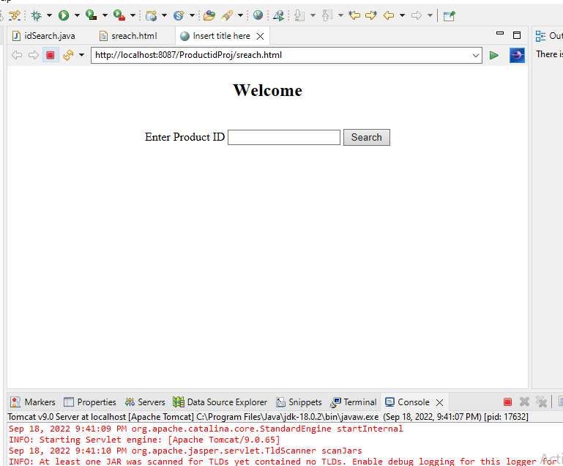

Database for the product

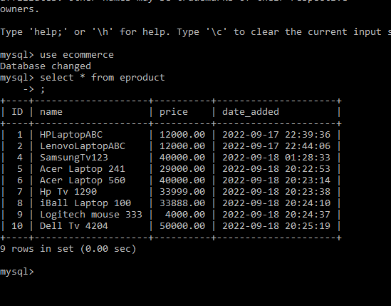

If the product is found, the servlet will display the product details, otherwise it will show an error message

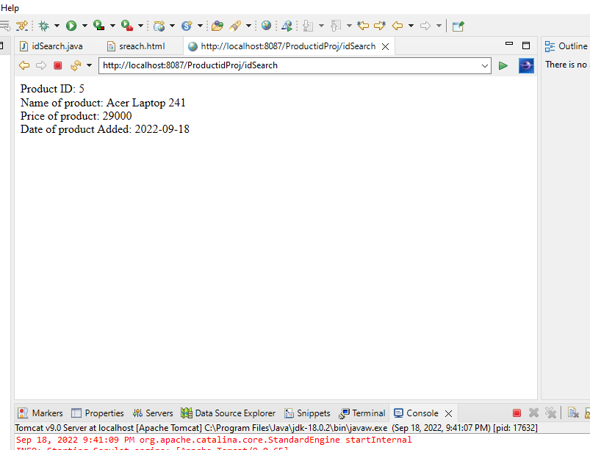

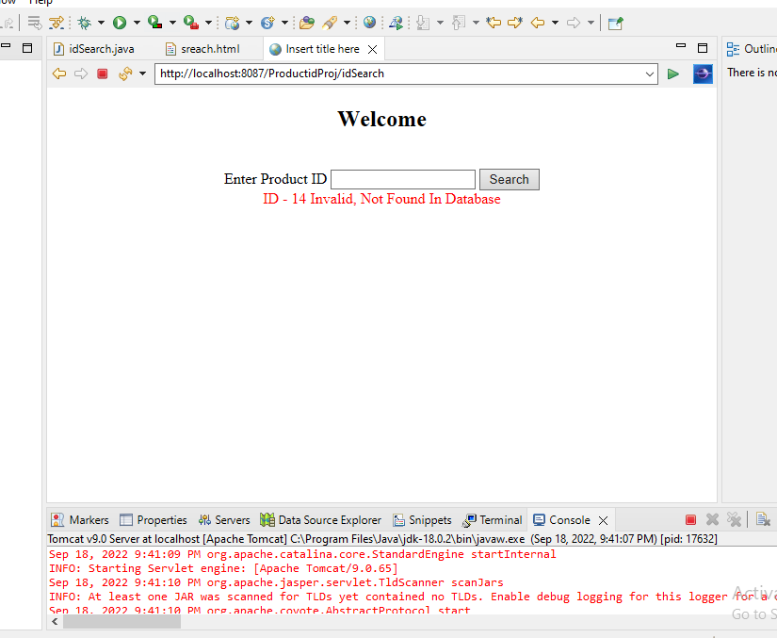

**Pushing to GitHub**