**Product Details Portal.**

**DESCRIPTION**

Create a servlet-based web application that shows a form to enter product details. Capture the details in a servlet and then display the data that was entered.

**Background of the problem statement:**  
As a part of developing an ecommerce web application, you have to prototype a form for adding products into the system entered by the users. There is no database involved here, so  
the product is just captured and displayed without storing it anywhere.

**Code:**

**form.jsp**

<%@ page language=*"java"* contentType=*"text/html; charset=UTF-8"*

pageEncoding=*"UTF-8"*%>

<!DOCTYPE html>

<html>

<head>

<meta charset=*"UTF-8"*>

<title>welcome</title>

</head>

<body>

<div align=*"center"*>

<h2>PRODUCT DETAILS PORTAL</h2>

<form action=*""* method =*"post"*><br>

Product ID <input type =*"number"* name=*"uid"* ><br>

<br>

Product Name <input type =*"text"* name=*"uname"* ><br>

<br>

Product Price <input type =*"number"* name=*"uprice"* ><br>

<br>

Seller Details <input type =*"text"* name=*"usd"* ><br>

<br>

<input type=*"submit"* name =*"add"* value=*"Submit"*>

</form>

<% **if**(request.getParameter("add") != **null**) {%>

<jsp:useBean id=*"product"* class=*"com.product"* scope=*"request"*></jsp:useBean>

<jsp:setProperty property=*"*"* name=*"product"*/>

<jsp:forward page=*"displayServlet"*></jsp:forward>

<% } %>

</div>

</body>

</html>

**Product.java**

**package** com;

**public** **class** product {

**public** **int** uid;

**public** String uname;

**public** **int** uprice;

**public** String usd;

**public** product() {

**super**();

}

**public** **int** getUid() {

**return** uid;

}

**public** **void** setUid(**int** uid) {

**this**.uid = uid;

}

**public** String getUname() {

**return** uname;

}

**public** **void** setUname(String uname) {

**this**.uname = uname;

}

**public** **int** getUprice() {

**return** uprice;

}

**public** **void** setUprice(**int** uprice) {

**this**.uprice = uprice;

}

**public** String getUsd() {

**return** usd;

}

**public** **void** setUsd(String usd) {

**this**.usd = usd;

}

@Override

**public** String toString() {

**return** "product [uid=" + uid + ", uname=" + uname + ", uprice=" + uprice + ", usd=" + usd + "]";

}

}

**displayServlet.java**

package com;

import java.io.IOException;

import java.io.PrintWriter;

import javax.servlet.ServletException;

import javax.servlet.http.HttpServlet;

import javax.servlet.http.HttpServletRequest;

import javax.servlet.http.HttpServletResponse;

/**

* Servlet implementation class displayServlet

*/

public class displayServlet extends HttpServlet {

private static final long serialVersionUID = 1L;

/**

* @see HttpServlet#HttpServlet()

*/

public displayServlet() {

super();

// TODO Auto-generated constructor stub

}

/**

* @see HttpServlet#service(HttpServletRequest request, HttpServletResponse response)

*/

protected void service(HttpServletRequest request, HttpServletResponse response) throws ServletException, IOException {

PrintWriter out = response.getWriter();

product obj = (product) request.getAttribute("product");

out.println("<h1>Product Details<h1>");

out.print("<h3>Id: "+obj.getUid());

out.print("<h3>Name: "+obj.getUname());

out.print("<h3>Price: "+obj.getUprice());

out.print("<h3>Seller: "+obj.getUsd());

}

}\

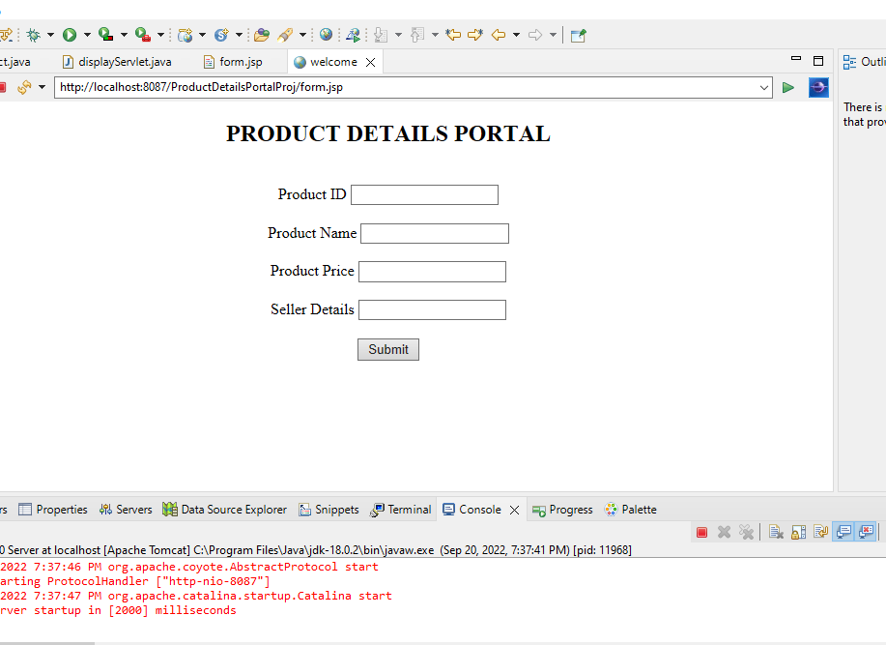

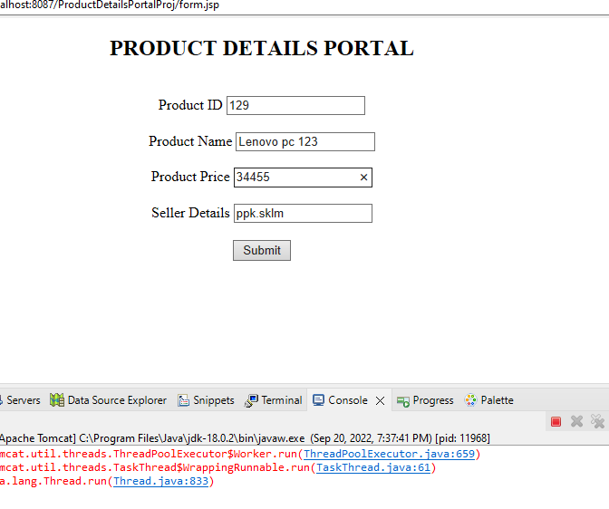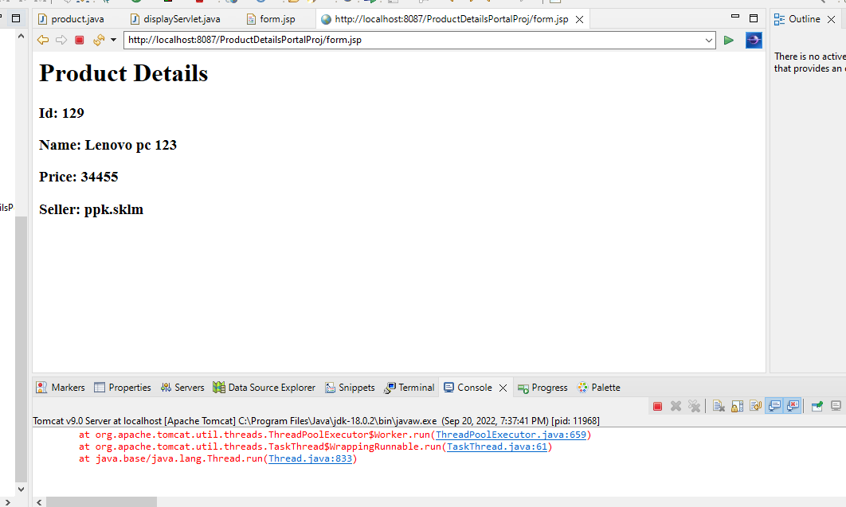

**Pushing to GitHub**