**Online Test Application**

DESCRIPTION

The Online Test Application system creates an application that enables users to provide online tests, review them, and display the results.

**System Details**  
This system contains three main modules: Quiz, Review, and Result. The quiz section of the online test application accepts the questions in JSON format. The JSON file can be easily shared from the server in the pre-defined format. The application renders the test at the client-side.  
The “Review and display result” section allows users to declare the results immediately. You can simply call another JSON with the answers in it and evaluate and display the results immediately.

**Developer Details**: P Praveen Kumar

Ppraveen62.ppk@gmail.com

9502646206

**Code**

**Index.html**

<!doctype html>

<html lang="en">

<head>

  <meta charset="utf-8">

  <title>QuizProj</title>

  <base href="/">

  <meta name="viewport" content="width=device-width, initial-scale=1">

  <link rel="icon" type="image/x-icon" href="favicon.ico">

  <link rel="stylesheet" href="https://cdn.jsdelivr.net/npm/bootstrap@4.6.2/dist/css/bootstrap.min.css" integrity="sha384-xOolHFLEh07PJGoPkLv1IbcEPTNtaed2xpHsD9ESMhqIYd0nLMwNLD69Npy4HI+N" crossorigin="anonymous">

  <script src="https://cdn.jsdelivr.net/npm/jquery@3.5.1/dist/jquery.slim.min.js" integrity="sha384-DfXdz2htPH0lsSSs5nCTpuj/zy4C+OGpamoFVy38MVBnE+IbbVYUew+OrCXaRkfj" crossorigin="anonymous"></script>

<script src="https://cdn.jsdelivr.net/npm/bootstrap@4.6.2/dist/js/bootstrap.bundle.min.js" integrity="sha384-Fy6S3B9q64WdZWQUiU+q4/2Lc9npb8tCaSX9FK7E8HnRr0Jz8D6OP9dO5Vg3Q9ct" crossorigin="anonymous"></script>

</head>

<body>

  <div class="id">

    <app-root></app-root>

  </div>

</body>

</html>

**Styles.css**

html {

    height: 100%;

}

body {

    height: 100%;

    margin: 0;

    font-family: Arial, Helvetica, sans-serif;

    background-color:#0a0845;

}

app-root{

    margin: 10%;

    width: 80%;

    height: 80%;

    display: grid;

    align-items: center;

    padding: 50px;

    background-color: #cecdd0;

    border-radius: 20px;

}

**questions.json**

[

  {

    "questionNo":1,

    "questionDesc": "Which country hosted the 2018 FIFA World Cup?",

    "choice1": "Russia",

    "choice2": "Saudi Arabia",

    "choice3": "US",

    "choice4": "India"

  },

  {

    "questionNo":2,

    "questionDesc": "Who won the 2015 Formula 1 World Championship?",

    "choice1": "Nico Rosberg",

    "choice2": "Sebastian Vettel",

    "choice3": "Lewis Hamilton",

    "choice4": "Jenson Button"

  },

  {

    "questionNo":3,

    "questionDesc": "Who won the 2011 Cricket World Cup?",

    "choice1": "Pakistan",

    "choice2": "Sri Lanka",

    "choice3": "New Zealand",

    "choice4": "India"

  },

  {

    "questionNo":4,

    "questionDesc": "Who won the UEFA Champions League in 2019?",

    "choice1": "Real Madrid",

    "choice2": "Liverpool",

    "choice3": "Barcelona",

    "choice4": "Tottenham"

  },

  {

    "questionNo":5,

    "questionDesc": "Which player holds the NHL record of 2,857 points?",

    "choice1": "Sidney Crosby",

    "choice2": "Mario Lemieux",

    "choice3": "Gordie Howe",

    "choice4": "Wayne Gretzky"

  }

]

**answers.json**

[

    {

        "questionNo":1,

        "answer": "A"

      },

      {

        "questionNo":2,

        "answer": "C"

      },

      {

        "questionNo":3,

        "answer": "D"

      },

      {

        "questionNo":4,

        "answer": "B"

      },

      {

        "questionNo":5,

        "answer": "D"

      }

]

**app.component.html**

<div class="box">

  <router-outlet></router-outlet>

</div>

**app.component.css**

.box{

    position:center;

}

**app.module.ts**

import { NgModule } from '@angular/core';

import { BrowserModule } from '@angular/platform-browser';

import { AppRoutingModule } from './app-routing.module';

import { AppComponent } from './app.component';

import { StatQuizComponent } from './stat-quiz/stat-quiz.component';

import { HomeComponent } from './home/home.component';

import { FormsModule } from '@angular/forms';

import { FinishComponent } from './finish/finish.component';

@NgModule({

  declarations: [

    AppComponent,

    StatQuizComponent,

    HomeComponent,

    FinishComponent

  ],

  imports: [

    BrowserModule,

    AppRoutingModule,

    FormsModule

  ],

  providers: [],

  bootstrap: [AppComponent]

})

export class AppModule { }

**app-routing-module.ts**

import { NgModule } from '@angular/core';

import { BrowserModule } from '@angular/platform-browser';

import { AppRoutingModule } from './app-routing.module';

import { AppComponent } from './app.component';

import { StatQuizComponent } from './stat-quiz/stat-quiz.component';

import { HomeComponent } from './home/home.component';

import { FormsModule } from '@angular/forms';

import { FinishComponent } from './finish/finish.component';

@NgModule({

  declarations: [

    AppComponent,

    StatQuizComponent,

    HomeComponent,

    FinishComponent

  ],

  imports: [

    BrowserModule,

    AppRoutingModule,

    FormsModule

  ],

  providers: [],

  bootstrap: [AppComponent]

})

export class AppModule { }

**stat-quiz.component.html**

<div>

  <div id="quiz" class="justify-center flex-column">

    <p id="countdown">{{Minutes}}:{{Seconds}}</p>

    <div id="hud">

      <div id="hud-item">

        <p class="hud-prefix">Question</p>

        <h3 class="hud-text" id="questionNo">{{qsn[i].questionNo}}/{{qsn.length}}</h3>

      </div>

    </div>

    <p id="question">{{qsn[i].questionDesc}}</p>

    <div class="choicebox">

      <input type="radio" class="radioButton" id="a" name="choice" [(ngModel)]="choiceRes" (click)="RadioHandler($event)" value="A">

      <label for="A" class="choice-text">{{qsn[i].choice1}}</label>

    </div>

    <div class="choicebox">

      <input type="radio" class="radioButton" id="b" name="choice" [(ngModel)]="choiceRes" (click)="RadioHandler($event)" value="B">

      <label for="B" class="choice-text">{{qsn[i].choice2}}</label>

    </div>

    <div class="choicebox">

      <input type="radio" class="radioButton" id="c" name="choice" [(ngModel)]="choiceRes" (click)="RadioHandler($event)" value="C">

      <label for="C" class="choice-text">{{qsn[i].choice3}}</label>

    </div>

    <div class="choicebox">

      <input type="radio" class="radioButton" id="d" name="choice" [(ngModel)]="choiceRes" (click)="RadioHandler($event)" value="D">

      <label for="D" class="choice-text">{{qsn[i].choice4}}</label>

    </div>

  </div>

</div>

<div class="finishBox">

  <div class="f1box">

    <button type="button" disabled class="click" id="submitOption" (click)="submit()" routerLink="/finish">Submit</button>

  </div>

  <div class="f2box">

    <button type="button" disabled class="click" id="previousOption" (click)="previousQuestion()">Prev</button>

    <button type="button" class="click" id="nextOption" (click)="nextQuestion()">Next</button>

  </div>

</div>

**stat-quiz.component.css**

  .container{

    max-width: fit-content;

      margin: 0 auto;

  }

  .choicebox{

    display: flex;

    align-items:baseline;

    background-color:#030313;

    border-radius: 15px;

    color: whitesmoke;

    margin-bottom: 1rem;

    padding-left: 10px;

    padding-top: 10px;

    padding-right: 10px;

    font-weight:normal;

  }

  .choicebox:hover {

    color:dodgerblue;

    box-shadow: 0 0.4rem 1rem 0 dodgerblue;

    transform: translateY(-0.1rem);

    transition: transform 150ms;

  }

  .radioButton{

    font-family: system-ui, sans-serif;

    font-size: 2rem;

    font-weight: bold;

    line-height: 1.1;

    display: grid;

    grid-template-columns: 1em auto;

    cursor: pointer;

  }

  .choice-text{

    padding-left: 10px;

    background-color: #030313;

  }

  #hud {

    display: inline-block;

    justify-content: space-between;

    text-transform: uppercase;

  }

  .hud-prefix {

    text-align: center;

    font-size: 1.5rem;

  }

  .hud-text {

    color: firebrick;

    font-weight: bolder;

    text-align: center;

    text-justify:auto

  }

  #question{

    font-size: 1.5rem;

    font-weight: normal;

    text-align:left;

    width:100%;

  }

  .click{

    border-radius: 10px;

    background-color: rgb(3, 3, 46);

    border-color:rgb(3, 3, 46);

    color: white;

    margin-right: 10px;

  }

  .click:hover{

    background-color:seagreen;

    border-color:seagreen;

    box-shadow: 0 0.4rem 1rem 0 yellowgreen;

    transform: translateY(-0.1rem);

    transition: transform 150ms;

  }

  .click[disabled]:hover{

    background-color:firebrick;

    border-color:firebrick;

    box-shadow: 0 0.4rem 1rem 0 tomato;

    transform: translateY(-0.1rem);

    transition: transform 150ms;

    cursor: not-allowed;

  }

  .f1box{

    float: right;

  }

  #countdown{

    text-align: right;

    padding-left: 10px;

    padding-right: 1opx;

    padding: 2px;

    color:black;

    font-weight: 600;

    font-size: xx-large;

  }

**stat-quiz.component.ts**

import { FinishComponent } from './../finish/finish.component';

import { Component, EventEmitter, OnInit, Output } from '@angular/core';

import questionData from '../../assets/questions.json';

import answerData from '../../assets/answers.json';

import { interval, Subscription, takeUntil, timeout, timer } from 'rxjs';

import { Router, RouterLink } from '@angular/router';

interface question {

  questionNo: Number,

  questionDesc: String,

  choice1: String,

  choice2: String,

  choice3: String,

  choice4: String,

}

interface answer {

  questionNo: Number,

  answer: String,

}

@Component({

  selector: 'app-stat-quiz',

  templateUrl: './stat-quiz.component.html',

  styleUrls: ['./stat-quiz.component.css']

}

)

export class StatQuizComponent implements OnInit {

  qsn: question[] = questionData;

  ans: answer[] = answerData;

  userAnswerlist: String[] = [];

  choiceRes: String = "";

  i: number = 0;

  public static QsnTotal: number = questionData.length;

  public static QsnAnswered: number = 0;

  public static RightAnswered: number = 0;

  //countdown

  startingMinutes: number = 2;

  time: number = this.startingMinutes * 60;

  countdownEl = <HTMLInputElement>document.getElementById("countdown");

  Minutes: any = 0;

  Seconds: any = 0;

  subs: Subscription = new Subscription;

  ///

  constructor(private router: Router) { }

  ngOnInit(): void {

    //

    const obs = interval(1000);

    this.subs = obs.subscribe((d) => {

      const minutes = Math.floor(this.time / 60);

      let seconds = this.time % 60;

      this.Minutes = minutes

      this.Seconds = seconds

      this.time--;

      if ((this.startingMinutes * 60) == d) {

        this.subs.unsubscribe();

        this.submit();

        this.router.navigate(["/finish"])

      }

    })

  }

  reset() {

    let e1 = <HTMLInputElement>document.getElementById('a');

    e1.checked = false

    let e2 = <HTMLInputElement>document.getElementById('b');

    e2.checked = false

    let e3 = <HTMLInputElement>document.getElementById('c');

    e3.checked = false

    let e4 = <HTMLInputElement>document.getElementById('d');

    e4.checked = false

  }

  submit(): void {

    for (let i = 0; i < this.qsn.length; i++) {

      if (this.ans[i].answer == this.userAnswerlist[i]) {

        StatQuizComponent.RightAnswered++;

      }

      if (this.userAnswerlist[i] == "A" || this.userAnswerlist[i] == "B" || this.userAnswerlist[i] == "C" || this.userAnswerlist[i] == "D") {

        StatQuizComponent.QsnAnswered++;

      }

    }

  }

  previousQuestion(): void {

    if (this.i > 0 || this.i < this.qsn.length - 1) {

      this.i--;

    }

    if (this.i != this.qsn.length - 1) {

      let element = <HTMLInputElement>document.getElementById('nextOption');

      element.disabled = false;

    }

    if (this.i == 0) {

      let element = <HTMLInputElement>document.getElementById('previousOption');

      element.disabled = true;

    }

    this.reset();

  }

  nextQuestion(): void {

    if (this.i == 0 || this.i < this.qsn.length - 1) {

      console.log(this.i);

      this.i++;

      let element = <HTMLInputElement>document.getElementById('previousOption');

      element.disabled = false;

    }

    if (this.i == this.qsn.length - 1) {

      let element = <HTMLInputElement>document.getElementById('nextOption');

      element.disabled = true;

    }

    if (this.i == 0) {

      let element = <HTMLInputElement>document.getElementById('previousOption');

      element.disabled = true;

    }

    this.reset();

    if (this.i == this.qsn.length - 1) {

      let element = <HTMLInputElement>document.getElementById('submitOption');

      element.disabled = false;

    }

  }

  RadioHandler(e: any) {

    let answer = e.target.value;

    this.userAnswerlist[this.i] = answer;

    console.log(this.userAnswerlist);

  }

}

**home.component.html**

<div class="startbutton">

    <h1>Are you ready to Start...</h1><br>

</div>

<div class="box">

    <h2 style="text-align:center">Instructions</h2>

    <p class="para">

        1. Read carefully and answer the questions.<br>

        2. There will be a submit Option to complete the Quiz.<br>

        3. Submit option will be enabled on last Question of Quiz.<br>

        4. The total score for the quiz is based on your responses to all questions.<br>

        5. It auto submit on completion of time.<br>

        6.On selecting options it auto saves the given answers.<br>

    </p>

</div>

<div class="startbutton">

    <button type="button"  class="click" id="submitOption" routerLink="/start">Start</button>

</div>

**home.component.css**

.startbutton{

    text-align: center;

    padding: 10px;

}

.click{

    border-radius: 10px;

    background-color: rgb(3, 3, 46);

    border-color:rgb(3, 3, 46);

    color: white;

    padding-left:20px;

    padding-right:20px;

    padding-top:5px;

    padding-bottom:5px;

    font-weight: bold;

  }

  .para{

    font-size:1rem;

    font-weight: bold;

    padding: 20px;

}

.box{

    display:grid;

    background-color:mintcream;

    border-radius: 20px;

}

h2{

    font-weight: bolder;

    color: crimson;

}

h1{

    color: midnightblue;

    font-weight: 900;

    font-style: italic;

}

**home.component.ts**

import { Component, OnInit } from '@angular/core';

@Component({

  selector: 'app-home',

  templateUrl: './home.component.html',

  styleUrls: ['./home.component.css']

})

export class HomeComponent implements OnInit {

  constructor() { }

  ngOnInit(): void {

  }

}

**Finish.component.html**

<h2>Result</h2><br>

<p class="para">

    Total no of questions : <b>{{questionsTotal}}</b><br>

    Total no of questions attempted: <b>{{questionsAnswered}}</b><br>

    Total no of questions answered right : <b>{{rightAnswered}}</b><br>

    Total no of questions answered wrong : <b>{{wrongAnswered}}</b>

</p>

<h3>Score : <b class="score">{{rightAnswered*1}}</b></h3>

<br>

<div class="finish">

    <button type="button" class="click" id="submitOption" (click)="submit()">Done</button>

</div>

**finish.component.css**

.finish{text-align: center;}

.para{

    font-size:1.5rem;

    font-weight: normal;

}

h2{

    text-align: center;

    font-weight:bolder;

    color: midnightblue;

    background-color:cornflowerblue;

    border-radius: 12px;

}

b{

    color: red;

}

.click{

    border-radius: 10px;

    background-color: rgb(3, 3, 46);

    border-color:rgb(3, 3, 46);

    color: white;

    padding-left:20px;

    padding-right:20px;

    padding-top:5px;

    padding-bottom:5px;

    font-weight: bold;

  }

  .score{

    color: midnightblue;

    background-color: springgreen;

    padding: 2px;

    padding-left: 20px;

    padding-right: 20px;

}

**finish.component.ts**

import { Component, OnInit,Input } from '@angular/core';

import { StatQuizComponent } from '../stat-quiz/stat-quiz.component';

@Component({

  selector: 'app-finish',

  templateUrl: './finish.component.html',

  styleUrls: ['./finish.component.css']

})

export class FinishComponent implements OnInit {

  constructor() { }

  ngOnInit(): void {

  }

  questionsTotal:number= StatQuizComponent.QsnTotal;

  questionsAnswered:number=StatQuizComponent.QsnAnswered;

  rightAnswered: number =StatQuizComponent.RightAnswered;

  wrongAnswered: number=StatQuizComponent.QsnAnswered-StatQuizComponent.RightAnswered;

  submit(){

    window.location.replace("");

  }

}

**Path structures**

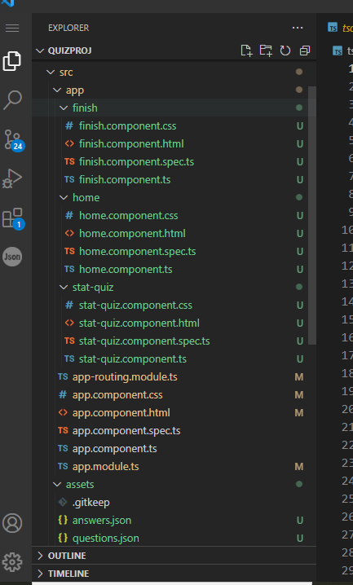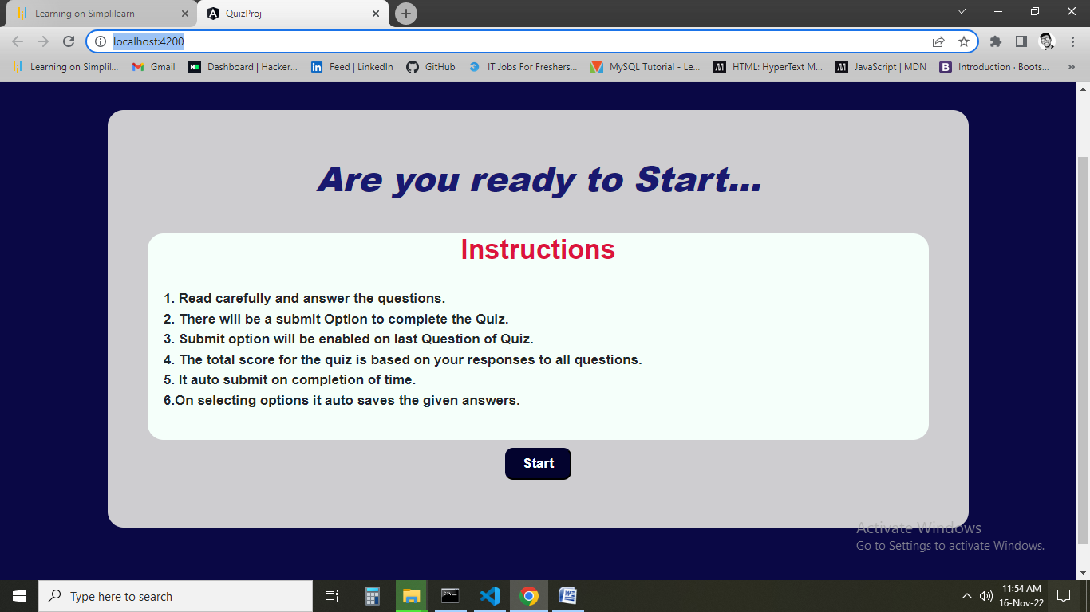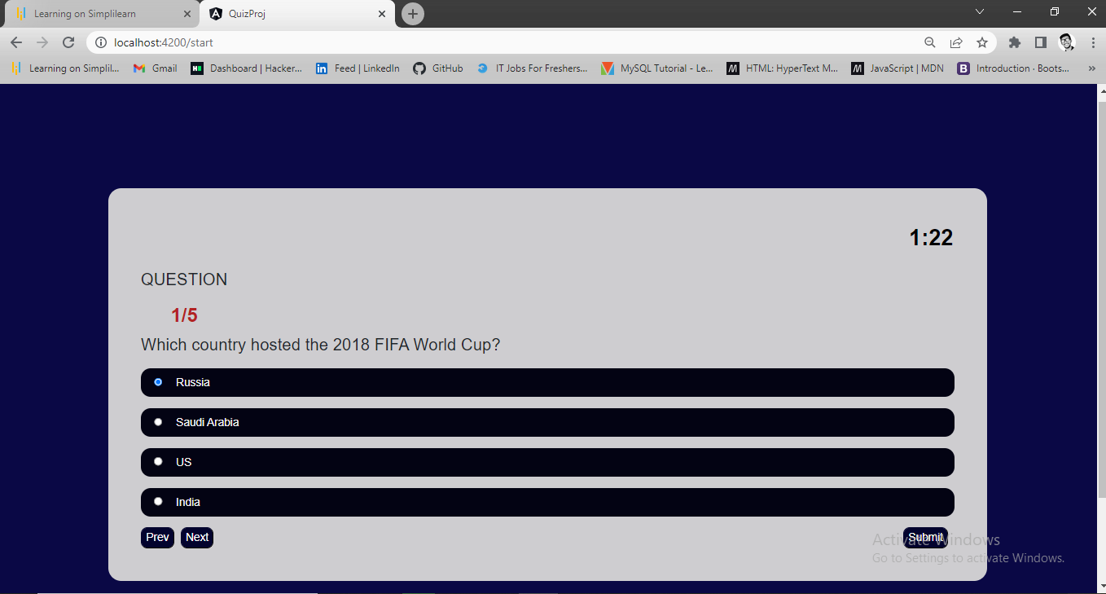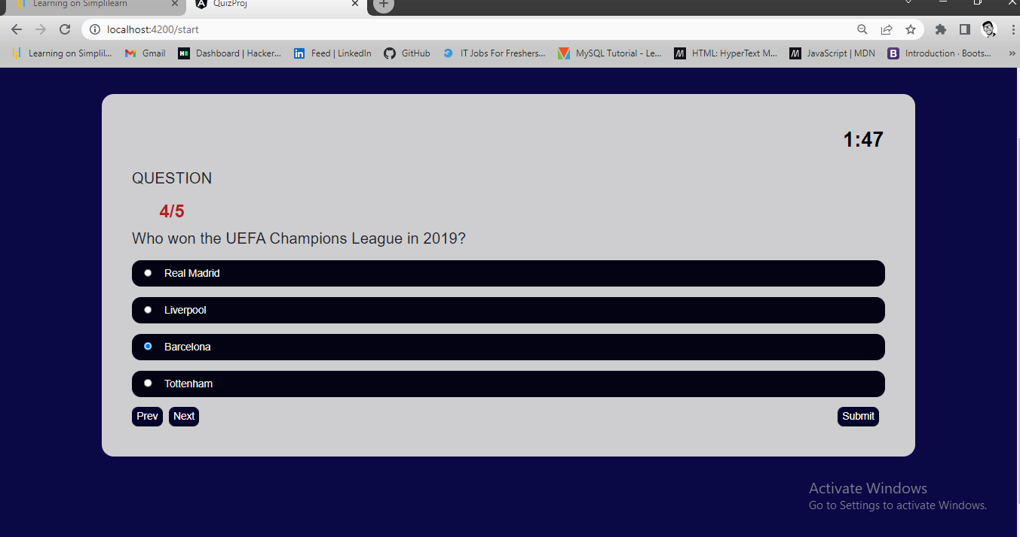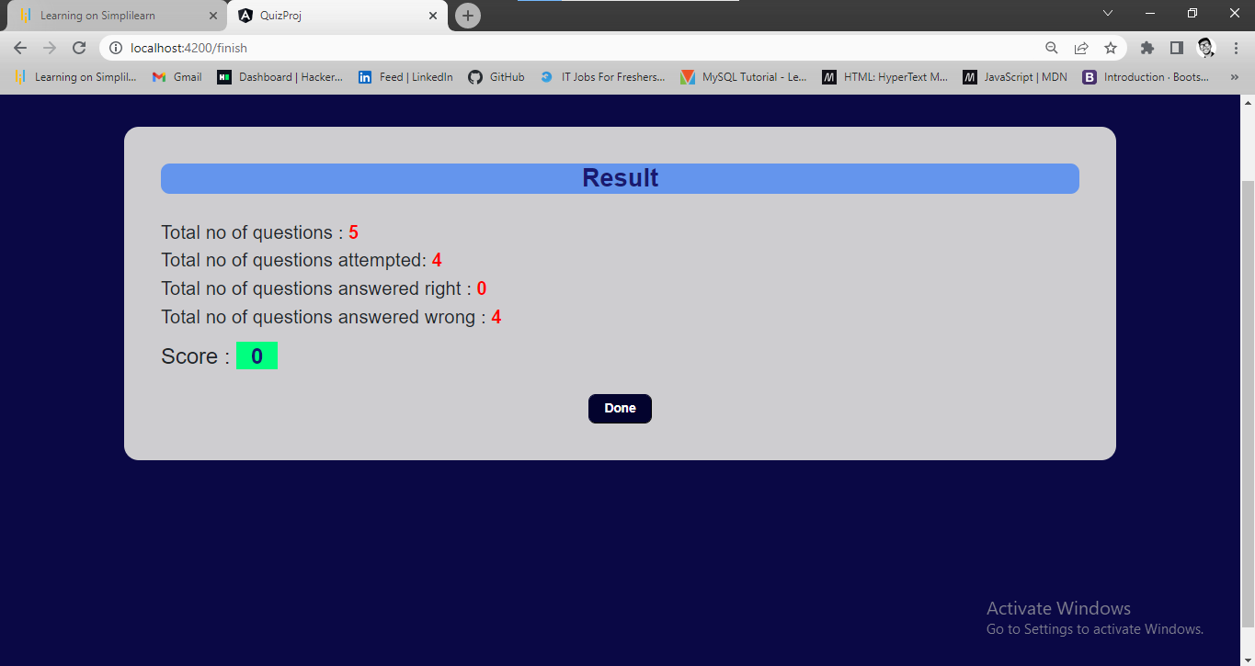

**Another attempt**

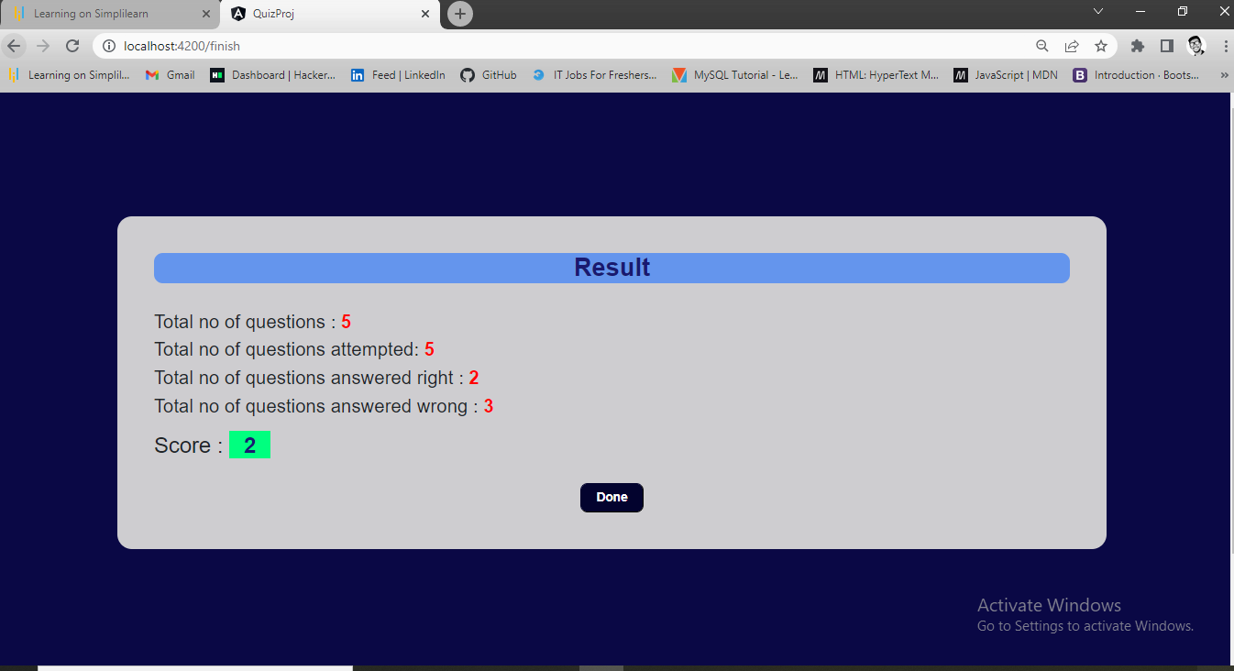

**GitHub Link**

**https://github.com/ppraveen62/QuizProj-final-angular.git**