**Adding a new Product in Database**

**DESCRIPTION**

Create a servlet-based web application that shows a form to add new products. A MySQL database will be created to store product data. The form data will be validated, and a row will be added to the database. All database processing will be done using Hibernate.

**Background of the problem statement:**  
As a part of developing an e-commerce web application, you have to create a database table for storing product information. A form is needed to add new products. The form submission is validated, and a new record is created in the product table.

.

**Code:**

**form.jsp**

<%@ page language=*"java"* contentType=*"text/html; charset=UTF-8"*

pageEncoding=*"UTF-8"*%>

<!DOCTYPE html>

<html>

<head>

<meta charset=*"UTF-8"*>

<title>Add Product</title>

</head>

<body>

<div align=*"center"*>

<h2>ADD PRODUCT DETAILS PORTAL</h2>

<form action=*"addServlet"* method =*"post"*><br>

Product ID <input type =*"number"* name=*"uid"* ><br>

<br>

Product Name <input type =*"text"* name=*"uname"* ><br>

<br>

Product Price <input type =*"number"* name=*"uprice"* ><br>

<br>

Seller Details <input type =*"text"* name=*"usd"* ><br>

<br>

<input type=*"submit"* name =*"add"* value=*"Submit"*>

</form>

<% **if**(request.getParameter("add")!=**null**) { %>

<jsp:useBean id=*"product"* class=*"com.product"* scope=*"request"*></jsp:useBean>

<jsp:setProperty property=*"*"* name=*"product"*/>

<%} %>

</div>

</body>

</html>

**Hibernate.cfg.xml**

<?xml version=*"1.0"* encoding=*"UTF-8"*?>

<!DOCTYPE hibernate-configuration PUBLIC "-//Hibernate/Hibernate Configuration DTD 3.0//EN"

"http://www.hibernate.org/dtd/hibernate-configuration-3.0.dtd">

<hibernate-configuration>

<session-factory name=*""*>

<property name=*"hibernate.connection.driver_class"*>com.mysql.cj.jdbc.Driver</property>

<property name=*"hibernate.connection.password"*>root</property>

<property name=*"hibernate.connection.url"*>jdbc:mysql://localhost:3306/HibernateDemo</property>

<property name=*"hibernate.connection.username"*>root</property>

<property name=*"hibernate.dialect"*>org.hibernate.dialect.MySQL8Dialect</property>

<property name=*"hibernate.show_sql"*>true</property>

<property name=*"hibernate.hbm2ddl.auto"*>update</property>

<mapping class=*"com.product"*/>

</session-factory>

</hibernate-configuration>

**Product.java**

package com;

import javax.persistence.Column;

import javax.persistence.Entity;

import javax.persistence.Id;

import javax.persistence.Table;

@Entity

@Table

public class product {

@Id

@Column(name="Id")

public int uid;

@Column(name="Name")

public String uname;

@Column(name="Price")

public int uprice;

@Column(name="SellerDetails")

public String usd;

public product() {

super();

// TODO Auto-generated constructor stub

}

public int getUid() {

return uid;

}

public void setUid(int uid) {

this.uid = uid;

}

public String getUname() {

return uname;

}

public void setUname(String uname) {

this.uname = uname;

}

public int getUprice() {

return uprice;

}

public void setUprice(int uprice) {

this.uprice = uprice;

}

public String getUsd() {

return usd;

}

public void setUsd(String usd) {

this.usd = usd;

}

@Override

public String toString() {

return "product [uid=" + uid + ", uname=" + uname + ", uprice=" + uprice + ", usd=" + usd + "]";

}

}

**addServlet.java**

package com;

import java.io.IOException;

import java.io.PrintWriter;

import javax.servlet.RequestDispatcher;

import javax.servlet.ServletException;

import javax.servlet.http.HttpServlet;

import javax.servlet.http.HttpServletRequest;

import javax.servlet.http.HttpServletResponse;

import org.hibernate.Session;

import org.hibernate.SessionFactory;

import org.hibernate.Transaction;

import org.hibernate.cfg.Configuration;

public class addServlet extends HttpServlet {

private static final long serialVersionUID = 1L;

public addServlet() {

super();

// TODO Auto-generated constructor stub

}

protected void doGet(HttpServletRequest request, HttpServletResponse response) throws ServletException, IOException {

String idd =request.getParameter("uid");

String pric=request.getParameter("uprice");

if (idd=="") {

idd = "0";

}

if (pric=="") {

pric = "0";

}

int id=Integer.parseInt(idd);

String name=request.getParameter("uname");

int price=Integer.parseInt(pric);

String sellerdetails=request.getParameter("usd");

if (id!=0 && name!="" && price!=0 && sellerdetails!="") {

try {

Configuration cfg= new Configuration().configure("hibernate.cfg.xml");

SessionFactory factory=cfg.buildSessionFactory();

Session session=factory.openSession();

Transaction trx=session.beginTransaction();

product p=new product();

p.setUid(id);

p.setUname(name);

p.setUprice(price);

p.setUsd(sellerdetails);

session.save(p);

trx.commit();

session.close();

System.out.println("completed");

}

catch (Exception e){

e.printStackTrace();

}

}

PrintWriter out=response.getWriter();

if (id!=0 && name!="" && price!=0 && sellerdetails!="") {

RequestDispatcher rd =request.getRequestDispatcher("form.jsp");

rd.include(request, response);

out.println("<center> <span style = 'color:green'> Product "+name+" with Id "+id+" is added </span> </center>");

}

if (id==0 || name=="" || price==0 || sellerdetails=="") {

RequestDispatcher rd =request.getRequestDispatcher("form.jsp");

rd.include(request, response);

out.println("<center> <span style = 'color:red'> Missing Inputs </span> </center>");

}

}

/**

* @see HttpServlet#doPost(HttpServletRequest request, HttpServletResponse response)

*/

protected void doPost(HttpServletRequest request, HttpServletResponse response) throws ServletException, IOException {

// TODO Auto-generated method stub

doGet(request, response);

}

}

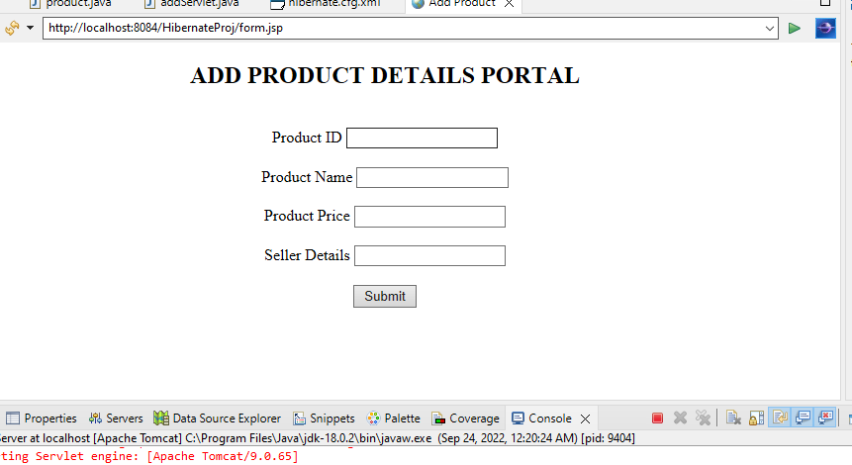

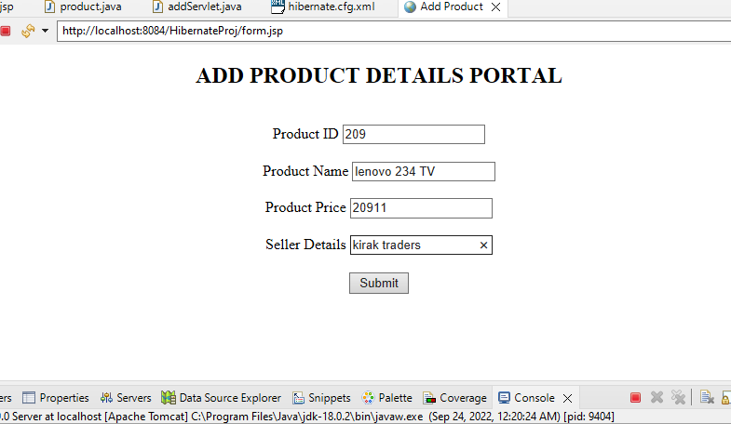

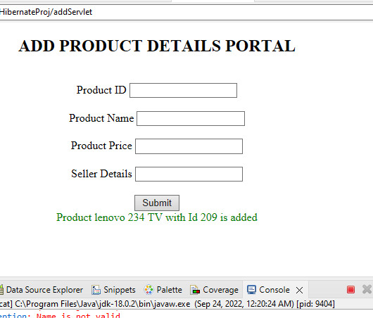

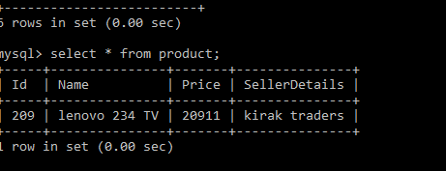

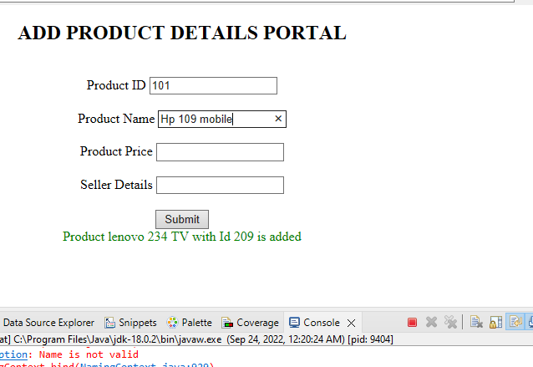

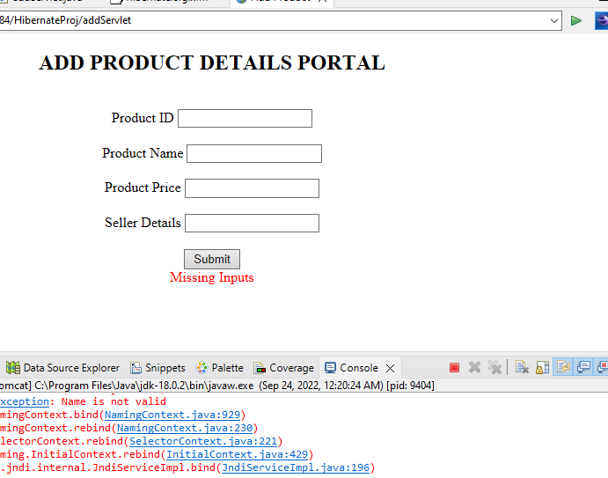

**Pushing to GitHub**