# **Scrum agile project management: The smart person's guide**

This is your go-to guide on scrum, a popular agile project management framework. You'll learn scrum terminology, how to use the methodology in software and product development projects, and more.

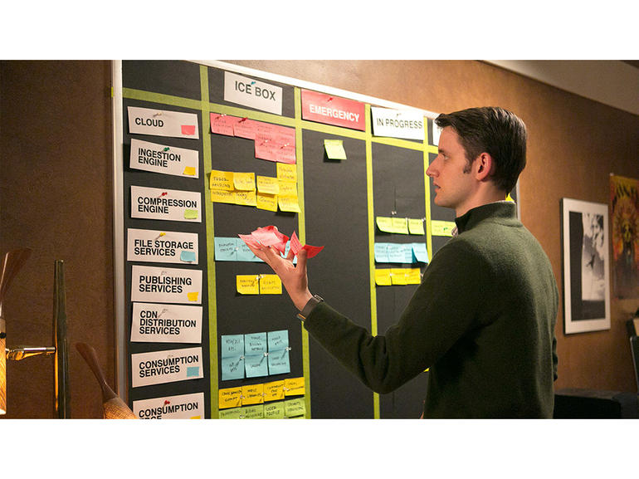

A scrum board in a scene from the TV show *Silicon Valley*.

Image: HBO

There are so many [agile project management](http://www.techrepublic.com/article/agile-project-management-the-smart-persons-guide/) frameworks that it can be difficult for newcomers to the field to get a good grasp of each one. Here's a quick introduction to scrum, which is one of the most popular agile methodologies.

This resource guide is intended to be useful for project managers, business leaders, developers, project and product teams, consultants, stakeholders, and students. We'll update this primer when new information is available about scrum.

**SEE:** [**All of TechRepublic's smart person's guides**](http://www.techrepublic.com/topic/smart-persons-guides/)

## **Executive summary**

* **What is scrum agile project management?** Scrum is a popular iterative software development framework that is often used to manage product development. It uses short, iterative cycles called sprints to complete work.
* **Why does scrum agile project management matter?** This agile framework is highly adaptable due to its simplicity, its flexibility, and the learning opportunities available to leaders and teams, who also benefit from the high degree of customer satisfaction.
* **Who does scrum agile project management affect?** Project leaders, teams (made up of a scrum master, a product owner, and a scrum team), developers, stakeholders, end users, the business as a whole, and ultimately clients.
* **When is scrum agile project management happening?** Scrum has been applied as a methodology since 2001 and is now one of the most widely used agile frameworks within various companies and industries worldwide.
* **How do I use scrum agile project management?** There are numerous online resources, which include the [Scrum Alliance](https://www.scrumalliance.org/) founded in 2002 by [Ken Schwaber](http://www.scrumguides.org/) and others; [Scrum Guides](http://www.scrumguides.org/), which were started by Ken Schwaber and Jeff Sutherland; and various organizations, including [PMI](https://www.pmi.org/) and [Scrum.org](http://www.scrum.org/), that provide in-depth background information about the framework, as well as training and certification options.

**SEE:** [**IT leader's guide to Agile development**](http://www.techproresearch.com/downloads/it-leader-s-guide-to-agile-development/) **(Tech Pro Research)**

## **What is scrum agile project management?**

The word scrum originated from a rugby analogy in a [1986 study by Hirotaka Takeuchi and Ikujiro Nonaka](https://hbr.org/1986/01/the-new-new-product-development-game), and is just one of the many agile frameworks used in project management to improve quality and expedite product development and delivery. There are three key roles in scrum: the scrum master, the product owner, and the development team.

* **The scrum master** takes on the role of a coach/team leader who is responsible for overseeing and guiding the process and making sure the team meets its goals and deliverables. Although the team is self-organizing, the scrum master works with the team to ensure there is synergy and alignment in their focus.
* **The product owner** is, in essence, a project sponsor who develops the wish list of things to be done and prioritizes it. The product owner interacts with the team and the scrum master throughout the project.
* **The Scrum team** is a self-organizing collaborative team that is used across functions and brought together because of their relevant and necessary skills for a project. This team of usually 5 - 10 people has the full capabilities and authority to complete the work and determines their tools and techniques as well as the delegation of work.

There are core terms in scrum you should know.

* **Artifacts:** Product backlog, sprint backlog, etc.
* **Burndown chart:** Displays the work effort that remains over a timeline.
* **Burnup chart:** Displays the increase in a measure against time.
* **Definition of done (DoD):** A set of expectations defined by the development team that outlines when a product is releasable.
* **Scrum team:** A small team of 5 - 10 members that manages and completes the work within each sprint required to release a product to the customer.
* **Product owner:** The person who manages and communicates all requirements for a product to maximize value for the customer.
* **Scrum board:** The scrum team uses this physical board to diagram information needed to complete work.
* **Scrum master:** A coach/team leader who is responsible for overseeing and guiding the process and making sure the team meets its goals and deliverables.
* **Sprint:** A 2- to 4-week time frame increment that teams work within to complete the required work. There are usually iterations within a project.
* **Sprint backlog:** A high-level view of work to be done to realize a sprint goal.

**Additional resources:**

* [Get an overview of the Scrum agile project approach](http://www.techrepublic.com/blog/tech-decision-maker/get-an-overview-of-the-scrum-agile-project-approach/) (TechRepublic)
* [Agile project management: The smart person's guide](http://www.techrepublic.com/article/agile-project-management-the-smart-persons-guide/) (TechRepublic)
* [The roots of agile project management](http://www.techrepublic.com/blog/tech-decision-maker/the-roots-of-agile-project-management/) (TechRepublic)
* [Four variants of agile development methods](http://www.techrepublic.com/blog/tech-decision-maker/four-variants-of-agile-development-methods/) (TechRepublic)
* [Agile development: Cheat Sheet](http://www.techrepublic.com/blog/cio-insights/agile-development-cheat-sheet/) (TechRepublic)
* [Quick glossary: Project management](http://www.techproresearch.com/downloads/quick-glossary-project-management/) (Tech Pro Research)
* [Principles behind the Agile Manifesto](http://www.agilemanifesto.org/principles.html) (AgileManifesto.org)

## **Why scrum agile project management matters**

Scrum offers project teams and organizations the following benefits.

* Because scrum has a predetermined set of role, rules, and processes, it provides teams with an easy to implement process for getting work done, measuring success, and gaining higher levels of customer satisfaction.
* Teams get to continually hone their skills and enhance their knowledge to maintain quality standards, meet stakeholder requirements, and improve collaboration.
* Quality is mandated and defined within the DoD as a primary requirement before a product can be released. This increases the likelihood of success.
* Scrum is highly flexible, as sprints do not impact work that was previously done in project phases, and instead executes only the work in the current sprint, offering teams greater focus.
* Team collaboration and cohesiveness levels tend to be higher, as teams are self-organizing.
* Costs are usually more contained.

**Additional resources:**

* [User stories effectively bridge communication gaps between product and engineering](http://www.techrepublic.com/article/user-stories-effectively-bridge-communication-gaps-between-product-and-engineering/) (TechRepublic)
* [Why the hottest technology job this year may be scrum master](http://www.zdnet.com/article/hottest-tech-job-this-year-may-be-scrum-master/) (ZDNet)
* [Agile methodologies may save the day for digital transformation, McKinsey says](http://www.zdnet.com/article/agile-methodologies-key-to-digital-transformation-mckinsey-says/) (ZDNet)
* [Do we need 'industrial-strength' Agile computing?](http://www.zdnet.com/article/agile-computing-in-search-of-the-next-level/) (ZDNet)
* [10 ways to improve time-to-market for your applications](http://www.techrepublic.com/blog/10-things/10-ways-to-improve-time-to-market-for-your-applications/) (TechRepublic)

## **Who scrum agile project management affects**

### **More for CXOs**

* [How to create an introvert-friendly workplace: 10 tips](http://www.techrepublic.com/article/how-to-create-an-introvert-friendly-workplace-10-tips/)
* [Infographic: The top 10 cities for CIO job satisfaction](http://www.techrepublic.com/article/infographic-the-top-10-cities-for-cio-job-satisfaction/)
* [Research: Digital Transformation 2017: Strategy, Returns on Investment, and Challenges](http://www.techproresearch.com/downloads/digital-transformation-2017-strategy-returns-on-investment-and-challenges/)
* [Subscribe to TechRepublic's Executive Briefing newsletter](http://www.techrepublic.com/newsletters/)

The use of scrum benefits all members of a project team, including developers, project and product managers, testers, engineers, system designers, technical writers, and executives. The largest benefit is passed onto the customer through faster debugging, less frequent defects, and quicker turnaround of high-quality products.

**Additional resources:**

* [10 skills you need to become a great project manager](http://www.techrepublic.com/article/10-skills-you-need-to-become-a-great-project-manager/) (TechRepublic)
* [Report: 11 of the 25 highest paying jobs in the US are in tech](http://www.techrepublic.com/article/report-11-of-the-25-highest-paying-jobs-in-the-us-are-in-tech/) (TechRepublic)
* [7 most important tech jobs needed for today's digital enterprise](http://www.zdnet.com/article/7-most-important-tech-skillsets-needed-for-the-digital-enterprise/) (ZDNet)
* [Agile: why should software developers have all the fun?](http://www.zdnet.com/article/agile-why-should-software-developers-have-all-the-fun/) (ZDNet)
* [Job description: IT project manager](http://www.techproresearch.com/downloads/job-description-it-project-manager/) (Tech Pro Research)
* [Job description: Quality assurance engineer](http://www.techproresearch.com/downloads/job-description-quality-assurance-engineer/) (Tech Pro Research)

## **When scrum agile project management is happening**

In the Scrum Alliance's [2015 State of Scrum Report](https://www.scrumalliance.org/scrum/media/scrumalliancemedia/files%20and%20pdfs/state%20of%20scrum/scrum-alliance-state-of-scrum-2015.pdf) (PDF), 60% of scrum teams adhere to the 7-person team size and 2-week sprints, while 81% hold daily team meetings and 83% plan before each sprint. Further, 90% make use of some form of scrum artifacts, and approximately 56% say artifacts are widely used. Scrum continues to increase in popularity and practice.

**Additional resources:**

* [Research: The rise of agile IT](http://www.techproresearch.com/downloads/research-the-rise-of-agile-it/) (Tech Pro Research)
* [HPE targets DevOps and agile with new application lifecycle management software](http://www.techrepublic.com/article/hpe-targets-devops-and-agile-with-new-application-lifecycle-management-software/) (TechRepublic)
* [The four key tenets of Scrum, still not followed enough](http://www.zdnet.com/article/the-four-key-tenets-of-scrum-still-not-followed-enough/) (ZDNet)

## **How to use scrum agile project management**

During each sprint, the scrum team works together with the development team, which starts by looking at the wish list that was put together and prioritized by the product owner or backlog and plans how to tackle the tasks within a two- to four-week increment.

1. The team develops tasks and delegates each of the tasks.
2. The team identifies all deliverables.
3. The team updates the backlog status.
4. The team develops a new burndown chart.

You can achieve even greater benefits when using scrum with other frameworks such as Kanban and lean to create a hybrid solution.

**Additional resources:**

* [Kanban: The benefits of using this agile PM framework](http://www.techrepublic.com/article/kanban-the-benefits-of-using-this-agile-pm-framework/) (TechRepublic)
* [4 scrum best practices to keep your app development projects on track](http://www.techrepublic.com/article/4-scrum-best-practices-to-keep-your-app-development-projects-on-track/) (TechRepublic)
* [Three ceremonies to conduct in Scrum projects](http://www.techrepublic.com/blog/tech-decision-maker/three-ceremonies-to-conduct-in-scrum-projects/) (TechRepublic)
* [How to use scrum for app development QA testing](http://www.techrepublic.com/article/how-to-use-scrum-for-app-development-qa-testing/http://www.zdnet.com/article/hottest-tech-job-this-year-may-be-scrum-master/) (TechRepublic)
* [Don't take the SAFe route before answering these agile questions](http://www.techrepublic.com/article/dont-take-the-safe-route-before-answering-these-agile-questions/) (TechRepublic)
* [How to apply Agile practices with your non-tech team or business](http://www.techrepublic.com/article/how-to-apply-agile-practices-with-your-non-tech-team-or-business/) (TechRepublic)
* [8 simple rules for achieving 'Lean IT'](http://www.zdnet.com/article/8-simple-rules-for-achieving-lean-it/) (ZDNet)