High Level Design (HLD)

Personal Portfolio Website

Revision Number: 2.0

Last date of revision: 28 March 2023

Premraj Patil

**Document Version Control**

|  |  |  |  |
| --- | --- | --- | --- |
| **Date Issued** | **Version** | **Description** | **Author** |
| 20/03/2023 | 1.0 | Started with adding of Abstract, Introduction and General Description | Premraj Patil |
| 22/03/2023 | 1.1 | Added details related to designing of the website | Premraj Patil |
| 25/03/2023 | 1.2 | Overviewed, organized and updated the document | Premraj Patil |
| 28/03/2023 | 1.3 | Modified design details and added diagrams | Premraj Patil |
| 29/03/2023 | 2.0 | Final walkthrough and minor changes in the document | Premraj Patil |

**Table of Content**

Document Version Control ……………………………………………………………. 2

Abstract ………………………………………………………………………………………… 4

Introduction ………………………………………………………………………………….. 5

1. Why this High-Level Document? ……………………………………………. 5

2. Scope …………………………….………………………………………………………. 5

3. Definition ………………………………………………………………………………. 5

General Description ………………………………………………………………………. 6

1. Product Perspective ……………………………………………………….………. 6

2. Problem Statement ………………………………………………………..………. 6

3. Problem Solution ……………………………………………………………………. 6

4. Proposed Methodology …………………………………………………….……. 6

5. Further Improvements ……………………………………………………………. 6

6. Data Required ……………………………………………………...…………………. 6

7. Tools Used ………………………………………………………………………………. 7

8. Constraints …………………………………………………………………..…………. 7

9. Assumptions ……………………………………………………………………………. 7

Design Details ……………………………………………………………..…………………. 8

1. Process Workflow ………………………………………………………..…………. 8

2. Error Handling ………………………………………………………………..………. 9

Performance …………………………………………………………………………….……. 10

1. Reusability ……………………………………………………………..………………. 10

2. Application compatibility ………………………………………..………………. 10

3. Resources Utilization ………………………………………………………….……. 10

4. Deployment ……………………………………………………………………..…..…. 10

Conclusion ………………………………………………………………………….……..……. 11

Reference ………………………………………………………………………………..………. 12

**Abstract**

A Personal Portfolio is nothing but a professional website cum resume which highlights achievements of yours as a student and also as a working professional. Personal Portfolios sometimes have details of services that a company provides. It also includes several ways in which one can get in touch with the working professional or the company.

So, having a personal portfolio is worth so that we as a professionals can reach out to our customers while not actually seeing them physically and giving them a brief information about our professional career.

**Introduction**

**1. Why this High-Level Design Document?**

The purpose of this High-Level Design (HLD) Document is to add the necessary detail to the current project description to represent a suitable model for coding. This document is also intended to help detect contradictions prior to coding and can be used as a reference manual for how the modules interact at a high level.

The HLD will:

* Present all the design aspects and define them in detail
* Describe the user interface being implemented
* Describe the hardware and software interfaces
* Describe the performance requirements
* Include design features and the architecture of the project

**2. Scope**

The HLD documentation presents the structure of the system, such as the database architecture, application architecture (layers), application flow (Navigation), and technology architecture. The HLD uses non-technical to mildly technical terms which should be understandable to the administrators of the system.

**3. Definition**

The terms used in the projects are:

* Academics – Educational Background
* BE - Bachelor of Engineering
* Intermediate – HSC (12th)
* School – SSC (10th)

**General Description**

**1. Product Perspective**

Personal Portfolio is a user-friendly website which is helpful for someone who is looking for any sort of career opportunity. This is also useful for someone who wants to grow their business at higher level by attracting more and more customers and crowd.

**2. Problem Statement**

There are so many people who are struggling with finding a career opportunity. For this they have to travel a lot taking their CV or Resume in hand. To create the personal portfolio using various web development tools.

**3. Problem Solution**

Developing a web application using various web development technologies which will include the introduction an employee in brief, his/her achievements in professional career, educational background and ways to contact him/her to get in touch. Doing this will be helpful for someone who looking for any sort of career opportunity by reaching out to recruiters by sending them this personal portfolio remotely.

**4. Further Improvement**

The project can be extended by using database and backend technologies such as node.js and others so that if someone want to get in touch by simply messaging and not through any kind of social media. To do this we can connect database in backend which will store data such as name, text message, contact information of message sender and anything else that we might want to add/store.

**5. Data Required**

Data required to develop this personal portfolio website is the information about employee’s professional career and his/her field of interest. Along with this we also need this contact information so that peoples who may want to get in touch can.

Data like his educational background, projects completed by his/her, field of interest, languages known is essential for this project.

**6. Tools Used**

* Window 11 Operating System
* Visual Studio Code
* GitHub as Version Control System
* Canva
* Font Awesome, Google Fonts
* Color Hunt, uiGradient
* Netlify

**7. Constraints**

The personal portfolio website must be user friendly and well-structured so that anyone can get any sort of details. Website should use media-queries so that anyone visiting it on desktop or mobile should not affect their experience. It should also ensure that to connect employee should be user friendly and easy.

**8. Assumptions**

The main objective of the project is to simplify the process of getting in touch with recruiter or employer or customer being at our workspace and not going out anywhere by just sending them this hosted website.

**Design Details**

**1. Process Workflow**

Below is a basic diagram that represents the process flow at very superficial level.

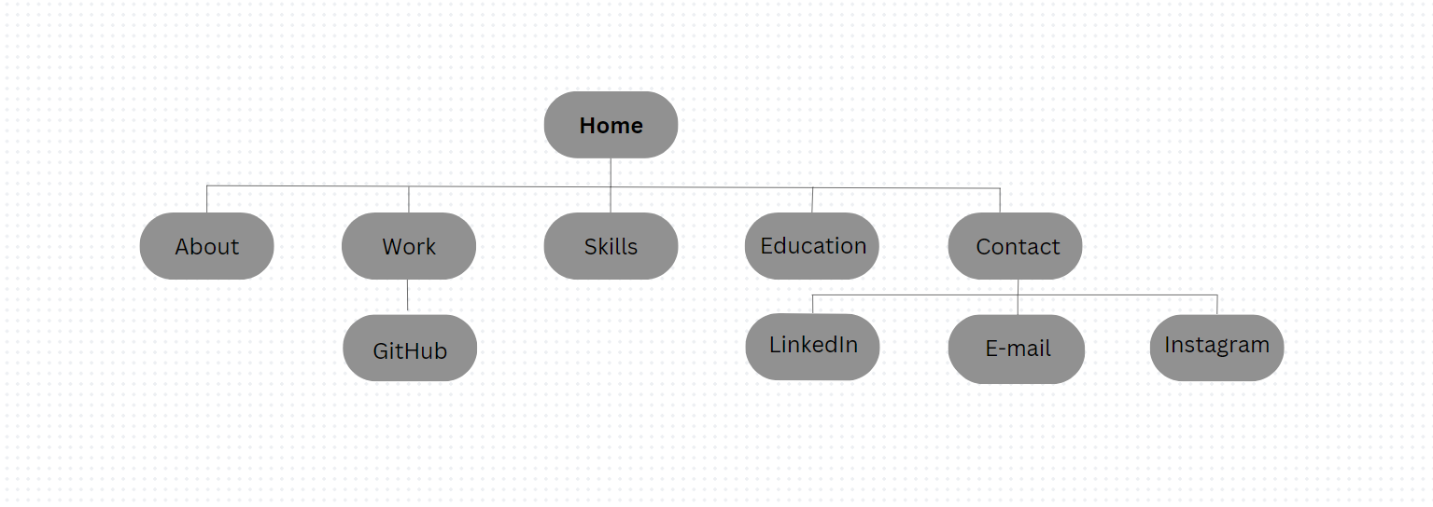

When anyone visits the portfolio, he/she would firstly come across the home page or home screen of the website which consists of a small quote and introduction of mine.

While on the home page there are several options that would directly navigate user to the various sections of the website.

Below home page of the website I have given a brief about my education and below it there are other several section such as skillsets I have, projects I did previously and finally at the end of the website I have added a quote along with contact details of mine through which anyone can connect with me through social media.

Deployment Process

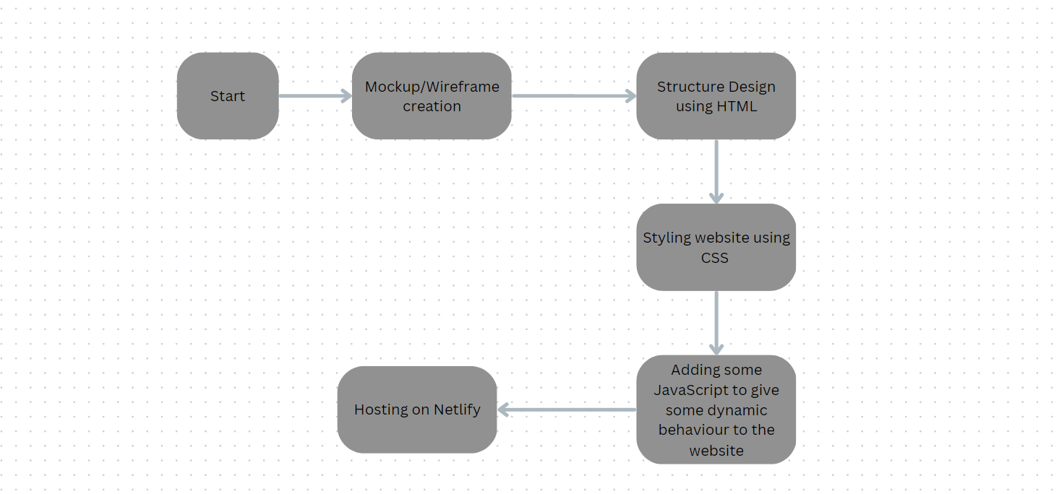

**2. Error Handling**

Initially I was very much confused about structuring the website and adding content on it. After some sort of research and suggestions I had figured out the structure for my website and content to add on it. All of the above errors have been resolved.

**Performance**

**1. Reusability**

This is the static website. The code template can as a whole can be reused to develop something that has portfolio kind of stuff on it. The stylesheet consists of various color gradients and other styling properties like font, margin etc. can be directly applied to other websites.

**2. Application compatibility**

Since I am using HTML, CSS and JavaScript to develop this project it is compatible with any platform, I follow Application compatibility.

**3. Resource utilization**

Since the portfolio website I we developed is the static one it doesn’t required much resources. Once successful hosting of the website the only thing it requires is browser supportability and a steady internet connection to render things properly on the browser.

**4. Deployment**

The code is deployed in GitHub. The whole system is live and is hosted on Netlify.

**Conclusion**

This project proposes the personal portfolio website which can be used as Resume/CV which is available online for everyone till its hosted. This project can be used to reach out to the employer or recruiter by sending him/her this project.

Thus, during this one month of internship I had successfully completed Personal Portfolio Website Development project which is responsive and has all the data that is necessary for anyone who want to know about my professional career.

**References**

1. <https://developer.mozilla.org/en-US/docs/Web/HTML>
2. <https://www.w3schools.com/css/>
3. <https://developer.mozilla.org/en-US/docs/Web/CSS>
4. <https://developer.mozilla.org/en-US/docs/Web/JavaScript>
5. <https://tusharsinghofficial.netlify.app/>
6. <https://personal-portfolio.freecodecamp.rocks/>
7. <https://fonts.google.com/>
8. <https://uigradients.com/#PurpleParadise>
9. <https://fontawesome.com/>
10. <https://colorhunt.co/>