Low Level Document (LLD)

Personal Portfolio Website

Version number: 1.0

Last date of revision: 29 March 2023

Premraj Patil

**DECLARATION**

We declare that this written submission represents us ideas is our own words and where others' ideas or words have been included, we have adequately cited and referenced the original sources.

We also declare that we have adhered to all principles of academic honesty and integrity and have not misrepresented or fabricated or falsified any idea/data/fact/source in my submission.

We understand that any violation of the above will be cause for disciplinary action by the Institute and can also evoke penal action from the sources which have thus not been properly cited or from whom proper permission has not been taken when needed.

**Revision History**

|  |  |  |  |  |  |
| --- | --- | --- | --- | --- | --- |
| **Version** | **Date** | **Author** | **Reviewer** | **Approver** | **Comments** |
| 0.1 | 26-01-2022 | Premraj Patil | Premraj Patil |  | Initial version of website as per mock-up/wireframe |
| 0.2 | 27-01-2022 | Premraj Patil | Premraj Patil |  | Edited some structure and added some design using CSS stylesheets |
| 0.3 | 28-01-2022 | Premraj Patil | Premraj Patil |  | Updated layout of the website using CSS Flexbox and added some |
| 0.4 | 29-01-2022 | Premraj Patil | Premraj Patil |  | Added some JavaScript code for better functionality |
| 1.0 | 30-03-2023 | Premraj Patil | Premraj Patil |  | Final Version |

**Table of Contents**

1. Introduction ………………………………………………………………………..6

1.1 Scope of the document…………………………………………………………6

1.2 Intended Audience………………………………………………………………6

1.3 System Overview………………………………………………………………..7

1. Project Briefing……………………………………………………………………….
2. Problem Statement…………………………………………………………………..
3. Problem Solution……………………………………………………………………..
4. Objective of Project…………………………………………………………………..
5. Scope of Project………………………………………………………………………
6. Block Diagram………………………………………………………………………...
7. Requirements Gathering………………………………………………………………
8. Analysis………………………………………………………………………………
9. Final Screenshot of Project Output…………………………………………………...
10. **Introduction:**

**1.1 Scope of the Document**

* This project is being created so that I can send it as my project cum resume with some additional design components to it. It will help me to create a positive impression in terms of my creative ability in front of recruiter/interviewer.

**1.2 Intended Audience**

* The intended audience for this project consist people at higher positions in organizations who takes care of recruitment process for vacant positions. Also, the audience for this project consist of my college professors who want to know what kind of progress and work I am doing as a professional. Everyone who is connected to me in some or other ways is also the intended audience for this project.

**1.3 System Overview**

* Personal Portfolio Website is a website that contains almost everything that is related to anyone’s professional career. It contains information like qualification, current employment status, works/project that he/she worked upon, internship details if done etc.
* I am the only stake holder of this website because this website contains only things that I want to display and I’m the one who is going to benefitted from this project.
* Once the website is fully developed and hosted successfully, it is open for the audience and viewers. Anyone can connect me through social media which I added in the project. Also, they are able to check out my GitHub on which I had added some of my work of UI/UX design and a bit of coding stuff.

1. **Project Briefing:**

In the proposed project, I had defined a layout which has a welcome section which contains my name, few links which navigates to different sections of the webpage along with a picture of mine and a quote which defines my personality to some extent.

This is followed by a section which lists my schooling details along with the college that I am currently pursuing. Below this I added another section that consist of skill sets I own along with proficiency in them. The section below it consists of a small section which have a list of some beginner level templets that I designed during the learning of technologies like HTML, CSS etc.

In the end of the project, the footer section of the website contains my name followed by another quote by Nelson Mandela which again defines my personality to some extent. Below it I listed out my social media handles along with LinkedIn and GitHub.

The whole as a one, this project contains information related to my professional career and also some popular ways to connect me by the means of social media and LinkedIn.

1. **Problem Statement:**

Personal Portfolio is a user-friendly website which is helpful for someone who is looking for any sort of career opportunity. This is also useful for someone who wants to grow their business at higher level by attracting more and more customers and crowd.

1. **Problem Solution:**

Developing a web application using various web development technologies which will include the introduction an employee in brief, his/her achievements in professional career, educational background and ways to contact him/her to get in touch. Doing this will be helpful for someone who looking for any sort of career opportunity by reaching out to recruiters by sending them this personal portfolio remotely.

1. **Objective of the Project:**

Objective of this project is to reach out the audience being at remote location, giving a brief introduction of me and my work through my personal portfolio which is developed by me.

1. **Scope of Project:**

This Personal Portfolio Website will be helpful for recruiters to sort the candidates by navigating to the skill section of the website. Companies look for a candidate who is able to do any sort of task within the time limit specified. They will be able to estimate of the candidate’s calibre using his skill sets.

1. **Block Diagram:**

Below is a basic diagram that represents the process flow at very superficial level.

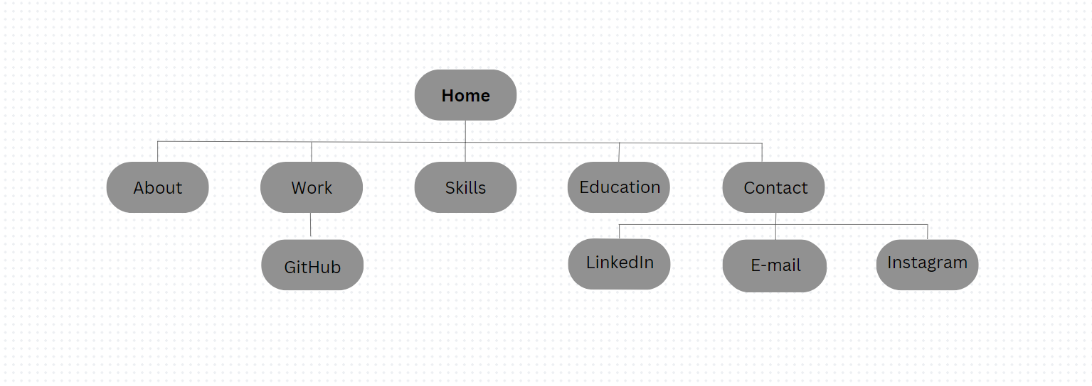

Deployment Process

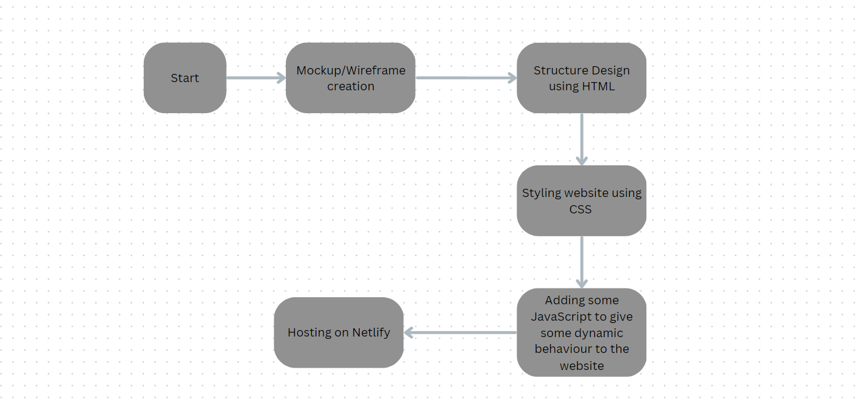

1. **Requirements Gathering:**

* Window 11 Operating System
* Visual Studio Code
* GitHub as Version Control System
* Canva
* Font Awesome, Google Fonts
* Color Hunt, uiGradient
* Netlify

1. **Analysis:**

Doing project of Personal Portfolio Website Development as a beginner is the best way to start and showcase your skills and creative ability. This is also a good way to start career as a web developer because having a portfolio never goes out of style.

When anyone visits the portfolio, he/she would firstly come across the home page or home screen of the website which consists of a small quote and introduction of mine.

While on the home page there are several options that would directly navigate user to the various sections of the website.

Below home page of the website, I have given a brief about my education and below it there are other several section such as skillsets I have, projects I did previously and finally at the end of the website I have added a quote along with contact details of mine through which anyone can connect with me through social media.

1. **Final Screenshot of Project Output**