CS 440 MPX Project- R5
Setup Guide for Serial Port Emulator for Windows

*Requirements: computer must be running Microsoft Windows (XP or Vista).
If you computer already has serial ports (if it is a desktop), go to the device manager and DISABLE all COM ports (do not uninstall them, just disable them). This will allow you to install COM1 and COM2 as virtual serial ports. Once you are done with the project, you can uninstall the serial port emulator and then enable the physical serial ports in the device manager, and use them as normal.
- Go to http://www.chiark.greenend.org.uk/~sgtatham/putty/download.html and download the “PuTTY” binary (putty.exe)
- Go to http://sourceforge.net/project/showfiles.php?group_id=129551&package_id=141993 and download/save “com0com-2.1.0.0-i386-chk.zip”
- Extract the folder
- Run “setup” and do not change any of the defaults. If the Found New Hardware Wizard pops up, click “No, not this time” when asked about checking windows update, then click next, then select “Install automatically” and click next.
- Goto Start->Programs-> com0com-> setup command prompt
- Type the following commands
  - “change cnca0 PortName=COM1”
  - “change cncb0 PortName=COM2”
You should now have the COM1 and COM2 ports available to you.
- Open Putty and type the following in (make sure to select “serial”):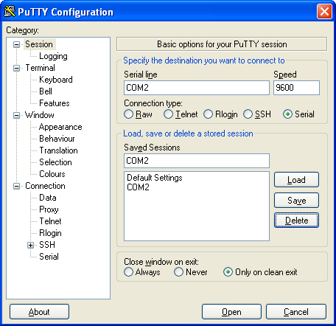

- Click Open

- You may test the serial port emulator by creating another Putty session using the COM1 port and typing in each window. If what you type appears in the other Putty Window, everything is working correctly.

- You are now ready to roll… for R5- create a Turbo C project and compile like this:
Note that for R5, you only compile MPX_SUPT.C, R5.C, and one of the test processes (will be made available on the web). This will connect MPX to COM1, and Putty will be connected to COM2.
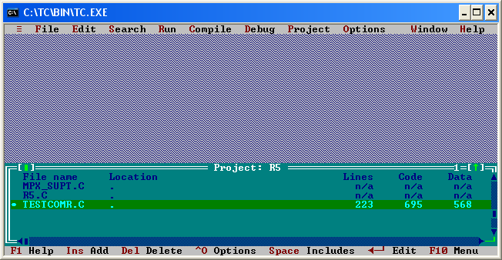

- Then Run it with Putty Open….
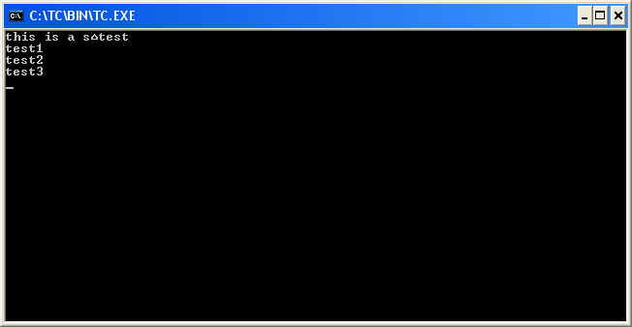
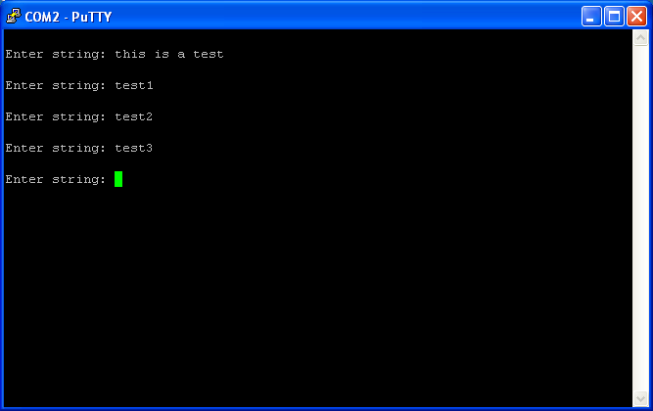

- Also test your R5 by compiling R5 with TestComW.C

Notes

If you experience problems when trying to connect to COM1 or COM2 in Putty, go to the device manager and make sure the device drivers for the com0com ports are installed correctly. If you see a yellow question mark, update the drivers (allow windows to install them automatically). Also, make sure you complete steps 5 and 6 above.

This does not work on Linux, even if you use DosBox or some other emulator. If you are using Linux, it is up to you to find a serial port emulator that works, or you will have to port your project to Windows.

